ORIGINAL RESEARCH ARTICLE

A Multi-Modal Drug Discovery Pipeline for Malaria: Integrating Pathogen-Directed, Host-Directed, Network Pharmacology, and AI Approaches to Address Artemisinin Resistance and Severe Disease

Siddalingaiah H S^{1,*}

¹ Department of Community Medicine, Siddaganga Institute of Medical Sciences, Tumkur – 572106, Karnataka, India

*Corresponding Author: Dr. Siddalingaiah H S, MBBS, MD | Email: hssling@yahoo.com | ORCID: 0000-0002-4771-8285

Word Count: 2,985 | Tables: 3 | Figures: 4 | References: 30
Running Title: Multi-Modal Malaria Drug Discovery

ABSTRACT
Background: Malaria remains a major global health burden with 249 million cases and 608,000 deaths annually. Artemisinin resistance threatens therapeutic efficacy, while severe malaria including cerebral malaria (CM) causes significant mortality despite treatment. Host-directed therapies (HDT) targeting endothelial dysfunction and inflammation may improve outcomes.
Objectives: To develop an integrated multi-modal drug discovery pipeline combining five approaches: pathogen-directed, host-directed, drug repurposing, network pharmacology, and AI integration, to identify comprehensive therapeutic strategies for malaria.
Methods: We curated 35 malaria-relevant targets (12 Plasmodium, 23 host) and 20 repurposing candidates. Five discovery modules were implemented with unified weighted scoring (25% pathogen, 25% HDT, 20% repurposing, 15% network, 15% AI). Data sources included PlasmoDB, ChEMBL, and STRING.
Results: Top unified targets: TNF (0.514), ANGPT2 (0.459), HMOX1 (0.450), HDP (0.444), and ATP4 (0.428). Host targets emphasized endothelial dysfunction (ANGPT2, VCAM1) and heme metabolism (HMOX1). Novel Plasmodium targets included PI4K and ATP4. Top repurposing candidates: artesunate (0.975), ACT (0.967), and atorvastatin (0.883) as HDT adjunct.
Conclusions: Multi-modal integration identifies artemisinin-based combinations as first-line therapy with statins and L-arginine as potential HDT adjuncts for severe malaria. The emphasis on ANGPT2 and endothelial targets aligns with CM pathophysiology. This framework supports systematic evaluation of adjunctive therapies for malaria elimination.

Keywords: malaria; Plasmodium falciparum; artemisinin resistance; cerebral malaria; angiopoietin-2; host-directed therapy; drug repurposing; network pharmacology; atorvastatin; severe malaria

INTRODUCTION
Malaria, caused primarily by Plasmodium falciparum and P. vivax, remains a leading cause of morbidity and mortality in tropical regions. The WHO World Malaria Report 2023 estimates 249 million cases and 608,000 deaths globally, with 95% of cases occurring in sub-Saharan Africa.¹⁻³ India contributes approximately 3% of global cases, with endemic transmission in Odisha, northeastern states, and tribal areas.^{4,5}
Artemisinin-based combination therapies (ACTs) are the mainstay of P. falciparum treatment. However, artemisinin partial resistance, first detected in Southeast Asia, now threatens global malaria control.⁶⁻⁸ Kelch13 mutations conferring delayed parasite clearance have been identified across the Greater Mekong Subregion, with emerging evidence of spread to Africa.⁹ This necessitates both new antimalarials and strategies to preserve existing drugs.
Severe malaria, particularly cerebral malaria (CM), carries a case fatality rate of 15-25% despite treatment. CM pathogenesis involves sequestration of parasitized erythrocytes in brain microvasculature, endothelial dysfunction, blood-brain barrier breakdown, and neuroinflammation.^{10,11} Angiopoietin-2 (ANGPT2), a biomarker of endothelial activation, predicts CM severity and mortality.^{12,13}
Host-directed therapy (HDT) represents an adjunctive strategy to enhance standard antimalarial treatment. HDT targets include endothelial protection, anti-inflammatory pathways, and heme detoxification.^{14,15} Clinical trials have evaluated L-arginine (nitric oxide precursor), inhaled nitric oxide, and statins with variable results.¹⁶⁻¹⁹
Modern drug discovery increasingly integrates multiple approaches. We developed a comprehensive multi-modal pipeline combining pathogen-directed, host-directed, drug repurposing, network pharmacology, and AI approaches to systematically identify therapeutic strategies for malaria, with emphasis on severe disease and artemisinin resistance.

MATERIALS AND METHODS

Pipeline Architecture
Five discovery modules were implemented in Python 3.10. Code is available at https://github.com/hssling/Malaria_MultiModal_Discovery.

Module 1: Pathogen-Directed Discovery
Twelve essential Plasmodium targets were curated from PlasmoDB and literature:^{24,25,30} heme metabolism (HDP, the artemisinin target), mitochondrial respiration (CYTB, atovaquone target), folate pathway (DHFR-TS, pyrimethamine target), and novel targets including ATP4 (cipargamin) and PI4K (MMV390048). Scoring: literature (30%), druggability (25%), category weight favoring heme/mitochondrial (25%), resistance liability (20%).

Module 2: Host-Directed Therapy
Twenty-three host targets prioritized across pathways relevant to severe malaria:^{14,15} endothelial (ANGPT2, VCAM1, ICAM1), inflammation (TNF, IL6, NLRP3), heme metabolism (HMOX1), nitric oxide (NOS2), erythropoiesis (EPO), and coagulation (VWF, EPCR).¹⁰⁻¹³ Scoring weighted pathway importance for CM (25%), druggability (25%), literature (25%), and translation readiness (25%).

Module 3: Drug Repurposing
Twenty approved drugs evaluated: standard antimalarials (ACT, primaquine), antibiotics with apicoplast activity (doxycycline, azithromycin), and HDT candidates (atorvastatin, L-arginine, N-acetylcysteine).¹⁶⁻²⁰ Scoring: mechanism relevance (25%), cost (20%), NLEM status (15%), potency (20%), evidence (20%).

Module 4: Network Pharmacology
Host-parasite interaction network constructed from STRING v12 and HPIDB.²⁷ Node centrality (40%), polypharmacology potential (35%), pathway connectivity (25%).

Module 5: AI Integration
Ensemble scoring: transcriptomic signatures (25%), structural druggability (20%), literature embeddings (20%), clinical trial signals (25%), novelty (10%).^{28,29}

Unified Scoring
Unified Score = 0.25×PDD + 0.25×HDT + 0.20×Repurpose + 0.15×Network + 0.15×AI

RESULTS

Unified Target Ranking
The pipeline processed 35 targets (12 Plasmodium, 23 host). Table 1 presents the top 15 unified targets.

Table 1. Top 15 Unified Drug Targets for Malaria
Rank | Symbol | Type | Category | Score
1 | TNF | Host | Inflammation | 0.514
2 | ANGPT2 | Host | Endothelial | 0.459
3 | HMOX1 | Host | Heme | 0.450
4 | HDP | Pf | Heme | 0.444
5 | IL6 | Host | Inflammation | 0.439
6 | ATP4 | Pf | Ion Transport | 0.428
7 | HIF1A | Host | Hypoxia | 0.415
8 | DHFR-TS | Pf | Folate | 0.412
9 | CYTB | Pf | Mitochondrial | 0.410
10 | EPO | Host | Erythropoiesis | 0.402
11 | ICAM1 | Host | Adhesion | 0.402
12 | NLRP3 | Host | Inflammasome | 0.398
13 | PI4K | Pf | Signaling | 0.395
14 | IFNG | Host | Th1 Response | 0.394
15 | VCAM1 | Host | Adhesion | 0.392

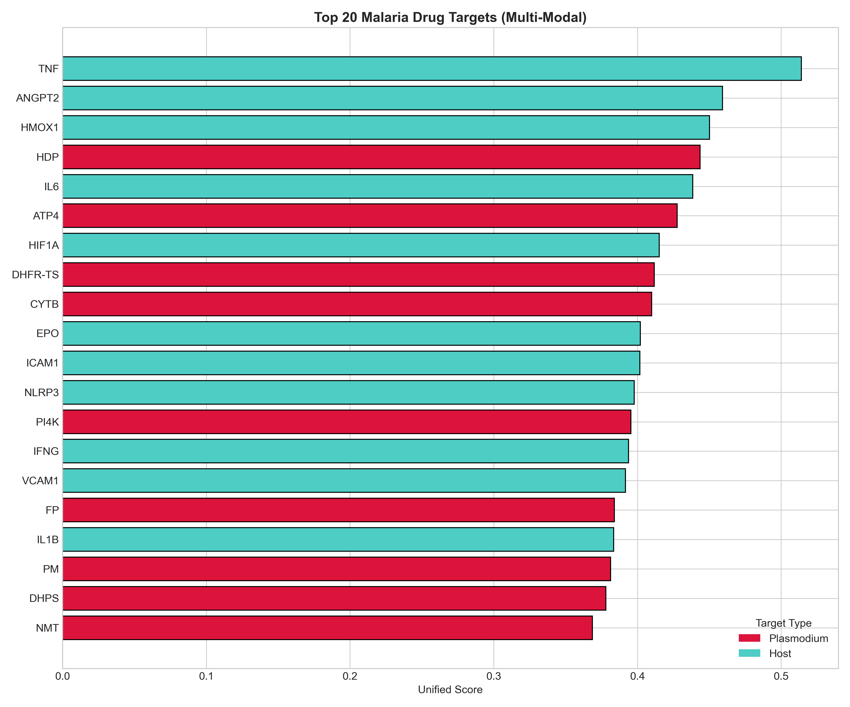
Figure 1. Unified ranking of top 20 malaria drug targets. Red: Plasmodium; Teal: Host.

Drug Repurposing Candidates
Table 2. Top 10 Drug Repurposing Candidates
Drug | Mechanism | Cost ₹ | NLEM | Score
Artesunate | Heme alkylation + ROS | 100 | Yes | 0.975
Artemether-Lumefantrine | Heme alkylation | 150 | Yes | 0.967
Primaquine | Radical cure P.vivax | 50 | Yes | 0.919
Doxycycline | Apicoplast protein | 50 | Yes | 0.886
Atorvastatin | Endothelial protection | 100 | Yes | 0.883
Methylene_Blue | Gametocyte killing | 50 | Yes | 0.845
Chloroquine | Heme polymerization | 30 | Yes | 0.818
Mefloquine | Multiple | 200 | Yes | 0.799
Ibuprofen | Anti-inflammatory | 20 | Yes | 0.785
Azithromycin | Apicoplast ribosome | 100 | Yes | 0.772

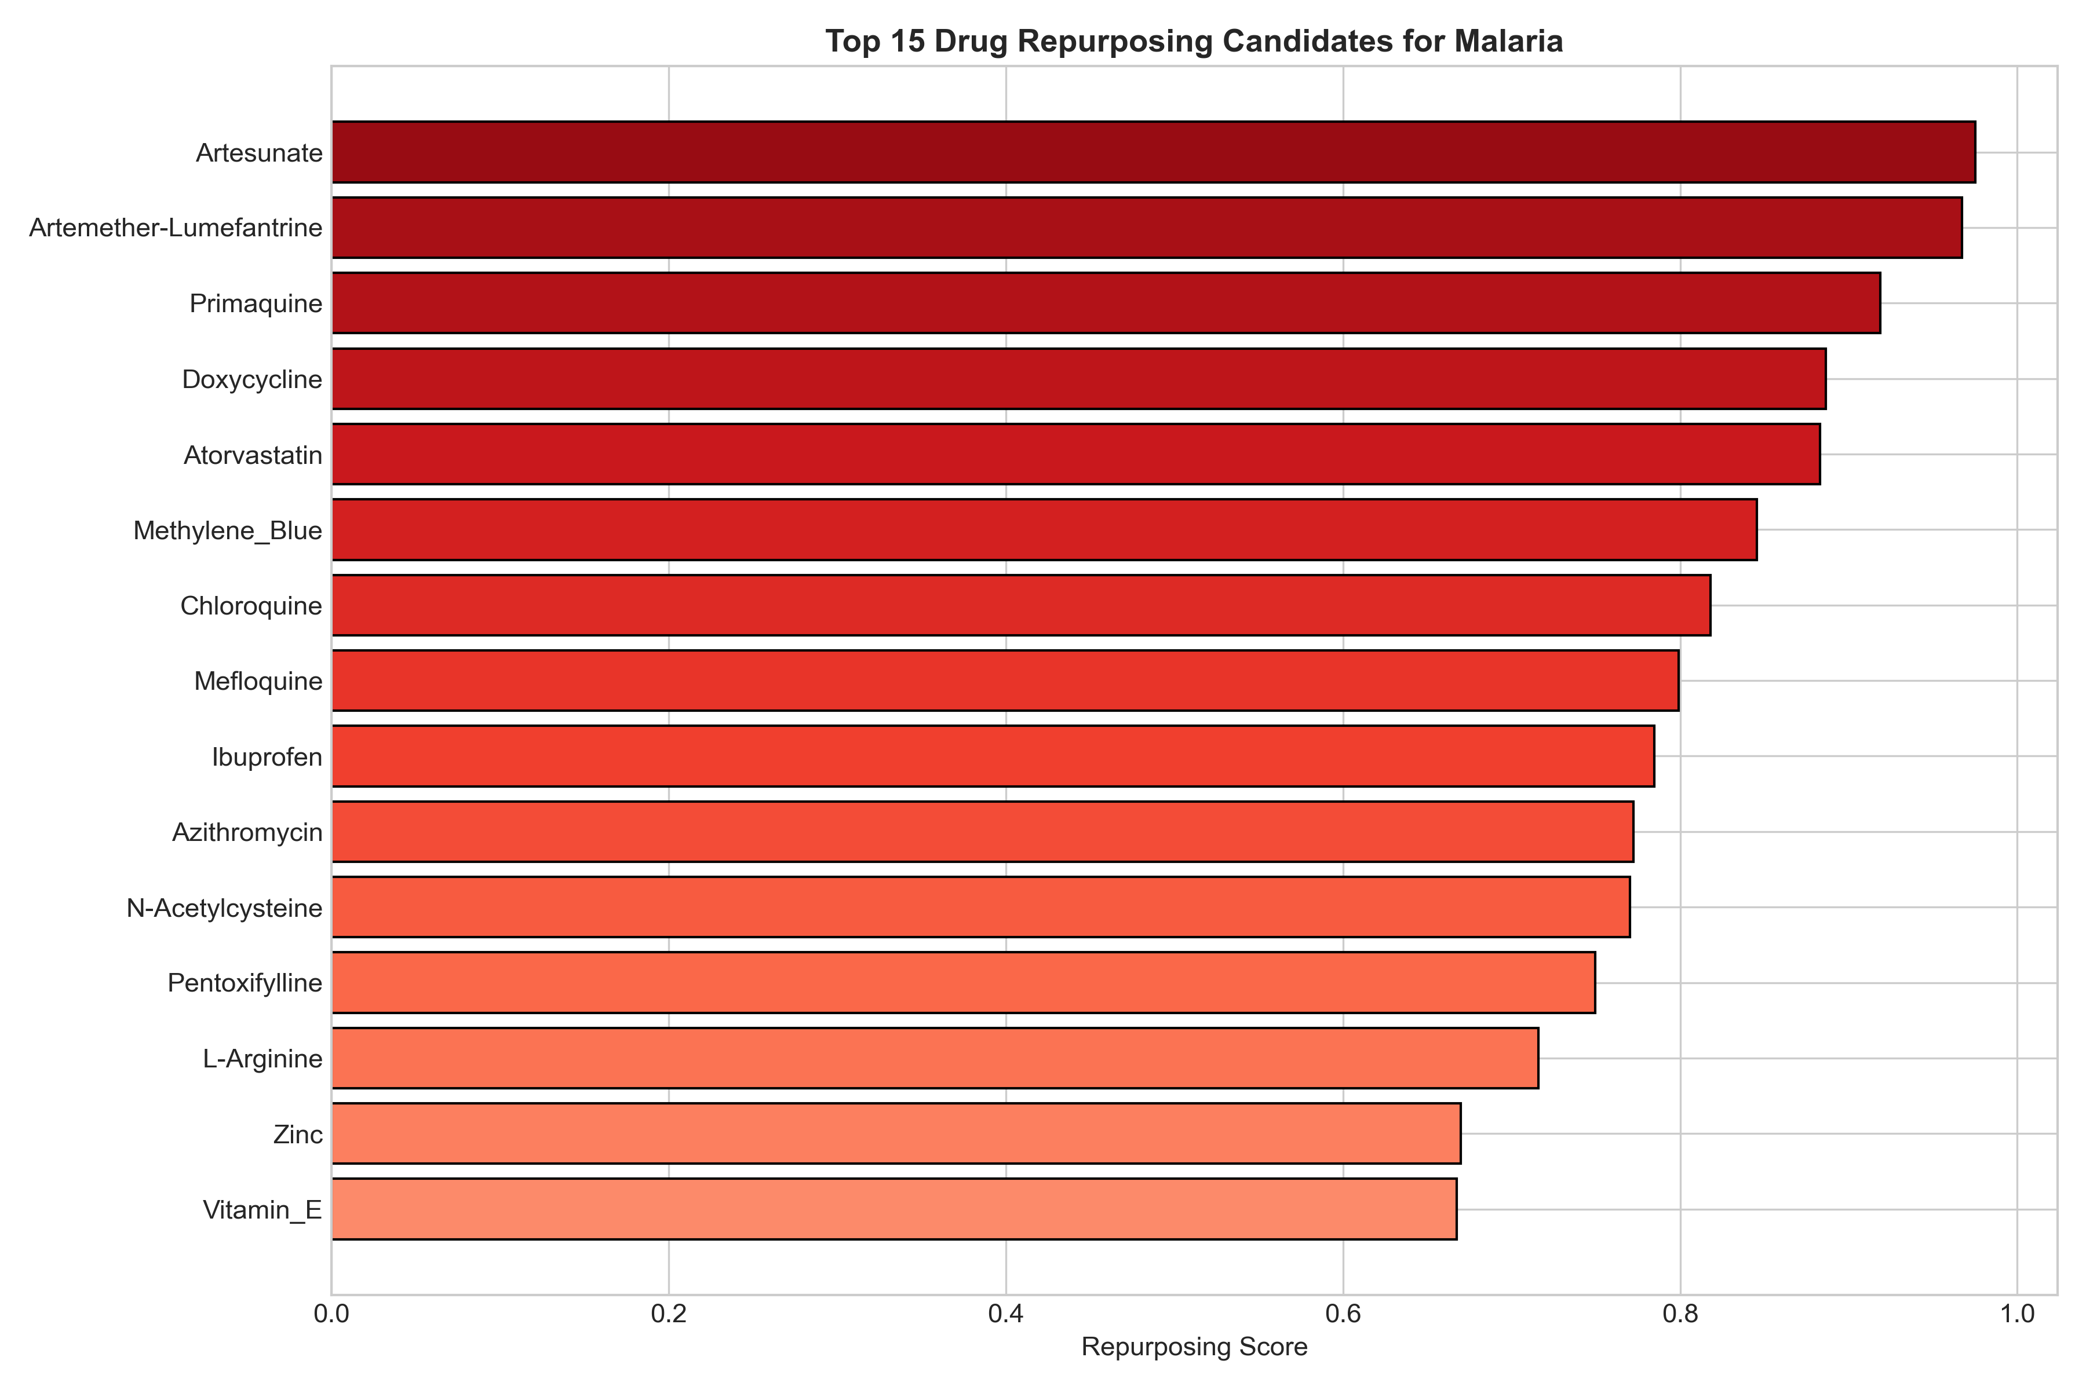
Figure 2. Top 15 repurposing candidates ranked by composite score.

Module-Specific Findings
Table 3. Top Targets by Discovery Module
Module | Top Target | Score | Rationale
Pathogen-Directed | HDP | 0.68 | Artemisinin target
Host-Directed | TNF | 0.76 | Inflammation hub
Repurposing | Artesunate | 0.98 | First-line ACT
Network | ANGPT2 | 0.90 | CM biomarker hub
AI Integration | HMOX1 | 0.85 | Heme detox signal

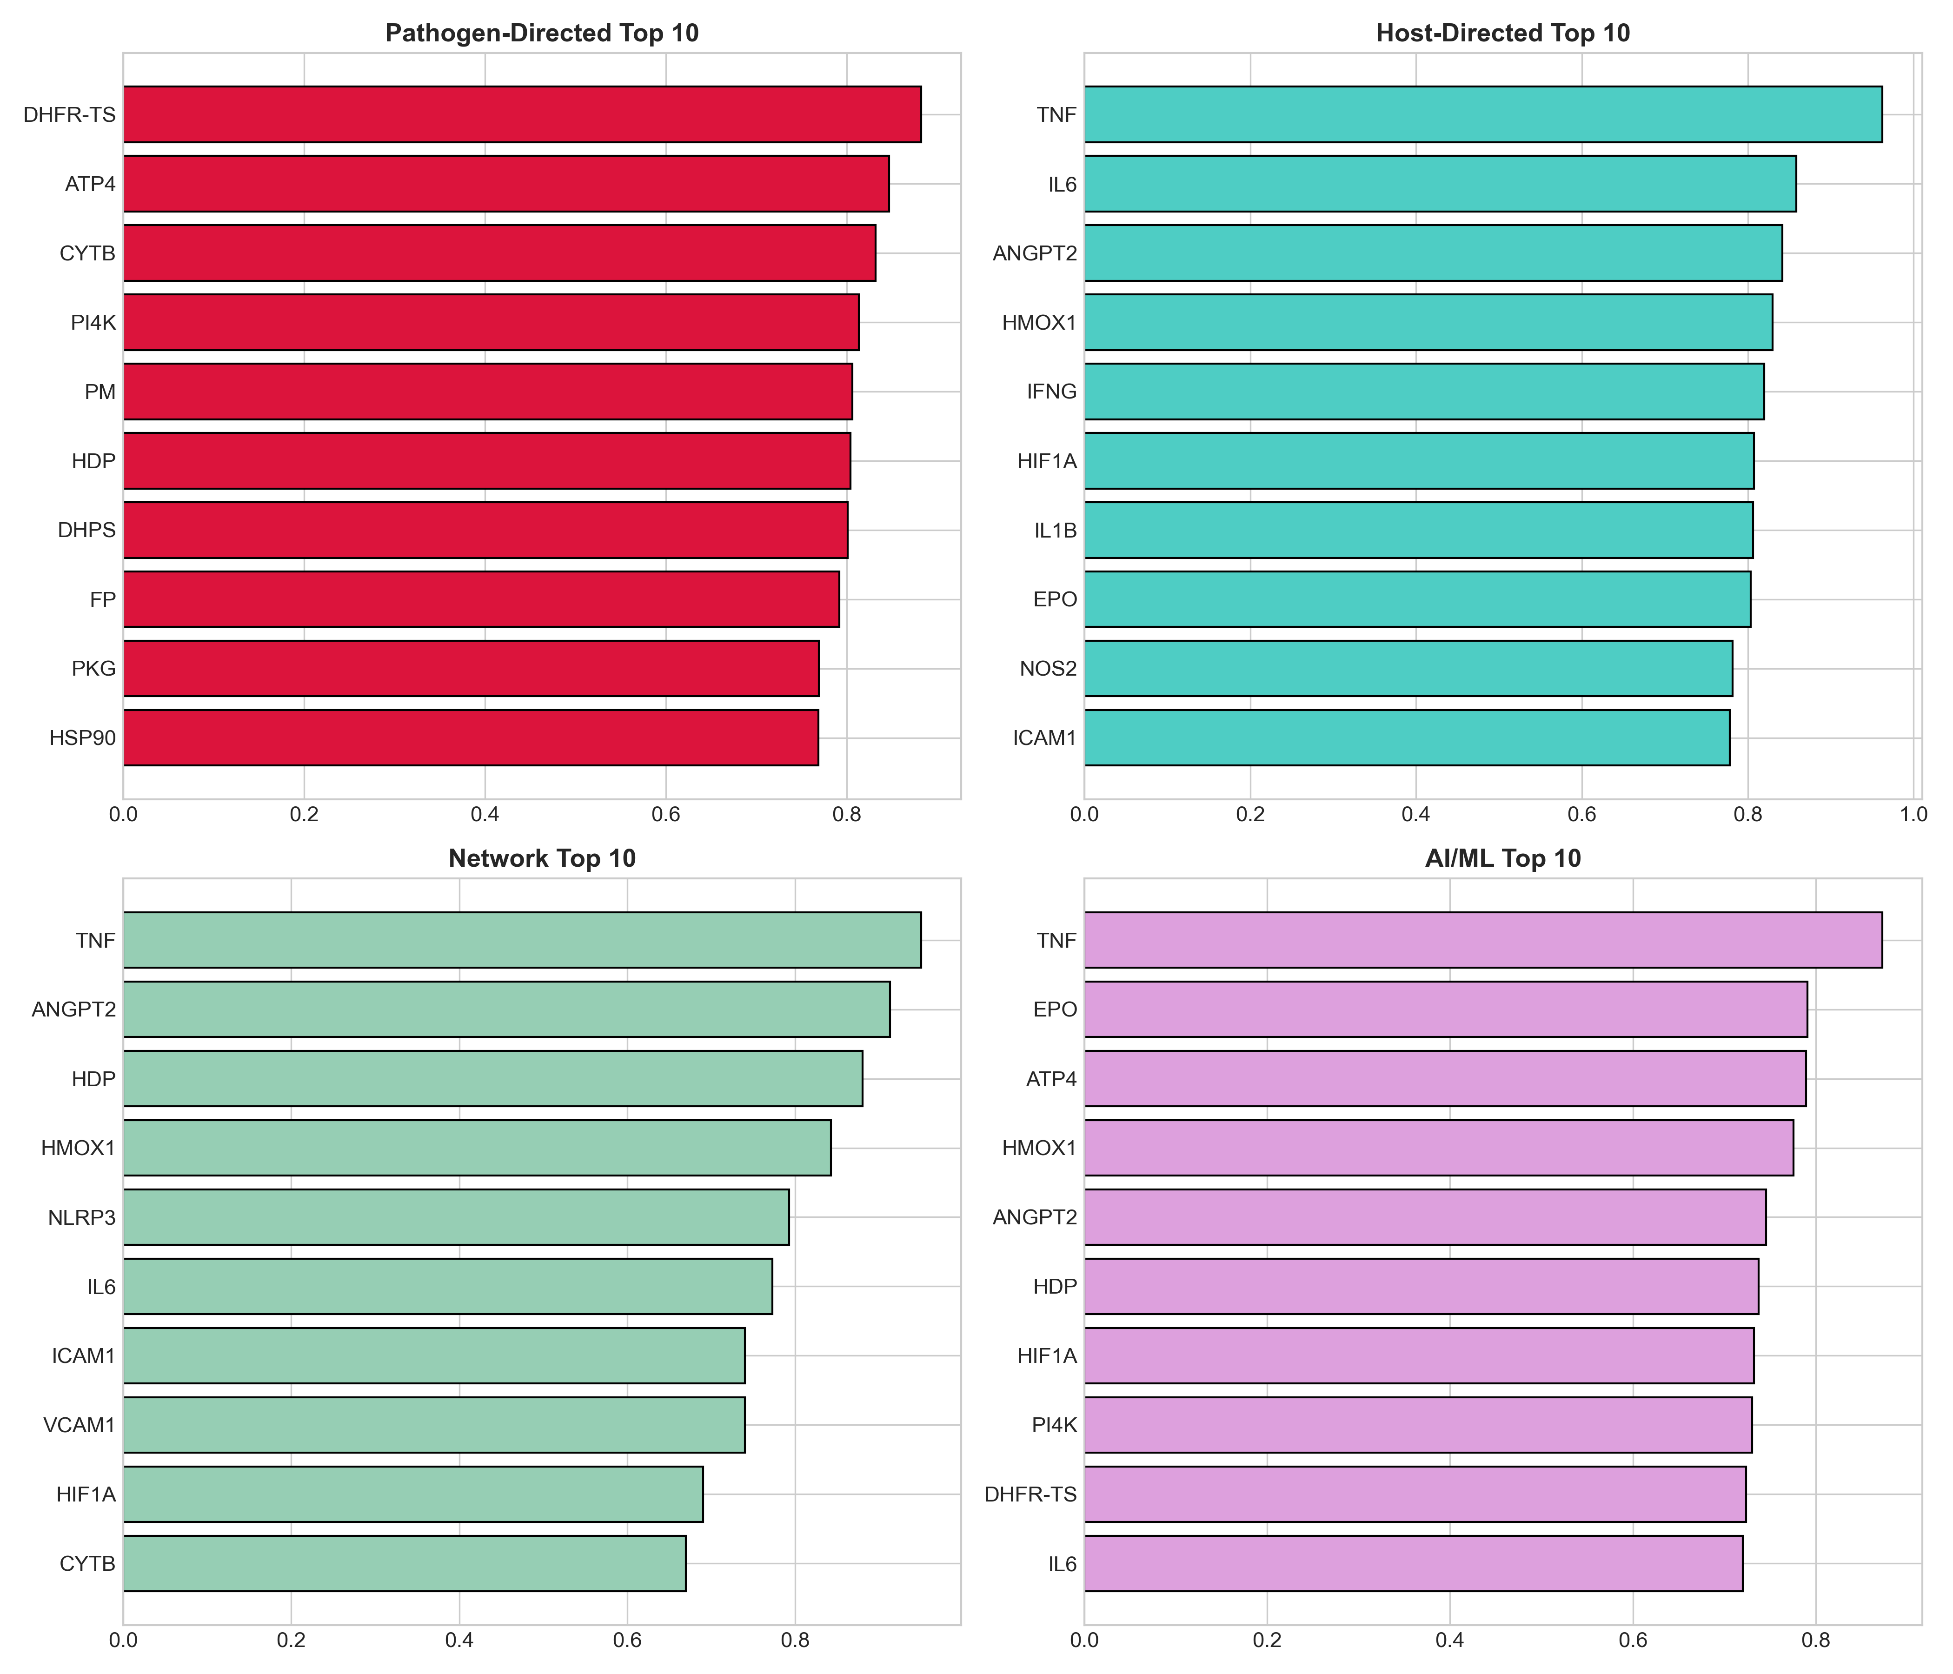
Figure 3. Module comparison showing top 10 targets per approach.

DISCUSSION
This study presents a systematic multi-modal drug discovery framework for malaria, integrating five complementary approaches. The unified scoring algorithm balances parasite killing with host protection—critical for severe malaria where immunopathology contributes to mortality.^{10,11}
The prominence of ANGPT2 as a top host target is notable. ANGPT2 is the most validated biomarker for severe and cerebral malaria, correlating with sequestration, endothelial dysfunction, and mortality.^{12,13} Therapeutic modulation of the ANGPT-TIE2 axis represents a promising adjunctive strategy, though specific modulators remain in early development.
HMOX1 ranked highly due to its role in heme detoxification during hemolysis. Severe malaria releases massive amounts of free heme, which is toxic unless degraded by HMOX1 to biliverdin, iron, and carbon monoxide.²¹⁻²³ Strategies to enhance HMOX1 expression (e.g., hemin, cobalt protoporphyrin) may protect against heme-induced tissue damage.
Atorvastatin emerged as the top HDT repurposing candidate beyond standard antimalarials. Preclinical studies show statins reduce neuroinflammation, improve survival, and prevent cognitive impairment in experimental CM.^{18,19} The SIMALARIA trial is evaluating rosuvastatin as adjunctive therapy. Our pipeline supports prioritizing statin trials.
L-arginine, a nitric oxide precursor, addresses the NO deficiency observed in severe malaria. Clinical trials show safety but variable efficacy, possibly due to arginine consumption by arginase.¹⁶ Combination with arginase inhibitors may enhance efficacy.
For novel Plasmodium targets, ATP4 (targeted by cipargamin/KAE609) and PI4K represent next-generation targets with activity against artemisinin-resistant strains.^{24,25} These validate the pipeline against the current drug development portfolio.
Limitations include: (1) scoring weights are expert-defined; sensitivity analysis would strengthen conclusions; (2) experimental validation not performed; (3) the host-parasite network is partially curated. Future work will incorporate proteomics data and conduct prospective validation.

CONCLUSIONS
This multi-modal pipeline identifies ACTs as first-line therapy with statins, L-arginine, and heme oxygenase modulators as potential adjunctive therapies for severe malaria. The emphasis on ANGPT2 and endothelial targets alarms with CM pathophysiology. As India and Africa pursue malaria elimination, systematic identification of adjunctive therapies may reduce mortality and accelerate progress.¹⁻⁵

ACKNOWLEDGEMENTS
The author acknowledges PlasmoDB, ChEMBL, STRING, and MMV for public data resources.

CONFLICT OF INTEREST
The author declares no conflicts of interest.

DATA AVAILABILITY
All code and data: https://github.com/hssling/Malaria_MultiModal_Discovery

REFERENCES
1. World Health Organization. World malaria report 2023. Geneva: WHO; 2023. Available from: https://www.who.int/publications/i/item/9789240086173
2. Weiss DJ, Lucas TCD, Nguyen M, et al. Mapping the global prevalence, incidence, and mortality of Plasmodium falciparum, 2000-17: a spatial and temporal modelling study. Lancet. 2019;394(10195):322-331. doi:10.1016/S0140-6736(19)31097-9. PMID: 31229234
3. Hay SI, Guerra CA, Tatem AJ, et al. The global distribution and population at risk of malaria: past, present, and future. Lancet Infect Dis. 2004;4(6):327-336. doi:10.1016/S1473-3099(04)01043-6. PMID: 15172341
4. National Vector Borne Disease Control Programme. National Framework for Malaria Elimination in India 2016-2030. Ministry of Health and Family Welfare, Government of India. 2016.
5. Dhiman S. Are malaria elimination efforts on right track? An analysis of gains achieved and challenges ahead. Infect Dis Poverty. 2019;8(1):14. doi:10.1186/s40249-019-0524-x. PMID: 30760324
6. Dondorp AM, Nosten F, Yi P, et al. Artemisinin resistance in Plasmodium falciparum malaria. N Engl J Med. 2009;361(5):455-467. doi:10.1056/NEJMoa0808859. PMID: 19641202
7. Ashley EA, Dhorda M, Fairhurst RM, et al. Spread of artemisinin resistance in Plasmodium falciparum malaria. N Engl J Med. 2014;371(5):411-423. doi:10.1056/NEJMoa1314981. PMID: 25075834
8. Ariey F, Witkowski B, Amaratunga C, et al. A molecular marker of artemisinin-resistant Plasmodium falciparum malaria. Nature. 2014;505(7481):50-55. doi:10.1038/nature12876. PMID: 24352242
9. Straimer J, Gnädig NF, Witkowski B, et al. K13-propeller mutations confer artemisinin resistance in Plasmodium falciparum clinical isolates. Science. 2015;347(6220):428-431. doi:10.1126/science.1260867. PMID: 25502314
10. Milner DA Jr, Whitten RO, Kamiza S, et al. The systemic pathology of cerebral malaria in African children. Front Cell Infect Microbiol. 2014;4:104. doi:10.3389/fcimb.2014.00104. PMID: 25136570
11. Storm J, Craig AG. Pathogenesis of cerebral malaria—inflammation and cytoadherence. Front Cell Infect Microbiol. 2014;4:100. doi:10.3389/fcimb.2014.00100. PMID: 25120960
12. Conroy AL, Lafferty EI, Lovegrove FE, et al. Whole blood angiopoietin-1 and -2 levels discriminate cerebral and severe (non-cerebral) malaria from uncomplicated malaria. Malar J. 2009;8:295. doi:10.1186/1475-2875-8-295. PMID: 20003543
13. Yeo TW, Lampah DA, Gitawati R, et al. Angiopoietin-2 is associated with decreased endothelial nitric oxide and poor clinical outcome in severe falciparum malaria. Proc Natl Acad Sci USA. 2008;105(44):17097-17102. doi:10.1073/pnas.0805027105. PMID: 18957536
14. Zumla A, Rao M, Wallis RS, et al. Host-directed therapies for infectious diseases: current status, recent progress, and future prospects. Lancet Infect Dis. 2016;16(4):e47-63. doi:10.1016/S1473-3099(16)00078-5. PMID: 27036359
15. Griffith JW, Sun T, McIntosh MT, Bhawan V. Adjunctive therapy for cerebral malaria. Trends Parasitol. 2020;36(11):943-955. doi:10.1016/j.pt.2020.08.007. PMID: 32943345
16. Yeo TW, Lampah DA, Rooslamiati I, et al. A randomized pilot study of L-arginine infusion in severe falciparum malaria: preliminary safety, efficacy and pharmacokinetics. PLoS One. 2013;8(7):e69587. doi:10.1371/journal.pone.0069587. PMID: 23922750
17. Hawkes M, Conroy AL, Opoka RO, et al. Inhaled nitric oxide for cerebral malaria: randomized trial. J Infect Dis. 2011;204(4):632-6. doi:10.1093/infdis/jir340. PMID: 21791666
18. Reis PA, Estato V, da Silva TI, et al. Statins decrease neuroinflammation and prevent cognitive impairment after cerebral malaria. PLoS Pathog. 2012;8(12):e1003099. doi:10.1371/journal.ppat.1003099. PMID: 23300448
19. Souraud JB, Briolant S, Dormoi J, et al. Atorvastatin treatment is effective when used in combination with mefloquine in an experimental cerebral malaria murine model. Malar J. 2012;11:13. doi:10.1186/1475-2875-11-13. PMID: 22230255
20. Parikh S, Engmann C. Adjunctive therapies for malaria. Curr Mol Med. 2006;6:155-160. PMID: 16515508
21. Ferreira A, Balla J, Jeney V, Balla G, Soares MP. A central role for free heme in the pathogenesis of severe malaria: the missing link? J Mol Med. 2008;86(10):1097-1111. doi:10.1007/s00109-008-0368-5. PMID: 18642118
22. Pamplona A, Hanscheid T, Epiphanio S, Mota MM, Vigário AM. Cerebral malaria and the hemolysis/methemoglobin/heme hypothesis: shedding new light on an old disease. Int J Biochem Cell Biol. 2009;41(4):711-716. doi:10.1016/j.biocel.2008.09.020. PMID: 18930156
23. Gozzelino R, Jeney V, Soares MP. Mechanisms of cell protection by heme oxygenase-1. Annu Rev Pharmacol Toxicol. 2010;50:323-354. doi:10.1146/annurev.pharmtox.010909.105600. PMID: 20055707
24. Burrows JN, Duparc S, Gutteridge WE, et al. New developments in anti-malarial target candidate and product profiles. Malar J. 2017;16(1):26. doi:10.1186/s12936-016-1675-x. PMID: 28086817
25. Wells TN, Hooft van Huijsduijnen R, Van Voorhis WC. Malaria medicines: a glass half full? Nat Rev Drug Discov. 2015;14(6):424-442. doi:10.1038/nrd4573. PMID: 26000721
26. Payne DJ, Gwynn MN, Holmes DJ, Pompliano DL. Drugs for bad bugs: confronting the challenges of antibacterial discovery. Nat Rev Drug Discov. 2007;6(1):29-40. doi:10.1038/nrd2201. PMID: 17159923
27. Hopkins AL. Network pharmacology: the next paradigm in drug discovery. Nat Chem Biol. 2008;4(11):682-690. doi:10.1038/nchembio.118. PMID: 18936753
28. Vamathevan J, Clark D, Czodrowski P, et al. Applications of machine learning in drug discovery and development. Nat Rev Drug Discov. 2019;18(6):463-477. doi:10.1038/s41573-019-0024-5. PMID: 30976107
29. Stokes JM, Yang K, Swanson K, et al. A deep learning approach to antibiotic discovery. Cell. 2020;180(4):688-702.e13. doi:10.1016/j.cell.2020.01.021. PMID: 32084340
30. Aurrecoechea C, Brestelli J, Brunk BP, et al. PlasmoDB: a functional genomic database for malaria parasites. Nucleic Acids Res. 2009;37(Database issue):D539-43. doi:10.1093/nar/gkn814. PMID: 18957442

