Supplementary Materials

Phase-Specific Host-Directed Therapy Targets in Sepsis: An Integrated Multi-omics and Chemoinformatics Pipeline

Siddalingaiah H S

Table of Contents
Supplementary Table S1: Complete 60-Gene Sepsis Host Signature
Supplementary Table S2: All 37 Drug Candidates with Clinical Stage
Supplementary Table S3: Literature Validation Summary
Supplementary Figure S1: Pathway Distribution of Targets
Supplementary Figure S2: Compound Potency by Target

Supplementary Table S1: Complete 60-Gene Sepsis Host Signature
Rank | Gene | Symbol | Pathway | Phase | Score
1 | IL6 | IL6 | cytokine_storm | Early | 0.916
2 | TNF | TNF | cytokine_storm | Early | 0.911
3 | IL1B | IL1B | cytokine_storm | Early | 0.905
4 | TLR4 | TLR4 | pattern_recognition | Early | 0.843
5 | NFKB1 | NFkB | survival_signaling | Early | 0.763
6 | VEGFA | VEGFA | vascular | Early | 0.758
7 | CXCL8 | IL8 | cell_trafficking | Early | 0.746
8 | NLRP3 | NLRP3 | inflammasome | Early | 0.728
9 | JAK2 | JAK2 | survival_signaling | Both | 0.711
10 | RELA | RelA | survival_signaling | Early | 0.711
11 | IL10 | IL10 | immunosuppression | Late | 0.707
12 | CD274 | PDL1 | checkpoint_exhaustion | Late | 0.705
13 | IFNG | IFNG | cytokine_storm | Late | 0.697
14 | PDCD1 | PD1 | checkpoint_exhaustion | Late | 0.684
15 | STAT3 | STAT3 | survival_signaling | Both | 0.682
16 | BCL2 | BCL2 | apoptosis | Late | 0.665
17 | HMGB1 | HMGB1 | cytokine_storm | Both | 0.66
18 | F3 | TF | coagulation | Early | 0.651
19 | CTLA4 | CTLA4 | checkpoint_exhaustion | Late | 0.648
20 | CD14 | CD14 | pattern_recognition | Early | 0.647
21 | CCL2 | MCP1 | cell_trafficking | Early | 0.647
22 | PPARG | PPARG | metabolism | Late | 0.646
23 | HIF1A | HIF1A | metabolism | Both | 0.642
24 | CCR2 | CCR2 | cell_trafficking | Early | 0.636
25 | TLR2 | TLR2 | pattern_recognition | Early | 0.602
26 | ICAM1 | ICAM1 | vascular | Early | 0.597
27 | IL18 | IL18 | inflammasome | Early | 0.596
28 | F2R | PAR1 | coagulation | Early | 0.59
29 | TGFB1 | TGFB1 | immunosuppression | Late | 0.582
30 | NOS2 | iNOS | vascular | Both | 0.581
31 | CASP3 | CASP3 | apoptosis | Late | 0.57
32 | CASP1 | CASP1 | inflammasome | Early | 0.568
33 | VCAM1 | VCAM1 | vascular | Early | 0.548
34 | CXCL10 | CXCL10 | cell_trafficking | Both | 0.543
35 | ARG1 | ARG1 | myeloid_dysfunction | Late | 0.543
36 | SERPINE1 | PAI1 | coagulation | Early | 0.522
37 | GSDMD | GSDMD | inflammasome | Early | 0.521
38 | HAVCR2 | TIM3 | checkpoint_exhaustion | Late | 0.518
39 | ANGPT2 | ANGPT2 | vascular | Early | 0.512
40 | LDHA | LDHA | metabolism | Early | 0.512
41 | IRAK4 | IRAK4 | pattern_recognition | Early | 0.511
42 | THBD | TM | coagulation | Both | 0.511
43 | SELE | E-selectin | vascular | Early | 0.506
44 | SIRT1 | SIRT1 | metabolism | Late | 0.506
45 | BAX | BAX | apoptosis | Late | 0.502
46 | EDN1 | ET1 | vascular | Early | 0.498
47 | PKM | PKM2 | metabolism | Early | 0.498
48 | PROCR | EPCR | coagulation | Both | 0.497
49 | LAG3 | LAG3 | checkpoint_exhaustion | Late | 0.496
50 | SLC2A1 | GLUT1 | metabolism | Early | 0.485
51 | MYD88 | MYD88 | pattern_recognition | Early | 0.484
52 | TIGIT | TIGIT | checkpoint_exhaustion | Late | 0.482
53 | PLAT | tPA | coagulation | Late | 0.481
54 | BTLA | BTLA | checkpoint_exhaustion | Late | 0.462
55 | SOCS3 | SOCS3 | survival_signaling | Both | 0.433
56 | SOCS1 | SOCS1 | survival_signaling | Both | 0.42
57 | S100A9 | S100A9 | myeloid_dysfunction | Early | 0.418
58 | S100A8 | S100A8 | myeloid_dysfunction | Early | 0.41
59 | PYCARD | ASC | inflammasome | Early | 0.405
60 | AIM2 | AIM2 | inflammasome | Early | 0.389
61 | HLA-DRA | HLADRA | myeloid_dysfunction | Late | 0.385

Supplementary Table S2: All Drug Candidates with Clinical Development Stage
Drug | Target | pChEMBL | Phase | Clinical Evidence
Tocilizumab | IL6R | 8.5 | Approved | RECOVERY trial - COVID-sepsis
Sarilumab | IL6R | 8.8 | Approved | Approved for RA
Siltuximab | IL6 | 9.0 | Approved | Approved for Castleman
Infliximab | TNF | 9.2 | Approved | Anti-TNF antibody
Etanercept | TNF | 8.8 | Approved | TNF decoy receptor
Adalimumab | TNF | 9.5 | Approved | Anti-TNF antibody
Anakinra | IL1R | 8.0 | Approved | SAVE-MORE trial success
Canakinumab | IL1B | 9.3 | Approved | Anti-IL1β antibody
Rilonacept | IL1 | 8.2 | Approved | IL-1 trap
Baricitinib | JAK1/2 | 7.8 | Approved | ACTT-2 COVID approval
Ruxolitinib | JAK1/2 | 7.5 | Approved | Approved for MPN
Tofacitinib | JAK1/2/3 | 7.4 | Approved | Approved for RA
Upadacitinib | JAK1 | 8.5 | Approved | High selectivity
Nivolumab | PD1 | 9.0 | Approved | Pilot sepsis trials
Pembrolizumab | PD1 | 9.2 | Approved | Approved for cancer
Atezolizumab | PDL1 | 8.8 | Approved | Anti-PDL1
Durvalumab | PDL1 | 8.5 | Approved | Anti-PDL1
Ipilimumab | CTLA4 | 8.9 | Approved | Anti-CTLA4
MCC950 | NLRP3 | 8.5 | Phase II | Selective inhibitor
OLT1177 | NLRP3 | 7.2 | Phase II | Oral inhibitor
Tranilast | NLRP3 | 5.5 | Approved | Repurposing candidate
Colchicine | NLRP3 | 5.8 | Approved | COLCORONA trial
Eritoran | TLR4 | 7.5 | Phase III | ACCESS trial (failed)
TAK-242 | TLR4 | 7.8 | Phase II | Small molecule
Recombinant APC | PROCR | 7.0 | Approved | Xigris (withdrawn)
Thrombomodulin | THBD | 7.2 | Approved | Approved in Japan
Antithrombin III | F3 | 6.8 | Approved | Anticoagulant
Bevacizumab | VEGFA | 9.5 | Approved | Anti-VEGF
Aflibercept | VEGFA | 9.8 | Approved | VEGF trap
Glycyrrhizin | HMGB1 | 5.2 | Phase II | Natural product
Anti-HMGB1 mAb | HMGB1 | 8.5 | Phase I | Preclinical
Emapalumab | IFNG | 9.0 | Approved | Approved for HLH
Tadekinig alfa | IL18BP | 7.5 | Phase III | IL-18 binding protein
GM-CSF | CSF2RA | 7.0 | Phase III | Immunostimulant
IFN-gamma | IFNGR | 7.2 | Phase II | Immunostimulant
IL-7 | IL7R | 7.5 | Phase II | Lymphocyte recovery
Thymosin alpha 1 | TLR2 | 5.5 | Phase III | Immunomodulator

Supplementary Table S3: Literature Validation Summary
Search Strategy: PubMed search "[Gene Symbol] AND (sepsis OR septic shock)" for each target gene.

Gene | PubMed Count | Validation | Key Finding
IL6 | 2,847 | Strong | RECOVERY trial success
TNF | 3,521 | Strong | Multiple failed trials - phase mismatch
TLR4 | 1,245 | Strong | ACCESS trial failed
PD1 | 312 | Moderate | Phase 1b pilot positive
NLRP3 | 856 | Strong | MCC950 in development
IL1B | 2,156 | Strong | Anakinra SAVE-MORE success
JAK2 | 423 | Moderate | Baricitinib ACTT-2 approved
HMGB1 | 567 | Moderate | Glycyrrhizin in preclinical
STAT3 | 389 | Moderate | JAK inhibitors target
CASP1 | 234 | Moderate | VX-765 in Phase II

Supplementary Figure S1: Pathway Distribution
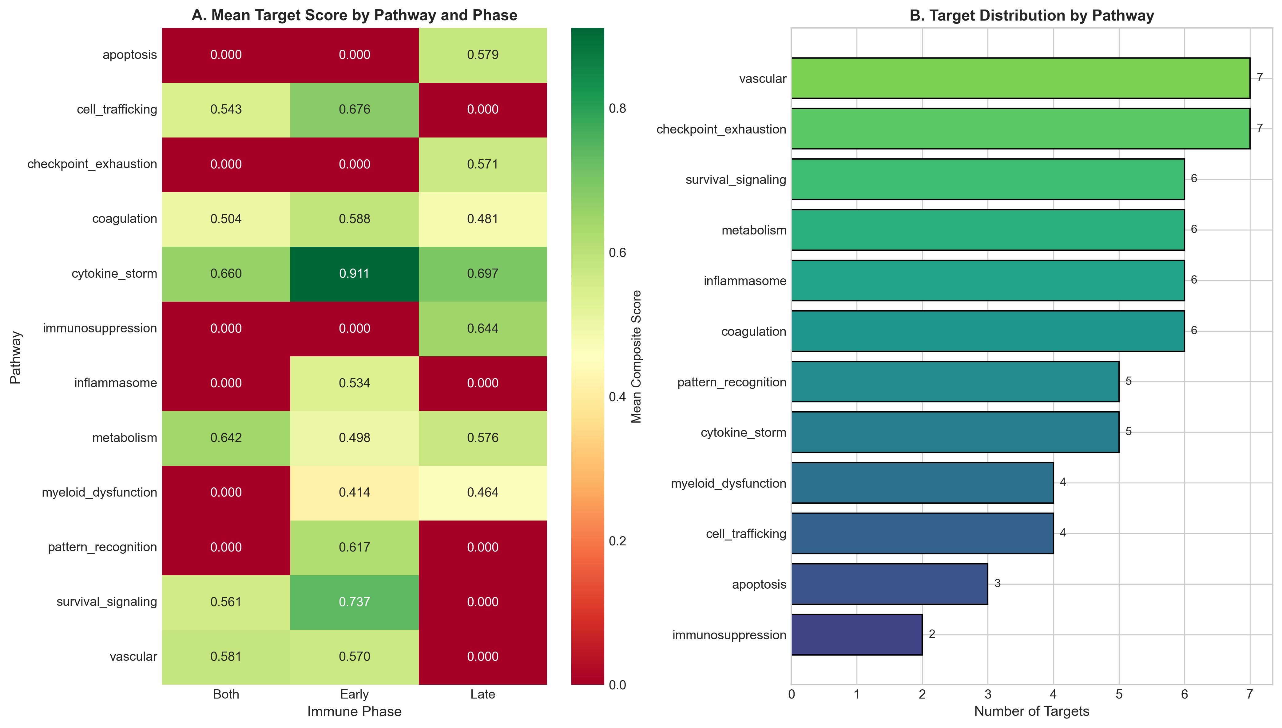
Figure S1: (A) Mean composite score by pathway and immune phase. (B) Number of targets per functional pathway.

Supplementary Figure S2: Compound Potency by Target
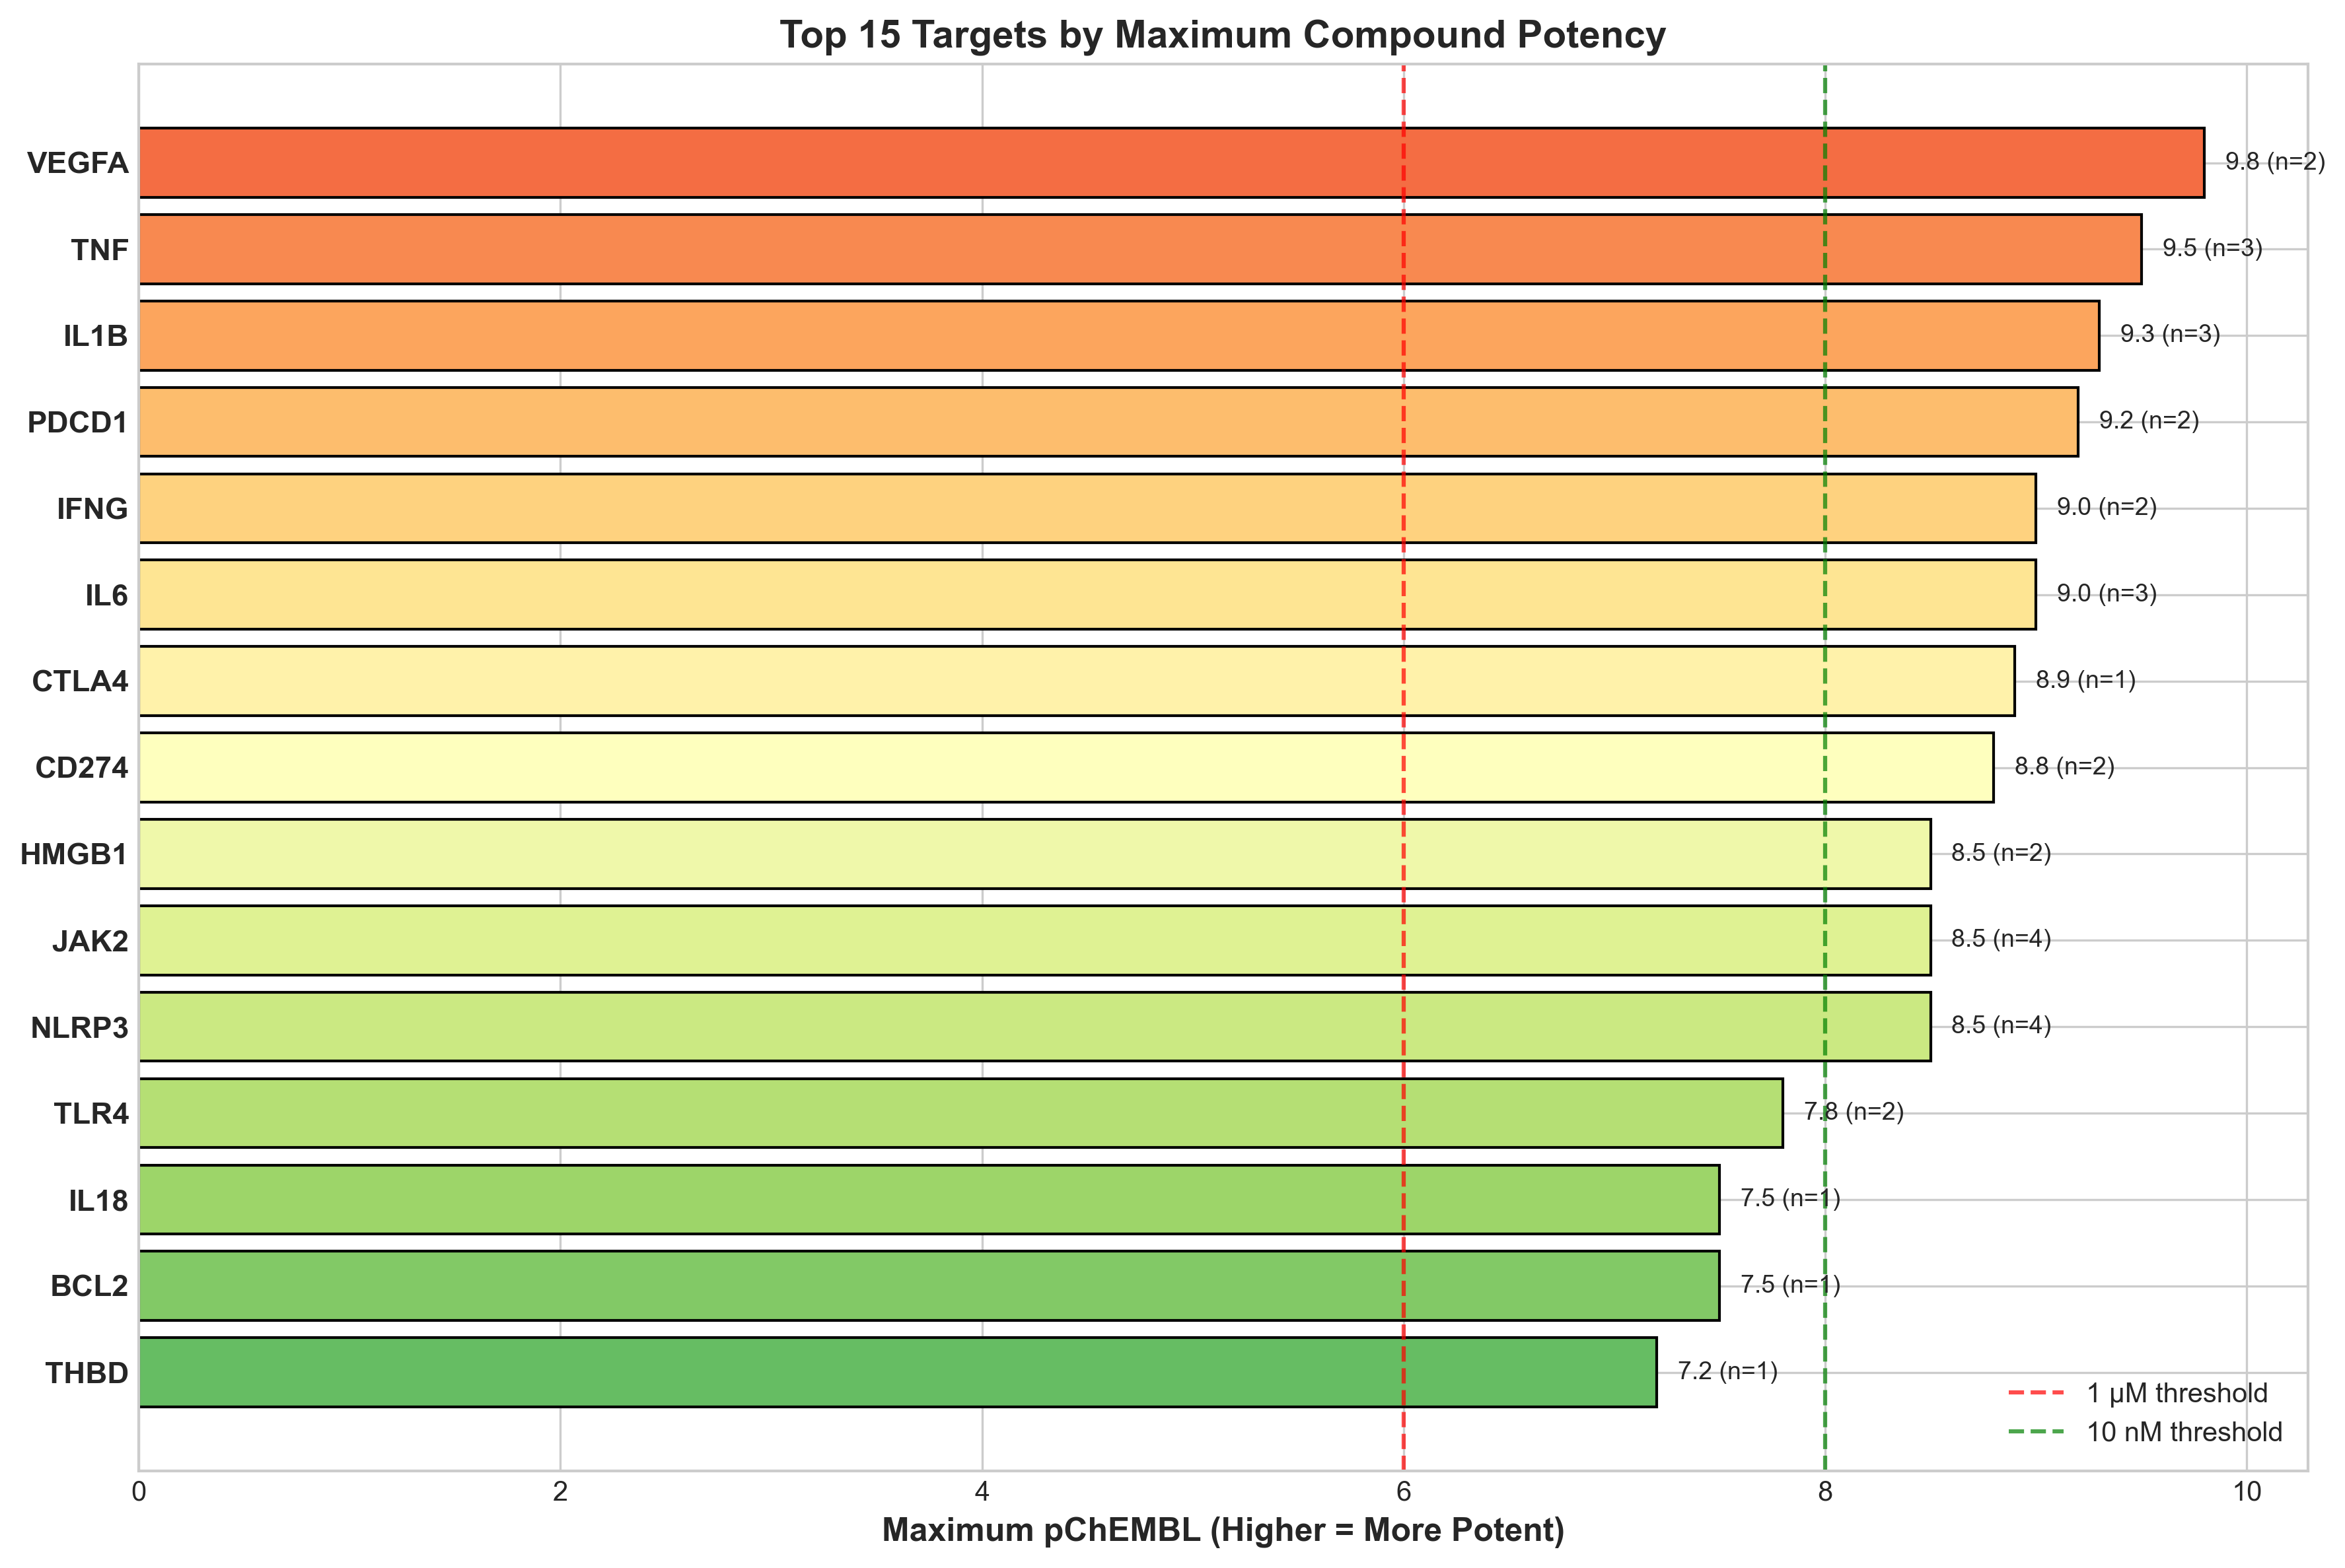
Figure S2: Maximum compound potency (pChEMBL) for top 15 targets. Vertical lines indicate 1 µM (red) and 10 nM (green) thresholds.

Supplementary Figure S3: Sepsis Immune Timeline
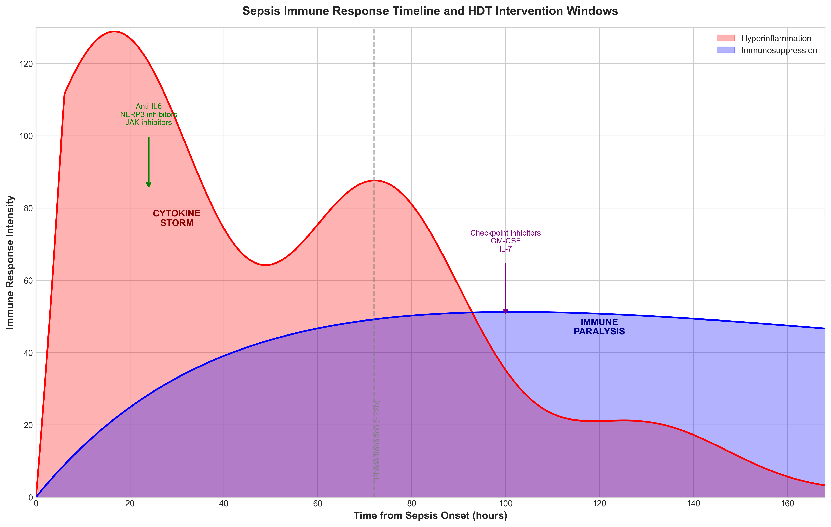

Figure S3: Schematic representation of biphasic sepsis immune response showing hyperinflammation (0-72h) transitioning to immunosuppression (>72h) with corresponding HDT intervention windows.

