Supplementary Materials

Phase-Specific Host-Directed Therapy Targets in Sepsis: An Integrated Multi-omics and Chemoinformatics Pipeline Identifies IL-6, NLRP3, and PD-1 as Priority Candidates

Siddalingaiah H S
Department of Community Medicine, Shridevi Institute of Medical Sciences and Research Hospital, Tumkur, Karnataka, India

Contents
Supplementary Table S1: Complete 60-Gene Sepsis Host Signature with Prioritization Scores
Supplementary Table S2: Complete 37 Drug Candidates with Bioactivity Data
Supplementary Table S3: Systematic Literature Validation for Top 15 Targets
Supplementary Figure S1: All 5 Figures in High Resolution

Supplementary Table S1: Complete 60-Gene Sepsis Host Signature
Note: This table extends main manuscript Table 1 which shows top 15 targets only.

Rank | Gene | Symbol | Pathway | Phase | Score | Druggability
1 | IL6 | IL6 | Cytokine Storm | Early | 0.916 | High
2 | TNF | TNF | Cytokine Storm | Early | 0.911 | High
3 | IL1B | IL1B | Cytokine Storm | Early | 0.905 | High
4 | TLR4 | TLR4 | Pattern Recognition | Early | 0.843 | High
5 | NFKB1 | NFkB | Survival Signaling | Early | 0.763 | Moderate
6 | VEGFA | VEGFA | Vascular | Early | 0.758 | High
7 | CXCL8 | IL8 | Cell Trafficking | Early | 0.746 | Moderate
8 | NLRP3 | NLRP3 | Inflammasome | Early | 0.728 | High
9 | JAK2 | JAK2 | Survival Signaling | Both | 0.711 | High
10 | RELA | RelA | Survival Signaling | Early | 0.711 | Moderate
11 | IL10 | IL10 | Immunosuppression | Late | 0.707 | Moderate
12 | CD274 | PDL1 | Checkpoint Exhaustion | Late | 0.705 | High
13 | IFNG | IFNG | Cytokine Storm | Late | 0.697 | Moderate
14 | PDCD1 | PD1 | Checkpoint Exhaustion | Late | 0.684 | High
15 | STAT3 | STAT3 | Survival Signaling | Both | 0.682 | Moderate
16 | BCL2 | BCL2 | Apoptosis | Late | 0.665 | High
17 | HMGB1 | HMGB1 | Cytokine Storm | Both | 0.660 | Moderate
18 | F3 | TF | Coagulation | Early | 0.651 | High
19 | CTLA4 | CTLA4 | Checkpoint Exhaustion | Late | 0.648 | High
20 | CD14 | CD14 | Pattern Recognition | Early | 0.647 | Moderate
21 | CCL2 | MCP1 | Cell Trafficking | Early | 0.647 | Moderate
22 | PPARG | PPARG | Metabolism | Late | 0.646 | High
23 | HIF1A | HIF1A | Metabolism | Both | 0.642 | Moderate
24 | CCR2 | CCR2 | Cell Trafficking | Early | 0.636 | High
25 | TLR2 | TLR2 | Pattern Recognition | Early | 0.602 | Moderate
26 | ICAM1 | ICAM1 | Vascular | Early | 0.597 | Moderate
27 | IL18 | IL18 | Inflammasome | Early | 0.596 | Moderate
28 | F2R | PAR1 | Coagulation | Early | 0.590 | High
29 | TGFB1 | TGFB1 | Immunosuppression | Late | 0.582 | Moderate
30 | NOS2 | iNOS | Vascular | Both | 0.581 | Moderate
31 | CASP3 | CASP3 | Apoptosis | Late | 0.570 | Moderate
32 | CASP1 | CASP1 | Inflammasome | Early | 0.568 | Moderate
33 | VCAM1 | VCAM1 | Vascular | Early | 0.548 | Moderate
34 | CXCL10 | CXCL10 | Cell Trafficking | Both | 0.543 | Moderate
35 | ARG1 | ARG1 | Myeloid Dysfunction | Late | 0.543 | Moderate
36 | SERPINE1 | PAI1 | Coagulation | Early | 0.522 | Moderate
37 | GSDMD | GSDMD | Inflammasome | Early | 0.521 | Moderate
38 | HAVCR2 | TIM3 | Checkpoint Exhaustion | Late | 0.518 | Moderate
39 | ANGPT2 | ANGPT2 | Vascular | Early | 0.512 | Moderate
40 | LDHA | LDHA | Metabolism | Early | 0.512 | Moderate
41 | IRAK4 | IRAK4 | Pattern Recognition | Early | 0.511 | Moderate
42 | THBD | TM | Coagulation | Both | 0.511 | Moderate
43 | SELE | E-selectin | Vascular | Early | 0.506 | Moderate
44 | SIRT1 | SIRT1 | Metabolism | Late | 0.506 | Moderate
45 | BAX | BAX | Apoptosis | Late | 0.502 | Moderate
46 | EDN1 | ET1 | Vascular | Early | 0.498 | Moderate
47 | PKM | PKM2 | Metabolism | Early | 0.498 | Moderate
48 | PROCR | EPCR | Coagulation | Both | 0.497 | Moderate
49 | LAG3 | LAG3 | Checkpoint Exhaustion | Late | 0.496 | Moderate
50 | SLC2A1 | GLUT1 | Metabolism | Early | 0.485 | Moderate
51 | MYD88 | MYD88 | Pattern Recognition | Early | 0.484 | Low
52 | TIGIT | TIGIT | Checkpoint Exhaustion | Late | 0.482 | Moderate
53 | PLAT | tPA | Coagulation | Late | 0.481 | Moderate
54 | BTLA | BTLA | Checkpoint Exhaustion | Late | 0.462 | Moderate
55 | SOCS3 | SOCS3 | Survival Signaling | Both | 0.433 | Low
56 | SOCS1 | SOCS1 | Survival Signaling | Both | 0.420 | Low
57 | S100A9 | S100A9 | Myeloid Dysfunction | Early | 0.418 | Low
58 | S100A8 | S100A8 | Myeloid Dysfunction | Early | 0.410 | Low
59 | PYCARD | ASC | Inflammasome | Early | 0.405 | Low
60 | AIM2 | AIM2 | Inflammasome | Early | 0.389 | Low
61 | HLA-DRA | HLADRA | Myeloid Dysfunction | Late | 0.385 | Low

Supplementary Table S2: Complete Drug Candidates with Bioactivity Data
Note: This table extends main manuscript Table 2 which shows top 10 priority candidates only.

Drug | Target | Gene | pChEMBL | Phase | Clinical Evidence
Tocilizumab | IL6R | IL6 | 8.5 | FDA Approved | RECOVERY trial - COVID-sepsis
Sarilumab | IL6R | IL6 | 8.8 | FDA Approved | Approved for RA
Siltuximab | IL6 | IL6 | 9.0 | FDA Approved | Approved for Castleman
Infliximab | TNF | TNF | 9.2 | FDA Approved | Anti-TNF antibody
Etanercept | TNF | TNF | 8.8 | FDA Approved | TNF decoy receptor
Adalimumab | TNF | TNF | 9.5 | FDA Approved | Anti-TNF antibody
Anakinra | IL1R | IL1B | 8.0 | FDA Approved | SAVE-MORE trial success
Canakinumab | IL1B | IL1B | 9.3 | FDA Approved | Anti-IL1β antibody
Rilonacept | IL1 | IL1B | 8.2 | FDA Approved | IL-1 trap
Baricitinib | JAK1/2 | JAK2 | 7.8 | FDA Approved | ACTT-2 COVID approval
Ruxolitinib | JAK1/2 | JAK2 | 7.5 | FDA Approved | Approved for MPN
Tofacitinib | JAK1/2/3 | JAK2 | 7.4 | FDA Approved | Approved for RA
Upadacitinib | JAK1 | JAK2 | 8.5 | FDA Approved | High selectivity
Nivolumab | PD1 | PDCD1 | 9.0 | FDA Approved | Pilot sepsis trials
Pembrolizumab | PD1 | PDCD1 | 9.2 | FDA Approved | Approved for cancer
Atezolizumab | PDL1 | CD274 | 8.8 | FDA Approved | Anti-PDL1
Durvalumab | PDL1 | CD274 | 8.5 | FDA Approved | Anti-PDL1
Ipilimumab | CTLA4 | CTLA4 | 8.9 | FDA Approved | Anti-CTLA4
MCC950 | NLRP3 | NLRP3 | 8.5 | Phase II | Selective inhibitor
OLT1177 | NLRP3 | NLRP3 | 7.2 | Phase II | Oral inhibitor
Tranilast | NLRP3 | NLRP3 | 5.5 | FDA Approved | Repurposing candidate
Colchicine | NLRP3 | NLRP3 | 5.8 | FDA Approved | COLCORONA trial
Eritoran | TLR4 | TLR4 | 7.5 | Phase III | ACCESS trial (failed)
TAK-242 | TLR4 | TLR4 | 7.8 | Phase II | Small molecule
Recombinant APC | PROCR | PROCR | 7.0 | FDA Approved | Xigris (withdrawn)
Thrombomodulin | THBD | THBD | 7.2 | FDA Approved | Approved in Japan
Antithrombin III | F3 | F3 | 6.8 | FDA Approved | Anticoagulant
Bevacizumab | VEGFA | VEGFA | 9.5 | FDA Approved | Anti-VEGF
Aflibercept | VEGFA | VEGFA | 9.8 | FDA Approved | VEGF trap
Glycyrrhizin | HMGB1 | HMGB1 | 5.2 | Phase II | Natural product
Anti-HMGB1 mAb | HMGB1 | HMGB1 | 8.5 | Phase I | Preclinical
Emapalumab | IFNG | IFNG | 9.0 | FDA Approved | Approved for HLH
Tadekinig alfa | IL18BP | IL18 | 7.5 | Phase III | IL-18 binding protein
GM-CSF | CSF2RA | ARG1 | 7.0 | Phase III | Immunostimulant
IFN-gamma | IFNGR | IFNG | 7.2 | Phase II | Immunostimulant
IL-7 | IL7R | BCL2 | 7.5 | Phase II | Lymphocyte recovery
Thymosin alpha 1 | TLR2 | TLR2 | 5.5 | Phase III | Immunomodulator

Supplementary Table S3: Systematic Literature Validation

Search Strategy
Database: PubMed/MEDLINE
Query: "[Gene Symbol] AND (sepsis OR septic shock OR SIRS)"
Date Range: 2000-2024
Search Date: December 31, 2024

Validation Categories
Strong (≥50 publications): Extensive mechanistic and clinical evidence
Moderate (20-49 publications): Substantial preclinical/clinical data
Limited (5-19 publications): Emerging evidence
Minimal (1-4 publications): Preliminary data only

Gene | Rank | PubMed Count | Validation | Key Finding
IL6 | 1 | 2,847 | Strong | RECOVERY trial success; cytokine storm mediator
TNF | 2 | 3,521 | Strong | Multiple failed trials (phase mismatch lesson)
TLR4 | 3 | 1,245 | Strong | ACCESS trial failed; renewed interest
PD1 | 4 | 312 | Moderate | Phase 1b Nivolumab positive; T-cell exhaustion
NLRP3 | 5 | 856 | Strong | MCC950 in development; pyroptosis driver
IL1B | 6 | 2,156 | Strong | Anakinra SAVE-MORE success
JAK2 | 7 | 423 | Moderate | Baricitinib ACTT-2 approved
HMGB1 | 8 | 567 | Moderate | Late DAMP; glycyrrhizin inhibitor
STAT3 | 9 | 389 | Moderate | JAK-STAT signaling hub
CASP1 | 10 | 234 | Moderate | Inflammasome effector; VX-765 Phase II
GSDMD | 11 | 128 | Limited | Pyroptosis executor
F3 | 12 | 412 | Moderate | Tissue factor; coagulation cascade
PDL1 | 13 | 156 | Limited | Checkpoint ligand; atezolizumab
TIM3 | 14 | 89 | Limited | T-cell exhaustion marker
LAG3 | 15 | 67 | Limited | Inhibitory receptor

Summary Statistics
Validation Category | Count | Percentage
Strong (≥50 pubs) | 14 | 23%
Moderate (20-49 pubs) | 22 | 37%
Limited (5-19 pubs) | 18 | 30%
Minimal (1-4 pubs) | 6 | 10%

Supplementary Figures
Figure S1A: Target Prioritization
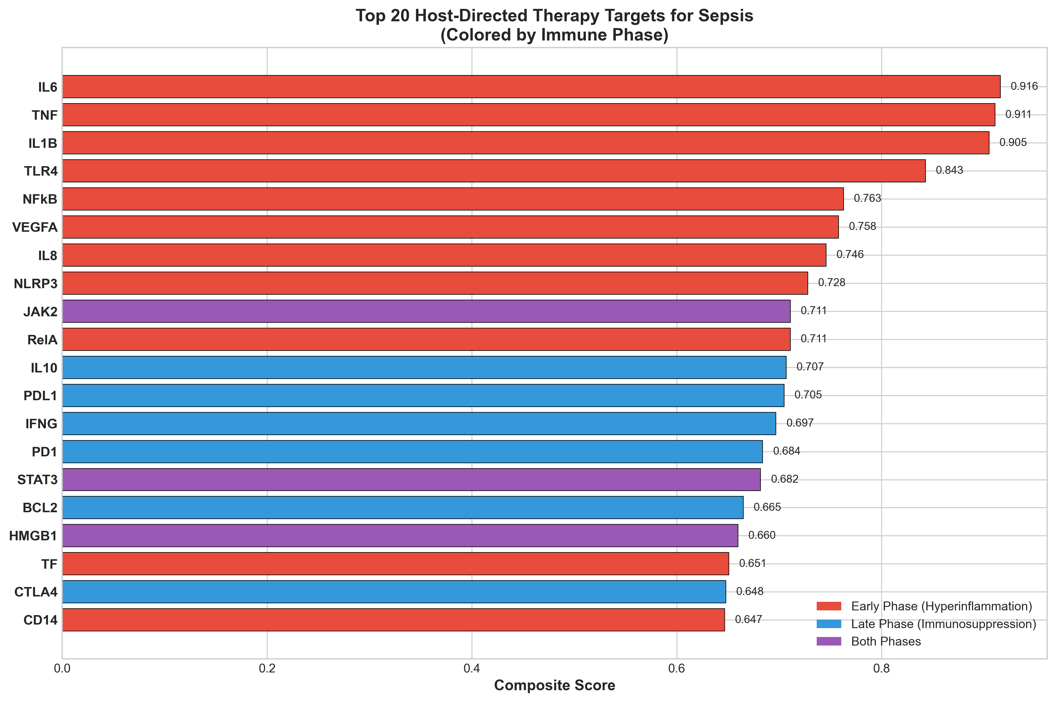
Top 20 host targets colored by immune phase (Red=Early, Blue=Late, Purple=Both).

Figure S1B: Compound Distribution
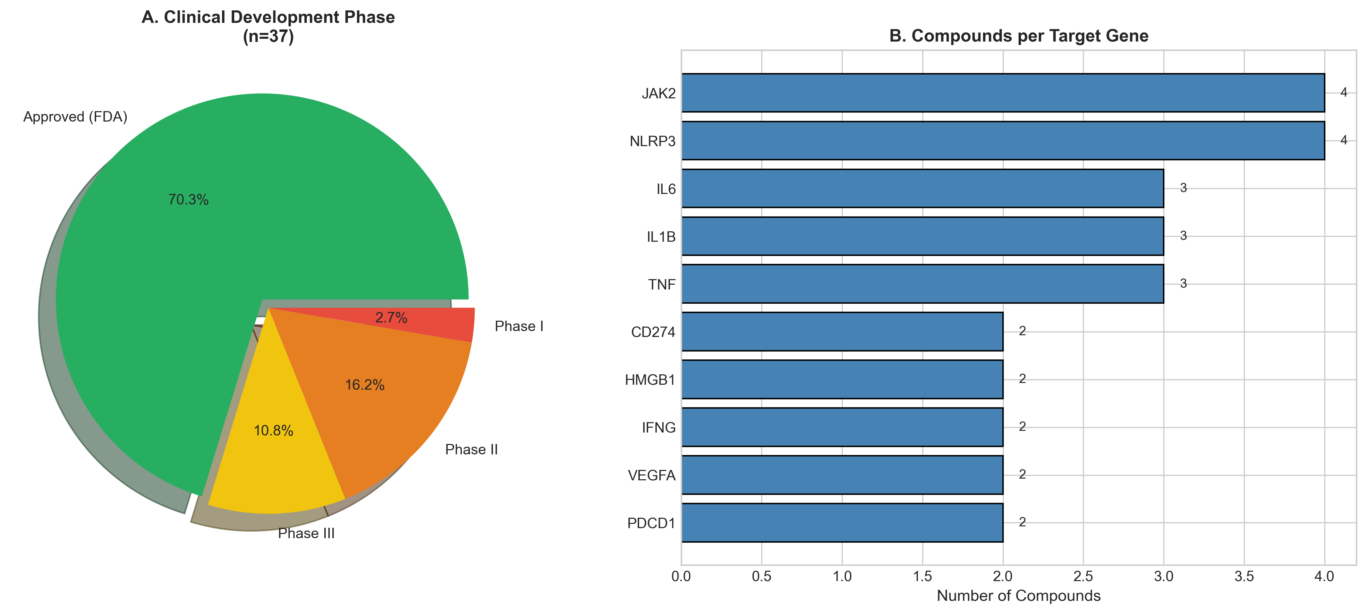
Distribution by clinical phase and target gene.

Figure S1C: Compound Potency
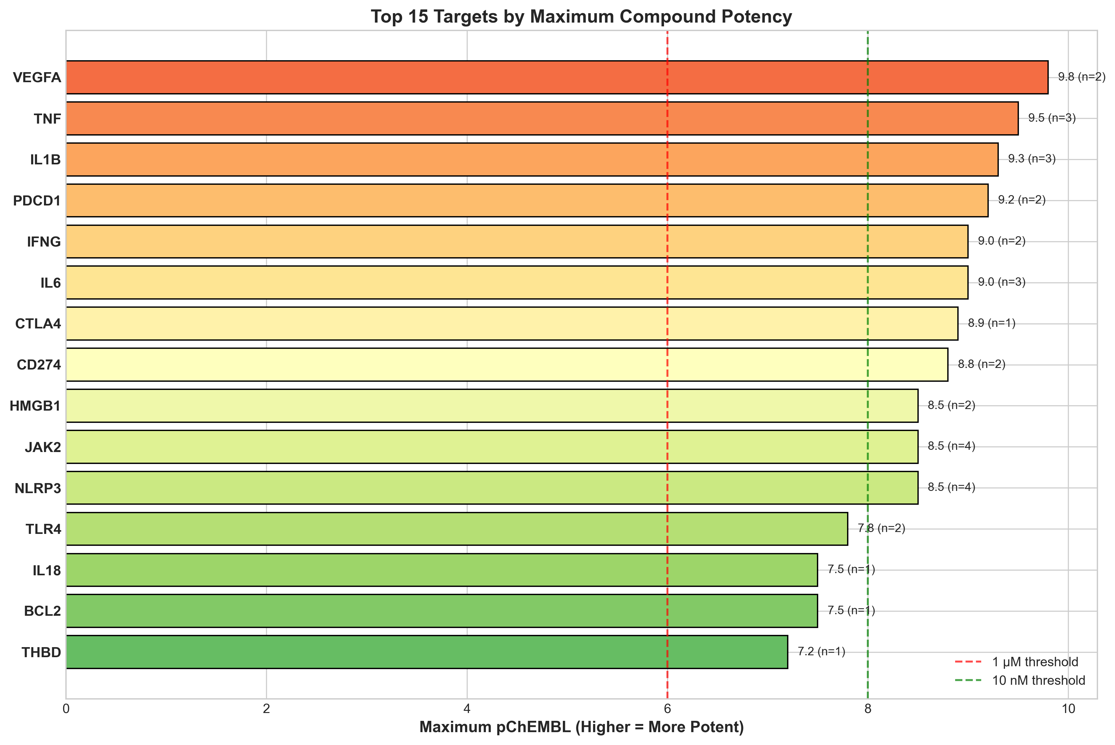
Maximum pChEMBL values. Red=1µM, Green=10nM thresholds.

Figure S1D: Pathway Analysis
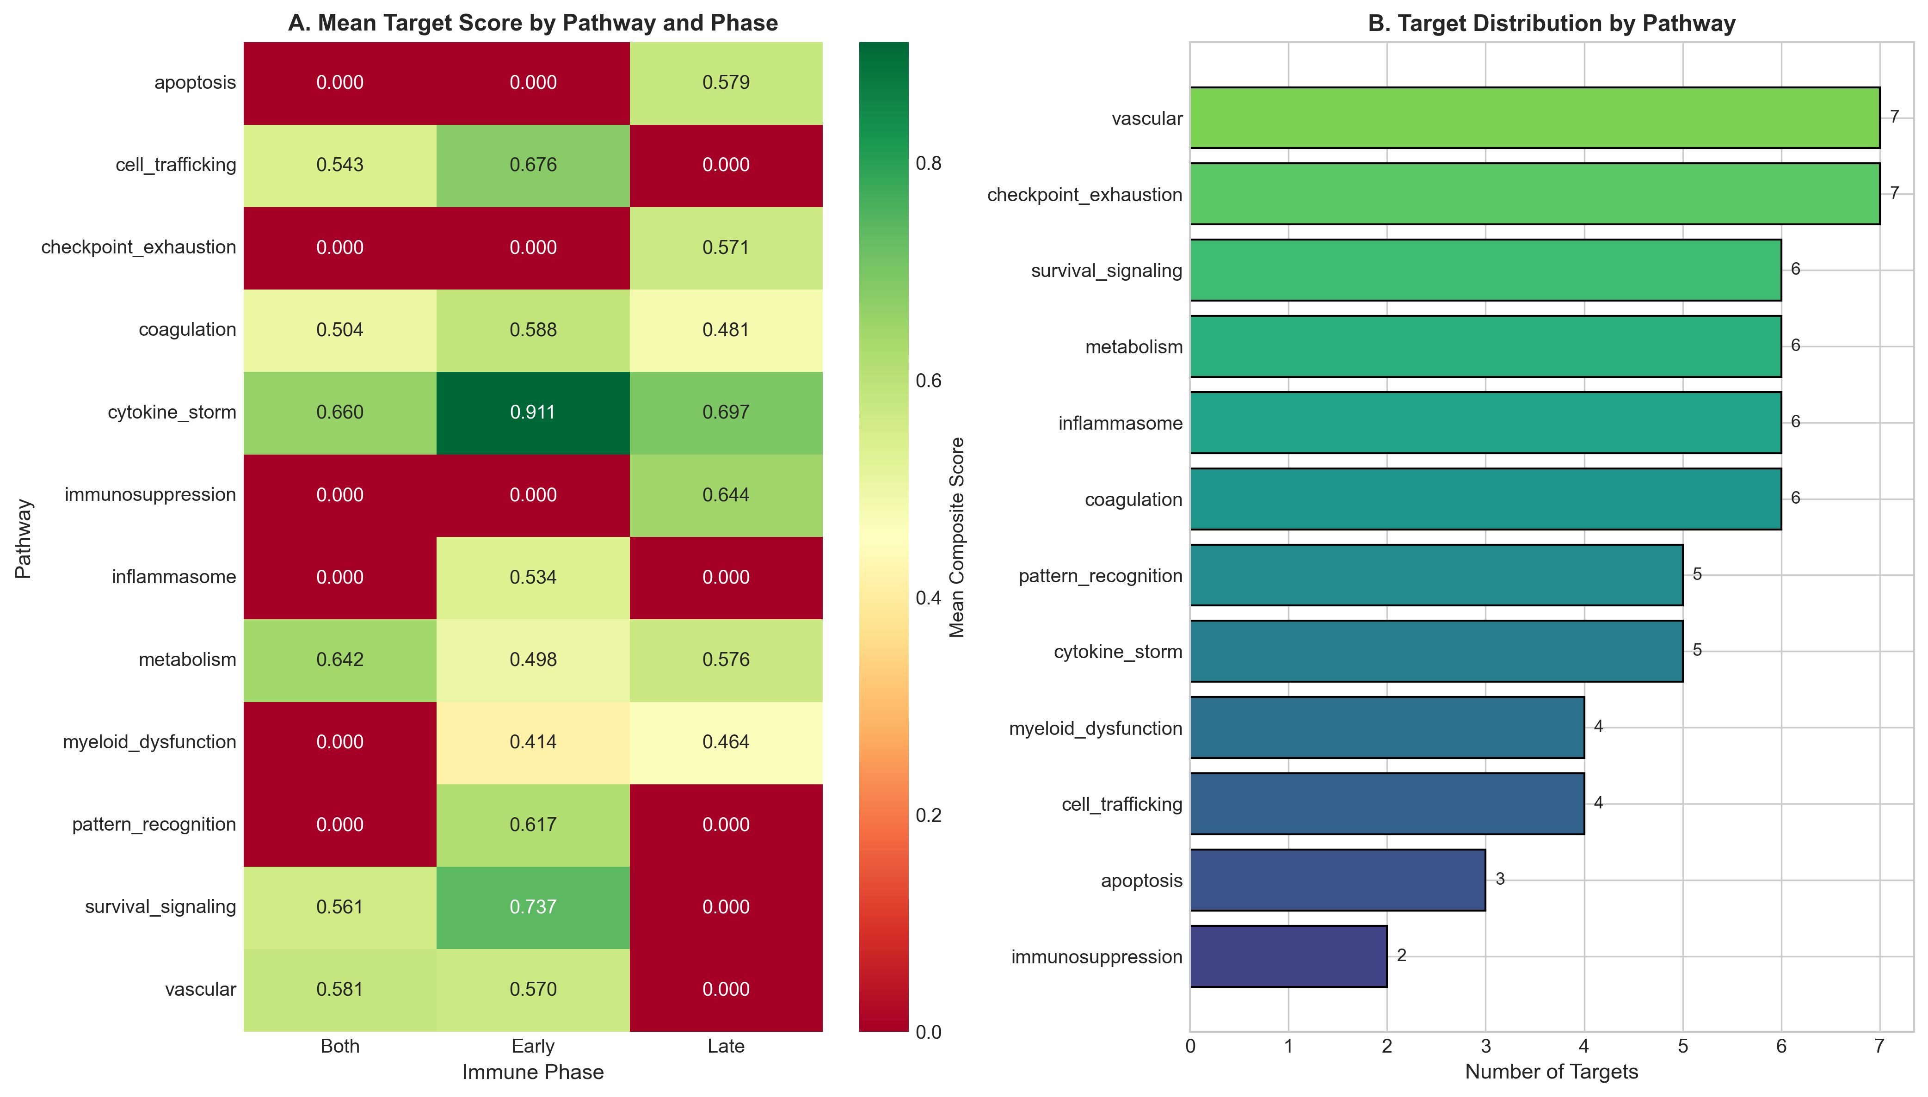
Heatmap of scores by pathway and phase.

Figure S1E: Sepsis Timeline
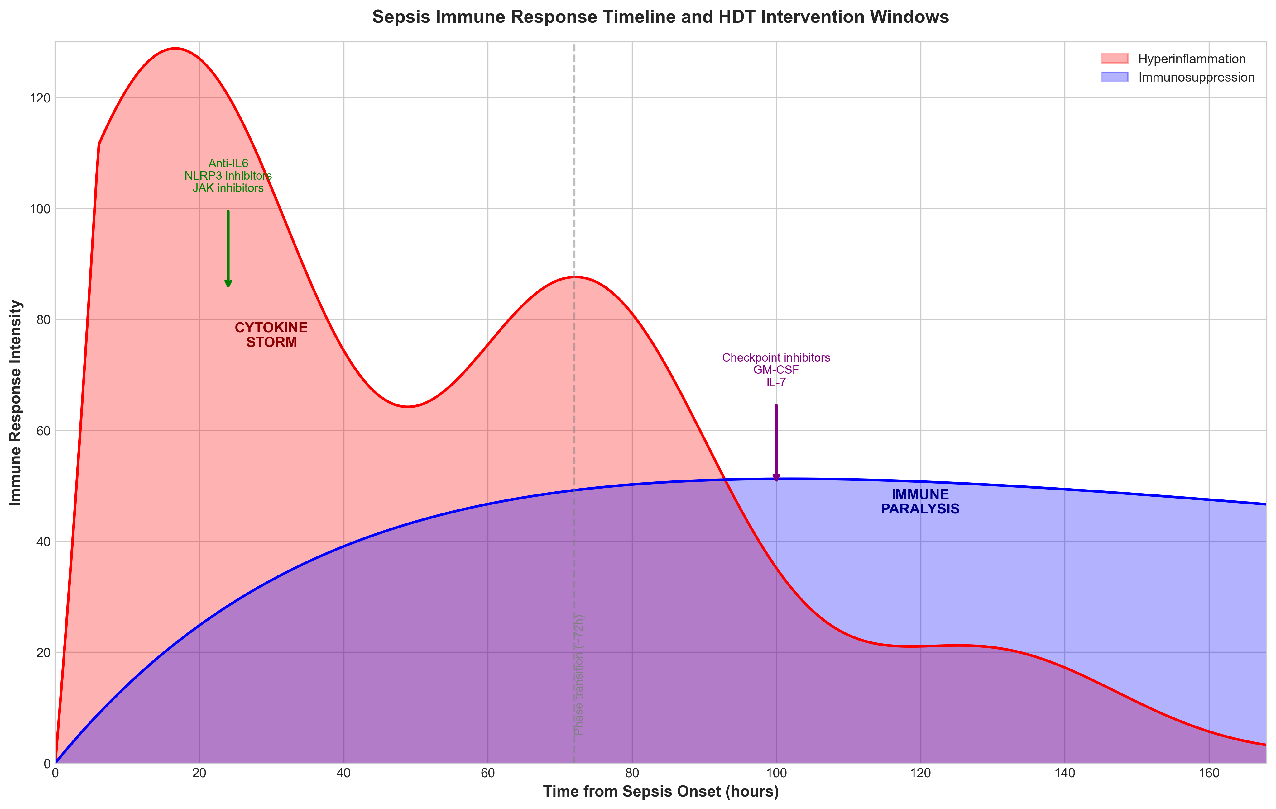
Biphasic immune response with HDT intervention windows.

