Whole-blood transcriptomic signatures of unfavourable tuberculosis treatment outcome before and during therapy: an exploratory machine-learning and immune-deconvolution study
Article type: Original Article
Siddalingaiah H S, MD
Professor, Department of Community Medicine, Shridevi Institute of Medical Sciences and Research Hospital, Tumkur, Karnataka, India
Correspondence: Dr Siddalingaiah H S. Email: hssling@yahoo.com

Abstract
Background. Tuberculosis treatment fails in a minority of patients, and those patients sustain transmission and drug resistance. Whole blood carries information about the host immune response, but it is unclear how much of that information relates to eventual outcome, and at which point in the treatment course it becomes readable. Pooling samples taken before and during therapy conflates two distinct biological states and obscures that question. We therefore analysed each state separately and then compared them.
Methods. We reanalysed the complete GSE89403 whole-blood RNA sequencing deposit: 367 libraries from 98 adults with pulmonary tuberculosis and a recorded outcome, sampled at diagnosis, day 7, week 4 and week 24. Outcome was dichotomised as unfavourable versus cured. One preprocessing and modelling protocol was applied to every timepoint. Penalised logistic regression, random forest and gradient boosting were compared by repeated stratified cross-validation with feature selection confined to training folds. We report sensitivity and specificity for each outcome class alongside ROC-AUC, precision–recall AUC, calibration and a label-permutation null. SHAP attribution on the gradient-boosted model produced a ranked feature panel per timepoint, which was then carried into pathway enrichment and a graphical-lasso conditional-dependency network. Marker-based immune deconvolution, a sex and bacterial-load audit, and replication in an independent cohort (GSE67589; 20 patients, cure versus relapse, different platform and country) completed the analysis.
Results. Discrimination depended strongly on when blood was sampled. Before treatment it was modest (0.65 (95% CI 0.34–0.89); precision–recall AUC 0.18) and did not separate from a permutation null (p = 0.182); no gene survived false-discovery correction. At the end of therapy it was strong (0.93 (95% CI 0.81–1.00); precision–recall AUC 0.67; permutation p = 0.006), with 5,924 genes differentially expressed at a false-discovery rate below 0.05. Class-specific performance at week 24 reached sensitivity 0.86 and specificity 0.91 for the unfavourable class. Across timepoints, predicted risk tracked a neutrophil-high, T-cell-low axis (Spearman ρ up to 0.82). The neutrophil association was independent of sex, and sex-linked transcripts showed no differential expression by outcome. Four published signatures of active tuberculosis, applied without fitting, reproduced the week-24 separation (best ROC-AUC 0.96, p = 1.4e-06) and matched or exceeded our fitted models in every arm. The signature did not transfer to the independent cohort: discrimination there was indistinguishable from chance (ROC-AUC 0.31–0.53, all confidence intervals spanning 0.5), and cell-composition differences were absent.
Conclusions. Outcome is not readable from whole blood before treatment or during its first four weeks, and is clearly readable at the end of therapy, where patients recorded as not cured retain the established interferon-driven signature of active disease. That end-of-treatment signal is concurrent with outcome ascertainment and is therefore a marker of unresolved disease rather than a forecast. Two findings temper any enthusiasm for machine learning here: unfitted published signatures outperformed our models in every arm, and the signature did not generalise to an independent cohort. The contribution is a map of when whole blood is and is not informative, not a new predictor. Event numbers are small and the findings are exploratory.
Keywords: tuberculosis; treatment outcome; whole-blood transcriptomics; machine learning; immune deconvolution; neutrophils; explainable artificial intelligence

1. Introduction
Tuberculosis remains the deadliest infection caused by a single agent, with an estimated 1.25 million deaths in 2023 [1]. Standard six-month chemotherapy cures most patients, but fails in roughly 5–10% of drug-susceptible disease and in a considerably larger share of multidrug-resistant disease [1]. The patients in whom it fails carry a disproportionate share of onward transmission and acquired resistance. Directly observed short-course treatment standardises the regimen and its supervision, but does not adapt therapy to the biology of the individual patient [1,2].
Blood transcriptomics is an established route to that biology. Signatures reported by Berry, Zak, Sweeney and Singhania distinguish active from latent infection and anticipate progression to disease [3–6]. Predicting how a patient will respond to treatment has proved harder. In a large drug-susceptible Brazilian cohort, transcriptomic prediction of failure from a pre-treatment sample reached an area under the curve below 0.70, although prediction of death and of recurrence was stronger [7]. Related approaches integrate radiological, microbiological and clinical data across thousands of patients [9], characterise the interaction between tuberculosis and diabetes [10], and predict failure from electronic medical records [11].
Two problems recur in this literature. The first is resolution. Bulk blood expression averages across a leukocyte mixture whose composition itself shifts with disease, so an apparent increase in inflammatory signalling may reflect a change in which cells are present rather than a change in what those cells are doing [8]. The second is design. Longitudinal cohorts sample the same patient repeatedly, and analyses that pool those samples mix pre-treatment biology with treatment-induced change. Because unfavourable outcomes are rare, such pooling can produce impressive aggregate accuracy that reflects when a sample was taken rather than what it says about the patient.
Separating the timepoints turns that problem into a question worth asking. A pre-treatment sample reflects intrinsic patient biology before any therapeutic perturbation, and is the only state from which genuine stratification is possible. Samples taken during and at the end of therapy reflect how the immune system responded to that perturbation; they describe what a good response looks like and identify patients in whom it did not occur. Comparing the two states shows which signals are intrinsic, which emerge only under treatment, and what that difference implies about the biology of failure.
We therefore reanalysed a longitudinal whole-blood cohort as separate biological states under one common protocol, and asked three questions. How well can outcome be discriminated in each state, reported for both outcome classes and against a permutation null? Which transcripts does the model use, what pathways do they represent, and how are they organised relative to one another? And does the resulting immune axis hold in an independent cohort, in different patients measured on a different platform? Throughout, features derived by machine learning are checked against established bioinformatic methods rather than reported on their own.

2. Methods

2.1 Cohort and outcome definition
The discovery cohort was GSE89403, a longitudinal whole-blood RNA sequencing study of adults with pulmonary tuberculosis receiving standard therapy [12]. Enrolment was restricted to HIV-negative patients with rifampicin-susceptible disease, so both factors are fixed by design rather than modelled here. Diabetes status was not recorded.
The deposit contains 914 sequencing libraries. Libraries sequenced across lanes from the same biological specimen were merged, giving 453 samples. Non-tuberculosis controls and samples without an evaluable outcome were excluded, leaving 367 samples from 98 subjects at four protocol timepoints: diagnosis, day 7, week 4 and week 24. Outcome was dichotomised as unfavourable (recorded as not cured) versus cured (definite, probable or possible cure). Study flow is shown in Figure 1.

2.2 Analytical arms
Each timepoint was analysed as a separate arm, because each represents a different biological state. The pre-treatment arm reflects patient biology before therapy and is the arm relevant to stratification. The day 7, week 4 and week 24 arms reflect the immune response to treatment, at increasing distance from its start. A fifth analysis pooled all timepoints with subject-grouped cross-validation; it is reported for contrast only, since it mixes states, and no predictive claim is made from it.
Table 1. Composition of each analytical arm.
Arm | Samples | Unfavourable | Cured | Prevalence
Pre-treatment | 90 | 7 | 83 | 7.8%
Day 7 | 91 | 6 | 85 | 6.6%
Week 4 | 92 | 8 | 84 | 8.7%
Week 24 | 94 | 7 | 87 | 7.4%
All timepoints | 367 | 28 | 339 | 7.6%

2.3 Preprocessing
Gene counts were taken from the deposited count matrix. Genes detected in fewer than 10% of libraries were removed, leaving 16,145 genes. Counts were normalised to counts per million to remove library-size differences, then log-transformed as log₂(x+1). The identical pipeline was applied to every arm, so differences between arms reflect biology and not preprocessing.

2.4 Predictive modelling
Three classifiers were compared in every arm: penalised logistic regression, random forest and gradient boosting. Each was fitted inside a pipeline that performed univariate feature pre-selection to 200 genes, so selection saw only training data and no information crossed the train–test boundary. Discrimination was estimated by stratified five-fold cross-validation repeated 40 times, with out-of-fold probabilities averaged across repeats and metrics computed on the pooled predictions. Class imbalance was handled by class weighting rather than resampling. The pooled analysis used subject-grouped folds so that no subject appeared in both training and test sets.

2.5 Performance measures
Sensitivity, specificity, positive and negative predictive value and F1 are reported separately for each outcome class at the Youden operating point, because a single summary figure conceals how differently a model behaves on a rare class and a common one. These accompany ROC-AUC and precision–recall AUC with bootstrap confidence intervals from 2,000 resamples, the Matthews correlation coefficient, balanced accuracy, the confusion matrix and the Brier score. Discrimination was additionally tested against a null distribution built by permuting outcome labels 500 times and repeating the whole cross-validation, with observed and permuted values computed under one identical protocol. Leave-one-out cross-validation was run as a further check.

2.6 Feature attribution and model choice
SHAP values were computed on the gradient-boosted model using TreeExplainer, which returns exact Shapley values for additive tree ensembles rather than a sampled approximation. Gradient boosting was chosen for attribution on that ground: it captures non-additive structure that a linear model cannot, and it admits an exact attribution method that a random forest ensemble of the same size does not. Discrimination for all three classifiers is reported in every arm so that this choice can be judged against the alternatives rather than assumed. Attribution was computed on a 50-gene panel per arm, and the ranking was carried forward unchanged into the two downstream analyses.

2.7 Pathway analysis
Pathway analysis was run on the model's own attribution ranking, so that the biology described corresponds to what the classifier used rather than to a separately derived list. A fifty-gene panel is too small to support open-ended testing against tens of thousands of terms, so the primary test was targeted: the panel from each arm was tested by hypergeometric over-representation against six pre-specified immune programmes relevant to tuberculosis — neutrophil degranulation, T-cell receptor signalling, the interferon-inducible response, inflammatory and myeloid activation, cytotoxic and natural-killer effector function, and the B-cell programme. Six tests per arm keeps the multiple-testing burden negligible, and false-discovery correction was applied within each arm. Programme membership is listed in full with the code.
Open-ended enrichment against Gene Ontology biological processes, KEGG, Hallmark and Reactome was run separately on the genes surviving false-discovery correction in the differential-expression analysis, where the gene list is large enough for such testing to be meaningful. Results of open-ended testing on the attribution panels themselves are reported in the supplement for completeness.

2.8 Immune deconvolution
Cell composition was estimated by marker-gene-set enrichment: expression was standardised across samples and averaged within canonical marker panels for neutrophils, T cells, monocytes, B cells and natural killer cells. We describe the method as marker-panel enrichment rather than by a proprietary name because that is exactly what was computed. Group differences used the Mann–Whitney U test with rank-biserial correlation as the effect size. Agreement between the cell scores and the model's predicted probability was quantified by Spearman correlation; this is the step that tests whether the machine-learning signal and an established deconvolution method describe the same biology.

2.9 Conditional-dependency network
A Gaussian graphical model was estimated with the graphical lasso on the SHAP-ranked panel of each arm. Using the attribution panel as the node set keeps one feature set flowing through the pipeline, so the network describes how the signal the model relies on is internally organised rather than forming a parallel result. Each edge is a partial correlation: the association between two transcripts once every other transcript in the panel has been conditioned out, which removes the indirect links that a marginal correlation network would display. Edges are undirected, outcome is not a node, and high-degree genes are described as hubs and not as regulators or drivers.

2.10 Benchmarking against published signatures
Model-derived features are only worth reporting if they add something to what is already established, so each arm was also scored with four published blood signatures of active tuberculosis: the three-gene set of Sweeney and colleagues, the interferon core of the Berry signature, the myeloid-up and lymphoid-down set of Kaforou and colleagues, and the interferon-dominated risk signature of Zak and colleagues [3–6]. Each was computed as the mean standardised expression of its up-weighted members minus that of its down-weighted members. No parameter was fitted, so these scores are free of any optimism from our own data and provide an external reference against which our fitted models can be judged.

2.11 Within-subject treatment response
Comparing different patients at one timepoint leaves between-subject variation inside every contrast. For subjects with both a diagnosis sample and a later sample, the change vector between them removes that variation and describes the individual response to therapy. Averaging those vectors across cured subjects defines a reference direction for a successful response, and each subject was scored by the cosine alignment of their own change with it. The reference was rebuilt leaving out each cured subject in turn, so no subject contributed to the direction used to score them. The change vectors were also submitted to the same classification protocol used for the arms, giving a like-for-like comparison between the cross-sectional state and the within-subject change.

2.12 Independent replication
Replication used GSE67589, an independent cohort of 20 patients with pulmonary tuberculosis sampled at diagnosis, week 2 and week 4, in whom outcome was recorded as cure or relapse after apparently successful treatment [14]. The cohort differs from the discovery data in patients, country, measurement platform and outcome definition, so agreement across it is a conservative test rather than a repeat measurement. Because the platforms differ, transfer used rank-standardised signature scores rather than model coefficients: cell-composition scores were recomputed with the same marker panels, and a directional score built from the discovery cohort's differential expression was applied to the replication samples.

2.13 Confounder audit
Sex was inferred from XIST and RPS4Y1 expression, since it is not deposited. Bacterial load was represented by time to culture positivity and Xpert cycle threshold. Multivariable logistic regression tested whether the neutrophil association survived adjustment for both. Sex-linked transcripts were tested directly for differential expression, because they can dominate an unadjusted feature ranking when a small outcome group is skewed by sex.

2.14 Software and reproducibility
Analyses used Python with scikit-learn, XGBoost, SHAP, statsmodels and SciPy. Tests were two-sided at α = 0.05, with Benjamini–Hochberg false-discovery control where indicated. Effect sizes are reported alongside p-values throughout. Analysis code, the frozen models and all intermediate outputs are released so that results can be verified without re-execution.
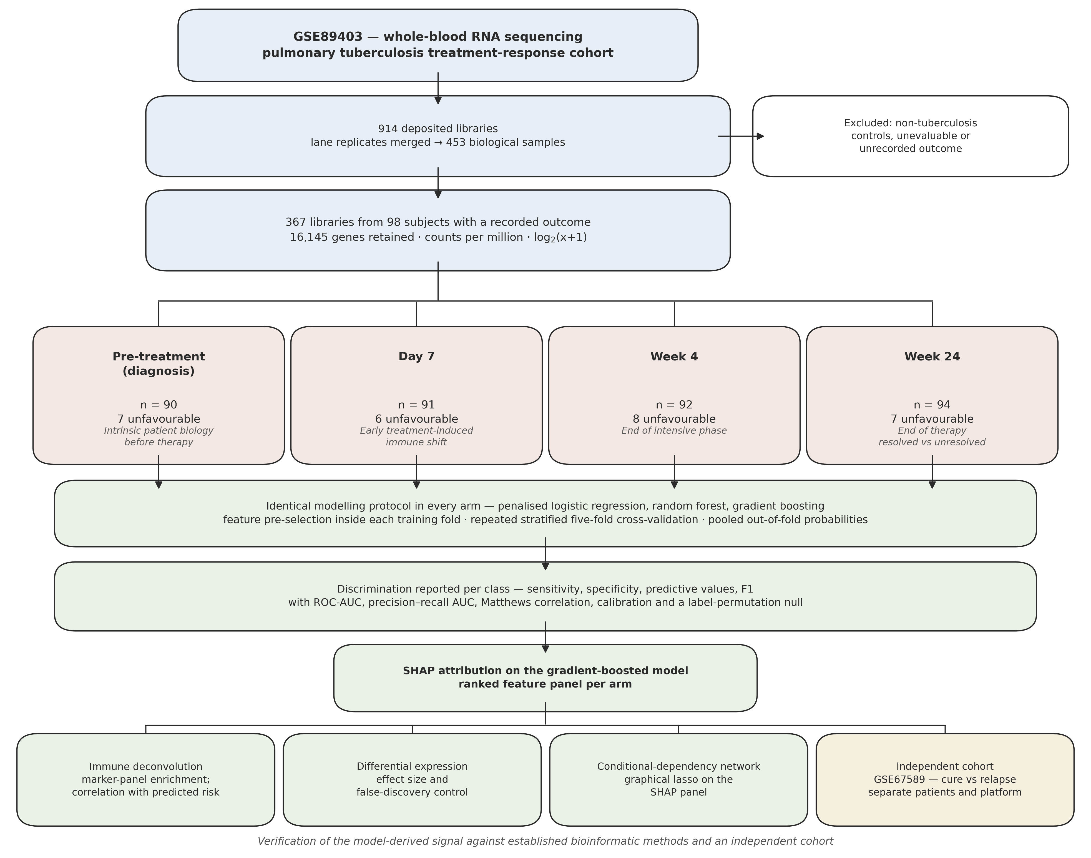
Figure 1. Study flow. Cohort assembly, the four biological states analysed as separate arms, the common modelling protocol, and the verification of model-derived features against deconvolution, differential expression, network estimation and an independent cohort.

3. Results

3.1 Cohort
After exclusions, 367 samples from 98 subjects were analysed. Unfavourable outcomes were uncommon at every timepoint, ranging from 6 to 8 events per arm against 83 to 87 cured patients (Table 1). Every performance estimate below rests on fewer than ten events and is correspondingly uncertain; the confidence intervals reported alongside each estimate should be read as part of the result.

3.2 Outcome is barely readable before treatment
In pre-treatment blood, discrimination was modest. The best of the three classifiers (random forest) reached a ROC-AUC of 0.65 (95% CI 0.34–0.89), with a precision–recall AUC of 0.18 against a prevalence of 0.08. The confidence interval includes 0.5, and the estimate did not separate from a label-permutation null (observed 0.61 against a null mean of 0.48; p = 0.182). Leave-one-out cross-validation gave 0.69, agreeing with the repeated-fold estimate.
At the Youden operating point the model behaved very differently on the two classes. For the unfavourable class, sensitivity was 0.71 and specificity 0.77, but positive predictive value was only 0.21 against a negative predictive value of 0.97. In practical terms a negative result is somewhat informative and a positive result is not. Differential expression told the same story: 2,276 genes reached nominal significance but none survived false-discovery correction.
This is a negative result, and we report it as one. Pre-treatment whole blood, in a cohort of this size, does not support risk stratification for eventual treatment outcome.

3.3 Outcome becomes readable only at the end of therapy
Early treatment samples were little better than pre-treatment ones. At day 7 discrimination was 0.69 (95% CI 0.56–0.82) and at week 4 0.60 (95% CI 0.33–0.85); neither separated from its permutation null (p = 0.202 and p = 0.263 respectively), and neither yielded a gene surviving false-discovery correction. Where the bootstrap interval at day 7 excludes 0.5 but the permutation test does not reject, we take the permutation result as the more conservative and more appropriate check, because it repeats the entire cross-validation under the null rather than resampling a fixed set of predictions.
Week 24, the end of therapy, is different. Discrimination was 0.93 (95% CI 0.81–1.00) with a precision–recall AUC of 0.67 against a prevalence of 0.07, a Matthews correlation of 0.56, and a permutation p = 0.006. All three classifiers agreed at this timepoint (Table 2), which argues that the signal is a property of the data rather than of one algorithm. The change is therefore abrupt rather than gradual: outcome is unreadable through the first four weeks of treatment and clearly readable at its end.
Differential expression moved in step. The number of genes surviving false-discovery correction rose from none before treatment to 5,924 at week 24. Class-specific performance at week 24 was balanced across both classes: sensitivity 0.86 and specificity 0.91 for the unfavourable class, against sensitivity 0.91 and specificity 0.86 for the cured class.
The interpretation of this result requires care. Week 24 is also the point at which treatment outcome is ascertained, so a model reading week-24 blood is describing a state concurrent with the outcome rather than forecasting a future event. What it identifies is unresolved immune activation in patients whose disease has not been cleared. That is a treatment-response signal, not a prediction, and the distinction matters for how such a marker could ever be used.
Pooling all timepoints with subject-grouped folds gave 0.68 (95% CI 0.57–0.79), with a permutation p = 0.004. That significance is instructive rather than reassuring: it is inherited from the week-24 samples inside the pool, and it attaches to a figure that describes neither the pre-treatment state nor the end-of-treatment state. A pooled analysis of this cohort will therefore look moderately successful while concealing that its information comes almost entirely from samples taken when the outcome was already being determined. We report it to make that point and attach no predictive claim to it.
Table 2. Discrimination in each biological state. Sensitivity, specificity and predictive values refer to the unfavourable class at the Youden operating point.
Arm | n | Events | Model | ROC-AUC (95% CI) | PR-AUC | Sens. | Spec. | PPV | NPV | MCC | Perm. p
Pre-treatment | 90 | 7 | random forest | 0.65 (0.34–0.89) | 0.18 | 0.71 | 0.77 | 0.21 | 0.97 | 0.29 | 0.182
Day 7 | 91 | 6 | random forest | 0.69 (0.56–0.82) | 0.11 | 1.00 | 0.54 | 0.13 | 1.00 | 0.27 | 0.202
Week 4 | 92 | 8 | gradient boosting | 0.60 (0.33–0.85) | 0.21 | 0.62 | 0.67 | 0.15 | 0.95 | 0.17 | 0.263
Week 24 | 94 | 7 | random forest | 0.93 (0.81–1.00) | 0.67 | 0.86 | 0.91 | 0.43 | 0.99 | 0.56 | 0.006
All timepoints | 367 | 28 | random forest | 0.68 (0.57–0.79) | 0.16 | 0.54 | 0.83 | 0.20 | 0.96 | 0.24 | 0.004

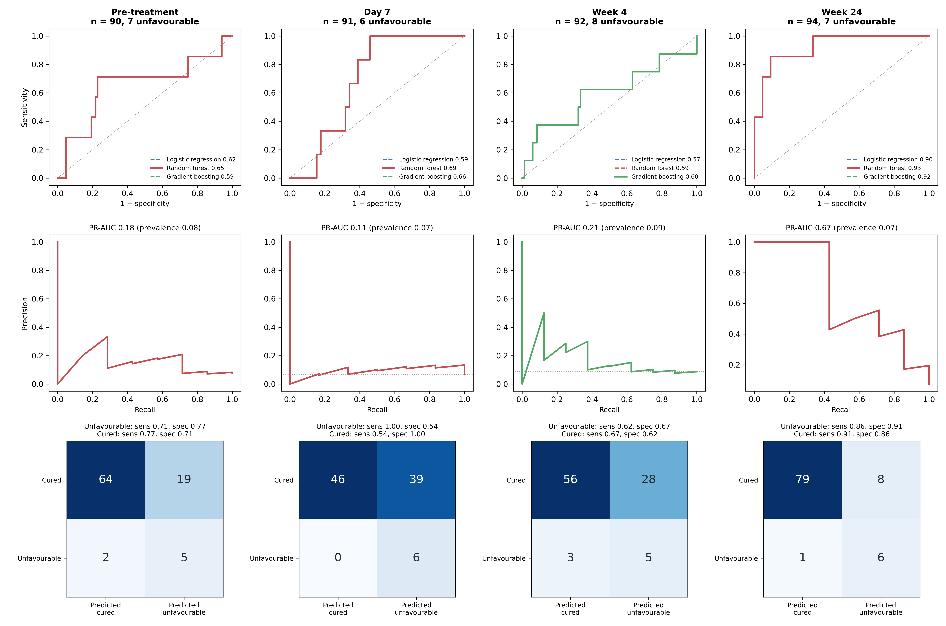
Figure 2. Discrimination by biological state. Top row, receiver operating characteristic curves; middle row, precision–recall curves with the prevalence baseline; bottom row, confusion matrices at the Youden operating point with sensitivity and specificity given for both outcome classes.

3.4 What the model uses, and which pathways those genes represent
SHAP attribution on the gradient-boosted model produced a ranked panel for each arm (Figure 3). Before treatment the highest-ranked genes were STT3A, LA16c-380H5.5, UCP2, PGLYRP1, NRN1, BIVM. At week 24 the panel was headed by FAM20A, TEX2, FCGR1A, RGS19, BBS9, PRPF4; the fifteen highest-ranked genes at that timepoint also include the high-affinity Fc gamma receptor gene FCGR1B and the interferon-inducible transcripts VAMP5 and METTL7B.
Testing each attribution panel against six pre-specified immune programmes made that impression quantitative (Table 3). No programme was over-represented in the pre-treatment, day 7 or week 4 panels. In the week 24 panel, the interferon-inducible programme was strongly over-represented (4/28 genes, adjusted p = 1.0e-05), as was the inflammatory and myeloid activation programme (adjusted p = 0.005).
Table 3. Over-representation of pre-specified immune programmes among the highest-ranked genes by SHAP attribution. Programmes with no overlapping gene are omitted and are listed in full in Supplementary Table S10.
Arm | Immune programme | Overlap | p | Adjusted p
Day 7 | T-cell receptor signalling and adaptive response | 1/21 | 0.063 | 0.377
Week 24 | Interferon-inducible response | 4/28 | 1.7e-06 | 1.0e-05
Week 24 | Inflammatory and myeloid activation | 2/20 | 0.002 | 0.005

Open-ended enrichment was possible only at week 24, since that is the only arm producing genes that survive false-discovery correction. Applied to those genes it recovered cytokine signalling in the immune system (adjusted p = 0.0037) and interferon signalling among the leading immune terms, alongside generic transcription and RNA-metabolism categories of the kind expected from a gene list of several thousand members (Supplementary Table S11).
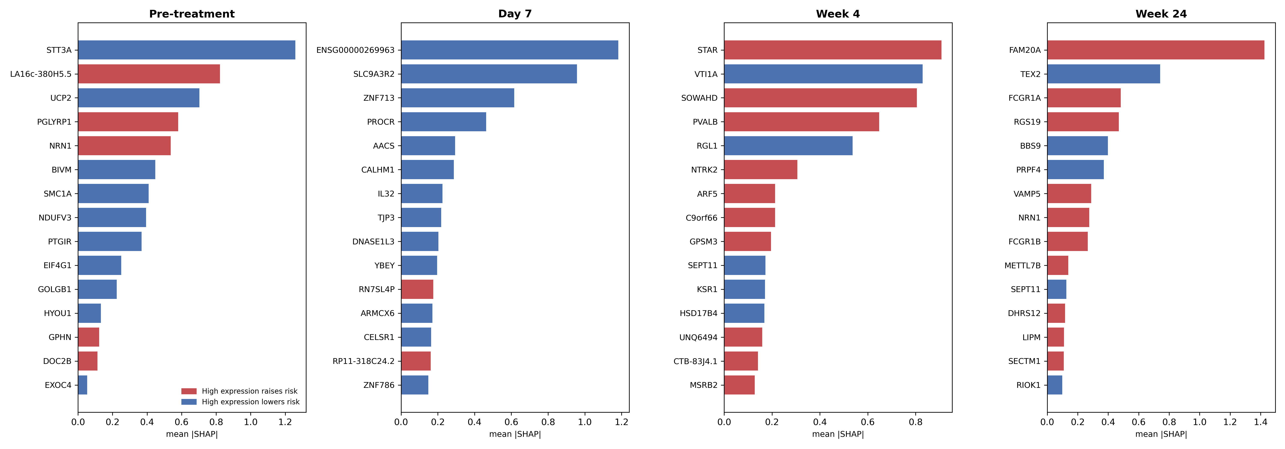
Figure 3. Feature attribution by biological state. Bars show mean absolute SHAP value for the fifteen highest-ranked genes in each arm. Colour indicates the direction of the association: red where high expression raises predicted risk, blue where it lowers it.

3.5 Predicted risk tracks a neutrophil-high, T-cell-low axis
Marker-panel deconvolution recovered the cellular basis of the signal (Figure 4). Before treatment, neutrophil scores were higher in patients with an unfavourable outcome, with a moderate effect size (rank-biserial r = +0.35) that fell short of significance at this sample size (p = 0.130). By week 24 the same contrast was pronounced (r = +0.65, p = 0.003).
The decisive check is whether the machine-learning signal and the deconvolution describe the same thing. They do. Predicted probability of an unfavourable outcome correlated positively with the neutrophil score and negatively with the T-cell score in every arm (Figure 5): before treatment ρ = +0.60 and -0.69 respectively, and at week 24 ρ = +0.50 and -0.62. A model given no cell-composition information arrived independently at the axis that an established deconvolution method identifies.
One comparison deserves note. At day 7 the composite neutrophil-minus-T-cell score separated outcome groups clearly (r = +0.72, p = 0.002) even though the classifiers trained on the same samples did not survive permutation testing. A single pre-specified summary of immune composition is estimated from a handful of parameters, whereas a model selecting from sixteen thousand genes must spend its limited statistical budget on that selection. With six events, the low-dimensional summary is the more sensitive instrument.
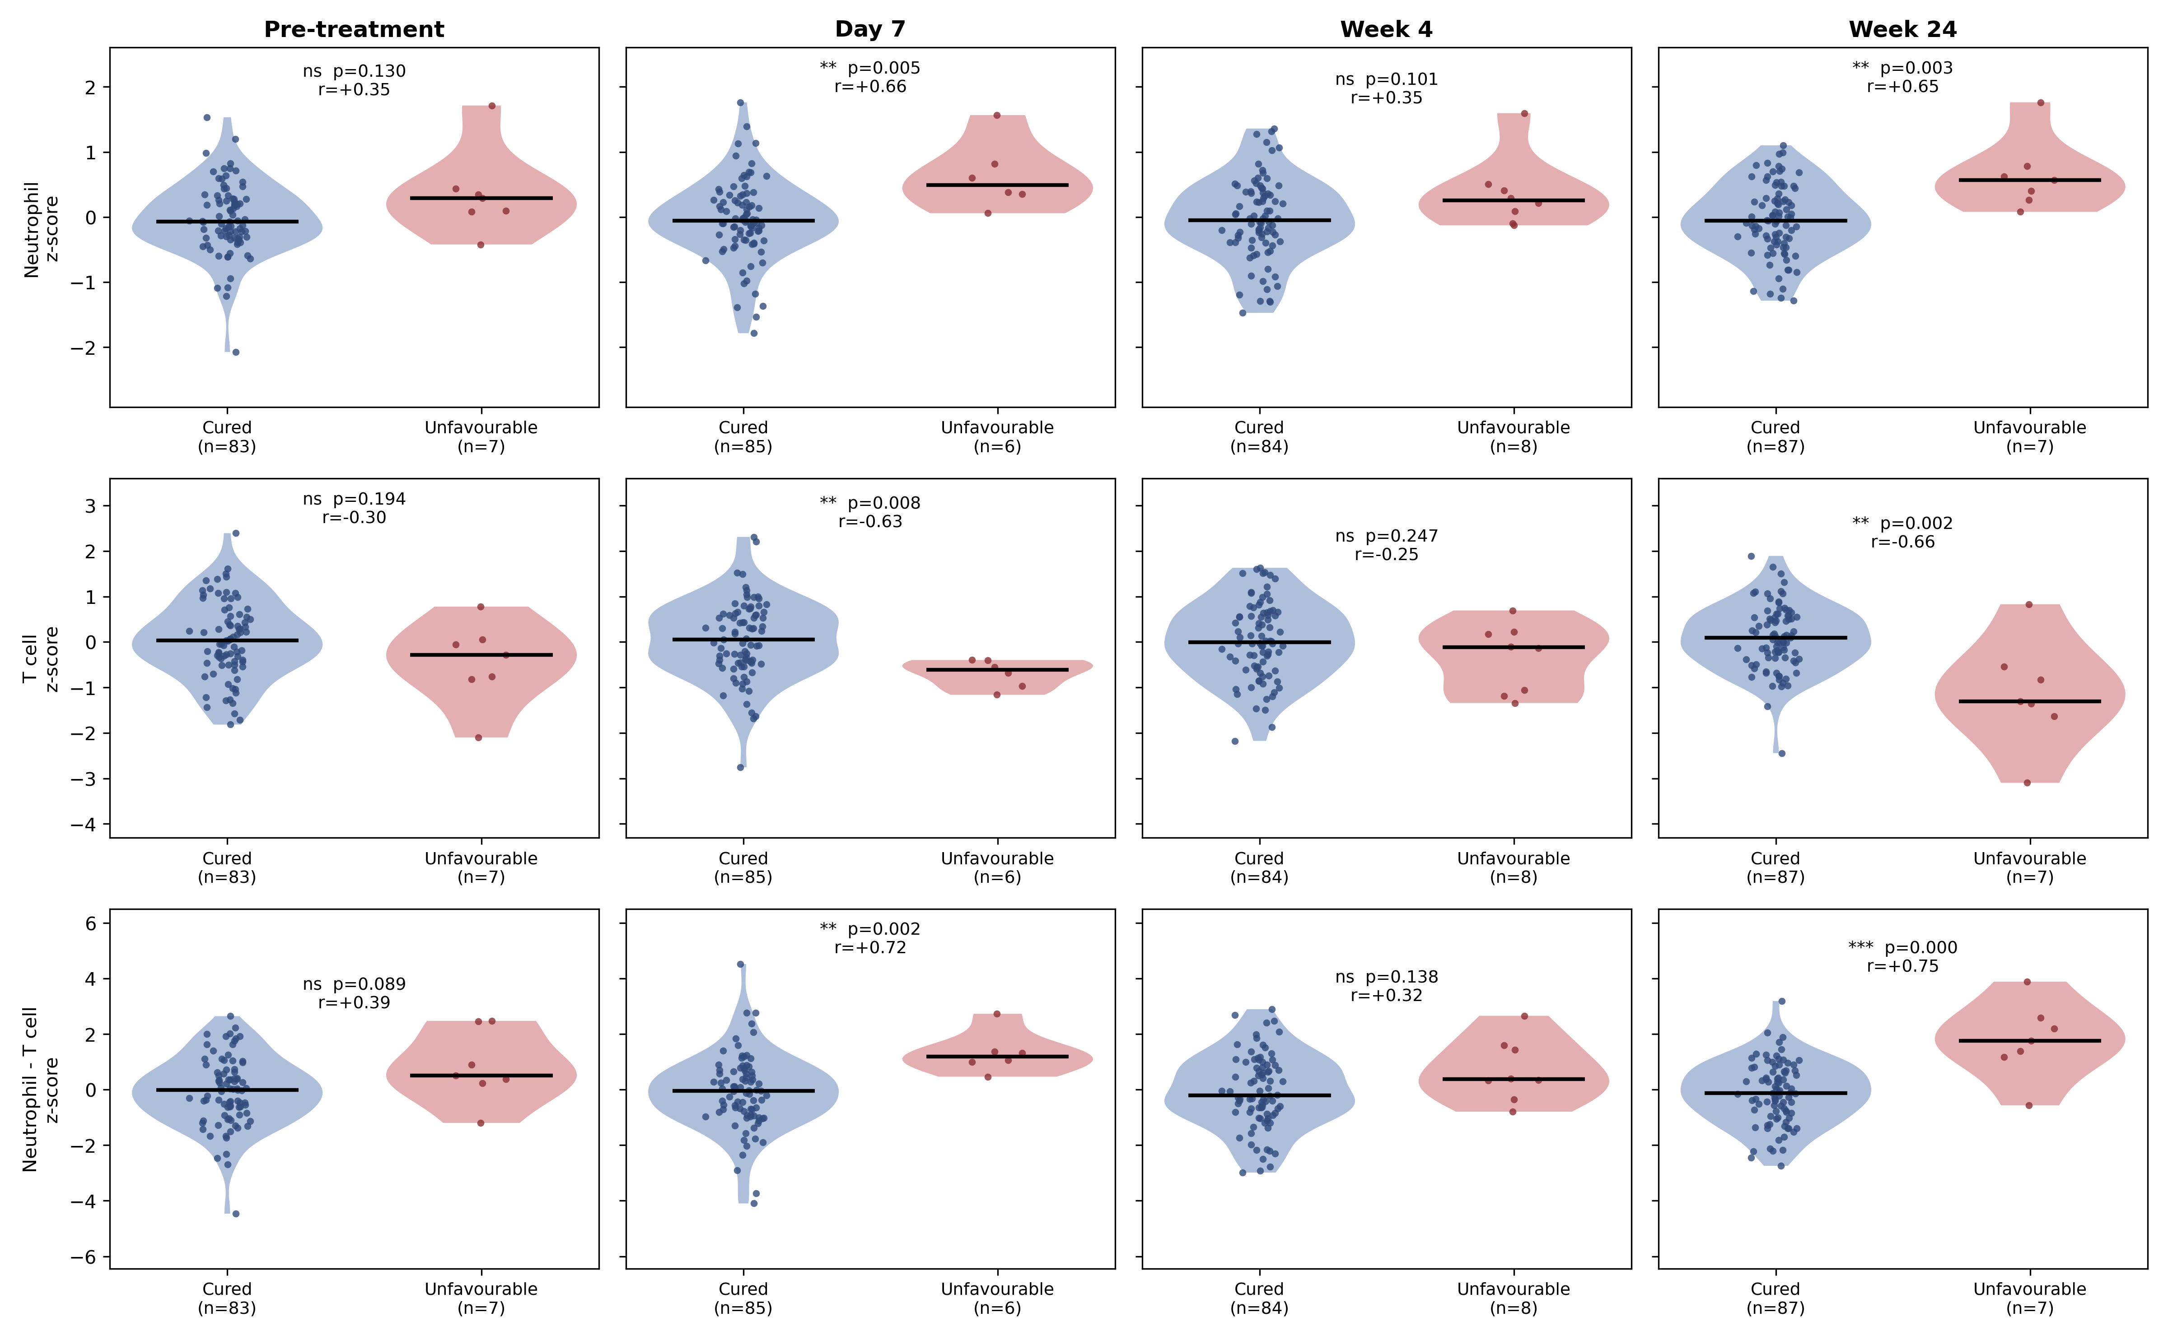
Figure 4. Immune composition by outcome in each biological state. Violin plots show marker-panel enrichment scores for neutrophils, T cells and their difference, with individual samples, medians, Mann–Whitney p-values and rank-biserial effect sizes.
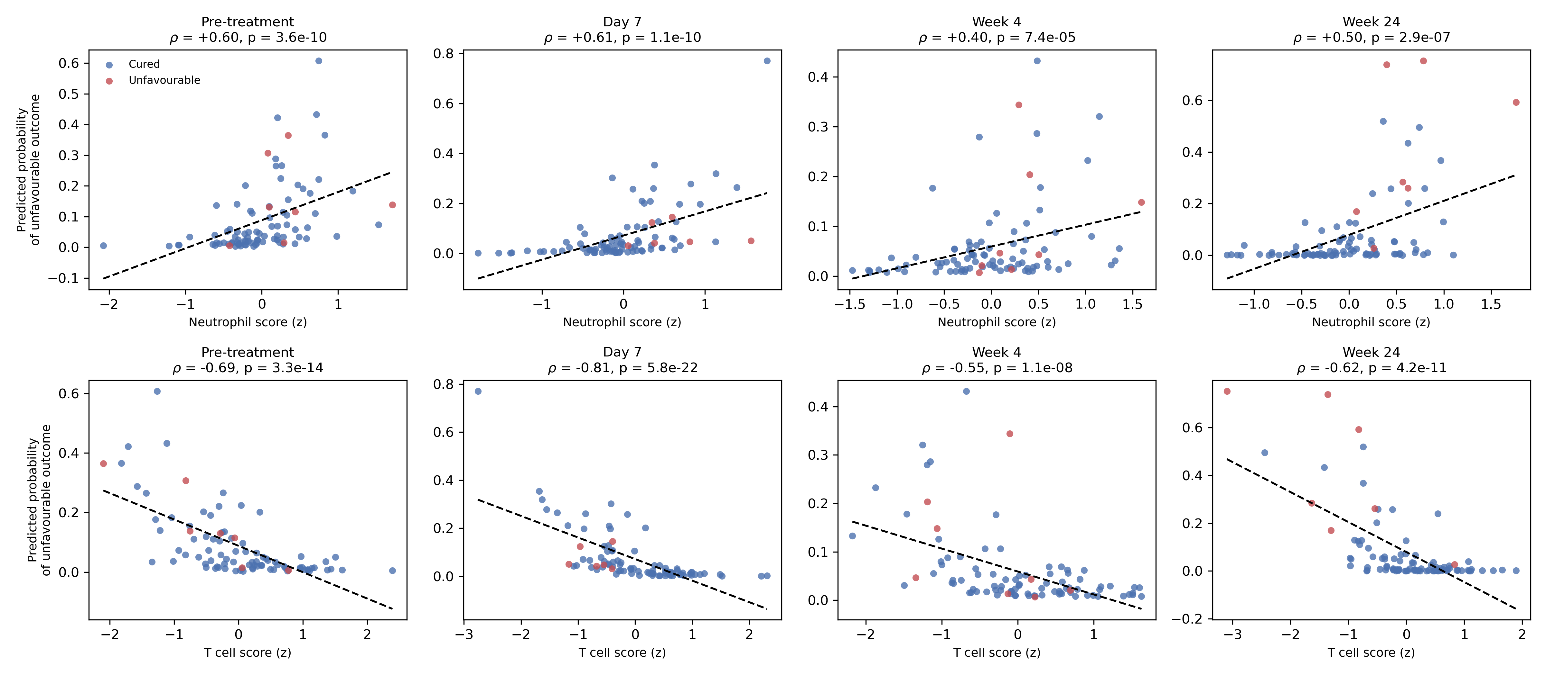
Figure 5. Predicted probability of an unfavourable outcome against immune-cell scores. Each point is one sample, coloured by observed outcome, with the least-squares fit and Spearman correlation shown for each arm.

3.6 Organisation of the signal
Estimating a Gaussian graphical model on each SHAP panel showed how those features relate to one another once indirect associations are removed (Figure 6). Hub genes by degree were UCP2, SEC31A, EMC1, EIF4G1 before treatment and HSP90AB1, ALMS1, FCGR1A, PRPF4 at week 24. These are undirected conditional associations. They indicate which transcripts carry shared information within the panel, and they do not establish regulatory direction, causation, or therapeutic relevance.
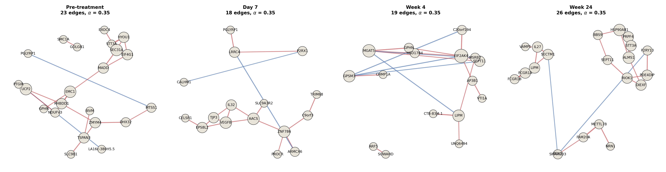
Figure 6. Conditional-dependency structure of the attribution panel in each arm. Nodes are the highest-ranked genes by SHAP value; edges are partial correlations from a graphical-lasso estimate, red for positive and blue for negative; node size reflects degree. Outcome is not a node and no direction is implied.

3.7 Published signatures reproduce the result, and outperform our models
The strongest test of the week-24 finding is whether it survives without any model of ours. Scoring the same samples with four published signatures of active tuberculosis, none of which has a parameter fitted to these data, reproduces it emphatically. The three-gene Sweeney signature separated outcome groups at week 24 with a ROC-AUC of 0.92 (p = 3.8e-05), and the Kaforou myeloid-up, lymphoid-down signature reached 0.96 (p = 1.4e-06). Before treatment, the same signatures behaved as our models did, discriminating weakly and without significance (Kaforou 0.70, p = 0.080; Table 4).
Table 4. Published blood signatures of active tuberculosis applied to each arm without fitting. Scores are the mean standardised expression of up-weighted members minus that of down-weighted members.
Arm | Published signature | ROC-AUC | Rank-biserial r | p
Pre-treatment | Sweeney 3-gene | 0.632 | +0.26 | 0.258
Pre-treatment | Berry 393-gene core (interferon module) | 0.616 | +0.23 | 0.320
Pre-treatment | Kaforou 44-gene (myeloid up / lymphoid down) | 0.701 | +0.40 | 0.080
Pre-treatment | Zak 16-gene risk (interferon-dominated) | 0.668 | +0.34 | 0.147
Day 7 | Sweeney 3-gene | 0.698 | +0.40 | 0.109
Day 7 | Berry 393-gene core (interferon module) | 0.641 | +0.28 | 0.260
Day 7 | Kaforou 44-gene (myeloid up / lymphoid down) | 0.763 | +0.53 | 0.030
Day 7 | Zak 16-gene risk (interferon-dominated) | 0.710 | +0.42 | 0.089
Week 4 | Sweeney 3-gene | 0.594 | +0.19 | 0.393
Week 4 | Berry 393-gene core (interferon module) | 0.610 | +0.22 | 0.315
Week 4 | Kaforou 44-gene (myeloid up / lymphoid down) | 0.677 | +0.35 | 0.101
Week 4 | Zak 16-gene risk (interferon-dominated) | 0.647 | +0.29 | 0.176
Week 24 | Sweeney 3-gene | 0.916 | +0.83 | 3.8e-05
Week 24 | Berry 393-gene core (interferon module) | 0.901 | +0.80 | 9.4e-05
Week 24 | Kaforou 44-gene (myeloid up / lymphoid down) | 0.956 | +0.91 | 1.4e-06
Week 24 | Zak 16-gene risk (interferon-dominated) | 0.923 | +0.85 | 2.4e-05

Two conclusions follow, and the second is uncomfortable. The first is that the week-24 result is not an artefact of our modelling: an externally derived, unfitted three-gene score reproduces it at a significance level our own cross-validated model does not reach. The second is that our models add nothing. In every arm the best published signature matched or exceeded the best fitted classifier (Table 5), by 0.03 to 0.08 in ROC-AUC. A machine-learning pipeline with access to sixteen thousand genes did not improve on a score built from three.
Table 5. Fitted models compared with unfitted published signatures. A negative difference means the published signature discriminated better.
Arm | Best fitted model | Best published signature | Published ROC-AUC | Difference
Pre-treatment | 0.654 | Kaforou 44-gene (myeloid up / lymphoid down) | 0.701 | -0.046
Day 7 | 0.694 | Kaforou 44-gene (myeloid up / lymphoid down) | 0.763 | -0.069
Week 4 | 0.597 | Kaforou 44-gene (myeloid up / lymphoid down) | 0.677 | -0.080
Week 24 | 0.926 | Kaforou 44-gene (myeloid up / lymphoid down) | 0.956 | -0.030

3.8 Within-subject change discriminates far less well than state
The arm analyses compare different patients, so between-subject variation sits inside each contrast. Restricting to subjects with a paired diagnosis sample and forming the within-subject change vector removes it. The picture weakens substantially. Alignment of each subject's change with the cured-response direction was lower in patients with an unfavourable outcome at week 24, in the expected direction, but did not reach significance (rank-biserial r = -0.36, p = 0.146; n = 86 paired subjects, 6 unfavourable). Applying the arm classification protocol to the change vectors gave a ROC-AUC of 0.61, against 0.93 for the cross-sectional week-24 state.
This gap matters for interpretation. Part of it is expected on statistical grounds, since differencing two noisy measurements roughly doubles the variance while the paired subset is smaller. But it also means we cannot attribute the week-24 separation specifically to a failure to resolve under treatment. The evidence supports the weaker and more defensible claim: at the end of therapy, patients recorded as not cured occupy a different immunological state. Whether they travelled a different distance to reach it is not established by these data.
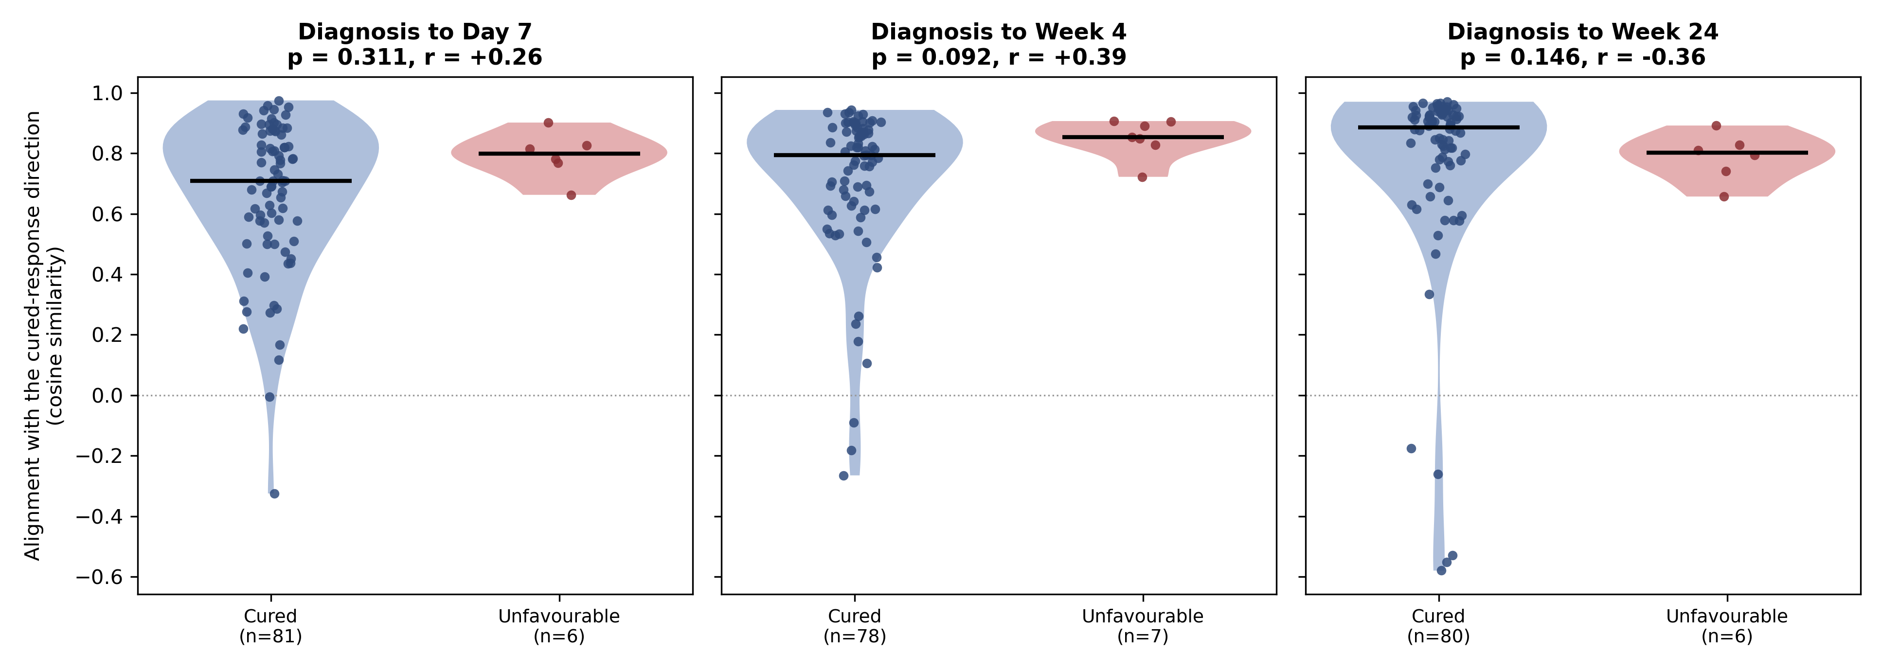
Figure 7. Within-subject treatment response. Alignment between each subject's diagnosis-to-later change vector and the average change of cured subjects, with the reference direction rebuilt leaving out each cured subject in turn.

3.9 The signature does not transfer to an independent cohort
We tested the immune axis in GSE67589, an independent cohort of 20 patients sampled at diagnosis, week 2 and week 4, in whom outcome was recorded as cure or relapse after apparently successful treatment [14]. Patients, country, array platform and outcome definition all differ from the discovery cohort.
It did not transfer. Neutrophil scores were indistinguishable between outcome groups at diagnosis (rank-biserial r = +0.00, p = 1.00), and the neutrophil-minus-T-cell contrast, while nominally in the expected direction (r = +0.22), was far from significance (p = 0.44). No cell-composition comparison reached significance at any of the three timepoints (Figure 8; Supplementary Table S15).
Directional gene signatures derived from the discovery cohort performed no better than chance when applied to the replication data (ROC-AUC 0.31–0.53, all confidence intervals spanning 0.5; Table 6). We report this as a failure to generalise rather than as an inconclusive result.
Table 6. Transfer of discovery-derived signatures to the independent cohort. Scores apply discovery gene directions to rank-standardised replication data. The week-24 rows are cross-timepoint comparisons, since the replication cohort stops at week 4.
Replication timepoint | Discovery arm | Comparison | Genes transferred | n | Relapse | ROC-AUC (95% CI) | p
Diagnosis | Pre-treatment | matched timepoint | 53 | 19 | 9 | 0.47 (0.20–0.76) | 0.84
Diagnosis | Week 24 | cross-timepoint | 55 | 19 | 9 | 0.50 (0.23–0.78) | 1.00
Week 2 | Day 7 | matched timepoint | 58 | 18 | 8 | 0.31 (0.07–0.61) | 0.20
Week 2 | Week 24 | cross-timepoint | 55 | 18 | 8 | 0.53 (0.22–0.83) | 0.90
Week 4 | Week 4 | matched timepoint | 55 | 20 | 10 | 0.35 (0.12–0.64) | 0.27
Week 4 | Week 24 | cross-timepoint | 55 | 20 | 10 | 0.49 (0.19–0.76) | 0.97

Three features of this test limit what its failure establishes. The replication cohort defines an unfavourable outcome as relapse after treatment was judged successful, which is not the same phenotype as failure to be cured. It contains between eight and ten patients per group, so its confidence intervals are extremely wide. And it stops at week 4, so the discovery arm in which we observe a strong signal has no matching timepoint to be tested against; the week-24 rows in Table 6 compare across different stages of treatment. The result therefore shows that the signature does not generalise to this cohort, and leaves open whether it would generalise to a cohort matched in outcome definition and sampling schedule.
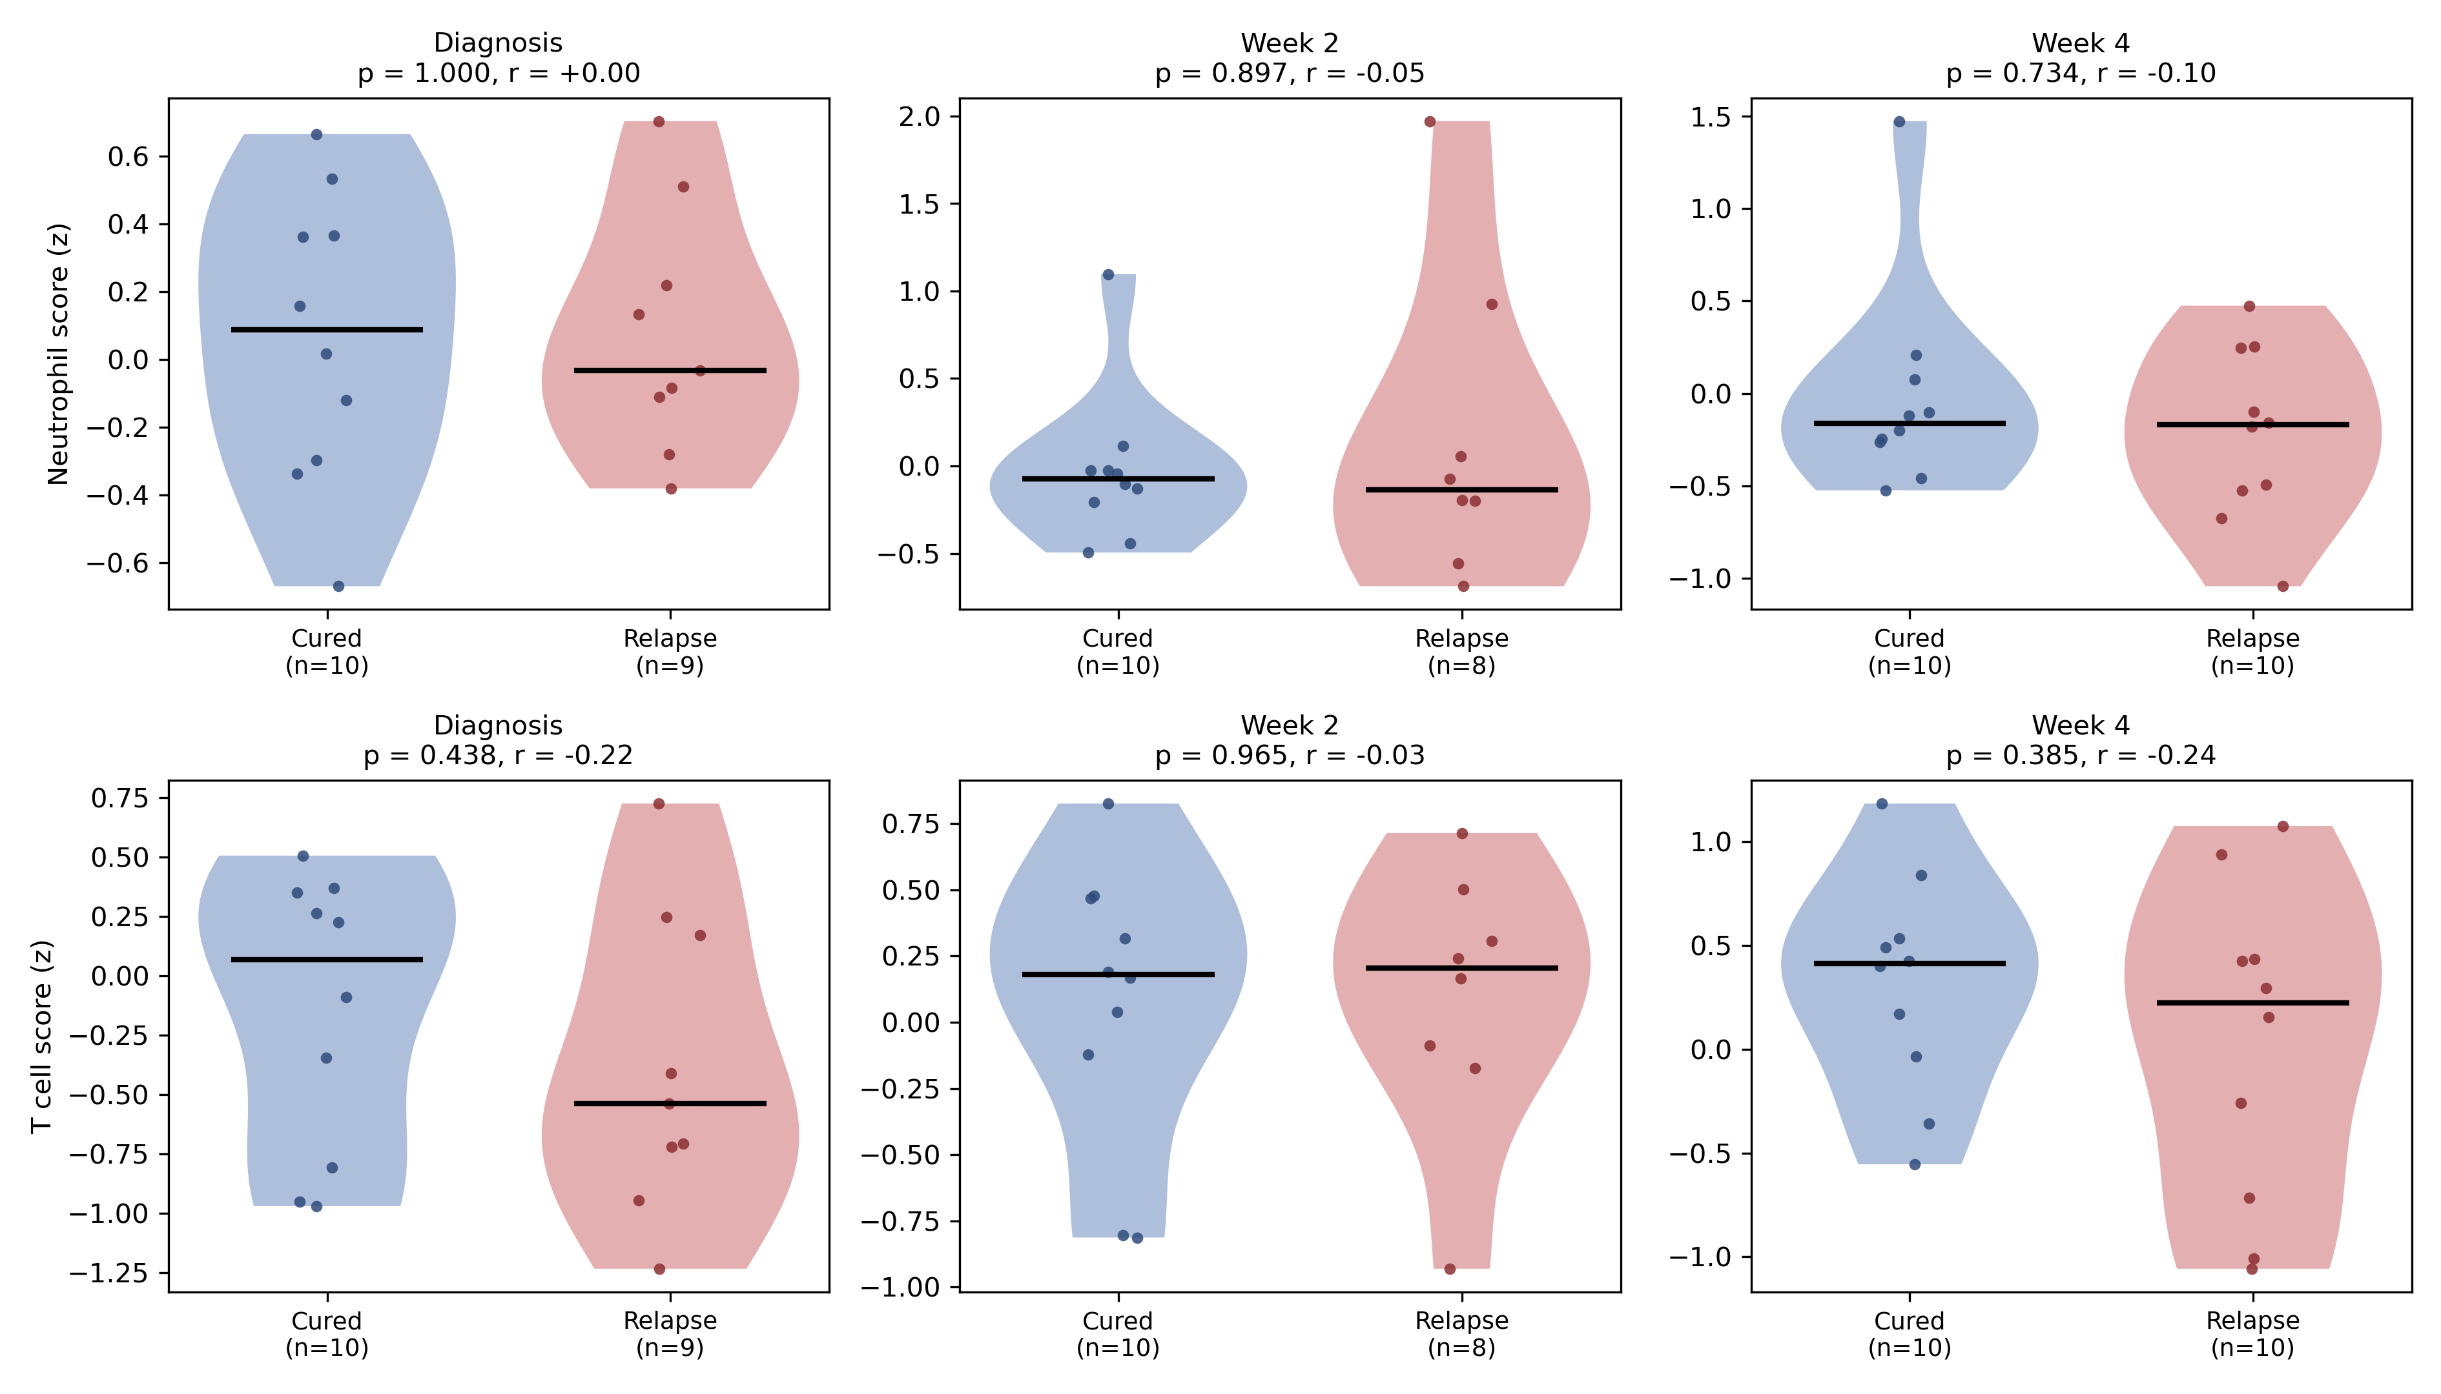
Figure 8. Independent cohort GSE67589. Neutrophil and T-cell scores by outcome at each sampled timepoint, with Mann–Whitney p-values and rank-biserial effect sizes. No comparison reaches significance.

3.10 What the comparison between states shows
Bringing the arms together identifies where the outcome signal lives (Figure 9). Of the genes separating outcome groups, 71 did so only before treatment, 277 did so in both states, and 4762 appeared only after treatment had begun. The signal is therefore overwhelmingly a property of the treated state, not an intrinsic property of the patient that treatment merely reveals.
The attribution panels tell the same story: the genes the model relies on before treatment overlap little with those it relies on at week 24. The immune axis behaves differently again. Its direction is the same in all four states — neutrophil-high and T-cell-low in patients with an unfavourable outcome — but its magnitude does not simply grow with time on treatment (rank-biserial r = +0.39, +0.72, +0.32 and +0.75 at diagnosis, day 7, week 4 and week 24). The contrast is clearest at day 7 and at week 24 and weakest at week 4. What changes across states is therefore not which axis matters but how far apart the two outcome groups sit along it, and that distance is not a monotonic function of time.
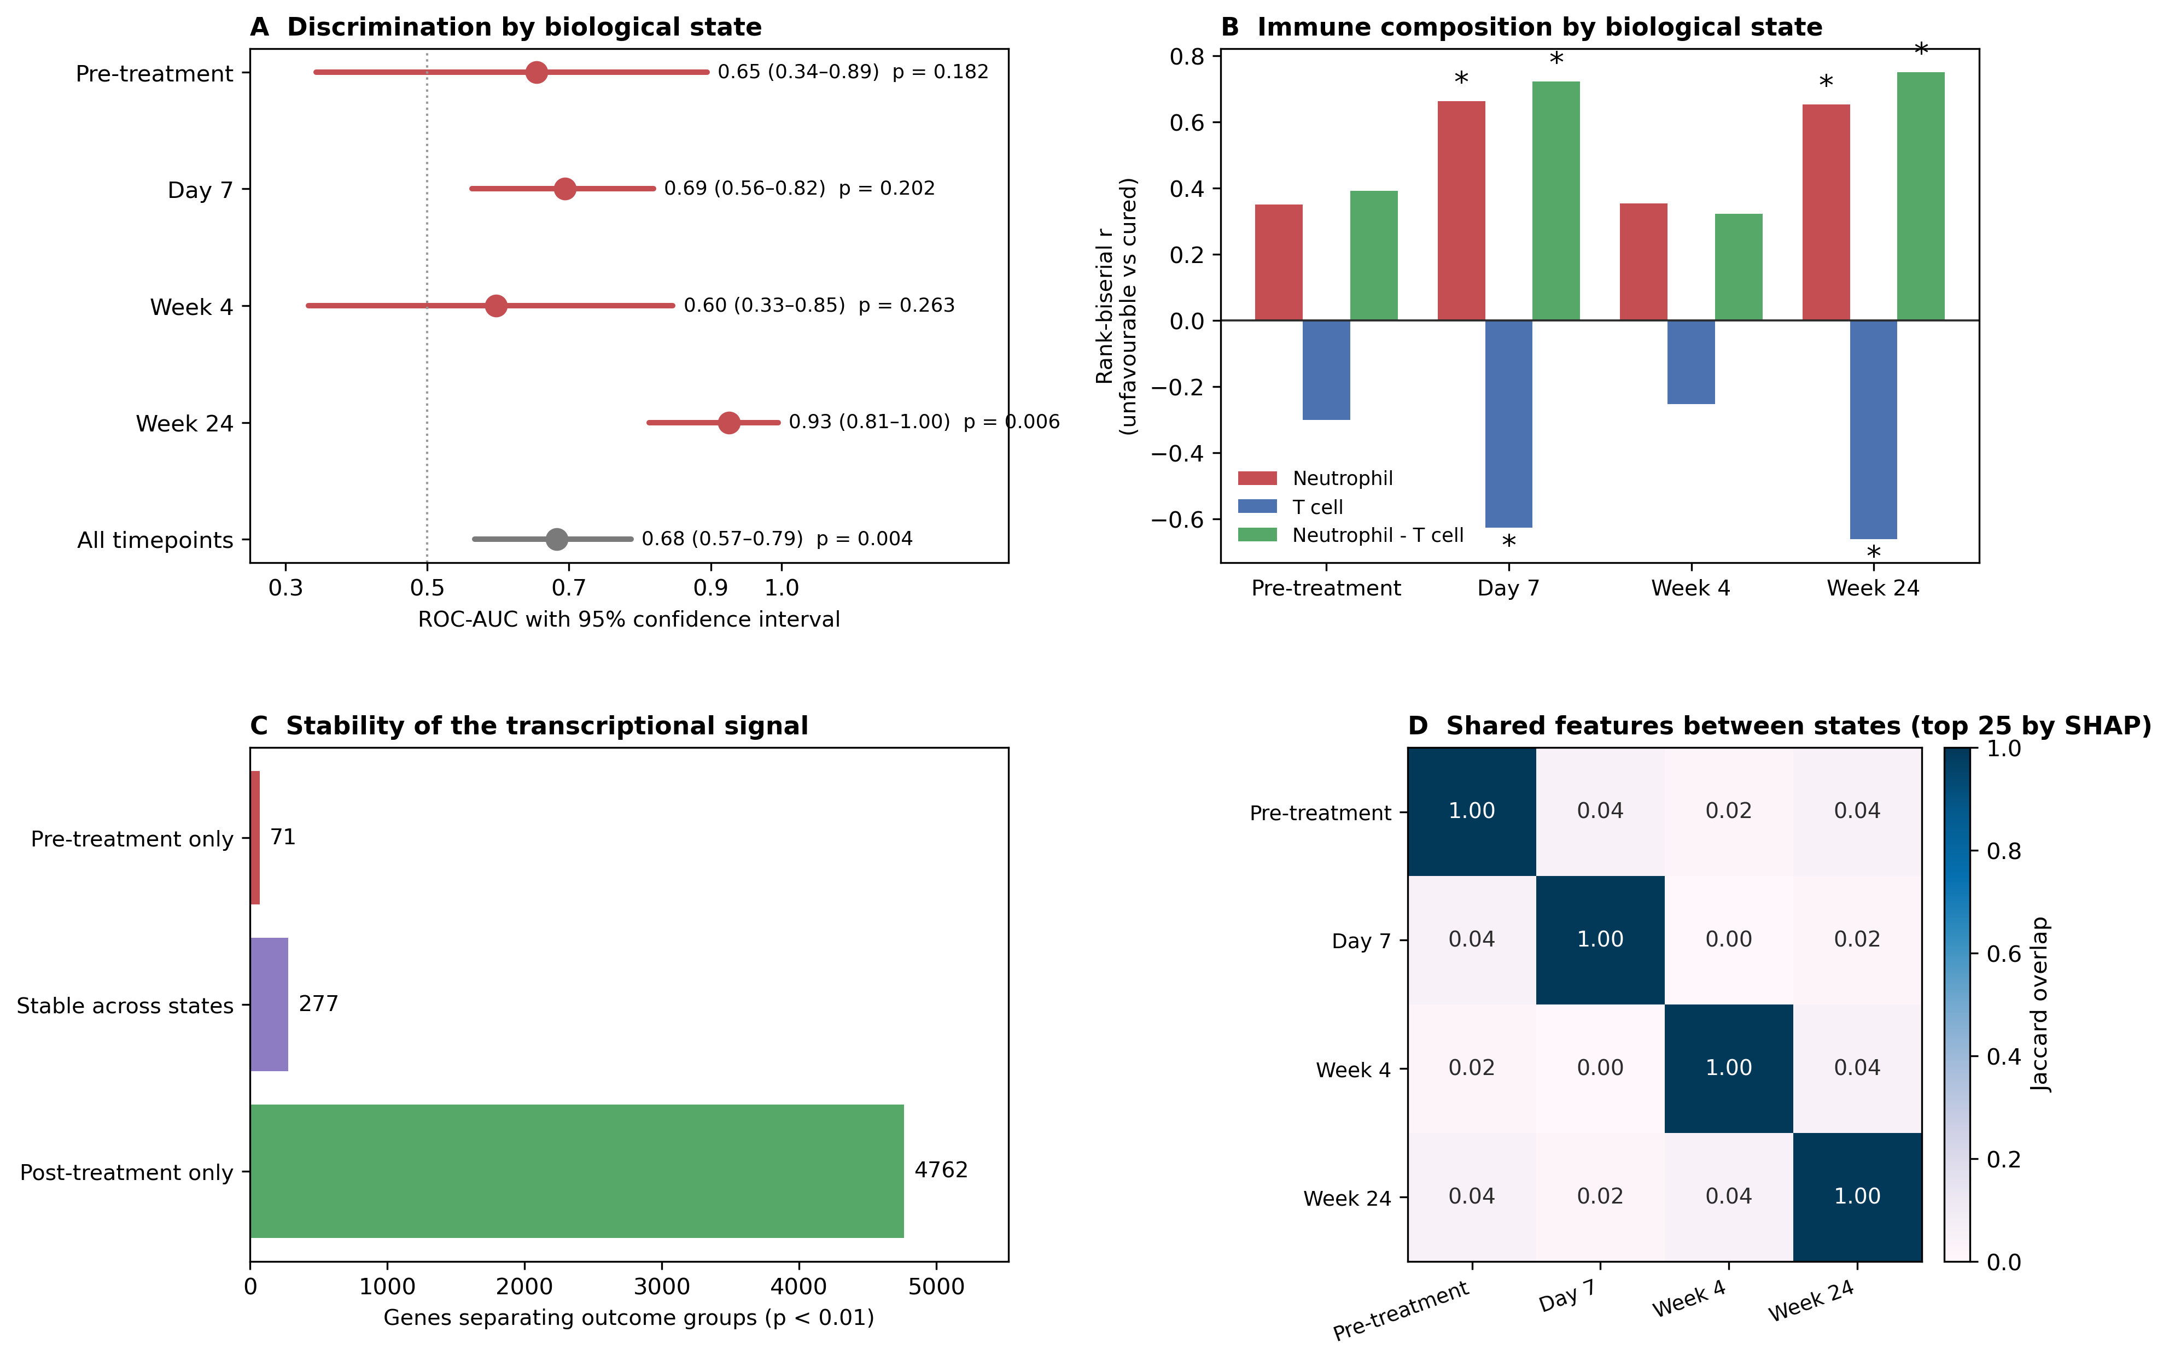
Figure 9. Contrast between biological states. (A) Discrimination with 95% confidence intervals and permutation p-values. (B) Immune-cell effect sizes by arm; asterisks mark p < 0.05. (C) Genes separating outcome groups, partitioned by the states in which they do so. (D) Overlap between the attribution panels of different arms.

3.11 Robustness of the end-of-treatment result
Because the week-24 arm carries the study's only positive finding, it was attacked directly. Library size and gene-detection rate did not differ between outcome groups in any arm (smallest p = 0.14), so the result is not a sequencing-depth artefact. Removing any single patient with an unfavourable outcome and refitting left discrimination between 0.89 and 0.96, so it does not rest on one or two individuals. All three classifiers agreed (0.90 to 0.93). Four arms were tested, and week 24 remains significant after Holm correction across them (adjusted p = 0.024), while no other arm approaches significance.
One check was less reassuring. Bacterial load measured at diagnosis correlated with the week-24 predicted risk (MGIT ρ = -0.31, p = 0.013, XPERT ρ = -0.28, p = 0.011, TGRV ρ = +0.23, p = 0.027), so patients who began treatment with a heavier burden tended to receive higher risk scores six months later. The deposit records no culture result at week 24, so residual bacterial load at the time of sampling cannot be adjusted for. Part of what the week-24 model reads may therefore be persistent mycobacterial burden rather than a host response that is informative independently of it.

3.12 Sex and bacterial load do not explain the association
Unfavourable outcomes were more common in men (5/7 before treatment). Adjusting for inferred sex left the neutrophil association essentially unchanged in every arm: the adjusted odds ratio was 3.6 before treatment (p = 0.070, not significant at this sample size) and 12.3 at week 24 (p = 0.009). Adding bacterial load attenuated the association without removing it; at day 7, where the estimate is best determined, the fully adjusted odds ratio was 4.8 (p = 0.036). Confidence intervals on all of these estimates are wide, as the event counts require.
Sex-linked transcripts were tested directly and showed no differential expression by outcome in any arm (smallest p = 0.29). Where such genes appear high in an unadjusted feature ranking, they reflect the sex composition of a small outcome group rather than a biological signal of treatment failure.

4. Discussion
This study asked when, during tuberculosis treatment, whole blood carries information about the outcome of that treatment. The answer is sharply time-dependent. Through diagnosis, day 7 and week 4 it carries very little: discrimination was modest, confidence intervals included chance, no arm separated from its permutation null, and no gene survived false-discovery correction. At the end of therapy it carries a great deal, with strong discrimination, agreement across three independent classifiers, and thousands of genes differentially expressed at a controlled false-discovery rate.
Reporting both halves matters. A pooled analysis of the same data yields an intermediate figure that describes neither state and would, if presented alone, misrepresent both. Separating the states converts what looks like a single mediocre result into two interpretable ones: an honest negative for pre-treatment stratification, and a robust positive for treatment-response monitoring.
The end-of-treatment result should not be mistaken for prediction. Outcome is ascertained at approximately the same stage at which the week-24 sample is drawn, so the model is reading a concurrent state rather than anticipating a future one. Its value lies elsewhere: it characterises what immunological resolution looks like when treatment has worked, and shows that patients in whom treatment has not worked remain measurably distinct. The day 7 and week 4 arms show that this separation is not simply a function of time on treatment: outcome remained unreadable through the first four weeks and became readable only at the end of therapy. Whatever distinguishes the two groups at week 24 is therefore a property of completed or failed resolution rather than an early response to chemotherapy.
Neutrophils and tuberculosis. Within the discovery cohort, every strand of evidence converges on a neutrophil-high, T-cell-low axis. The machine-learning models, given no information about cell composition, produced predictions correlated with deconvolved neutrophil and T-cell scores. Pathway analysis of the attribution panel recovered the interferon-inducible and myeloid activation programmes rather than neutrophil granule genes as such, which is what the interferon-driven neutrophil signature of active tuberculosis would predict: the cellular shift shows up in composition, and the transcriptional shift shows up in interferon-inducible myeloid genes. The association survived adjustment for sex and attenuated only partially on adjustment for bacterial load. Neutrophils have a recognised dual role in tuberculosis, contributing to early containment but also to tissue damage and to a permissive replicative niche in established disease [8,13], so a neutrophil-dominated state accompanying unfavourable outcome is biologically coherent. Our data are observational and cannot establish whether that state causes failure, follows from higher bacterial burden, or marks disease severity by another route.
What the machine learning added. Very little, and saying so is part of the result. In every arm, a published signature computed without fitting a single parameter matched or exceeded the best of three cross-validated classifiers with access to the whole transcriptome. At week 24 a three-gene score reached a significance level our own models did not. Two things follow. The week-24 finding is unusually well supported, because it is reproduced by external, independently derived instruments rather than only by a model fitted to these data. And the flexible learner conferred no advantage at this sample size, which is what should be expected when seven events must support selection among sixteen thousand features. The useful role for machine learning here was not prediction but attribution: it identified which transcripts carried the signal, and those transcripts then turned out to be the ones the published signatures already contain.
What the end-of-treatment signature is. The genes involved — FCGR1A, FCGR1B, VAMP5, METTL7B and their interferon-inducible neighbours — are the canonical markers of active tuberculosis rather than anything specific to treatment failure. The most parsimonious reading of the week-24 arm is therefore that patients recorded as not cured still have active disease and still carry its signature, while cured patients have resolved it. That is coherent, and it is confirmed by four independent signatures, but it is closer to a restatement of established biology than to a discovery. It also explains the failed replication rather neatly: the replication cohort's unfavourable outcome is relapse after treatment was judged successful, so those patients had by definition resolved their disease at the point of sampling and would not be expected to carry an active-disease signature.
Convergence within a cohort is not generalisation. That distinction is the second main result of this study. Four methods agreeing inside GSE89403 establishes internal coherence, and it is tempting to read such agreement as evidence that a signature is real in a transferable sense. The independent cohort shows why that inference is unsafe: the signature did not transfer, and the cell-composition contrast that is pronounced at week 24 in the discovery data is absent throughout the replication data. Some of this is attributable to the mismatch between cohorts in outcome definition, platform and sampling schedule, and some may be attributable to the small numbers on both sides. We cannot separate those explanations here, and we do not claim the signature would fail in a better-matched cohort. What we can say is that the evidence currently available does not support generalisation, and reporting that is more useful than reporting the internal convergence alone.
Relation to other work. These results are consistent with the difficulty of baseline outcome prediction reported in larger cohorts [7], and complement models built from clinical records and multimodal data [9–11] by adding cellular resolution and an explicit audit of confounding. The design also follows a pattern that has proved useful elsewhere: derive features by machine learning, then verify them against established bioinformatic methods rather than reporting the model output alone [15].

4.1 Limitations
The limitations are substantial and shape every conclusion. Event numbers are small, between six and eight per arm, so confidence intervals are wide and estimates unstable. The discovery cohort is a single study from one setting. The signature did not transfer to the one independent cohort we could identify, and although that cohort is small and differs in outcome definition, platform and sampling schedule, no external support for generalisation is currently available. The design is observational, so no causal claim is possible, and network edges are conditional associations only. Cell composition is inferred computationally and would need flow cytometry or single-cell measurement to confirm. Diabetes status and several other clinically relevant covariates are unrecorded. Week-24 discrimination is concurrent with outcome ascertainment and is not evidence of predictive capability; it is also associated with bacterial load measured at diagnosis, and the deposit carries no week-24 culture result, so residual mycobacterial burden cannot be separated from host response. The within-subject change from diagnosis discriminated far less well than the week-24 state itself, so the separation cannot be attributed specifically to differential resolution under treatment. Nothing reported here is ready for clinical use. The work is exploratory, and what we claim for it is that its negative and positive findings are reported with equal weight: outcome is not readable from pre-treatment blood in this cohort, it is strongly readable at the end of therapy, and neither the pre-treatment nor the on-treatment signature generalised when tested.

Declarations

Ethical approval
This study analysed publicly available, de-identified gene-expression data from the NCBI Gene Expression Omnibus. No new participants were enrolled and no identifiable data were accessed, so formal ethical approval was not required. The source studies obtained the approvals described in their primary publications [12,14].

Consent to participate
Not applicable; no new participants were enrolled.

Consent to publish
Not applicable; no individually identifiable data are presented.

Data availability
GSE89403 and GSE67589 are available from the NCBI Gene Expression Omnibus. Processed matrices and analysis outputs accompany the code release.

Code availability
Analysis code, frozen models and intermediate outputs are available at https://github.com/hssling/TB-Transcriptomics-Project.

Funding
This research received no specific grant from any funding agency in the public, commercial or not-for-profit sectors.

Competing interests
The author declares no competing interests.

Author contributions
Siddalingaiah H S: conceptualisation, methodology, software, formal analysis, investigation, data curation, writing of the original draft, review and editing, and visualisation.

Use of artificial intelligence
Generative artificial-intelligence tools assisted with code development, literature searching and manuscript drafting. All such content was verified and edited by the author, who takes full responsibility for the work.

References
1. World Health Organization. Global tuberculosis report 2024. Geneva: World Health Organization; 2024. ISBN 9789240101531.
2. World Health Organization. Treatment of tuberculosis: guidelines. 4th ed. Geneva: World Health Organization; 2010. ISBN 9789241547833.
3. Berry MPR, Graham CM, McNab FW, et al. An interferon-inducible neutrophil-driven blood transcriptional signature in human tuberculosis. Nature. 2010;466(7309):973–977. doi:10.1038/nature09247.
4. Zak DE, Penn-Nicholson A, Scriba TJ, et al. A blood RNA signature for tuberculosis disease risk: a prospective cohort study. Lancet. 2016;387(10035):2312–2322. doi:10.1016/S0140-6736(15)01316-1.
5. Sweeney TE, Braviak L, Tato CM, Khatri P. Genome-wide expression for diagnosis of pulmonary tuberculosis: a multicohort analysis. Lancet Respir Med. 2016;4(3):213–224. doi:10.1016/S2213-2600(16)00048-5.
6. Singhania A, Verma R, Graham CM, et al. A modular transcriptional signature identifies phenotypic heterogeneity of human tuberculosis infection. Nat Commun. 2018;9(1):2308. doi:10.1038/s41467-018-04579-w.
7. Mendelsohn SC, Andrade BB, Araújo-Pereira M, et al. Blood transcriptomic signatures predict poor treatment outcomes in drug-susceptible pulmonary TB in Brazil. medRxiv [preprint]. 2025 Oct 8. doi:10.1101/2025.10.07.25337480.
8. Lowe DM, Redford PS, Wilkinson RJ, O’Garra A, Martineau AR. Neutrophils in tuberculosis: friend or foe? Trends Immunol. 2012;33(1):14–25. doi:10.1016/j.it.2011.10.003.
9. Sambarey A, Smith K, Chung C, et al. Integrative analysis of multimodal patient data identifies personalized predictors of tuberculosis treatment prognosis. iScience. 2024;27(2):109025. doi:10.1016/j.isci.2024.109025.
10. Vinhaes CL, Fukutani ER, Santana GC, et al. An integrative multi-omics approach to characterize interactions between tuberculosis and diabetes mellitus. iScience. 2024;27(3):109135. doi:10.1016/j.isci.2024.109135.
11. Peng A-Z, Kong X-H, Liu S-T, et al. Explainable machine learning for early predicting treatment failure risk among patients with TB-diabetes comorbidity. Sci Rep. 2024;14(1):6814. doi:10.1038/s41598-024-57446-8.
12. Thompson EG, Du Y, Malherbe ST, et al. Host blood RNA signatures predict the outcome of tuberculosis treatment. Tuberculosis (Edinb). 2017;107:48–58. doi:10.1016/j.tube.2017.08.004.
13. Krug S, Parveen S, Bishai WR. Host-directed therapies: modulating inflammation to treat tuberculosis. Front Immunol. 2021;12:660916. doi:10.3389/fimmu.2021.660916.
14. Cliff JM, Cho J-E, Lee J-S, et al. Excessive cytolytic responses predict tuberculosis relapse after apparently successful treatment. J Infect Dis. 2016;213(3):485–495. doi:10.1093/infdis/jiv447.
15. Naidu A, Lulu SS. Systems and computational analysis of gene expression datasets reveals GRB-2 suppression as an acute immunomodulatory response against enteric infections in endemic settings. Front Immunol. 2024;15:1285785. doi:10.3389/fimmu.2024.1285785.
16. Friedman J, Hastie T, Tibshirani R. Sparse inverse covariance estimation with the graphical lasso. Biostatistics. 2008;9(3):432–441. doi:10.1093/biostatistics/kxm045.
17. Lundberg SM, Lee S-I. A unified approach to interpreting model predictions. Adv Neural Inf Process Syst. 2017;30:4765–4774.
18. Chen T, Guestrin C. XGBoost: a scalable tree boosting system. In: Proceedings of the 22nd ACM SIGKDD International Conference on Knowledge Discovery and Data Mining. 2016:785–794. doi:10.1145/2939672.2939785.
19. Pedregosa F, Varoquaux G, Gramfort A, et al. Scikit-learn: machine learning in Python. J Mach Learn Res. 2011;12:2825–2830.
20. Benjamini Y, Hochberg Y. Controlling the false discovery rate: a practical and powerful approach to multiple testing. J R Stat Soc Series B. 1995;57(1):289–300.

