Supplementary Material
Baseline whole-blood transcriptomic risk stratification for unfavourable tuberculosis treatment outcome (DAI major revision).
Supplementary Methods — class distribution and design
Primary cohort: GSE89403 pre-treatment (diagnosis) whole-blood RNA-seq, one sample per subject. N=90 subjects: 7 unfavourable ('Not Cured') and 83 cured (Definite/Probable/Possible Cure). Prevalence 7.8%. 16,147 gene features. Subject-level design eliminates timepoint leakage.
Supplementary Table S1 — Cross-validated performance (all models, with 95% CI)
Model | ROC-AUC | ROC 95% CI | PR-AUC | Brier
Logistic_L2 | 0.52 | 0.31-0.71 | 0.09 | 0.19
RandomForest | 0.67 | 0.38-0.89 | 0.22 | 0.07
XGBoost | 0.59 | 0.28-0.85 | 0.19 | 0.07

Operating point (Youden, random forest): sensitivity 0.71, specificity 0.73, PPV 0.19, NPV 0.97, F1 0.29, MCC 0.26; confusion TN=61, FP=22, FN=2, TP=5.
Supplementary Table S2 — Full ranked predictor list with HGNC symbols (SHAP)
ensembl | gene_symbol | mean_abs_shap | univariate_F
ENSG00000151952 | TMEM132D | 0.74 | 21.3
ENSG00000134897 | BIVM | 0.703 | 13.6
ENSG00000067365 | METTL22 | 0.532 | 15.1
ENSG00000154309 | DISP1 | 0.521 | 13
ENSG00000143578 | CREB3L4 | 0.484 | 21.1
ENSG00000157873 | TNFRSF14 | 0.438 | 14.1
ENSG00000111962 | UST | 0.407 | 15
ENSG00000127463 | EMC1 | 0.395 | 14.3
ENSG00000138698 | RAP1GDS1 | 0.365 | 15.9
ENSG00000168887 | C2orf68 | 0.291 | 14.3
ENSG00000125740 | FOSB | 0.274 | 13.4
ENSG00000184497 | TMEM255B | 0.251 | 15.7
ENSG00000134909 | ARHGAP32 | 0.117 | 15.4
ENSG00000119737 | GPR75 | 0.0503 | 13.5
ENSG00000135437 | RDH5 | 0.0466 | 13.5
ENSG00000089094 | KDM2B | 0.0424 | 13
ENSG00000205436 | EXOC3L4 | 0.0385 | 13.5
ENSG00000085511 | MAP3K4 | 0.023 | 15.6
ENSG00000122641 | INHBA | 0.0219 | 13.5
ENSG00000170873 | MTSS1 | 0.0198 | 13.1
ENSG00000070159 | PTPN3 | 0.0123 | 13.5
ENSG00000109674 | NEIL3 | 0.00862 | 13.5
ENSG00000004776 | HSPB6 | 0.00654 | 13.5
ENSG00000117597 | UTP25 | 0.00545 | 12.9
ENSG00000084710 | EFR3B | 0 | 13.5
ENSG00000105146 | AURKC | 0 | 13.5
ENSG00000129951 | PLPPR3 | 0 | 13.5
ENSG00000152760 | DYNLT5 | 0 | 13.4
ENSG00000137941 | TTLL7 | 0 | 13.5
ENSG00000144407 | PTH2R | 0 | 13.5
ENSG00000137819 | PAQR5 | 0 | 13.5
ENSG00000165685 | TMEM52B | 0 | 13.5
ENSG00000174697 | LEP | 0 | 13.5
ENSG00000139194 | RBP5 | 0 | 13.5
ENSG00000177181 | RIMKLA | 0 | 13.5
ENSG00000186417 | GLDN | 0 | 13.5
ENSG00000188076 | SCGB1C1 | 0 | 13.5
ENSG00000188761 | BCL2L15 | 0 | 13.5
ENSG00000223779 | ENSG00000223779 | 0 | 13.5
ENSG00000224652 | LINC00885 | 0 | 13.5
ENSG00000226124 | FTCDNL1 | 0 | 13.5
ENSG00000231256 | CFAP97D1 | 0 | 13.5
ENSG00000236882 | LINC01554 | 0 | 13.5
ENSG00000248235 | ENSG00000248235 | 0 | 12.9
ENSG00000251381 | LINC00958 | 0 | 13.5
ENSG00000253394 | LINC00534 | 0 | 13.5
ENSG00000254006 | LOC105375878 | 0 | 13.5
ENSG00000266490 | ENSG00000266490 | 0 | 13.5
ENSG00000271043 | ENSG00000271043 | 0 | 13.5
ENSG00000272787 | ENSG00000272787 | 0 | 13.5

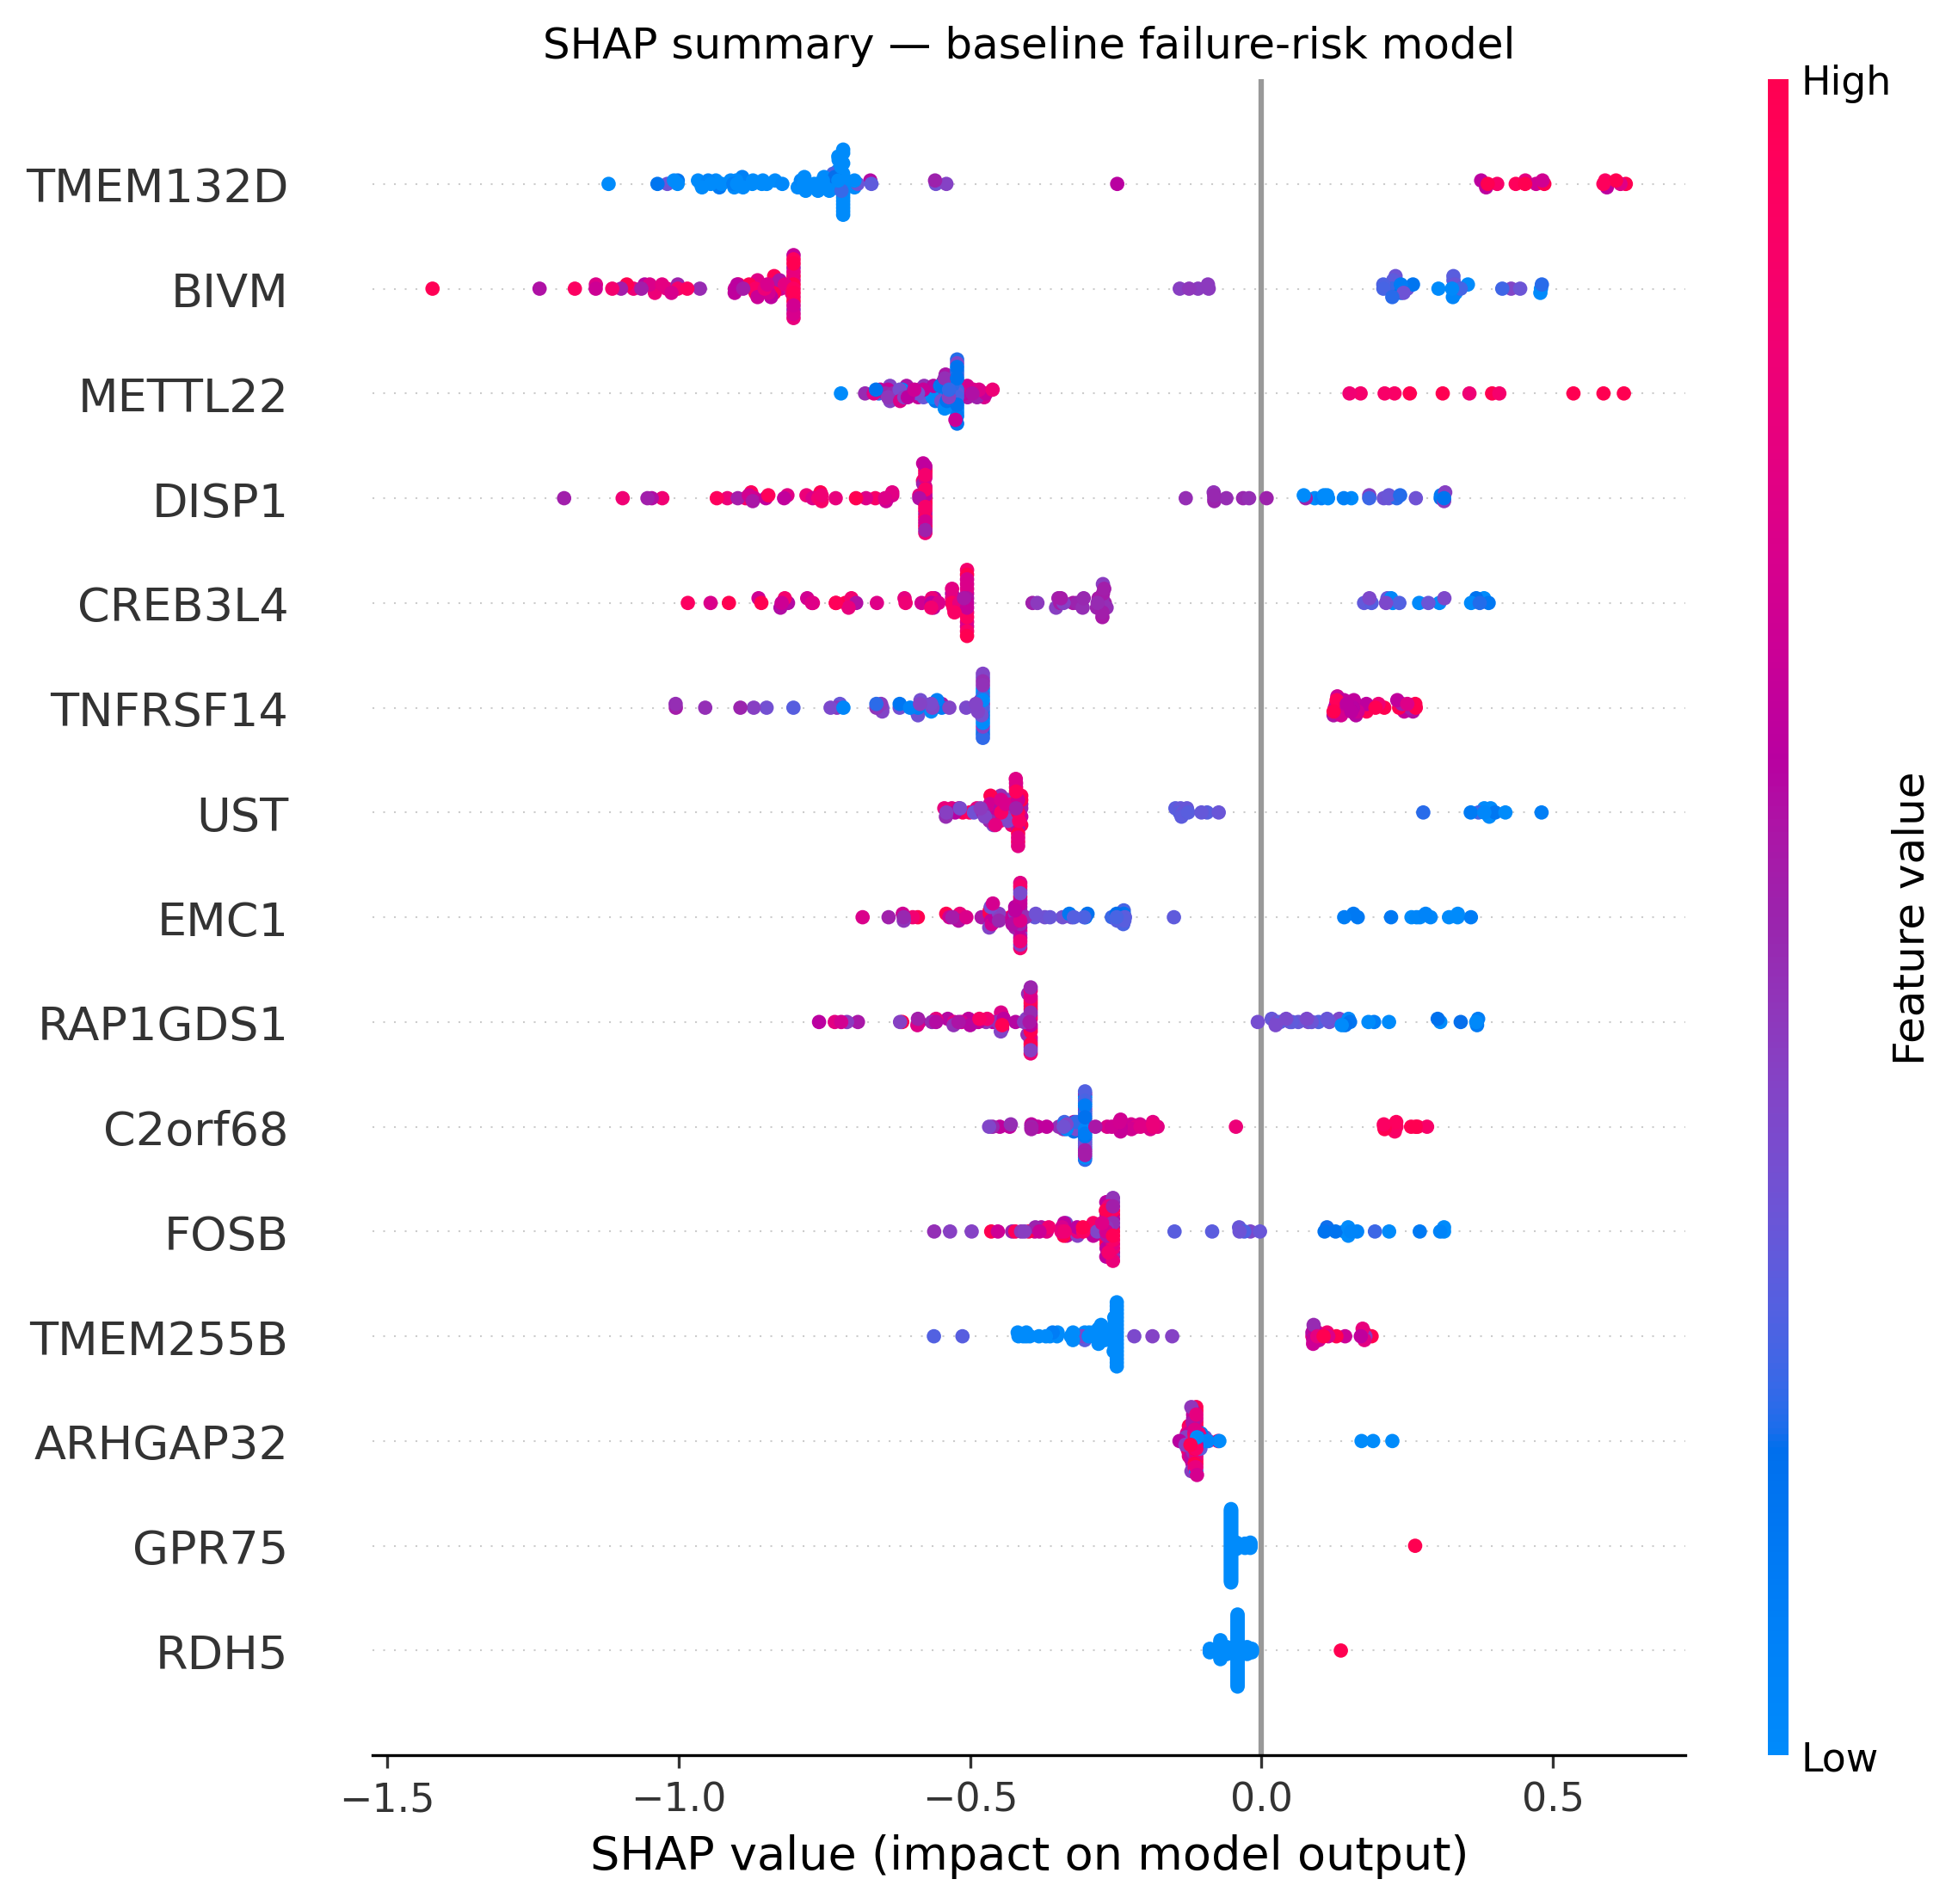
Supplementary Figure S2. SHAP summary (beeswarm) for the baseline gradient-boosting model; top predictors by mean |SHAP|.
Supplementary Table S3 — Differential expression (true log2 fold-change), top 60
gene_symbol | log2FC | p_value | fdr
NADSYN1 | 0.271 | 5.14e-05 | 0.439
CREB3L4 | -0.455 | 8.68e-05 | 0.439
LA16c-380H5.5 | 0.669 | 8.68e-05 | 0.439
SLC9B1 | -1.1 | 0.000128 | 0.439
METTL22 | 0.349 | 0.000203 | 0.439
ALOX5AP | 0.669 | 0.000242 | 0.439
EMC1 | -0.291 | 0.000242 | 0.439
RAP1GDS1 | -0.245 | 0.000288 | 0.439
DUSP18 | 0.449 | 0.000313 | 0.439
SEPT11 | -0.359 | 0.00034 | 0.439
MTG2 | 0.322 | 0.000369 | 0.439
INO80 | -0.205 | 0.000369 | 0.439
ALMS1 | -0.348 | 0.000401 | 0.439
DISP1 | -0.412 | 0.000434 | 0.439
AGPAT9 | 0.546 | 0.00047 | 0.439
USP30 | 0.269 | 0.000508 | 0.439
NRN1 | 1.78 | 0.000508 | 0.439
EPRS | -0.26 | 0.000549 | 0.439
DHX57 | -0.296 | 0.000593 | 0.439
CLDN9 | 0.62 | 0.000593 | 0.439
FKBP1C | 0.639 | 0.00069 | 0.439
C2orf68 | 0.288 | 0.00069 | 0.439
INTS7 | -0.234 | 0.00069 | 0.439
UST | -0.587 | 0.000743 | 0.439
BIVM | -0.594 | 0.000743 | 0.439
BRF1 | -0.305 | 0.000743 | 0.439
BAZ1B | -0.246 | 0.00086 | 0.439
MARVELD2 | -0.74 | 0.00086 | 0.439
TNFRSF14 | 0.311 | 0.00086 | 0.439
KIAA1467 | -0.325 | 0.00086 | 0.439
CKAP5 | -0.319 | 0.000992 | 0.439
STT3A | -0.279 | 0.000992 | 0.439
NUP155 | -0.254 | 0.000992 | 0.439
PCCA | -0.35 | 0.000992 | 0.439
MAP3K4 | -0.327 | 0.00106 | 0.439
HEATR1 | -0.297 | 0.00106 | 0.439
DDI2 | -0.215 | 0.00106 | 0.439
NUP133 | -0.195 | 0.00106 | 0.439
AOC2 | 0.64 | 0.00106 | 0.439
FOSB | -0.752 | 0.00114 | 0.439
PVALB | 1.73 | 0.00114 | 0.439
FADD | 0.35 | 0.00114 | 0.439
GPHN | -0.338 | 0.00122 | 0.449
CCDC28A | 0.271 | 0.00122 | 0.449
HYOU1 | -0.364 | 0.00131 | 0.45
AP4B1 | -0.196 | 0.00131 | 0.45
SDHB | 0.27 | 0.00131 | 0.45
MSH6 | -0.178 | 0.0014 | 0.454
NANOS1 | -0.279 | 0.0014 | 0.454
SEC31A | -0.235 | 0.0015 | 0.454
ATP1A1 | -0.242 | 0.0015 | 0.454
ZNF552 | 0.442 | 0.0015 | 0.454
EXOC6B | -0.254 | 0.0016 | 0.454
PARP1 | -0.329 | 0.0016 | 0.454
ZMYM4 | -0.228 | 0.0016 | 0.454
DAAM1 | -0.429 | 0.00171 | 0.454
NAB2 | -0.332 | 0.00171 | 0.454
ABCA7 | 0.522 | 0.00171 | 0.454
RN7SKP26 | 1.12 | 0.00183 | 0.454
CSAD | 0.376 | 0.00183 | 0.454

No gene survived FDR<0.05 at baseline (n=7 events); table is hypothesis-generating. ALOX5AP (neutrophil leukotriene gene) is up-regulated in failure.
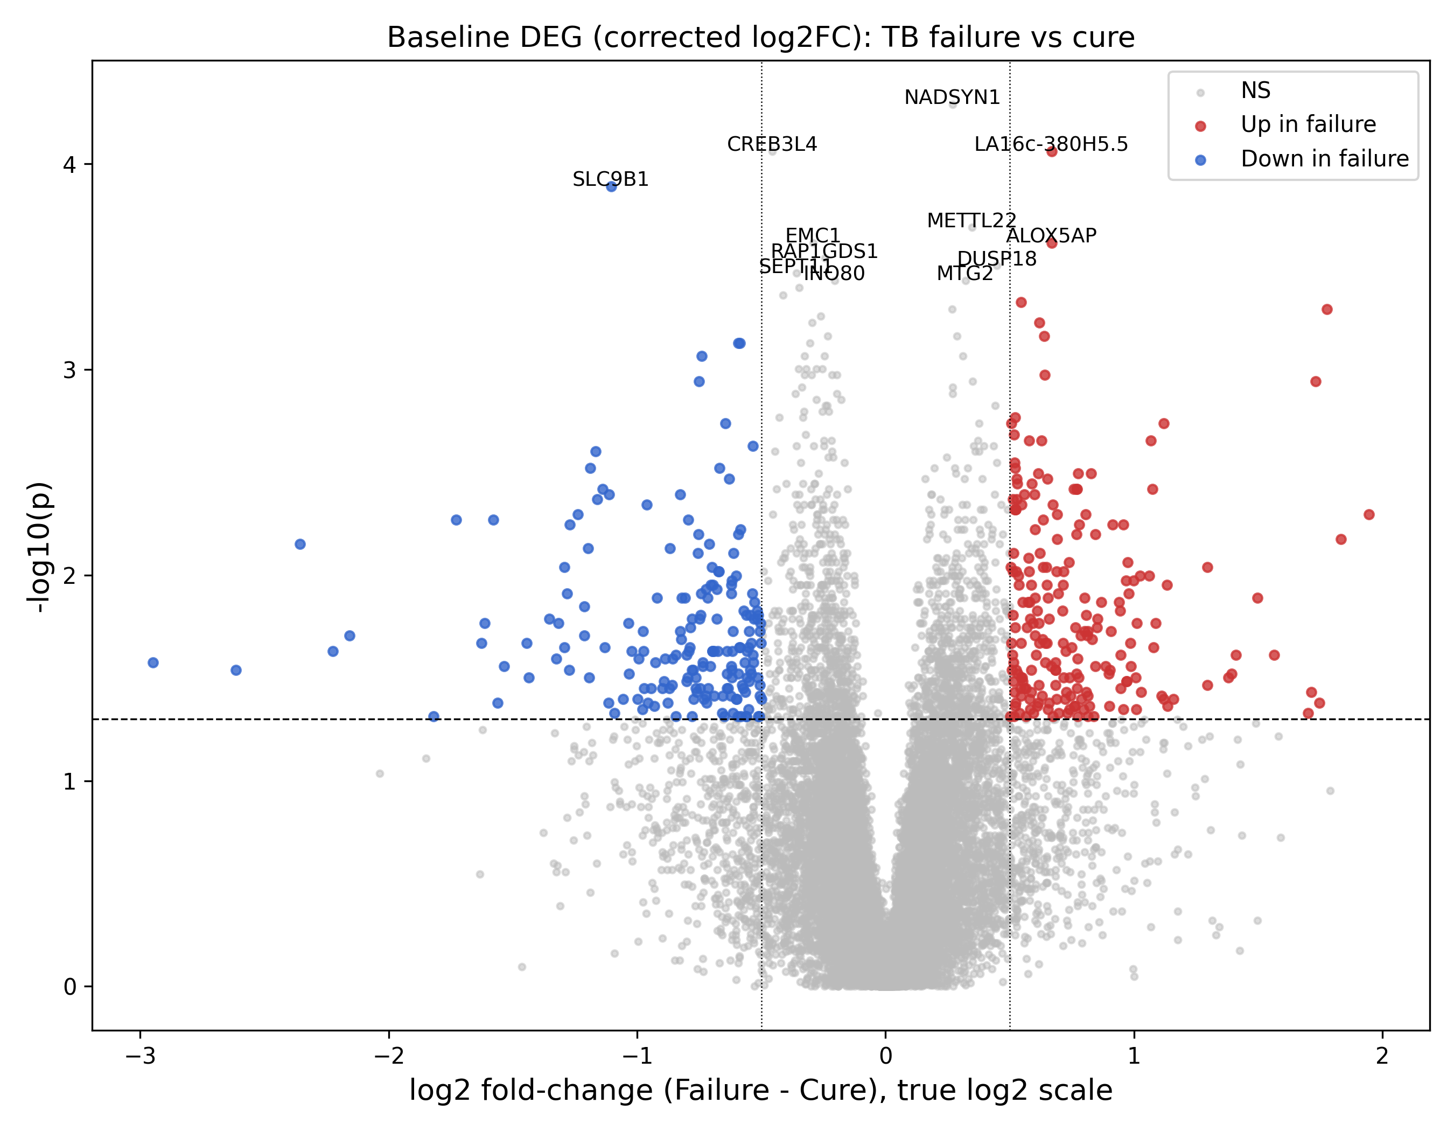
Supplementary Figure S1. Volcano plot of baseline differential expression (true log2 fold-change, failure vs cure). Dashed line p=0.05.
Supplementary Table S4 — Immune deconvolution: effect sizes (rank-biserial)
Unnamed: 0 | median_failure | median_cure | mannwhitney_p | rank_biserial_r
Neutrophil | 0.358 | -0.118 | 0.0565 | -0.435
T_cell | -0.0639 | -0.0369 | 0.469 | 0.17
Monocyte | 0.375 | 0.122 | 0.459 | -0.174
B_cell | -0.137 | 0.259 | 0.122 | 0.356
NK_cell | 0.0863 | 0.0826 | 0.366 | 0.212
NLR_score | 0.367 | -0.00152 | 0.13 | -0.349

Concordance (deconvolution vs model probability): neutrophil Spearman rho=0.66 (p~1e-12); T-cell rho=-0.66.
Supplementary Table S5 — External-cohort search and exclusion rationale
cohort | n | outcome_labels | role | suitable_external
GSE89403 (Catalysis, Thompson 2017) | 254 (DX baseline 90) | Yes (Cure/Not-Cured) | DISCOVERY cohort (this study) | No - discovery
GSE193979 (TANDEM, SA+Indonesia 2022) | ~175 samples / 63 patients | Good/Poor (paper only) | Closest treatment-outcome RNA-seq cohort | No - per-patient outcome NOT in GEO; count matrix keyed by internal RSEQ IDs with no public bridge to GSM/patient metadata
GSE107994 (Leicester, Singhania 2018) | 175 | Progression (ATB/LTBI), not treatment outcome | TB progression | No - outcome mismatch (progression, not treatment failure)
GSE79362 (ACS, Zak 2016) | ~355 | Progression to active TB | TB progression | No - outcome mismatch
GSE107991 (Berry/London) | 54 | ATB vs LTBI | TB status | No - no treatment-outcome labels

Label-free portability (GSE193979, n=148): neutrophil vs T-cell score Spearman rho=-0.41 (p~3e-7) — expected anti-structure reproduced.
Supplementary Table S6 — Benchmark vs prior TB treatment-outcome / ML studies
Study | Data | N / events | Approach | Treatment-failure AUC | Contribution
This study (baseline, leakage-free) | Whole-blood RNA-seq (GSE89403), baseline DX | 90 / 7 | Marker deconvolution + ML + GGM network (associative) | 0.68 (95% CI 0.38-0.89) | Cellular-resolved, sex-confounder-audited baseline risk signal
Thompson 2017 (PMID 29050771) | Whole-blood RNA-seq (Catalysis = our source) | ~70 / ~ | Co-expression modules / RT-PCR signature | Baseline failure signature derived; modest | Original treatment-monitoring signatures
Vianello/TANDEM 2022 (PMID 35precip; GSE193979) | Whole-blood RNA-seq SA+Indonesia | 63 / 14 poor | 8- & 22-gene signatures | 0.815 (diagnosis), 0.834 (week 2) | Good vs poor outcome at diagnosis
RePORT-Brazil 2025 (PMID 41282706) | Whole-blood transcriptomic signatures | Large cohort | Curated signatures, multi-timepoint | <0.70 for failure (death/recurrence higher) | Shows baseline FAILURE prediction is hard field-wide
Sambarey 2024 (PMID 38357663) | Multimodal clinical/radiological/microbiological | 5060 / - | Random forest, 203 features | ~0.83 accuracy | Personalized multimodal prognosis (not transcriptomic-cellular)
Vinhaes 2024 (PMID 38380250) | Multi-omics (cytokines, expression, eicosanoids) | 76 / - | ML on multi-platform TB-DM | n/a (characterization) | Multi-omic TB-diabetes interaction
Peng 2024 (PMID 38514736) | Electronic medical records (TB-DM) | 429 / - | XGBoost + SHAP + Boruta | 0.93 | Explainable EMR-based failure prediction (not omics)

Supplementary Table S7 — Confounder-adjusted logistic regression
Unnamed: 0 | OR | CI_low | CI_high | p | n
neutrophil_only:neutrophil | 4.38 | 0.998 | 19.2 | 0.0503 | 90
neutrophil_adj_sex:neutrophil | 4.57 | 1.03 | 20.4 | 0.0461 | 90
neutrophil_adj_sex:male | 1.77 | 0.307 | 10.2 | 0.524 | 90
neutrophil_adj_sex_load:neutrophil | 4.5 | 0.752 | 27 | 0.0995 | 80
neutrophil_adj_sex_load:male | 2.33 | 0.316 | 17.2 | 0.406 | 80
neutrophil_adj_sex_load:load | 0.105 | 0.0106 | 1.05 | 0.055 | 80
tcell_adj_sex_load:tcell | 0.586 | 0.169 | 2.04 | 0.401 | 80
tcell_adj_sex_load:male | 1.64 | 0.249 | 10.7 | 0.608 | 80
tcell_adj_sex_load:load | 0.101 | 0.0111 | 0.918 | 0.0417 | 80

Supplementary Table S8 — Cell-type specificity of signature genes (HPA atlas)
Neutrophil-signature genes max-expressed in neutrophils: 10/12; T-cell-signature genes in T cells: 6/10. Reference: Human Protein Atlas blood atlas (granulocyte-containing).
Supplementary Table S9 — Independent robustness recheck
Leave-one-out CV ROC-AUC = 0.64 (vs repeated-KFold ~0.67). Permutation null (1000 label shuffles): observed AUC 0.69 vs null mean 0.48, permutation p = 0.110. Neutrophil rank-biserial r=-0.44 (95% CI -0.80..0.05), MWU p=0.056.
Supplementary Table S10 — Pathway enrichment of top nominal DEGs (exploratory)
Gene_set | Term | P-value | Adjusted P-value
KEGG_2021_Human | RNA polymerase | 0.000575 | 0.106
GO_Biological_Process_2021 | regulation of gene silencing by miRNA (GO:0060964) | 0.00019 | 0.222
GO_Biological_Process_2021 | regulation of gene silencing by RNA (GO:0060966) | 0.000613 | 0.222
GO_Biological_Process_2021 | import into nucleus (GO:0051170) | 0.000406 | 0.222
GO_Biological_Process_2021 | regulation of posttranscriptional gene silencing (GO:0060147) | 0.000613 | 0.222
MSigDB_Hallmark_2020 | Unfolded Protein Response | 0.0138 | 0.297
MSigDB_Hallmark_2020 | Protein Secretion | 0.00713 | 0.297
GO_Biological_Process_2021 | amyloid-beta metabolic process (GO:0050435) | 0.00115 | 0.334
GO_Biological_Process_2021 | response to UV (GO:0009411) | 0.00153 | 0.346
GO_Biological_Process_2021 | transcription-dependent tethering of RNA polymerase II gene DNA at nuclear periphery (GO:0000972) | 0.00226 | 0.346
GO_Biological_Process_2021 | cellular response to cold (GO:0070417) | 0.00226 | 0.346
GO_Biological_Process_2021 | protein import into nucleus (GO:0006606) | 0.00263 | 0.346
GO_Biological_Process_2021 | establishment of protein localization to organelle (GO:0072594) | 0.00263 | 0.346
GO_Biological_Process_2021 | protein localization to nucleus (GO:0034504) | 0.00216 | 0.346
GO_Biological_Process_2021 | positive regulation of adaptive immune response (GO:0002821) | 0.00415 | 0.378
GO_Biological_Process_2021 | osteoblast development (GO:0002076) | 0.00415 | 0.378
GO_Biological_Process_2021 | negative regulation of alpha-beta T cell proliferation (GO:0046642) | 0.00655 | 0.378
GO_Biological_Process_2021 | protein import (GO:0017038) | 0.00519 | 0.378
GO_Biological_Process_2021 | ERAD pathway (GO:0036503) | 0.00471 | 0.378
GO_Biological_Process_2021 | positive regulation of interferon-gamma production (GO:0032729) | 0.0056 | 0.378

No term survived FDR<0.05 (minimum adjusted p≈0.11), consistent with the underpowered DEG; weak exploratory signals included adaptive-immune-response and protein-secretion/unfolded-protein-response terms.
Supplementary Table S11 — Conditional-dependency network hub genes (degree)
gene | degree
ALMS1 | 4
ALOX5AP | 3
EMC1 | 3
MTG2 | 3
CLDN9 | 3
LA16c-380H5.5 | 3
BRF1 | 3
INO80 | 2
SEPT11 | 2
EPRS | 2
AGPAT9 | 2
BAZ1B | 2
DHX57 | 2
UST | 1
NADSYN1 | 1
RAP1GDS1 | 1
METTL22 | 1
CREB3L4 | 1
DISP1 | 1
INTS7 | 1
C2orf68 | 1
DUSP18 | 0
USP30 | 0
NRN1 | 0
FKBP1C | 0
BIVM | 0

Undirected Gaussian graphical model on top baseline failure-associated genes; outcome not included as a node (R2 comment 8).

