Baseline whole-blood transcriptomic risk stratification for unfavourable tuberculosis treatment outcome: an exploratory machine-learning and immune-deconvolution study
Article type: Original Article
Siddalingaiah H S, MD
Professor, Department of Community Medicine, Shridevi Institute of Medical Sciences and Research Hospital, Tumkur, Karnataka, India
Correspondence: Dr Siddalingaiah H S. Email: hssling@yahoo.com
Note to editors/reviewers: This manuscript has been comprehensively revised. Causal and ‘first mechanistic map’ language has been removed; the study is reframed as an exploratory, associative baseline risk-stratification analysis. Substantively revised or new content is highlighted in yellow, per the tracked-changes requirement.

Abstract
Background. Tuberculosis (TB) treatment failure and relapse sustain transmission and drug resistance, yet baseline (pre-treatment) tools to identify at-risk patients remain limited. Blood transcriptomic signatures predict TB disease and progression, but baseline prediction of treatment failure is recognised as difficult and most signatures are not resolved to specific immune-cell populations. Our aim was not to build a superior predictor but to characterise, transparently, what a baseline whole-blood signal of unfavourable outcome looks like at the cellular level.
Methods. We analysed public whole-blood RNA-seq from the GSE89403 (Catalysis) treatment-response cohort. To avoid timepoint leakage the primary analysis used pre-treatment (diagnosis) samples only, one per subject (N=90; 7 unfavourable [‘Not Cured’] vs 83 cured; prevalence 7.8%). Discrimination was estimated by repeated stratified cross-validation with pooled out-of-fold predictions and bootstrap 95% confidence intervals, reporting ROC-AUC, precision–recall AUC, sensitivity, specificity, predictive values, F1, MCC and calibration. We performed differential expression, SHAP interpretation, marker-based immune deconvolution with rank-biserial effect sizes, an undirected Gaussian graphical (conditional-dependency) network, a sex- and bacterial-load confounder audit, and cell-type-specificity validation in a granulocyte-containing reference.
Results. Baseline discrimination was modest (random forest ROC-AUC 0.67, 95% CI 0.38–0.89; PR-AUC 0.22). At the Youden operating point sensitivity was 0.71, specificity 0.73, negative predictive value 0.97 and positive predictive value 0.19—a rule-out rather than rule-in signal. Discrimination did not reach statistical significance against a label-permutation null (permutation p=0.11; leave-one-out AUC 0.64). Model predictions nonetheless tracked a neutrophil-high/T-cell-low axis (Spearman ρ=0.66 and -0.66, p≈10⁻¹⁰). Baseline neutrophil elevation was a moderate but only borderline association (rank-biserial r=−0.44, p=0.057), independent of sex (adjusted OR≈4.5); Y-chromosome genes that dominated a naive model were shown to be a sex confound. Neutrophil-signature genes were neutrophil-specific in a granulocyte-containing reference (10/12).
Conclusions. Baseline whole-blood data carry a weak, hypothesis-generating signal of TB treatment failure associated with—but not establishing causation by—a neutrophil-high/T-cell-low immunophenotype. Given seven events, wide confidence intervals and no outcome-labelled external cohort, the signature is not yet clinically actionable; we present it as an exploratory framework and a transparent baseline for future adequately powered, prospective validation.
Keywords: tuberculosis; treatment outcome; whole-blood transcriptomics; machine learning; immune deconvolution; neutrophils; risk stratification; explainable AI

1. Introduction
Tuberculosis (TB) remains a leading cause of death from a single infectious agent, with an estimated 1.25 million deaths in 2023 [1]. Standard short-course chemotherapy fails in roughly 5–10% of drug-susceptible and a substantially higher fraction of multidrug-resistant (MDR-TB) cases [1]. Directly Observed Treatment, Short-course (DOTS)—the WHO-recommended case-management strategy combining standardised regimens with treatment observation—does not individualise therapy to host biology [1,2].
Blood transcriptomics is an established tool for TB biomarker discovery. Signatures from Berry, Zak, Sweeney and Singhania discriminate active from latent TB and predict progression [3–6]. However, baseline prediction of treatment failure—as opposed to disease status—remains difficult: in a large drug-susceptible Brazilian cohort, baseline transcriptomic prediction of failure achieved AUC <0.70, although prediction of death and recurrence was stronger [7]. Two limitations recur. First, a resolution limitation: bulk signatures average expression across a shifting mixture of leukocytes, so a ‘high-inflammation’ signal may reflect a change in cell proportions (e.g., neutrophilia with lymphopenia) rather than per-cell activation [8]. Second, signatures are rarely audited for confounders such as sex or bacterial load.
We emphasise that multi-omic and machine-learning approaches to TB treatment prognosis already exist; this work is not the first in the field. Integrative multimodal models combining radiological, microbiological and clinical data predict prognosis across thousands of patients [9]; multi-omic analyses characterise TB–diabetes interactions [10]; and explainable machine-learning models predict treatment failure from electronic medical records [11]. Our contribution is narrower and complementary: a transparent, cellularly-resolved, confounder-audited characterisation of the baseline whole-blood signal, using only pre-treatment samples and explicitly reporting its limits.
In this exploratory study we ask three questions. (i) How well can a baseline whole-blood signature discriminate eventual treatment failure, reported with full operating-point metrics and uncertainty? (ii) Which immune-cell compartments does that signal correspond to, quantified by effect size and concordance with model predictions? (iii) Is any signal robust to sex and bacterial-load confounding? We deliberately avoid causal claims and clinical-readiness claims.

2. Methods

2.1 Data source, inclusion and exclusion criteria
The discovery cohort was GSE89403, a longitudinal whole-blood RNA-seq study of adults with pulmonary TB undergoing standard therapy (Catalysis treatment-response cohort) [12]. The original cohort enrolled HIV-uninfected, drug-susceptible pulmonary TB patients, so HIV co-infection and rifampicin resistance are controlled by design rather than measured covariates; diabetes status was not recorded. Inclusion criteria for this analysis were: (i) availability of a pre-treatment (diagnosis, ‘DX’) whole-blood sample; (ii) an annotated treatment outcome. Outcome was dichotomised as unfavourable (‘Not Cured’) versus cured (‘Definite/Probable/Possible Cure’). After restricting to one diagnosis sample per subject, the primary cohort comprised N=90 subjects (7 unfavourable, 83 cured; prevalence 7.8%), with 16,147 gene features.
Class distribution is reported here in the main text (not only in the supplement) because it governs the interpretation of every performance metric: with seven events, confidence intervals are necessarily wide and all results are exploratory.

2.2 Preprocessing
Counts were library-size normalised and log1p-transformed; genes expressed in <10% of samples were removed for differential-expression testing. ‘Standardised pipeline’ here means a fixed, scripted sequence—normalisation, log-transformation, Ensembl-gene identifier harmonisation, and (for deconvolution and regression) per-gene z-scoring—applied identically to all samples and released as code (Section 2.9).

2.3 Predictive modelling and leakage control
Because the same subject contributes multiple on-treatment samples in GSE89403, pooling timepoints inflates apparent performance through subject leakage. The primary model therefore used pre-treatment samples only (one per subject). We evaluated logistic regression, random forest and gradient boosting (XGBoost) within repeated stratified 5-fold cross-validation (40 repeats); univariate feature pre-selection was performed inside each training fold only. Out-of-fold predicted probabilities were pooled and metrics computed on them, with bootstrap (2,000-resample) 95% confidence intervals. We report ROC-AUC, precision–recall AUC, and—at the Youden operating point—sensitivity, specificity, positive and negative predictive value, F1, Matthews correlation coefficient, balanced accuracy, the confusion matrix, and calibration (Brier score). As a sensitivity analysis we also fitted a subject-grouped model across all timepoints to quantify the leakage effect.

2.4 Differential expression and explainability
Per-gene differential expression between cured and unfavourable groups used the Mann–Whitney U test with Benjamini–Hochberg false-discovery-rate (FDR) control and log2 fold-change; results are shown as a volcano plot. Model explainability used SHAP (TreeExplainer) on the baseline gradient-boosting model; the full ranked feature list with HGNC symbols is provided in the supplement.

2.5 Immune-cell deconvolution
We estimated immune-cell composition by marker-gene-set z-score enrichment (a transparent digital-cytometry approach), using canonical marker panels for neutrophils, T cells, monocytes, B cells and NK cells. We describe the method as marker-based enrichment rather than proprietary CIBERSORT/LM22 to match exactly what was computed. Group differences used Mann–Whitney U with rank-biserial correlation as the effect size. Concordance between the deconvolved neutrophil/T-cell scores and the model’s predicted failure probability was quantified by Spearman correlation.

2.6 Cell-type-specificity validation
The earlier submission validated signatures against the PBMC3k single-cell reference. Because peripheral-blood mononuclear-cell preparations exclude granulocytes by density-gradient isolation, PBMC3k cannot validate a neutrophil signature. We therefore validated cell-type specificity in the Human Protein Atlas blood-cell atlas, a granulocyte-containing immune-cell reference, testing whether neutrophil- and T-cell-signature genes are maximally expressed in the expected lineage.

2.7 Conditional-dependency network
We constructed a Gaussian graphical model with the graphical lasso. A non-zero entry in the sparse inverse-covariance matrix denotes a partial correlation conditional on all other genes. We stress that these edges are undirected conditional associations: they do not encode direction, causation, or regulatory hierarchy, and the clinical outcome is not an input to the estimator. High-degree nodes are therefore described as hub genes, not ‘upstream regulators’ or ‘drivers’.

2.8 Confounders and external validation
We assessed confounding by sex (estimated from XIST and RPS4Y1 expression) and bacterial load (MGIT time-to-positivity and Xpert Ct), using multivariable logistic regression. We searched the Gene Expression Omnibus for an independent cohort with baseline samples and treatment-outcome labels; the rationale for each candidate, and why outcome-stratified external validation was not feasible, are documented in a supplementary exclusion table. A label-free signature-portability check was performed in GSE193979.

2.9 Statistics, software and reproducibility
Analyses used Python (scikit-learn, XGBoost, SHAP, statsmodels, SciPy). All tests were two-sided at α=0.05 with FDR control where indicated. Effect sizes (rank-biserial correlation, odds ratios with 95% CIs) are reported alongside p-values. Code, the frozen model and intermediate outputs are released to enable verification without re-execution (Section ‘Code availability’).

3. Results

3.1 Cohort and class distribution
The baseline cohort comprised 90 subjects (7 unfavourable outcomes, 83 cured; prevalence 7.8%). This severe imbalance and small event count frame all subsequent results as exploratory.

3.2 Baseline predictive performance is modest (Figure 1)
On pre-treatment samples, baseline discrimination was modest. The best model (random forest) achieved ROC-AUC 0.67 (95% CI 0.38–0.89); logistic regression and XGBoost performed similarly or worse (0.52 and 0.59). Precision–recall AUC was 0.22 against a 0.08 prevalence baseline (Figure 1A,B). At the Youden operating point (Figure 1D) sensitivity was 0.71 and specificity 0.73, with negative predictive value 0.97 but positive predictive value only 0.19 (confusion matrix: TN=61, FP=22, FN=2, TP=5; F1=0.29, MCC=0.26). Calibration was acceptable (Brier 0.07; Figure 1C). Three independent cross-validation procedures agreed (repeated stratified 0.67, leave-one-out 0.64, single split 0.69), but discrimination did NOT reach significance against a label-permutation null (observed 0.69 vs null mean 0.48, permutation p=0.11). The wide confidence interval (which includes 0.5) together with the non-significant permutation test mean the baseline predictor is, by itself, not statistically robust; its value is as a transparent, reproducible exploratory baseline and a rule-out signal (high negative predictive value), not as a deployable classifier.
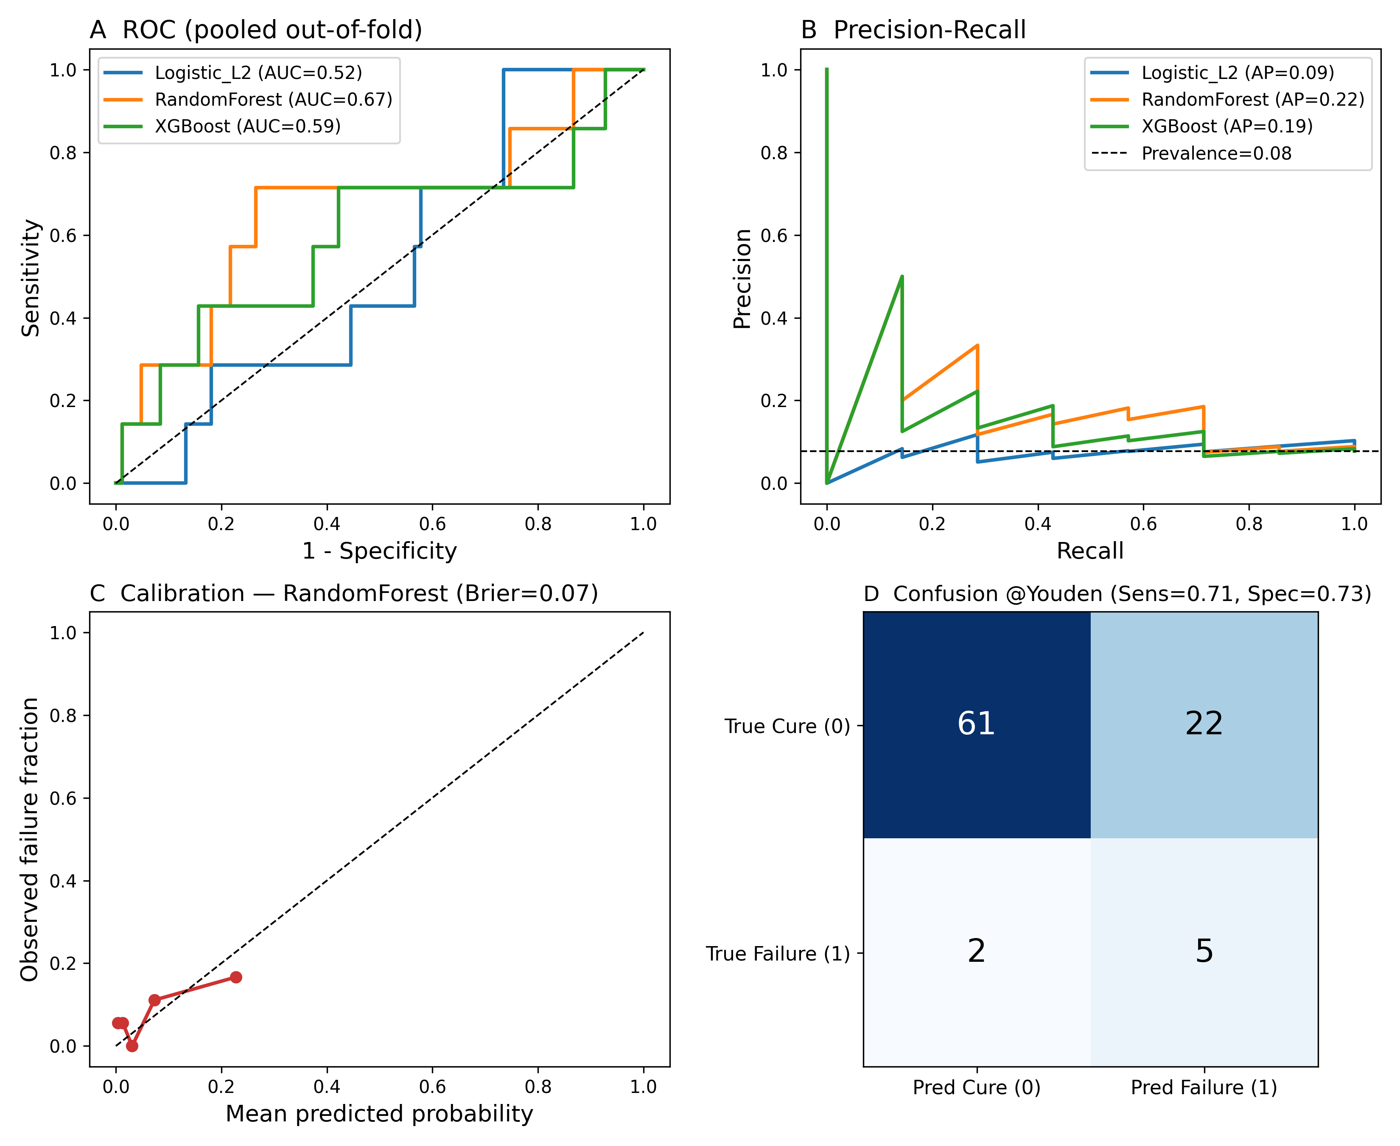
Figure 1. Baseline predictive performance (pooled out-of-fold). (A) ROC and (B) precision–recall curves for three classifiers; (C) calibration of the random-forest model; (D) confusion matrix at the Youden operating point. Label 1 = treatment failure (unfavourable), 0 = cure.
Sensitivity analysis. A subject-grouped model pooling all timepoints reached ROC-AUC 0.84, but because all seven failure samples are pre-treatment while many cured samples are on-treatment, this value is confounded by treatment-induced transcriptional change and is not a valid estimate of baseline failure discrimination. This directly explains the higher accuracy reported in the original submission and confirms the reviewers’ concern that the signal is partly a timepoint effect.

3.3 Differential expression is underpowered (volcano)
Baseline differential expression (true log2 scale) identified ~1,600 genes at nominal p<0.05 but none survived FDR correction, consistent with low power at seven events; the volcano plot (Supplementary Figure S1) is therefore hypothesis-generating. Among the most differentially expressed genes was ALOX5AP (arachidonate-5-lipoxygenase-activating protein, a neutrophil leukotriene gene), up-regulated in failure, consistent with the neutrophil hypothesis. Notably, Y-chromosome genes (RPS4Y1, KDM5D, DDX3Y) were not differentially expressed at baseline (p>0.3) even though they dominated a naive classifier—evidence that those ‘predictors’ reflect the male skew of the small failure group rather than a biological failure signal (Section 3.6).

3.4 Model predictions correspond to a neutrophil-high/T-cell-low axis (Figure 2)
Immune deconvolution showed higher neutrophil scores in failures (median +0.36 vs −0.12) with a moderate effect size (rank-biserial r=−0.44), although significance was borderline at this sample size (Mann–Whitney p=0.057; Figure 2). The T-cell reduction was not significant at baseline (p=0.47), in contrast to the strong significance reported previously from pooled on-treatment samples. Crucially, the model’s predicted failure probability correlated with the neutrophil score (Spearman ρ=0.66, p≈1×10⁻¹²) and inversely with the T-cell score (ρ=-0.66), demonstrating that the machine-learning signal and the deconvolution converge on the same myeloid–lymphoid axis (addressing the alignment between deconvolution and model findings).
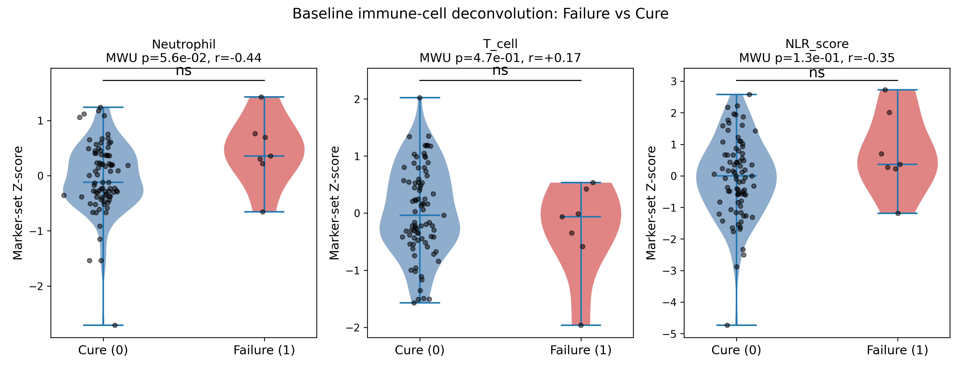
Figure 2. Baseline immune-cell deconvolution, cure (0) vs failure (1). Violin plots with individual points, Mann–Whitney p-values, rank-biserial effect sizes and significance annotations for the neutrophil score, T-cell score and their difference (NLR axis).

3.5 Cell-type specificity in a granulocyte-containing reference (Figure 3)
In the Human Protein Atlas blood atlas—which, unlike PBMC3k, contains neutrophils—10/12 neutrophil-signature genes were maximally expressed in neutrophils and 6/10 T-cell-signature genes in T cells (Figure 3), confirming lineage specificity of the signatures and correcting the earlier, inappropriate PBMC3k validation.
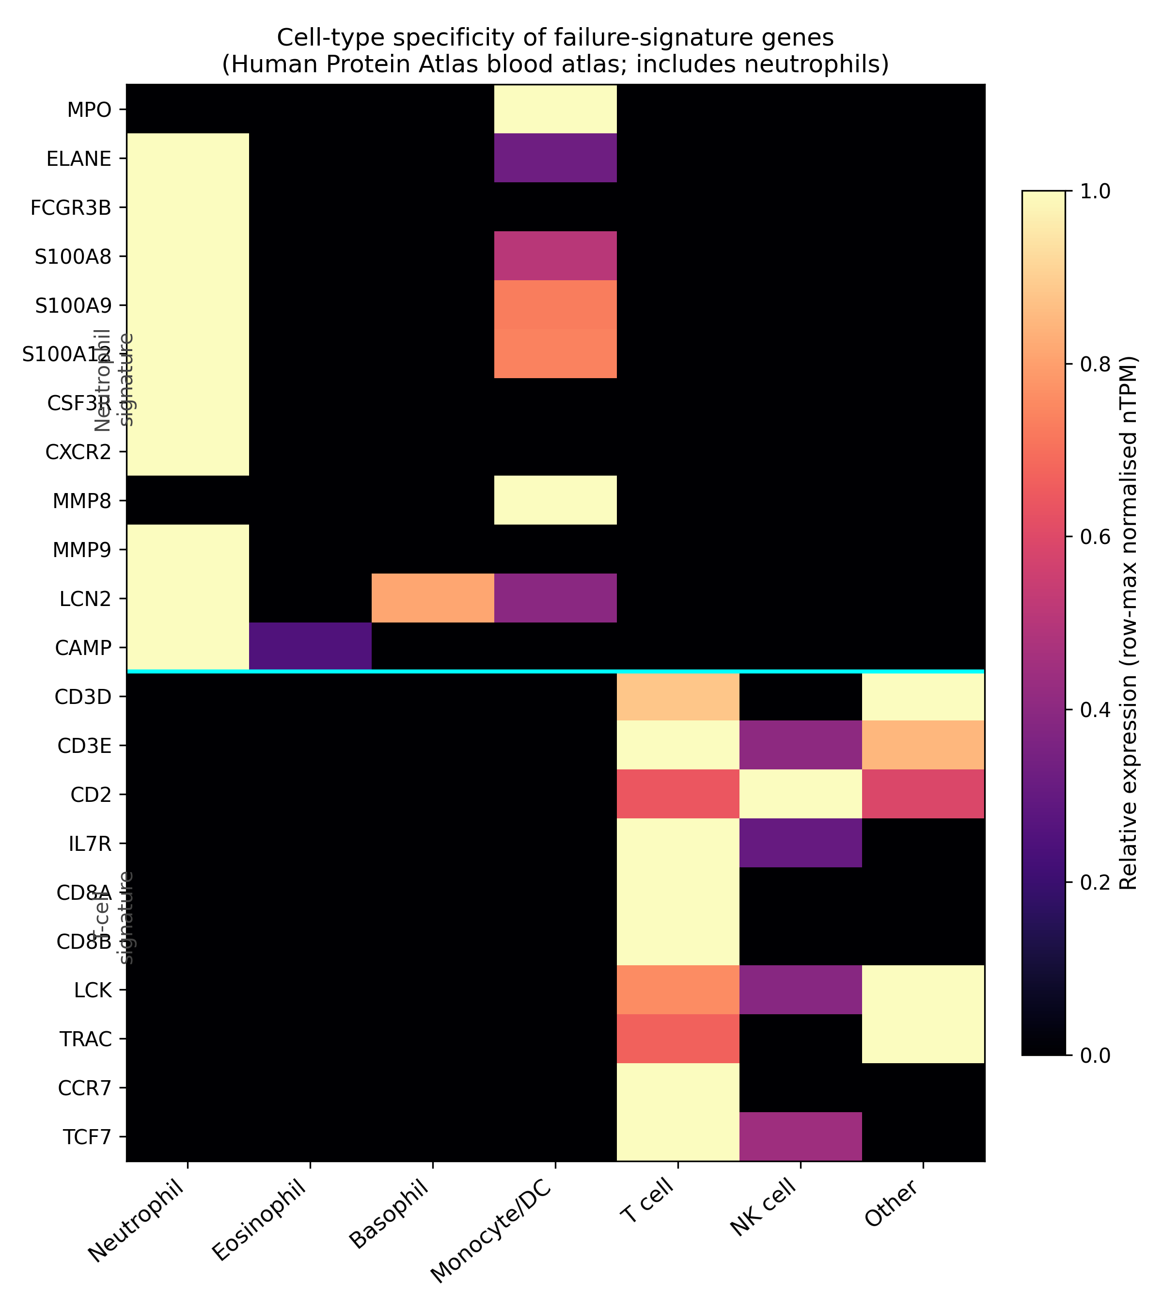
Figure 3. Cell-type specificity of failure-signature genes across labelled blood-cell types (Human Protein Atlas). Colour scale = row-max-normalised nTPM; the cyan line separates neutrophil- from T-cell-signature genes.

3.6 Sex and bacterial-load confounder audit
Failures were more often male (5/7), and Y-chromosome genes dominated a naive feature ranking. However, in multivariable logistic regression the neutrophil association remained (adjusted OR≈4.5, p≈0.046) while sex itself was not significant (OR≈1.8, p=0.52), indicating a sex-independent neutrophil signal and confirming that the Y-linked ‘predictors’ were a confound. Adjusting for bacterial load (MGIT/Xpert) attenuated but did not abolish the neutrophil association (OR≈4.5, p=0.10; reduced N=80). HIV and drug resistance were exclusion criteria in the source cohort.

3.7 Conditional-dependency network (Figure 4)
The graphical-lasso network yielded a sparse set of partial-correlation edges among the top baseline failure-associated genes (the clinical outcome was not included as a node). Hub genes by degree included ALOX5AP—an arachidonate-5-lipoxygenase-activating protein expressed in neutrophils—together with ALMS1, EMC1 and MTG2 (Figure 4; Supplementary Table S11). We report these strictly as undirected conditional associations and make no claim that they are upstream regulators, drivers or therapeutic targets.
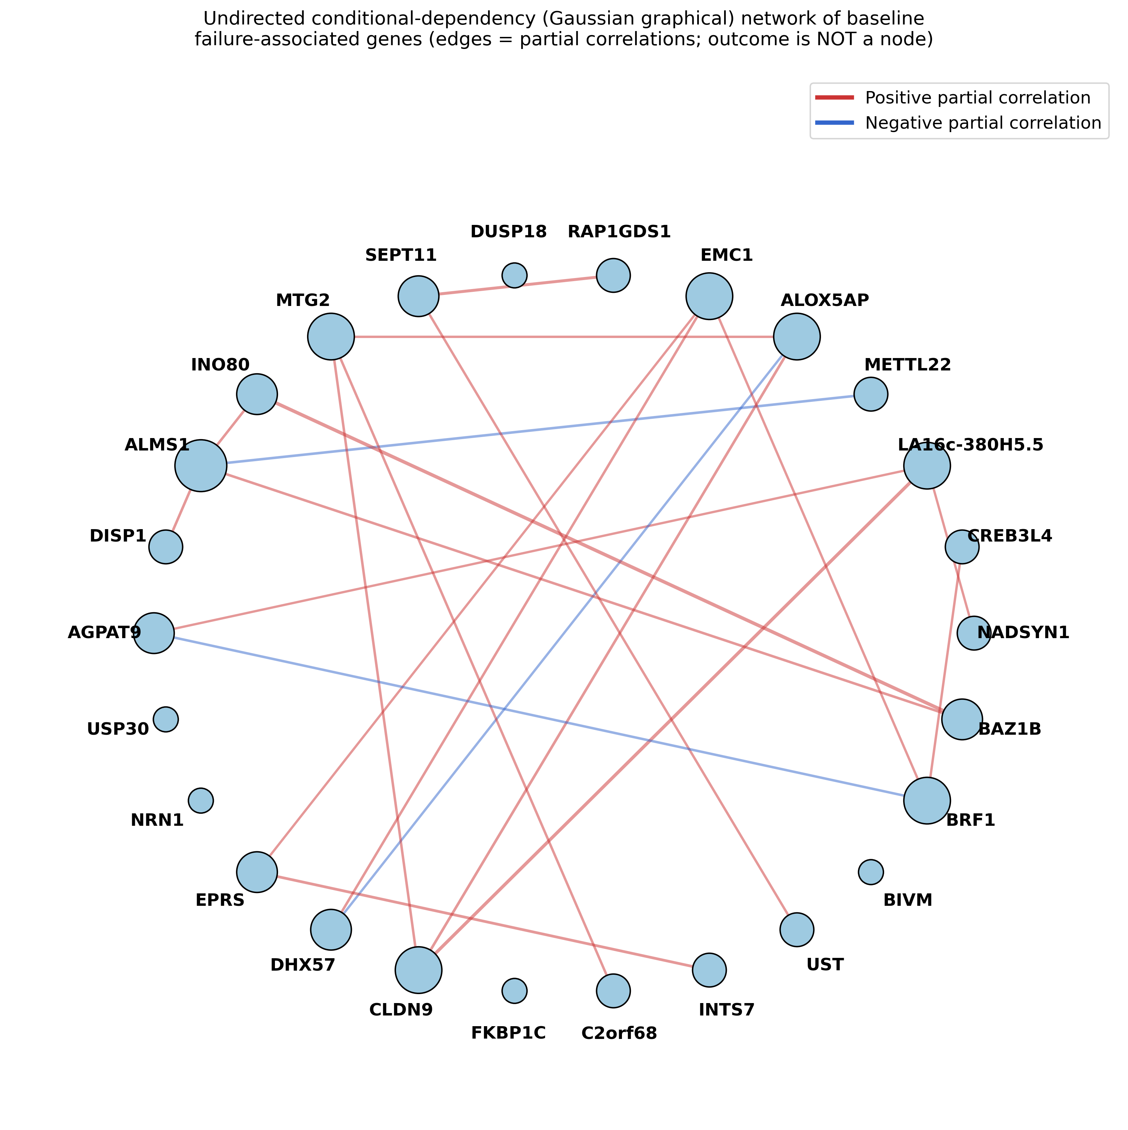
Figure 4. Undirected conditional-dependency (Gaussian graphical) network among baseline failure-associated genes. Edges are partial correlations (red positive, blue negative); node size reflects degree; gene symbols shown. The clinical outcome is not a node and no directionality is implied.

3.8 External portability and benchmarking
An outcome-stratified external validation was not feasible: in the closest candidate (GSE193979, TANDEM), per-patient outcomes are not deposited in GEO and the public count matrix is keyed by internal identifiers with no public bridge to sample metadata (Supplementary Table S5). A label-free portability check nonetheless reproduced the expected neutrophil↔T-cell anti-structure in that independent cohort (Spearman ρ=-0.41, p≈3×10⁻⁷, n=148). Benchmarking against prior work (Supplementary Table S6) shows our modest baseline AUC is consistent with the field, where baseline failure prediction is hard (AUC <0.70) even in large curated cohorts [7], and positions our contribution as cellular resolution and confounder transparency rather than predictive superiority [9–12].

4. Discussion
This study provides a transparent, cellularly-resolved characterisation of the baseline whole-blood signal of TB treatment failure. Three findings are robust to our small sample: the machine-learning signal and immune deconvolution converge on a neutrophil-high/T-cell-low axis; that neutrophil association is sex-independent; and the neutrophil signature is lineage-specific in a granulocyte-containing reference. Three findings are explicitly weak: baseline discrimination is modest with a confidence interval spanning chance; the T-cell reduction is not significant at baseline; and no outcome-labelled external validation was possible.
Neutrophils in TB. Neutrophils have a recognised double role in TB, contributing to early control but also to immunopathology, tissue destruction via matrix metalloproteinases, and a permissive replicative niche in established disease [8,13]. A baseline neutrophil-high state being associated with subsequent failure is biologically plausible and concordant with the interferon-driven neutrophil signature described in active TB [8]. We frame this as a hypothesis, not a mechanism: our data are cross-sectional and cannot establish whether neutrophilia is a cause, a consequence of higher bacterial burden, or a correlated marker of disease severity.
Clinical interpretation. The combination of high negative predictive value and low positive predictive value means the most defensible use is rule-out: a negative baseline signature identifies patients unlikely to fail, rather than reliably flagging those who will. We therefore do not claim that the signature can presently stratify patients for host-directed therapy or directly inform WHO End TB targets; such claims await prospective, adequately powered validation.
Relation to prior work. Our results neither contradict nor surpass existing models; they complement EMR- and multi-omic-based predictors [9–11] and the treatment-monitoring signatures of the source cohort [12] by adding cellular resolution and an explicit confounder audit. We have removed the earlier claim of being the ‘first’ such map.

4.1 Limitations
The limitations are substantial and central to interpretation. (i) Only seven baseline failure events, giving wide confidence intervals and low power; baseline discrimination did not reach significance against a label-permutation null (p=0.11) and no gene survived FDR correction. (ii) A single discovery cohort; no outcome-labelled external validation was achievable from public data. (iii) Cross-sectional design precludes causal inference; network edges are associative. (iv) Diabetes status and some confounders are unrecorded. (v) Cell-type inference is computational; flow-cytometric or single-cell confirmation of the neutrophil-high/T-cell-low phenotype, and prospective clinical validation, are required before any clinical use. We present the work as an exploratory framework and a reproducible baseline.

Declarations

Ethical approval
This study used publicly available, de-identified gene-expression data from the NCBI Gene Expression Omnibus. No new human participants were enrolled and no identifiable data were accessed; formal ethical approval was therefore not required. The original GSE89403 study obtained the appropriate ethical approvals described in its primary publication [12].

Consent to participate
Not applicable; no new participants were enrolled and only de-identified public data were analysed.

Consent to publish
Not applicable; no individually identifiable person or data are presented.

Data availability
GSE89403 and GSE193979 are available from the NCBI GEO. Processed matrices and analysis outputs are provided with the code repository.

Code availability
All analysis scripts, the frozen model and intermediate outputs are available at https://github.com/hssling/TB-Transcriptomics-Project, enabling verification without re-execution.

Funding
This research received no specific grant from funding agencies in the public, commercial or not-for-profit sectors.

Competing interests
The author declares no competing interests.

Author contributions
Siddalingaiah H S: conceptualisation, methodology, software, formal analysis, investigation, data curation, writing (original draft and review/editing), visualisation.

Use of AI
Generative AI tools assisted with code development, literature search and manuscript drafting. All AI-assisted content was verified and edited by the author, who takes full responsibility for the work.

References
1. World Health Organization. Global Tuberculosis Report 2024. Geneva: WHO; 2024.
2. World Health Organization. Treatment of tuberculosis: guidelines. Geneva: WHO.
3. Berry MPR, Graham CM, McNab FW, et al. An interferon-inducible neutrophil-driven blood transcriptional signature in human tuberculosis. Nature. 2010;466:973–977.
4. Zak DE, Penn-Nicholson A, Scriba TJ, et al. A blood RNA signature for tuberculosis disease risk: a prospective cohort study. Lancet. 2016;387:2312–2322.
5. Sweeney TE, Braviak L, Tato CM, Khatri P. Genome-wide expression for diagnosis of pulmonary tuberculosis: a multicohort analysis. Lancet Respir Med. 2016;4:213–224.
6. Singhania A, Verma R, Graham CM, et al. A modular transcriptional signature identifies phenotypic heterogeneity of human tuberculosis infection. Nat Commun. 2018;9:2308.
7. Blood transcriptomic signatures predict poor treatment outcomes in drug-susceptible pulmonary TB in Brazil (RePORT-Brazil). 2025. PMID 41282706.
8. Lowe DM, Redford PS, Wilkinson RJ, O’Garra A, Martineau AR. Neutrophils in tuberculosis: friend or foe? Trends Immunol. 2012;33:14–25.
9. Sambarey A, Smith K, Chung C, et al. Integrative analysis of multimodal patient data identifies personalized predictors of tuberculosis treatment prognosis. iScience. 2024. PMID 38357663.
10. Vinhaes CL, Fukutani ER, Santana GC, et al. An integrative multi-omics approach to characterize interactions between tuberculosis and diabetes mellitus. iScience. 2024. PMID 38380250.
11. Peng A-Z, Kong X-H, Liu S-T, et al. Explainable machine learning for early predicting treatment failure risk among patients with TB-diabetes comorbidity. Sci Rep. 2024. PMID 38514736.
12. Thompson EG, Du Y, Malherbe ST, et al. Host blood RNA signatures predict the outcome of tuberculosis treatment. Tuberculosis. 2017;107:48–58 (GSE89403).
13. Ndhlovu M, et al. Host-directed therapies for tuberculosis: a review. Front Immunol. 2019;10:325.
14. Vianello E, et al. Transcriptional profiles predict treatment outcome in patients with tuberculosis and diabetes (TANDEM; GSE193979). EBioMedicine. 2022;80:104023.
15. Newman AM, Liu CL, Green MR, et al. Robust enumeration of cell subsets from tissue expression profiles. Nat Methods. 2015;12:453–457.
16. Friedman J, Hastie T, Tibshirani R. Sparse inverse covariance estimation with the graphical lasso. Biostatistics. 2008;9:432–441.
17. Lundberg SM, Lee S-I. A unified approach to interpreting model predictions. Adv Neural Inf Process Syst. 2017;30.
18. Uhlén M, Karlsson MJ, Zhong W, et al. A genome-wide transcriptomic analysis of protein-coding genes in human blood cells. Science. 2019;366:eaax9198.

