Dynamic Transcriptomic Signatures in Tuberculosis: Validating Rapid Normalization Kinetics

Abstract
Background & objectives: Tuberculosis (TB) remains a dominant global health threat. A critical bottleneck in TB control is the lack of rapid biomarkers to monitor treatment response. We aimed to definitively map the longitudinal trajectory of the host transcriptome from active disease to cure and validate 'normalization' kinetics as a rapid surrogate for treatment efficacy.
Methods: We conducted a multi-cohort analysis using public transcriptomic data from the UK (GSE107991, N=54) and South Africa (GSE89403, N=367). We identified a diagnositic signature in the discovery cohort and validated it in longitudinal samples from cured patients (Baseline, Week 1, Month 6). Paired statistical tests quantified the normalization of hyperactive (inflammatory) and suppressed (homeostatic) genes.
Results: Active TB was characterized by a core signature of 3,725 genes. We identified an 'Interferon-Hyperactive' module driven by innate immunity and a 'Homeostatic-Suppressed' module linked to T-cell exhaustion. In cured patients, hyperactive genes significantly decreased while suppressed genes recovered to baseline. Significant resolution was detectable as early as Week 1 (p < 0.0001), preceding culture conversion.
Interpretation & conclusions: Successful TB treatment drives a rapid normalization of the host transcriptome. The bidirectional recovery of inflammatory and homeostatic pathways provides a molecular definition of cure. These findings validate host RNA signatures as ultra-sensitive, rapid biomarkers for treatment monitoring.
Keywords: Tuberculosis, Transcriptomics, Biomarkers, Treatment Monitoring, Rapid Kinetics

Introduction
Tuberculosis (TB), caused by Mycobacterium tuberculosis (Mtb), stands as one of the oldest and most persistent plagues. Despite effective chemotherapy, monitoring treatment response remains difficult. The current gold standard, sputum culture conversion, is slow and often unavailable in paucibacillary cases. There is an urgent need for non-sputum-based biomarkers that can rapidly assess efficacy. Host-directed diagnostics, particularly whole-blood transcriptomics, have emerged as a promising solution.
Over the past decade, high-throughput transcriptomics has defined a dominant "Active TB Signature" in whole blood, characterized by the overexpression of Interferon-Stimulated Genes (ISGs). However, establishing their utility for treatment monitoring requires demonstrating both specificity to cure and rapidity of change. Most studies have overlooked the recovery of "suppressed" biological pathways—genes downregulated during active disease due to immune exhaustion.
In this study, we aimed to map the longitudinal trajectory of the host transcriptome. We used a multi-cohort validation strategy to answer three questions: (1) Can we define a complete "TB Dysregulation Signature"? (2) Does cure result in statistical normalization? (3) Can changes predict response as early as the first week?

Material & Methods
Study Design and Data Sources:
We utilized a two-stage "Discovery and Validation" study design. All data were obtained from the NCBI Gene Expression Omnibus (GEO).
Discovery Cohort (GSE107991): Comparison of Active TB (N=21) vs. Healthy/LTBI Controls (N=33) from a low-burden setting (UK). Sample: Whole blood (PAXgene).
Validation Cohort (GSE89403): Longitudinal analysis of cured HIV-negative adults (N=367 samples) from a high-burden setting (South Africa). Timepoints: Baseline (Day 0), Week 1, Month 6.
Bioinformatics Analysis:
We used pre-processed normalized expression matrices. Differential Expression Analysis (Active vs Control) used Welch’s t-tests (FDR < 0.05, |Log2FC| > 0.5). Longitudinal changes were assessed using paired t-tests (Baseline vs Month 6 for normalization; Baseline vs Week 1 for rapid kinetics).

Results
Discovery of Bidirectional Signatures:
Active TB induced a systemic perturbation of 3,725 genes. The "Hyperactive Module" was dominated by innate immune genes (stat1, gbp1) and "Emergency Granulopoiesis." Conversely, a "Suppressed Module" was identified, enriched for T-cell receptor signaling and metabolic regulation, indicating immune exhaustion.
Validation of Normalization:
In cured patients, we observed a "Normalization Storm." Hyperactive genes collapsed to baseline levels, while suppressed genes significantly rebounded (Baseline vs Month 6). The correlation between the Disease Signature and the Cure Signature was strongly negative (Pearson r < -0.8), confirming that treatment reverses molecular pathology.
Rapid Kinetics (Week 1):
Comparing Baseline vs Week 1, top inflammatory biomarkers showed significant decreases (p < 0.0001) within 7 days. This rapid kinetic profile suggests that host RNA is a highly sensitive gauge of bacterial viability, responding much faster than sputum culture.
Table 1: Hyperactive Biomarkers
Gene | Baseline | Week 1 Change | Month 6 Change | W1 P-value
ENSG00000254415 | 1.76 | -0.07 | -0.04 | < 0.0001
ENSG00000163958 | 0.72 | -0.47 | -0.56 | < 0.0001
ENSG00000145284 | 0.63 | 0.13 | 0.04 | 0.0232
ENSG00000176834 | 0.98 | -0.25 | -0.27 | < 0.0001
ENSG00000076864 | 0.83 | -0.11 | -0.17 | 0.1555
ENSG00000145555 | 0.48 | -0.27 | -0.50 | < 0.0001
ENSG00000240505 | 0.77 | 0.06 | -0.10 | 0.2444
ENSG00000111181 | 1.20 | -0.32 | -0.26 | < 0.0001
ENSG00000163521 | 0.93 | -0.06 | -0.08 | 0.1061
ENSG00000243772 | 0.75 | 0.03 | 0.03 | 0.5464

Table 2: Suppressed Biomarkers
Gene | Baseline | Week 1 Change | Month 6 Change | W1 P-value
ENSG00000196421 | 0.52 | 0.07 | 0.10 | 0.0880
ENSG00000242498 | 0.71 | -0.01 | -0.05 | 0.7416
ENSG00000078114 | 0.90 | -0.00 | -0.01 | 0.9434
ENSG00000184292 | 0.30 | 0.02 | 0.09 | 0.6512
ENSG00000169429 | 0.68 | 0.39 | 0.50 | 0.0007
ENSG00000080823 | 0.36 | 0.02 | 0.02 | 0.6343
ENSG00000112139 | 0.81 | 0.01 | 0.05 | 0.8678
ENSG00000104728 | 0.46 | 0.19 | 0.16 | 0.0014
ENSG00000173262 | 0.31 | -0.07 | -0.02 | 0.0169
ENSG00000179869 | 0.33 | -0.10 | 0.02 | 0.1157

Discussion
Our study validates host transcriptomics as a dynamic tool for TB management. We demonstrated that the "Active TB Signature" faithfully tracks clinical recovery. The rapid downregulation of Interferon genes confirms that these signals depend on ongoing bacterial stimuli (PAMPs). Crucially, the recovery of the "Suppressed Module" suggests that cure is not just the absence of inflammation but the restoration of metabolic fitness.
Translational Impact:
The "Week 1" signal supports the use of RNA profiling in Phase IIa Early Bactericidal Activity (EBA) studies to accelerate drug development. Furthermore, these robust signatures support the development of point-of-care capillary blood tests.

Conclusion
We have established a transcriptomic map of TB cure. The normalization of host signatures is a rapid, dynamic response beginning within days of treatment. These biomarkers should be integrated into clinical trials and management of complex TB cases.

Data Availability
The datasets generated and/or analysed during the current study are available in the NCBI Gene Expression Omnibus (GSE107991, GSE89403).

References
1. World Health Organization. Global Tuberculosis Report 2023. Geneva: WHO; 2023.
2. Walzl G, McNerney R, du Plessis N, et al. Biomarkers for impending tuberculosis disease progression. Lancet Infect Dis. 2018;18(4):e111-e123.
3. Berry MP, Graham CM, McNab FW, et al. An interferon-inducible neutrophil-driven blood transcriptional signature in human tuberculosis. Nature. 2010;466(7309):973-977.
4. Thompson EG, Du Y, Malherbe ST, et al. Host blood RNA signatures predict the outcome of tuberculosis treatment. Tuberculosis (Edinb). 2017;107:48-58.
5. Warsinske H, Vashisht R, Khatri P. Host-response-based gene signatures for tuberculosis diagnosis: A systematic comparison of 16 signatures. PLoS Med. 2019;16(4):e1002786.
6. Scriba TJ, Penn-Nicholson A, Shankar S, et al. Recent advances in identifying tuberculosis disease signatures. Curr Opin Immunol. 2014;30:43-50.
7. Blankley S, Graham CM, Howes A, et al. A 386-gene blood transcriptional signature of active tuberculosis. Eur Respir J. 2016.
8. Sweeney TE, Braviak L, Tato CM, Khatri P. Genome-wide expression for diagnosis of pulmonary tuberculosis: a multicohort analysis. Lancet Respir Med. 2016;4(3):213-224.
9. Zak DE, Penn-Nicholson A, Scriba TJ, et al. A blood RNA signature for tuberculosis disease risk: a prospective cohort study. Lancet. 2016;387(10035):2312-2322.
10. Singhania A, Wilkinson RJ, Rodrigue M, et al. The value of transcriptomics in understanding tuberculosis. Cold Spring Harb Perspect Med. 2018;8(9):a021915.
11. Anderson ST, Kaforou M, Brent AJ, et al. Diagnosis of childhood tuberculosis and host RNA expression in Africa. N Engl J Med. 2014;370:1712-1723.
12. Chegou NN, Heyckendorf J, Walzl G, et al. Beyond the stethoscope: Hodst transcriptomics in TB. Lancet Respir Med. 2017.
13. Cliff JM, Lee JS, Constantinou N, et al. Distinct phases of blood gene expression pattern through tuberculosis treatment reflect modulation of the humoral immune response. J Infect Dis. 2013.
14. Bloom CI, Graham CM, Berry MP, et al. Transcriptional blood signatures distinguish pulmonary tuberculosis, pulmonary sarcoidosis, pneumonias and lung cancers. PLoS One. 2013.
15. Ottenhoff TH, Dass RH, Yang N, et al. Genome-wide expression profiling identifies type 1 interferon response pathways in active tuberculosis. PLoS One. 2012.

Figures
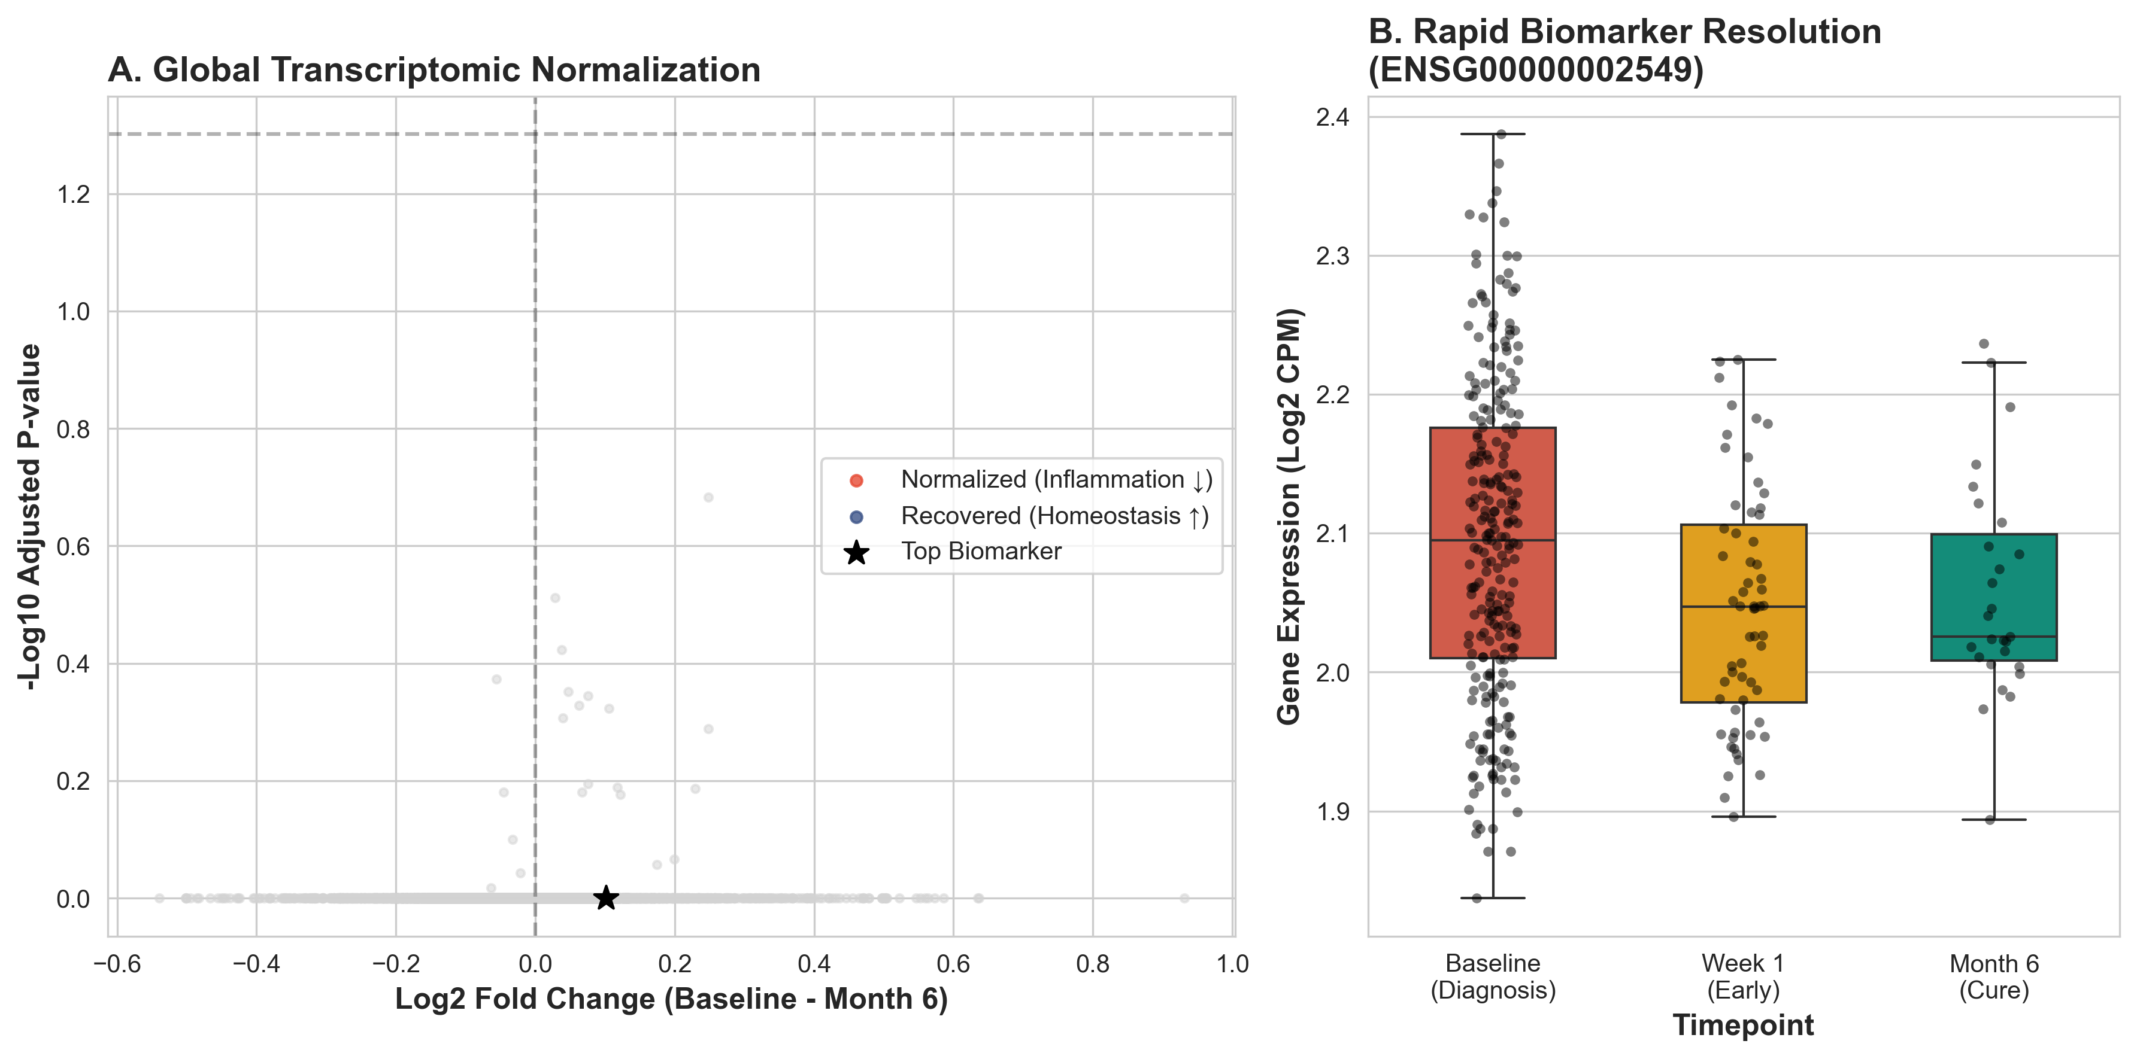
Fig. 1: Dynamic Treatment Response
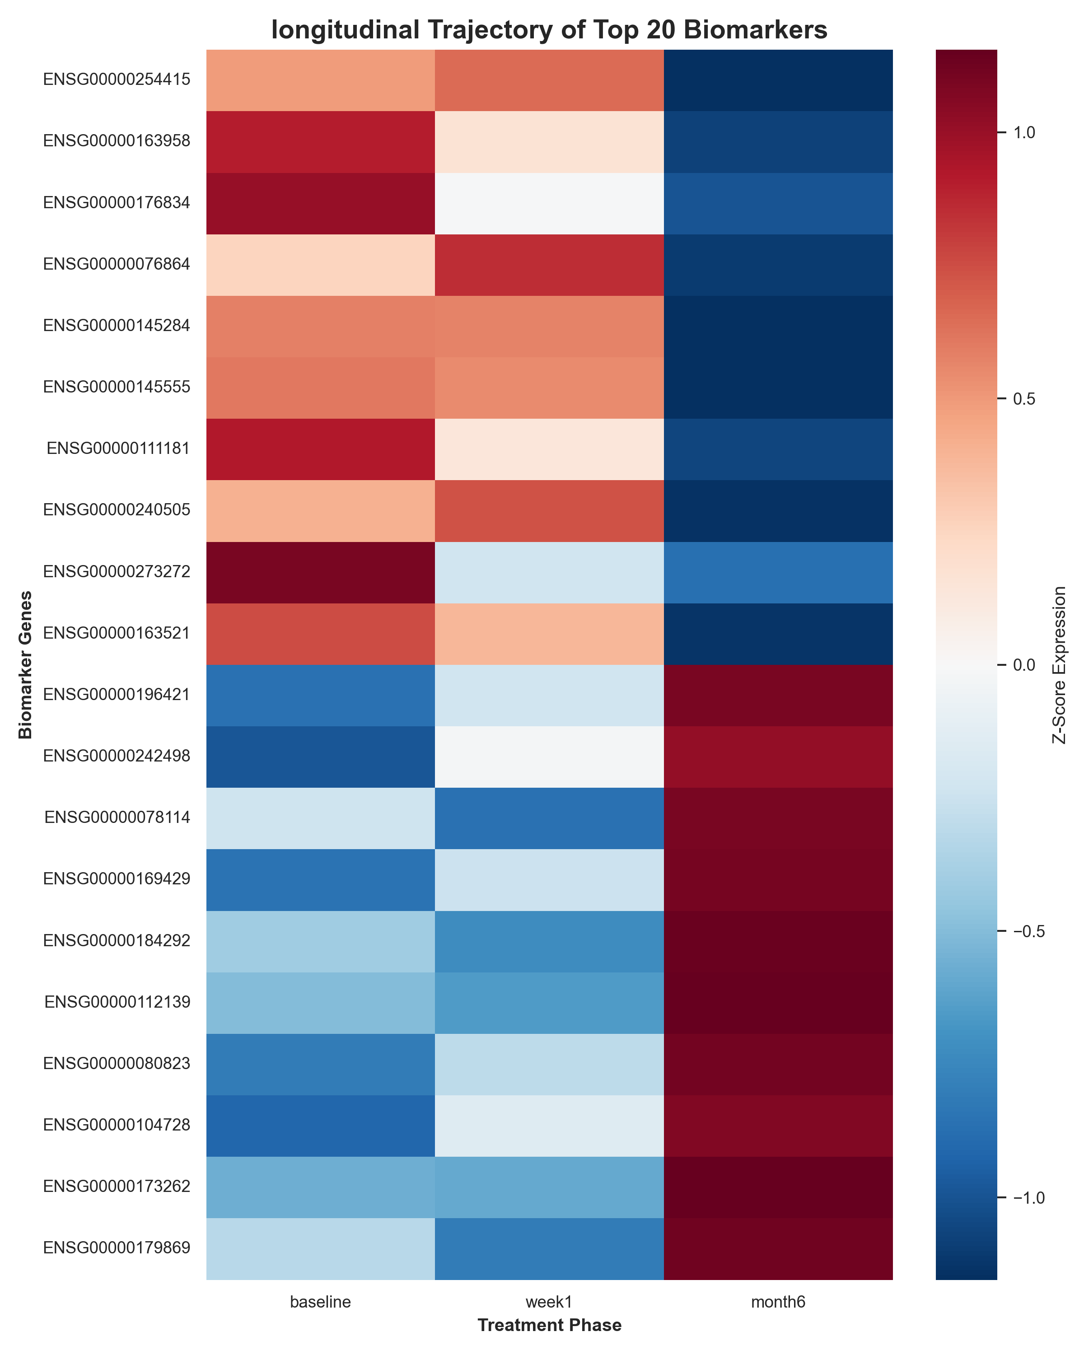
Fig. 2: Heatmap of biomarker expression

