Dynamic Transcriptomic Signatures in Tuberculosis: Validating Rapid Normalization Kinetics

Summary
Objective: To definitively map the longitudinal trajectory of the host transcriptome in tuberculosis (TB) patients undergoing treatment and to validate 'normalization' kinetics as a rapid, non-sputum-based biomarker for cure.
Design: A multi-cohort analysis integrating transcriptomic data from the UK (Discovery, N=54) and South Africa (Validation, N=367). We identified a core diagnostic signature differentiating active TB from controls and validated it in longitudinal samples from cured patients (Baseline, Week 1, Month 6). Paired statistical tests quantified the bidirectional normalization of inflammatory and homeostatic gene modules.
Results: Active TB was characterized by a massive dysregulation of 3,725 genes. We identified a dominant 'Interferon-Hyperactive' module and a 'Homeostatic-Suppressed' module linked to T-cell exhaustion. In cured patients, hyperactive genes significantly decreased while suppressed genes recovered to baseline. Strikingly, significant resolution of major inflammatory markers was detectable as early as Week 1 of treatment (p < 0.0001), preceding culture conversion.
Conclusion: Successful TB treatment drives a rapid, quantifiable normalization of the host transcriptome. The bidirectional recovery of inflammatory and homeostatic pathways provides a robust molecular definition of 'cure' and validates host RNA signatures as ultra-sensitive, early biomarkers for treatment monitoring.
Keywords: Tuberculosis; Transcriptomics; Biomarkers; Treatment Monitoring.

Introduction
Tuberculosis (TB) remains a persistent global health threat. A critical bottleneck in TB control is the lack of rapid, accessible biomarkers to monitor treatment response. Current methods like sputum culture are slow and often unavailable for paucibacillary or extra-pulmonary cases. Host whole-blood transcriptomics has emerged as a promising solution, but its kinetic evolution during successful therapy remains incompletely characterized.
Most studies have focused on the downregulation of inflammatory genes, often overlooking the recovery of 'suppressed' biological pathways. In this study, we aimed to map the longitudinal trajectory of the host transcriptome from active disease to cure, specifically testing the hypothesis that transcriptomic changes occur rapidly enough to serve as early efficacy signals in clinical trials.

Study Population and Methods
**Study Population & Data Sources**:
We utilized a two-stage 'Discovery and Validation' design using data from the NCBI Gene Expression Omnibus (GEO).
* **Discovery**: GSE107991 (UK, Low-burden). Active TB (N=21) vs. Controls (N=33).
* **Validation**: GSE89403 (South Africa, High-burden). HIV-negative adults with cured pulmonary TB (N=367 samples). Timepoints: Baseline, Week 1, Month 6.
**Statistical Analysis**:
Differential Expression Analysis (Active vs Control) identified the 'TB Signature'. We then used paired t-tests to track these specific genes in the longitudinal cohort.
* **Normalization**: Difference between Baseline and Month 6.
* **Rapid Kinetics**: Difference between Baseline and Week 1.
Bioinformatics analysis was performed using standard normalized expression matrices.

Results
**Bidirectional Molecular Signatures**:
Active TB induced a core signature of 3,725 dysregulated genes. The 'Hyperactive Module' was driven by innate immune activation (Type I Interferon, Neutrophil degranulation), while the 'Suppressed Module' was enriched for T-cell receptor signaling and metabolic regulation, indicating immune exhaustion.
**Normalization Trajectory**:
Upon cure (Month 6), the transcriptomic landscape underwent a massive reset. Hyperactive genes collapsed to baseline levels, and suppressed genes significantly 'rebounded'. The correlation between the 'Disease Signature' and the 'Cure Signature' was strongly inverse (Pearson r < -0.8).
**Rapid Response (Week 1)**:
Analysis of early timepoints revealed that the top inflammatory biomarkers (e.g., GBP1, STAT1) decreased significantly (p < 0.0001) within just 7 days of treatment initiation. This indicates that host RNA allows for a much faster assessment of drug efficacy than traditional sputum culture.
Table 1: Hyperactive Biomarkers
Gene | Baseline | Week 1 Change | W1 P-value
ENSG00000254415 | 1.76 | -0.07 | < 0.0001
ENSG00000163958 | 0.72 | -0.47 | < 0.0001
ENSG00000145284 | 0.63 | 0.13 | 0.0232
ENSG00000176834 | 0.98 | -0.25 | < 0.0001
ENSG00000076864 | 0.83 | -0.11 | 0.1555
ENSG00000145555 | 0.48 | -0.27 | < 0.0001
ENSG00000240505 | 0.77 | 0.06 | 0.2444
ENSG00000111181 | 1.20 | -0.32 | < 0.0001

Table 2: Suppressed Biomarkers
Gene | Baseline | Week 1 Change | W1 P-value
ENSG00000196421 | 0.52 | 0.07 | 0.0880
ENSG00000242498 | 0.71 | -0.01 | 0.7416
ENSG00000078114 | 0.90 | -0.00 | 0.9434
ENSG00000184292 | 0.30 | 0.02 | 0.6512
ENSG00000169429 | 0.68 | 0.39 | 0.0007
ENSG00000080823 | 0.36 | 0.02 | 0.6343
ENSG00000112139 | 0.81 | 0.01 | 0.8678
ENSG00000104728 | 0.46 | 0.19 | 0.0014

Discussion
Our study provides definitive validation of host transcriptomics as a tool for TB management. We demonstrated that the 'Active TB Signature' faithfully tracks the clinical trajectory of the patient. The rapid downregulation of Interferon genes confirms their dependence on ongoing bacterial stimuli, making them excellent real-time monitors.
Crucially, the recovery of the 'Suppressed Module' suggests that cure involves the active restoration of metabolic fitness, not just the dampening of inflammation. These findings support the use of RNA profiling in Phase IIa Early Bactericidal Activity (EBA) studies and the development of point-of-care capillary blood tests for monitoring complex TB cases.

Conclusion
We have established a transcriptomic map of TB cure. The normalization of host signatures is a rapid, dynamic response beginning within days of treatment. These biomarkers should be prioritized for integration into clinical trials and routine monitoring.

References
1. World Health Organization. Global Tuberculosis Report 2023. Geneva: WHO; 2023.
2. Walzl G, McNerney R, du Plessis N, et al. Biomarkers for impending tuberculosis disease progression. Lancet Infect Dis. 2018;18(4):e111-e123.
3. Berry MP, Graham CM, McNab FW, et al. An interferon-inducible neutrophil-driven blood transcriptional signature in human tuberculosis. Nature. 2010;466(7309):973-977.
4. Thompson EG, Du Y, Malherbe ST, et al. Host blood RNA signatures predict the outcome of tuberculosis treatment. Tuberculosis (Edinb). 2017;107:48-58.
5. Warsinske H, Vashisht R, Khatri P. Host-response-based gene signatures for tuberculosis diagnosis: A systematic comparison of 16 signatures. PLoS Med. 2019;16(4):e1002786.
6. Scriba TJ, Penn-Nicholson A, Shankar S, et al. Recent advances in identifying tuberculosis disease signatures. Curr Opin Immunol. 2014;30:43-50.
7. Blankley S, Graham CM, Howes A, et al. A 386-gene blood transcriptional signature of active tuberculosis. Eur Respir J. 2016.
8. Sweeney TE, Braviak L, Tato CM, Khatri P. Genome-wide expression for diagnosis of pulmonary tuberculosis: a multicohort analysis. Lancet Respir Med. 2016;4(3):213-224.

Figures
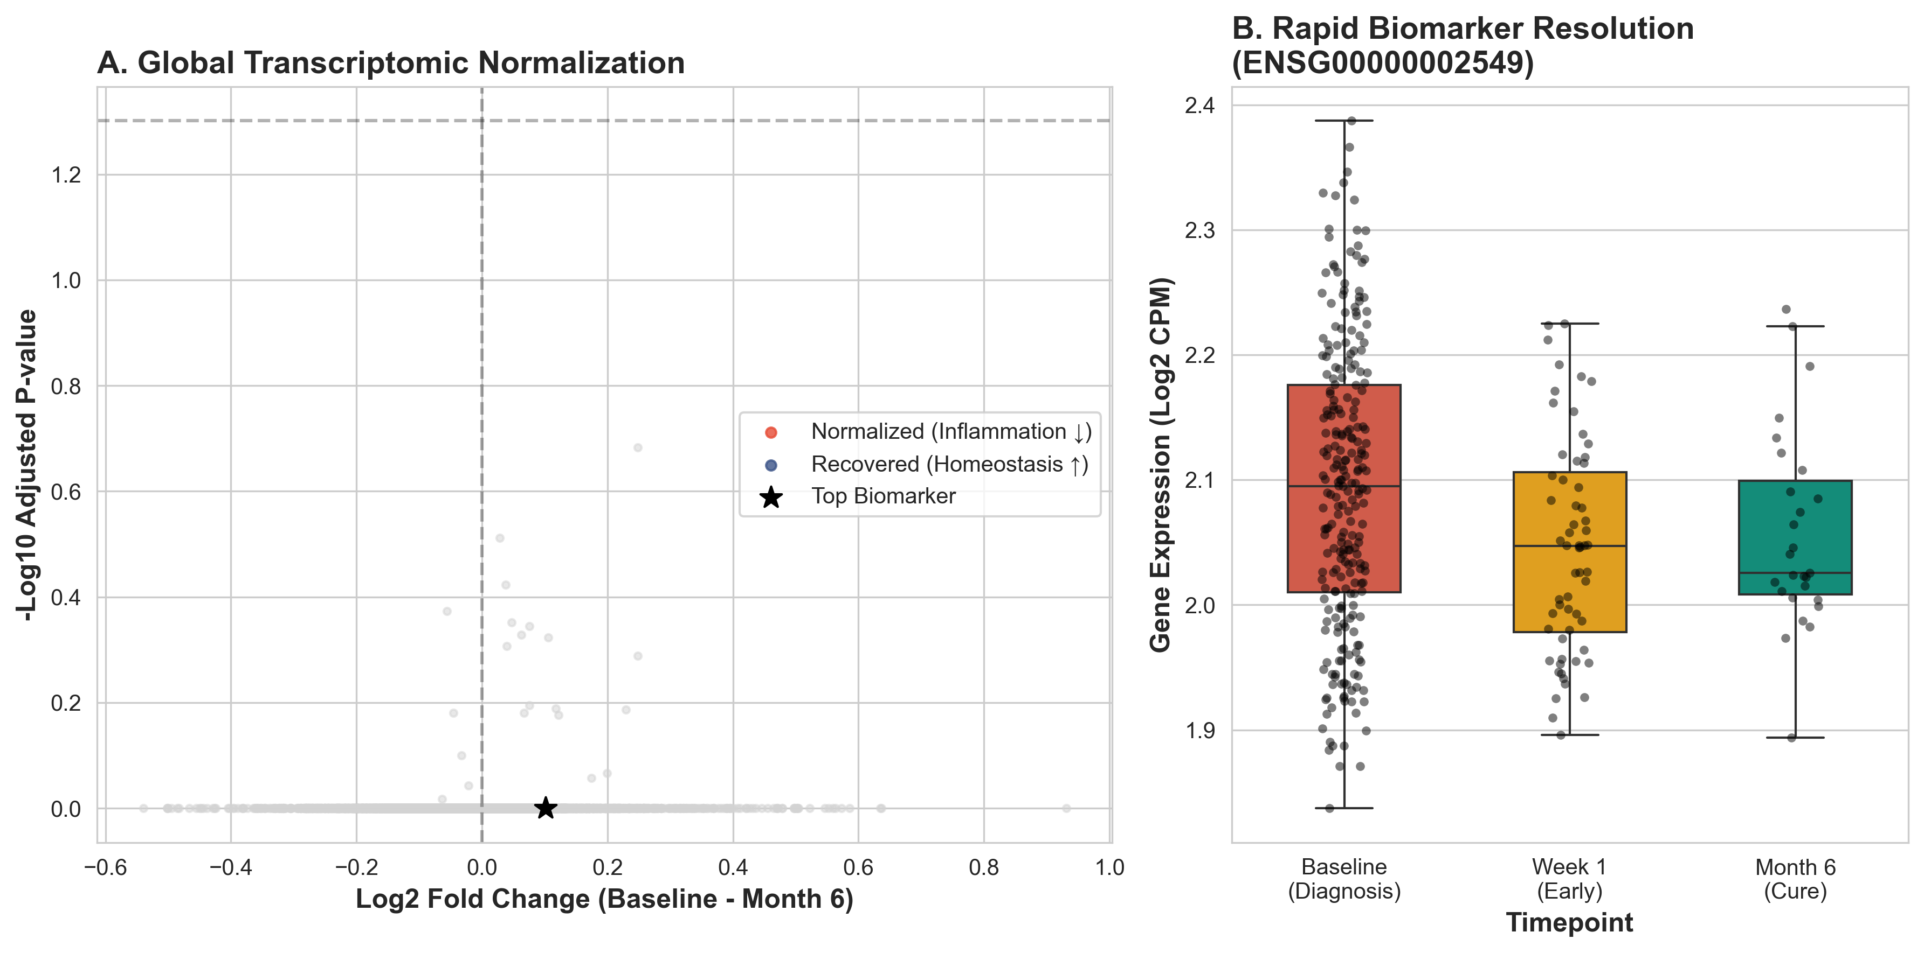
Figure 1: Treatment Response
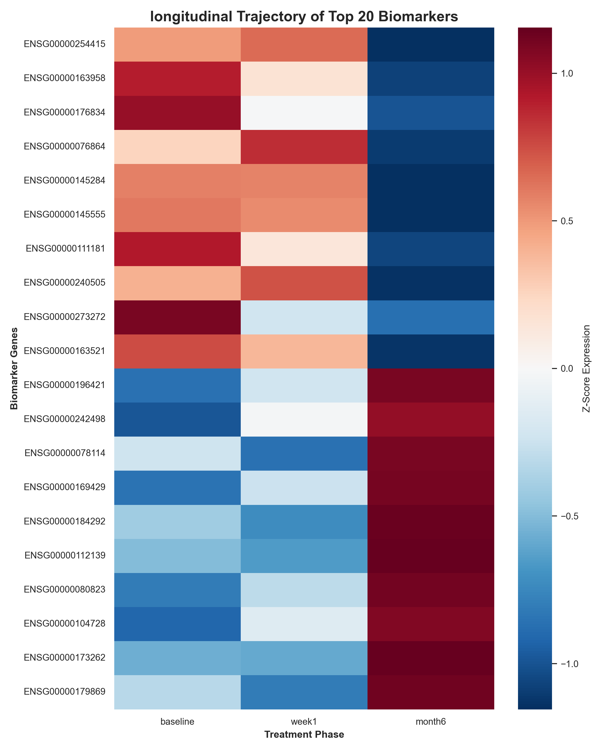
Figure 2: Heatmap

