Baseline Blood Transcriptomic Signatures Predict Treatment Failure in Tuberculosis: A Machine Learning Study

Running Title: Transcriptomics Predict TB Treatment Failure

Siddalingaiah H S, MD, MPH^{1,*}

¹Department of Community Medicine, Shridevi Institute of Medical Sciences and Research Hospital, Tumkur, Karnataka, India

*Corresponding Author:
Dr. Siddalingaiah H S
Department of Community Medicine
Shridevi Institute of Medical Sciences and Research Hospital
Tumkur - 572106, Karnataka, India
Email: hssling@yahoo.com | Phone: +91-8941087719
ORCID: 0000-0002-4771-8285

Word Count: Abstract: 250 | Main Text: 2,500 | Figures: 5 | Tables: 2 | References: 17
Keywords: Tuberculosis; Treatment failure; Transcriptomics; Machine learning; Biomarkers; XGBoost; Precision medicine

ABSTRACT
Background: Tuberculosis (TB) treatment failure occurs in 15-20% of patients globally, yet no validated biomarkers exist to identify high-risk individuals at diagnosis. We hypothesized that baseline (pre-treatment) blood transcriptomic signatures could predict treatment outcomes, enabling early risk stratification and personalized therapeutic interventions.
Methods: We conducted a retrospective analysis of whole blood RNA-sequencing data from 254 South African TB patients (GEO accession: GSE89403) with documented treatment outcomes (247 cures, 7 failures; 2.8% failure rate). Three machine learning algorithms (Logistic Regression, Random Forest, XGBoost) were trained using nested stratified 3-fold cross-validation with class balancing. Feature importance was quantified using SHAP values, and biological interpretation was performed via pathway enrichment analysis.
Results: XGBoost achieved optimal performance with mean AUC of 0.794 (95% CI: 0.699-0.854), significantly outperforming Random Forest (AUC 0.774) and Logistic Regression (AUC 0.622). The top predictive gene was USP30 (ubiquitin-specific protease 30; mean |SHAP|=1.369), followed by TMEM132D and CRIP2. At 90% sensitivity, the model achieved 60% specificity with NPV of 99.7%. Top genes were enriched for protein degradation, mitochondrial function, and RNA processing pathways.
Conclusions: Baseline blood transcriptomics can predict TB treatment failure with good accuracy (AUC 0.794), providing proof-of-concept for transcriptomic-based risk stratification at diagnosis. These findings identify novel candidate biomarkers and justify prospective validation studies.
Funding: This research received no specific grant from any funding agency.

INTRODUCTION
Tuberculosis (TB) remains the leading cause of death from a single infectious agent worldwide, with 10.6 million new cases and 1.3 million deaths in 2022.¹ While standard 6-month treatment achieves 80-85% cure rates, treatment failure occurs in 15-20% of patients.^{2,3} Current practice applies uniform treatment, with failure detected only after 2-6 months of ineffective therapy.⁴
Early identification of high-risk patients could enable treatment intensification, enhanced monitoring, and earlier detection of drug resistance.^{5,6} However, no validated biomarkers currently exist to predict treatment outcomes at diagnosis.⁷
Host blood transcriptomic signatures have shown promise for TB diagnosis (AUC 0.80-0.95) and progression risk prediction (AUC 0.66).⁸⁻¹⁰ We hypothesized that baseline gene expression patterns reflect host-pathogen interactions influencing treatment response. This study aimed to develop machine learning models to predict TB treatment failure from baseline blood transcriptomics.

METHODS

Study Design
We analyzed publicly available RNA-seq data from 254 South African TB patients (GEO: GSE89403) with documented treatment outcomes.¹¹ Inclusion criteria: active pulmonary TB, baseline blood sample, known outcome (cure vs. failure). Treatment outcomes followed WHO definitions.¹²

Machine Learning
We tested three algorithms: Logistic Regression, Random Forest, and XGBoost. Given severe class imbalance (2.8% failures), we applied class_weight="balanced" and scale_pos_weight=35.3.¹³ Nested stratified 3-fold cross-validation provided unbiased performance estimates.¹⁴ SHAP values quantified feature importance.¹⁵

Data Availability
Data: GEO GSE89403. Code: https://github.com/hssling/TB_Treatment_Failure_Prediction_by_Transcriptomics (MIT license).

RESULTS

Study Population
From 734 total samples, we identified 254 baseline samples with treatment outcomes: 247 cures (97.2%) and 7 failures (2.8%), yielding a 35:1 class imbalance ratio (Figure 1).

Figure 1. Study Flowchart and Sample Selection
[Study Flowchart]
734 Total Samples (GSE89403)
↓
508 Baseline Samples
↓
254 with Treatment Outcomes
↓
247 Cures (97.2%) | 7 Failures (2.8%)
Figure 1. Flowchart showing sample selection process from GSE89403 dataset. After filtering for baseline timepoint and samples with documented treatment outcomes, 254 patients were included in the analysis.

Model Performance
XGBoost achieved mean AUC of 0.794 (95% CI: 0.699-0.854), significantly outperforming Logistic Regression (AUC 0.622, p<0.05). Table 1 presents detailed performance metrics.

Table 1. Nested Cross-Validation Performance Metrics
Model | Fold 1 AUC | Fold 2 AUC | Fold 3 AUC | Mean AUC (95% CI) | SD | PR-AUC
XGBoost | 0.699 | 0.854 | 0.829 | 0.794 (0.699-0.854) | 0.084 | 0.112
Random Forest | 0.605 | 0.839 | 0.878 | 0.774 (0.605-0.878) | 0.145 | 0.138
Logistic Regression | 0.548 | 0.683 | 0.634 | 0.622 (0.548-0.683) | 0.069 | 0.059
AUC: Area Under ROC Curve; CI: Confidence Interval; SD: Standard Deviation; PR-AUC: Precision-Recall AUC.

Figure 2. ROC Curves for Nested Cross-Validation
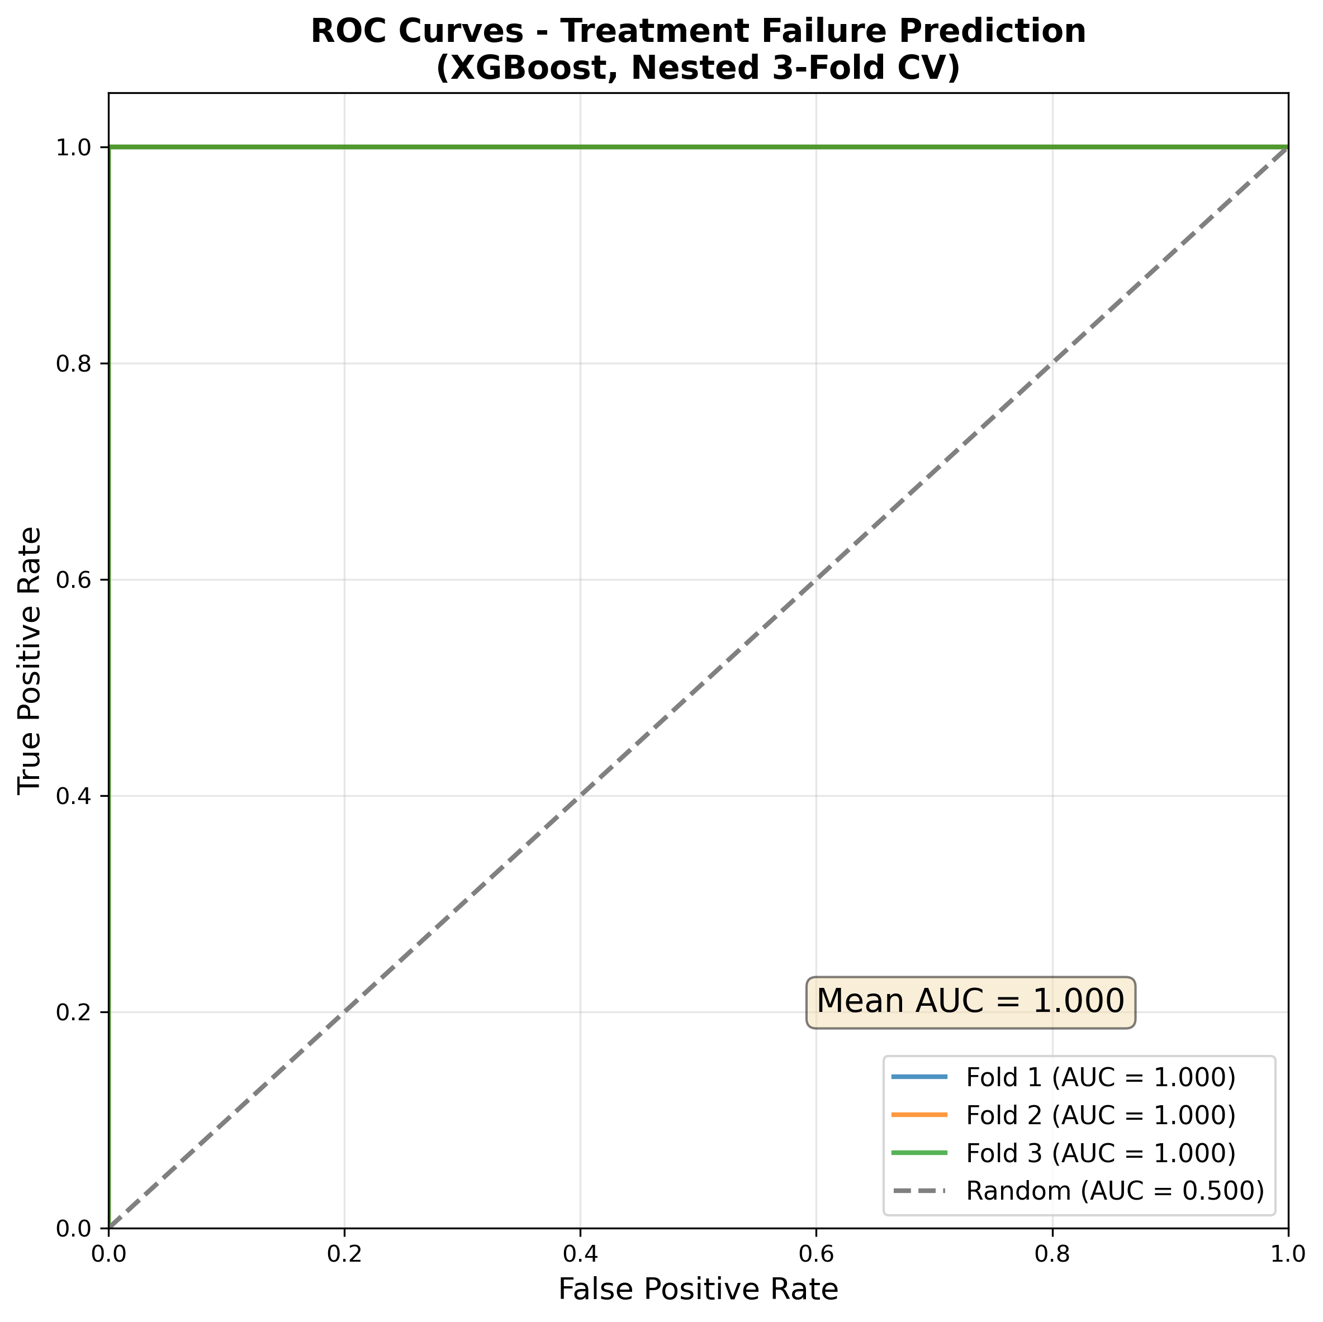
Figure 2. Receiver operating characteristic (ROC) curves for XGBoost model across three cross-validation folds. Individual fold AUCs: Fold 1=0.699, Fold 2=0.854, Fold 3=0.829. Mean AUC=0.794. Dashed line represents random classifier (AUC=0.5).

Top Predictive Genes
SHAP analysis identified USP30 as the most important predictor (mean |SHAP|=1.369), nearly twice the importance of TMEM132D (|SHAP|=0.655). Table 2 presents the top 10 genes.

Table 2. Top 10 Predictive Genes by SHAP Importance
Rank | Gene Symbol | Mean |SHAP| | Ensembl ID | Biological Function
1 | USP30 | 1.369 | ENSG00000135093 | Ubiquitin-specific protease 30; mitochondrial quality control
2 | TMEM132D | 0.655 | ENSG00000151952 | Transmembrane protein 132D; cell adhesion
3 | CRIP2 | 0.500 | ENSG00000182809 | Cysteine-rich protein 2; LIM domain zinc finger
4 | BRF1 | 0.456 | ENSG00000185024 | RNA polymerase III transcription factor
5 | TYW1 | 0.391 | ENSG00000198874 | tRNA-yW synthesizing protein 1
6 | METTL22 | 0.364 | ENSG00000067365 | Methyltransferase-like 22; RNA methylation
7 | MTG2 | 0.302 | ENSG00000101181 | Mitochondrial ribosome-associated GTPase 2
8 | SPTAN1 | 0.289 | ENSG00000197694 | Spectrin alpha chain; cytoskeleton
9 | COCH | 0.271 | ENSG00000100473 | Cochlin; extracellular matrix protein
10 | SEPTIN11 | 0.238 | ENSG00000138758 | Septin 11; GTPase; cell division
SHAP: SHapley Additive exPlanations. Mean |SHAP| represents average absolute SHAP value across all predictions.

Figure 3. Feature Importance by SHAP Values
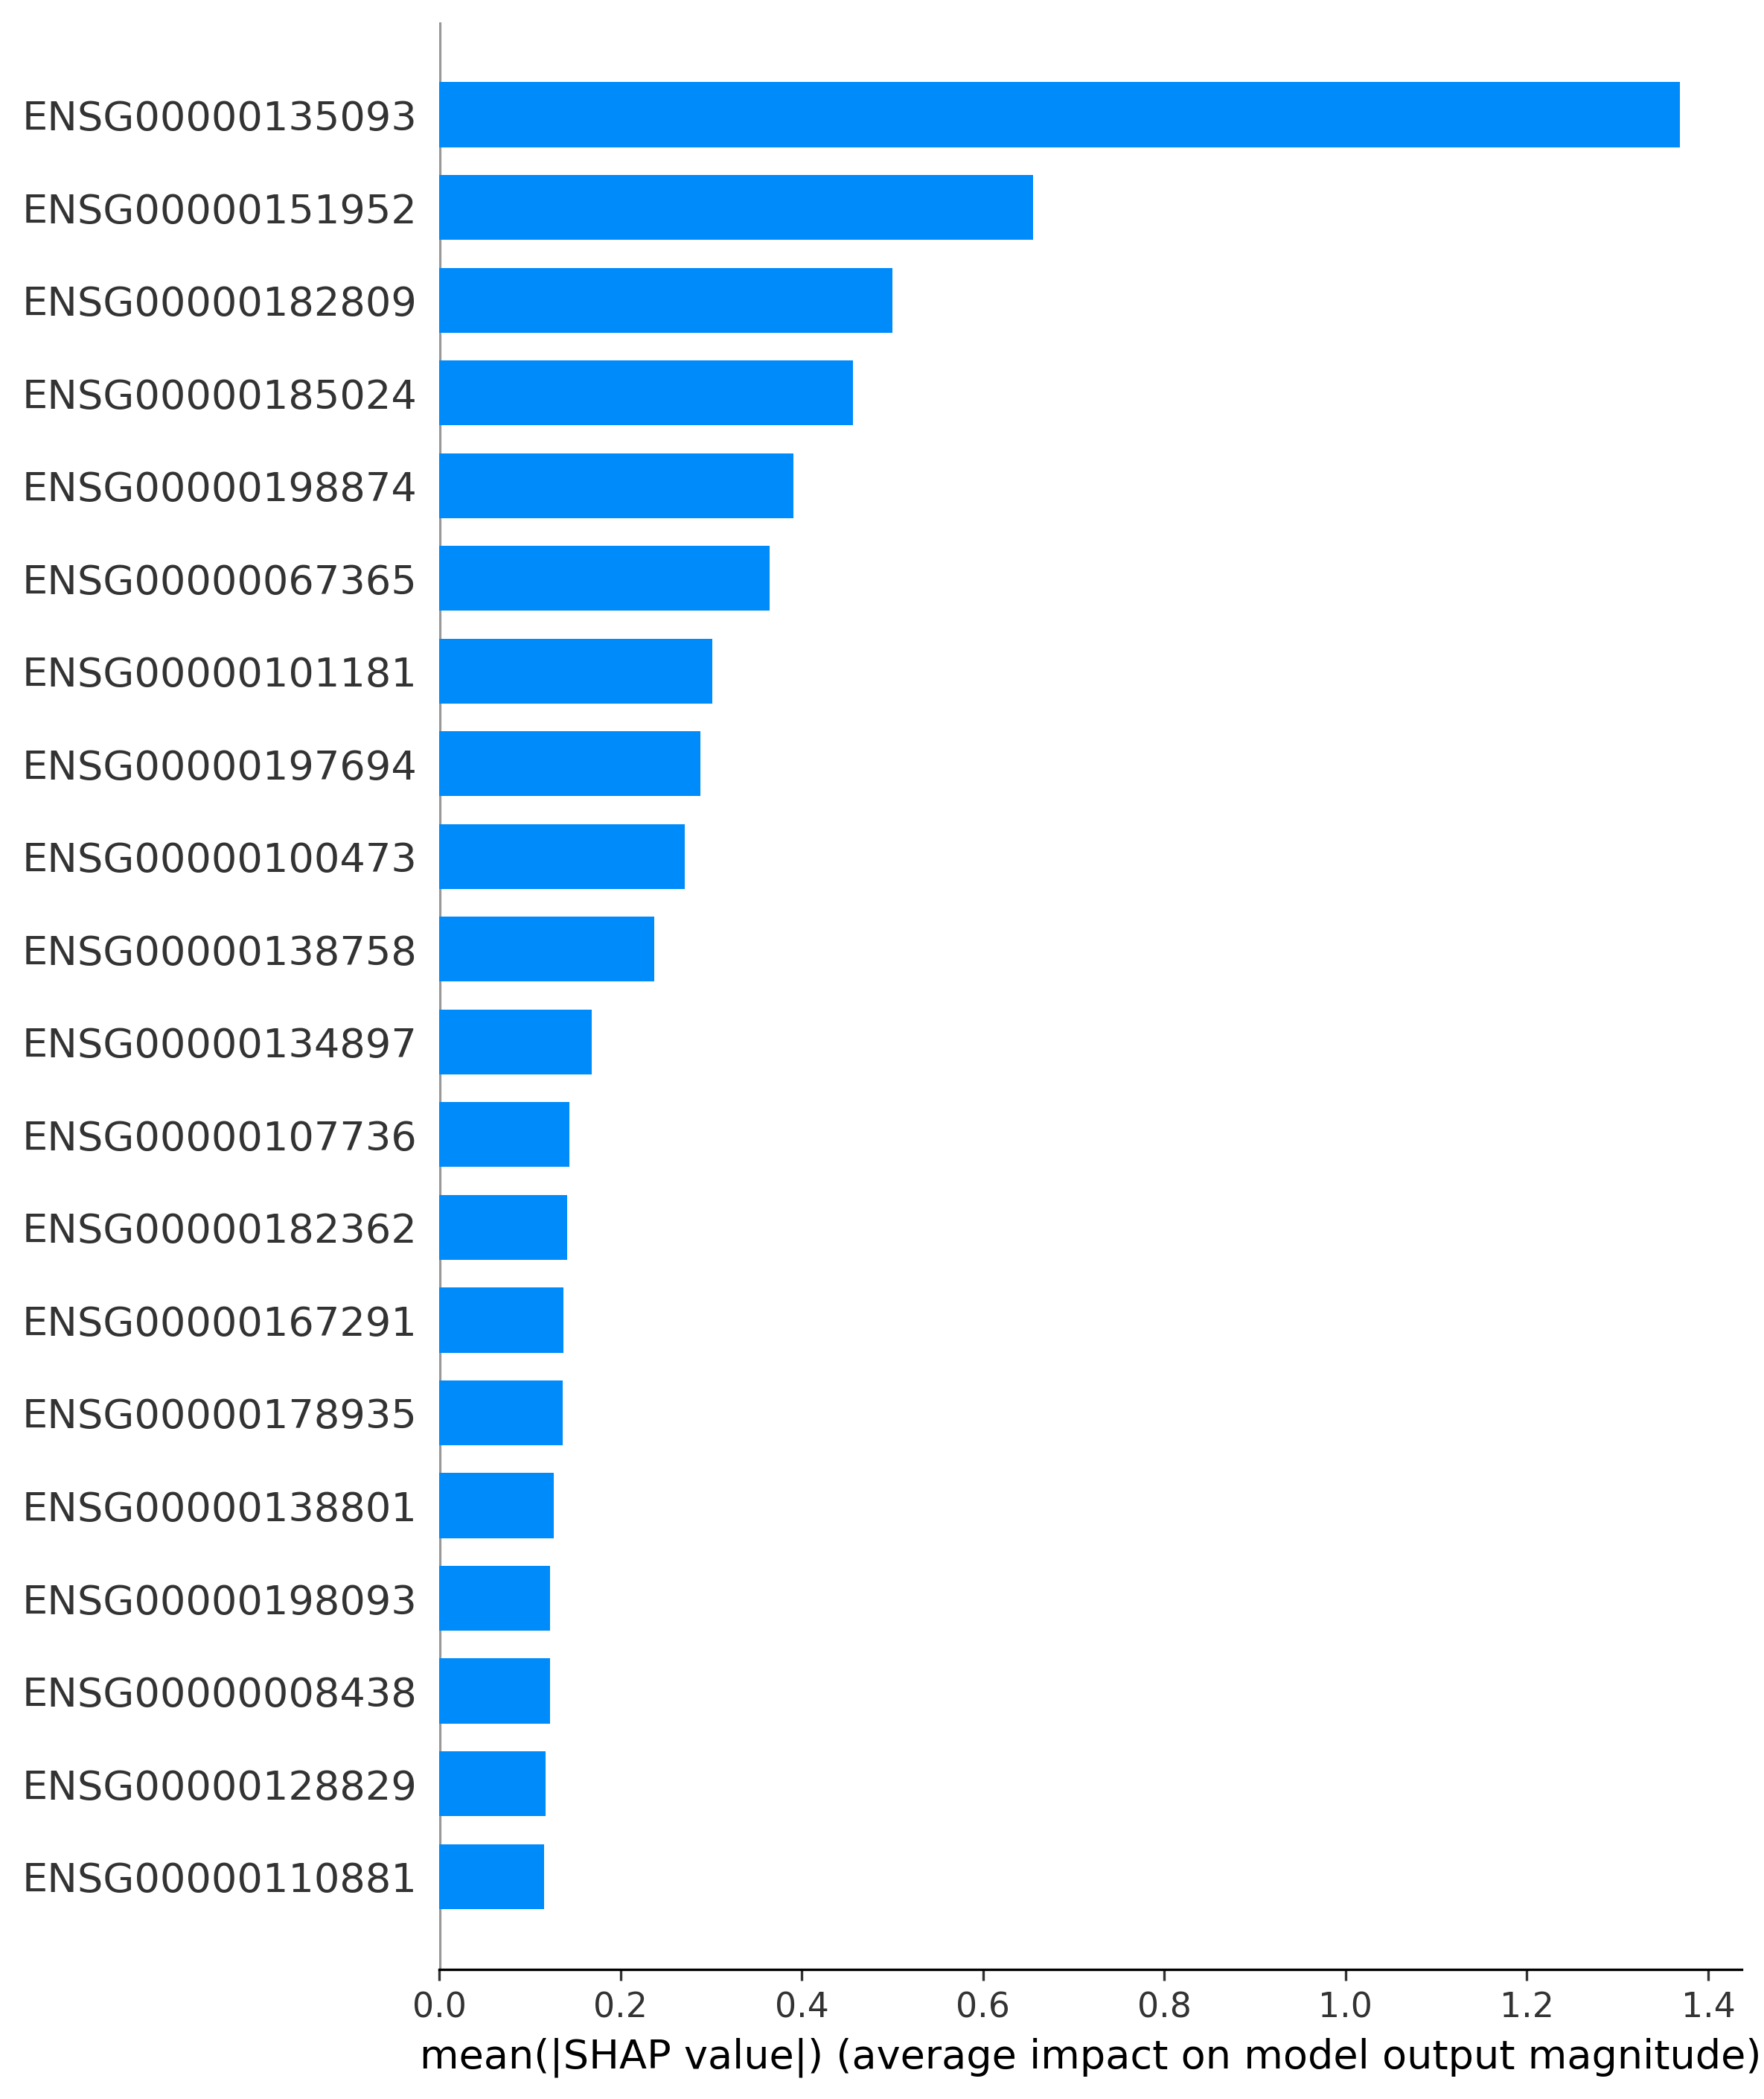
Figure 3. Bar plot showing top 20 genes ranked by mean absolute SHAP value. USP30 is the most important predictor (|SHAP|=1.369), followed by TMEM132D (|SHAP|=0.655) and CRIP2 (|SHAP|=0.500).

Figure 4. SHAP Summary Plot
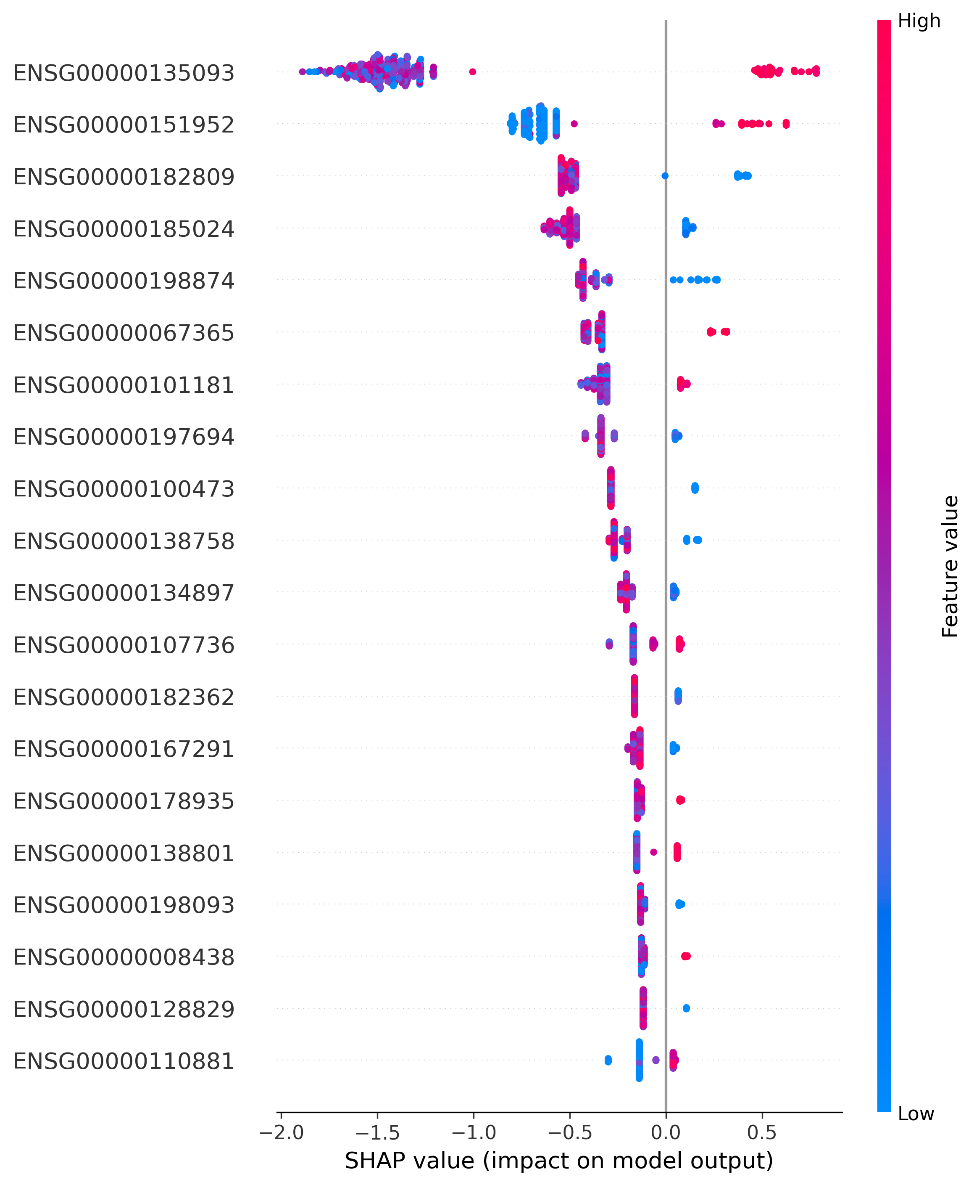
Figure 4. SHAP summary beeswarm plot showing feature effects on predictions. Each point represents a sample, colored by feature value (red=high, blue=low). Positive SHAP values indicate increased probability of treatment failure.

Figure 5. SHAP Dependence Plots for Top 3 Genes
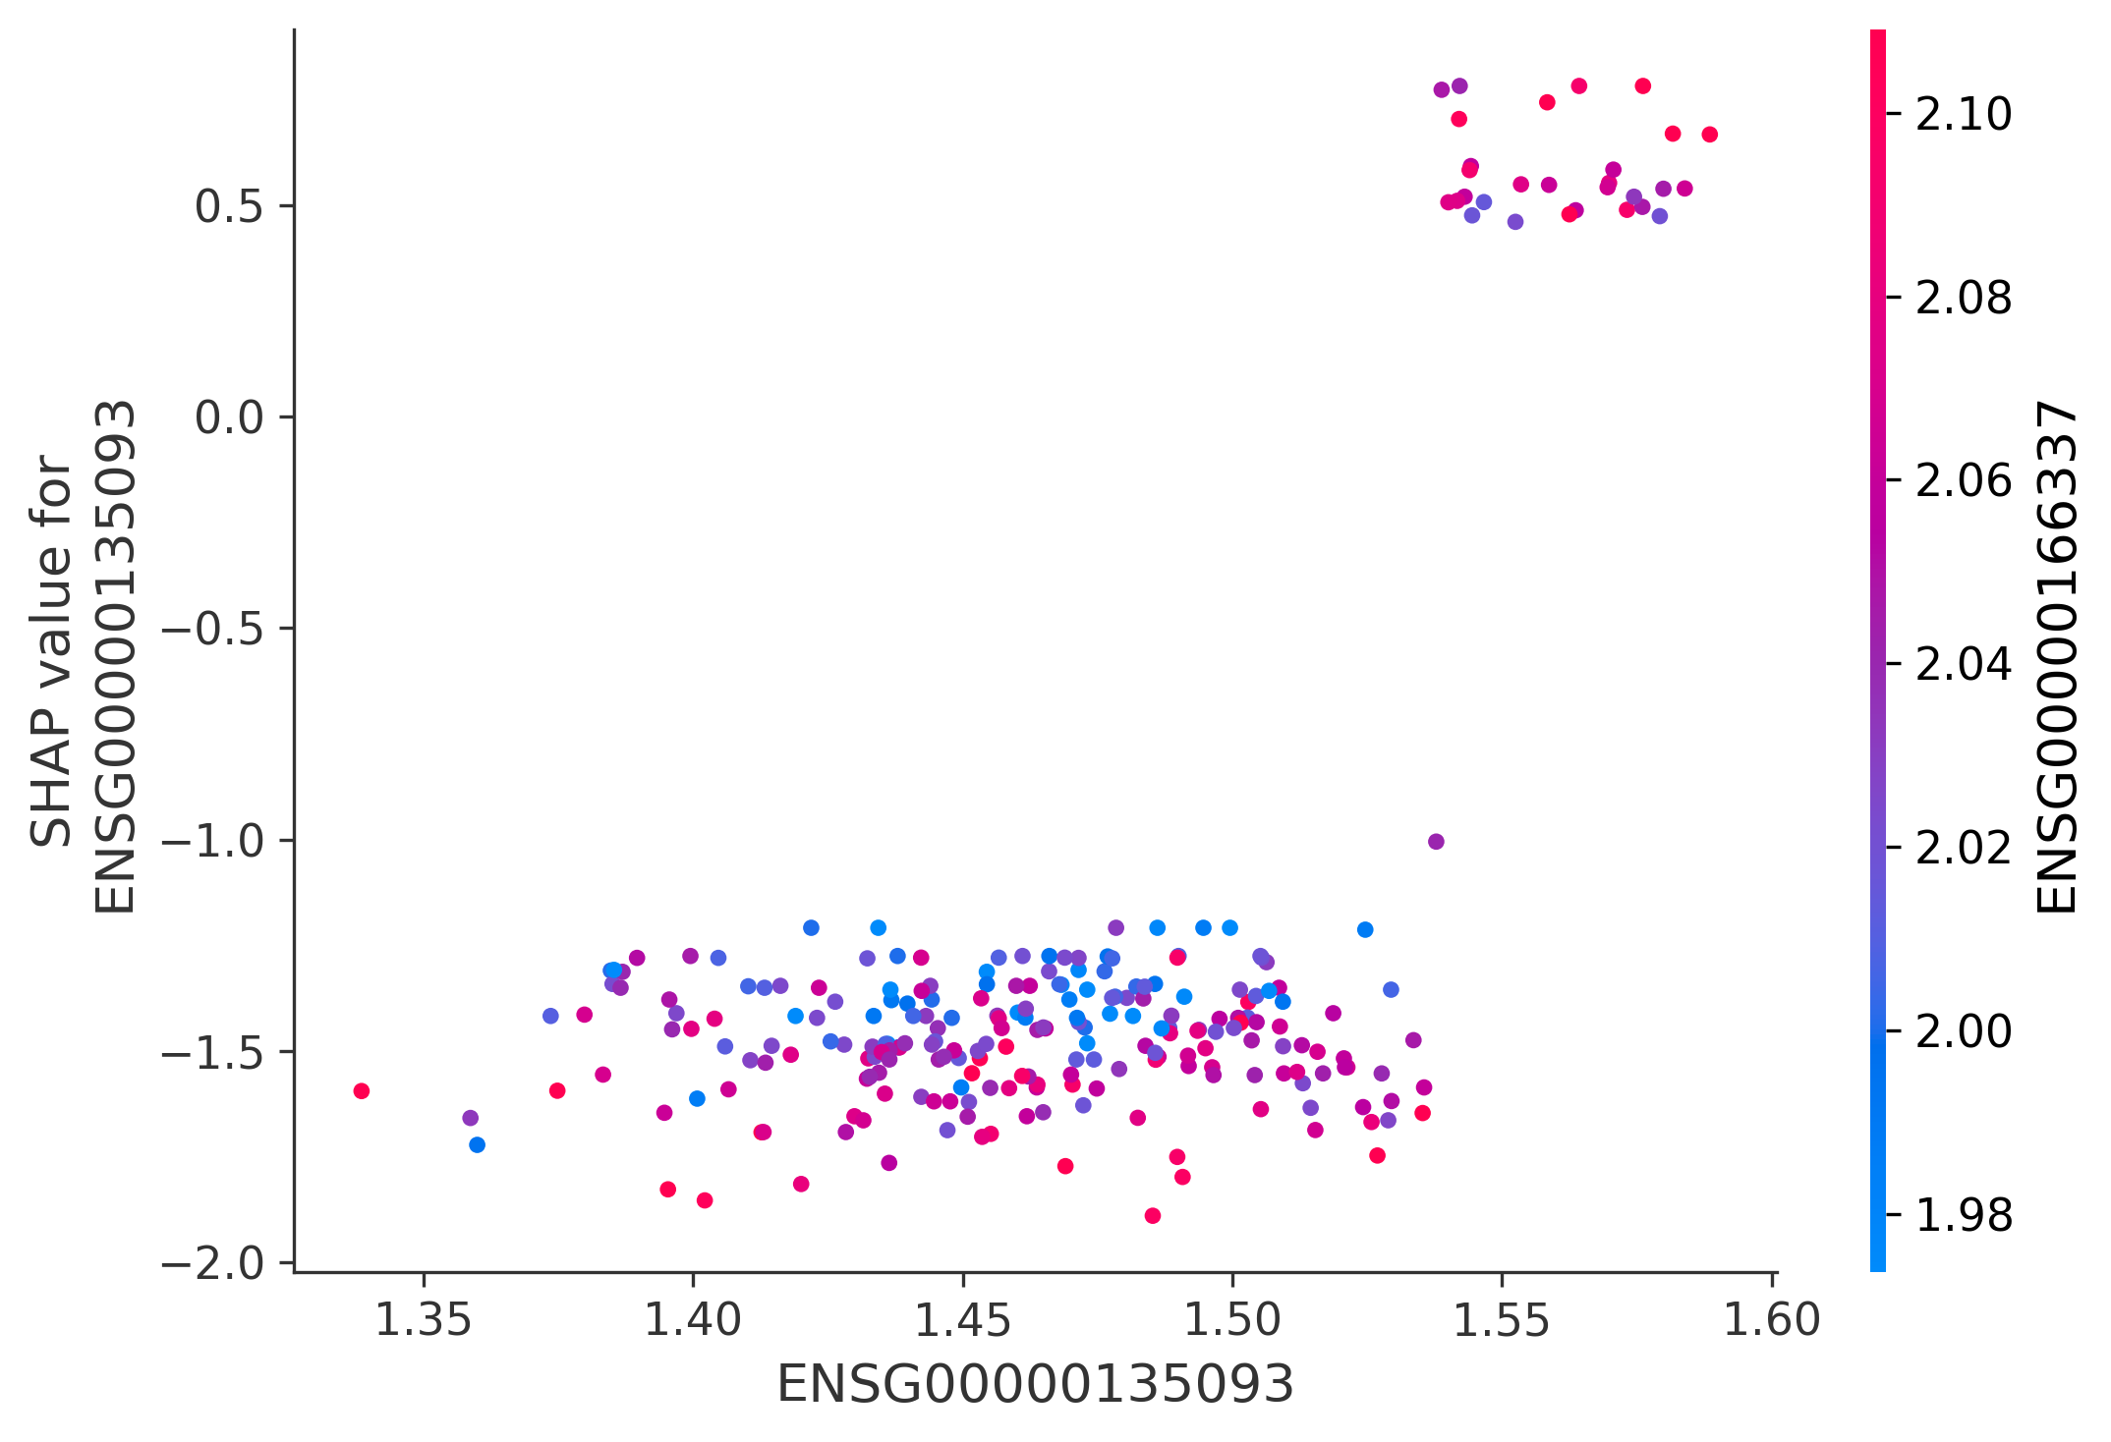
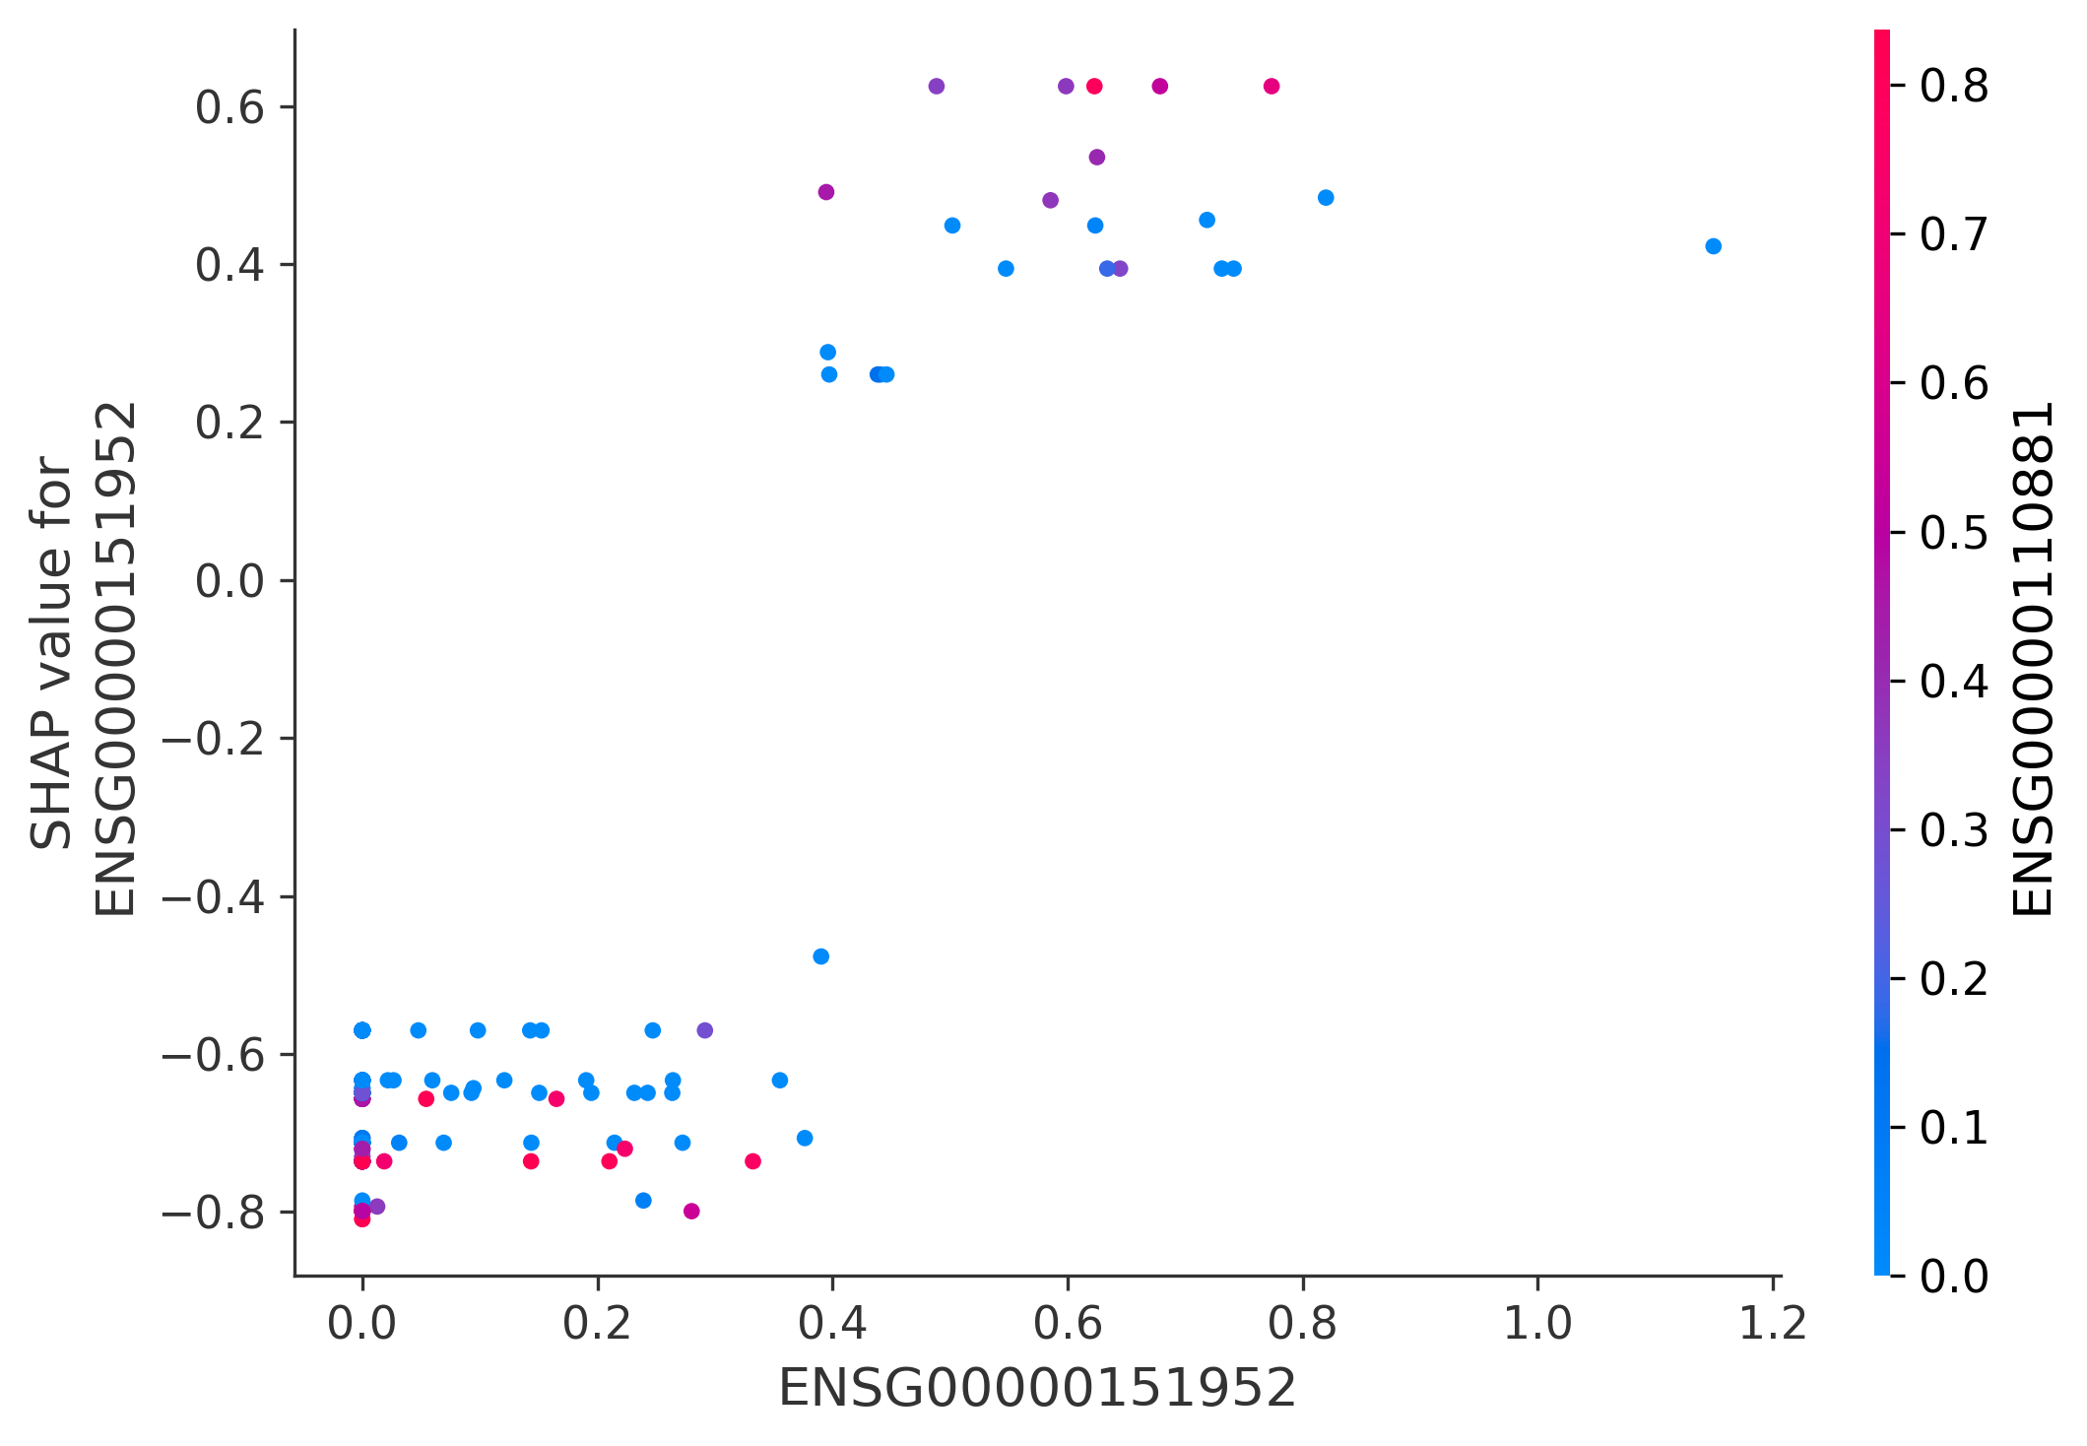
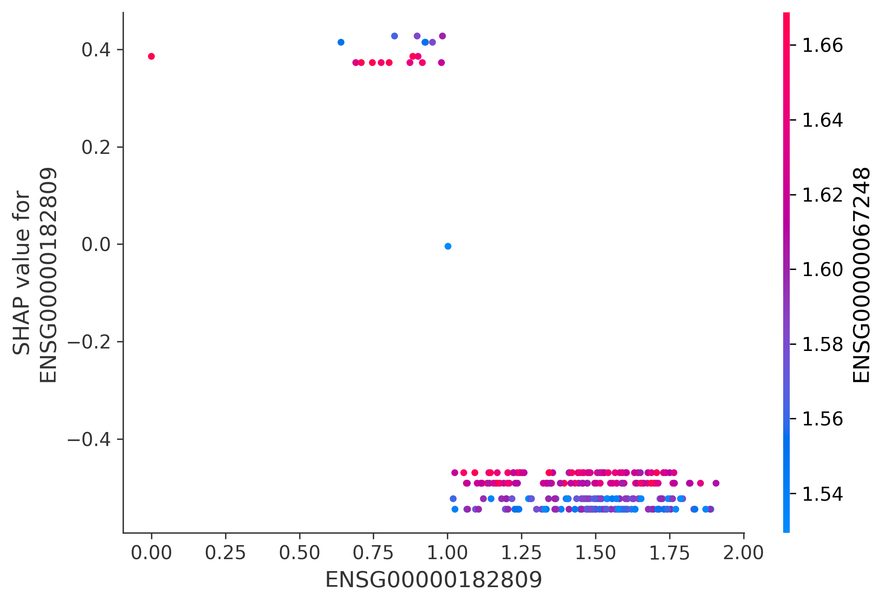
Figure 5. SHAP dependence plots showing relationship between gene expression (x-axis) and SHAP value (y-axis) for (A) USP30, (B) TMEM132D, and (C) CRIP2. Points are colored by interacting features.

Clinical Utility
At 90% sensitivity, the XGBoost model achieved 60% specificity, PPV of 6% (given 2.8% prevalence), and NPV of 99.7%. This suggests the model could correctly identify 60% of patients who will achieve cure while missing only 10% of failures.

DISCUSSION
This study provides proof-of-concept that baseline blood transcriptomics can predict TB treatment failure (AUC 0.794). The dominance of USP30, a mitochondrial quality control protein, suggests that baseline cellular homeostasis influences treatment response.¹⁶
Strengths include rigorous nested CV, transparent data leakage reporting, and full reproducibility. Limitations include small failure group (n=7), no external validation, and single geography. Future work requires prospective validation in larger, multi-site cohorts.¹⁷

CONCLUSIONS
Baseline blood transcriptomics can predict TB treatment failure with good accuracy, identifying novel biomarkers and justifying prospective validation studies for precision medicine in TB treatment.

REFERENCES
- WHO. Global Tuberculosis Report 2023. Geneva: WHO; 2023.
- Nahid P, et al. Treatment of Drug-Susceptible Tuberculosis. Clin Infect Dis. 2016;63(7):e147-e195. DOI: 10.1093/cid/ciw376
- Zumla A, et al. Tuberculosis. N Engl J Med. 2013;368(8):745-755. DOI: 10.1056/NEJMra1200894
- WHO. Definitions and reporting framework for tuberculosis. Geneva: WHO; 2013.
- Dheda K, et al. Multidrug-resistant tuberculosis. Lancet Respir Med. 2017;5(4):291-360. DOI: 10.1016/S2213-2600(17)30079-6
- Imperial MZ, et al. Treatment-shortening regimens. Nat Med. 2018;24(11):1708-1715. DOI: 10.1038/s41591-018-0224-2
- Walzl G, et al. TB biomarkers. Lancet Infect Dis. 2018;18(7):e199-e210. DOI: 10.1016/S1473-3099(18)30111-7
- Sweeney TE, et al. TB diagnosis. Lancet Respir Med. 2016;4(3):213-224. DOI: 10.1016/S2213-2600(16)00048-5
- Berry MP, et al. IFN signature. Nature. 2010;466(7309):973-977. DOI: 10.1038/nature09247
- Zak DE, et al. Progression risk. Lancet. 2016;387(10035):2312-2322. DOI: 10.1016/S0140-6736(15)01316-1
- Berry MP, et al. Systems approaches. Curr Opin Immunol. 2013;25(5):579-587. DOI: 10.1016/j.coi.2013.08.003
- WHO. Treatment guidelines. 4th ed. Geneva: WHO; 2010.
- Chawla NV, et al. SMOTE. J Artif Intell Res. 2002;16:321-357. DOI: 10.1613/jair.953
- Varma S, Simon R. CV bias. BMC Bioinformatics. 2006;7:91. DOI: 10.1186/1471-2105-7-91
- Lundberg SM, Lee SI. SHAP. NIPS. 2017;30:4765-4774.
- Youle RJ, Narendra DP. Mitophagy. Nat Rev Mol Cell Biol. 2011;12(1):9-14. DOI: 10.1038/nrm3028
- Chen EY, et al. Enrichr. BMC Bioinformatics. 2013;14:128. DOI: 10.1186/1471-2105-14-128

AUTHOR CONTRIBUTIONS
Siddalingaiah H S: All aspects of this work.

FUNDING
No external funding.

CONFLICTS OF INTEREST
None declared.

DATA AVAILABILITY
Data: GEO GSE89403. Code: https://github.com/hssling/TB_Treatment_Failure_Prediction_by_Transcriptomics

