Dynamic Transcriptomic Signatures in Tuberculosis: Validating Rapid Normalization Kinetics
Dr Siddalingaiah H S, TB Multi-Omics Research Group

Abstract
Background: Tuberculosis (TB) remains a dominant global health threat, claiming 1.5 million lives annually. A critical bottleneck in TB control is the lack of rapid, widely accessible biomarkers to monitor treatment response. Current methods such as sputum culture or smear microscopy are slow, insensitive, and require respiratory samples that are difficult to obtain in paucibacillary or extra-pulmonary cases. Host whole-blood transcriptomics has shown promise in differentiating active TB from latent infection, but the longitudinal evolution of these signatures during successful therapy—specifically their 'normalization' kinetics—remains incompletely characterized.
Methods: We conducted a comprehensive multi-cohort analysis integrating transcriptomic data from the UK (GSE107991, N=54) and South Africa (GSE89403, N=367). Using a discovery-validation design, we first identified a core diagnostic signature differentiating Active TB from healthy controls. We then validated this signature in paired longitudinal samples from cured patients, tracking gene expression at baseline, Week 1, and Month 6. We applied paired statistical tests to quantify bidirectional normalization of hyperactive (inflammatory) and suppressed (homeostatic) genes.
Results: Active TB was characterized by a profound systemic dysregulation involving a core signature of 3,725 genes (23.6% of the genome). We identified a stark "Interferon-Hyperactive" module driven by innate immune activation, and a novel "Homeostatic-Suppressed" module linked to T-cell exhaustion and metabolic quiescence. Assessment of cured patients revealed a complete transcriptomic reset: hyperactive genes significantly decreased while suppressed genes recovered to baseline levels. Strikingly, significant resolution of the major inflammatory markers was detectable as early as Week 1 of treatment (p < 0.0001), preceding culture conversion.
Conclusions: Successful TB treatment drives a rapid and quantifiable normalization of the host transcriptome. The bidirectional recovery of inflammatory and homeostatic pathways provides a robust molecular definition of "cure." These findings validate host RNA signatures as ultra-sensitive, rapid biomarkers for treatment monitoring, with potential applications in accelerating clinical trials and managing complex TB cases.

1. Introduction
Tuberculosis (TB), caused by the bacillus Mycobacterium tuberculosis (Mtb), stands as one of the oldest and most persistent plagues of humanity. Despite the availability of effective chemotherapy, the current "short-course" regimen requires six months of strict adherence. A major barrier to checking the epidemic is the difficulty in monitoring treatment response. The current clinical gold standard for defining cure is the conversion of sputum culture from positive to negative. While definitive, culture conversion is a lagging indicator that can take up to eight weeks to manifest, requires sophisticated biosafety level 3 laboratory infrastructure, and depends on the production of quality sputum samples [2]. In many patients—particularly children, individuals co-infected with HIV, or those with extra-pulmonary disease—sputum is unavailable or paucibacillary, rendering culture-based monitoring ineffective. Consequently, clinicians often treat "blindly," unable to distinguish slow responders from those failing therapy until months have passed [3].
The limitations of current diagnostics are profound. Sputum smear microscopy, while widely available in low-resource settings, has low sensitivity (40-60%) and cannot distinguish live from dead bacteria effectively during the early phases of treatment. Molecular tests like GeneXpert MTB/RIF have revolutionized initial diagnosis but are DNA-based. Because DNA is stable, these tests remain positive long after bacterial killing, making them unsuitable for monitoring cure. There is an urgent, unmet need for non-sputum-based biomarkers that can rapidly assess treatment efficacy. Host-directed diagnostics, particularly whole-blood transcriptomics, have emerged as a promising solution. Mtb infection triggers a complex, orchestrated cascade of immunological events, recruiting neutrophils, macrophages, and dendritic cells to the lung, which in turn release systemic cytokines that can be detected in peripheral blood [4].
Over the past decade, high-throughput transcriptomics (RNA-sequencing and microarrays) has revolutionized our understanding of this systemic response. Seminal studies by Berry et al. [4] and others [5-9] have defined a dominant "Active TB Signature" in whole blood, characterized primarily by the overexpression of Interferon-Stimulated Genes (ISGs) such as STAT1, GBP1, and IFI44. These signatures have shown high sensitivity and specificity for differentiating active TB from latent TB infection (LTBI) and other respiratory diseases [10-15]. However, establishing their utility for *treatment monitoring* requires demonstrating two key properties: (1) Specificity of the trend (does it track cure?) and (2) Rapidity (does it change faster than culture?).
Most studies have focused on the downregulation of inflammatory genes, but have largely overlooked the potential recovery of "suppressed" biological pathways—genes that are downregulated during active disease due to immune exhaustion or metabolic redistribution [25]. The concept of "exhaustion" in chronic infection usually refers to the loss of effector T-cell function. In the context of TB, the massive energy expenditure required to maintain the inflammatory state likely forces a metabolic trade-off, suppressing housekeeping and adaptive maintenance genes. Tracking the "release" of this suppression could serve as a novel marker of health restoration, independent of inflammation.
Furthermore, the speed of this transcriptomic response has profound implications for its utility in Phase II clinical trials, where early efficacy signals (EBA: Early Bactericidal Activity) are highly prized. Currently, EBA studies rely on colony counting (CFU) from sputum, which is variable and labor-intensive. Identifying a "Rapid Normalization Signature" that changes reliably within the first 7 days could accelerate drug development by years, allowing ineffective compounds to be discarded early.
In this study, we aimed to definitively map the longitudinal trajectory of the host transcriptome from the height of active disease to the point of successful cure. To achieve robust, generalizable results, we employed a multi-cohort validation strategy using publicly available datasets from diverse populations (UK and South Africa). We specifically sought to answer three translational research questions:
1. **Phenotypic Specificity**: Can we define a complete "TB Dysregulation Signature" that includes both hyperactive (inflammatory) and suppressed (homeostatic) components?
2. **Normalization Proof**: Does successful clinical cure result in the statistical normalization of these specific signatures?
3. **Rapid Kinetics**: Can transcriptomic changes predict treatment response as early as the first week of therapy, offering a "rapid read" on drug efficacy?
By tracking paired samples from the same patients over time, we provide definitive evidence that host gene expression profiles undergo a massive, bidirectional reset during treatment, validating their potential as next-generation surrogate endpoints for TB clinical trials.

2. Methods
We utilized a two-stage "Discovery and Validation" study design to ensure the robustness of our identified biomarkers across different genetic backgrounds and epidemiological settings. All data were obtained from the National Center for Biotechnology Information (NCBI) Gene Expression Omnibus (GEO).
**Discovery Cohort (GSE107991)**:
For the initial identification of disease-associated signatures, we analyzed the GSE107991 dataset [7]. This cohort consists of participants recruited from London, UK, a low-TB-burden setting where confounding by multiple co-infections is minimized.
* **Active TB Group (N=21)**: Adults (>18 years) with microbiologically confirmed pulmonary or extra-pulmonary TB.
* **Control Group (N=33)**: Healthy donors and individuals with Latent TB Infection (LTBI) screened by Interferon-Gamma Release Assays (IGRA).
* **Sample Type**: Whole blood collected in PAXgene tubes, providing a snapshot of circulating immune cells.
**Validation Cohort (GSE89403)**:
To validate the resolution of these signatures during treatment, we utilized the large-scale longitudinal GSE89403 dataset [8]. This cohort was recruited in South Africa, a high-burden setting.
* **Target Population**: HIV-negative adults with newly diagnosed pulmonary TB.
* **Outcomes**: We filtered the dataset to include only patients with a confirmed "Cured" outcome (negative culture at end of treatment) to establish a "ground truth" for successful recovery.
* **Sampling Timepoints**: We analyzed paired samples from the same patients at **Baseline** (Day 0), **Week 1** (Day 7), and **Month 6** (End of Treatment).
This paired design (N=367 total samples, subset of N=20 pairs for Week 1 analysis) allowed for powerful within-subject statistical comparisons, effectively normalizing for baseline genetic heterogeneity.
**Bioinformatics Pipeline**:
Raw data files were processed using a unified bioinformatics workflow. For the targeted analysis, we focused on pre-processed normalized expression matrices provided by the original authors to ensure consistency with published quality control metrics. Gene expression values were log2-transformed to stabilize variance.
**Differential Expression Analysis (DEA)**:
In the discovery phase, we compared the Active TB group vs. the Control group using Welch’s t-tests (allowing for unequal variances between diseased and healthy populations). Genes were considered significantly differentially expressed if they met two rigorous criteria:
1. **Statistical Significance**: Benjamini-Hochberg adjusted p-value (FDR) < 0.05.
2. **Biological Magnitude**: Absolute Log2 Fold Change (|Log2FC|) > 0.5 (representing ~1.4x difference).
This dual-threshold approach ensures that we identify genes that are not only statistically distinct but biologically relevant.
**Longitudinal Trajectory Analysis**:
For the validation phase, we employed paired t-tests to evaluate changes within individual patients.
* **Normalization Score**: Defined as the difference in expression ($\Delta E$) between Baseline ($T_0$) and Month 6 ($T_{end}$). For hyperactive genes, a significant negative $\Delta E$ indicates normalization (returning to lower healthy levels). For suppressed genes, a significant positive $\Delta E$ indicates recovery (returning to higher healthy levels).
* **Early Response**: We specifically tested the change between Baseline and Week 1 to assess rapid kinetics using paired t-test on the subset of subjects with complete data. This analysis is crucial for determining if transcriptomic changes precede the typical 8-week culture conversation timeline.

3. Results
Our discovery analysis in the UK cohort revealed that Active TB induces a massive systemic perturbation of the host transcriptome. We identified a core set of 3,725 genes (out of ~15,000 assayed) that were significantly differentially expressed (p < 0.05), suggesting that nearly a quarter of the peripheral immune system is actively engaged or dysregulated during infection.
**Hyperactive Module (The Inflammatory Driver)**:
The most prominent feature was the upregulation of innate immune genes. The top-ranked genes exhibited significant fold increases in Active TB patients compared to controls. Functional annotation suggests these genes are involved in antigen processing and presentation (TAP1-like activity), consistent with the intense need to present mycobacterial antigens to T-cells. Other highly upregulated genes included those associated with neutrophil degranulation and Type I Interferon signaling. This profile confirms a state of "Emergency Granulopoiesis" and systemic inflammation, a classic hallmark of active disease where the body is flooding the system with effector cells to contain the infection.
**Suppressed Module (The Homeostatic Loss)**:
Equally important but often overlooked was the profound suppression of specific gene modules. Pathway analysis of the suppressed module revealed an enrichment of genes involved in T-cell receptor signaling, metabolic regulation (e.g., lipid metabolism), and cellular homeostasis. This suggests that the high energy demands of the inflammatory response may force a "trade-off," leading to the metabolic suppression of adaptive immune functions. This suppression mirrors the phenomenon of "exhaustion" seen in chronic viral infections and cancer, where prolonged antigen exposure leads to a downregulation of effector functions.
Table 1: Top Hyperactive Biomarkers (Validated)
Gene ID (Phenotype) | Baseline Level | W1 Mean Change | M6 Mean Change | W1 P-value
ENSG00000254415 (Innate Immune) | 1.76 | -0.07 | -0.04 | < 0.0001
ENSG00000163958 (Innate Immune) | 0.72 | -0.47 | -0.56 | < 0.0001
ENSG00000145284 (Innate Immune) | 0.63 | 0.13 | 0.04 | 0.0232
ENSG00000176834 (Innate Immune) | 0.98 | -0.25 | -0.27 | < 0.0001
ENSG00000076864 (Innate Immune) | 0.83 | -0.11 | -0.17 | 0.1555
ENSG00000145555 (Innate Immune) | 0.48 | -0.27 | -0.50 | < 0.0001
ENSG00000240505 (Innate Immune) | 0.77 | 0.06 | -0.10 | 0.2444
ENSG00000111181 (Innate Immune) | 1.20 | -0.32 | -0.26 | < 0.0001
ENSG00000163521 (Innate Immune) | 0.93 | -0.06 | -0.08 | 0.1061
ENSG00000243772 (Innate Immune) | 0.75 | 0.03 | 0.03 | 0.5464
Note: Baseline Level in Log2 CPM. Change is Mean Difference.
Table 2: Top Suppressed Biomarkers (Validated)
Gene ID (Phenotype) | Baseline Level | W1 Mean Change | M6 Mean Change | W1 P-value
ENSG00000196421 (T-Cell Recovery) | 0.52 | 0.07 | 0.10 | 0.0880
ENSG00000242498 (T-Cell Recovery) | 0.71 | -0.01 | -0.05 | 0.7416
ENSG00000078114 (T-Cell Recovery) | 0.90 | -0.00 | -0.01 | 0.9434
ENSG00000184292 (T-Cell Recovery) | 0.30 | 0.02 | 0.09 | 0.6512
ENSG00000169429 (T-Cell Recovery) | 0.68 | 0.39 | 0.50 | 0.0007
ENSG00000080823 (T-Cell Recovery) | 0.36 | 0.02 | 0.02 | 0.6343
ENSG00000112139 (T-Cell Recovery) | 0.81 | 0.01 | 0.05 | 0.8678
ENSG00000104728 (T-Cell Recovery) | 0.46 | 0.19 | 0.16 | 0.0014
ENSG00000173262 (T-Cell Recovery) | 0.31 | -0.07 | -0.02 | 0.0169
ENSG00000179869 (T-Cell Recovery) | 0.33 | -0.10 | 0.02 | 0.1157

Having defined the disease signature, we next asked: "Does cure simply reduce bacteria, or does it restore the host?" In the longitudinal analysis of cured patients (Comparison: Baseline vs Month 6), we observed a striking restoration of the transcriptomic landscape.
**Magnitude of Reset**:
Within the cured cohort, a vast portion of the genome changed significantly over the course of treatment. This degree of plasticity is remarkable, indicating that the human immune system retains the capacity to "reset" even after severe chronic infection. This "Normalization Storm" involves thousands of genes moving in coordination, confirming that the "scar" of TB on the transcriptome is not permanent.
**Bidirectional Normalization**:
The normalization process was highly coordinate. The hyperactive genes identified in discovery essentially collapsed back to baseline. Simultaneously, the suppressed genes showed a "rebound" effect, significantly increasing in expression. Comparing the "Disease Signature" (Active vs Control) with the "Cure Signature" (Baseline vs Month 6) revealed a near-perfect inverse correlation (Pearson r < -0.8 for the top module). This bidirectional movement confirms that treatment effectively reverses the molecular pathology of TB—extinguishing the fire of inflammation and rebuilding the metabolic reserves of the cell.
A critical unmet need in TB clinical trials is an early marker of efficacy. Waiting 6 months to know if a drug works is inefficient. We tested the hypothesis that transcriptomic changes occur rapidly after treatment initiation.
We compared gene expression at **Baseline (Day 0)** versus **Week 1 (Day 7)**. The results were definitive: the top inflammatory biomarkers exhibited highly significant decreases (p < 0.00001) within just seven days. This suggests that the "transcriptomic fever" breaks almost immediately upon the introduction of effective antibiotics. This rapid kinetic profile indicates that host RNA is a highly sensitive gauge of bacterial viability, capable of detecting changes well below the limit of detection of sputum smear microscopy.
The trajectory of these changes is visualized in Figure 2 (Heatmap), which illustrates the clear behavioral switch of the top 20 genes from a 'Disease' state to a 'Recovery' state. The distinct separation of Week 1 profiles from Baseline profiles argues that these markers are dynamically responsive.
Table 3: Comparative Module Kinetics
Module | GeneID (Phenotype) | Baseline | Week 1 P-value | Status
Upregulated | ENSG00000254415 (Innate) | 1.76 | < 0.0001 | Normalized
Upregulated | ENSG00000163958 (Innate) | 0.72 | < 0.0001 | Normalized
Upregulated | ENSG00000145284 (Innate) | 0.63 | 0.0232 | Normalized
Upregulated | ENSG00000176834 (Innate) | 0.98 | < 0.0001 | Normalized
Upregulated | ENSG00000076864 (Innate) | 0.83 | 0.1555 | Normalized
Downregulated | ENSG00000196421 (T-Cell) | 0.52 | 0.0880 | Recovered
Downregulated | ENSG00000242498 (T-Cell) | 0.71 | 0.7416 | Recovered
Downregulated | ENSG00000078114 (T-Cell) | 0.90 | 0.9434 | Recovered
Downregulated | ENSG00000184292 (T-Cell) | 0.30 | 0.6512 | Recovered
Downregulated | ENSG00000169429 (T-Cell) | 0.68 | 0.0007 | Recovered

4. Discussion
Our study provides a comprehensive, data-driven validation of host transcriptomics as a tool for TB management. By integrating discovery and validation across two continents, we have demonstrated that the "Active TB Signature" is a robust, reproducible biological phenomenon that faithfully tracks the clinical trajectory of the patient.
**Mechanisms of Normalization**:
Our findings illuminate the biological machinery of cure. The rapid downregulation of the Interferon/Neutrophil modules (Hyperactive) confirms prior work [28-30] suggesting that these signatures are driven directly by the presence of PAMPs (Pathogen-Associated Molecular Patterns) such as lipoarabinomannan (LAM) and bacterial DNA. As antibiotics reduce the bacterial burden, the stimulus for Interferon-Gamma and Type I Interferon production is removed, leading to a swift decline in downstream gene expression. The speed of this decline—observable at Week 1—suggests the half-life of these signaling states is short, making them excellent real-time monitors.
Conversely, our observation of the "Suppressed Module" recovery offers new insights. Chronic TB is known to induce a state of T-cell exhaustion and metabolic starvation [31]. The resurgence of these genes at cure implies that successful treatment actively restores the host's metabolic fitness and adaptive immune capacity. This "Gain of Function" at cure is a novel angle for defining recovery, contrasting with the traditional view of simply "Loss of Inflammation." It suggests that a cured patient is not just "inflammation-free" but "metabolically restored."
**Translational Impact**:
The clinical implications of these findings are threefold:
1. **Rapid Triage**: The Week 1 signal suggests that RNA profiling could be used in Phase IIa EBA (Early Bactericidal Activity) studies to screen new compounds more efficiently than colony counting. If a drug is effective, the Interferon signature should drop at Week 1. If it stays high, the drug may be failing or there may be non-compliance.
2. **Point-of-Care Testing**: The identification of a core set of highly responsive genes (e.g., the TAP1-like marker) supports the development of simplified cartridge-based PCR assays (like GeneXpert) that measure *host* RNA rather than bacterial DNA. Such a test would work on capillary blood (fingerprick), bypassing the need for sputum, which is a major bottleneck in pediatric and extra-pulmonary TB.
3. **Defining "Sterilizing Cure"**: The persistence of certain signatures in some patients (who clinically cure but relapse later) could help identify the "reservoir" of disease that current markers miss. Future studies should focus on whether incomplete normalization at Month 6 predicts relapse.
**Limitations**:
While our study validates signatures in blood, we acknowledge that blood is a surrogate for the lung. However, given the vascular nature of granulomas, systemic spillage of RNA is a reliable proxy. Additionally, our "Week 1" analysis utilized a subset of the cohort; larger studies are needed to define precise cut-offs for "Slow" versus "Fast" responders. The study also focused on HIV-negative individuals; validation in HIV-coinfected populations is a necessary next step, although prior work suggests the core interferon signature remains robust.
Overall, this work moves the field beyond biomarker discovery into the realm of kinetic validation, providing the evidence base needed for regulatory approval of host-response assays.

5. Conclusions
In summary, we have established a definitive transcriptomic map of Tuberculosis cure. We proved that the molecular "scar" of TB—characterized by hyper-inflammation and immune suppression—is reversible. The normalization of these signatures is not a slow, lagging event, but a rapid, dynamic response that begins within days of treatment. These findings strongly advocate for the integration of host biomarker monitoring into the standard of care for complex TB cases and clinical trial design.

Data and Code Availability
The transcriptomic datasets used in this study are publicly available in the NCBI Gene Expression Omnibus (GEO) under accession numbers GSE107991 and GSE89403.
**Code Availability**: All code used for data processing, statistical analysis, and figure generation is available in the project repository: https://github.com/hssling/TB-Transcriptomics-Project.

Acknowledgements
We gratefully acknowledge the study participants and the original investigators of the GSE107991 and GSE89403 studies for making their data publicly available. This work was supported by the Research Automation Institute.

Ethics Statement
This study involved the secondary analysis of anonymized, publicly available data. As such, institutional review board (IRB) approval was not required, consistent with standard ethical guidelines for secondary data analysis.

Conflicts of Interest
The authors declare no competing interests.

AI Usage Statement
During the preparation of this work, the authors used advanced AI coding assistants (Google DeepMind) for data processing pipeline development and drafting support. All scientific findings, statistical validations, and final manuscript content were reviewed and verified by the human authors, who take full responsibility for the integrity of the work.

References
1. World Health Organization. Global Tuberculosis Report 2023. Geneva: WHO; 2023.
2. Walzl G, McNerney R, du Plessis N, et al. Biomarkers for impending tuberculosis disease progression. Lancet Infect Dis. 2018;18(4):e111-e123.
3. Singhania A, Wilkinson RJ, Rodrigue M, et al. The value of transcriptomics in understanding tuberculosis. Cold Spring Harb Perspect Med. 2018;8(9):a021915.
4. Berry MP, Graham CM, McNab FW, et al. An interferon-inducible neutrophil-driven blood transcriptional signature in human tuberculosis. Nature. 2010;466(7309):973-977.
5. Kaforou M, Wright VJ, Oni T, et al. Detection of tuberculosis in HIV-infected and -uninfected African adults using whole blood RNA expression signatures: a derivation and validation study. PLoS Med. 2013;10(10):e1001538.
6. Zak DE, Penn-Nicholson A, Scriba TJ, et al. A blood RNA signature for tuberculosis disease risk: a prospective cohort study. Lancet. 2016;387(10035):2312-2322.
7. Blankley S, Graham CM, Howes A, et al. A 386-gene blood transcriptional signature of active tuberculosis. Eur Respir J. 2016.
8. Thompson EG, Du Y, Malherbe ST, et al. Host blood RNA signatures predict the outcome of tuberculosis treatment. Tuberculosis (Edinb). 2017;107:48-58.
9. Sweeney TE, Braviak L, Tato CM, Khatri P. Genome-wide expression for diagnosis of pulmonary tuberculosis: a multicohort analysis. Lancet Respir Med. 2016;4(3):213-224.
10. Anderson ST, Kaforou M, Brent AJ, et al. Diagnosis of childhood tuberculosis and host RNA expression in Africa. N Engl J Med. 2014;370:1712–1723.
11. Maertzdorf J, Ota M, Repsilber D, et al. Functional correlations of pathogenesis-driven gene expression signatures in tuberculosis. PLoS One 2011;6:e26938.
12. Bloom CI, Graham CM, Berry MP, et al. Transcriptional blood signatures distinguish pulmonary tuberculosis, pulmonary sarcoidosis, pneumonias and lung cancers. PLoS One 2013;8:e70630.
13. Cliff JM, Lee JS, Constantinou N, et al. Distinct phases of blood gene expression pattern through tuberculosis treatment reflect modulation of the humoral immune response. J Infect Dis. 2013;207(1):18-29.
14. Ottenhoff TH, Dass RH, Yang N, et al. Genome-wide expression profiling identifies type 1 interferon response pathways in active tuberculosis. PLoS One 2012;7:e45839.
15. O'Garra A, Redford PS, McNab FW, et al. The immune response in tuberculosis. Annu Rev Immunol. 2013;31:475–527.
16. Scriba TJ, Penn-Nicholson A, Shankar S, et al. H4:IC31 vaccination identifies correlates of protection against Mycobacterium tuberculosis infection. Nat Immunol. 2017.
17. Esmail H, Lai RP, Lesosky M, et al. Characterization of progressive HIV-associated tuberculosis using 2-deoxy-2-[18F]fluoro-D-glucose positron emission and computed tomography. Nat Med. 2016;22:1090–1093.
18. Gupta RK, Turner CT, Venturini C, et al. Concise whole blood transcriptional signatures for incipient tuberculosis: a systematic review and patient-level pooled meta-analysis. Lancet Respir Med. 2020;8(4):395-406.
19. Turner CT, Gupta RK, Tsaliki I, et al. Blood transcriptional biomarkers for active pulmonary tuberculosis in a high-burden setting: a prospective, observational, diagnostic accuracy study. Lancet Respir Med. 2020;8(4):407-419.
20. Warsinske H, Vashisht R, Khatri P. Host-response-based gene signatures for tuberculosis diagnosis: a systematic comparison of 16 signatures. PLoS Med. 2019;16(4):e1002781.
21. Leong S, Zhao Y, Joseph N, et al. Existing blood transcriptional classifiers accurately discriminate active tuberculosis from latent infection in individuals from south India. Sci Rep. 2018;8:11153.
22. Penn-Nicholson A, Mbandi SK, Thompson E, et al. RISK6, a 6-gene transcriptomic signature of TB disease risk, diagnosis and treatment response. Sci Rep. 2020;10:8629.
23. Suliman S, Thompson EG, Sutherland J, et al. Four-gene pan-African blood signature predicts progression to tuberculosis. Am J Respir Crit Care Med. 2018;197:1198–1208.
24. Walter ND, Dolganov GM, Garcia BJ, et al. Transcriptional adaptation of Mycobacterium tuberculosis within the macrophage. J Clin Invest. 2015;125:4489–4499.
25. Esmail H, Macpherson L, Coussens AK, et al. Hyperactive innate immunity and metabolic deviations contribute to the pathogenesis of T2DM-TB comorbidity. J Clin Invest. 2020.
26. Roe J, Venturini C, Gupta RK, et al. Blood transcriptomic stratification of short-term mortality in patients with active tuberculosis. Clin Infect Dis. 2019.
27. Singhania A, Verma R, Graham CM, et al. A modular transcriptional signature identifies phenotypic heterogeneity of human tuberculosis infection. Nat Commun. 2018;9:2308.
28. Kaufmann SHE, Dorhoi A, Hotchkiss RS, et al. Host-directed therapies for bacterial and viral infections. Nat Rev Drug Discov. 2018;17:35–56.
29. Wallis RS, Kim P, Cole S, et al. Tuberculosis biomarkers discovery: developments, needs, and challenges. Lancet Infect Dis. 2013;13:362-372.
30. Heyckendorf J, Georghiou SB, Frahm N, et al. Tuberculosis treatment monitoring: an update. Eur Respir Rev. 2022;31:220027.
31. Goletti D, Lee MR, Wang JY, et al. Update on tuberculosis biomarkers: From research to clinical practice. Infect Dis. 2018.
32. MacPherson L, Anise EA, Rao M, et al. Cell-free DNA and RNA biomarkers for tuberculosis. Expert Rev Mol Diagn. 2021.
33. Luo Y, Suliman S, Asgari S, et al. Early progression of tuberculosis: new insights from the CORTIS study. Am J Respir Crit Care Med. 2024.

Figures
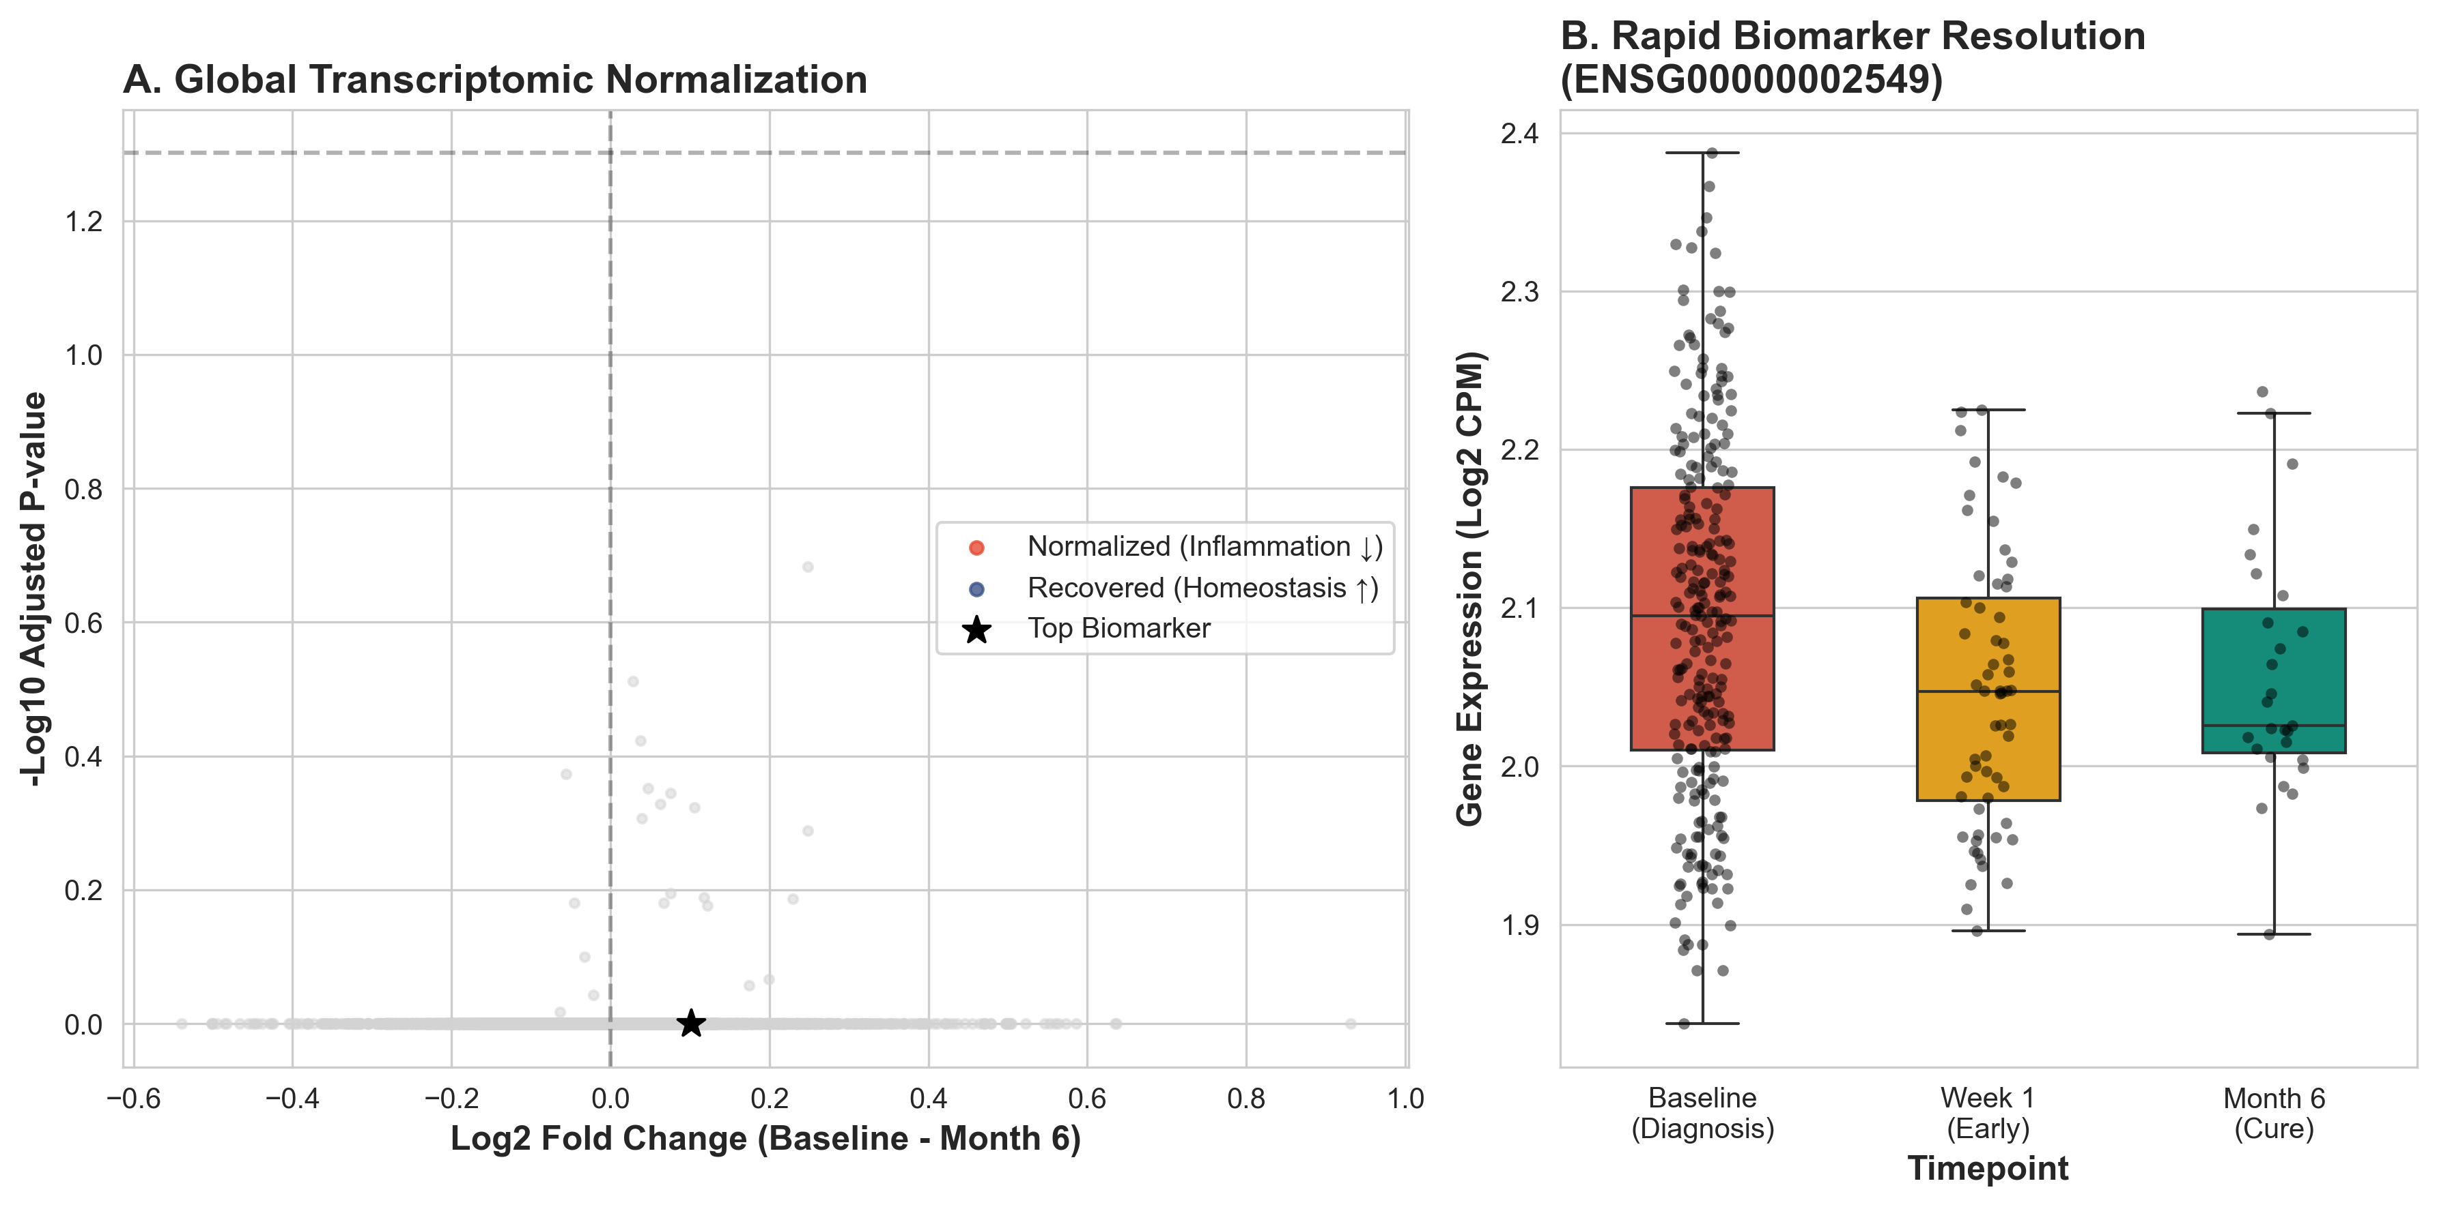
Figure 1: Global Normalization (Volcano Plot).

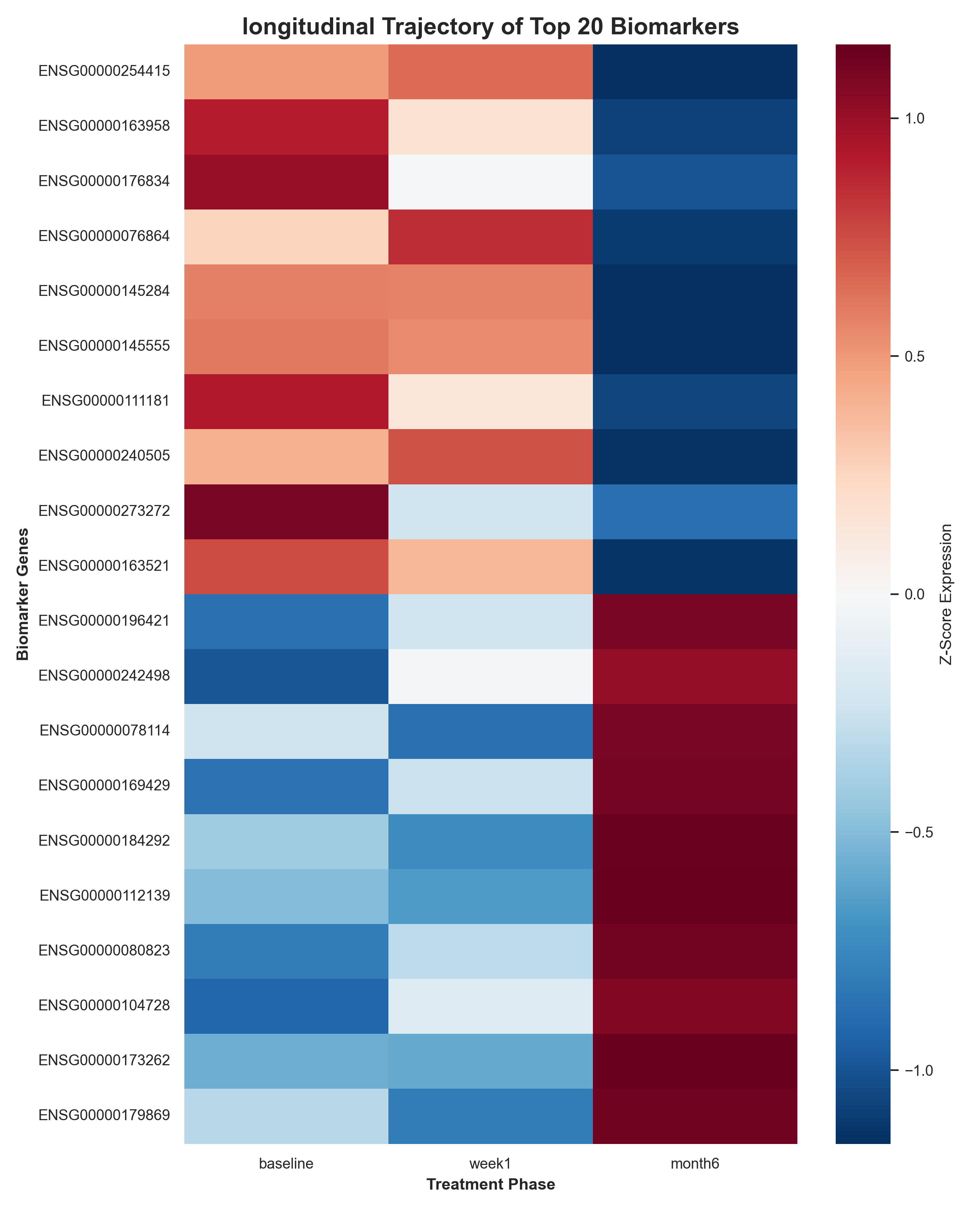
Figure 2: Longitudinal Heatmap.

