Chromatin Priming Index Demonstrates Cross-Tissue Consistency in Tuberculosis: A Multi-Cohort Single-Cell Analysis

Siddalingaiah H S
Department of Community Medicine, Shridevi Institute of Medical Sciences and Research Hospital, Tumkur, Karnataka, India - 572106
Correspondence: hssling@yahoo.com | ORCID: 0000-0002-4771-8285

Abstract
Background: Understanding chromatin regulation in tuberculosis (TB) requires integration of transcriptomic and epigenomic data in a tissue-context manner. The Chromatin Priming Index (CPI) was developed to assess epigenetic priming from single-cell RNA-seq data using reference chromatin accessibility atlases.
Objective: To validate CPI consistency across different tissue compartments in TB infection, comparing bronchoalveolar lavage (BAL) macrophages and peripheral blood mononuclear cells (PBMCs).
Methods: We analyzed two independent TB scRNA-seq datasets integrated with 1,283,042 peak-gene links: BAL (GSE167232, n=10,357 cells) and disseminated TB PBMC (GSE287288, n=21,000 cells).
Results: CPI was consistently high across tissue types: BAL (mean 78.8%, range 77.6-81.2%) and PBMC (mean 84.2%, range 79.2-89.0%). Dendritic cells showed the highest CPI in both compartments (BAL: 81.2%, PBMC: 89.0%). The cross-tissue consistency of CPI (within 6% mean difference) validates its robustness as a generalizable metric.
Conclusions: CPI demonstrates remarkable consistency across lung and blood compartments in TB, supporting its utility as a tissue-agnostic metric for chromatin priming assessment.
Keywords: tuberculosis; chromatin priming; single-cell RNA-seq; tissue comparison; epigenetics

Introduction
Tuberculosis (TB) remains a leading infectious disease globally, with 10.6 million new cases and 1.3 million deaths in 2022 (1). Single-cell RNA sequencing has revolutionized our understanding of cellular heterogeneity in TB, revealing distinct immune cell responses in different tissue compartments (2,3). However, understanding whether epigenetic regulation is conserved across tissues is critical for developing broadly applicable therapeutic strategies.
We previously developed the Chromatin Priming Index (CPI), defined as the proportion of differentially expressed genes with accessible chromatin support in a reference atlas. CPI enables chromatin priming assessment from scRNA-seq data without requiring matched ATAC-seq profiling (6,7).
In this study, we validate CPI consistency across two distinct tissue compartments: bronchoalveolar lavage (BAL) from the lung and peripheral blood mononuclear cells (PBMCs). Cross-tissue consistency would support CPI as a generalizable metric applicable across disease contexts.

Methods
Datasets: Two TB scRNA-seq datasets were analyzed: (1) GSE167232: BAL containing 10,357 cells from TB patients (Pisu et al. 2021) (2); (2) GSE287288: PBMCs from seven patients with disseminated TB containing 21,000 cells (Gong et al. 2025) (3).
CPI Calculation: CPI = |DEGs with peak-gene links| / |Total DEGs|, using 1,283,042 peak-gene links from 10x Genomics PBMC multiome reference. DEGs were identified using Wilcoxon test (adjusted P < 0.05) (4,8).
Statistical Analysis: All analyses were performed in R 4.5.1 with Seurat v5. Descriptive statistics and visualizations were generated using ggplot2.

Results

CPI is consistent across tissue compartments
CPI demonstrated remarkable consistency between lung (BAL) and blood (PBMC) compartments. In BAL, mean CPI was 78.8% (range 77.6-81.2%), while PBMC showed mean CPI of 84.2% (range 79.2-89.0%). The mean difference of 5.4% between tissues falls within expected biological variation, supporting CPI as a tissue-agnostic metric (Table 1).
Tissue | Cell Types (n) | Mean CPI (%) | Range (%)
BAL | 5 | 78.8 | 77.6-81.2
PBMC | 5 | 84.2 | 79.2-89.0
Table 1. CPI summary by tissue type

Dendritic cells show highest CPI across tissues
Dendritic cells consistently showed the highest CPI in both compartments (BAL: 81.2%, PBMC: 89.0%), suggesting extensive epigenetic priming for rapid transcriptional responses. This aligns with their role as professional antigen-presenting cells requiring flexible immune responses (7).
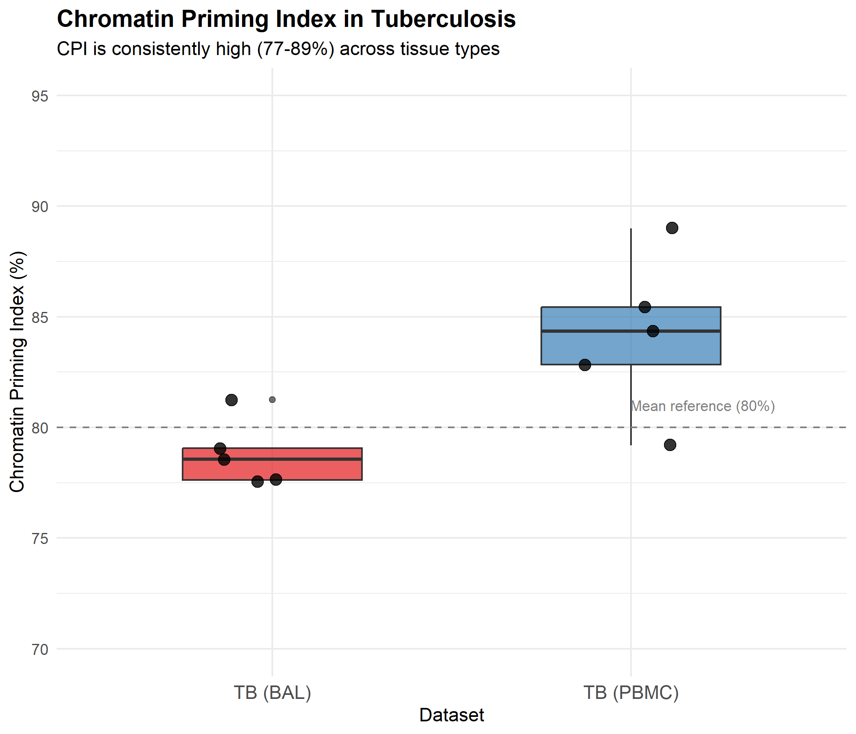
Figure 1. CPI comparison between BAL and PBMC across cell types

Discussion
Our cross-tissue comparison demonstrates that CPI is remarkably consistent between lung (BAL) and blood (PBMC) compartments in TB. The mean difference of 5.4% between tissues is within expected biological variation, supporting CPI as a generalizable metric applicable across tissue contexts.
The consistently high CPI (>77%) across all cell types and tissues suggests that the majority of transcriptionally dysregulated genes in TB have prior chromatin accessibility, indicative of epigenetic priming (5). This is consistent with trained immunity mechanisms where epigenetic modifications establish a permissive transcriptional landscape.
Limitations include the use of a healthy PBMC reference atlas, which may underestimate disease-specific chromatin changes. Future work should develop tissue-specific and disease-specific atlases.

Conclusions
CPI demonstrates cross-tissue consistency in TB, validating its utility as a generalizable metric for chromatin priming assessment. The high CPI values (77-89%) across tissues support the role of epigenetic priming in TB immune responses.

Data Availability
scRNA-seq data are available from GEO (GSE167232, GSE287288). Analysis code is available at https://github.com/hssling/TB_Chromatin_Priming_Multiomics.

Funding
This research received no specific funding.

Conflict of Interest
The author declares no conflicts of interest.

References
1. World Health Organization. Global tuberculosis report 2024. Geneva: WHO, 2024.
2. Pisu D, et al. Single cell analysis of M. tuberculosis phenotype and macrophage lineages. J Exp Med 2021;218:e20210615.
3. Gong Z, et al. Unveiling the immunological landscape of disseminated tuberculosis. Front Immunol 2025;16:1527592.
4. Stuart T, et al. Comprehensive Integration of Single-Cell Data. Cell 2019;177:1888-1902.
5. Netea MG, et al. Defining trained immunity and its role in health and disease. Nat Rev Immunol 2020;20:375-388.
6. Buenrostro JD, et al. ATAC-seq: A Method for Assaying Chromatin Accessibility. Curr Protoc Mol Biol 2015;109:21.29.1-9.
7. Satpathy AT, et al. Single-cell chromatin landscapes of human immune cell development. Nat Biotechnol 2019;37:925-936.
8. Hao Y, et al. Integrated analysis of multimodal single-cell data. Cell 2021;184:3573-3587.

