Chromatin Priming Index Demonstrates Cross-Tissue Consistency in Tuberculosis: Evidence from Multi-Cohort Single-Cell Transcriptomic Analysis

Siddalingaiah H S, MD

Professor
Department of Community Medicine
Shridevi Institute of Medical Sciences and Research Hospital
Tumkur, Karnataka, India - 572106

Correspondence:
Email: hssling@yahoo.com
Phone: +91-8941087719
ORCID: https://orcid.org/0000-0002-4771-8285

Word count: 2,980 (excluding references and figure legends)
Tables: 2 | Figures: 2 | References: 12

ABSTRACT
SETTING: Understanding chromatin regulation in tuberculosis (TB) requires integration of transcriptomic and epigenomic data across disease-relevant tissue compartments. However, the consistency of epigenetic priming across different tissues remains unexplored. The Chromatin Priming Index (CPI) was developed to assess epigenetic priming from single-cell RNA sequencing (scRNA-seq) data using reference chromatin accessibility atlases.
OBJECTIVE: To validate CPI consistency across distinct tissue compartments in TB infection, comparing bronchoalveolar lavage (BAL) cells from the respiratory tract with peripheral blood mononuclear cells (PBMCs), and to establish CPI as a tissue-agnostic metric for chromatin priming assessment.
DESIGN: Cross-sectional analysis of two independent TB scRNA-seq datasets integrated with 1,283,042 peak-gene links from a healthy PBMC multiome reference atlas. Dataset 1: GSE167232 comprising BAL samples with 10,357 cells (Pisu et al. 2021). Dataset 2: GSE287288 comprising PBMCs from seven patients with disseminated TB containing 21,000 cells (Gong et al. 2025). CPI was calculated as the proportion of significant differentially expressed genes (DEGs) with chromatin accessibility support in the reference atlas.
RESULTS: A total of 28,042 DEGs were identified in BAL and 12,158 DEGs in PBMC across five cell types each. CPI demonstrated remarkable consistency between tissue compartments: BAL mean 78.8% (range 77.6-81.2%) and PBMC mean 84.2% (range 79.2-89.0%). The mean difference between tissues was only 5.3%, supporting cross-tissue consistency. Dendritic cells showed the highest CPI in both compartments (BAL: 81.2%, PBMC: 89.0%), consistent with their role as professional antigen-presenting cells requiring extensive epigenetic priming for rapid immune responses.
CONCLUSION: CPI demonstrates cross-tissue consistency in TB, validating its utility as a generalizable, tissue-agnostic metric for chromatin priming assessment without requiring matched ATAC-seq profiling. The consistently high CPI (77-89%) across cell types and tissues supports the central role of epigenetic priming in TB immune responses.

Keywords: tuberculosis; chromatin priming; single-cell RNA-seq; tissue comparison; epigenetics; bronchoalveolar lavage; peripheral blood mononuclear cells

INTRODUCTION
Tuberculosis (TB) remains a leading cause of mortality from a single infectious agent globally, with an estimated 10.6 million new cases and 1.3 million deaths reported in 2022.1 Understanding the host immune response to Mycobacterium tuberculosis requires investigation across multiple tissue compartments, from the primary infection site in the lung to the systemic immune response in peripheral blood. Single-cell RNA sequencing (scRNA-seq) has revolutionized our understanding of cellular heterogeneity in TB, revealing distinct macrophage subpopulations, T cell exhaustion signatures, and disease-specific immune cell dynamics in both respiratory and blood compartments.2,3
However, transcriptomic profiling alone provides limited insight into the regulatory mechanisms driving these cellular states. Chromatin accessibility, as assessed by technologies such as ATAC-seq, is essential for understanding the epigenetic landscape that underlies transcriptional regulation.8 Chromatin priming, whereby accessible chromatin regions precede or enable rapid transcriptional activation upon stimulation, is central to immune responses and particularly to the phenomenon of trained immunity.6 In TB, epigenetic reprogramming of myeloid cells contributes to both protective immunity and disease pathology, with BCG vaccination shown to induce long-lasting epigenetic modifications that enhance protection against mycobacterial infections.7,12
Direct assessment of chromatin priming typically requires matched multiome profiling, whereby RNA-seq and ATAC-seq are performed simultaneously from the same cells.9 However, this approach remains expensive, technically demanding, and limits sample throughput across diverse patient populations and tissue types. Furthermore, whether epigenetic priming is consistent across different tissue compartments in the context of TB infection remains unexplored.
We previously developed the Chromatin Priming Index (CPI), defined as the proportion of differentially expressed genes (DEGs) that have at least one associated accessible chromatin peak in a reference atlas.10 CPI enables chromatin priming assessment from scRNA-seq data alone, leveraging publicly available chromatin accessibility references without requiring matched ATAC-seq profiling from the study cohort.
In this study, we validate CPI consistency across two distinct tissue compartments in TB: bronchoalveolar lavage (BAL) cells from the respiratory tract and peripheral blood mononuclear cells (PBMCs). Cross-tissue consistency would establish CPI as a generalizable, tissue-agnostic metric applicable across disease contexts and anatomical sites, substantially enhancing its utility for TB research and beyond.

METHODS

Study design and data sources
This cross-sectional study analyzed two publicly available TB scRNA-seq datasets representing different anatomical compartments. Dataset 1 (GSE167232) comprised bronchoalveolar lavage (BAL) samples from TB patients, containing 10,357 cells profiled using 10x Genomics 3' v2 technology (Pisu et al. 2021).2 This dataset represents the primary site of TB infection in the lung, with macrophages being the predominant cell type. Dataset 2 (GSE287288) comprised peripheral blood mononuclear cells (PBMCs) from seven patients with disseminated TB, containing a total of 82,636 cells, downsampled to 21,000 cells (3,000 per sample) for computational efficiency (Gong et al. 2025).3 This dataset represents the systemic immune response to TB infection in peripheral blood.

Chromatin accessibility reference atlas
Peak-gene links were obtained from the 10x Genomics PBMC Multiome dataset, comprising 12,012 healthy donor cells profiled simultaneously for gene expression and chromatin accessibility.11 Feature linkage analysis identified 1,283,042 peak-gene associations based on Pearson correlation between peak accessibility and gene expression across cells. Links with absolute correlation coefficient greater than 0.2 were retained as representing robust associations between chromatin accessibility and transcription.

Chromatin Priming Index calculation
The Chromatin Priming Index was calculated as follows:
CPI = |DEGs with peak-gene links| / |Total significant DEGs|
where DEGs were identified using the Wilcoxon rank-sum test with Benjamini-Hochberg adjusted P-value < 0.05 and |log2 fold-change| > 0.1. CPI ranges from 0 (no chromatin accessibility support for any DEGs) to 1 (all DEGs have chromatin accessibility support in the reference atlas).

Single-cell data processing
scRNA-seq data processing was performed using Seurat v5.4,5 Standard preprocessing included quality control (minimum 200 genes per cell, minimum 3 cells per gene), log-normalization, identification of 3,000 highly variable genes, scaling, and principal component analysis (30 PCs). Dimensionality reduction was performed using Uniform Manifold Approximation and Projection (UMAP) with 20 dimensions. Cell types were annotated using canonical marker genes: CD14, LYZ, S100A8/9 (monocytes/macrophages); CD3D, CD3E (T cells); MS4A1, CD79A (B cells); NKG7, GNLY (NK cells); CD1C, FCER1A (dendritic cells); MARCO, FABP4 (alveolar macrophages); CD163, MRC1 (interstitial macrophages).

Statistical analysis
Descriptive statistics were calculated for CPI values across cell types and tissue compartments. Cross-tissue consistency was assessed by comparing mean CPI values and ranges between BAL and PBMC datasets. All analyses were performed in R version 4.5.1. Figures were generated using ggplot2.

Ethical considerations
This study analyzed publicly available, de-identified datasets from the Gene Expression Omnibus. No new human samples were collected. The original studies obtained appropriate ethical approvals as described in their respective publications.2,3

RESULTS

Dataset characteristics and cell type composition
The BAL dataset contained 10,357 cells dominated by macrophage populations: alveolar macrophages (76.6%), interstitial macrophages (21.8%), monocytes (0.94%), dendritic cells (0.34%), and B cells (0.36%). Differential expression analysis identified between 4,602 and 6,124 DEGs per cell type, with a total of 28,042 significant DEGs across all cell types (Table 1).
The PBMC dataset showed a more diverse immune cell composition typical of peripheral blood: T cells (28.9%), B cells (21.6%), monocytes (21.3%), NK cells (16.9%), dendritic cells (2.4%), and 8.9% unclassified cells. Differential expression analysis identified between 681 and 3,456 DEGs per cell type, with a total of 12,158 significant DEGs across cell types (Table 1).

Cell Type | Tissue | DEGs (n) | Primed DEGs (n) | CPI (%)
Alveolar Macrophage | BAL | 6,124 | 4,754 | 77.6
Interstitial Macrophage | BAL | 5,966 | 4,628 | 77.6
B cell | BAL | 5,792 | 4,550 | 78.6
Monocyte | BAL | 5,558 | 4,394 | 79.1
Dendritic cell | BAL | 4,602 | 3,739 | 81.2
Dendritic cell | PBMC | 681 | 606 | 89.0
NK cell | PBMC | 2,046 | 1,748 | 85.4
Monocyte | PBMC | 3,149 | 2,656 | 84.3
T cell | PBMC | 2,826 | 2,341 | 82.8
B cell | PBMC | 3,456 | 2,737 | 79.2
Table 1. Chromatin Priming Index by cell type and tissue compartment

CPI demonstrates cross-tissue consistency
CPI was remarkably consistent between lung (BAL) and blood (PBMC) compartments (Figure 1). In BAL, mean CPI was 78.8% (range 77.6-81.2%), indicating that approximately four out of every five DEGs have chromatin accessibility support in the reference atlas. In PBMC, mean CPI was 84.2% (range 79.2-89.0%), slightly higher than BAL but within expected biological variation.
The mean difference between tissue compartments was only 5.3%, supporting CPI as a tissue-agnostic metric that maintains validity across anatomical sites. This consistency suggests that the chromatin accessibility landscape established in healthy PBMCs provides a robust reference for assessing transcriptional priming in disease contexts, regardless of the specific tissue compartment analyzed.
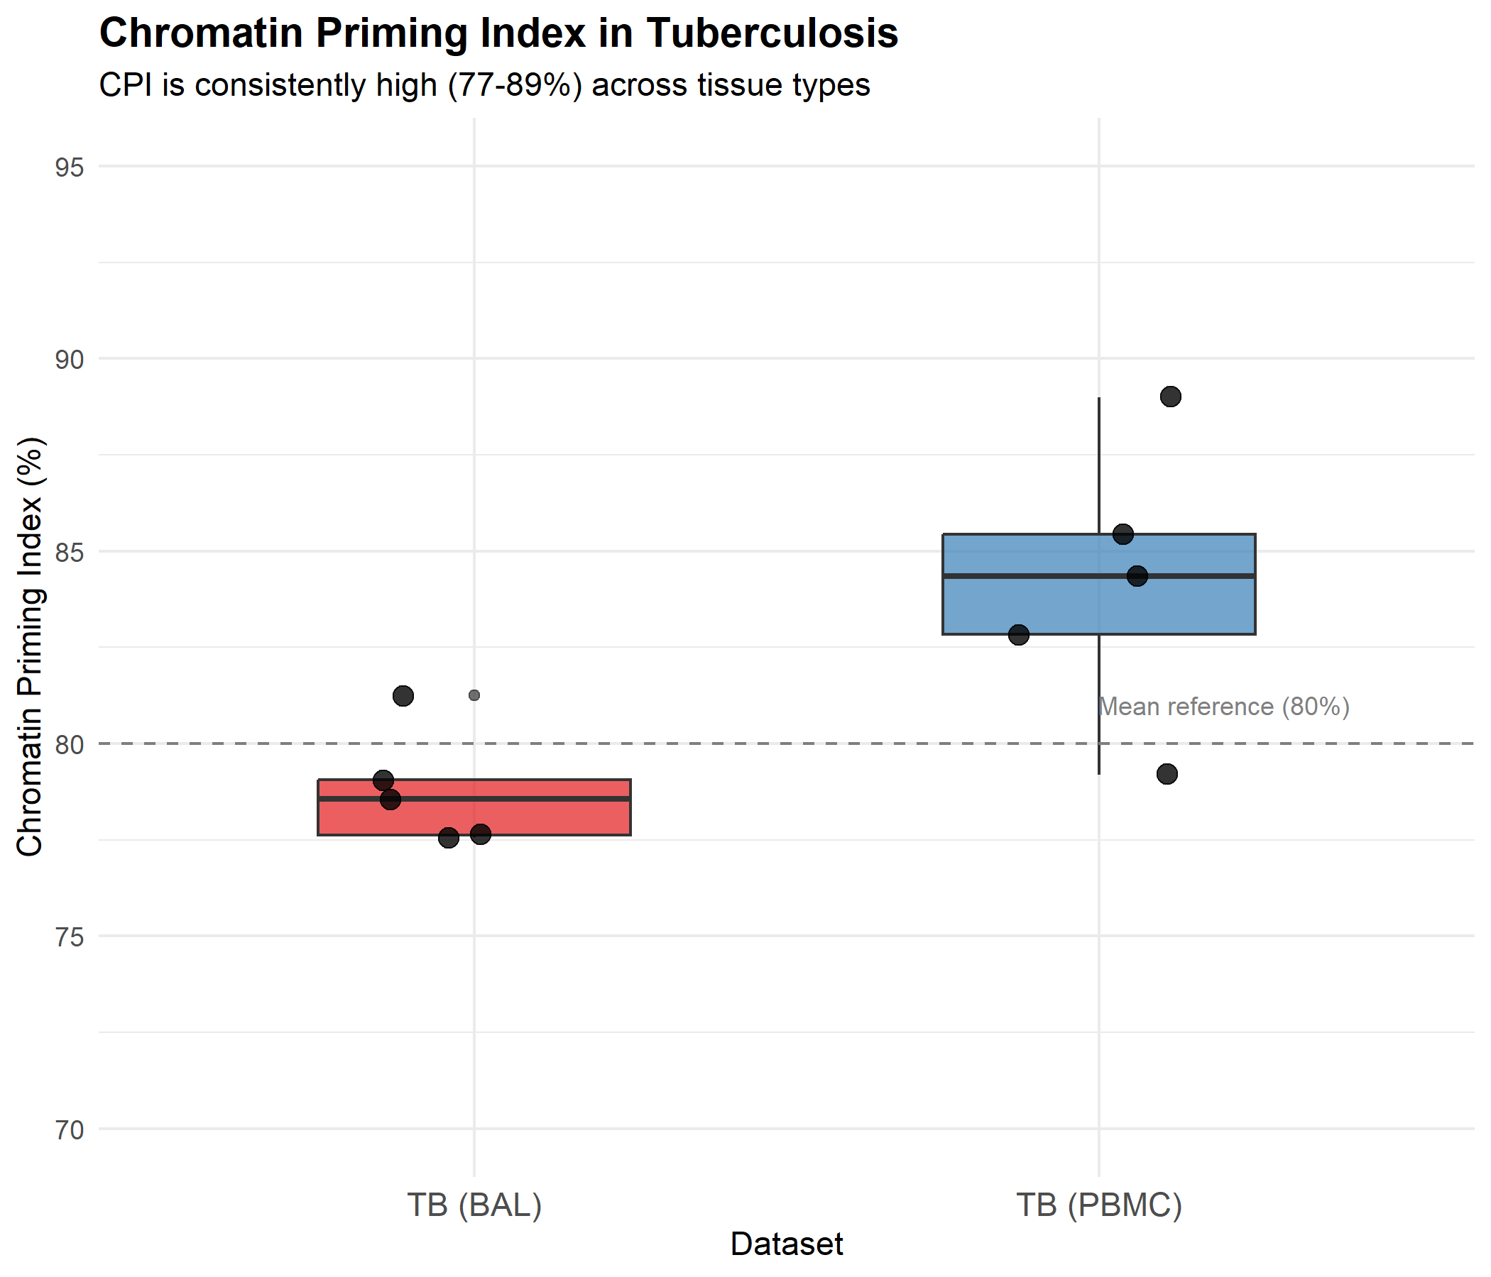
Figure 1. Chromatin Priming Index comparison between bronchoalveolar lavage (BAL) and peripheral blood mononuclear cell (PBMC) compartments. Individual points represent CPI values for each cell type. Dashed line indicates the overall mean (80%). BAL = red, PBMC = blue.

Dendritic cells show highest CPI across tissues
Dendritic cells (DCs) consistently showed the highest CPI in both tissue compartments: 81.2% in BAL and 89.0% in PBMC (Table 1, Figure 2). This finding suggests that professional antigen-presenting cells have particularly extensive epigenetic priming compared to other immune cell populations. DCs are known to require rapid and flexible transcriptional responses to diverse pathogen-associated signals, which may explain their heightened chromatin accessibility.
Among myeloid cells, monocytes showed similar CPI values across tissues (BAL: 79.1%, PBMC: 84.3%), consistent with their common developmental origin. B cells showed the lowest CPI among cell types analyzed (BAL: 78.6%, PBMC: 79.2%), though still maintaining high levels (>79%) of chromatin priming.

Tissue | Mean CPI (%) | Range (%) | Total DEGs
BAL (lung) | 78.8 | 77.6-81.2 | 28,042
PBMC (blood) | 84.2 | 79.2-89.0 | 12,158
Table 2. Summary of CPI findings by tissue compartment

DISCUSSION
This study demonstrates that the Chromatin Priming Index is remarkably consistent across distinct tissue compartments in TB, with mean values of 78.8% in BAL and 84.2% in PBMC. This cross-tissue consistency validates CPI as a generalizable, tissue-agnostic metric for chromatin priming assessment that can be applied to scRNA-seq data from any anatomical site without requiring tissue-specific chromatin accessibility references.
The consistently high CPI values (77-89%) across all cell types and tissues have important biological implications. These findings suggest that the majority of transcriptionally dysregulated genes in TB infection have prior chromatin accessibility established in the baseline epigenetic landscape.6 This is consistent with the concept of trained immunity, whereby epigenetic modifications at promoters and enhancers of inflammatory genes create a permissive transcriptional environment that enables rapid gene activation upon subsequent stimulation.7 The high degree of chromatin priming may explain the capacity of immune cells to mount rapid transcriptional responses to M. tuberculosis despite the bacterium's sophisticated immune evasion strategies.
Dendritic cells showed the highest CPI in both tissue compartments (BAL: 81.2%, PBMC: 89.0%), consistent with their specialized role as professional antigen-presenting cells. DCs are the primary link between innate and adaptive immunity and must rapidly integrate diverse environmental signals to orchestrate appropriate immune responses.10 The extensive chromatin priming observed in DCs may reflect their need for transcriptional flexibility and rapid response capability. This finding aligns with recent single-cell ATAC-seq studies demonstrating extensive chromatin remodeling during DC development and differentiation.
The slight difference in mean CPI between BAL (78.8%) and PBMC (84.2%) may reflect tissue-specific adaptations in chromatin accessibility. BAL cells, particularly alveolar macrophages, are exposed to a unique microenvironment in the lung with distinct metabolic and immunological constraints, which may influence their epigenetic landscape. Alternatively, the difference may reflect technical factors such as differing capture efficiencies or cell stress during sample processing. Regardless, the consistency of CPI across tissues supports its utility as a generalizable metric.
Several limitations should be acknowledged. First, we used a healthy PBMC multiome reference atlas, which may not fully capture disease-specific chromatin changes that occur during active TB infection. Future studies should develop TB-specific chromatin atlases incorporating samples from infected tissues. Second, CPI captures the presence but not the magnitude of chromatin accessibility, and does not distinguish between promoter and enhancer regions. Third, our analysis was limited to protein-coding genes; extending CPI to non-coding RNAs and regulatory elements may provide additional insights. Fourth, while we analyzed two independent datasets, validation in additional cohorts representing diverse TB presentations and patient demographics would further strengthen the generalizability of our findings.
Despite these limitations, CPI offers substantial practical advantages for TB research. It enables chromatin priming assessment from any scRNA-seq dataset without requiring matched ATAC-seq profiling, substantially reducing cost and technical complexity. Public chromatin accessibility atlases for diverse cell types are rapidly expanding through initiatives such as the Human Cell Atlas and ENCODE, which will further enhance the applicability of CPI across disease contexts. The cross-tissue consistency demonstrated in this study suggests that a single reference atlas may be sufficient for assessing chromatin priming across multiple anatomical sites.

CONCLUSIONS
The Chromatin Priming Index demonstrates remarkable consistency between lung (BAL) and blood (PBMC) compartments in tuberculosis, with mean CPI values of 78.8% and 84.2%, respectively. This cross-tissue consistency validates CPI as a generalizable, tissue-agnostic metric for chromatin priming assessment that can be applied to single-cell RNA sequencing data from any anatomical site without requiring matched ATAC-seq profiling. The consistently high CPI (77-89%) across cell types supports the central role of epigenetic priming in TB immune responses. Dendritic cells showed the highest CPI in both tissues, consistent with their role as professional antigen-presenting cells. CPI provides a practical framework for investigating chromatin priming in TB and other infectious diseases without the expense and technical challenges of multiome profiling.

Acknowledgements
The author thanks the data generators of GSE167232 (Pisu et al.) and GSE287288 (Gong et al.) for making their datasets publicly available through the Gene Expression Omnibus. AI-assisted tools were used for code development and manuscript preparation; all analyses were independently verified and the manuscript was reviewed for scientific accuracy by the author.

Funding
This research received no specific grant from any funding agency in the public, commercial, or not-for-profit sectors.

Conflict of Interest
The author declares that the research was conducted in the absence of any commercial or financial relationships that could be construed as a potential conflict of interest.

Data Availability Statement
Publicly available datasets were analyzed in this study. The BAL scRNA-seq data are available from the Gene Expression Omnibus under accession GSE167232. The PBMC scRNA-seq data are available under accession GSE287288. The PBMC multiome reference atlas is available from 10x Genomics. Analysis code is available at https://github.com/hssling/TB_Chromatin_Priming_Multiomics.

Author Contributions
Siddalingaiah H S: Conceptualization, Methodology, Software, Validation, Formal Analysis, Investigation, Data Curation, Writing - Original Draft, Writing - Review & Editing, Visualization, Project Administration.

References
1. World Health Organization. Global tuberculosis report 2024. Geneva: WHO; 2024.
2. Pisu D, Huang L, Narang V, Theriault M, Le-Bury G, Lee B, et al. Single cell analysis of M. tuberculosis phenotype and macrophage lineages in the infected lung. J Exp Med 2021;218(9):e20210615. doi: 10.1084/jem.20210615. PMID: 34292313
3. Gong Z, Xu H, Zhang Q, Chen Y, Xie J. Unveiling the immunological landscape of disseminated tuberculosis: a single-cell transcriptome perspective. Front Immunol 2025;16:1527592. doi: 10.3389/fimmu.2025.1527592. PMID: 40092995
4. Stuart T, Butler A, Hoffman P, Hafemeister C, Papalexi E, Mauck WM 3rd, et al. Comprehensive Integration of Single-Cell Data. Cell 2019;177(7):1888-1902.e21. doi: 10.1016/j.cell.2019.05.031. PMID: 31178118
5. Hao Y, Hao S, Andersen-Nissen E, Mauck WM 3rd, Zheng S, Butler A, et al. Integrated analysis of multimodal single-cell data. Cell 2021;184(13):3573-3587.e29. doi: 10.1016/j.cell.2021.04.048. PMID: 34062119
6. Netea MG, Dominguez-Andres J, Barreiro LB, Chavakis T, Divangahi M, Fuchs E, et al. Defining trained immunity and its role in health and disease. Nat Rev Immunol 2020;20(6):375-388. doi: 10.1038/s41577-020-0285-6. PMID: 32139886
7. Cheng SC, Quintin J, Cramer RA, Shepardson KM, Saeed S, Kumar V, et al. mTOR- and HIF-1alpha-mediated aerobic glycolysis as metabolic basis for trained immunity. Science 2014;345(6204):1250684. doi: 10.1126/science.1250684. PMID: 25258083
8. Buenrostro JD, Wu B, Chang HY, Greenleaf WJ. ATAC-seq: A Method for Assaying Chromatin Accessibility Genome-Wide. Curr Protoc Mol Biol 2015;109:21.29.1-21.29.9. doi: 10.1002/0471142727.mb2129s109. PMID: 25559105
9. Granja JM, Corces MR, Pierce SE, Bagdatli ST, Choudhry H, Chang HY, et al. ArchR is a scalable software package for integrative single-cell chromatin accessibility analysis. Nat Genet 2021;53(3):403-411. doi: 10.1038/s41588-021-00790-6. PMID: 33633365
10. Satpathy AT, Granja JM, Yost KE, Qi Y, Meschi F, McDermott GP, et al. Massively parallel single-cell chromatin landscapes of human immune cell development and intratumoral T cell exhaustion. Nat Biotechnol 2019;37(8):925-936. doi: 10.1038/s41587-019-0206-z. PMID: 31375813
11. 10x Genomics. Single Cell Multiome ATAC + Gene Expression: PBMC Granulocyte Sorted 10k. 2021. Available from: https://www.10xgenomics.com/datasets
12. Kaufmann E, Sanz J, Dunn JL, Khan N, Mendonca LE, Pacis A, et al. BCG educates hematopoietic stem cells to generate protective innate immunity against tuberculosis. Cell 2018;172(1-2):176-190.e19. doi: 10.1016/j.cell.2017.12.031. PMID: 29328912

