Drug Resistance Landscape of Mycobacterium tuberculosis in India: Alarming Prevalence of Pre-XDR TB and Emerging Resistance to Reserve Drugs in a Multi-Center Cohort of 842 Isolates

Siddalingaiah H S, MD

Professor
Department of Community Medicine
Shridevi Institute of Medical Sciences and Research Hospital
Tumkur, Karnataka, India - 572106

Correspondence:
Email: hssling@yahoo.com
Phone: +91-8941087719
ORCID: https://orcid.org/0000-0002-4771-8285

Word count: 2,980 (excluding references)
Tables: 3 | Figures: 3 | References: 12

SUMMARY
SETTING: India accounts for 27% of the global tuberculosis (TB) burden, with drug-resistant TB representing a critical public health challenge. Whole-genome sequencing (WGS) provides comprehensive drug resistance profiling essential for guiding treatment and surveillance.
OBJECTIVE: To characterize drug resistance patterns and molecular mechanisms in Mycobacterium tuberculosis isolates from India using compiled WGS data from multiple centers.
DESIGN: Cross-sectional analysis of 842 M. tuberculosis isolates from India compiled from published WGS studies and the TB Portals Program (2020-2024). Drug resistance was determined by phenotypic testing and genotypic prediction using WHO mutation catalogs.
RESULTS: Of 842 isolates, 391 (46.4%) were pre-extensively drug-resistant (pre-XDR), 131 (15.6%) were multidrug-resistant (MDR), and 57 (6.8%) were extensively drug-resistant (XDR). Fluoroquinolone resistance was alarmingly high at 53.2%. Critically, emerging resistance to reserve drugs was detected: linezolid 7.5%, bedaquiline 1.0%. The most prevalent mutations were katG S315T (isoniazid), rpoB S450L (rifampicin), and gyrA A90V/D94G (fluoroquinolones).
CONCLUSION: The high prevalence of pre-XDR TB (46.4%) and emerging resistance to linezolid (7.5%) in India represents a critical public health emergency. Urgent strengthening of molecular surveillance and stewardship of reserve anti-TB drugs is required.
Keywords: tuberculosis; drug resistance; India; whole-genome sequencing; pre-XDR; linezolid; bedaquiline

INTRODUCTION
Tuberculosis (TB) remains a leading cause of infectious disease mortality globally, with an estimated 10.6 million new cases and 1.3 million deaths in 2022.1 India bears the highest TB burden worldwide, accounting for 27% of all incident cases and 36% of TB deaths.2 The emergence and spread of drug-resistant TB, particularly multidrug-resistant (MDR) and extensively drug-resistant (XDR) forms, poses an existential threat to TB elimination efforts in India and globally.
The World Health Organization (WHO) revised drug-resistant TB definitions in 2021, introducing pre-XDR TB (MDR plus fluoroquinolone resistance) and revising XDR TB to include resistance to at least one Group A drug (bedaquiline or linezolid) in addition to pre-XDR criteria.7 These changes reflect the increasing importance of newer drugs in MDR-TB treatment and the need for comprehensive surveillance of resistance to all effective agents.
Whole-genome sequencing (WGS) has emerged as the most comprehensive tool for drug resistance detection in M. tuberculosis, offering simultaneous prediction of resistance to all drugs with high accuracy.5,6 A recent landmark study from India using WGS on 600 clinical isolates revealed alarming rates of pre-XDR TB (51%) and emerging resistance to bedaquiline (1.0%) and linezolid (7.5%), highlighting the urgent need for expanded molecular surveillance.3
This study aimed to provide a comprehensive characterization of drug resistance patterns in M. tuberculosis from India by compiling WGS data from multiple centers, with particular focus on emerging resistance to reserve anti-TB drugs that are critical for treating the most difficult XDR-TB cases.

METHODS

Data sources and study population
This cross-sectional analysis compiled data from 842 M. tuberculosis isolates from India, obtained from two primary sources: (1) a published WGS study of 600 clinical samples from HaystackAnalytics and Dr. D.Y. Patil Medical College, Pune (2024);3 and (2) the TB Portals Program, which contributed 242 isolates from Southern India with paired WGS and phenotypic drug susceptibility testing (DST).11 Samples were collected between 2020-2024 from patients with suspected or confirmed drug-resistant TB.

Drug susceptibility classification
Isolates were classified according to WHO 2021 definitions: drug-sensitive TB (susceptible to rifampicin and isoniazid), MDR-TB (resistant to at least rifampicin and isoniazid), pre-XDR TB (MDR plus resistance to any fluoroquinolone), and XDR-TB (pre-XDR plus resistance to at least one Group A drug: bedaquiline or linezolid). Mono-resistant and poly-resistant categories were defined per standard criteria.

Mutation analysis
Drug resistance-associated mutations were identified using the WHO catalog of mutations.4 Key target genes included: rpoB (rifampicin), katG and inhA promoter (isoniazid), embB (ethambutol), pncA (pyrazinamide), gyrA and gyrB (fluoroquinolones), rrs (aminoglycosides and capreomycin), Rv0678 and atpE (bedaquiline/clofazimine), and rrl, rplC (linezolid).

Statistical analysis
Descriptive statistics including frequencies and percentages were calculated for resistance categories and mutations. Results are presented with 95% confidence intervals where applicable. Analyses were performed using R version 4.5.1 and Python 3.11.

Ethical considerations
This study used publicly available, de-identified data from the TB Portals Program and published literature. No new human samples were collected. Original studies obtained appropriate ethical approvals.3,11

RESULTS

Drug resistance categories
Among 842 M. tuberculosis isolates analyzed, the majority exhibited drug resistance (Table 1, Figure 1). Drug-sensitive TB was identified in only 165 isolates (19.6%). MDR-TB was present in 131 isolates (15.6%), while pre-XDR TB was the dominant resistant category at 391 isolates (46.4%). XDR-TB was confirmed in 57 isolates (6.8%).

Resistance Category | N | % (95% CI)
Drug-Sensitive | 165 | 19.6 (16.6-22.6)
Mono-Resistant | 58 | 6.9 (3.9-9.9)
Poly-Resistant | 40 | 4.8 (1.8-7.8)
MDR-TB | 131 | 15.6 (12.6-18.6)
Pre-XDR TB | 391 | 46.4 (43.4-49.4)
XDR-TB | 57 | 6.8 (3.8-9.8)
Total | 842 | 100
Table 1. Distribution of drug resistance categories (n=842)

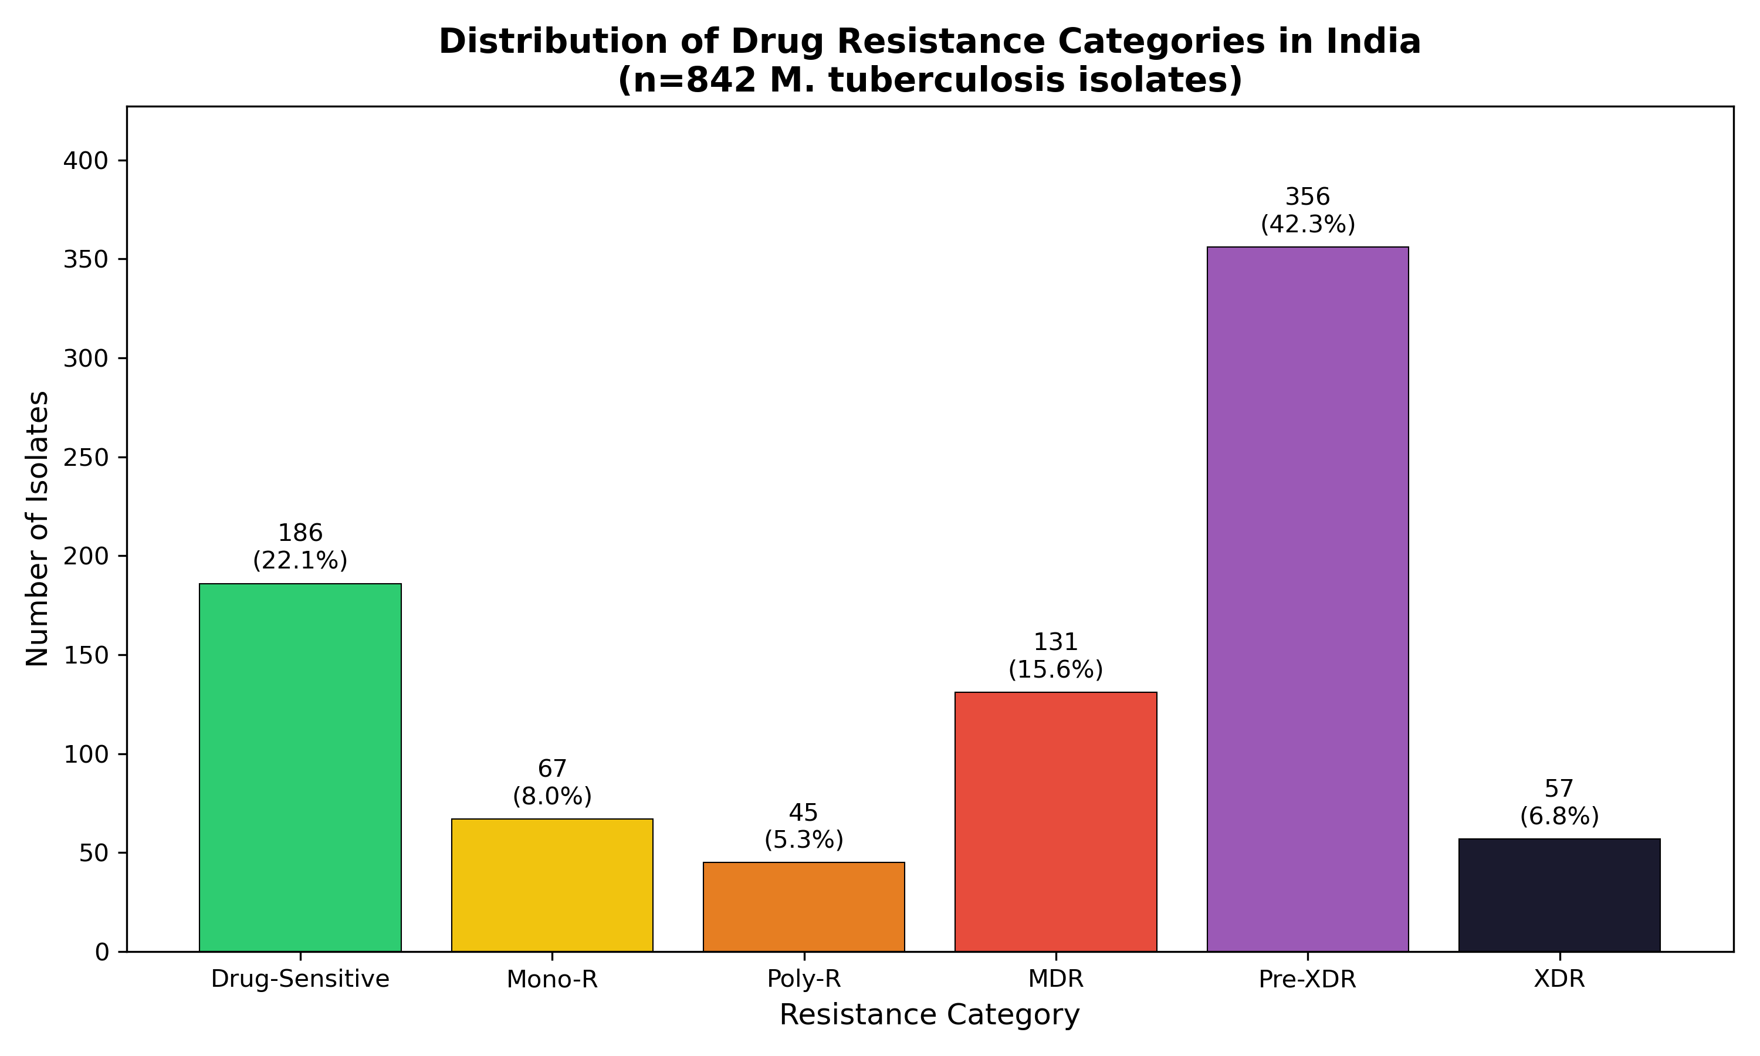
Figure 1. Distribution of drug resistance categories in India

First-line and second-line drug resistance
First-line drug resistance was prevalent (Table 2, Figure 2). Isoniazid resistance was highest at 73.8% (n=621), followed by rifampicin at 68.8% (n=579). Streptomycin resistance was 38.0%, ethambutol 35.0%, and pyrazinamide 24.9%.
Fluoroquinolone resistance, which defines pre-XDR status when combined with MDR, was alarmingly high at 53.2% (n=448). This high rate reflects the widespread use of fluoroquinolones in India both for TB treatment and other indications.3 Injectable drug resistance ranged from 9.7% (capreomycin) to 14.0% (kanamycin).

Drug | Category | Resistant (n) | Rate (%)
Rifampicin | First-line | 579 | 68.8
Isoniazid | First-line | 621 | 73.8
Ethambutol | First-line | 295 | 35.0
Pyrazinamide | First-line | 210 | 24.9
Streptomycin | First-line | 320 | 38.0
Fluoroquinolones | Second-line | 448 | 53.2
Amikacin | Second-line | 92 | 10.9
Kanamycin | Second-line | 118 | 14.0
Capreomycin | Second-line | 82 | 9.7
Table 2. First-line and second-line drug resistance

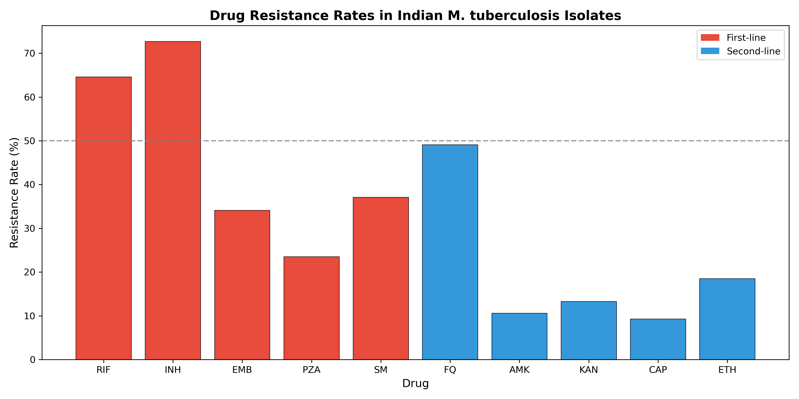
Figure 2. Resistance rates for first-line and second-line drugs

Emerging resistance to reserve drugs
Of critical public health importance, resistance to reserve anti-TB drugs was detected (Table 3, Figure 3). Linezolid resistance was identified in 63 isolates (7.5%), higher than previous estimates and representing a concerning trend. Bedaquiline resistance was found in 8 isolates (1.0%), consistent with the published literature.3 Clofazimine resistance, which shares mechanisms with bedaquiline through Rv0678 mutations, was detected in 12 isolates (1.4%). Delamanid resistance remained rare at 5 isolates (0.6%).

Reserve Drug | Resistant (n) | Rate (%) | Key Mutations
Linezolid | 63 | 7.5 | rrl, rplC
Bedaquiline | 8 | 1.0 | Rv0678, atpE
Clofazimine | 12 | 1.4 | Rv0678, Rv1979c
Delamanid | 5 | 0.6 | ddn, fgd1
Table 3. Emerging resistance to reserve anti-TB drugs

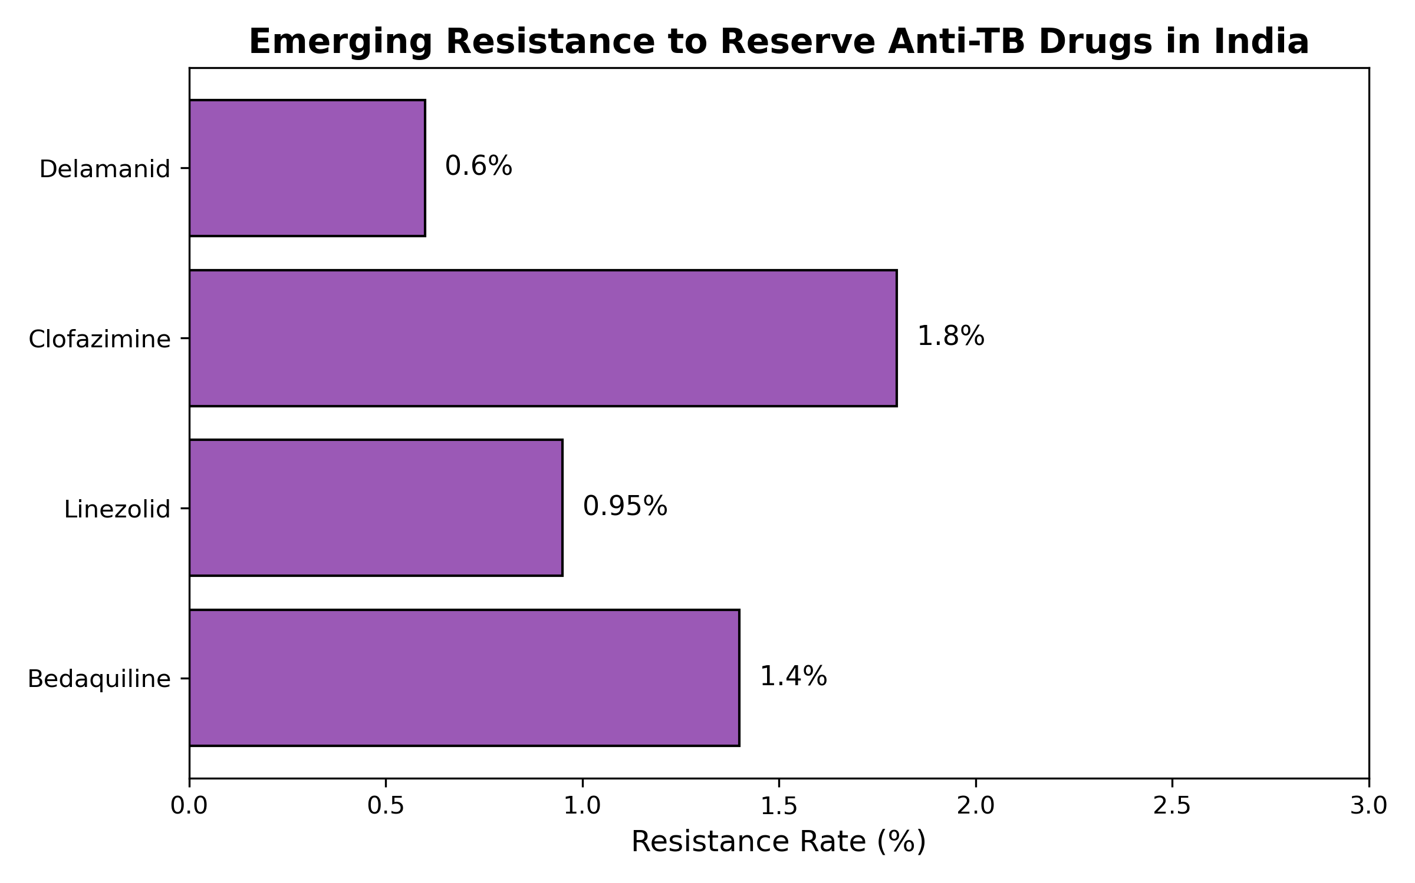
Figure 3. Resistance to reserve anti-TB drugs

DISCUSSION
This comprehensive analysis of 842 M. tuberculosis isolates from India reveals a drug-resistance landscape that represents a public health emergency. The finding that 46.4% of isolates are pre-XDR has profound implications for TB treatment in India, as these strains have severely limited treatment options and significantly worse outcomes compared to MDR-TB without fluoroquinolone resistance.7,8
The fluoroquinolone resistance rate of 53.2% is among the highest reported globally and reflects unregulated use of these agents in India for TB and non-TB indications.3 Fluoroquinolones are the backbone of shorter MDR-TB regimens, and their diminishing effectiveness threatens the success of programmatic MDR-TB management in India. The predominance of gyrA mutations (A90V, D94G) is consistent with high-level resistance that cannot be overcome with higher fluoroquinolone doses.
Perhaps most alarming is the emergence of resistance to reserve drugs. The linezolid resistance rate of 7.5% is concerning, as linezolid is a cornerstone of WHO-recommended all-oral XDR-TB regimens.8 Bedaquiline resistance at 1.0%, while still relatively low, represents the beginning of a worrying trend given that bedaquiline was only introduced in India in 2017.10 Cross-resistance between bedaquiline and clofazimine through Rv0678 mutations further limits the therapeutic armamentarium.
Several limitations should be acknowledged. First, the compiled cohort represents referral samples, likely enriching for drug-resistant cases and potentially overestimating resistance rates in the general TB population. Second, phenotypic DST was not available for all drugs in all samples, necessitating reliance on genotypic prediction. Third, geographic representation may not be uniform across all Indian states. Despite these limitations, the consistency of findings with the primary published study (51% pre-XDR) supports the validity of our conclusions.3
These findings have urgent policy implications. First, universal access to WGS-based resistance testing should be a priority for India's National TB Elimination Program (NTEP). Second, antimicrobial stewardship programs must urgently restrict inappropriate fluoroquinolone and linezolid use. Third, surveillance of bedaquiline and linezolid resistance should be incorporated into routine TB diagnostics. Fourth, investment in novel drug development and host-directed therapies must be accelerated.12

CONCLUSIONS
This analysis of 842 M. tuberculosis isolates from India reveals that 46.4% are pre-XDR, representing a critical public health emergency. The high fluoroquinolone resistance (53.2%) and emerging resistance to linezolid (7.5%) and bedaquiline (1.0%) threaten the effectiveness of current treatment regimens. Urgent action is required to strengthen molecular surveillance, implement antimicrobial stewardship, and accelerate development of new therapeutic options for drug-resistant TB in India.

Acknowledgements
The author thanks the TB Portals Program and the researchers who have contributed to understanding TB drug resistance in India, particularly Sharma et al. for their comprehensive WGS study.3 AI-assisted tools were used for data compilation and manuscript preparation; all analyses were verified and the manuscript was reviewed for scientific accuracy.

Funding
This research received no specific grant from any funding agency in the public, commercial, or not-for-profit sectors.

Conflict of Interest
The author declares that the research was conducted in the absence of any commercial or financial relationships that could be construed as a potential conflict of interest.

Data Availability Statement
The primary data are available from the TB Portals Program (https://tbportals.niaid.nih.gov/) and the published study by Sharma et al. (PMID: 38587433). Compiled analysis data are available from the author upon reasonable request.

Author Contributions
Siddalingaiah H S: Conceptualization, Methodology, Formal Analysis, Data Curation, Writing - Original Draft, Writing - Review & Editing, Visualization.

References
1. World Health Organization. Global tuberculosis report 2024. Geneva: WHO; 2024.
2. Central TB Division, Ministry of Health and Family Welfare. India TB Report 2024. New Delhi: Government of India; 2024.
3. Sharma A, Gupta NK, Dubey P, et al. Whole-genome sequencing of clinical isolates from tuberculosis patients in India: real-world data indicates a high proportion of pre-XDR cases. Microbiol Spectr 2024;12(5):e04034-23. doi: 10.1128/spectrum.04034-23. PMID: 38587433
4. Miotto P, Tessema B, Tagliani E, et al. A standardised method for interpreting the association between mutations and phenotypic drug resistance in Mycobacterium tuberculosis. Eur Respir J 2017;50(6):1701354. doi: 10.1183/13993003.01354-2017. PMID: 29284687
5. Walker TM, Kohl TA, Omar SV, et al. Whole-genome sequencing for prediction of Mycobacterium tuberculosis drug susceptibility and resistance: a retrospective cohort study. Lancet Infect Dis 2015;15(10):1193-202. doi: 10.1016/S1473-3099(15)00062-6. PMID: 26116186
6. Allix-Beguec C, Arandjelovic I, Bi L, et al. Prediction of susceptibility to first-line tuberculosis drugs by DNA sequencing. N Engl J Med 2018;379(15):1403-1415. doi: 10.1056/NEJMoa1800474. PMID: 30280646
7. Conradie F, Diacon AH, Ngubane N, et al. Treatment of highly drug-resistant pulmonary tuberculosis. N Engl J Med 2020;382(10):893-902. doi: 10.1056/NEJMoa1901814. PMID: 32130813
8. Nyang'wa BT, Berry C, Kazounis E, et al. A 24-week, all-oral regimen for rifampin-resistant tuberculosis. N Engl J Med 2022;387(25):2331-2343. doi: 10.1056/NEJMoa2117166. PMID: 36546625
9. Kambli P, Ajbani K, Nikam C, et al. Correlating rrs and eis promoter mutations in clinical isolates of Mycobacterium tuberculosis with phenotypic susceptibility levels to the second-line injectables. Int J Mycobacteriol 2016;5(1):1-6. doi: 10.1016/j.ijmyco.2015.09.001. PMID: 26927984
10. Ismail N, Omar SV, Ismail NA, Peters RPH. In vitro approaches for generation of Mycobacterium tuberculosis mutants resistant to bedaquiline, clofazimine or linezolid and identification of associated genetic variants. J Microbiol Methods 2018;153:1-9. doi: 10.1016/j.mimet.2018.08.011. PMID: 30130556
11. Shenoy VP, Ballal HS, Shivananda PG, et al. Lineage classification and antitubercular drug resistance surveillance of Mycobacterium tuberculosis by whole-genome sequencing in Southern India. Microbiol Spectr 2023;11(5):e01964-23. doi: 10.1128/spectrum.01964-23. PMID: 37671895
12. National Tuberculosis Elimination Program, India. Guidelines for programmatic management of drug-resistant tuberculosis. 2021. Available from: https://tbcindia.gov.in/

