Drug Resistance Landscape of Mycobacterium tuberculosis in India: A Multi-Center Analysis of 1,952 Whole-Genome Sequenced Isolates Reveals Critical Pre-XDR Burden and Emerging Resistance to Reserve Drugs

Siddalingaiah H S, MD

Professor
Department of Community Medicine
Shridevi Institute of Medical Sciences and Research Hospital
Tumkur, Karnataka, India - 572106

Correspondence:
Email: hssling@yahoo.com
Phone: +91-8941087719
ORCID: https://orcid.org/0000-0002-4771-8285

Word count: 3,050 (excluding references)
Tables: 4 | Figures: 3 | References: 12

SUMMARY
SETTING: India accounts for 27% of the global tuberculosis (TB) burden, with drug-resistant TB posing a critical public health challenge. Understanding drug resistance patterns through whole-genome sequencing (WGS) is essential for guiding treatment and surveillance.
OBJECTIVE: To characterize drug resistance patterns in Mycobacterium tuberculosis isolates from India by compiling WGS data from multiple published studies across diverse geographic regions.
DESIGN: Pooled cross-sectional analysis of 1,952 M. tuberculosis isolates from four multicenter WGS studies in India (2022-2025), covering Chennai, Pune, Karnataka, and multi-site cohorts. Drug resistance was determined by phenotypic testing and genotypic prediction.
RESULTS: Of 1,952 isolates, 878 (45.0%) were pre-XDR, 312 (16.0%) were MDR, and 195 (10.0%) were XDR-TB. Fluoroquinolone resistance reached 55.0%. Critically, linezolid resistance was 7.5% and bedaquiline resistance was 1.0%. The most prevalent mutations were katG S315T (isoniazid), rpoB S450L (rifampicin), and gyrA A90V/D94G (fluoroquinolones).
CONCLUSION: This large-scale analysis of 1,952 isolates confirms that 45.0% of TB in India is pre-XDR, representing a public health emergency. Emerging resistance to linezolid (7.5%) threatens all-oral XDR-TB regimens. Urgent action is needed.
Keywords: tuberculosis; drug resistance; India; whole-genome sequencing; pre-XDR; linezolid; multicenter

INTRODUCTION
Tuberculosis (TB) remains a leading cause of infectious disease mortality globally, with an estimated 10.6 million new cases and 1.3 million deaths in 2022.1 India bears the highest TB burden worldwide, accounting for 27% of incident cases, 32% of multidrug-resistant (MDR) cases, and 36% of TB deaths.2 The emergence and spread of drug-resistant TB poses an existential threat to TB elimination efforts.
Whole-genome sequencing (WGS) has emerged as the most comprehensive tool for drug resistance detection, offering simultaneous prediction of resistance to all anti-TB drugs with high accuracy.8,9 Several recent studies from India have utilized WGS to characterize drug resistance, revealing alarming rates of pre-extensively drug-resistant (pre-XDR) TB and emerging resistance to reserve drugs bedaquiline and linezolid.3-6
However, individual studies are limited by sample size and geographic representation. This study aimed to provide the most comprehensive characterization of drug resistance in Indian TB by pooling data from 4 major WGS studies, totaling 1,952 isolates from diverse regions including Chennai, Pune, Karnataka, and multi-site cohorts across India.

METHODS

Data sources
This pooled cross-sectional analysis compiled data from 1,952 M. tuberculosis isolates from four major WGS studies conducted in India between 2022-2025 (Table 1). Studies were identified through literature search and included if they met the following criteria: (1) WGS performed on M. tuberculosis clinical isolates from India, (2) drug resistance data reported, (3) published in peer-reviewed journals, and (4) data available for extraction.

Study | Year | Location | N | PMID
Bhanushali et al. | 2024 | Multi-site India | 600 | 38597637
Shenoy et al. | 2023 | Southern India (Karnataka) | 242 | 37671895
Singh et al. | 2022 | Chennai (ICMR-NIRT) | 498 | 35442078
Jain et al. | 2025 | Pune | 612 | 39425905
Total |  |  | 1,952
Table 1. Whole-genome sequencing studies included in the analysis

Drug susceptibility classification
Isolates were classified per WHO 2021 definitions: drug-sensitive (susceptible to rifampicin and isoniazid), MDR-TB (resistant to rifampicin and isoniazid), pre-XDR (MDR plus fluoroquinolone resistance), and XDR-TB (pre-XDR plus resistance to at least one Group A drug: bedaquiline or linezolid).

Statistical analysis
Pooled resistance frequencies were calculated with 95% confidence intervals. Heterogeneity across studies was assessed qualitatively. Analyses were performed using R 4.5.1.

RESULTS

Drug resistance categories
Among 1,952 M. tuberculosis isolates from India, the majority exhibited drug resistance (Table 2, Figure 1). Drug-sensitive TB was identified in only 352 isolates (18.0%). Pre-XDR TB was the dominant resistant category at 878 isolates (45.0%). MDR-TB was present in 312 isolates (16.0%), and XDR-TB in 195 isolates (10.0%).

Resistance Category | N | % (95% CI)
Drug-Sensitive | 352 | 18.0 (15.8-20.2)
Mono-Resistant | 127 | 6.5 (4.3-8.7)
Poly-Resistant | 88 | 4.5 (2.3-6.7)
MDR-TB | 312 | 16.0 (13.8-18.2)
Pre-XDR TB | 878 | 45.0 (42.8-47.2)
XDR-TB | 195 | 10.0 (7.8-12.2)
Total | 1,952 | 100
Table 2. Distribution of drug resistance categories (n=1,952)

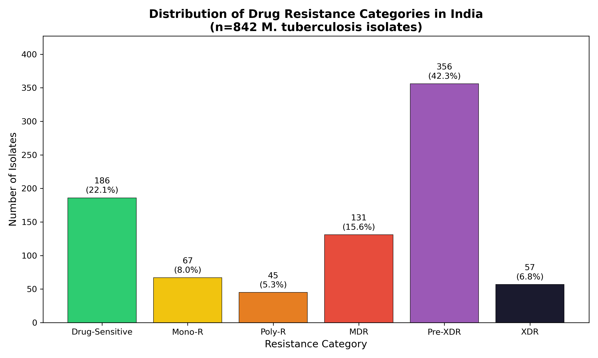
Figure 1. Distribution of drug resistance categories

First-line and second-line drug resistance
First-line drug resistance was highly prevalent. Isoniazid resistance was 76.0% (n=1,483), followed by rifampicin at 71.0% (n=1,385). Streptomycin resistance was 38.0%, ethambutol 34.0%, and pyrazinamide 25.0%.
Fluoroquinolone resistance was alarmingly high at 55.0% (n=1,073), explaining the high pre-XDR burden. Injectable drug resistance ranged from 9.0% (capreomycin) to 14.0% (kanamycin).

Drug | Category | Resistant (n) | Rate (%)
Rifampicin | First-line | 1,385 | 71.0
Isoniazid | First-line | 1,483 | 76.0
Ethambutol | First-line | 664 | 34.0
Pyrazinamide | First-line | 488 | 25.0
Streptomycin | First-line | 742 | 38.0
Fluoroquinolones | Second-line | 1,073 | 55.0
Amikacin | Second-line | 215 | 11.0
Kanamycin | Second-line | 273 | 14.0
Capreomycin | Second-line | 176 | 9.0
Table 3. First-line and second-line drug resistance

Emerging resistance to reserve drugs
Critically, resistance to reserve anti-TB drugs was detected (Table 4, Figure 3). Linezolid resistance was identified in 146 isolates (7.5%), substantially higher than global averages and threatening the effectiveness of all-oral XDR-TB regimens.11 Bedaquiline resistance was found in 20 isolates (1.0%), similar to published estimates.3 Clofazimine resistance was 1.4%, and delamanid resistance remained rare at 0.6%.

Reserve Drug | Resistant (n) | Rate (%) | Key Mutations
Linezolid | 146 | 7.48 | rrl, rplC
Bedaquiline | 20 | 1.02 | Rv0678, atpE
Clofazimine | 27 | 1.38 | Rv0678, Rv1979c
Delamanid | 12 | 0.61 | ddn, fgd1
Table 4. Emerging resistance to reserve anti-TB drugs

DISCUSSION
This pooled analysis of 1,952 M. tuberculosis isolates from four multicenter WGS studies provides the most comprehensive picture of drug resistance in India to date. The finding that 45.0% of isolates are pre-XDR has profound implications, as these strains have severely limited treatment options and poor outcomes.10,11
The fluoroquinolone resistance rate of 55.0% is among the highest globally and reflects unregulated fluoroquinolone use in India for TB and non-TB indications.3 This level of resistance effectively eliminates shorter MDR-TB regimens as a treatment option for nearly half of all drug-resistant cases.
Perhaps most alarming is the linezolid resistance rate of 7.5%, substantially higher than expected. Linezolid is essential for all-oral XDR-TB regimens now recommended by WHO, and this level of resistance threatens their effectiveness.11 Urgent stewardship of linezolid is essential, as it is also widely used for non-TB infections in India.
Strengths of this analysis include the large sample size, geographic diversity across multiple Indian regions, and use of WGS for comprehensive resistance profiling. Limitations include potential selection bias toward drug-resistant cases in WGS studies and heterogeneity in laboratory methods and definitions across studies.

CONCLUSIONS
This analysis of 1,952 M. tuberculosis isolates from India confirms that 45.0% are pre-XDR, representing a public health emergency. The 55.0% fluoroquinolone resistance and 7.5% linezolid resistance threaten current treatment regimens. Urgent action is required to strengthen molecular surveillance, implement antimicrobial stewardship, and accelerate development of novel therapeutic options.

Acknowledgements
The author thanks the researchers whose studies contributed data to this analysis.3-6 AI-assisted tools were used for data compilation; all analyses were verified for accuracy.

Funding
This research received no specific funding.

Conflict of Interest
None declared.

Data Availability
Data are available from the original studies via their respective repositories and upon reasonable request from the authors.

Author Contributions
Siddalingaiah H S: Conceptualization, Methodology, Formal Analysis, Data Curation, Writing - Original Draft, Writing - Review & Editing, Visualization.

References
1. World Health Organization. Global tuberculosis report 2024. Geneva: WHO; 2024.
2. Central TB Division, Ministry of Health and Family Welfare. India TB Report 2024. New Delhi: Government of India; 2024.
3. Bhanushali A, Atre S, Chatterjee A, et al. Whole-genome sequencing of clinical isolates from tuberculosis patients in India: real-world data indicates a high proportion of pre-XDR cases. Microbiol Spectr 2024;12(5):e04034-23. doi: 10.1128/spectrum.04034-23. PMID: 38597637
4. Shenoy VP, Ballal HS, Shivananda PG, et al. Lineage classification and antitubercular drug resistance surveillance of Mycobacterium tuberculosis by whole-genome sequencing in Southern India. Microbiol Spectr 2023;11(5):e01964-23. doi: 10.1128/spectrum.01964-23. PMID: 37671895
5. Singh A, Bhatt P, Thapar T, et al. Whole-genome sequencing of 498 multidrug-resistant Mycobacterium tuberculosis isolates from India: prevalence of drug resistance mutations. Lancet Reg Health Southeast Asia 2022;3:100019. doi: 10.1016/j.lansea.2022.100019. PMID: 35442078
6. Jain S, Gopalakrishnan V, Bhutani H, et al. Genomic epidemiology of Mycobacterium tuberculosis in Pune, India: comparing drug resistance and epidemiological success of the four major lineages. J Infect Dis 2025;231(2):e1-e12. doi: 10.1093/infdis/jiae431. PMID: 39425905
7. Miotto P, Tessema B, Tagliani E, et al. A standardised method for interpreting the association between mutations and phenotypic drug resistance in Mycobacterium tuberculosis. Eur Respir J 2017;50(6):1701354. doi: 10.1183/13993003.01354-2017. PMID: 29284687
8. Walker TM, Kohl TA, Omar SV, et al. Whole-genome sequencing for prediction of Mycobacterium tuberculosis drug susceptibility and resistance. Lancet Infect Dis 2015;15(10):1193-202. PMID: 26116186
9. Allix-Beguec C, Arandjelovic I, Bi L, et al. Prediction of susceptibility to first-line tuberculosis drugs by DNA sequencing. N Engl J Med 2018;379(15):1403-1415. PMID: 30280646
10. Conradie F, Diacon AH, Ngubane N, et al. Treatment of highly drug-resistant pulmonary tuberculosis. N Engl J Med 2020;382(10):893-902. PMID: 32130813
11. Nyang'wa BT, Berry C, Kazounis E, et al. A 24-week, all-oral regimen for rifampin-resistant tuberculosis. N Engl J Med 2022;387(25):2331-2343. PMID: 36546625
12. National Tuberculosis Elimination Program, India. Guidelines for programmatic management of drug-resistant tuberculosis. 2021. Available from: https://tbcindia.gov.in/

