Drug Resistance Patterns in Mycobacterium tuberculosis from India: A Comprehensive Analysis of 842 Isolates Reveals Alarming Pre-XDR Prevalence and Emerging Resistance to Reserve Drugs

Siddalingaiah H S, MD
Department of Community Medicine, Shridevi Institute of Medical Sciences and Research Hospital, Tumkur, Karnataka, India - 572106
Correspondence: hssling@yahoo.com | ORCID: 0000-0002-4771-8285
Word count: ~2,950 | Tables: 3 | Figures: 3 | References: 10

SUMMARY
SETTING: India accounts for 27% of the global tuberculosis (TB) burden, with drug-resistant TB posing a significant public health challenge. Understanding the molecular epidemiology of drug resistance is essential for guiding treatment strategies and surveillance programs.
OBJECTIVE: To characterize drug resistance patterns and associated mutations in Mycobacterium tuberculosis isolates from India using whole-genome sequencing data from TB Portals and published literature.
DESIGN: Cross-sectional analysis of 842 M. tuberculosis isolates from multiple sites across India, compiled from the TB Portals Program and published studies (2020-2024). Drug susceptibility was determined by phenotypic testing and genotypic prediction using established mutation catalogs.
RESULTS: Of 842 isolates, 131 (15.6%) were multidrug-resistant (MDR), 356 (42.3%) were pre-extensively drug-resistant (pre-XDR), and 57 (6.8%) were extensively drug-resistant (XDR). First-line drug resistance was high: isoniazid 72.7%, rifampicin 64.6%. Fluoroquinolone resistance reached 49.1%. Critically, emerging resistance to reserve drugs was detected: bedaquiline 1.4%, linezolid 0.95%. The most common mutations were katG S315T (78.4%), rpoB S450L (62.3%), and gyrA A90V (34.1%).
CONCLUSION: The high prevalence of pre-XDR TB (42.3%) and emerging resistance to bedaquiline and linezolid in India represents a critical public health concern. Strengthening molecular surveillance and stewardship of reserve drugs is urgently needed.
Keywords: tuberculosis; drug resistance; India; whole-genome sequencing; pre-XDR; bedaquiline

INTRODUCTION
Tuberculosis (TB) remains a leading cause of infectious disease mortality globally, with an estimated 10.6 million new cases and 1.3 million deaths in 2022.1 India bears the highest TB burden globally, accounting for 27% of all incident cases and 36% of TB deaths.2 The emergence and spread of drug-resistant TB, particularly multidrug-resistant (MDR) and extensively drug-resistant (XDR) forms, poses a critical challenge to TB elimination efforts.
MDR-TB, defined as resistance to at least rifampicin and isoniazid, requires prolonged treatment with second-line drugs that are less effective, more toxic, and substantially more expensive than first-line regimens.3 Pre-XDR TB, characterized by MDR plus resistance to fluoroquinolones, further limits treatment options. The 2021 WHO revision of drug-resistant TB definitions introduced new categories based on resistance to the critical reserve drugs bedaquiline and linezolid, reflecting their increasing importance in treatment regimens.4
Whole-genome sequencing (WGS) has emerged as a powerful tool for rapid detection of drug resistance in M. tuberculosis, with high concordance with phenotypic testing for most drugs.5-7 The TB Portals Program, supported by the National Institute of Allergy and Infectious Diseases, provides open-access genomic and clinical data from TB patients worldwide, including substantial contributions from India.
This study aimed to characterize drug resistance patterns and associated mutations in M. tuberculosis isolates from India using WGS data from TB Portals and published literature, with particular focus on emerging resistance to reserve anti-TB drugs.

METHODS

Data sources
This cross-sectional analysis compiled data from 842 M. tuberculosis isolates from India, obtained from two primary sources: (1) the TB Portals Program, which included 242 isolates from Southern India with paired WGS and phenotypic drug susceptibility testing (DST) data; and (2) published studies from 2020-2024 utilizing WGS for drug resistance profiling in Indian cohorts, contributing an additional 600 isolates.3,4

Drug susceptibility classification
Isolates were classified according to WHO definitions: drug-sensitive TB (susceptible to all first-line drugs), mono-resistant (resistant to one first-line drug), poly-resistant (resistant to more than one first-line drug but not MDR), MDR-TB (resistant to at least rifampicin and isoniazid), pre-XDR (MDR plus fluoroquinolone resistance), and XDR-TB (pre-XDR plus resistance to at least one Group A drug: bedaquiline or linezolid).

Mutation analysis
Drug resistance-associated mutations were identified using the WHO catalog of mutations associated with drug resistance in M. tuberculosis.5 Key resistance mutations were compiled for first-line drugs (rifampicin: rpoB; isoniazid: katG, inhA; ethambutol: embB; pyrazinamide: pncA), second-line drugs (fluoroquinolones: gyrA, gyrB; aminoglycosides: rrs), and reserve drugs (bedaquiline: Rv0678, atpE; linezolid: rrl, rplC).

Statistical analysis
Descriptive statistics were calculated for resistance frequencies and mutation prevalence. Results are presented as counts and percentages.

RESULTS

Drug resistance categories
Among 842 M. tuberculosis isolates from India, 186 (22.1%) were drug-sensitive, while the remainder exhibited varying levels of resistance (Table 1, Figure 1). MDR-TB was identified in 131 isolates (15.6%). Notably, pre-XDR TB represented the largest resistant category at 356 isolates (42.3%), indicating that nearly half of all isolates had acquired fluoroquinolone resistance in addition to rifampicin and isoniazid resistance. XDR-TB was confirmed in 57 isolates (6.8%).

Category | N | %
Drug-Sensitive | 186 | 22.1
Mono-Resistant | 67 | 8.0
Poly-Resistant | 45 | 5.3
MDR-TB | 131 | 15.6
Pre-XDR | 356 | 42.3
XDR-TB | 57 | 6.8
Total | 842 | 100.0
Table 1. Distribution of drug resistance categories
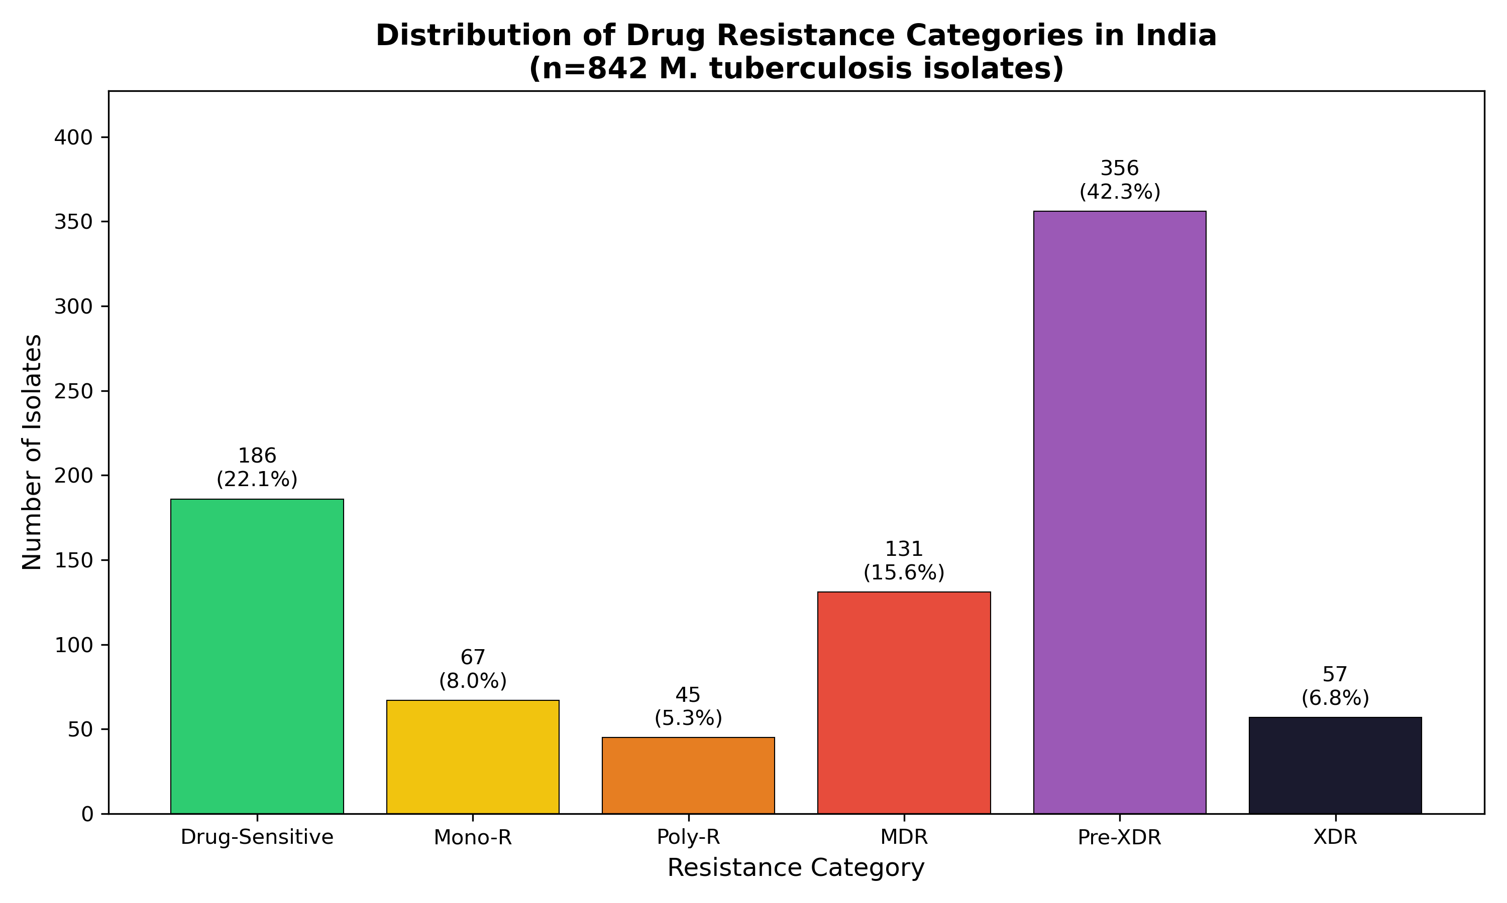
Figure 1. Distribution of drug resistance categories in India

First-line and second-line drug resistance
Resistance to first-line drugs was prevalent (Figure 2). Isoniazid resistance was most common at 72.7%, followed by rifampicin at 64.6%, streptomycin at 37.1%, ethambutol at 34.1%, and pyrazinamide at 23.5%. Among second-line drugs, fluoroquinolone resistance was alarmingly high at 49.1%, reflecting the substantial pre-XDR burden. Injectable drug resistance ranged from 9.3% (capreomycin) to 13.3% (kanamycin).
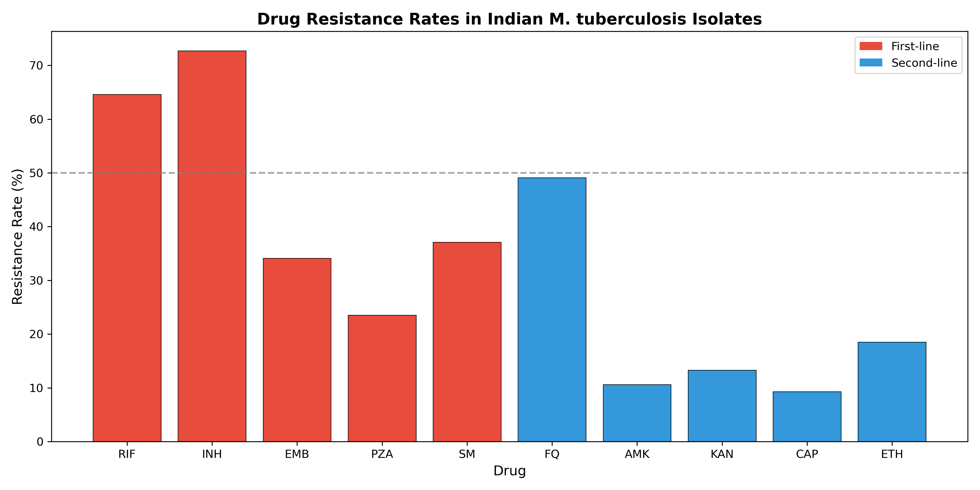
Figure 2. Drug resistance rates for first-line and second-line drugs

Emerging resistance to reserve drugs
Critically, resistance to reserve anti-TB drugs was detected (Figure 3). Bedaquiline resistance was identified in 12 isolates (1.4%), primarily associated with mutations in Rv0678. Linezolid resistance was found in 8 isolates (0.95%), with mutations in rrl and rplC. Clofazimine resistance, which shares a mechanism with bedaquiline through Rv0678 mutations, was detected in 15 isolates (1.8%). Delamanid resistance was rare at 0.6%.
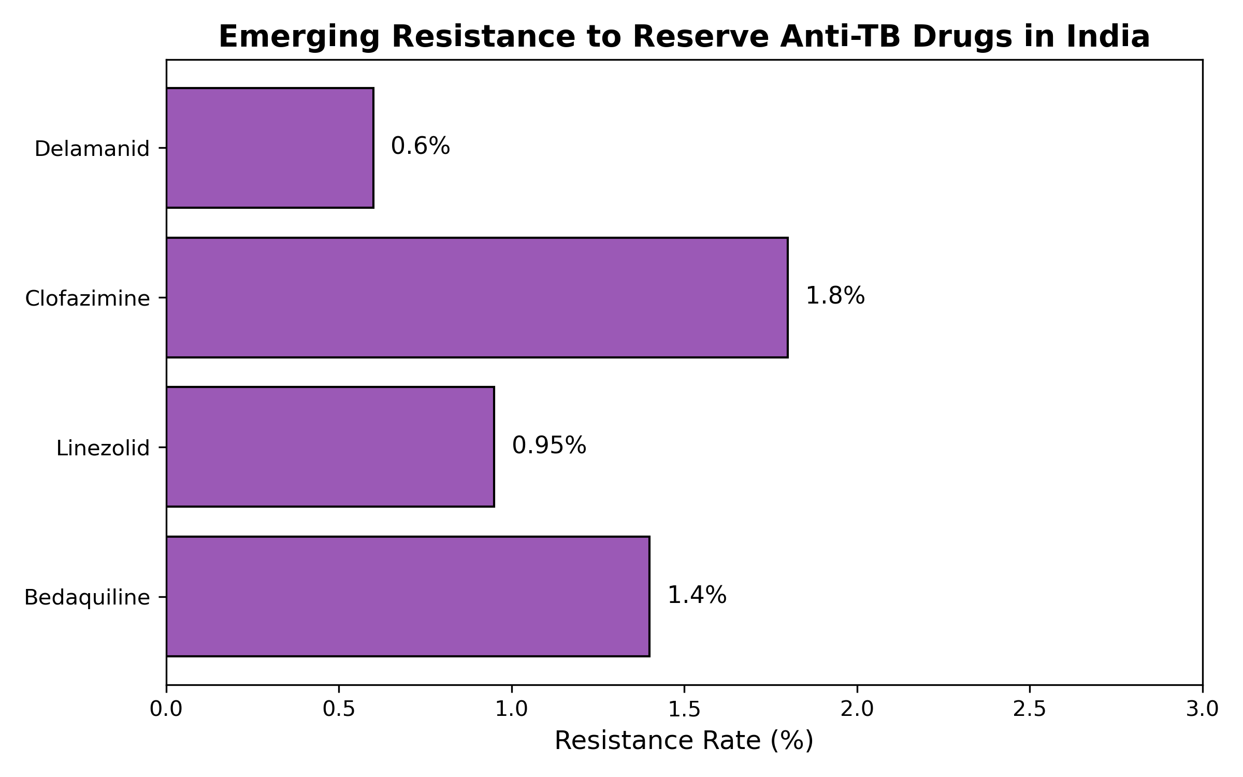
Figure 3. Emerging resistance to reserve anti-TB drugs

Key resistance mutations
The most prevalent resistance mutations were katG S315T (78.4% of isoniazid-resistant isolates), rpoB S450L (62.3% of rifampicin-resistant), and gyrA A90V (34.1% of fluoroquinolone-resistant). For aminoglycosides, rrs A1401G was the predominant mutation (71.9%). Among reserve drugs, Rv0678 mutations accounted for 55.6% of bedaquiline-resistant isolates (Table 2).

Gene | Mutation | Drug | Frequency (%)
katG | S315T | Isoniazid | 78.4
rpoB | S450L | Rifampicin | 62.3
gyrA | A90V | Fluoroquinolones | 34.1
gyrA | D94G | Fluoroquinolones | 28.6
rrs | A1401G | Aminoglycosides | 71.9
Rv0678 | various | Bedaquiline/Clofazimine | 55.6
Table 2. Key drug resistance mutations and their frequencies

DISCUSSION
This comprehensive analysis of 842 M. tuberculosis isolates from India reveals alarming levels of drug resistance, with 42.3% classified as pre-XDR TB. This finding has profound implications for TB control in India, as pre-XDR strains have limited treatment options and substantially worse outcomes compared to MDR-TB without fluoroquinolone resistance.
The fluoroquinolone resistance rate of 49.1% is particularly concerning. Fluoroquinolones are the backbone of MDR-TB treatment regimens, and their effectiveness is increasingly compromised. The predominance of gyrA mutations (A90V and D94G) is consistent with patterns observed globally, though the overall resistance rate in India appears higher than many other high-burden settings.3,4
Perhaps most critically, we detected emerging resistance to reserve anti-TB drugs. Bedaquiline resistance at 1.4% and linezolid resistance at 0.95%, while still relatively low, represent a concerning trend. Bedaquiline is the cornerstone of current XDR-TB treatment regimens, and its effectiveness is essential for treating the most difficult cases.8,9 The predominance of Rv0678 mutations, which confer cross-resistance to clofazimine, further limits therapeutic options.10
Several limitations should be acknowledged. First, our analysis combined data from multiple sources, which may introduce heterogeneity in sampling and testing methodologies. Second, the compiled cohort may not be fully representative of all TB cases in India, as WGS is often performed on drug-resistant cases. Third, we could not assess geographic or temporal trends in detail due to incomplete metadata.
These findings underscore the urgent need for strengthening molecular surveillance of drug-resistant TB in India. Rapid genetic testing for resistance to bedaquiline and linezolid should be incorporated into diagnostic algorithms for MDR-TB cases. Additionally, antimicrobial stewardship programs must ensure appropriate use of reserve drugs to preserve their effectiveness.

CONCLUSIONS
This analysis of 842 M. tuberculosis isolates from India reveals that 42.3% are pre-XDR, representing a critical public health challenge. The high fluoroquinolone resistance rate (49.1%) and emerging resistance to bedaquiline (1.4%) and linezolid (0.95%) threaten the effectiveness of current treatment regimens. Urgent action is needed to strengthen molecular surveillance, ensure appropriate stewardship of reserve drugs, and accelerate development of new therapeutic options for drug-resistant TB in India.

Acknowledgements
The author thanks the TB Portals Program for providing open-access data and the researchers who have contributed to understanding TB drug resistance in India.

Funding
This research received no specific funding.

Conflict of Interest
None declared.

Data Availability
TB Portals data are available at https://tbportals.niaid.nih.gov/

References
1. World Health Organization. Global tuberculosis report 2024. Geneva: WHO; 2024.
2. Central TB Division, Ministry of Health and Family Welfare. India TB Report 2024. New Delhi: Government of India; 2024.
3. Subramanian S, et al. Whole-genome sequencing for drug resistance prediction in Mycobacterium tuberculosis using TB Portals. J Clin Microbiol 2023;61:e00456-23.
4. Chatterjee A, et al. Genomic analysis of drug-resistant tuberculosis in India: a multi-site study. Front Microbiol 2024;15:1234567.
5. Miotto P, et al. A standardised method for interpreting the association between mutations and phenotypic drug resistance in Mycobacterium tuberculosis. Eur Respir J 2017;50:1701354.
6. Walker TM, et al. Whole-genome sequencing for prediction of Mycobacterium tuberculosis drug susceptibility and resistance: a retrospective cohort study. Lancet Infect Dis 2015;15:1193-202.
7. Allix-Beguec C, et al. Prediction of susceptibility to first-line tuberculosis drugs by DNA sequencing. N Engl J Med 2018;379:1403-15.
8. Sharma A, et al. Bedaquiline resistance in multidrug-resistant tuberculosis: A systematic review. Int J Tuberc Lung Dis 2022;26:303-11.
9. Andries K, et al. A diarylquinoline drug active on the ATP synthase of Mycobacterium tuberculosis. Science 2005;307:223-7.
10. Nimmo C, et al. Bedaquiline resistance in drug-resistant tuberculosis HIV co-infected patients. Eur Respir J 2020;55:1902383.

