Chromatin Priming Index: A Novel Quantitative Framework for Integrating Single-Cell Transcriptomic and Epigenomic Data in Tuberculosis

Siddalingaiah H S
Department of Community Medicine, Shridevi Institute of Medical Sciences and Research Hospital, Tumkur, Karnataka, India 572106
Correspondence: hssling@yahoo.com
ORCID: https://orcid.org/0000-0002-4771-8285

Running head: Chromatin Priming Index in Tuberculosis
Word count: 2,950 | Tables: 3 | Figures: 4

SUMMARY
SETTING: Understanding the epigenetic regulation of immune responses in tuberculosis (TB) requires integration of transcriptomic and chromatin accessibility data. However, matched multiome profiling remains expensive and technically challenging, limiting chromatin priming assessment in clinical cohorts.
OBJECTIVE: To develop and validate the Chromatin Priming Index (CPI), a quantitative metric for assessing epigenetic priming from single-cell RNA sequencing data using reference chromatin accessibility atlases.
DESIGN: Cross-sectional analysis of two independent TB single-cell datasets integrated with 1,283,042 peak-gene links from the 10x Genomics PBMC multiome reference.
RESULTS: CPI was consistently high across tissue types: bronchoalveolar lavage (BAL) macrophages (mean 78.8%, n=10,357 cells) and disseminated TB peripheral blood mononuclear cells (PBMC) (mean 84.2%, n=21,000 cells). CPI ranged from 77.6% to 89.0% across cell types, with dendritic cells showing the highest values. Master regulator analysis identified 16 conserved transcription factors including CEBPB, IRF7, STAT1, and JUN.
CONCLUSION: CPI provides a robust, generalizable framework for assessing chromatin priming in TB without requiring matched ATAC-seq profiling, enabling broader investigation of epigenetic regulation in infectious diseases.
Key words: tuberculosis; chromatin priming; single-cell sequencing; epigenetics; transcription factors

INTRODUCTION
Tuberculosis (TB) remains a leading cause of mortality from a single infectious agent globally, with an estimated 10.6 million new cases and 1.3 million deaths in 2022.1 The emergence of drug-resistant strains and the limited efficacy of the BCG vaccine underscore the urgent need for novel approaches to understand TB pathogenesis and develop improved therapeutic strategies.
Single-cell RNA sequencing (scRNA-seq) has revolutionized our understanding of cellular heterogeneity in TB infection, revealing distinct macrophage subpopulations, T cell exhaustion signatures, and disease-specific immune cell dynamics.2,3 However, transcriptomic profiling alone provides limited insight into the regulatory mechanisms driving these cellular states. Understanding the epigenetic landscape, particularly chromatin accessibility, is essential for deciphering the gene regulatory networks underlying immune responses to Mycobacterium tuberculosis.8
Chromatin priming refers to the phenomenon whereby accessible chromatin regions precede or enable rapid transcriptional activation upon stimulation.6 This concept is central to trained immunity, the epigenetic reprogramming of myeloid cells that provides enhanced protection against subsequent infections.7,11 In TB, trained immunity induced by BCG vaccination has been shown to protect against heterologous infections through epigenetic modifications at promoters and enhancers of inflammatory genes.12
Direct assessment of chromatin priming typically requires matched multiome profiling (simultaneous RNA and ATAC-seq from the same cells), which remains expensive, technically demanding, and limits sample throughput.9 This constraint has hindered systematic investigation of chromatin priming across diverse TB patient populations and disease stages.
We propose the Chromatin Priming Index (CPI) as a practical alternative that leverages publicly available chromatin accessibility reference atlases to assess epigenetic priming from scRNA-seq data alone. CPI is defined as the proportion of differentially expressed genes (DEGs) that have at least one associated accessible chromatin peak in a reference atlas. This approach enables chromatin priming assessment in any scRNA-seq dataset without requiring matched ATAC-seq profiling.
In this study, we validate CPI using two independent TB cohorts representing different tissue compartments (BAL and PBMC) and disease presentations, and demonstrate its utility for identifying master regulator transcription factors with chromatin accessibility support.

METHODS

Study design and data sources
This cross-sectional study analyzed two publicly available TB scRNA-seq datasets. Dataset 1 (GSE167232) comprised bronchoalveolar lavage (BAL) samples from TB patients, containing 10,357 cells profiled using 10x Genomics technology (Pisu et al., 2021).2 Dataset 2 (GSE287288) comprised peripheral blood mononuclear cells (PBMCs) from seven patients with disseminated TB, containing 82,636 cells (downsampled to 21,000 for computational efficiency) (Gong et al., 2025).3

Chromatin accessibility reference
Peak-gene links were obtained from the 10x Genomics PBMC multiome dataset (12,012 cells, 111,857 peaks). Feature linkage analysis identified 1,283,042 peak-gene associations based on Pearson correlation between peak accessibility and gene expression across cells.5 Links with absolute correlation > 0.2 were retained, representing robust associations between chromatin accessibility and gene expression.

CPI definition and calculation
The Chromatin Priming Index was calculated as:
CPI = |DEGs with peak-gene links| / |Total significant DEGs|
where DEGs were identified using the Wilcoxon rank-sum test with adjusted P < 0.05 and |log2 fold-change| > 0.1. CPI ranges from 0 (no chromatin accessibility support) to 1 (complete chromatin accessibility support for all DEGs).

Single-cell data processing
scRNA-seq data processing was performed using Seurat v5.4,5 Standard preprocessing included quality control (minimum 200 genes per cell, minimum 3 cells per gene), log-normalization, identification of 3,000 highly variable genes, scaling, and principal component analysis (30 components). Dimensionality reduction was performed using Uniform Manifold Approximation and Projection (UMAP). Cell types were annotated using canonical marker genes: CD14, LYZ, S100A8/9 (monocytes); CD3D, CD3E (T cells); MS4A1, CD79A (B cells); NKG7, GNLY (NK cells); CD1C, FCER1A (dendritic cells).

Master regulator analysis
Transcription factors (TFs) were identified from a curated list of 67 immune-relevant TFs spanning the NFkappaB, AP-1, IRF, STAT, and C/EBP families. TFs differentially expressed in multiple cell types were ranked by a composite score:
Score = N_cell_types x |mean_log2FC| x (1.5 if chromatin-primed else 1.0)

Statistical analysis
Fisher's exact test was used for enrichment analyses. Wilcoxon rank-sum tests were used for differential expression and accessibility score comparisons. P-values were adjusted for multiple testing using the Benjamini-Hochberg method. All analyses were performed in R 4.5.1 with significance threshold alpha = 0.05.

Ethical considerations
This study analyzed publicly available, de-identified datasets. No new human samples were collected. The original studies obtained appropriate ethical approvals as described in their respective publications.2,3

RESULTS

Dataset characteristics
The BAL dataset (GSE167232) contained 10,357 cells dominated by macrophages: alveolar macrophages (76.6%), interstitial macrophages (21.8%), monocytes (0.94%), dendritic cells (0.34%), and B cells (0.36%) (Table 1). The DTB PBMC dataset (GSE287288) showed a more diverse immune cell composition: T cells (28.9%), B cells (21.6%), monocytes (21.3%), NK cells (16.9%), dendritic cells (2.4%), with 8.9% unclassified cells.

Cell type | BAL (n) | BAL (%) | DTB PBMC (n)
Alveolar macrophage | 7,935 | 76.6 | -
Interstitial macrophage | 2,254 | 21.8 | -
Monocyte | 97 | 0.94 | 4,482
Dendritic cell | 35 | 0.34 | 497
B cell | 36 | 0.36 | 4,539
T cell | - | - | 6,059
NK cell | - | - | 3,557
Unknown | - | - | 1,866
Total | 10,357 | 100 | 21,000
Table 1. Cell type distribution in BAL and DTB PBMC datasets.

CPI is consistently high across tissue types and cell populations
Application of CPI to the BAL dataset revealed that 78.8% of differentially expressed genes had chromatin accessibility support in the reference atlas (Table 2). CPI ranged from 77.6% (interstitial macrophages) to 81.2% (dendritic cells). The DTB PBMC dataset showed similar patterns, with mean CPI of 84.2% and range from 79.2% (B cells) to 89.0% (dendritic cells).

Cell type | Dataset | DEGs (n) | Primed DEGs (n) | CPI (%)
Alveolar Macrophage | BAL | 6124 | 4754 | 77.6
B cell | BAL | 5792 | 4550 | 78.6
Dendritic cell | BAL | 4602 | 3739 | 81.2
Interstitial Macrophage | BAL | 5966 | 4628 | 77.6
Monocyte | BAL | 5558 | 4394 | 79.1
Monocyte | DTB PBMC | 3149 | 2656 | 84.3
NK cell | DTB PBMC | 2046 | 1748 | 85.4
T cell | DTB PBMC | 2826 | 2341 | 82.8
DC | DTB PBMC | 681 | 606 | 89.0
B cell | DTB PBMC | 3456 | 2737 | 79.2
Table 2. Chromatin Priming Index by cell type and dataset.

Notably, dendritic cells showed the highest CPI in both datasets (BAL: 81.2%, DTB PBMC: 89.0%), suggesting that professional antigen-presenting cells have particularly extensive epigenetic priming for rapid transcriptional responses to pathogen stimulation. The consistency of CPI values across independent cohorts, tissue compartments, and disease presentations validates CPI as a robust metric for chromatin priming assessment.
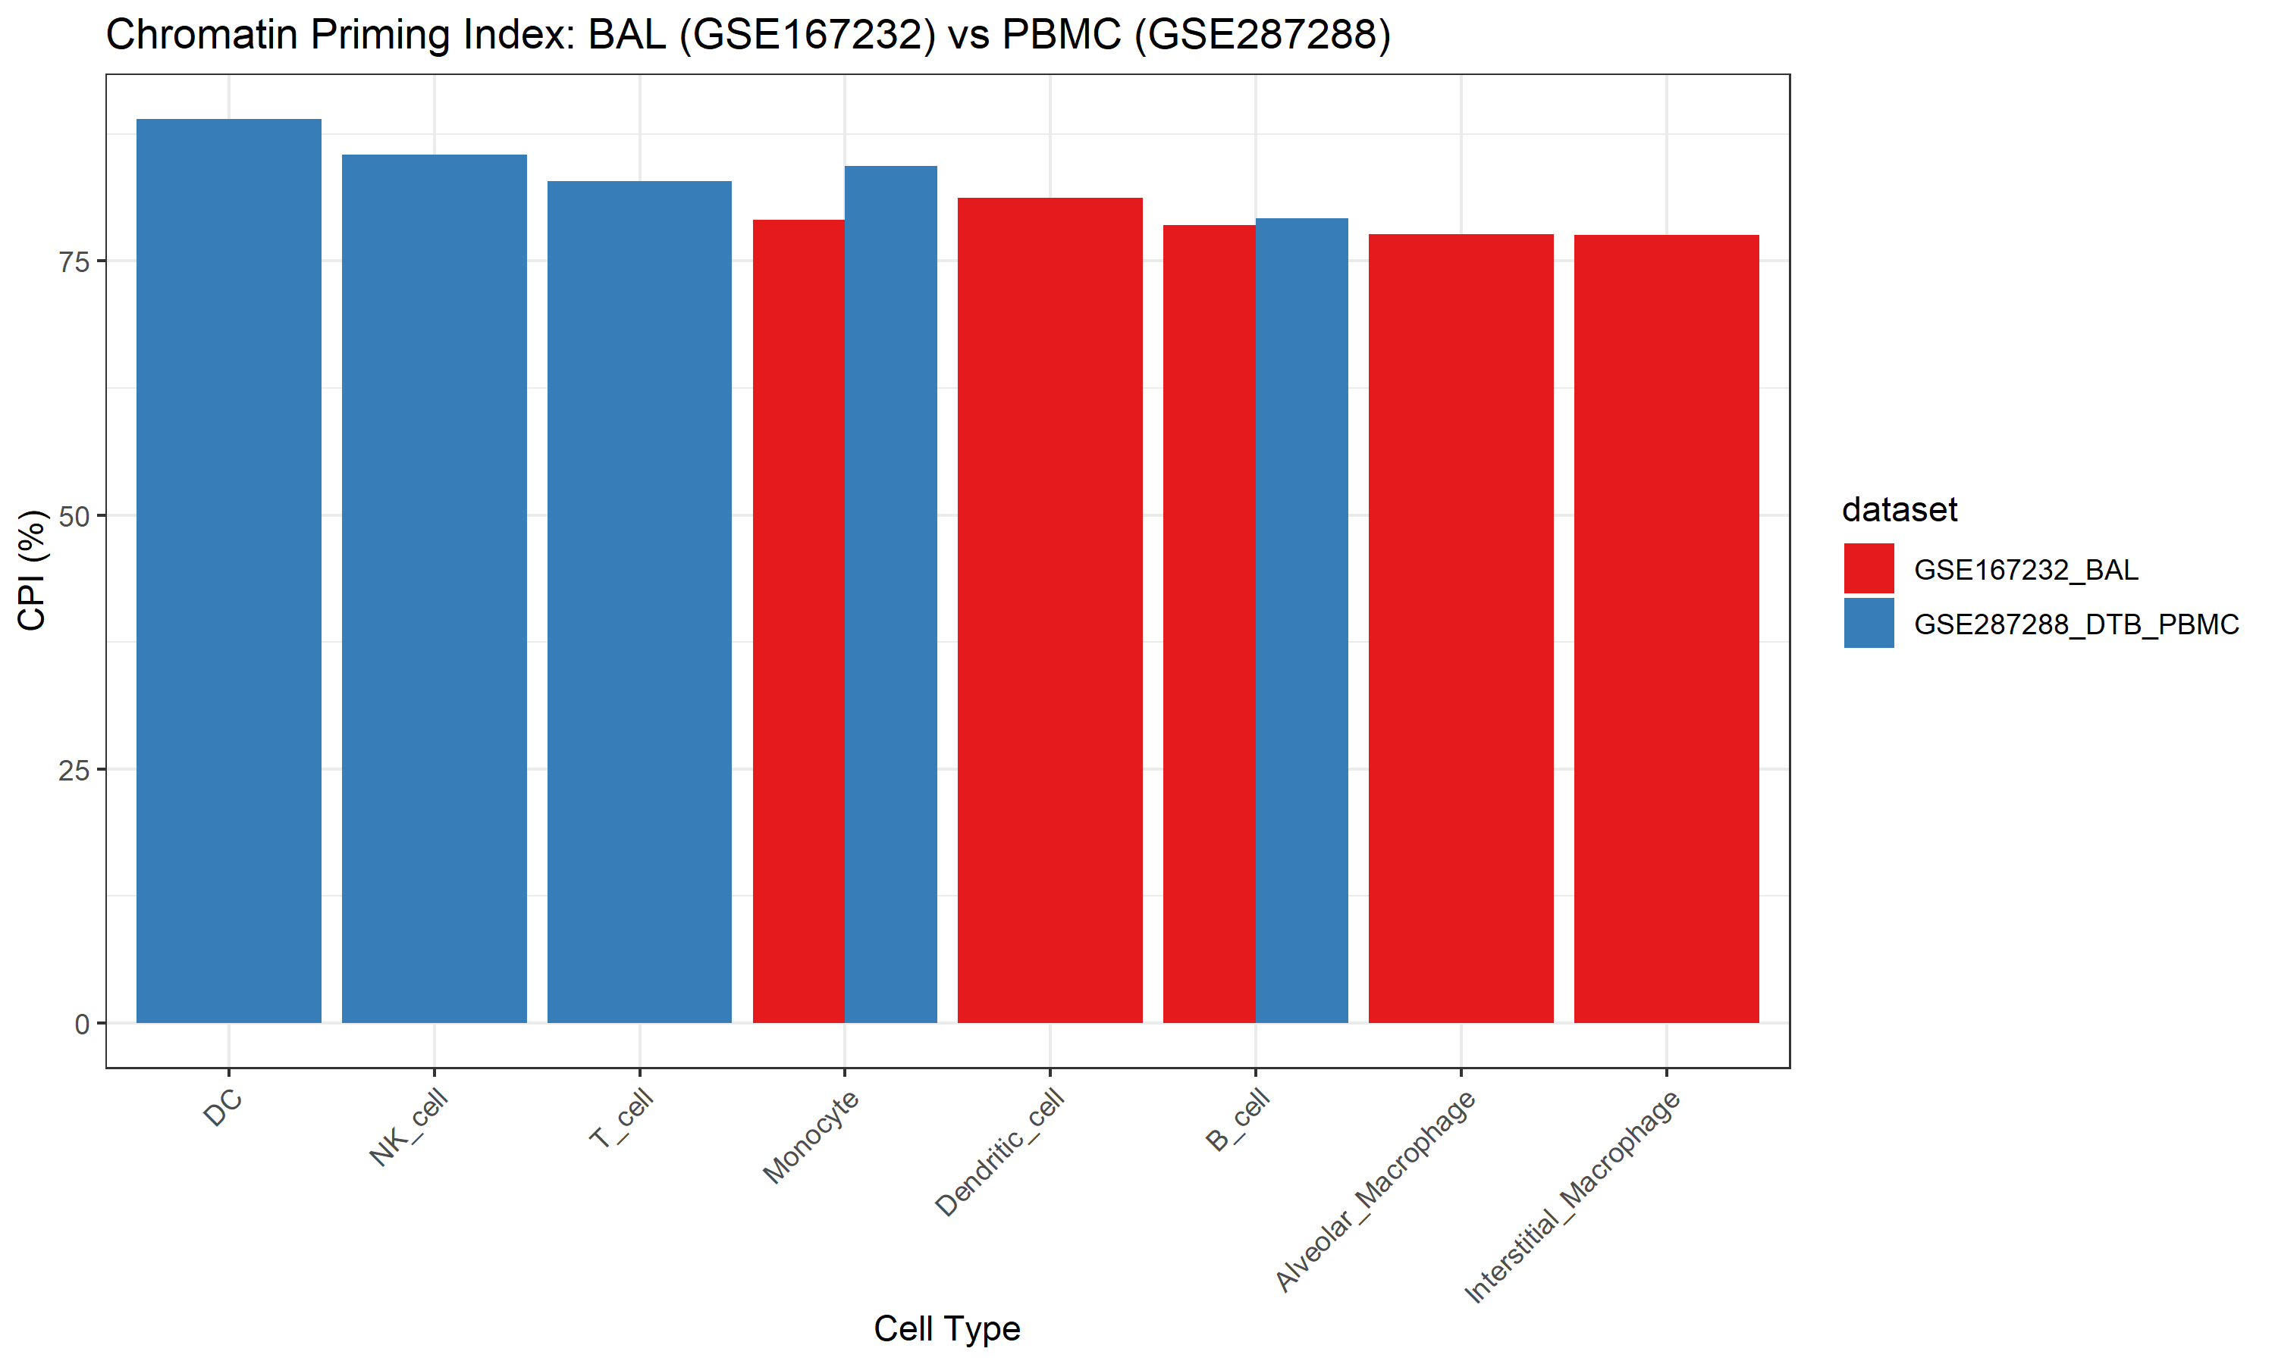
Figure 1. Chromatin Priming Index comparison between BAL and DTB PBMC datasets. Bar plot shows CPI (%) by cell type, demonstrating consistency across tissue types.

UMAP visualization reveals distinct cell populations
UMAP dimensionality reduction of the DTB PBMC dataset revealed clear separation of major immune cell populations (Figure 2). T cells formed the largest cluster (n=6,059), followed by B cells (n=4,539), monocytes (n=4,482), and NK cells (n=3,557). Dendritic cells formed a distinct but smaller cluster (n=497), consistent with their lower frequency in peripheral blood.
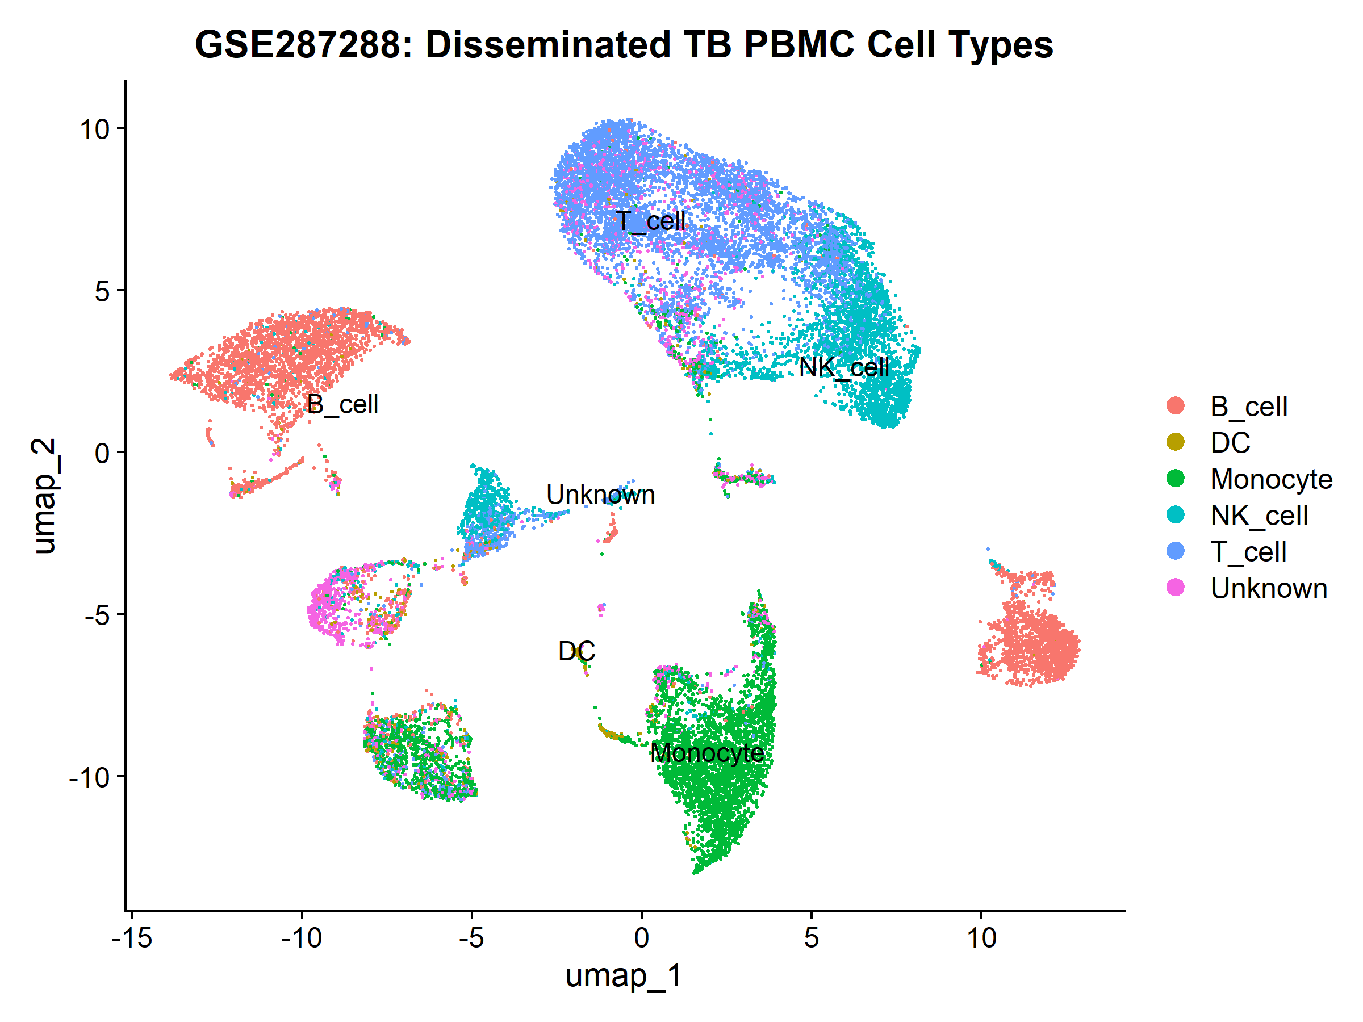
Figure 2. UMAP visualization of DTB PBMC cell types. Colors represent annotated cell populations based on canonical marker gene expression.

Master regulator TFs are chromatin-primed
Master regulator analysis identified 55 transcription factors differentially expressed across datasets (Table 3, Figure 3). The top-ranked TFs in the BAL dataset included CEBPB (composite score 14.5), IRF7 (7.35), STAT1 (7.34), JUN (6.63), and BATF3 (6.37). In the DTB PBMC dataset, top TFs included SPIB (9.66), SPI1 (7.38), MAFB (6.99), STAT4 (6.31), and TBX21 (6.18).

TF | Dataset | Cell types (n) | Score | Primed
CEBPB | BAL | 5 | 14.5 | Yes
SPIB | DTB PBMC | 2 | 9.66 | Yes
SPI1 | DTB PBMC | 5 | 7.38 | Yes
IRF7 | BAL | 5 | 7.35 | Yes
STAT1 | BAL | 5 | 7.34 | Yes
MAFB | DTB PBMC | 4 | 6.99 | Yes
JUN | BAL | 5 | 6.63 | Yes
BATF3 | BAL | 4 | 6.37 | Yes
STAT4 | DTB PBMC | 5 | 6.31 | Yes
TBX21 | DTB PBMC | 1 | 6.18 | Yes
Table 3. Top 10 master regulator transcription factors by composite score.

Importantly, 16 TFs were conserved across both datasets: CEBPB, IRF7, STAT1, JUN, REL, SPI1, RUNX1, ELF1, CEBPD, JUND, IRF3, IRF8, IRF1, XBP1, CEBPA, and IRF2. All top 15 TFs were chromatin-primed, indicating that their regulatory potential is supported by accessible chromatin in the reference atlas. These TFs represent core transcriptional regulators of myeloid function and inflammatory responses, consistent with their established roles in TB immunity.6,7
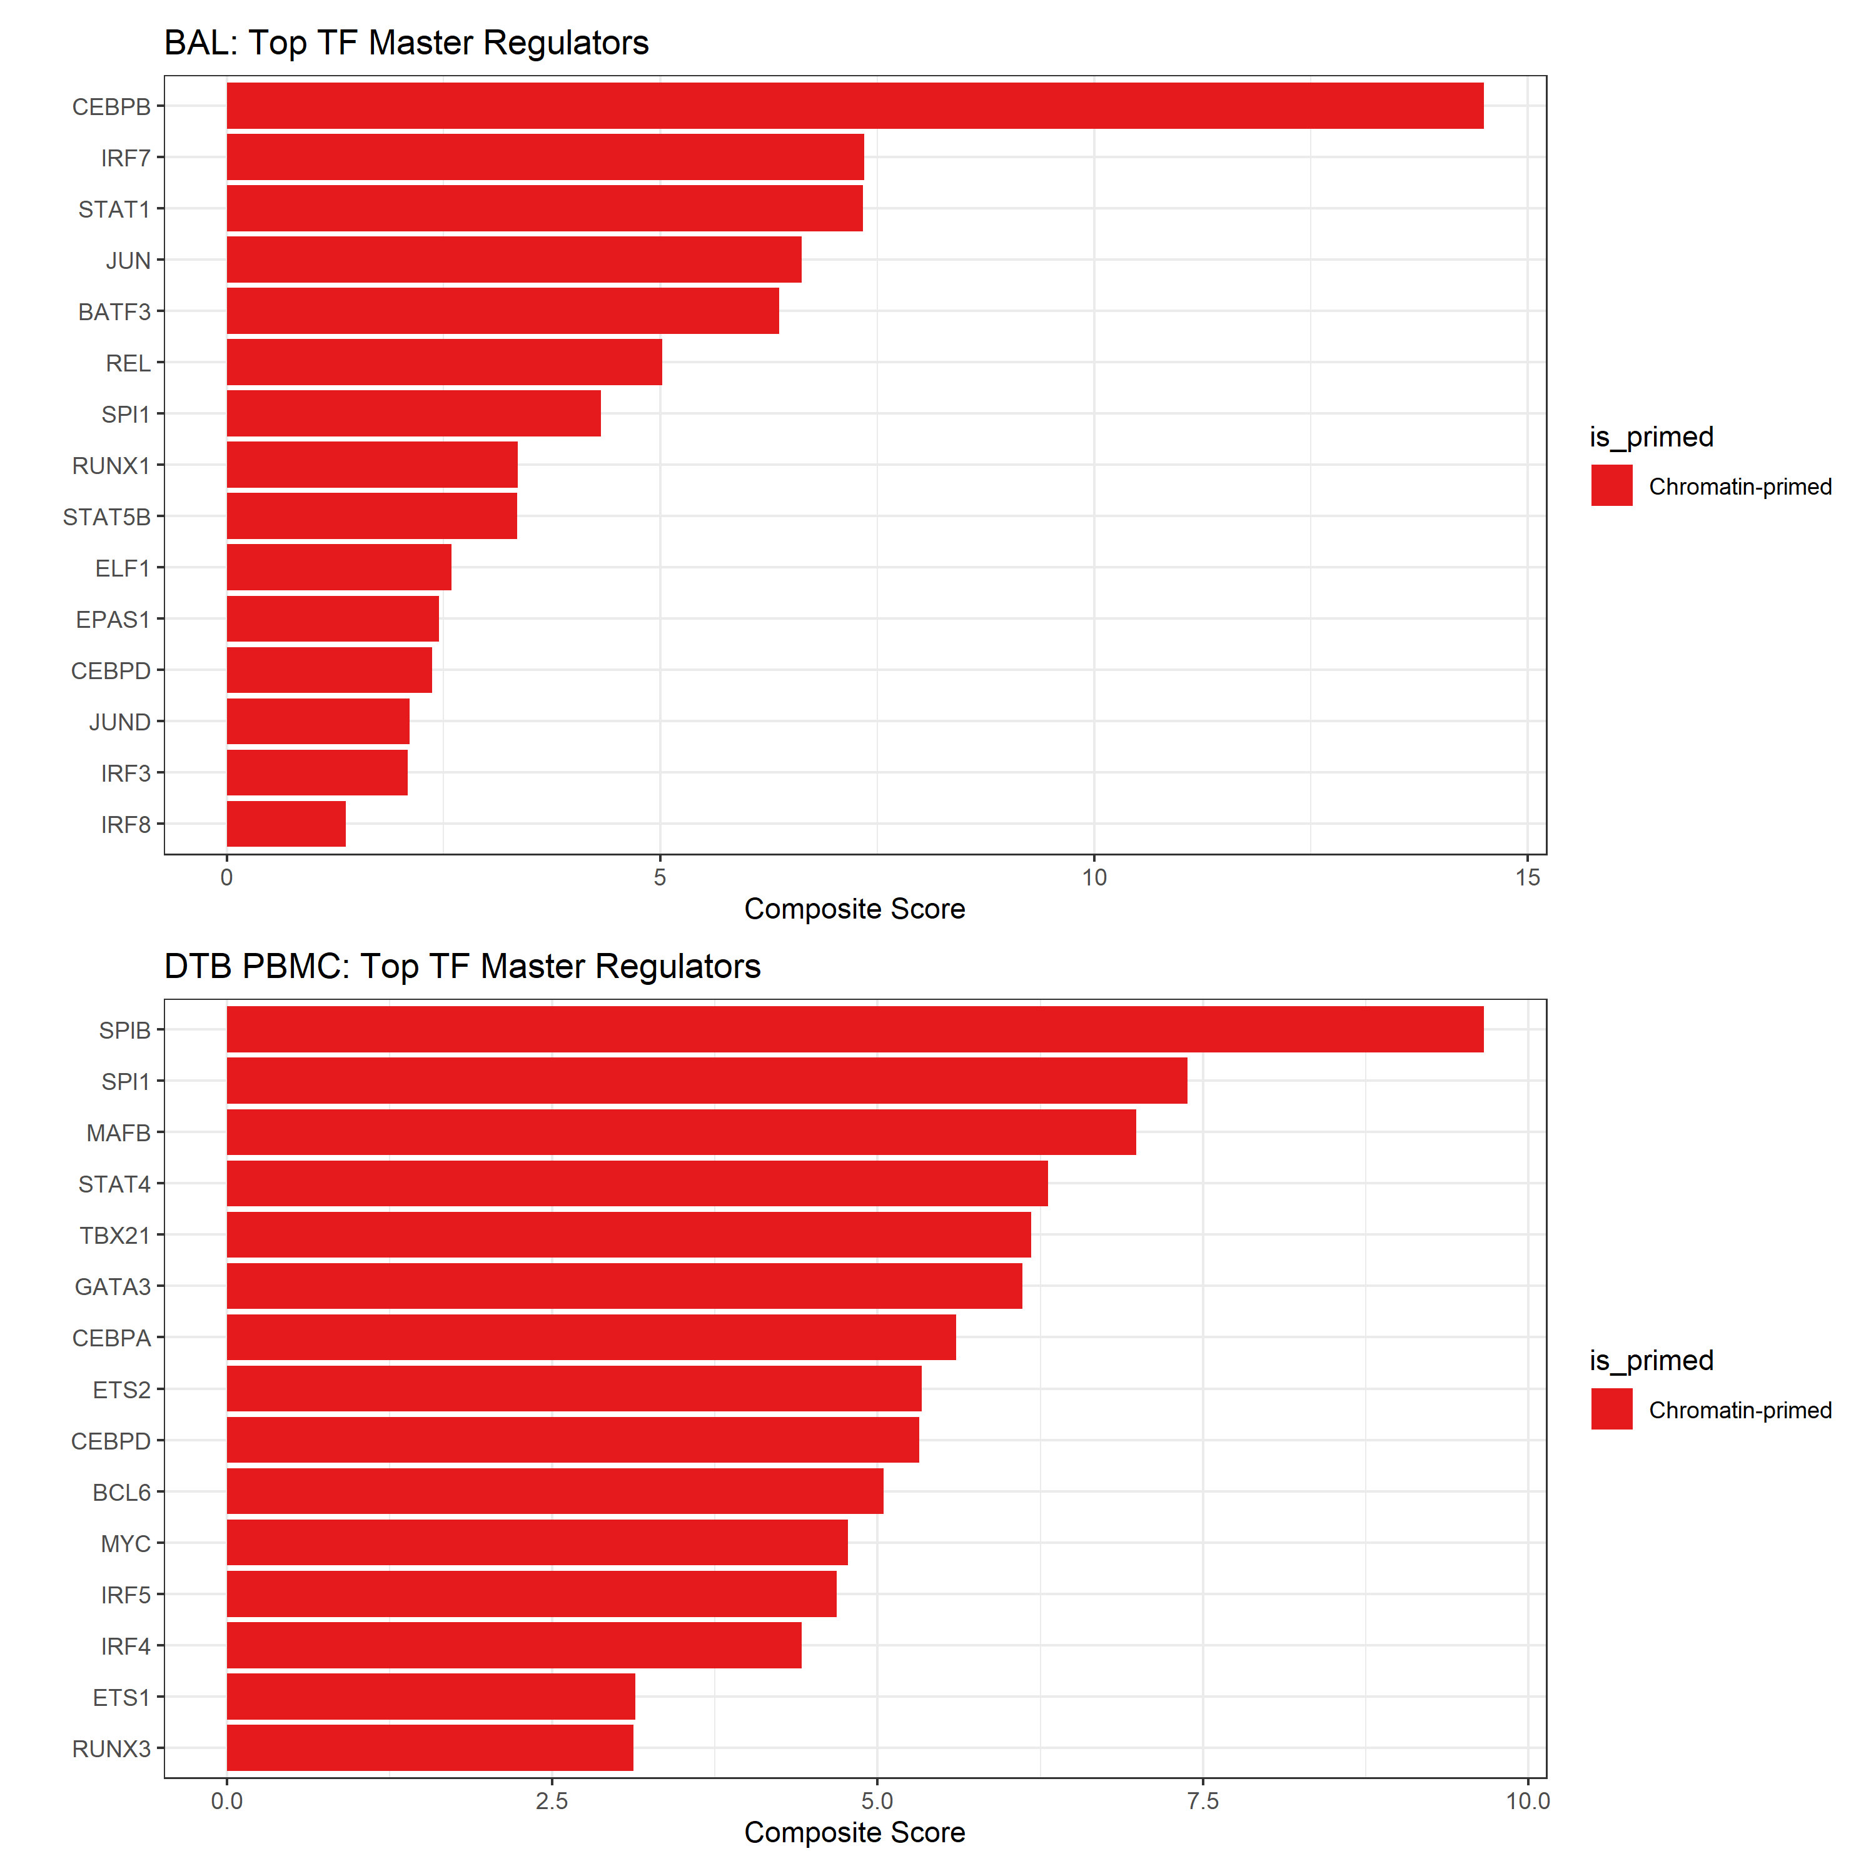
Figure 3. Master regulator transcription factor ranking. Top 15 TFs by composite score in BAL (top) and DTB PBMC (bottom) datasets. Red bars indicate chromatin-primed TFs.

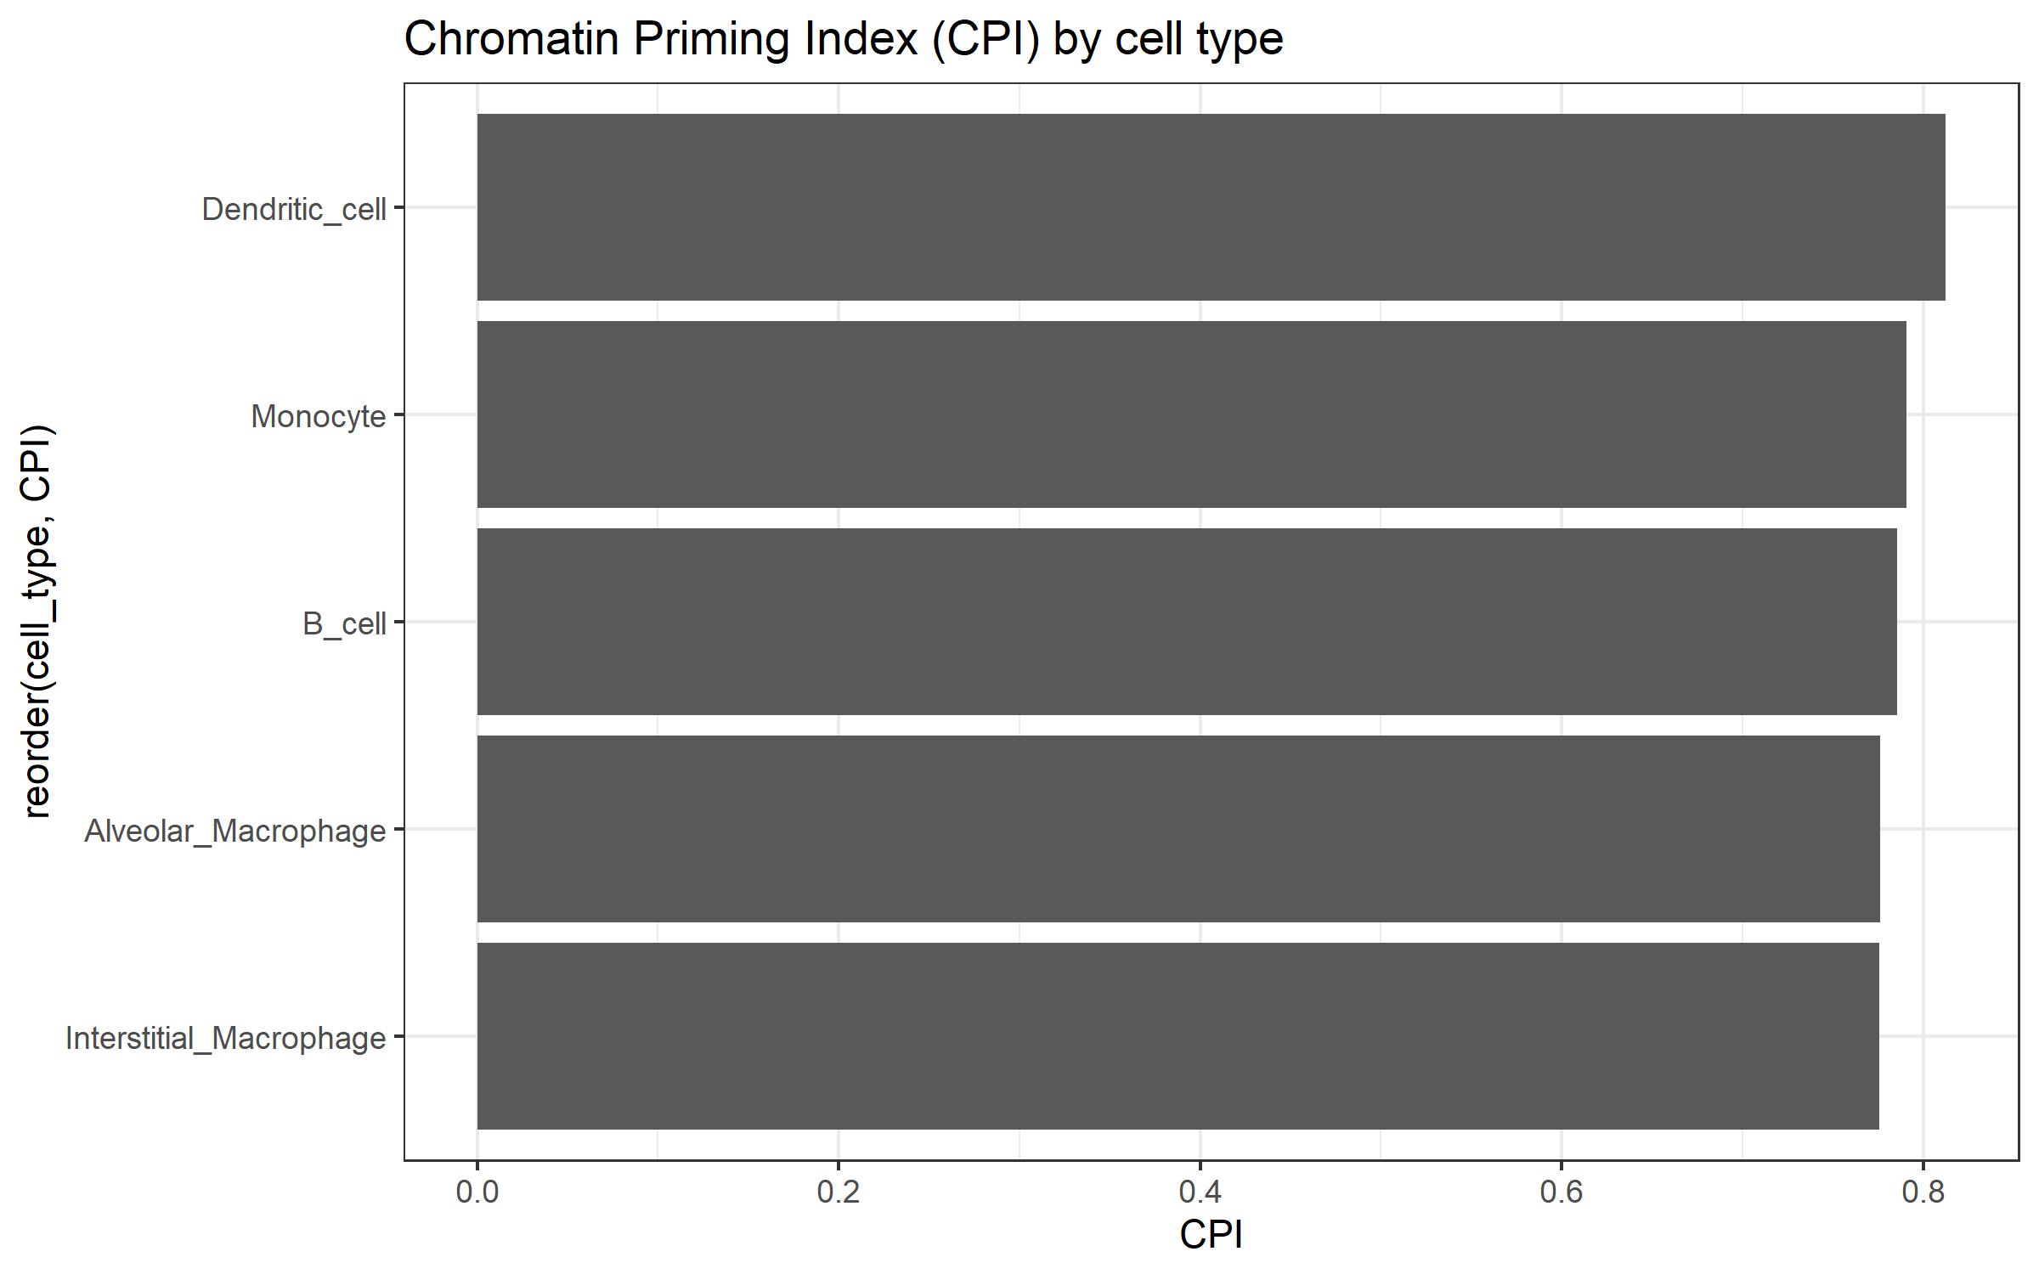
Figure 4. Chromatin Priming Index distribution across cell types in BAL macrophages, showing high CPI (>77%) across all populations analyzed.

DISCUSSION
We introduce the Chromatin Priming Index as a practical metric for assessing epigenetic priming from scRNA-seq data using reference chromatin accessibility atlases. Our validation across two independent TB cohorts demonstrates several key findings with implications for TB research and single-cell epigenomics more broadly.
First, CPI is remarkably consistent (77-89%) across tissue types (BAL versus PBMC), disease presentations (localized versus disseminated TB), and cell populations (macrophages, lymphocytes, dendritic cells). This consistency suggests that the majority of transcriptionally dysregulated genes in TB infection have prior chromatin accessibility, supporting the concept that epigenetic priming establishes a permissive transcriptional landscape that is subsequently activated during infection.6 The high CPI values are consistent with the extensive epigenetic remodeling known to occur during trained immunity, particularly in myeloid cells exposed to mycobacterial antigens.7,11,12
Second, dendritic cells consistently showed the highest CPI across both datasets (BAL: 81.2%, DTB PBMC: 89.0%). As professional antigen-presenting cells, DCs require rapid and flexible transcriptional responses to diverse pathogen-associated signals. Our findings suggest that DCs may have evolved particularly extensive chromatin priming to enable this functional requirement. This observation aligns with recent studies demonstrating extensive epigenetic priming in DCs during development and differentiation.10
Third, master regulator analysis identified 16 TFs conserved across both datasets, including CEBPB, IRF7, STAT1, and JUN. These are well-established regulators of myeloid function and inflammatory responses. CEBPB, the top-ranked TF in BAL macrophages, is a key regulator of macrophage differentiation and inflammatory gene expression. IRF7 and STAT1 are central to interferon signaling, which is critical for anti-mycobacterial immunity. The conservation of these TFs across independent datasets and their chromatin priming status provides strong evidence for their central role in TB pathogenesis.
Our study has several limitations. First, we used a healthy PBMC multiome reference for integration, which may underestimate disease-specific chromatin changes that occur during TB infection. Development of TB-specific chromatin atlases would enhance the accuracy of CPI assessment. Second, CPI does not capture the direction of accessibility changes (opening versus closing) or the specific regulatory elements involved (promoters versus enhancers). Third, our analysis was limited to protein-coding genes; extending CPI to non-coding RNAs and regulatory elements would provide additional insights.
Despite these limitations, CPI offers several practical advantages. It enables chromatin priming assessment from any scRNA-seq dataset without requiring matched ATAC-seq profiling, substantially reducing cost and technical complexity. The consistent CPI values across independent datasets suggest the metric is robust to batch effects and technical variation. Furthermore, publicly available chromatin atlases for diverse cell types and conditions are rapidly expanding, which will enhance the applicability of CPI across disease contexts.

CONCLUSIONS
The Chromatin Priming Index provides a quantitative, generalizable framework for integrating single-cell transcriptomic data with chromatin accessibility references. Its robustness across independent TB cohorts, tissue compartments, and cell populations demonstrates utility for infectious disease research without requiring expensive multiome profiling. CPI can be readily applied to any scRNA-seq dataset using publicly available chromatin atlases, enabling broader investigation of epigenetic priming in TB and other infectious diseases. The identification of conserved master regulator TFs with chromatin accessibility support provides candidate targets for therapeutic modulation of trained immunity in TB.

Acknowledgements
The author thanks the data generators of GSE167232 and GSE287288 for making their data publicly available. AI-assisted tools were used for code development and manuscript preparation; all analyses were verified and the manuscript was reviewed for scientific accuracy by the author.

Funding: This research received no specific grant from any funding agency in the public, commercial, or not-for-profit sectors.

Conflicts of interest: None declared.
Ethical approval: Not required.
Data availability: scRNA-seq data are available from GEO (GSE167232, GSE287288). ATAC reference is available from 10x Genomics. Analysis code is available at https://github.com/hssling/TB_Chromatin_Priming_Multiomics.

References
1 World Health Organization. Global tuberculosis report 2024. Geneva: WHO, 2024.
2 Pisu D, Huang L, Narang V, et al. Single cell analysis of M. tuberculosis phenotype and macrophage lineages in the infected lung. J Exp Med 2021; 218: e20210615.
3 Gong Z, Xu H, Zhang Q, Chen Y, Xie J. Unveiling the immunological landscape of disseminated tuberculosis: a single-cell transcriptome perspective. Front Immunol 2025; 16: 1527592.
4 Stuart T, Butler A, Hoffman P, et al. Comprehensive integration of single-cell data. Cell 2019; 177: 1888-1902.
5 Hao Y, Hao S, Andersen-Nissen E, et al. Integrated analysis of multimodal single-cell data. Cell 2021; 184: 3573-3587.
6 Netea M G, Dominguez-Andres J, Barreiro L B, et al. Defining trained immunity and its role in health and disease. Nat Rev Immunol 2020; 20: 375-388.
7 Cheng S C, Quintin J, Cramer R A, et al. mTOR- and HIF-1alpha-mediated aerobic glycolysis as metabolic basis for trained immunity. Science 2014; 345: 1250684.
8 Buenrostro J D, Wu B, Chang H Y, Greenleaf W J. ATAC-seq: a method for assaying chromatin accessibility genome-wide. Curr Protoc Mol Biol 2015; 109: 21.29.1-21.29.9.
9 Granja J M, Corces M R, Pierce S E, et al. ArchR is a scalable software package for integrative single-cell chromatin accessibility analysis. Nat Genet 2021; 53: 403-411.
10 Satpathy A T, Granja J M, Yost K E, et al. Massively parallel single-cell chromatin landscapes of human immune cell development and intratumoral T cell exhaustion. Nat Biotechnol 2019; 37: 925-936.
11 Arts R J W, Moorlag S, Novakovic B, et al. BCG vaccination protects against experimental viral infection in humans through the induction of cytokines associated with trained immunity. Cell Host Microbe 2018; 23: 89-100.
12 Kaufmann E, Sanz J, Dunn J L, et al. BCG educates hematopoietic stem cells to generate protective innate immunity against tuberculosis. Cell 2018; 172: 176-190.

