Supplementary Materials
Chromatin Priming Index: A Novel Quantitative Framework for Integrating Single-Cell Transcriptomic and Epigenomic Data in Tuberculosis

Siddalingaiah H S

Contents
Supplementary Methods
- S1. Data preprocessing parameters
- S2. Cell type annotation markers
- S3. CPI calculation algorithm
- S4. Master regulator scoring
Supplementary Tables
- Table S1. Complete DEG list (BAL dataset)
- Table S2. Complete DEG list (DTB PBMC dataset)
- Table S3. All transcription factors analyzed
- Table S4. Peak-gene link statistics
Supplementary Figures
- Figure S1. Volcano plots by cell type
- Figure S2. Trained immunity module scores
- Figure S3. Metabolic signature accessibility
Code Availability

Supplementary Methods

S1. Data preprocessing parameters
Single-cell RNA sequencing data were processed using the following parameters:
Parameter | Value | Description
min.cells | 3 | Minimum cells per gene
min.features | 200 | Minimum genes per cell
nfeatures | 3000 | Variable features for PCA
npcs | 30 | Principal components
dims | 1:20 | Dimensions for clustering
resolution | 0.8 | Clustering resolution
n.neighbors | 30 | UMAP neighbors

S2. Cell type annotation markers
Cell types were annotated using canonical marker gene expression. Module scores were calculated using Seurat's AddModuleScore function with nbin=24.
Cell Type | Marker Genes
T cell | CD3D, CD3E, CD4, CD8A
NK cell | GNLY, NKG7, NCAM1
B cell | CD79A, MS4A1, CD19
Monocyte | CD14, LYZ, S100A8, S100A9
Dendritic cell | CD1C, FCER1A, CLEC4C
Macrophage (alveolar) | MARCO, FABP4, MCEMP1
Macrophage (interstitial) | CD68, CD163, MRC1

S3. CPI calculation algorithm
The Chromatin Priming Index was calculated as follows:
Algorithm 1: CPI Calculation
Input: DEG_list (differentially expressed genes)
peak_links (peak-gene associations from reference)
Output: CPI (chromatin priming index, 0-1)

1. Filter DEGs: sig_DEGs = DEGs with adj.P < 0.05
2. Get linked genes: linked_genes = unique genes in peak_links
3. Calculate intersection: primed_DEGs = sig_DEGs ∩ linked_genes
4. Compute CPI: CPI = |primed_DEGs| / |sig_DEGs|
5. Return CPI

S4. Master regulator scoring
Transcription factors were ranked using a composite score incorporating multiple factors:
Score = N_cell_types × |mean(log2FC)| × priming_bonus
where N_cell_types is the number of cell types in which the TF is significantly differentially expressed, mean(log2FC) is the average fold-change across cell types, and priming_bonus = 1.5 if the TF has chromatin accessibility support, else 1.0.

Supplementary Tables

Table S1. Top 50 Differentially Expressed Genes (BAL Dataset)
p_val | avg_log2FC | pct.1 | pct.2 | p_val_adj | gene | cell_type | comparison
0 | -13.2760 | 0 | 0.8470 | 0 | RPS4Y1 | Interstitial_Macrophage | unin_hto_vs_unin3
0 | -2.1974 | 0.2830 | 0.8320 | 0 | IL3RA | Interstitial_Macrophage | unin_hto_vs_unin3
0 | 6.5537 | 0.5270 | 0.0160 | 0 | HLA-DQA2 | Interstitial_Macrophage | unin_hto_vs_unin3
0 | -1.4574 | 0.4210 | 0.8410 | 0 | MS4A4A | Interstitial_Macrophage | unin_hto_vs_unin3
0 | -10.8737 | 0 | 0.3640 | 0 | EIF1AY | Interstitial_Macrophage | unin_hto_vs_unin3
0 | 2.3456 | 0.7560 | 0.4120 | 0 | C4orf48 | Interstitial_Macrophage | unin_hto_vs_unin3
0 | -1.2492 | 0.6640 | 0.9600 | 0 | ATP5MC3 | Interstitial_Macrophage | unin_hto_vs_unin3
0 | -1.3964 | 0.6750 | 0.9680 | 0 | NDUFA4 | Interstitial_Macrophage | unin_hto_vs_unin3
0 | 2.0152 | 0.8250 | 0.5790 | 0 | TYMP | Interstitial_Macrophage | unin_hto_vs_unin3
0 | -1.0463 | 0.7320 | 0.9740 | 0 | MYL12B | Interstitial_Macrophage | unin_hto_vs_unin3
0 | 2.2705 | 0.7830 | 0.5420 | 0 | CES1 | Interstitial_Macrophage | unin_hto_vs_unin3
0 | -1.1843 | 0.7320 | 0.9720 | 0 | TXN | Interstitial_Macrophage | unin_hto_vs_unin3
0 | -1.3776 | 0.7640 | 0.9990 | 0 | HLA-DRB5 | Interstitial_Macrophage | unin_hto_vs_unin3
0 | -1.0358 | 0.7320 | 0.9630 | 0 | ATP5MG | Interstitial_Macrophage | unin_hto_vs_unin3
0 | -0.9802 | 0.7440 | 0.9720 | 0 | SRP14 | Interstitial_Macrophage | unin_hto_vs_unin3
0 | -1.2153 | 0.7890 | 0.9820 | 0 | MYL12A | Interstitial_Macrophage | unin_hto_vs_unin3
0 | -0.9792 | 0.8040 | 0.9770 | 0 | GSTO1 | Interstitial_Macrophage | unin_hto_vs_unin3
0 | -0.9502 | 0.8050 | 0.9760 | 0 | AIF1 | Interstitial_Macrophage | unin_hto_vs_unin3
0 | -0.9612 | 0.8430 | 0.9820 | 0 | S100A9 | Interstitial_Macrophage | unin_hto_vs_unin3
0 | -0.9370 | 0.8530 | 0.9880 | 0 | ARPC3 | Interstitial_Macrophage | unin_hto_vs_unin3
0 | -0.7979 | 0.8710 | 0.9870 | 0 | PRDX1 | Interstitial_Macrophage | unin_hto_vs_unin3
0 | -0.7651 | 0.8760 | 0.9870 | 0 | MGST3 | Interstitial_Macrophage | unin_hto_vs_unin3
0 | -0.8873 | 0.8910 | 0.9930 | 0 | UBB | Interstitial_Macrophage | unin_hto_vs_unin3
0 | -1.1629 | 0.8890 | 0.9860 | 0 | CD52 | Interstitial_Macrophage | unin_hto_vs_unin3
0 | -0.8220 | 0.9120 | 0.9960 | 0 | S100A10 | Interstitial_Macrophage | unin_hto_vs_unin3
0 | 1.6100 | 0.8940 | 0.8260 | 0 | RPS26 | Interstitial_Macrophage | unin_hto_vs_unin3
0 | -0.6779 | 0.9270 | 0.9940 | 0 | FCER1G | Interstitial_Macrophage | unin_hto_vs_unin3
0 | -0.9681 | 0.9260 | 0.9930 | 0 | HLA-DQA1 | Interstitial_Macrophage | unin_hto_vs_unin3
0 | -1.1997 | 0.9370 | 0.9970 | 0 | LGALS3 | Interstitial_Macrophage | unin_hto_vs_unin3
0 | -1.1307 | 0.9450 | 0.9980 | 0 | HLA-DPB1 | Interstitial_Macrophage | unin_hto_vs_unin3
0 | -0.6613 | 0.9530 | 0.9950 | 0 | CD63 | Interstitial_Macrophage | unin_hto_vs_unin3
0 | 1.2905 | 0.9000 | 0.8670 | 0 | CEBPB | Interstitial_Macrophage | unin_hto_vs_unin3
0 | -0.8372 | 0.9750 | 0.9990 | 0 | S100A11 | Interstitial_Macrophage | unin_hto_vs_unin3
0 | 1.7019 | 0.9670 | 0.9880 | 0 | APOE | Interstitial_Macrophage | unin_hto_vs_unin3
0 | -0.6902 | 0.9810 | 1 | 0 | VIM | Interstitial_Macrophage | unin_hto_vs_unin3
0 | -0.9812 | 0.9800 | 0.9970 | 0 | TSPO | Interstitial_Macrophage | unin_hto_vs_unin3
0 | -0.7223 | 0.9830 | 0.9990 | 0 | C1QB | Interstitial_Macrophage | unin_hto_vs_unin3
0 | -0.6735 | 0.9920 | 1 | 0 | S100A6 | Interstitial_Macrophage | unin_hto_vs_unin3
0 | -0.3588 | 1 | 1 | 0 | TMSB4X | Interstitial_Macrophage | unin_hto_vs_unin3
0.0000 | -1.1787 | 0.5520 | 0.9040 | 0.0000 | COX7B | Interstitial_Macrophage | unin_hto_vs_unin3
0.0000 | -1.5318 | 0.3780 | 0.7950 | 0.0000 | CKLF | Interstitial_Macrophage | unin_hto_vs_unin3
0.0000 | -0.7659 | 0.8890 | 0.9920 | 0.0000 | CALM1 | Interstitial_Macrophage | unin_hto_vs_unin3
0.0000 | -0.4654 | 0.9830 | 0.9980 | 0.0000 | CYBA | Interstitial_Macrophage | unin_hto_vs_unin3
0.0000 | -1.1142 | 0.5760 | 0.9090 | 0.0000 | ATP5PF | Interstitial_Macrophage | unin_hto_vs_unin3
0.0000 | -1.5124 | 0.3340 | 0.7630 | 0.0000 | MICOS10 | Interstitial_Macrophage | unin_hto_vs_unin3
0.0000 | -0.6181 | 0.9510 | 0.9970 | 0.0000 | HLA-DQB1 | Interstitial_Macrophage | unin_hto_vs_unin3
0.0000 | -1.3902 | 0.3780 | 0.8050 | 0.0000 | C20orf27 | Interstitial_Macrophage | unin_hto_vs_unin3
0.0000 | 0.9661 | 0.9140 | 0.9100 | 0.0000 | RAC1 | Interstitial_Macrophage | unin_hto_vs_unin3
0.0000 | -0.9564 | 0.6870 | 0.9450 | 0.0000 | COX7A2 | Interstitial_Macrophage | unin_hto_vs_unin3
0.0000 | -0.4755 | 0.9730 | 0.9950 | 0.0000 | ATP5F1E | Interstitial_Macrophage | unin_hto_vs_unin3

Table S2. Top 50 Differentially Expressed Genes (DTB PBMC Dataset)
p_val | avg_log2FC | pct.1 | pct.2 | p_val_adj | gene | cell_type
0 | 6.0732 | 0.9210 | 0.0920 | 0 | LYZ | Monocyte
0 | 7.0209 | 0.9020 | 0.0870 | 0 | S100A9 | Monocyte
0 | 8.0119 | 0.8760 | 0.0940 | 0 | S100A8 | Monocyte
0 | 3.2305 | 0.8660 | 0.1530 | 0 | FCER1G | Monocyte
0 | 3.3290 | 0.8980 | 0.1890 | 0 | TYROBP | Monocyte
0 | 5.7454 | 0.7290 | 0.0290 | 0 | FCN1 | Monocyte
0 | 3.6420 | 0.7870 | 0.0970 | 0 | LST1 | Monocyte
0 | 3.7679 | 0.8340 | 0.1520 | 0 | AIF1 | Monocyte
0 | 6.0642 | 0.6860 | 0.0190 | 0 | CD14 | Monocyte
0 | 3.4437 | 0.8270 | 0.1720 | 0 | TYMP | Monocyte
0 | 5.0442 | 0.6900 | 0.0390 | 0 | CSTA | Monocyte
0 | 3.3494 | 0.9140 | 0.2760 | 0 | CST3 | Monocyte
0 | 3.9854 | 0.7060 | 0.0680 | 0 | SPI1 | Monocyte
0 | 2.9758 | 0.7260 | 0.0960 | 0 | SERPINA1 | Monocyte
0 | 5.4003 | 0.6450 | 0.0300 | 0 | MNDA | Monocyte
0 | 4.3286 | 0.6250 | 0.0320 | 0 | MS4A6A | Monocyte
0 | 3.4420 | 0.6630 | 0.0730 | 0 | CD68 | Monocyte
0 | 4.7914 | 0.6190 | 0.0380 | 0 | VCAN | Monocyte
0 | 4.8339 | 0.5950 | 0.0260 | 0 | CLEC7A | Monocyte
0 | 3.8421 | 0.6060 | 0.0370 | 0 | CFD | Monocyte
0 | 3.1802 | 0.6960 | 0.1350 | 0 | GRN | Monocyte
0 | 3.6837 | 0.8150 | 0.2580 | 0 | CTSS | Monocyte
0 | 4.4809 | 0.6020 | 0.0480 | 0 | KLF4 | Monocyte
0 | 7.7342 | 0.5640 | 0.0120 | 0 | S100A12 | Monocyte
0 | -3.2934 | 0.1680 | 0.7160 | 0 | IL32 | Monocyte
0 | 1.7755 | 0.8940 | 0.3470 | 0 | HLA-DRA | Monocyte
0 | 3.7445 | 0.6010 | 0.0580 | 0 | CYBB | Monocyte
0 | 4.1720 | 0.5810 | 0.0470 | 0 | FGL2 | Monocyte
0 | 2.8490 | 0.6890 | 0.1660 | 0 | RGS2 | Monocyte
0 | 3.9459 | 0.5710 | 0.0500 | 0 | TNFSF13B | Monocyte
0 | 3.3017 | 0.6290 | 0.1130 | 0 | LGALS3 | Monocyte
0 | 4.4092 | 0.5480 | 0.0360 | 0 | PLAUR | Monocyte
0 | 4.9437 | 0.5270 | 0.0180 | 0 | CSF3R | Monocyte
0 | 4.8478 | 0.5250 | 0.0250 | 0 | NCF2 | Monocyte
0 | 4.3587 | 0.5270 | 0.0280 | 0 | TNFAIP2 | Monocyte
0 | 4.2474 | 0.5210 | 0.0220 | 0 | LILRB2 | Monocyte
0 | 3.1585 | 0.5970 | 0.1000 | 0 | RNF130 | Monocyte
0 | 1.5070 | 0.8440 | 0.3470 | 0 | LGALS1 | Monocyte
0 | 5.1902 | 0.5150 | 0.0190 | 0 | IGSF6 | Monocyte
0 | 3.1416 | 0.6040 | 0.1100 | 0 | NAMPT | Monocyte
0 | 3.0576 | 0.6720 | 0.1920 | 0 | NCF1 | Monocyte
0 | 4.2620 | 0.5190 | 0.0390 | 0 | CFP | Monocyte
0 | 2.6813 | 0.6820 | 0.2050 | 0 | PYCARD | Monocyte
0 | 2.8997 | 0.6330 | 0.1590 | 0 | AP1S2 | Monocyte
0 | 5.4890 | 0.4840 | 0.0140 | 0 | FPR1 | Monocyte
0 | 2.5883 | 0.5810 | 0.1160 | 0 | FGR | Monocyte
0 | 2.3109 | 0.6230 | 0.1590 | 0 | GLUL | Monocyte
0 | -3.3319 | 0.1160 | 0.5790 | 0 | PTPRCAP | Monocyte
0 | 3.4030 | 0.5070 | 0.0470 | 0 | RAB31 | Monocyte
0 | 1.6370 | 0.8330 | 0.3760 | 0 | HLA-DRB1 | Monocyte

Table S3. All Transcription Factors Analyzed
dataset | tf | n_cell_types | mean_log2FC | min_pval | is_primed | score
BAL | CEBPB | 5 | 1.9329 | 0 | TRUE | 14.4967
DTB_PBMC | SPIB | 2 | 3.2197 | 0 | TRUE | 9.6592
DTB_PBMC | SPI1 | 5 | -0.9843 | 0 | TRUE | 7.3823
BAL | IRF7 | 5 | 0.9799 | 0.0000 | TRUE | 7.3491
BAL | STAT1 | 5 | 0.9782 | 0.0001 | TRUE | 7.3367
DTB_PBMC | MAFB | 4 | -1.1644 | 0 | TRUE | 6.9862
BAL | JUN | 5 | 0.8843 | 0.0000 | TRUE | 6.6320
BAL | BATF3 | 4 | -1.0614 | 0.0007 | TRUE | 6.3687
DTB_PBMC | STAT4 | 5 | -0.8412 | 0.0000 | TRUE | 6.3091
DTB_PBMC | TBX21 | 1 | 4.1202 | 0 | TRUE | 6.1803
DTB_PBMC | GATA3 | 5 | -0.8148 | 0.0000 | TRUE | 6.1107
DTB_PBMC | CEBPA | 1 | 3.7356 | 0.0000 | TRUE | 5.6034
DTB_PBMC | ETS2 | 2 | 1.7798 | 0.0000 | TRUE | 5.3393
DTB_PBMC | CEBPD | 5 | -0.7090 | 0 | TRUE | 5.3177
DTB_PBMC | BCL6 | 2 | 1.6819 | 0.0000 | TRUE | 5.0458
BAL | REL | 4 | 0.8364 | 0.0000 | TRUE | 5.0182
DTB_PBMC | MYC | 5 | -0.6363 | 0.0000 | TRUE | 4.7722
DTB_PBMC | IRF5 | 2 | 1.5625 | 0 | TRUE | 4.6875
DTB_PBMC | IRF4 | 1 | 2.9433 | 0.0000 | TRUE | 4.4149
BAL | SPI1 | 5 | 0.5756 | 0.0000 | TRUE | 4.3173
BAL | RUNX1 | 5 | 0.4473 | 0.0000 | TRUE | 3.3547
BAL | STAT5B | 3 | 0.7439 | 0.0178 | TRUE | 3.3475
DTB_PBMC | ETS1 | 5 | -0.4188 | 0.0000 | TRUE | 3.1408
DTB_PBMC | RUNX3 | 5 | -0.4169 | 0.0000 | TRUE | 3.1265
DTB_PBMC | BATF | 5 | -0.4044 | 0.0000 | TRUE | 3.0329
DTB_PBMC | RUNX2 | 1 | 1.7741 | 0.0000 | TRUE | 2.6611
BAL | ELF1 | 5 | 0.3451 | 0.0000 | TRUE | 2.5882
BAL | EPAS1 | 2 | 0.8168 | 0.0000 | TRUE | 2.4503
BAL | CEBPD | 4 | 0.3945 | 0.0000 | TRUE | 2.3668
DTB_PBMC | CEBPB | 5 | -0.3117 | 0 | TRUE | 2.3375
DTB_PBMC | ATF3 | 5 | -0.2979 | 0 | TRUE | 2.2344
DTB_PBMC | JUNB | 5 | -0.2829 | 0 | TRUE | 2.1221
BAL | JUND | 5 | 0.2815 | 0.0000 | TRUE | 2.1116
BAL | IRF3 | 5 | 0.2777 | 0.0112 | TRUE | 2.0828
DTB_PBMC | NR4A3 | 1 | 1.2886 | 0.0000 | TRUE | 1.9329
DTB_PBMC | FOSB | 4 | -0.3074 | 0 | TRUE | 1.8446
DTB_PBMC | IRF8 | 5 | -0.2429 | 0.0000 | TRUE | 1.8215
DTB_PBMC | STAT3 | 4 | -0.2873 | 0.0000 | TRUE | 1.7238
DTB_PBMC | IRF7 | 5 | 0.2185 | 0.0000 | TRUE | 1.6390
DTB_PBMC | FOSL2 | 5 | -0.2157 | 0.0000 | TRUE | 1.6181
DTB_PBMC | MAF | 4 | -0.2444 | 0.0000 | TRUE | 1.4664
DTB_PBMC | STAT2 | 5 | -0.1933 | 0.0000 | TRUE | 1.4499
DTB_PBMC | RUNX1 | 3 | -0.3145 | 0.0000 | TRUE | 1.4153
DTB_PBMC | HIF1A | 5 | -0.1838 | 0.0000 | TRUE | 1.3783
BAL | IRF8 | 3 | 0.3057 | 0.0281 | TRUE | 1.3759
BAL | IRF1 | 5 | 0.1800 | 0.0020 | TRUE | 1.3500
DTB_PBMC | PRDM1 | 2 | -0.4357 | 0.0000 | TRUE | 1.3072
DTB_PBMC | NR4A1 | 5 | -0.1731 | 0 | TRUE | 1.2981
DTB_PBMC | STAT1 | 4 | -0.2149 | 0.0000 | TRUE | 1.2894
DTB_PBMC | MAX | 3 | -0.2768 | 0.0000 | TRUE | 1.2456
DTB_PBMC | ELF1 | 4 | -0.1883 | 0.0000 | TRUE | 1.1295
DTB_PBMC | FOS | 4 | -0.1638 | 0 | TRUE | 0.9829
DTB_PBMC | IRF1 | 5 | -0.1276 | 0.0000 | TRUE | 0.9568
DTB_PBMC | RELA | 4 | -0.1567 | 0.0000 | TRUE | 0.9401
DTB_PBMC | NR4A2 | 4 | -0.1550 | 0.0000 | TRUE | 0.9300
DTB_PBMC | XBP1 | 4 | -0.1538 | 0.0000 | TRUE | 0.9227
DTB_PBMC | JUN | 4 | -0.1510 | 0.0000 | TRUE | 0.9059
DTB_PBMC | IRF3 | 4 | -0.1379 | 0.0000 | TRUE | 0.8272
DTB_PBMC | STAT5A | 3 | -0.1693 | 0.0000 | TRUE | 0.7617
BAL | XBP1 | 5 | -0.1004 | 0.0000 | TRUE | 0.7527

Table S4. Peak-Gene Link Statistics
Metric | Value
Total peak-gene links | 1,283,042
Number of cells in reference | 12,012
Number of peaks | 111,857
Unique genes with links | ~15,000
Average links per gene | ~85
Reference dataset | 10x Genomics PBMC Multiome
Link correlation threshold | |r| > 0.2

Supplementary Figures

Figure S1. Volcano Plot of Differentially Expressed Genes
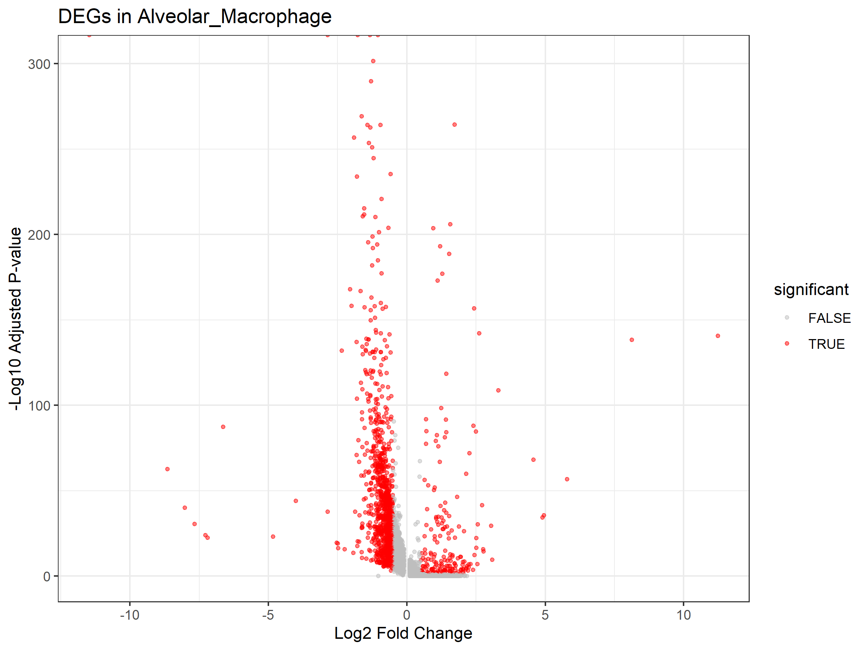
Volcano plot showing differentially expressed genes in BAL macrophages. Red points indicate significantly upregulated genes (log2FC > 0.5, adj.P < 0.05), blue points indicate significantly downregulated genes.

Figure S2. Trained Immunity Module Scores
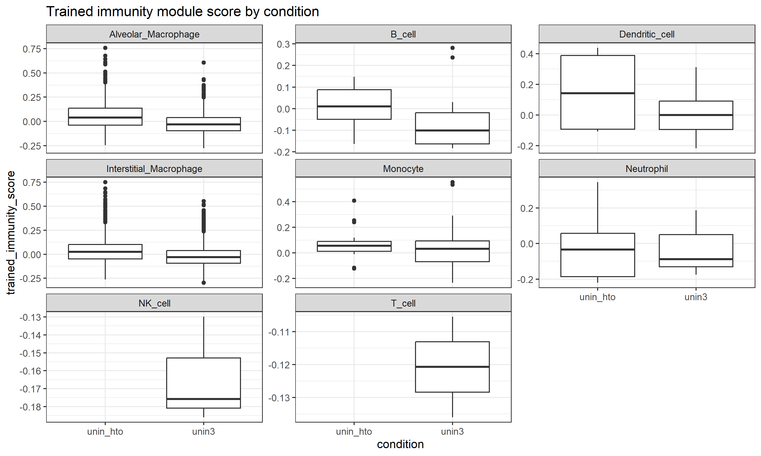
UMAP visualization colored by trained immunity module score. Higher scores indicate enrichment of trained immunity-associated genes.

Figure S3. Metabolic Gene Chromatin Accessibility
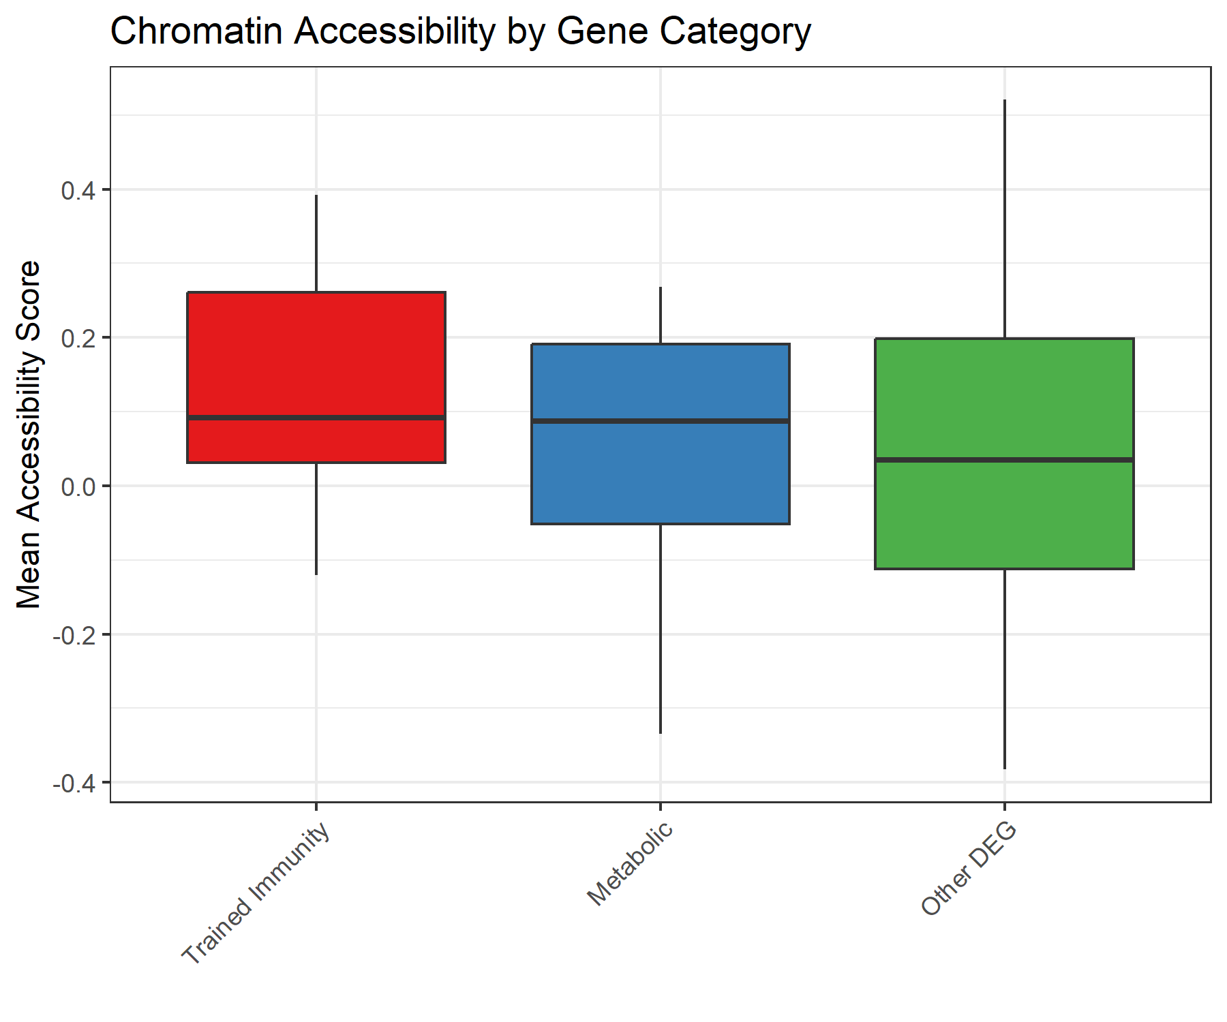
Comparison of chromatin accessibility scores for different gene categories. Boxplots show median and interquartile range.

Figure S4. Chromatin Priming Categories
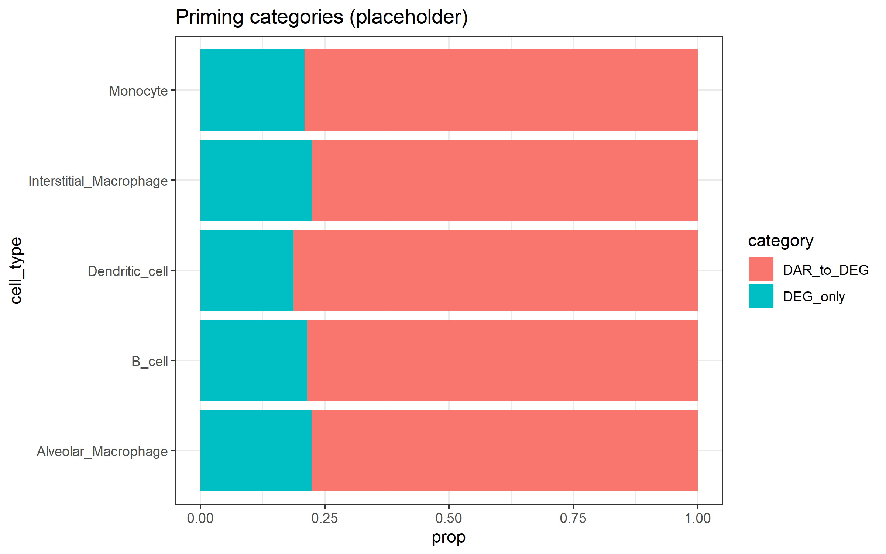
Distribution of genes across chromatin priming categories: primed (accessible chromatin), non-primed (no detected accessibility), and background.

Code Availability
All analysis code is available at the following GitHub repository:
https://github.com/hssling/TB_Chromatin_Priming_Multiomics
The repository includes:
• R scripts for single-cell RNA-seq analysis (Seurat v5)
• Python scripts for manuscript generation
• Configuration files for reproducibility
• Sample data and expected outputs
• GitHub Actions CI/CD workflow

Software versions
Software | Version
R | 4.5.1
Seurat | 5.0+
data.table | 1.14+
ggplot2 | 3.4+
Python | 3.11
python-docx | 0.8.11

