FIGURES:
Figure 1. Top 20 Prioritized Targets Stratified by Infection Phase
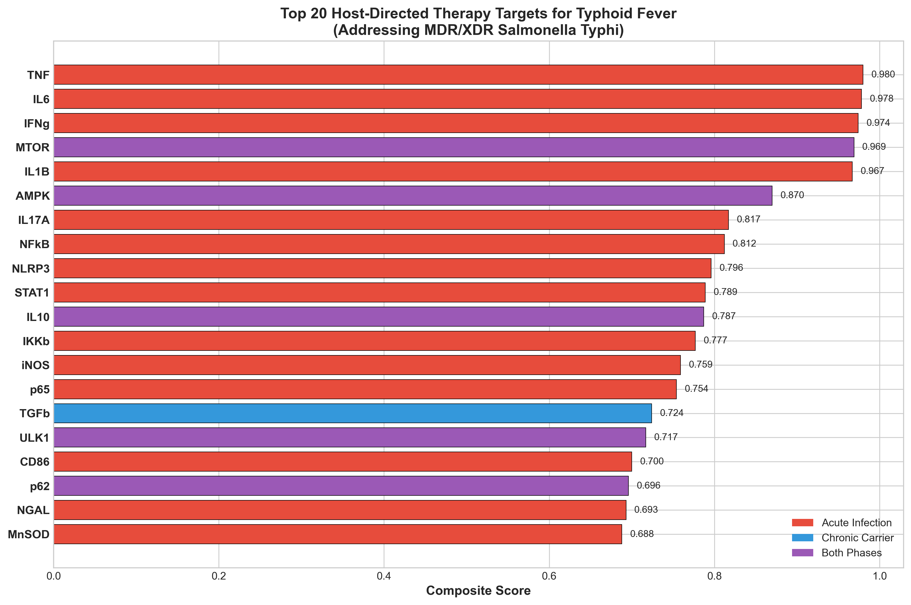

Figure 2. Compound Distribution by Clinical Development Phase
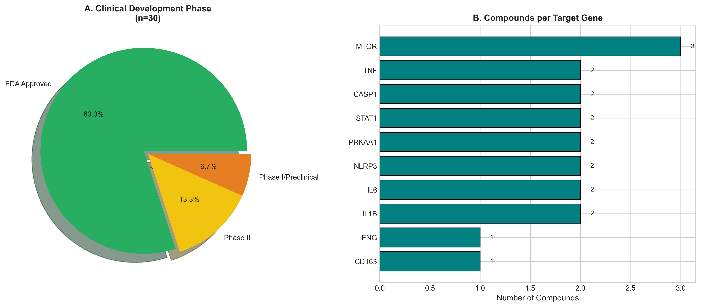

Figure 3. Maximum Compound Potency by Target
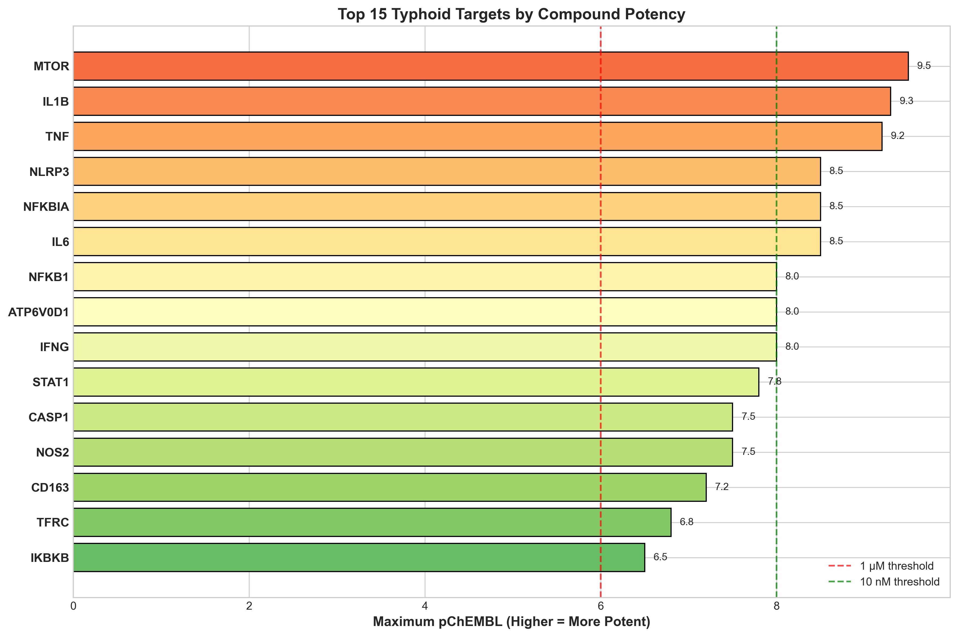

Figure 4. Pathway-Level Distribution and Score Comparison
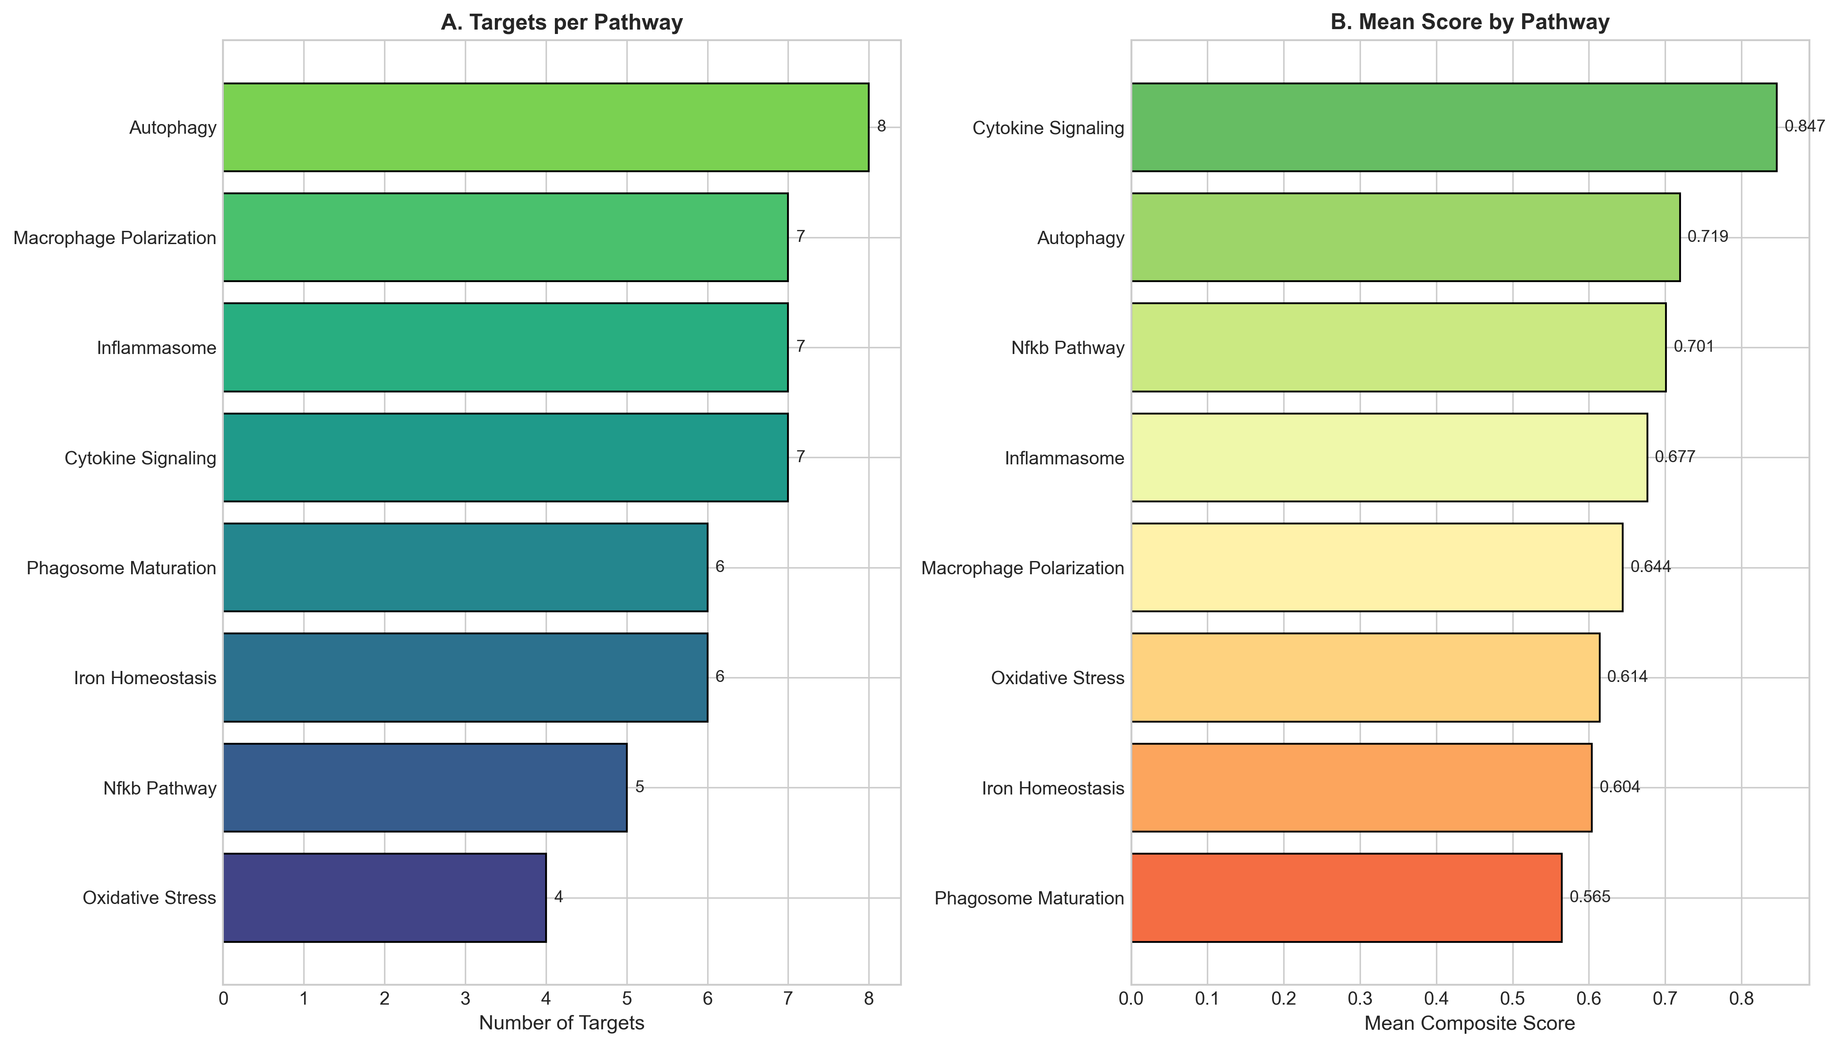

Figure 5. Typhoid Infection Timeline and HDT Intervention Windows
