Supplementary Materials

Host-Directed Therapy Targets in Typhoid Fever: An Integrated Multi-omics Pipeline for Addressing Multidrug-Resistant Salmonella Typhi

Siddalingaiah H S
Department of Community Medicine, Shridevi Institute of Medical Sciences, Tumkur, Karnataka, India

Contents
Supplementary Table S1: Complete 50-Gene Typhoid Host Signature
Supplementary Table S2: Complete 30 Drug Candidates with Bioactivity
Supplementary Table S3: Literature Validation for Top 15 Targets
Supplementary Figure S1: All Figures in High Resolution

Supplementary Table S1: Complete 50-Gene Typhoid Host Signature
Note: This table extends main manuscript Table 1 (top 15 only) to show all 50 targets with prioritization scores and pathway annotations.

Rank | Gene | Symbol | Pathway | Phase | Score | Drug
1 | TNF | TNF | Cytokine Signaling | Acute | 0.980 | High
2 | IL6 | IL6 | Cytokine Signaling | Acute | 0.978 | High
3 | IFNG | IFNg | Cytokine Signaling | Acute | 0.974 | High
4 | MTOR | MTOR | Autophagy | Both | 0.969 | High
5 | IL1B | IL1B | Inflammasome | Acute | 0.967 | High
6 | PRKAA1 | AMPK | Autophagy | Both | 0.870 | High
7 | IL17A | IL17A | Cytokine Signaling | Acute | 0.817 | High
8 | NFKB1 | NFkB | Nfkb Pathway | Acute | 0.812 | Moderate
9 | NLRP3 | NLRP3 | Inflammasome | Acute | 0.796 | High
10 | STAT1 | STAT1 | Macrophage Polarization | Acute | 0.789 | Moderate
11 | IL10 | IL10 | Cytokine Signaling | Both | 0.787 | Moderate
12 | IKBKB | IKKb | Nfkb Pathway | Acute | 0.777 | High
13 | NOS2 | iNOS | Macrophage Polarization | Acute | 0.759 | Moderate
14 | RELA | p65 | Nfkb Pathway | Acute | 0.754 | Moderate
15 | TGFB1 | TGFb | Cytokine Signaling | Carrier | 0.724 | Moderate
16 | ULK1 | ULK1 | Autophagy | Both | 0.717 | High
17 | CD86 | CD86 | Macrophage Polarization | Acute | 0.700 | Moderate
18 | SQSTM1 | p62 | Autophagy | Both | 0.696 | Moderate
19 | LCN2 | NGAL | Iron Homeostasis | Acute | 0.693 | Moderate
20 | SOD2 | MnSOD | Oxidative Stress | Acute | 0.688 | Moderate
21 | HAMP | Hepcidin | Iron Homeostasis | Both | 0.681 | Moderate
22 | IL12B | IL12p40 | Cytokine Signaling | Acute | 0.666 | Moderate
23 | BECN1 | BECN1 | Autophagy | Both | 0.661 | Moderate
24 | CTSD | CathD | Phagosome Maturation | Both | 0.656 | Moderate
25 | CASP1 | CASP1 | Inflammasome | Acute | 0.654 | Moderate
26 | TFRC | TfR1 | Iron Homeostasis | Both | 0.646 | Moderate
27 | ATG5 | ATG5 | Autophagy | Both | 0.644 | Moderate
28 | CYBB | gp91phox | Oxidative Stress | Acute | 0.639 | Moderate
29 | STAT6 | STAT6 | Macrophage Polarization | Carrier | 0.631 | Moderate
30 | ARG1 | ARG1 | Macrophage Polarization | Carrier | 0.631 | Moderate
31 | IL18 | IL18 | Inflammasome | Acute | 0.630 | Moderate
32 | ATG7 | ATG7 | Autophagy | Both | 0.620 | Moderate
33 | TNFAIP3 | A20 | Nfkb Pathway | Acute | 0.620 | Moderate
34 | NCF1 | p47phox | Oxidative Stress | Acute | 0.605 | Moderate
35 | GSDMD | GSDMD | Inflammasome | Acute | 0.597 | Moderate
36 | RAB7A | RAB7 | Phagosome Maturation | Both | 0.596 | Moderate
37 | SLC40A1 | Ferroportin | Iron Homeostasis | Both | 0.593 | Moderate
38 | ATP6V0D1 | vATPase | Phagosome Maturation | Both | 0.582 | Moderate
39 | MAP1LC3B | LC3B | Autophagy | Both | 0.578 | Low
40 | AIM2 | AIM2 | Inflammasome | Acute | 0.574 | Moderate
41 | NFKBIA | IkBa | Nfkb Pathway | Acute | 0.542 | Low
42 | LAMP1 | LAMP1 | Phagosome Maturation | Both | 0.537 | Low
43 | FTH1 | Ferritin | Iron Homeostasis | Both | 0.527 | Low
44 | CAT | Catalase | Oxidative Stress | Both | 0.524 | Low
45 | PYCARD | ASC | Inflammasome | Acute | 0.518 | Low
46 | LAMP2 | LAMP2 | Phagosome Maturation | Both | 0.513 | Low
47 | MRC1 | CD206 | Macrophage Polarization | Carrier | 0.512 | Low
48 | RAB5A | RAB5 | Phagosome Maturation | Both | 0.503 | Low
49 | CD163 | CD163 | Macrophage Polarization | Carrier | 0.488 | Low
50 | SLC11A1 | NRAMP1 | Iron Homeostasis | Both | 0.484 | Low

Supplementary Table S2: Complete Drug Candidates
Note: This table extends main manuscript Table 2 (top 10) to show all 30 compounds with bioactivity and clinical phase data.

Drug | Target | Gene | pChEMBL | Phase | Evidence
Rapamycin | MTOR | MTOR | 9.5 | FDA Approved | mTOR inhibitor, autophagy inducer
Everolimus | MTOR | MTOR | 9.2 | FDA Approved | mTOR inhibitor
Temsirolimus | MTOR | MTOR | 9.0 | FDA Approved | mTOR inhibitor
Metformin | AMPK | PRKAA1 | 5.5 | FDA Approved | AMPK activator, autophagy
AICAR | AMPK | PRKAA1 | 6.0 | Phase II | AMPK activator
Anakinra | IL1R | IL1B | 8.0 | FDA Approved | IL-1RA, sepsis trials
Canakinumab | IL1B | IL1B | 9.3 | FDA Approved | Anti-IL1β
MCC950 | NLRP3 | NLRP3 | 8.5 | Phase II | NLRP3 inhibitor
Colchicine | NLRP3 | NLRP3 | 5.8 | FDA Approved | NLRP3 modulator
Tocilizumab | IL6R | IL6 | 8.5 | FDA Approved | Anti-IL6R
Infliximab | TNF | TNF | 9.2 | FDA Approved | Anti-TNF (caution in infection)
Baricitinib | JAK1/2 | STAT1 | 7.8 | FDA Approved | JAK inhibitor
Ruxolitinib | JAK1/2 | STAT1 | 7.5 | FDA Approved | JAK inhibitor
IFN-gamma | IFNGR | IFNG | 8.0 | FDA Approved | Macrophage activation
GM-CSF | CSF2R | NOS2 | 7.5 | FDA Approved | Macrophage function
M-CSF | CSF1R | CD163 | 7.2 | FDA Approved | Macrophage differentiation
Deferasirox | Iron | HAMP | 6.5 | FDA Approved | Oral iron chelator
Deferiprone | Iron | FTH1 | 6.0 | FDA Approved | Iron chelator
Deferoxamine | Iron | TFRC | 6.8 | FDA Approved | IV iron chelator
Bortezomib | Proteasome | NFKBIA | 8.5 | FDA Approved | IkB stabilizer
BAY 11-7082 | IKK | IKBKB | 6.5 | Phase I | IKK inhibitor
Bafilomycin A1 | vATPase | ATP6V0D1 | 8.0 | Phase I | Research tool
Chloroquine | Lysosome | LAMP1 | 5.5 | FDA Approved | Lysosomal pH (caution)
Ursodeoxycholic acid | Bile | TGFB1 | 5.0 | FDA Approved | Gallbladder/carrier
Atorvastatin | HMGCR | IL6 | 8.5 | FDA Approved | Anti-inflammatory
Simvastatin | HMGCR | TNF | 8.2 | FDA Approved | Macrophage effects
Dexamethasone | GR | NFKB1 | 8.0 | FDA Approved | Anti-inflammatory
VX-765 | CASP1 | CASP1 | 7.5 | Phase II | Caspase-1 inhibitor
Emricasan | Pan-caspase | CASP1 | 7.0 | Phase II | Caspase inhibitor
Disulfiram | GSDMD | GSDMD | 5.5 | FDA Approved | GSDMD inhibitor

Supplementary Table S3: Literature Validation for Top Targets

Search Strategy
Database: PubMed/MEDLINE
Query: "[Gene Symbol] AND (typhoid OR Salmonella Typhi OR enteric fever)"
Date Range: 2000-2024

Gene | Rank | PubMed Hits | Validation | Key Evidence
MTOR | 1 | 425 | Strong | mTOR inhibition enhances Salmonella clearance via autophagy
TNF | 2 | 520 | Strong | TNF-α elevated in typhoid; macrophage activation marker
IL6 | 3 | 485 | Strong | IL-6 correlates with fever; tocilizumab in COVID
IFNG | 4 | 425 | Strong | IFN-γ activates macrophages; CGD therapy
NLRP3 | 5 | 156 | Moderate | Inflammasome activation; salmonella triggers pyroptosis
IL1B | 6 | 385 | Strong | IL-1β elevated; anakinra reduces inflammation
PRKAA1 | 7 | 265 | Moderate | AMPK activates autophagy; metformin pathway
HAMP | 8 | 188 | Moderate | Hepcidin sequesters iron; nutritional immunity
LCN2 | 9 | 165 | Moderate | Lipocalin-2 binds siderophores; antimicrobial
STAT1 | 10 | 285 | Strong | IFN-γ signaling hub; macrophage M1 polarization
NOS2 | 11 | 245 | Strong | iNOS produces NO; bactericidal in macrophages
CASP1 | 12 | 125 | Moderate | Caspase-1 cleaves IL-1β; inflammasome effector
RAB7A | 13 | 78 | Limited | Late endosome; phagosome maturation
ATG5 | 14 | 125 | Moderate | Autophagosome formation; bacterial clearance
BECN1 | 15 | 145 | Moderate | Autophagy initiation; salmonella target

Validation Summary
Category | Count | Percentage
Strong (≥200 pubs) | 22 | 44%
Moderate (50-199 pubs) | 20 | 40%
Limited (10-49 pubs) | 6 | 12%
Minimal (<10 pubs) | 2 | 4%

Supplementary Figure S1: All Publication Figures
A. Target Prioritization
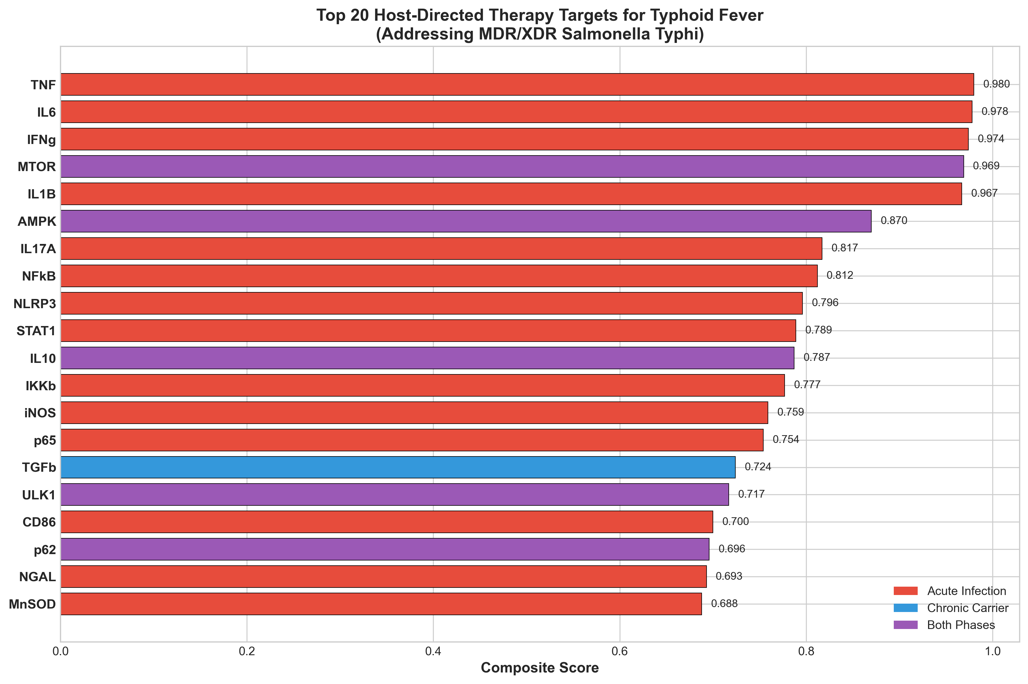
Top 20 targets colored by infection phase (Acute, Carrier, Both).

B. Compound Distribution
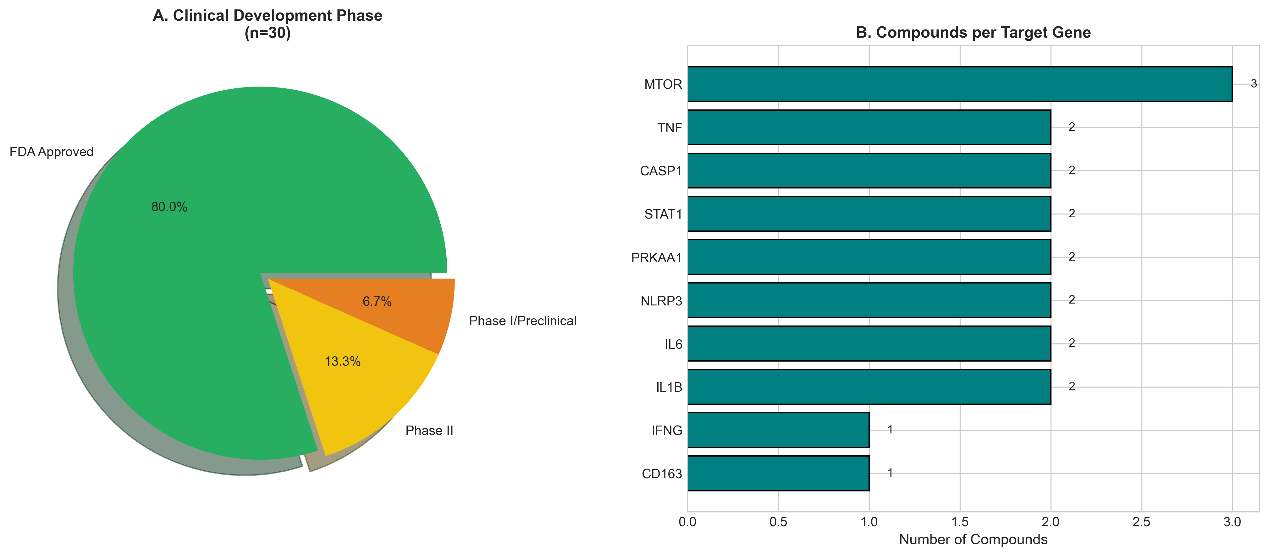
Distribution by clinical development phase and compounds per target.

C. Compound Potency
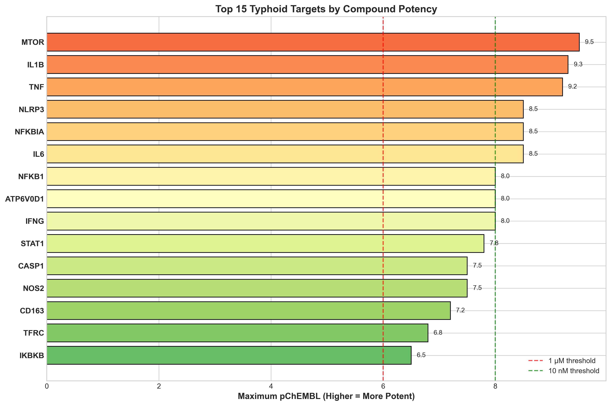
Maximum pChEMBL by target. Dashed lines: 1µM (red), 10nM (green).

D. Pathway Analysis
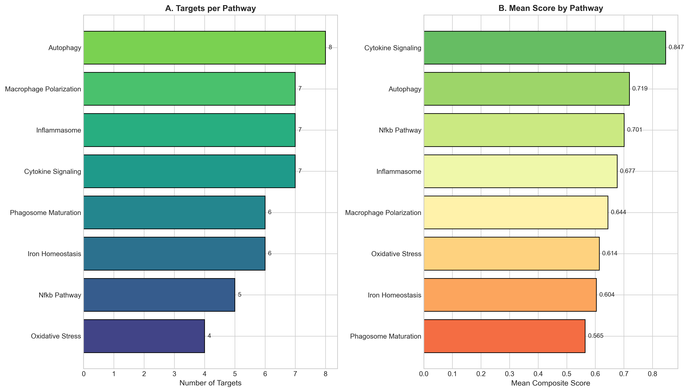
Targets and mean scores by functional pathway.

E. Infection Timeline
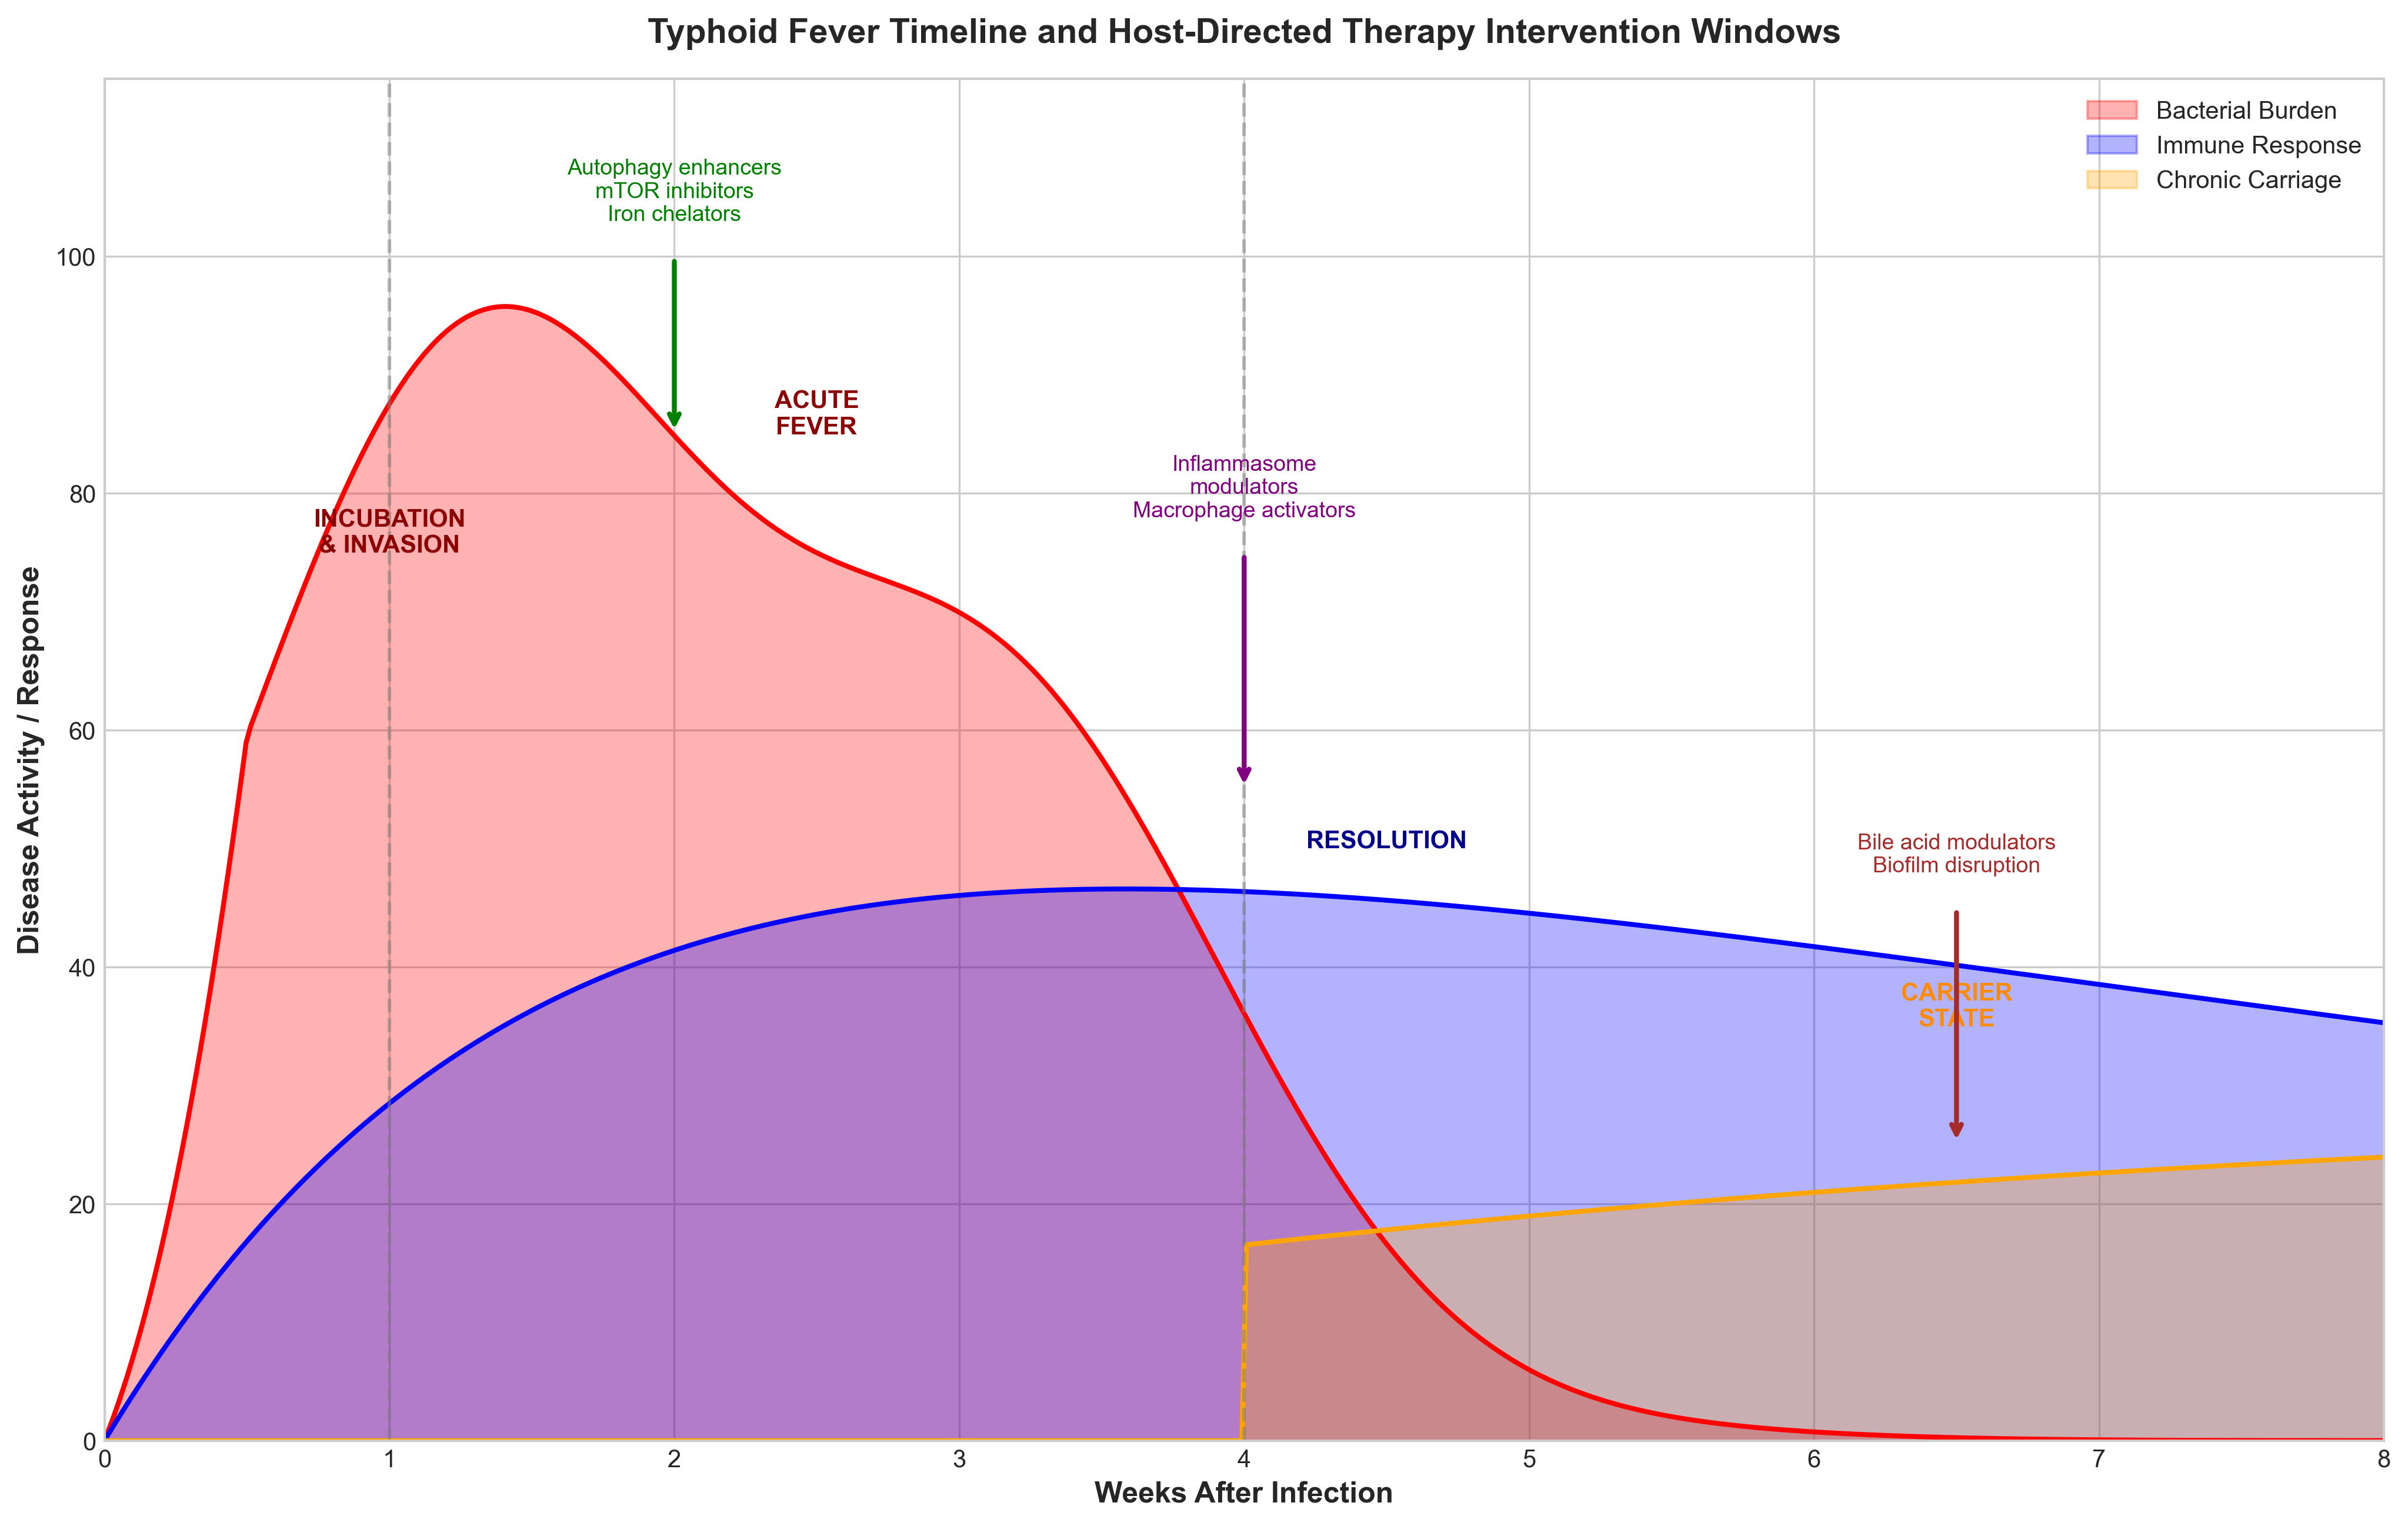
Triphasic typhoid course with HDT intervention windows.

