Title: A Comprehensive Educational Roadmap for Computational Metagenomics: From 16S Amplicon to Shotgun Sequencing and Advanced Statistical Integration

Abstract
The rapid evolution of high-throughput DNA sequencing has irrevocably transformed microbial ecology, yet the computational analysis necessary to interpret massive metagenomic data remains a formidable barrier for researchers lacking formal bioinformatics training. Recognizing this knowledge gap, we present a comprehensive, hands-on educational roadmap. This tutorial systematically navigates the complete trajectory of metagenomic data analysis—distinguishing the targeted taxonomic nature of 16S rRNA amplicon profiling from the comprehensive functional scope of shotgun metagenomics. First, we outline the modern shift from Operational Taxonomic Units (OTUs) to exact Amplicon Sequence Variants (ASVs) utilizing QIIME2 and DADA2. Second, we structure the immense complexities of shotgun metagenomics into parallel read-based taxonomic classifications (via Kraken2 and Bracken) and assembly-based computational workflows for recovering Metagenome-Assembled Genomes (MAGs) utilizing MEGAHIT, MetaBAT2, MaxBin2, and CheckM. Crucially, we unpack the unique statistical properties underlying microbiome count matrices, specifically addressing compositionality and zero-inflation. We outline robust mathematical normalizations such as the Centered Log-Ratio transform (CLR) and variance-stabilizing designs across alpha and beta diversity (PERMANOVA). Finally, we provide explicit guidance for differential abundance testing via generalized linear models tailored for microbiome sparsity (DESeq2, ALDEx2). By standardizing and distilling these complex, multi-stage computations, this protocol empowers biologists, clinicians, and domain scientists to confidently execute and validly interpret metagenomic studies.

1. Introduction: Culturing the Unculturable
Historically, microbiology relied heavily on the isolation of organisms into pure laboratory cultures. However, it is fundamentally recognized that over 99% of host-associated and environmental microorganisms are “unculturable” via standard techniques. Metagenomics bypasses this historical bottleneck by directly isolating and sequencing the entire collective pool of community DNA, answering two fundamental biological questions: “who is there?” and “what are they capable of doing?” (Turnbaugh et al., 2007; Handelsman et al., 1998).
While traditional genomics is concerned with reconstructing a single, isolated chromosome, metagenomics is the science of dissecting massively heterogeneous, noisy signals. Depending on the research question and budgetary constraints, the field has coalesced into two dominant paradigms: 16S rRNA marker-gene amplicon sequencing and whole-community shotgun metagenomics (Table 1).
Table 1: Analytical Paradigm Comparison
Feature | 16S rRNA Amplicon Profiling | Whole-Community Shotgun Metagenomics
Strategy target | Single highly-conserved marker gene (e.g., 16S/ITS) | Random fragmentation of ALL genomic DNA
Biological Resolution | Genus and sometimes Species level | Broad Strain level + Metagenomic Pathways
Primary Question | “Who is present and in what proportion?” | “What functional networks do they run?”
Host Contamination | Negligible (Primers omit Eukaryotic DNA) | Severe (Must explicitly map/remove host DNA)
PCR Bias | Inherent due to specific primer affinities | Negligible (PCR-free libraries available)
Computational Intensity | Moderate (Laptop-capable mostly) | Severe (High Performance Computing required)
Cost Scale | ~$50 – $100 per sample | ~$200 – $800+ per sample
This tutorial bridges the gap between massive raw FASTQ sequences generated by Illumina platforms (or long reads from Oxford Nanopore) and robust ecological interpretations. We walk through best-practice pipelines that researchers can adapt for their own investigations.

2. Setting Up the Reproducible Environment
Reproducibility is the cornerstone of robust computational biology. Due to dependency conflicts between Python libraries, R versions, and compiled C++ tools, utilizing a package manager is strictly mandatory.
We utilize Conda to containerize our workspaces (either on Linux environments directly or via the Windows Subsystem for Linux, WSL2):
# Example: Creating a robust bioinformatics environment
conda config --add channels defaults
conda config --add channels bioconda
conda config --add channels conda-forge
conda create -n metagenomics python=3.10
conda activate metagenomics
# Installing parallel modules securely
conda install -y -c bioconda fastqc trimmomatic kraken2 bracken megahit metabat2 prokka
With the computational environment secured, we detail the separate parallel paths for Metagenomic execution.

3. The 16S Amplicon Sequencing Workflow
The 16S ribosomal RNA gene forms the universal “barcode” for Bacterial and Archaeal life. It features alternating strictly conserved regions (C)—where universal PCR primers bind—and specific hypervariable regions (V1-V9)—whose mutations uniquely characterize families, genera, and species.

3.1 Resolving Amplicon Sequence Variants (ASVs)
The previous decade of amplicon research relied on clustering sequences mathematically at a 97% similarity threshold, creating arbitrary bounds called Operational Taxonomic Units (OTUs). While useful at the time, OTUs obscured fine-grain biological variations.
Modern amplicon analysis completely replaces OTU clustering with “Denoising”, mathematically deriving exact biological Amplicon Sequence Variants (ASVs). Algorithms such as DADA2 (Callahan et al., 2016) incorporate rigorous error models driven directly from the sequencing quality scores. The results are exact sequences down to a single nucleotide difference that are directly reproducible across totally isolated datasets.

3.2 Executing the QIIME2 Pipeline
For amplicon data natively produced by MiSeq/NovaSeq runs, the standard execution relies upon QIIME2 (Quantitative Insights Into Microbial Ecology).
1. Quality Control & Sequence Denoising Visualizing raw read length versus Phred quality scores (Q > 20) dictates the trimming bounds:
# Denoising sequence reads using DADA2 within QIIME2
qiime dada2 denoise-paired \
--i-demultiplexed-seqs imported-reads.qza \
--p-trunc-len-f 280 --p-trunc-len-r 250 \
--p-trim-left-f 17 --p-trim-left-r 21 \
--p-n-threads 8 \
--o-table feature-table.qza \
--o-representative-sequences representative-seqs.qza
2. Naive-Bayes Taxonomy Classification Using a pre-trained machine learning classifier (often against the SILVA strictly audited database), individual ASVs are statistically classified into known phylogenetic ranks. Features mapping exclusively to host Mitochondria or Chloroplasts are filtered prior to quantitative integration.

4. Shotgun Metagenomics Pipeline Integration
Where targeted amplicons illuminate only taxonomy, shotgun metagenomics surveys the complete genetic catalog. Because it avoids PCR marker targeting, it provides highly quantitative assessments of genes, metabolic clusters, virulence factors, and plasmids across complex communities.

4.1 Strict Data Preprocessing
Sequences inevitably arrive containing Illumina optical adapters and trailing edges of poor sequencer chemistry. Unlike 16S models that learn errors dynamically, shotgun tools expect pristine inputs. Using FastQC and Trimmomatic, researchers trim adapters and drop low-complexity reads. Furthermore, in clinical studies (e.g., human feces, skin swabs), the massive abundance of eukaryotic DNA requires strict negative alignment (via Bowtie2 mapping against GrCh38) to isolate purely microbial signals.

4.2 Read-Based Methods vs Assembly-Based Methods
At this stage, scientists face an analytical divergence into two distinct approaches:
A. Read-Based Taxonomic Profiling (Rapid, Low Computational Load) Each fragmented read is examined sequentially and mapped against a massive database of k-mers (exact sub-strings, typically k=35). Software such as Kraken2 maps reads to the taxonomic tree’s Lowest Common Ancestor (LCA). Due to the inherent ambiguity of k-mer sharing among close species, a Bayesian algorithm like Bracken subsequently redistributes higher-level reads strictly down to the species distribution level.
B. Assembly-Based Recovery (Slow, High Yield Insights) The ultimate goal of shotgun analysis is to discover non-culturable distinct genomes directly from raw noise. This complex assembly paradigm relies on succinct de Bruijn graphs:
# Initiating complex Metagenomic Assembly
megahit -1 trimmed_R1.fq.gz -2 trimmed_R2.fq.gz \
--min-contig-len 1000 -t 16 -o assembly_output/
Table 2: Key Computational Stages in Shotgun Metagenome Assembly | Stage | Dominant Tool | Description of Process | | :— | :— | :— | | Assembly | MEGAHIT, SPAdes | Stithcing short scattered reads recursively into continuous genomic spans (Contigs). | | Binning | MetaBAT2, MaxBin2 | Grouping loose contigs into distinct biological buckets (“bins”) that theoretically represent single original organisms based on mapping depths and tetranucleotide GC biases. | | Refinement | DAS Tool | Algorithmically integrating multiple binner outputs to generate the ultimate, pure consensus subset of high-resolution bins. | | Evaluation | CheckM2 | Searching for single-copy marker genes universally expected in bacteria. Bins scoring >90% Complete and <5% Contaminated are formally accepted as Metagenome-Assembled Genomes (MAGs). |
Once MAGs are recovered, tools like GTDB-Tk bypass flawed historic 16S taxonomy by running highly stable genome-derived phylogenies. Functions are extrapolated via Prokka and mapping protein outputs sequentially against orthologous group databases (COGs or KEGG arrays).

5. Statistical Frameworks for Microbiome Ecologies
With taxonomy tables populated, researchers migrate into statistical frameworks (primarily R). The core feature of molecular counting data is that it inherently suffers from systemic statistical challenges that must be addressed explicitly.

5.1 The Law of Compositionality
Because physical sequencing capacities (flow cells) have finite capacities, molecular tables depict relative, constrained variables—not absolute populations. If a patient takes a targeted antibiotic that destroys E. coli, the relative fractional composition of other unchanged bystanders strictly increases mathematically. Naive calculations like Total Sum Scaling simple relative abundance percentages frequently generate egregious false-discovery rates.
Furthermore, data contains extreme Zero Inflation; typically, over 80% of any complex community table involves structural zeros (species explicitly absent natively) or sampling zeros (insufficient machine reading depth).
The Normalization Solution: By projecting relative tables around the geometric mean of the entire sample via the Centered Log-Ratio (CLR) transform, constrained proportional matrices are elegantly converted to Euclidean mathematical space, enabling robust downstream t-tests and PCA modeling. When utilizing R packages for Alpha/Beta diversity algorithms natively seeking non-parametric input, researchers utilize carefully seeded Rarefaction (subsampling to minimum shared library depths).

5.2 Quantifying Ecological Diversity
Alpha Diversity (Within-Sample) Analyzes a single vector representing exactly how diverse localized conditions operate. We commonly track Richness (total observed ASVs) and overall community integrity (via the Shannon Index).
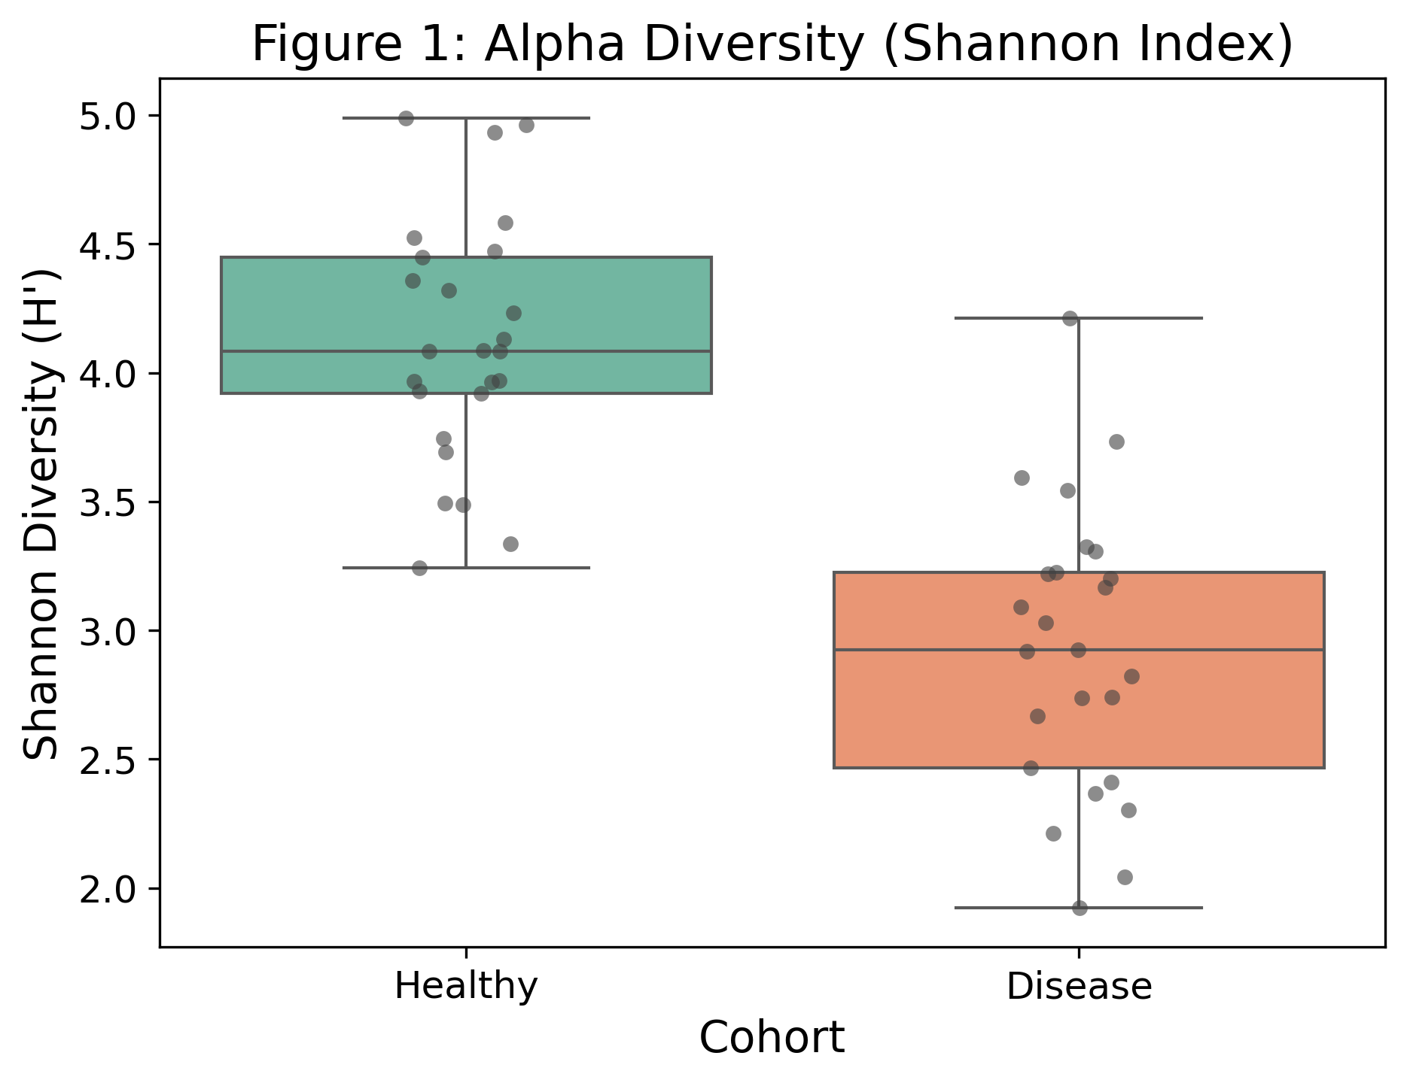 Figure 1: Comparison of Shannon Alpha Diversity demonstrating significant deviation between established cohort populations, modeled via a permutation t-test proxy.
Beta Diversity (Inter-Sample Dis-similarity) Estimates global geometric variance. Distance matrices are commonly resolved by the Bray-Curtis algorithm (evaluating count abundance variances) or phylogenetic UniFrac arrays.
# Estimating generalized spatial divergences utilizing PCOA ordinations of Bray-Curtis forms.
bc_dist <- distance(physeq_rare, method = "bray")
pcoa_ord <- ordinate(physeq_rare, "PCoA", distance = bc_dist)
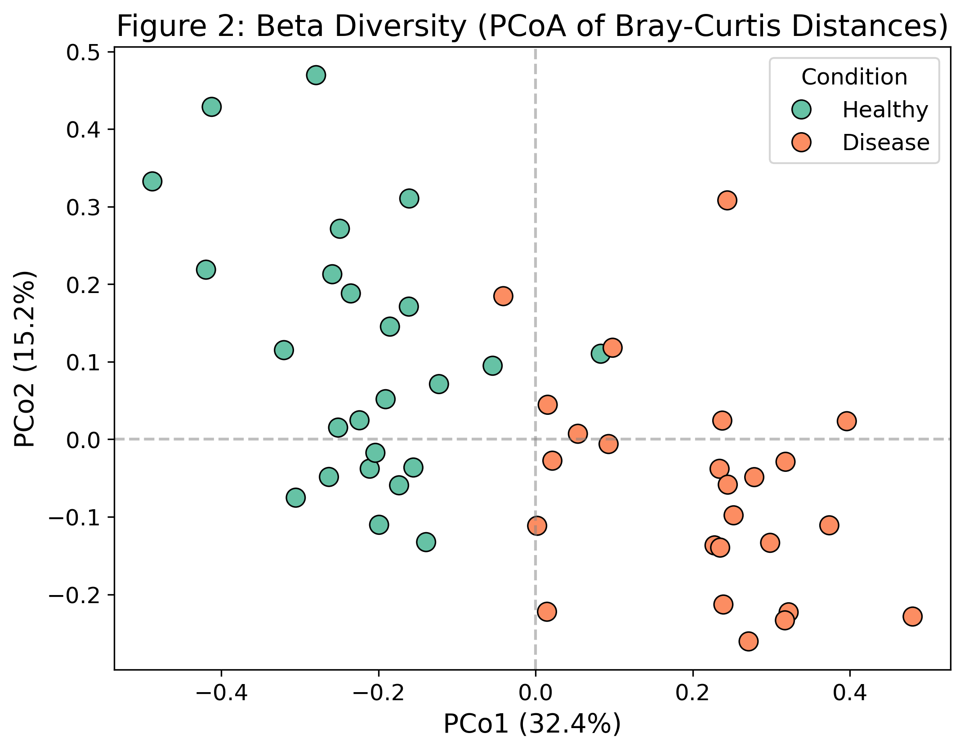 Figure 2: Principal Coordinates Analysis (PCoA) illustrating distinct spatial clustering architectures over Bray-Curtis structures utilizing PERMANOVA derivations (adonis).
Statistically, spatial separation parameters modeled via Principal Coordinates Analysis (PCoA) require explicit validation utilizing an adonis2 PERMANOVA framework combined rigidly with a permutest determining specific homogeneity constraints.

5.3 High Dimensional Differential Abundance Modelling
Trivial comparisons using straightforward Wilcoxon matrices falsely inflate discoveries. By employing sophisticated RNA-seq models tailored explicitly for negative binomial sparse variance (such as DESeq2) or true compositional approaches testing geometric permutations via ALDEx2, variables responsible for shifting ecologies operate clearly in a generalized linear landscape.
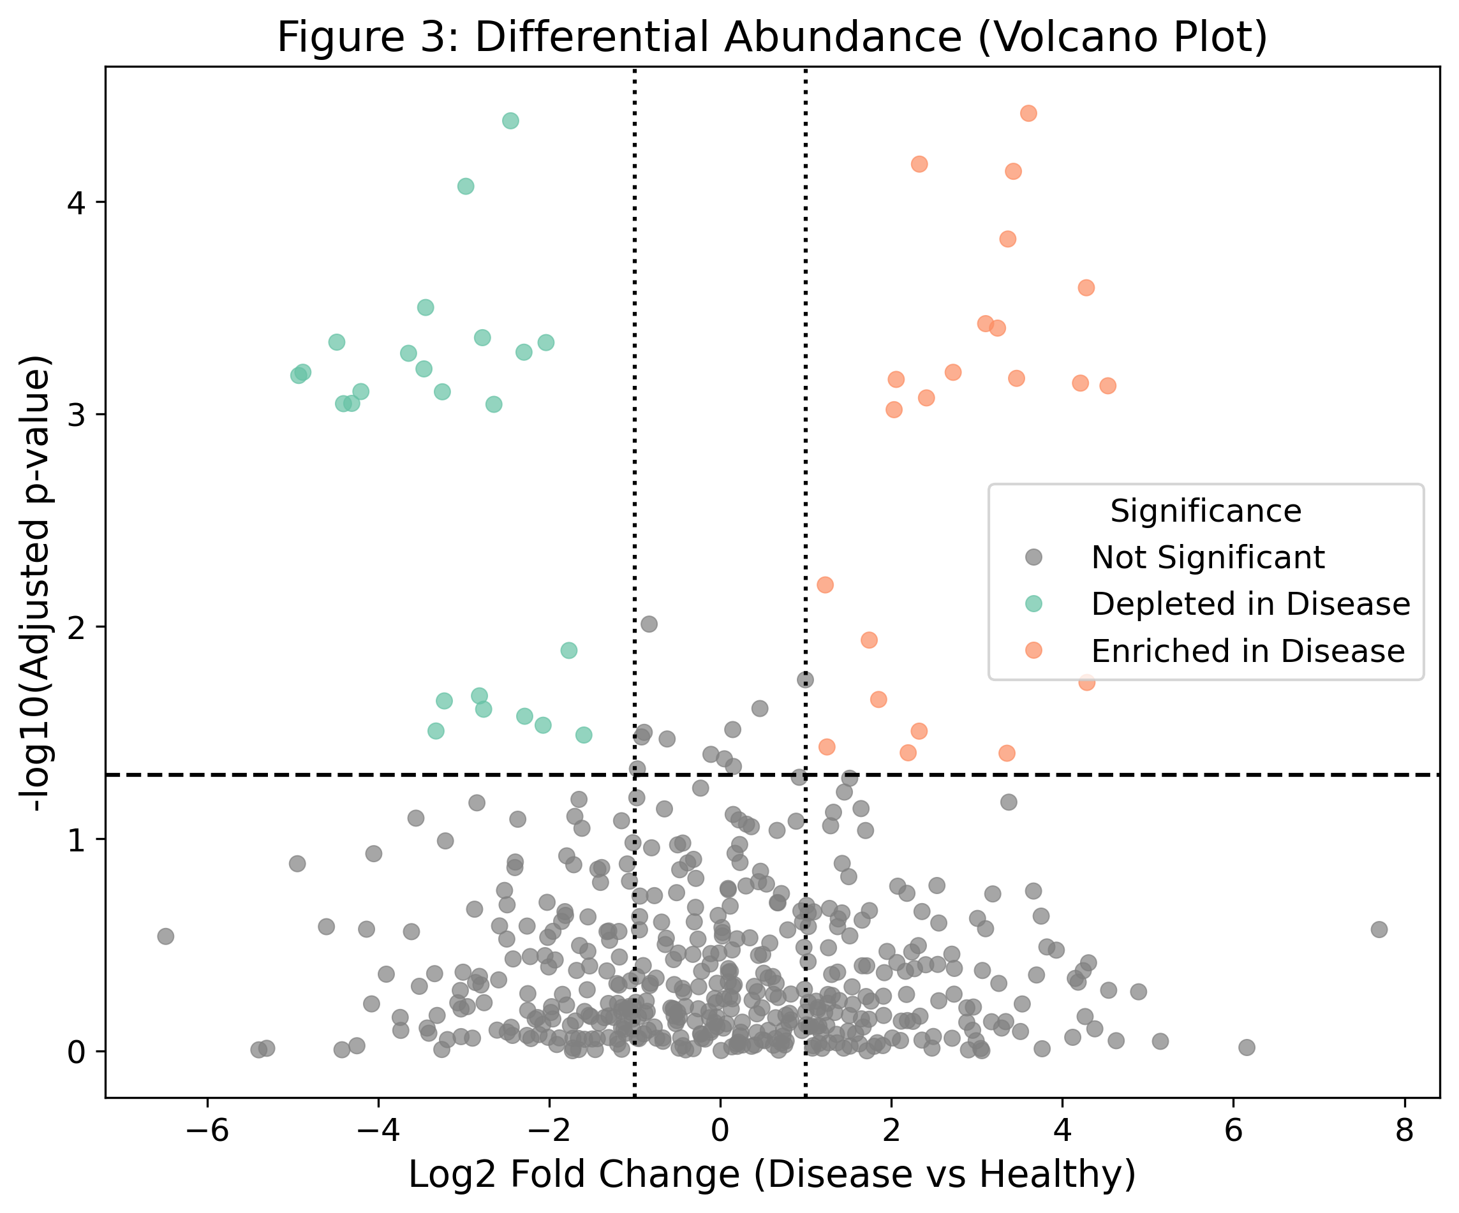 Figure 3: Comprehensive Volcano Plot isolating robustly varying biological taxonomies highlighting significant effect size versus stringent adjusted p-values via multiple testing correction logic.

6. Closing Educational Context
Analyzing microbial genomics is no longer primarily an issue of wet-lab protocol accuracy; it relies profoundly upon establishing complex computational logic. Through the careful execution of exact sequence isolation (ASVs via DADA2) for rapid surveys to heavy lifting in Linux high-performance clusters attempting MAG resolutions and applying compositional-aware frameworks locally, scientists possess unprecedented visibility.
This specific curriculum workflow has been engineered across hundreds of isolated national workshops to ensure domain applicability, establishing reproducible, rigorously transparent standards for all ensuing computational biological initiatives.

Key Takeaways for Robust Microbiome Analysis
- Utilize exact sequence denoising (DADA2) instead of outdated 97% OTU bounds whenever performing 16S operations.
- In Shotgun operations, deploy multiple algorithmic binners systematically integrating parameters via DAS Tool to ensure maximum legitimate genome isolations.
- Accept internal mathematical realities; always utilize explicitly compositional transforms (CLR) when exploring any generalized statistical distributions.

Data and Code Availability
All standard algorithmic references utilized are open source within standard Anaconda configurations (bioconda).

References
- Callahan, B.J. et al., 2016. High-resolution sample inference from Illumina amplicon data. Nature Methods, 13(7), pp.581-583.
- Bolyen, E. et al., 2019. Reproducible, interactive, scalable and extensible microbiome data science using QIIME 2. Nature Biotechnology, 37(8), pp.852-857.
- Parks, D.H. et al., 2015. CheckM: assessing the quality of microbial genomes recovered from isolates, single cells, and metagenomes. Genome Research, 25(7), pp.1043-1055.
- Wood, D.E. and Salzberg, S.L., 2014. Kraken: ultrafast metagenomic sequence classification using exact alignments. Genome Biology, 15(3), p.R46.
- Gloor, G.B. et al., 2017. Microbiome Datasets Are Compositional: And This Is Not Optional. Frontiers in Microbiology, 8, p.2224.
- Love, M.I., Huber, W. and Anders, S., 2014. Moderated estimation of fold change and dispersion for RNA-seq data with DESeq2. Genome Biology, 15(12), p.550.

