Title Page
Title: Emerging Omics Technologies in Biomedicine: A Computational Review of Spatial Proteomics, Perturb-omics, Epitranscriptomics, Exposomics, and Liquid Biopsy Multiomics
Article Type: Tutorial Review
Author: Dr Siddalingaiah H S
Affiliation: Professor, Community Medicine, Shridevi Institute of Medical Sciences and Research Hospital, Tumkur, India
Corresponding Author:
Dr Siddalingaiah H S
Professor, Community Medicine, Shridevi Institute of Medical Sciences and Research Hospital, Tumkur, India
Email: hssling@yahoo.com
Phone: +91 8941087719
ORCID: 0000-0002-4771-8285
Keywords: Spatial proteomics; perturb-omics; epitranscriptomics; exposomics; liquid biopsy; emerging omics; spatial biology; translational bioinformatics
Running Title: Emerging Omics Technologies
Figures: 4
Tables: 2

Emerging Omics Technologies in Biomedicine: A Computational Review of Spatial Proteomics, Perturb-omics, Epitranscriptomics, Exposomics, and Liquid Biopsy Multiomics

Abstract
The omics landscape has expanded beyond classical genomic and transcriptomic frameworks into a newer set of rapidly accelerating technologies. This review surveys several emerging domains with growing computational importance: spatial proteomics, perturb-omics, epitranscriptomics, exposomics, and liquid biopsy multiomics. The emphasis is practical, focusing on data structure, analysis goals, maturity, translational potential, and reporting standards.

Keywords
Spatial proteomics; perturb-omics; epitranscriptomics; exposomics; liquid biopsy; emerging omics; spatial biology; translational bioinformatics

1. Introduction
The term omics now covers a much broader methodological landscape than the classical genome-transcriptome-proteome-metabolome sequence. Several fast-moving domains have recently gained importance because of progress in multiplexed imaging, perturbation readouts, RNA modification profiling, environmental exposure characterization, and minimally invasive clinical sampling.

2. Spatial proteomics
Spatial proteomics has become prominent because it combines protein-level information with tissue architecture. Its computational challenges include image normalization, segmentation, marker harmonization, signal spillover, neighborhood analysis, and integration with pathology context.

3. Perturb-omics
Perturb-omics couples directed perturbation, often CRISPR-based, with high-dimensional readout such as single-cell expression. It is especially attractive because it moves from association to perturbation-informed inference, but guide assignment, perturbation efficiency, and indirect effects must be handled carefully.

4. Epitranscriptomics
Epitranscriptomic assays study RNA modifications such as m6A and related marks. Their computational difficulty lies in distinguishing genuine modification biology from assay-specific bias and from ordinary changes in transcript abundance or isoform structure.

5. Exposomics
Exposomics aims to characterize cumulative environmental and chemical exposures affecting health. It overlaps with metabolomics, adductomics, and systems epidemiology, and is defined by challenging feature annotation, strong batch sensitivity, and complex links to phenotype.

6. Liquid biopsy multiomics
Liquid biopsy multiomics integrates cell-free DNA, cell-free RNA, methylation, fragmentomics, proteins, and other analytes from minimally invasive samples. The analytical challenge is balancing sensitivity and specificity when signal fraction is low and analyte behavior differs across platforms.

7. Readiness and fit-for-purpose
Emerging technologies should be judged by assay maturity, reproducibility, cohort-size demands, software support, and translational realism rather than novelty alone. Not every method is ready for every biomedical question.

8. Common computational risks
Frequent risks include weak benchmarking, unstable preprocessing, immature reference resources, underdeveloped annotation pipelines, and translational overstatement. These issues are common in fast-moving fields and should be addressed explicitly in publication-oriented reviews.

9. Conclusion
Emerging omics methods are expanding what can be measured in biomedicine, but publication-quality work still depends on coherent design, transparent computation, realistic claims, and strong reporting discipline.
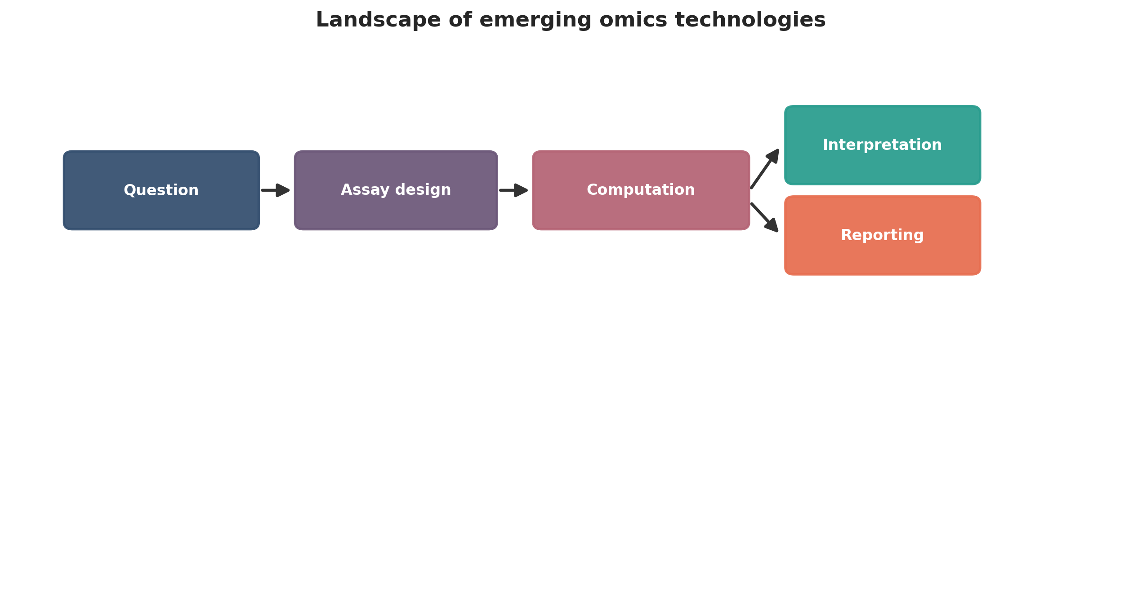
Landscape of emerging omics technologies. This figure is a publication-style schematic prepared for tutorial reporting.
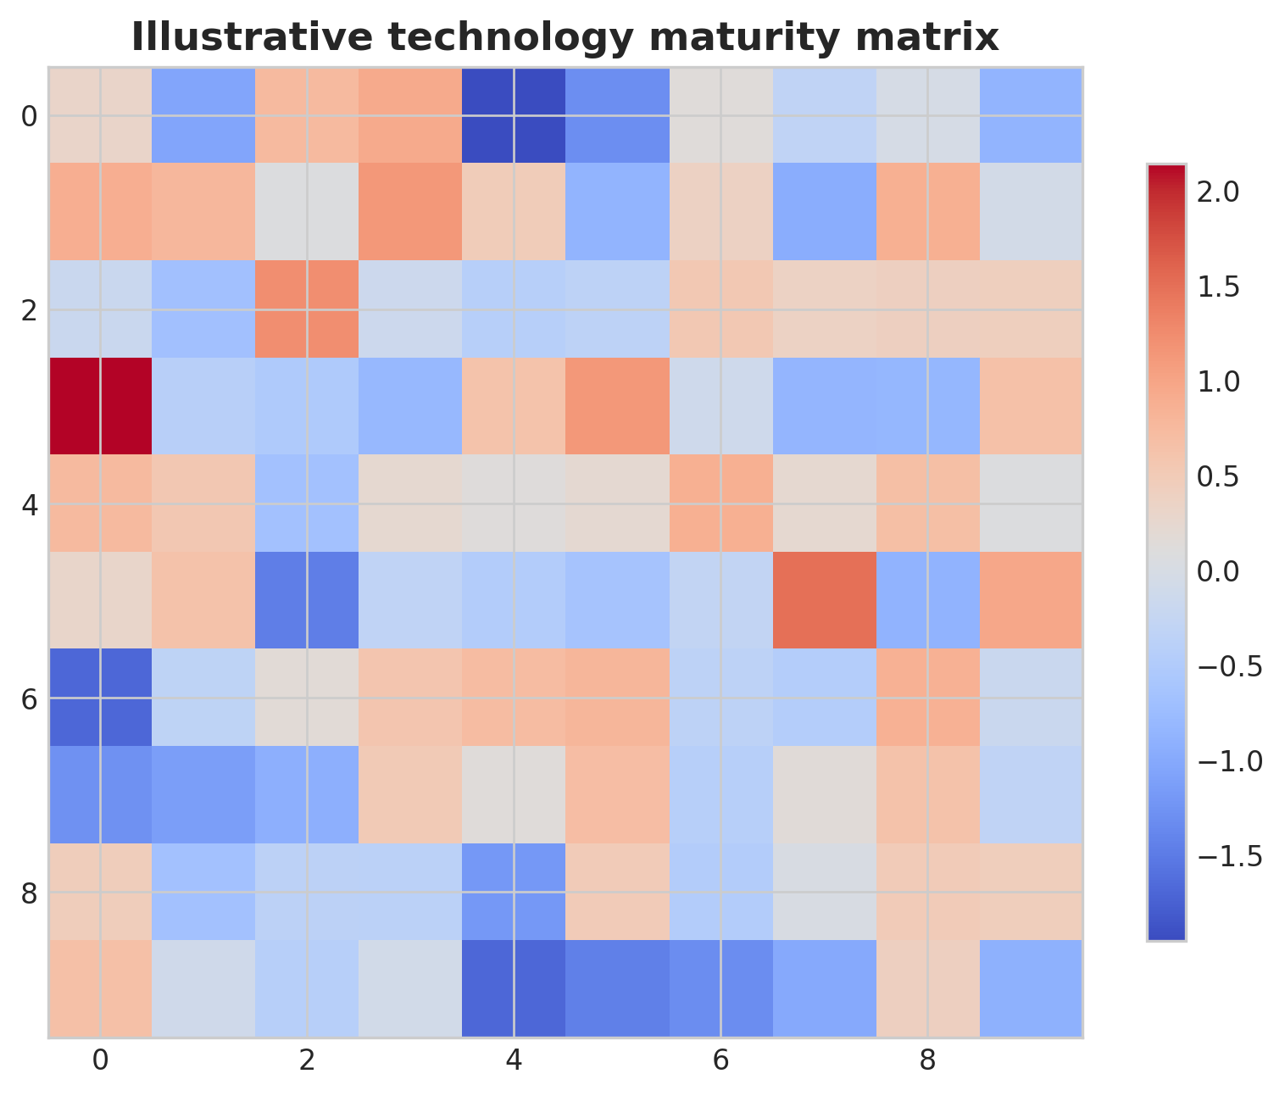
Illustrative technology maturity matrix. This figure is an illustrative formatted example and does not represent a new study dataset.
Practical decision matrix for computational study planning.
Question type | Preferred analytical emphasis | Key reporting requirement
Discovery-oriented | Broad exploratory analysis | Clear filtering and exploratory limits
Comparative cohort study | Statistical testing and covariate handling | Design formula and confounder reporting
Translational or clinical | Robust interpretation and validation | Explicit limitations and reproducibility
Atlas-building or systems analysis | Integration and uncertainty quantification | Transparent preprocessing and annotation logic

Minimum publication-ready computational reporting checklist.
Domain | Minimum expectation
Study design | Primary question, inclusion logic, metadata plan
Data processing | Quality control, reference versions, filtering thresholds
Statistics | Normalization, model choice, covariates, multiple-testing approach
Validation | Sensitivity analysis, external support, or orthogonal evidence
Reproducibility | Software versions, code or workflow trace, figure provenance
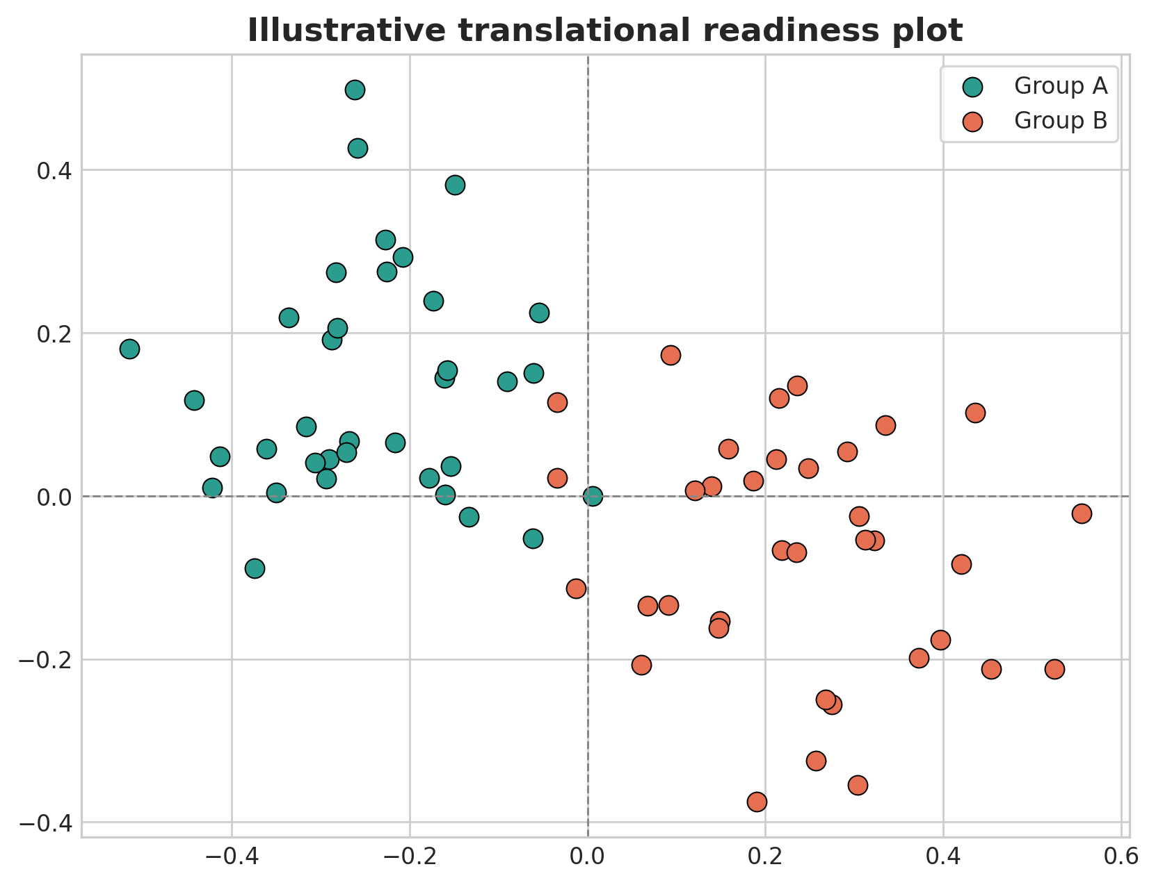
Illustrative translational readiness plot. This figure is an illustrative formatted example and does not represent a new study dataset.
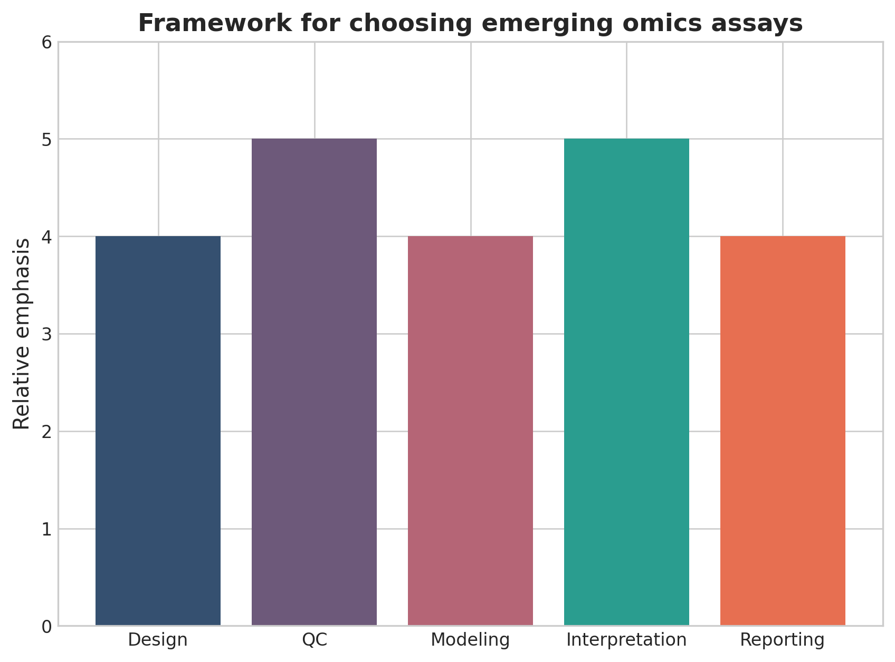
Framework for choosing emerging omics assays. This figure is a discipline-specific publication-style summary schematic.

Declarations

Author contributions
Dr Siddalingaiah H S conceived the tutorial review, prepared the manuscript, and approved the final version.

Funding
No external funding was declared for preparation of this manuscript.

Competing interests
The author declares no competing interests.

Ethics approval and consent to participate
Not applicable. This tutorial review does not report a new human-participant or animal experiment.

Consent for publication
Not applicable.

Availability of data and materials
No new dataset was generated or analyzed for this tutorial review. Figures are educational schematics and illustrative formatted examples created for explanatory purposes.

Author information
Dr Siddalingaiah H S, Professor, Community Medicine, Shridevi Institute of Medical Sciences and Research Hospital, Tumkur, India. ORCID: 0000-0002-4771-8285.

References
- Method of the Year 2024: spatial proteomics. Nat Methods. 2024;21:2195-2196.
- An update on spatial proteomics. Nat Methods. 2026;23:481.
- Mass spectrometry imaging for spatially resolved multi-omics molecular mapping. npj Imaging. 2024;2:25.
- Combining spatial metabolomics and proteomics profiling of single cells. Nat Rev Immunol. 2024.
- Emerging technologies of single-cell multi-omics. Haematologica. 2024.
- Epitranscriptomics in metabolic disease. Nat Metab. 2023;5:370-384.
- Implementation of multiomic mass spectrometry approaches for the evaluation of human health following environmental exposure. Mol Omics. 2024;20(5):296-321.
- Hasin Y, Seldin M, Lusis A. Multi-omics approaches to disease. Genome Biol. 2017;18:83.
- Vandereyken K, Sifrim A, Thienpont B, Voet T. Methods and applications for single-cell and spatial multi-omics. Nat Rev Genet. 2023;24(8):494-515.
- Rao A, Barkley D, Franca GS, Yanai I. Exploring tissue architecture using spatial transcriptomics. Nature. 2021;596(7871):211-220.

