Title Page
Title: Emerging Omics Technologies in Biomedicine: A Computational Review of Spatial Proteomics, Perturb-omics, Epitranscriptomics, Exposomics, and Liquid Biopsy Multiomics
Article Type: Tutorial Review
Author: Dr Siddalingaiah H S
Affiliation: Professor, Community Medicine, Shridevi Institute of Medical Sciences and Research Hospital, Tumkur, India
Corresponding Author:
Dr Siddalingaiah H S
Professor, Community Medicine, Shridevi Institute of Medical Sciences and Research Hospital, Tumkur, India
Email: hssling@yahoo.com
Phone: +91 8941087719
ORCID: 0000-0002-4771-8285
Keywords: Spatial proteomics; perturb-omics; epitranscriptomics; exposomics; liquid biopsy; emerging omics; spatial biology; translational bioinformatics
Running Title: Emerging Omics Technologies
Word Count: Approximately 2,851 words excluding title page and references
Figures: 4
Tables: 2

Emerging Omics Technologies in Biomedicine: A Computational Review of Spatial Proteomics, Perturb-omics, Epitranscriptomics, Exposomics, and Liquid Biopsy Multiomics

Abstract
The omics landscape has expanded beyond classical genomic and transcriptomic frameworks into a newer set of rapidly accelerating technologies. This review surveys several emerging domains with growing computational importance: spatial proteomics, perturb-omics, epitranscriptomics, exposomics, and liquid biopsy multiomics. The emphasis is practical, focusing on data structure, analysis goals, maturity, translational potential, and reporting standards.

Keywords
Spatial proteomics; perturb-omics; epitranscriptomics; exposomics; liquid biopsy; emerging omics; spatial biology; translational bioinformatics

1. Introduction
The term omics now covers a much broader methodological landscape than the classical genome-transcriptome-proteome-metabolome sequence. Several fast-moving domains have recently gained importance because of progress in multiplexed imaging, perturbation readouts, RNA modification profiling, environmental exposure characterization, and minimally invasive clinical sampling. What unifies these newer domains is not a common assay chemistry but a shared problem: each promises access to biology that was previously hard to observe, yet each arrives before standards, benchmarks, and mature computational pipelines are fully settled. That makes emerging omics especially attractive and especially vulnerable to overinterpretation.
Spatial proteomics, perturb-omics, epitranscriptomics, exposomics, and liquid biopsy multiomics generate very different data objects, but they all strain conventional workflows. Analysts must manage unusual measurement error, sparse or ambiguous annotations, evolving reference resources, and an evidence base that may still be uneven across diseases and specimen types.
A useful review in this space therefore needs to be explicitly practical. It should ask which technologies are analytically mature enough for publication-grade inference, which are best used for hypothesis generation, and what extra safeguards are needed before novelty is translated into biomedical claims.
It also helps to signal early what kinds of validation or external evidence will matter later, so readers understand from the outset which claims in introduction are meant to be descriptive and which are expected to support stronger inference.
The practical takeaway from introduction is that readers should finish the first section knowing exactly what problem the manuscript will solve and what kinds of conclusions it will deliberately avoid.

2. Spatial proteomics
Spatial proteomics has become prominent because it combines protein-level information with tissue architecture. Its computational challenges include image normalization, segmentation, marker harmonization, signal spillover, neighborhood analysis, and integration with pathology context. Spatial proteomics is powerful because proteins sit closer to phenotype than transcripts and because tissue architecture often determines biological interpretation. Imaging mass cytometry, multiplexed immunofluorescence, CODEX-like platforms, and related methods can identify cell states, tissue neighborhoods, and immune organization, but only after careful segmentation, channel normalization, spillover control, and marker-panel harmonization.
Unlike bulk proteomics, the signal here is inseparable from image quality and morphology. Poor segmentation can create false cell types, signal bleed can simulate marker co-expression, and tissue damage or fixation artifacts can distort neighborhood analysis. Review articles should therefore explain that image-processing decisions are part of the core analytical pipeline, not a cosmetic prelude to downstream statistics.
The strongest studies combine protein-level spatial signals with pathology review, orthogonal staining, or matched transcriptomic information. That triangulation is important because biological narratives about immune niches, tumor borders, or stromal programs are easy to overstate when derived from one imaging panel alone.
A strong section on spatial proteomics should also link method choice to downstream validation and reporting, stating which results are primarily descriptive and what additional evidence would be required for stronger claims.
The practical takeaway from spatial proteomics is to state what should be done by default, what should be justified explicitly, and which shortcuts most often weaken the final claim.

3. Perturb-omics
Perturb-omics couples directed perturbation, often CRISPR-based, with high-dimensional readout such as single-cell expression. It is especially attractive because it moves from association to perturbation-informed inference, but guide assignment, perturbation efficiency, and indirect effects must be handled carefully. Perturb-omics is attractive because it moves beyond passive observation and links molecular readout to experimentally imposed change. CRISPR screens coupled to single-cell transcriptomics, chromatin accessibility, or multimodal profiling can reveal regulatory programs and genetic dependencies at high resolution, but they also introduce specific technical risks.
Guide assignment, multiplicity of infection, editing efficiency, cell-state selection effects, and indirect downstream responses all complicate interpretation. A differential expression signature after perturbation does not automatically identify the direct target pathway, particularly when knockout efficiency varies or when the perturbation alters cell viability. These issues should be central in any computational roadmap for the field.
Strong analyses therefore model guide-level variability, include appropriate controls, and distinguish reproducible perturbation effects from assay noise or clonal bottlenecks. The value of perturb-omics lies in causal leverage, but that leverage depends on careful experimental accounting and conservative downstream inference.
A strong section on perturb-omics should also link method choice to downstream validation and reporting, stating which results are primarily descriptive and what additional evidence would be required for stronger claims.
The practical takeaway from perturb-omics is to state what should be done by default, what should be justified explicitly, and which shortcuts most often weaken the final claim.

4. Epitranscriptomics
Epitranscriptomic assays study RNA modifications such as m6A and related marks. Their computational difficulty lies in distinguishing genuine modification biology from assay-specific bias and from ordinary changes in transcript abundance or isoform structure. Epitranscriptomic assays attempt to measure RNA modifications such as m6A, m5C, pseudouridine, and related marks, often with antibody-based enrichment, direct RNA sequencing, or specialized chemical approaches. The computational challenge is to separate genuine modification signatures from changes caused by transcript abundance, isoform structure, sequence context, or platform bias.
This field is especially sensitive to reference annotation quality because modifications are often interpreted relative to transcript position, isoform usage, and motif context. Peak calling, site resolution, replicate handling, and normalization across transcripts with very different expression levels can all alter the apparent biology. A review in this area should make clear that many pipelines still infer more than they directly observe.
Interpretation is strongest when modification evidence is integrated with independent expression, splicing, ribosome profiling, or perturbation data. Without that context, it is easy to narrate broad RNA modification maps as regulatory mechanisms even when the assay mainly captures correlated transcript abundance patterns.
A strong section on epitranscriptomics should also link method choice to downstream validation and reporting, stating which results are primarily descriptive and what additional evidence would be required for stronger claims.
The practical takeaway from epitranscriptomics is to state what should be done by default, what should be justified explicitly, and which shortcuts most often weaken the final claim.

5. Exposomics
Exposomics aims to characterize cumulative environmental and chemical exposures affecting health. It overlaps with metabolomics, adductomics, and systems epidemiology, and is defined by challenging feature annotation, strong batch sensitivity, and complex links to phenotype. Exposomics aims to characterize the environmental, dietary, occupational, and chemical exposures that shape disease risk across the life course. Computationally, it resembles a difficult mixture of untargeted metabolomics, biomarker discovery, longitudinal epidemiology, and annotation science. Large numbers of features may be detected, while only a fraction can be identified with high confidence.
Batch effects, instrument drift, seasonality, biospecimen timing, and co-exposure structure complicate nearly every analysis. Association testing is therefore only one part of the problem; feature filtering, annotation confidence, adduct handling, and replication are equally important. Reviews should be explicit that the exposure signal can be technically unstable even before phenotype modeling begins.
Because exposomics sits close to public health interpretation, confounding control matters enormously. Diet, geography, occupation, medication, and socioeconomic structure can all create broad correlations. The best studies align exposure feature processing with rigorous epidemiologic design rather than treating high-dimensional feature tables as self-explanatory.
A strong section on exposomics should also link method choice to downstream validation and reporting, stating which results are primarily descriptive and what additional evidence would be required for stronger claims.
The practical takeaway from exposomics is to state what should be done by default, what should be justified explicitly, and which shortcuts most often weaken the final claim.

6. Liquid biopsy multiomics
Liquid biopsy multiomics integrates cell-free DNA, cell-free RNA, methylation, fragmentomics, proteins, and other analytes from minimally invasive samples. The analytical challenge is balancing sensitivity and specificity when signal fraction is low and analyte behavior differs across platforms. Liquid biopsy multiomics combines cell-free DNA, methylation patterns, fragmentomics, cell-free RNA, circulating proteins, and other analytes from blood or related minimally invasive samples. The attraction is obvious: repeated sampling, lower procedural burden, and potential early detection or response monitoring. The computational burden is equally obvious because the signal fraction is often small and analytes behave very differently.
Low tumor fraction, clonal hematopoiesis, preanalytical handling differences, and platform-specific background noise can all erode specificity. Analysts need to model signal detection limits, error suppression, and modality agreement carefully. A positive result in one analyte layer does not automatically validate another, particularly when each has different sensitivity to tumor burden or inflammatory context.
The best liquid biopsy studies are careful about intended use. Early detection, minimal residual disease monitoring, and therapy-response tracking impose different tolerances for false positives and false negatives. Manuscripts should show how that intended use shaped the choice of analytes, thresholds, and validation cohort design.
A strong section on liquid biopsy multiomics should also link method choice to downstream validation and reporting, stating which results are primarily descriptive and what additional evidence would be required for stronger claims.
The practical takeaway from liquid biopsy multiomics is to state what should be done by default, what should be justified explicitly, and which shortcuts most often weaken the final claim.

7. Readiness and fit-for-purpose
Emerging technologies should be judged by assay maturity, reproducibility, cohort-size demands, software support, and translational realism rather than novelty alone. Not every method is ready for every biomedical question. A central practical question is not whether a technology is exciting, but whether it is mature enough for the specific biomedical claim being made. Some platforms are already reliable for exploratory profiling or tissue mapping, whereas others remain best suited for focused hypothesis generation or benchmark development. Review articles should help readers make that distinction instead of treating all emerging assays as equally deployable.
Fit-for-purpose evaluation should include reproducibility across sites, availability of reference datasets, annotation maturity, throughput, cost, and the existence of software that can be defended in a publication setting. A method with impressive biological resolution may still be a weak choice for a clinical or population-scale study if the preprocessing pipeline is unstable or the evidence base is thin.
This is also where novelty bias should be addressed directly. A newer assay is not automatically the right assay. In many projects, the best computational decision is to pair one emerging modality with a well-established companion assay rather than relying entirely on an immature platform.
Validation expectations should be tied directly to readiness and fit-for-purpose, because cohort structure, reference choice, and assay pairing determine whether replication, orthogonal assays, or sensitivity analysis will be the decisive credibility check.
The practical takeaway from readiness and fit-for-purpose is to choose the minimum analytical complexity that truly serves the biological question, then document the tradeoffs before downstream results make those compromises harder to see.

8. Common computational risks
Frequent risks include weak benchmarking, unstable preprocessing, immature reference resources, underdeveloped annotation pipelines, and translational overstatement. These issues are common in fast-moving fields and should be addressed explicitly in publication-oriented reviews. Benchmark weakness is one of the defining risks in emerging omics. Many methods are first evaluated on highly curated showcase datasets, leaving uncertain how they behave across laboratories, tissue types, disease contexts, and sample quality gradients. As a result, published performance claims may be more optimistic than real-world use warrants.
Annotation immaturity is another recurring problem. Proteomic markers may lack harmonized panels, exposomic features may remain putative, RNA modification sites may depend on evolving transcript models, and liquid biopsy signatures may be trained on narrow cohorts. Reviews should therefore encourage authors to communicate uncertainty in labels and feature identities rather than presenting every detected signal as settled biology.
Translational overstatement is the final major risk. Emerging assays often enter the literature with language of precision medicine or early diagnosis before the computational robustness is proven. Full-length manuscripts in this area should insist on external validation, realistic intended-use framing, and explicit discussion of failure modes.
A useful review does not only list problems in common computational risks; it also shows what checks, controls, or external comparisons would reveal that those problems are distorting the result.
The practical takeaway from common computational risks is to treat these errors as expected analytical hazards, not as rare exceptions, and to build manuscript structure around showing they were checked.

9. Conclusion
Emerging omics methods are expanding what can be measured in biomedicine, but publication-quality work still depends on coherent design, transparent computation, realistic claims, and strong reporting discipline. The common lesson across emerging omics is that novelty increases both opportunity and interpretive risk. New assays can open biologically important windows, but they require unusually careful attention to preprocessing, reference resources, benchmarking, and claim calibration.
A strong conclusion should leave readers with a fit-for-purpose mindset. The right question is not whether an assay is fashionable, but whether its data structure, analytical maturity, and validation ecosystem are adequate for the study objective. That principle is what turns a fast-moving technology review into a useful computational guide.
As these fields mature, the most valuable advances will likely be shared standards, open benchmark datasets, clearer annotation confidence frameworks, and better integration with established modalities. Those infrastructure gains will determine whether emerging omics becomes routine science or remains a collection of impressive but fragile demonstrations.
A strong closing section should also remind readers that validation is not interchangeable across studies: the right confirmatory step depends on whether the manuscript’s main claim is descriptive, predictive, mechanistic, or translational.
The practical takeaway from conclusion is that a good manuscript leaves the reader with a usable decision framework, not just an impression that the field is complex.
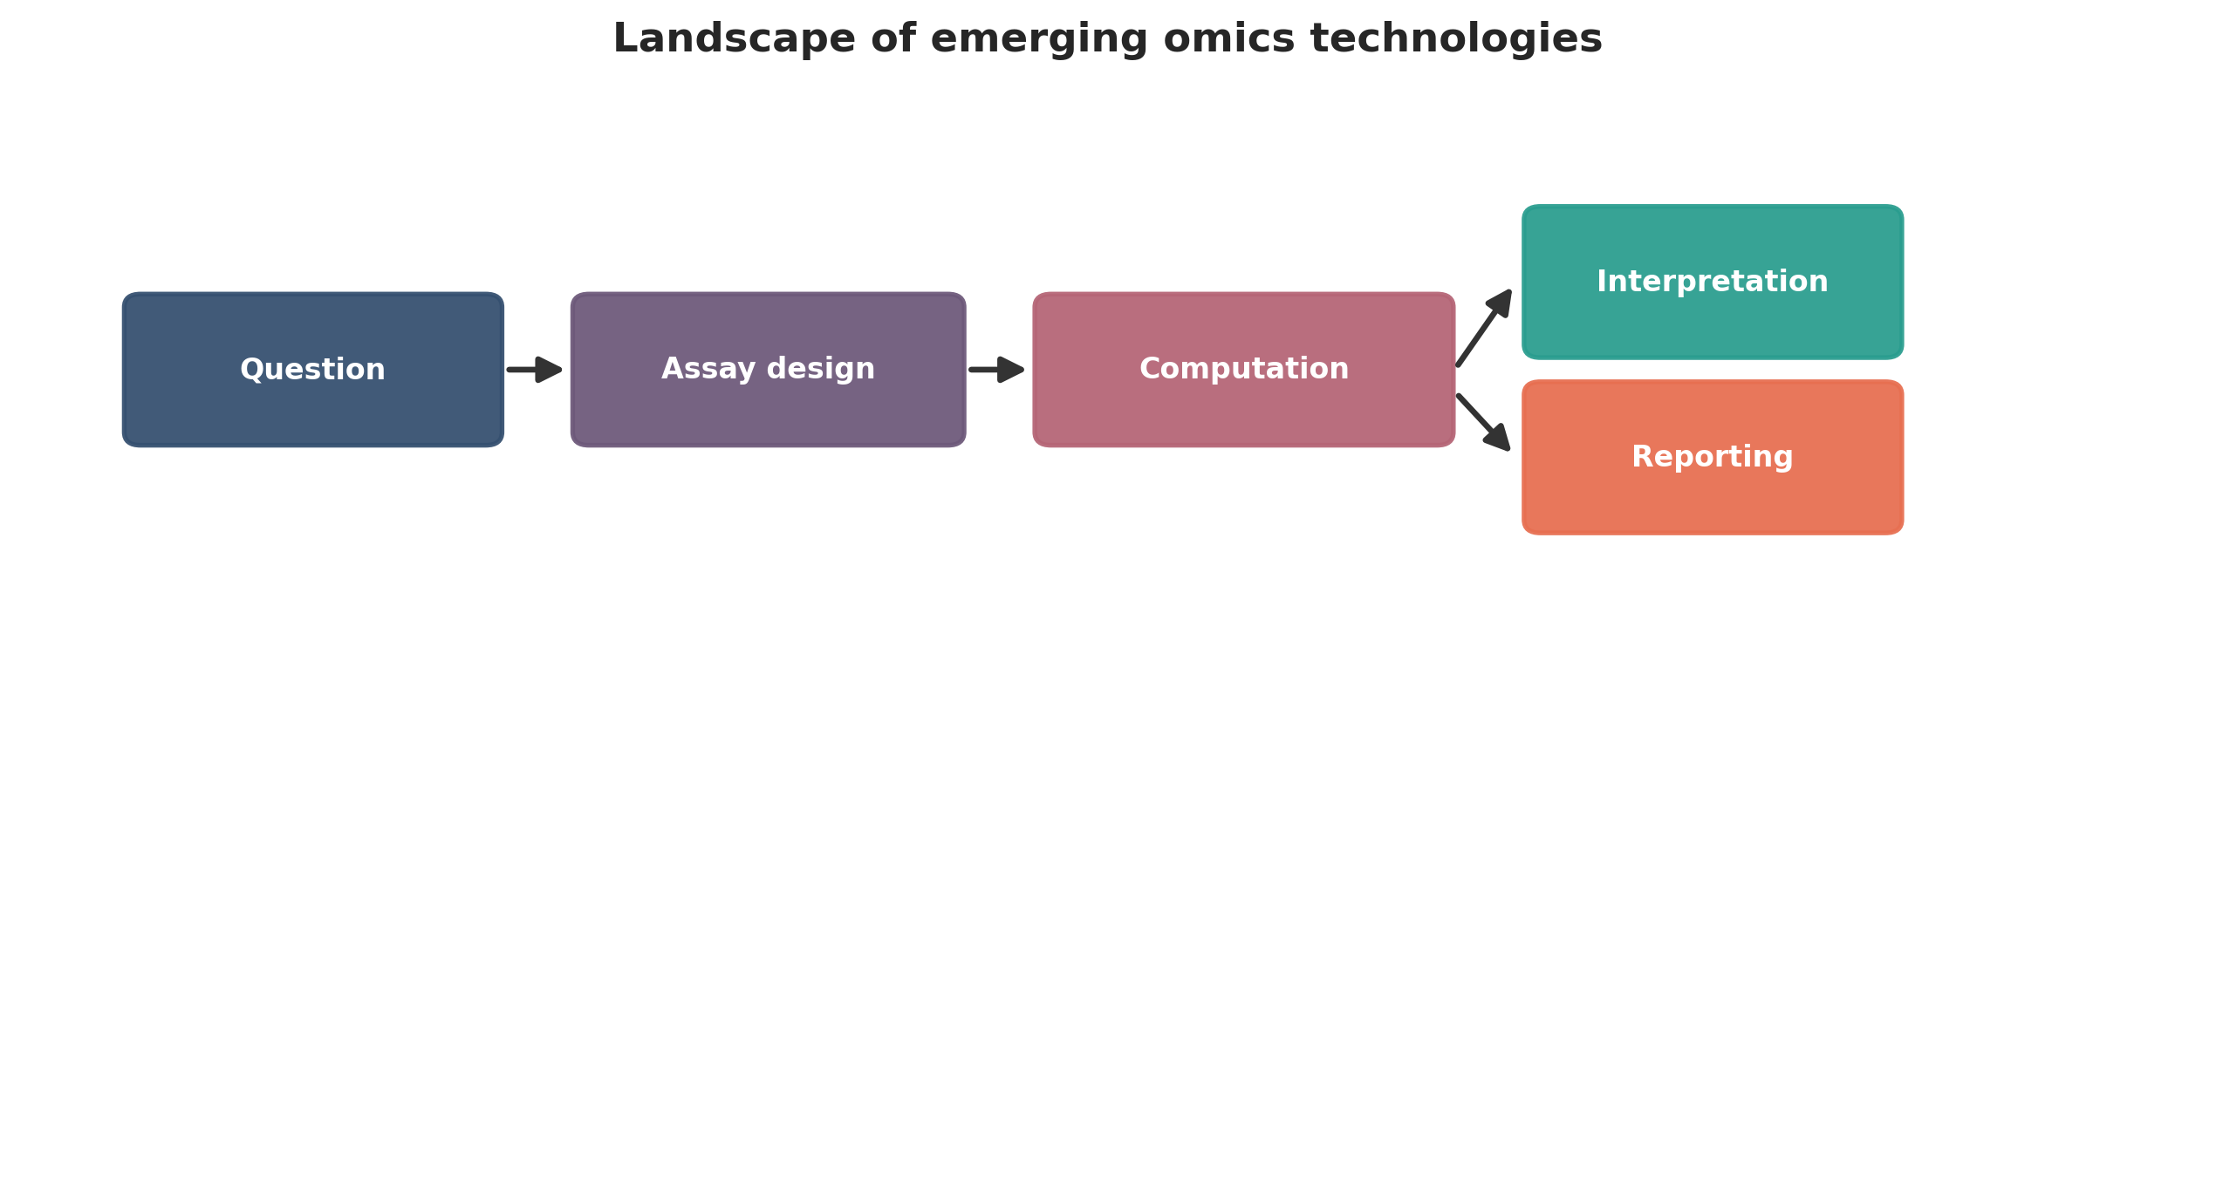
Landscape of emerging omics technologies. This figure is a publication-style schematic prepared for tutorial reporting.
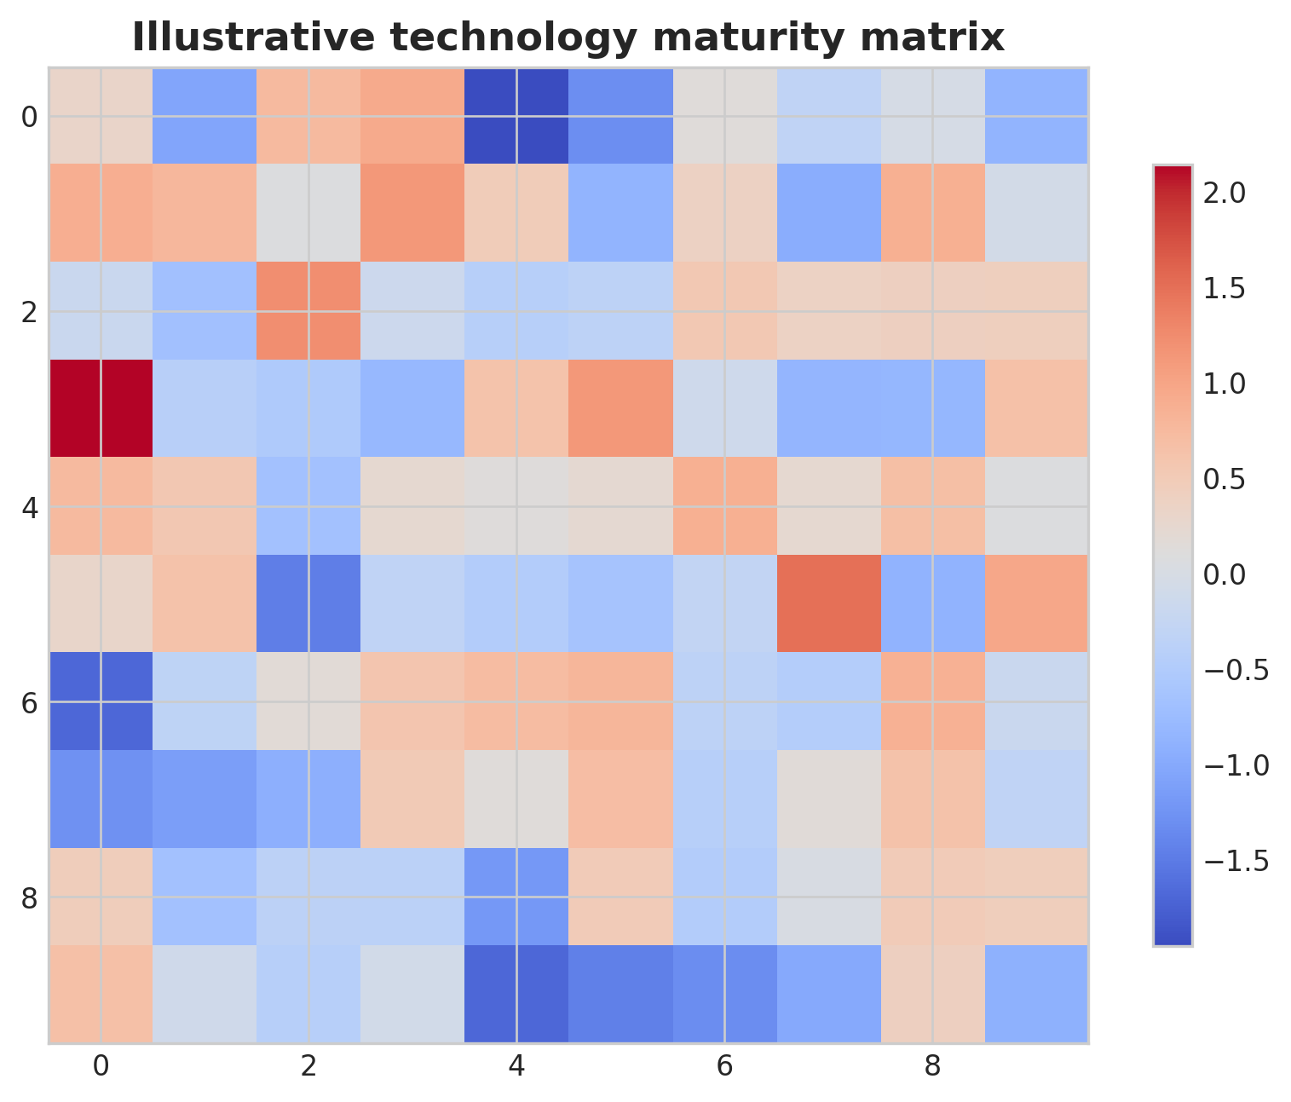
Illustrative technology maturity matrix. This figure is an illustrative formatted example and does not represent a new study dataset.
Practical decision matrix for computational study planning.
Question type | Preferred analytical emphasis | Key reporting requirement
Discovery-oriented | Broad exploratory analysis | Clear filtering and exploratory limits
Comparative cohort study | Statistical testing and covariate handling | Design formula and confounder reporting
Translational or clinical | Robust interpretation and validation | Explicit limitations and reproducibility
Atlas-building or systems analysis | Integration and uncertainty quantification | Transparent preprocessing and annotation logic

Minimum publication-ready computational reporting checklist.
Domain | Minimum expectation
Study design | Primary question, inclusion logic, metadata plan
Data processing | Quality control, reference versions, filtering thresholds
Statistics | Normalization, model choice, covariates, multiple-testing approach
Validation | Sensitivity analysis, external support, or orthogonal evidence
Reproducibility | Software versions, code or workflow trace, figure provenance
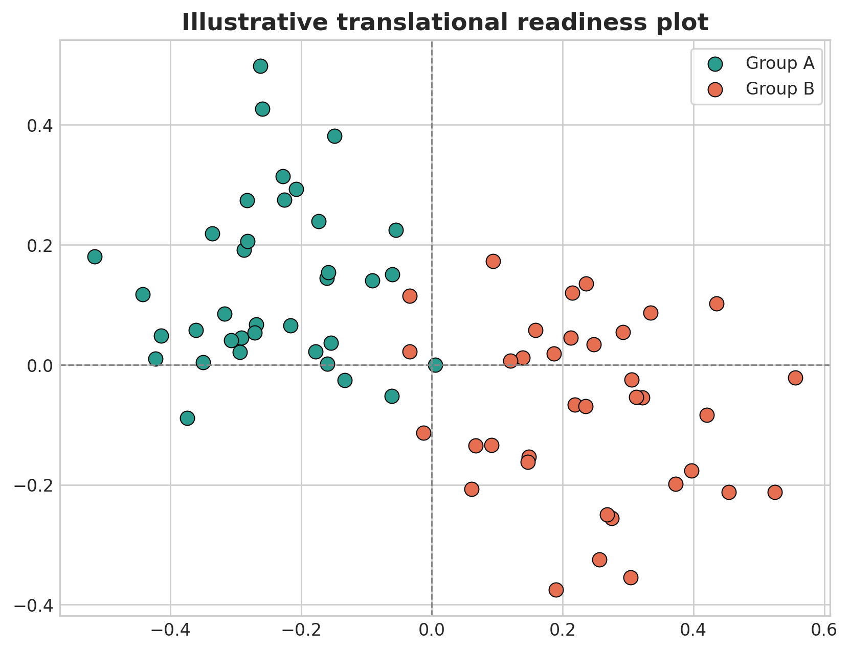
Illustrative translational readiness plot. This figure is an illustrative formatted example and does not represent a new study dataset.
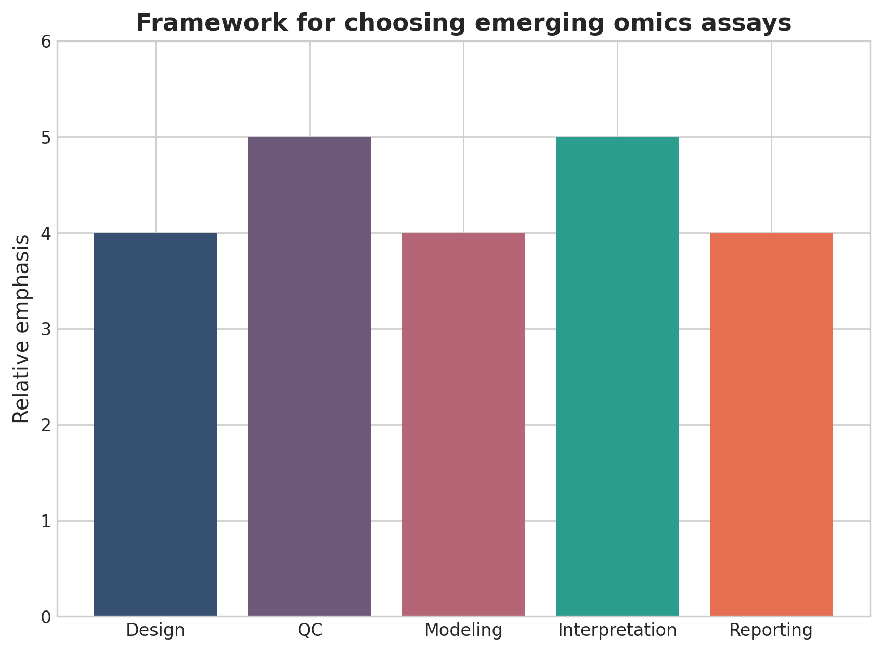
Framework for choosing emerging omics assays. This figure is a discipline-specific publication-style summary schematic.

Declarations

Author contributions
Dr Siddalingaiah H S conceived the tutorial review, prepared the manuscript, and approved the final version.

Funding
No external funding was declared for preparation of this manuscript.

Competing interests
The author declares no competing interests.

Ethics approval and consent to participate
Not applicable. This tutorial review does not report a new human-participant or animal experiment.

Consent for publication
Not applicable.

Availability of data and materials
No new dataset was generated or analyzed for this tutorial review. Figures are educational schematics and illustrative formatted examples created for explanatory purposes.

Author information
Dr Siddalingaiah H S, Professor, Community Medicine, Shridevi Institute of Medical Sciences and Research Hospital, Tumkur, India. ORCID: 0000-0002-4771-8285.

References
- Method of the Year 2024: spatial proteomics. Nat Methods. 2024;21:2195-2196.
- An update on spatial proteomics. Nat Methods. 2026;23:481.
- Mass spectrometry imaging for spatially resolved multi-omics molecular mapping. npj Imaging. 2024;2:25.
- Combining spatial metabolomics and proteomics profiling of single cells. Nat Rev Immunol. 2024.
- Emerging technologies of single-cell multi-omics. Haematologica. 2024.
- Epitranscriptomics in metabolic disease. Nat Metab. 2023;5:370-384.
- Implementation of multiomic mass spectrometry approaches for the evaluation of human health following environmental exposure. Mol Omics. 2024;20(5):296-321.
- Hasin Y, Seldin M, Lusis A. Multi-omics approaches to disease. Genome Biol. 2017;18:83.
- Vandereyken K, Sifrim A, Thienpont B, Voet T. Methods and applications for single-cell and spatial multi-omics. Nat Rev Genet. 2023;24(8):494-515.
- Rao A, Barkley D, Franca GS, Yanai I. Exploring tissue architecture using spatial transcriptomics. Nature. 2021;596(7871):211-220.

