Title Page
Title: Spatiotemporal Omics for Biology and Medicine: A Computational Framework for Dynamic Tissue-Resolved Analysis
Article Type: Tutorial Review
Author: Dr Siddalingaiah H S
Affiliation: Professor, Community Medicine, Shridevi Institute of Medical Sciences and Research Hospital, Tumkur, India
Corresponding Author:
Dr Siddalingaiah H S
Professor, Community Medicine, Shridevi Institute of Medical Sciences and Research Hospital, Tumkur, India
Email: hssling@yahoo.com
Phone: +91 8941087719
ORCID: 0000-0002-4771-8285
Keywords: Spatiotemporal omics; spatial biology; longitudinal omics; tissue dynamics; developmental trajectories; disease progression; dynamic systems biology
Running Title: Spatiotemporal Omics
Word Count: Approximately 2,715 words excluding title page and references
Figures: 4
Tables: 2

Spatiotemporal Omics for Biology and Medicine: A Computational Framework for Dynamic Tissue-Resolved Analysis

Abstract
Spatiotemporal omics extends molecular profiling beyond static snapshots by integrating tissue location with change over time. This review presents a computational framework for dynamic tissue-resolved studies, covering design, registration, temporal alignment, trajectory modeling, multimodal integration, uncertainty, and publication-ready reporting.

Keywords
Spatiotemporal omics; spatial biology; longitudinal omics; tissue dynamics; developmental trajectories; disease progression; dynamic systems biology

1. Introduction
Many important biological questions concern change rather than static state: development, repair, progression, relapse, and treatment response. Spatiotemporal omics addresses these questions by combining molecular state, tissue location, and temporal structure in one analytical framework. The key difference from static spatial biology is that this field tries to represent processes rather than snapshots. Developmental progression, regeneration, treatment response, and disease evolution all require claims about order, timing, and movement across tissue context. That makes the computational problem fundamentally harder than describing a single well-annotated section.
Spatiotemporal studies combine at least three sources of complexity: spatial registration, temporal alignment, and molecular interpretation. Each can fail independently. A false correspondence between sections can create an apparent trajectory, and a strong pseudotime model can still be misleading if the spatial alignment or sampling scheme is weak.
A practical review must therefore emphasize what kind of time is actually available in the data. Some studies observe time directly through serial sampling, some reconstruct it from developmental stage collections, and others infer it computationally from state similarity. Those are not equivalent evidentiary situations.
It also helps to signal early what kinds of validation or external evidence will matter later, so readers understand from the outset which claims in introduction are meant to be descriptive and which are expected to support stronger inference.
The practical takeaway from introduction is that readers should finish the first section knowing exactly what problem the manuscript will solve and what kinds of conclusions it will deliberately avoid.

2. Study design for dynamic tissues
The key design question is whether time is observed directly, reconstructed from serial sections, inferred computationally, or integrated across cohorts. Sampling interval, intervention timing, section provenance, and longitudinal metadata determine what temporal claims are defensible. Study design begins by defining whether temporal information is experimentally observed or computationally reconstructed. Repeated sampling from the same organism, aligned serial sections, synchronized perturbation experiments, and cross-sectional cohorts arranged by stage all support different kinds of claims. The manuscript should make that distinction explicit because it determines how strongly progression can be interpreted.
Sampling interval is also central. Fast processes such as immune infiltration after therapy or wound healing may require dense timepoints, whereas developmental atlases may tolerate broader staging if morphology is stable and stage assignment is reliable. Sparse sampling can still be valuable, but only if the analysis avoids implying fine-grained kinetics that the data cannot actually resolve.
Metadata matters here more than in static studies. Intervention timing, tissue orientation, section depth, anatomical landmarks, and specimen-level covariates all influence alignment and interpretation. Without them, differences across timepoints can reflect collection artifacts rather than biology.
Validation expectations should be tied directly to study design for dynamic tissues, because cohort structure, reference choice, and assay pairing determine whether replication, orthogonal assays, or sensitivity analysis will be the decisive credibility check.
The practical takeaway from study design for dynamic tissues is to choose the minimum analytical complexity that truly serves the biological question, then document the tradeoffs before downstream results make those compromises harder to see.

3. Registration and temporal alignment
Reliable spatiotemporal inference depends on coordinate alignment across sections or timepoints. Registration error can create false gradients or false movement. Studies should describe their reference frame, alignment method, and uncertainty handling explicitly. Accurate registration is the technical backbone of spatiotemporal inference. Whether alignment is performed through image landmarks, morphology-informed warping, atlas-based coordinates, or molecular similarity, the chosen reference frame controls every later claim about movement, persistence, or regional transition.
Registration error is not merely a nuisance variable. Small misalignments can create artificial gradients, suggest migration that did not occur, or obscure true boundaries between compartments. Review articles should therefore discuss quality metrics for alignment, uncertainty visualization, and how conclusions change when the reference frame is perturbed.
Temporal alignment has its own hazards. When timepoints are unequally sampled or pooled across individuals, computational smoothing may imply continuity that is not directly observed. Analysts should clarify where interpolation was used and where the results remain anchored only to discrete observations.
Robustness in registration and temporal alignment is best demonstrated through explicit quality metrics, versioned resources, and sensitivity to reasonable threshold changes rather than by asserting that standard pipelines were followed.
The practical takeaway from registration and temporal alignment is that reproducibility usually fails at the level of quiet preprocessing decisions, so explicit thresholds and references are more valuable than long software lists.

4. Dynamic modeling strategies
Spatiotemporal datasets often use trajectory inference, pseudotime, graph methods, tensor approaches, or dynamical models. The manuscript should always clarify whether results reflect observed change or computationally inferred progression. Dynamic modeling in this field ranges from simple stage-wise comparisons to pseudotime reconstruction, graph diffusion, optimal transport, tensor decomposition, and mechanistic dynamical systems. The correct choice depends on whether the goal is descriptive ordering, transition probability estimation, lineage coupling, or explicit state dynamics.
Pseudotime is useful when direct temporal labels are incomplete, but it should not be narrated as measured time. Likewise, optimal transport or graph-based trajectory models can reveal plausible flows between states, yet they depend strongly on neighborhood construction, regularization, and how the state space was defined. These assumptions deserve main-text discussion because they shape the biological narrative.
Model outputs should also be linked back to tissue structure. A compelling dynamic result is one that explains where transitions occur, which compartments are stable, and how state change relates to morphology or intervention timing. Models that remain only in latent space are harder to interpret biologically.
Results from dynamic modeling strategies should therefore be accompanied by stability checks, alternative parameterizations, or orthogonal evidence whenever the output is being used to support mechanism, subtype definition, or clinical relevance.
The practical takeaway from dynamic modeling strategies is to treat elegant models as aids to reasoning rather than substitutes for evidence, especially when interpretation begins to outrun what the data directly support.

5. Integration with references
Many analyses depend on single-cell references to identify states and infer transitions. These references add value but also impose assumptions, so robust studies assess whether conclusions change under alternative annotations or reference sets. Reference datasets are often used to label states, constrain trajectories, or compare observed tissue programs with better-characterized single-cell atlases. This can substantially improve interpretability, especially when the spatiotemporal assay has limited feature depth. But references also import assumptions about annotation, stage definition, and the completeness of known cell states.
A strong analysis therefore tests whether conclusions persist under alternative references or coarser annotation schemes. This matters especially in regeneration and disease settings, where transitional or treatment-induced states may not exist in the canonical atlas. Overconfident label transfer can erase exactly the novel biology the study hopes to capture.
Reference integration works best when it is used to bound uncertainty rather than to eliminate it. The manuscript should describe how much of the signal is directly observed in the target data and how much is inferred by borrowing structure from external resources.
Results from integration with references should therefore be accompanied by stability checks, alternative parameterizations, or orthogonal evidence whenever the output is being used to support mechanism, subtype definition, or clinical relevance.
The practical takeaway from integration with references is to treat elegant models as aids to reasoning rather than substitutes for evidence, especially when interpretation begins to outrun what the data directly support.

6. Common inferential errors
The most common mistakes are treating pseudotime as literal time, ignoring section effects, failing to separate abundance change from rearrangement in space, and overinterpreting spatial gradients without robust alignment. Treating pseudotime as literal time is the most frequent conceptual error, but it is not the only one. Another is failing to distinguish changes in abundance from changes in location. A cell type may appear to move across tissue simply because one region expands or contracts, not because individual cells migrate.
Section effects are another major risk. Differences in section thickness, orientation, staining, or imaging quality can create temporal-looking patterns that disappear once alignment uncertainty is considered. Analysts should show that major trends are not driven by one problematic slice or one poorly matched timepoint.
Overinterpretation of gradients is also common. Spatially smooth trends can be visually compelling, yet they may reflect averaging, tissue composition, or registration artifacts. Review articles should encourage formal checks before assigning developmental or disease-progression meaning to these patterns.
A useful review does not only list problems in common inferential errors; it also shows what checks, controls, or external comparisons would reveal that those problems are distorting the result.
The practical takeaway from common inferential errors is to treat these errors as expected analytical hazards, not as rare exceptions, and to build manuscript structure around showing they were checked.

7. Biological applications
This framework is relevant to embryology, tissue regeneration, neurodevelopment, wound healing, tumor evolution, and therapy response. Its practical strength lies in identifying where and when key transitions occur. Developmental systems are an obvious application because cell-state transitions unfold in defined anatomical space. Embryology, organogenesis, and neural patterning all benefit from models that link lineage progression to tissue compartments. Regeneration and wound healing pose similar questions, but with intervention timing and inflammatory context layered on top.
In cancer and chronic disease, spatiotemporal approaches can illuminate clonal expansion, immune remodeling, stromal adaptation, and therapy response. These settings are especially challenging because repeated sampling may be sparse and treatment itself changes tissue architecture, making alignment and interpretation more difficult than in developmental atlases.
The most compelling application papers answer focused questions about when and where key transitions occur. Broad claims about total tissue dynamics are harder to defend unless the sampling design, alignment quality, and validation burden are exceptionally strong.
The evidentiary bar in biological applications should rise with the ambition of the claim: exploratory biological framing may tolerate internal consistency, whereas biomarker or clinical language requires external validation and much tighter calibration.
The practical takeaway from biological applications is to match the language of impact to the strength of evidence, resisting clinical or mechanistic overstatement when the workflow is still best viewed as discovery-oriented.

8. Reporting standards
Publication-ready studies should report temporal logic, coordinate systems, registration strategy, modality integration assumptions, and sensitivity analysis for alternative alignments or trajectory settings. Reporting needs to be more explicit here than in static spatial studies because the reader must understand both the coordinate system and the temporal logic. Manuscripts should specify how time was observed or inferred, what anatomical reference was used, how sections were registered, and how uncertainty was represented.
It is also important to state which parts of the workflow are descriptive and which are model-based. Interpolated maps, smoothed trajectories, and borrowed annotations can be highly informative, but they should be labeled as such. Without that transparency, readers may mistake inferred continuity for direct observation.
Sensitivity analysis should be treated as standard rather than optional. Alternative alignments, trajectory parameters, stage definitions, or reference atlases can materially change conclusions. A publication-ready spatiotemporal paper should show at least the main robustness checks in the core manuscript.
A strong section on reporting standards should also link method choice to downstream validation and reporting, stating which results are primarily descriptive and what additional evidence would be required for stronger claims.
The practical takeaway from reporting standards is to state what should be done by default, what should be justified explicitly, and which shortcuts most often weaken the final claim.

9. Conclusion
Dynamic spatial biology is a promising frontier, but it requires stronger computational discipline than static atlas generation because both spatial and temporal claims can fail if alignment and inference are weak. Spatiotemporal omics is valuable because it lets investigators ask dynamic questions in their anatomical setting, but that advantage comes with a much higher inferential burden than static atlas work. Claims about progression, movement, or response are only as strong as the registration, sampling design, and uncertainty handling that support them.
The strongest closing message is therefore one of disciplined ambition. These methods are worth using when the biological question genuinely concerns change over time in tissue context, not merely because four-dimensional plots look modern or comprehensive.
As the field matures, better alignment benchmarks, standardized uncertainty reporting, and richer multimodal reference atlases will likely matter more than incremental increases in modeling complexity. Those advances will make dynamic tissue biology more reproducible and more clinically credible.
A strong closing section should also remind readers that validation is not interchangeable across studies: the right confirmatory step depends on whether the manuscript’s main claim is descriptive, predictive, mechanistic, or translational.
The practical takeaway from conclusion is that a good manuscript leaves the reader with a usable decision framework, not just an impression that the field is complex.
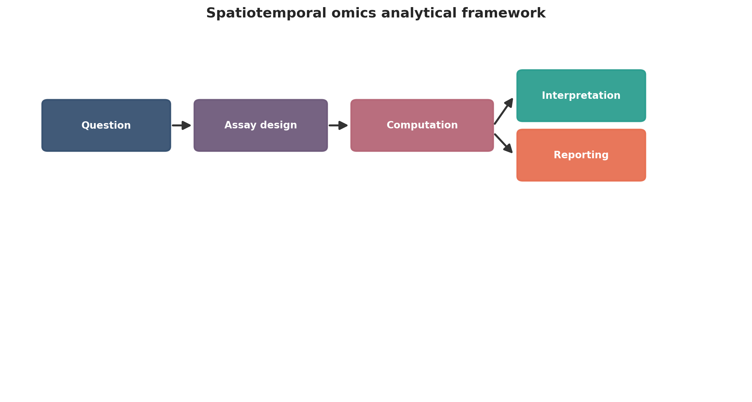
Spatiotemporal omics analytical framework. This figure is a publication-style schematic prepared for tutorial reporting.
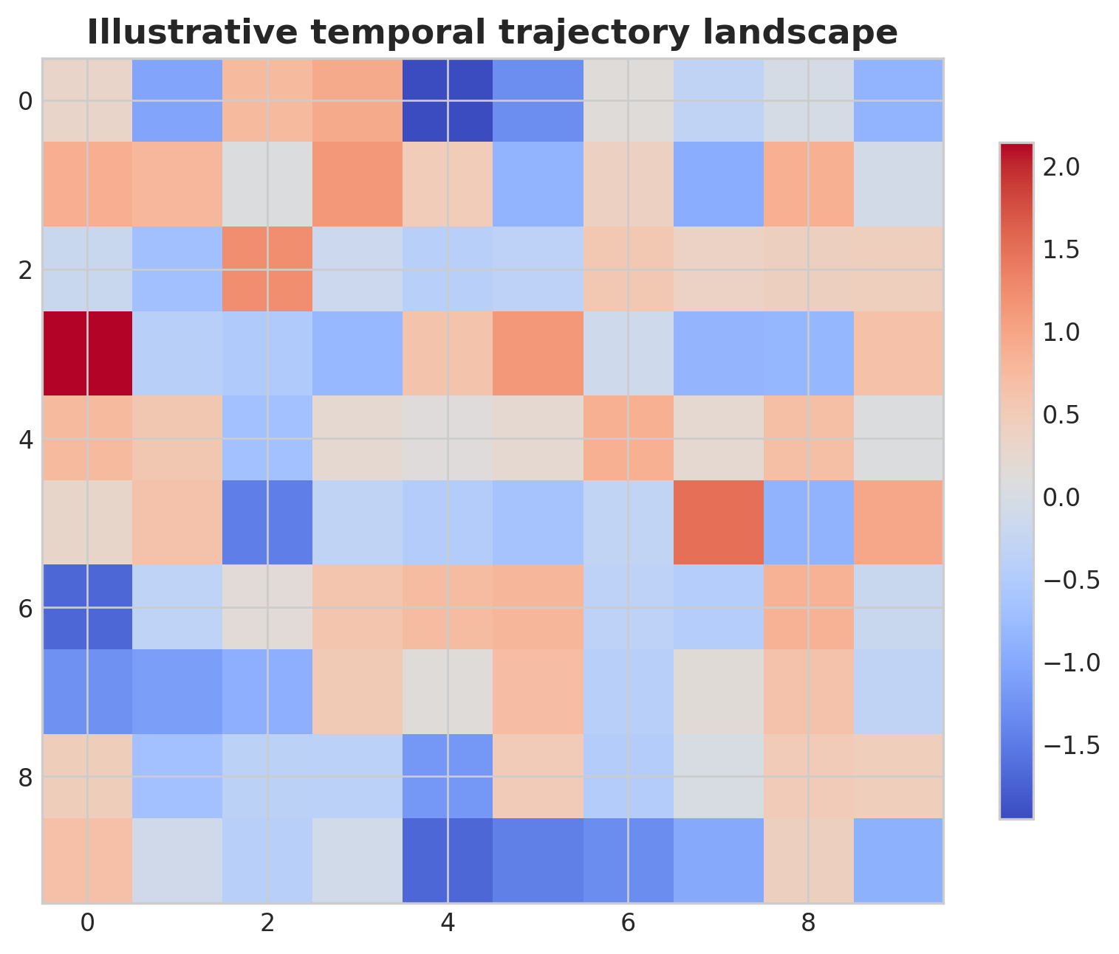
Illustrative temporal trajectory landscape. This figure is an illustrative formatted example and does not represent a new study dataset.
Practical decision matrix for computational study planning.
Question type | Preferred analytical emphasis | Key reporting requirement
Discovery-oriented | Broad exploratory analysis | Clear filtering and exploratory limits
Comparative cohort study | Statistical testing and covariate handling | Design formula and confounder reporting
Translational or clinical | Robust interpretation and validation | Explicit limitations and reproducibility
Atlas-building or systems analysis | Integration and uncertainty quantification | Transparent preprocessing and annotation logic

Minimum publication-ready computational reporting checklist.
Domain | Minimum expectation
Study design | Primary question, inclusion logic, metadata plan
Data processing | Quality control, reference versions, filtering thresholds
Statistics | Normalization, model choice, covariates, multiple-testing approach
Validation | Sensitivity analysis, external support, or orthogonal evidence
Reproducibility | Software versions, code or workflow trace, figure provenance
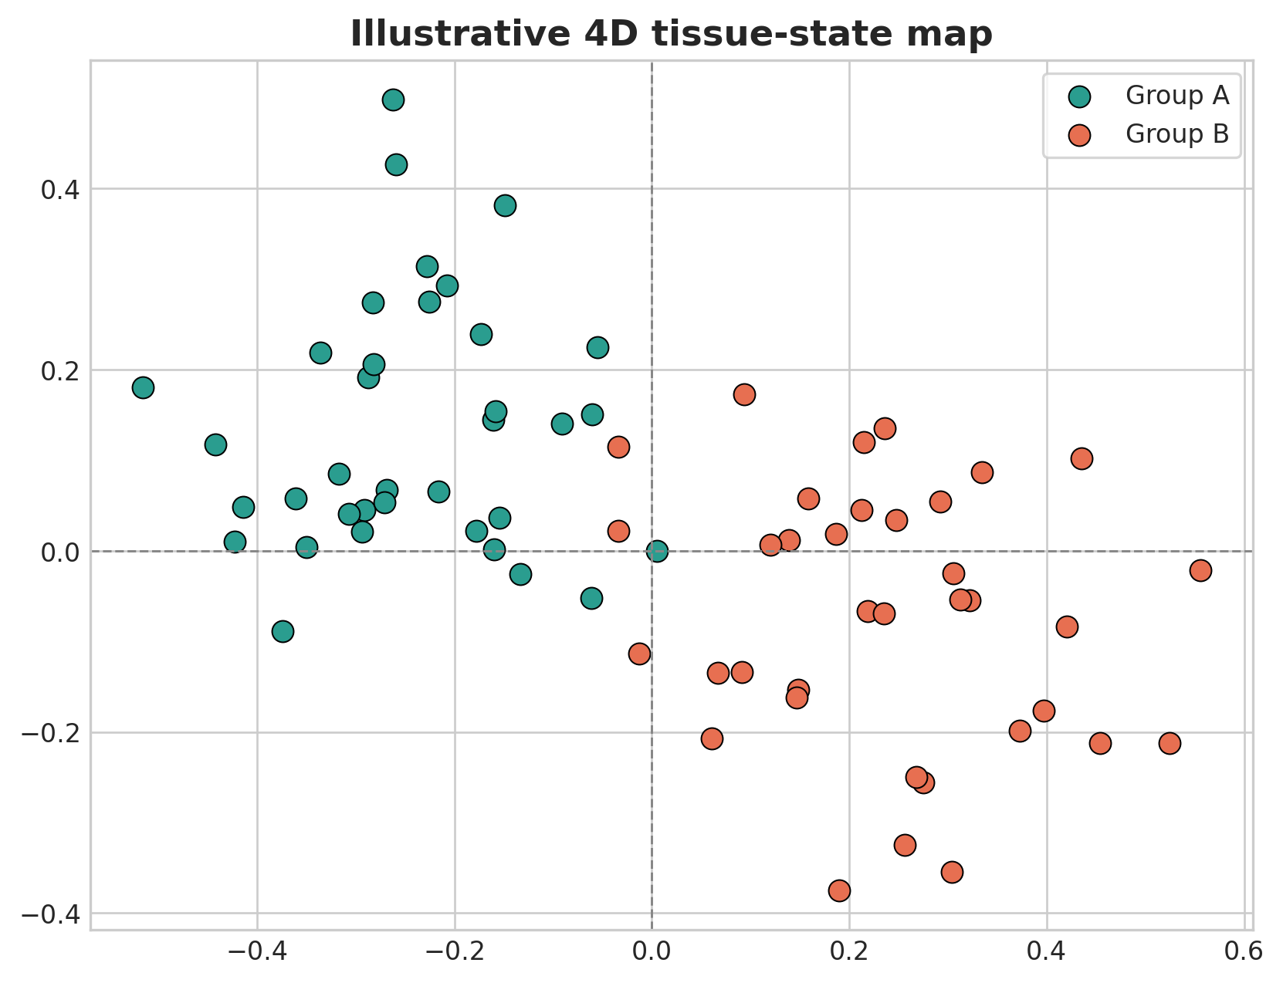
Illustrative 4D tissue-state map. This figure is an illustrative formatted example and does not represent a new study dataset.
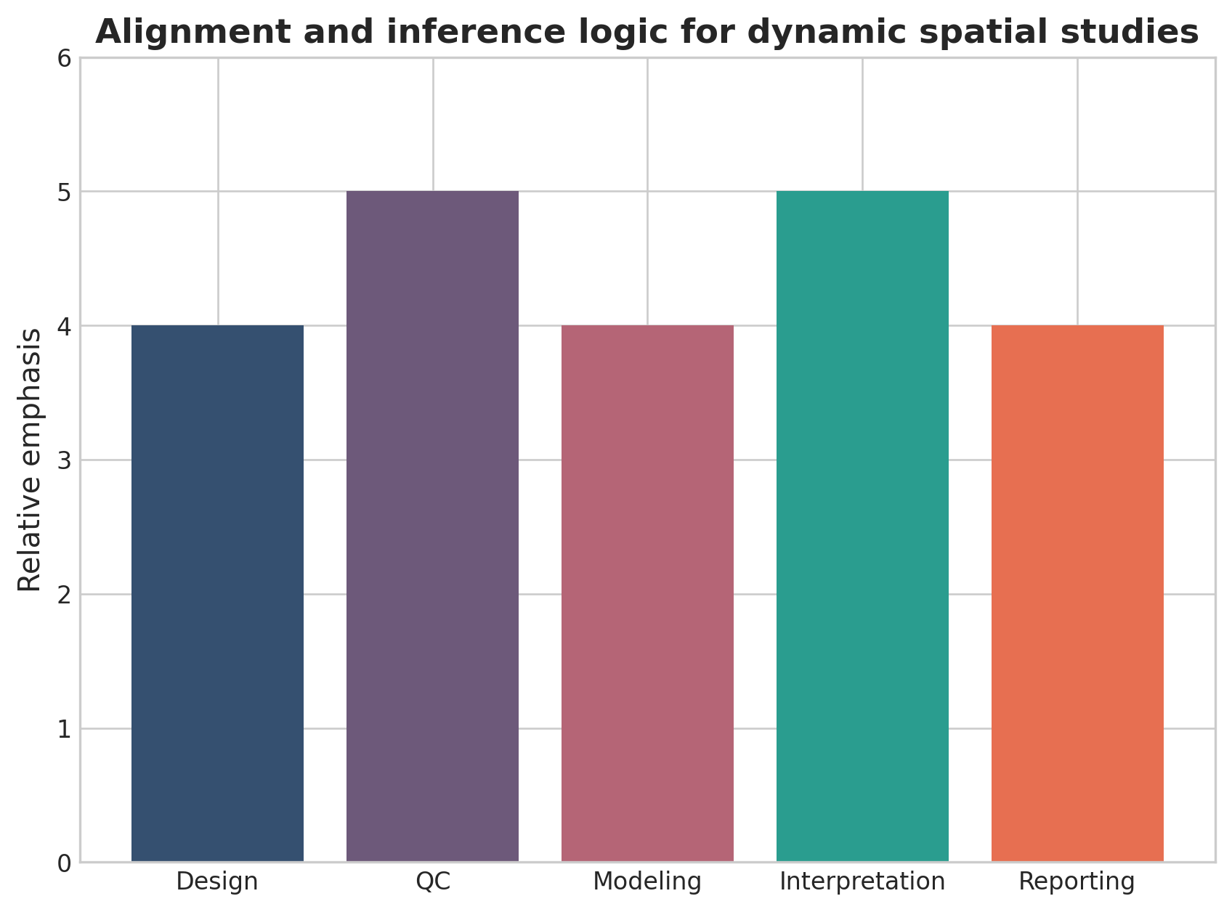
Alignment and inference logic for dynamic spatial studies. This figure is a discipline-specific publication-style summary schematic.

Declarations

Author contributions
Dr Siddalingaiah H S conceived the tutorial review, prepared the manuscript, and approved the final version.

Funding
No external funding was declared for preparation of this manuscript.

Competing interests
The author declares no competing interests.

Ethics approval and consent to participate
Not applicable. This tutorial review does not report a new human-participant or animal experiment.

Consent for publication
Not applicable.

Availability of data and materials
No new dataset was generated or analyzed for this tutorial review. Figures are educational schematics and illustrative formatted examples created for explanatory purposes.

Author information
Dr Siddalingaiah H S, Professor, Community Medicine, Shridevi Institute of Medical Sciences and Research Hospital, Tumkur, India. ORCID: 0000-0002-4771-8285.

References
- Rao A, Barkley D, Franca GS, Yanai I. Exploring tissue architecture using spatial transcriptomics. Nature. 2021;596(7871):211-220.
- Palla G, Spitzer H, Klein M, et al. Squidpy: a scalable framework for spatial omics analysis. Nat Methods. 2022;19(2):171-178.
- Vandereyken K, Sifrim A, Thienpont B, Voet T. Methods and applications for single-cell and spatial multi-omics. Nat Rev Genet. 2023;24(8):494-515.
- Longo SK, Guo MG, Ji AL, Khavari PA. Integrating single-cell and spatial transcriptomics to elucidate intercellular tissue dynamics. Nat Rev Genet. 2021;22(10):627-644.
- Marx V. Method of the Year: spatially resolved transcriptomics. Nat Methods. 2021;18:9-14.
- Williams CG, Lee HJ, Asatsuma T, et al. An introduction to spatial transcriptomics for biomedical research. Genome Med. 2022;14:68.
- Enablers and challenges of spatial omics, a melting pot of technologies. Mol Syst Biol. 2022;18:e10571.
- Spatiotemporal omics for biology and medicine. Cell. 2024.
- Spatial omics at the forefront: emerging technologies, analytical innovations, and clinical applications. Cancer Cell. 2025.
- Moses L, Pachter L. Museum of spatial transcriptomics. Nat Methods. 2022;19(5):534-546.

