Figure
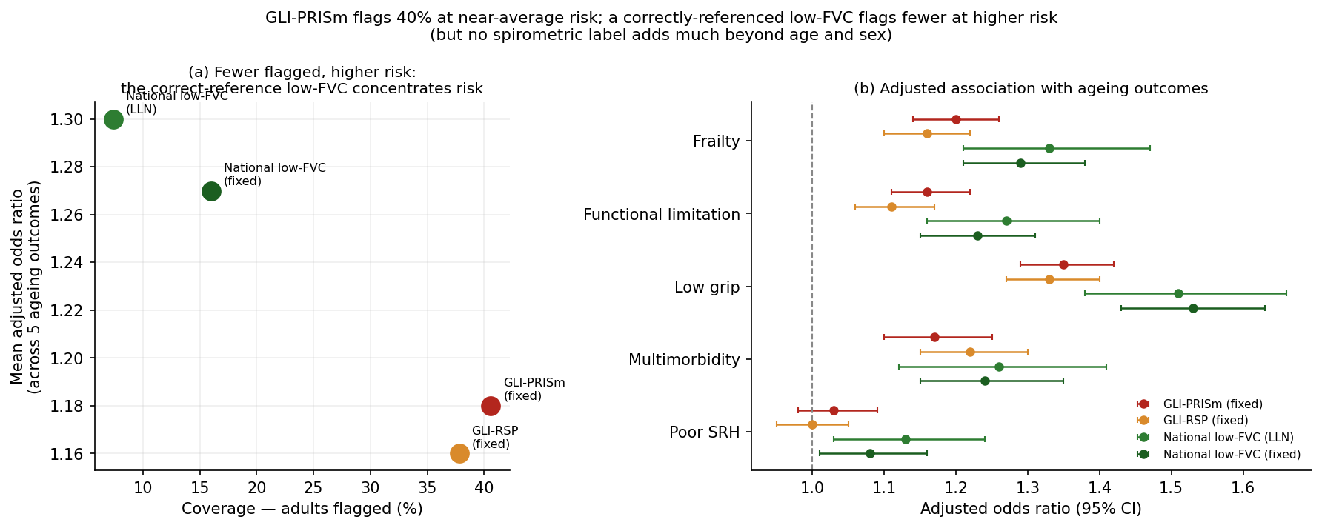
Figure 1. (a) Coverage versus mean adjusted odds ratio across five ageing outcomes: flags that cover fewer adults concentrate more risk, the correctly-referenced low FVC flagging far fewer people at higher risk than GLI-PRISm. (b) Adjusted odds ratios (95% CI) by flag for each outcome; the national-reference low FVC shows stronger associations, most clearly for low grip strength.

