Figures
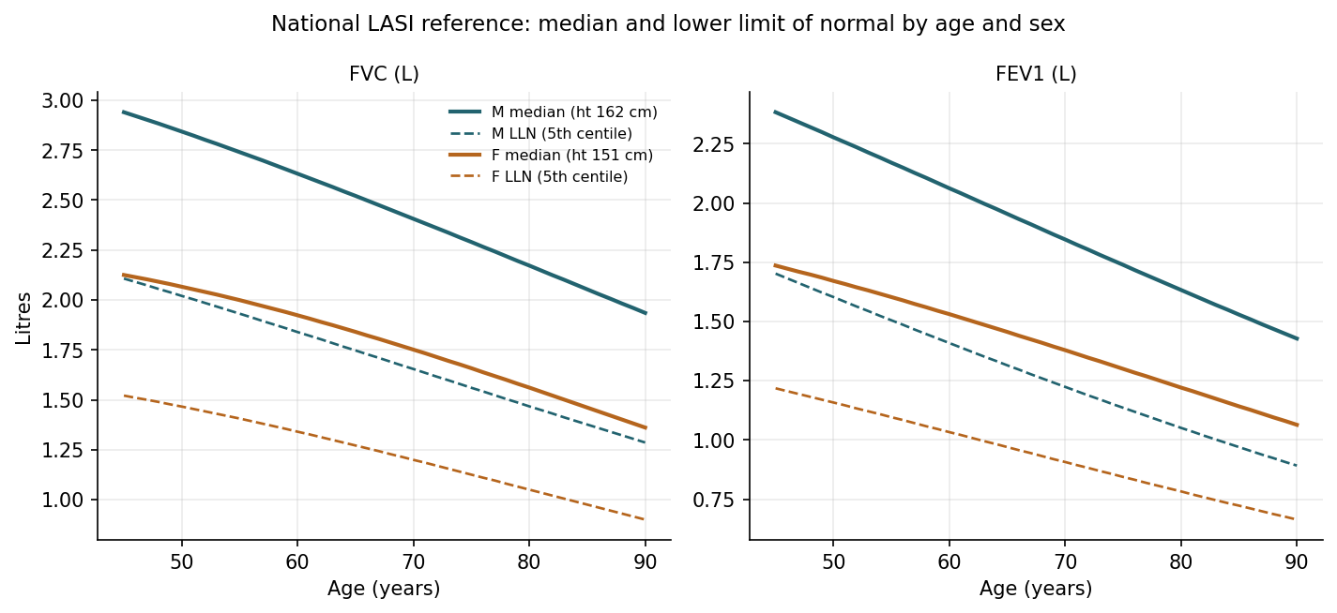
Figure 1. National LASI reference curves: predicted median (solid) and lower limit of normal (dashed) for FVC and FEV1 by age and sex, at each sex's reference height.

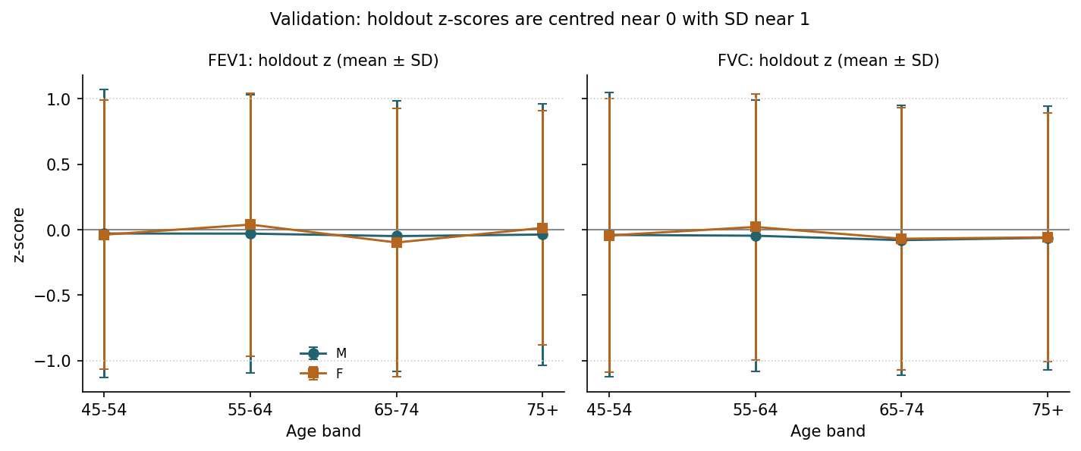
Figure 2. Internal validation: held-out z-scores by age band for FEV1 and FVC in men and women; a well-calibrated reference gives means near 0 and standard deviations near 1.

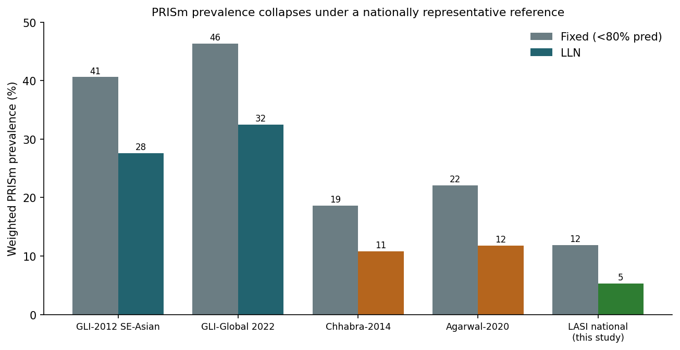
Figure 3. Weighted PRISm prevalence in the same national sample under five reference equations and two thresholds. Prevalence collapses under the nationally representative LASI reference.

