Figure
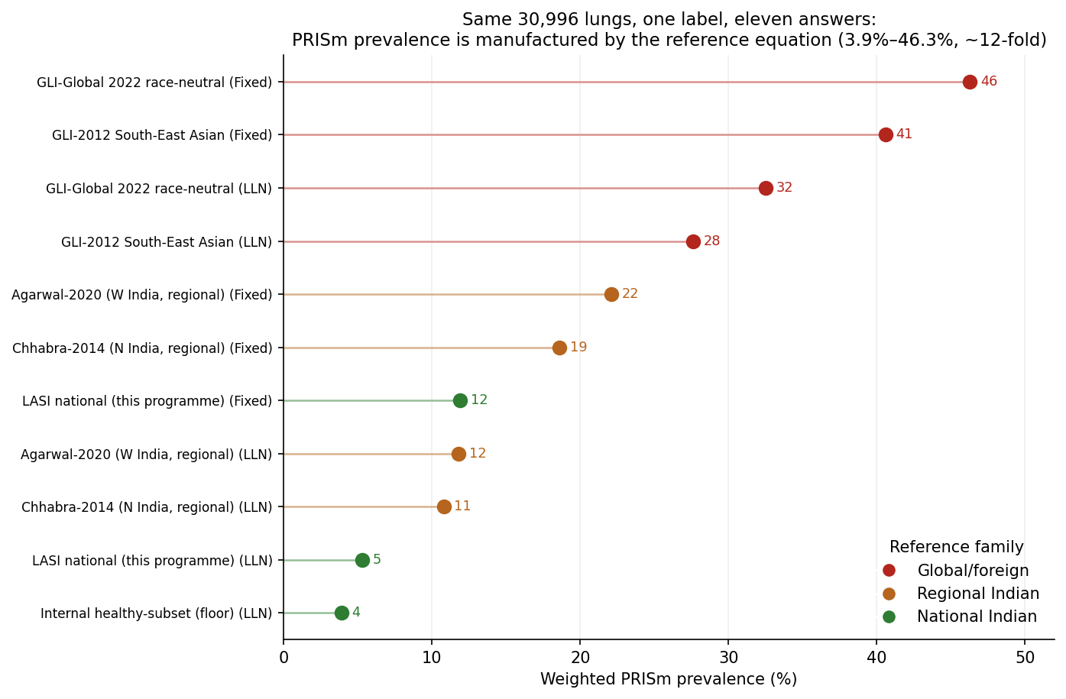
Figure 1. Weighted PRISm prevalence in the identical national sample under eleven reference x definition scenarios, coloured by reference family. The estimate is manufactured across a 12-fold range, with foreign references (including race-neutral GLI-Global) highest and the nationally representative reference lowest.

