Figures
All figures are survey-weighted and supplied at 600 dpi in the figures folder.
Figure 1. Catastrophic health expenditure among older adults at three thresholds, for all adults aged 60 yr and over and for those aged 70 yr and over.
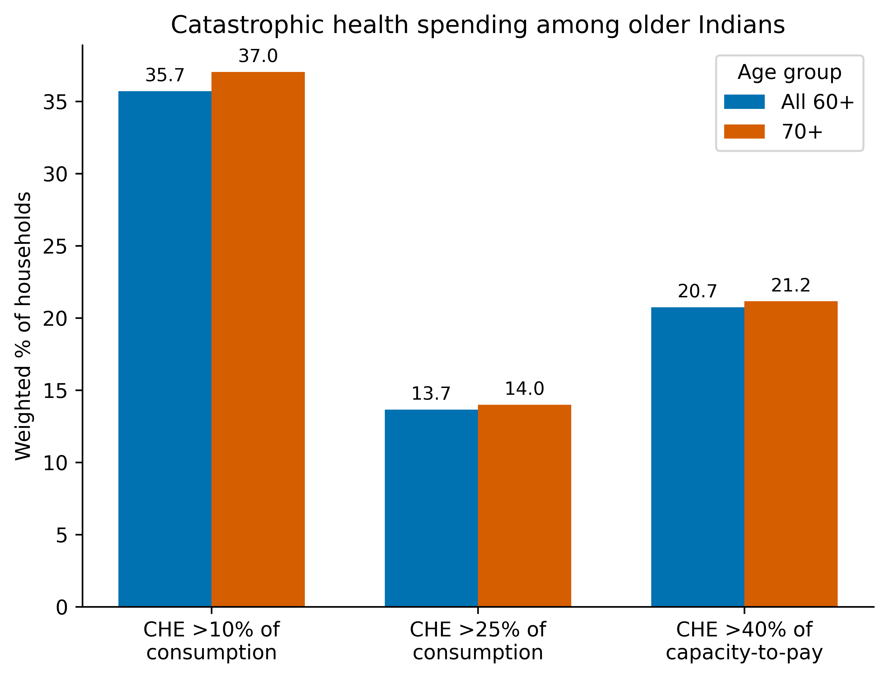
Figure 1
Figure 2. Share of older adults below the poverty line before and after out-of-pocket payment, overall and by sex and residence.
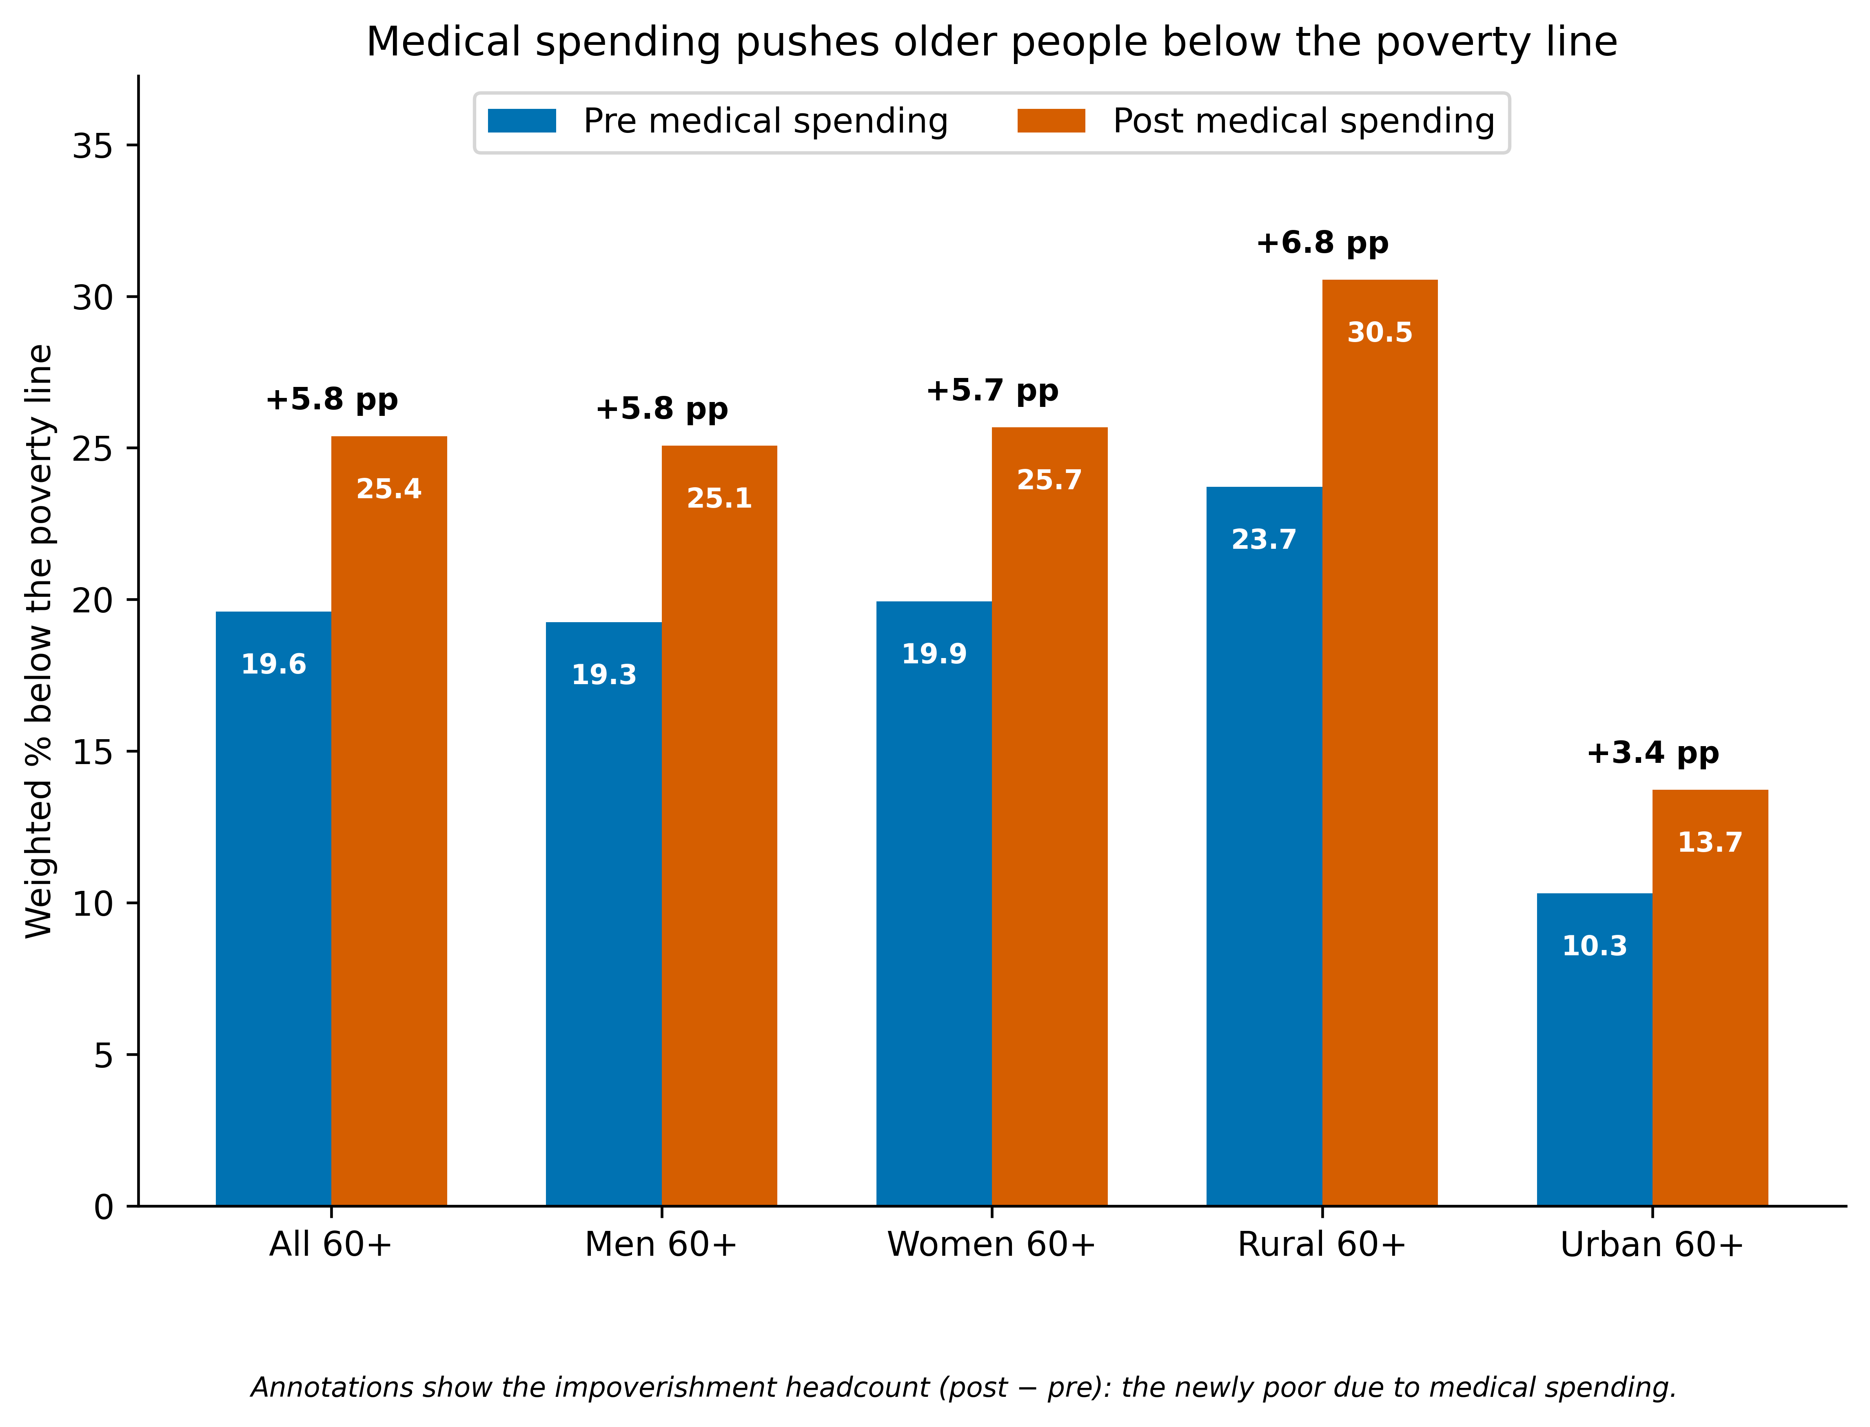
Figure 2
Figure 3. Drivers of catastrophic spending ranked by mean absolute SHAP value from the gradient-boosting model (predictive, not causal).
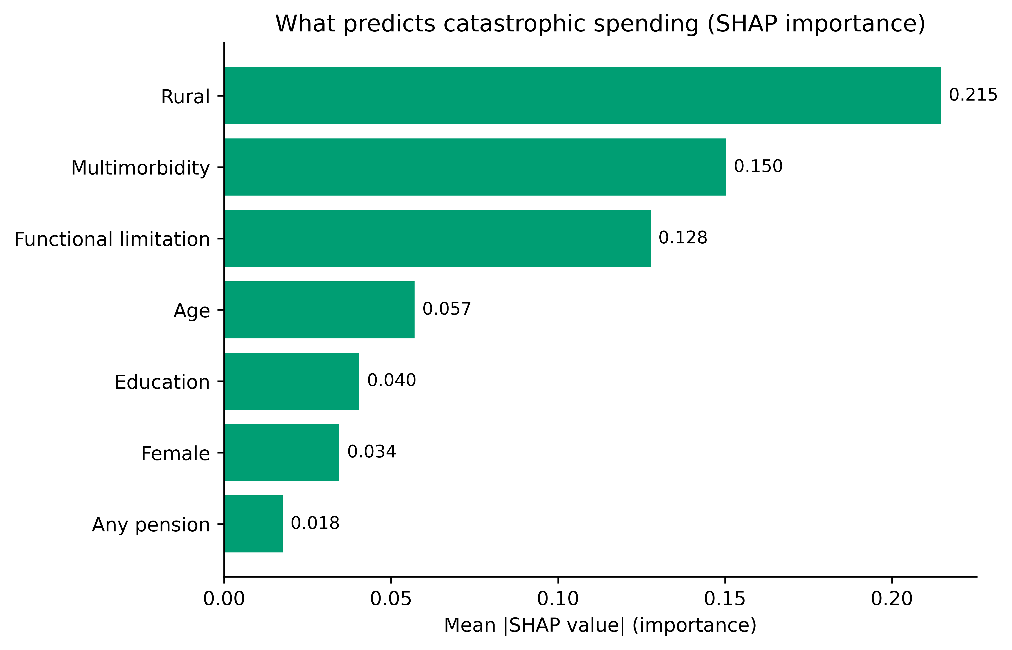
Figure 3
Figure 4. Percentage-point change in catastrophic spending under four financing-reform scenarios, with each scenario’s fiscal cost annotated. Scenarios assume full coverage and are upper-bound ceilings.
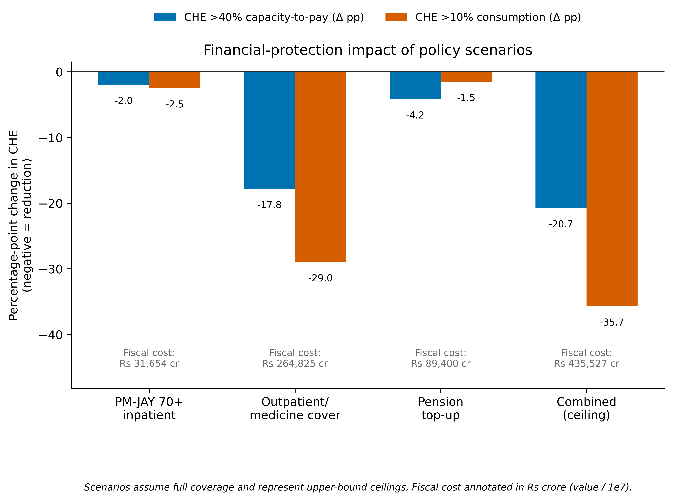
Figure 4
Figure 5. Ranking of States and union territories by the share of older households with catastrophic spending (>40% of capacity to pay). The dashed line marks the national 60+ average (20.7%).
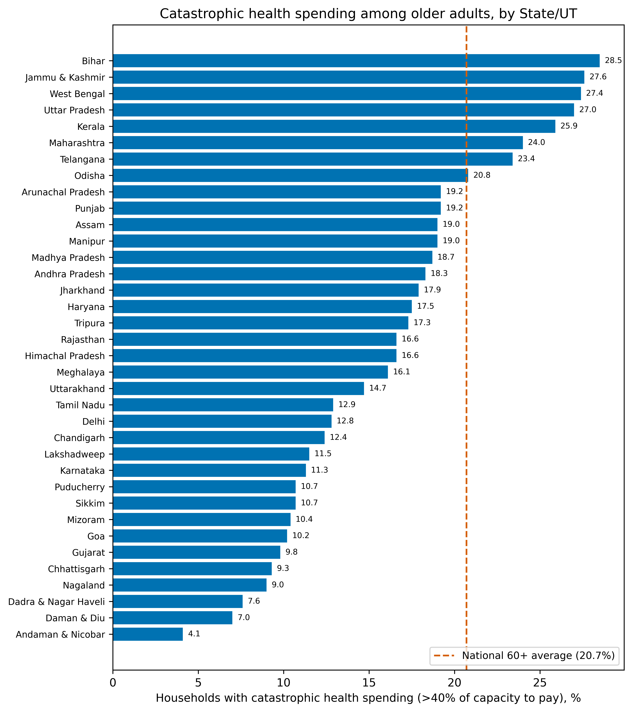
Figure 5
Figure 6. Projected number of older adults in catastrophic-spending households and the annual cost of universal outpatient and medicine cover, 2022–2050, holding the 2017–18 rate constant.
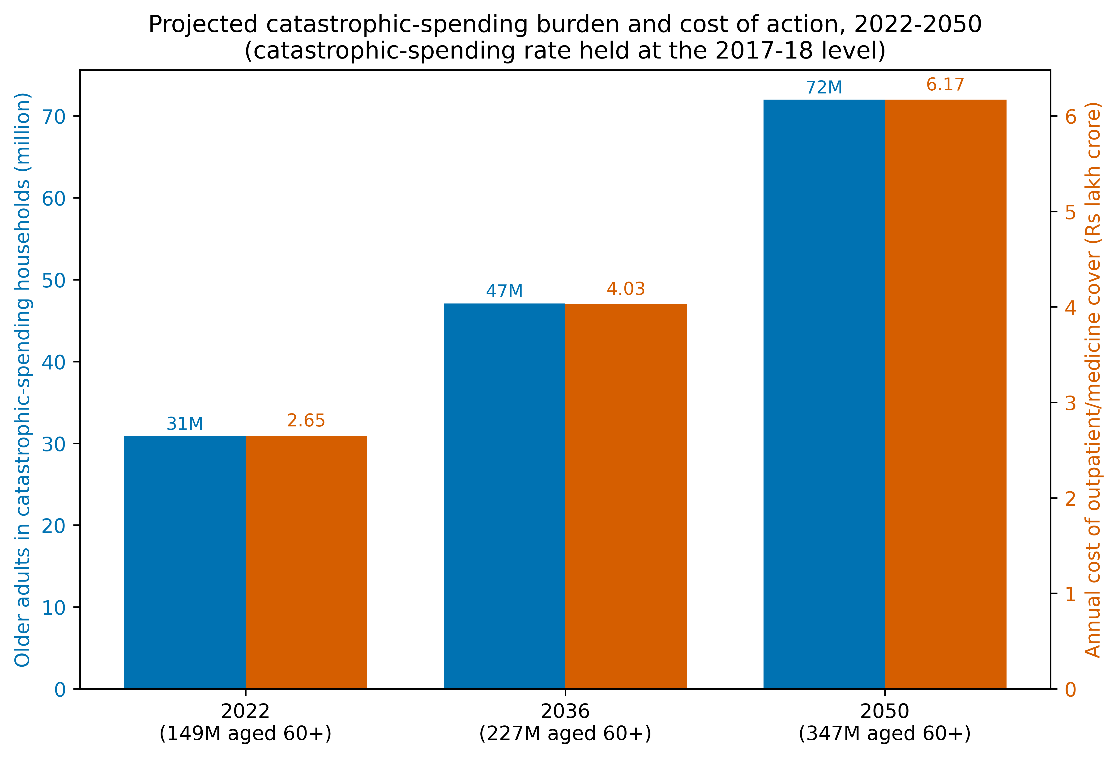
Figure 6

Supplementary Figure S1. Concentration curve for catastrophic spending against cumulative population ranked by per-capita consumption.
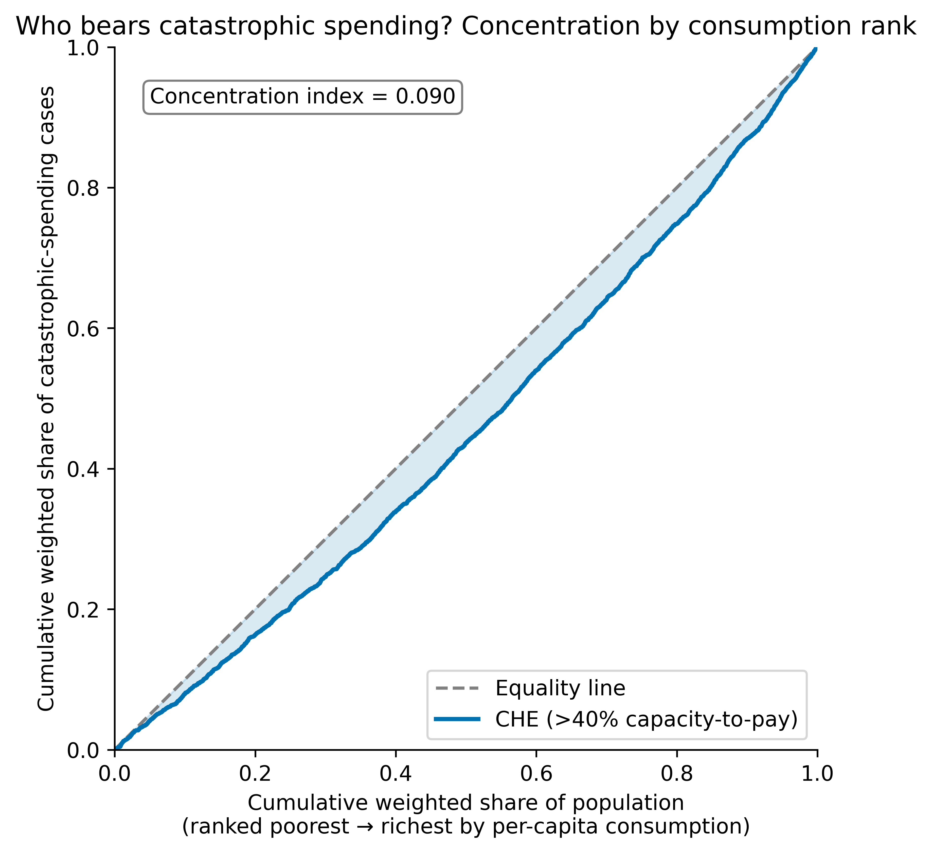
Supplementary Figure S1
Supplementary Figure S2. The economic value of unpaid family caregiving for older adults.
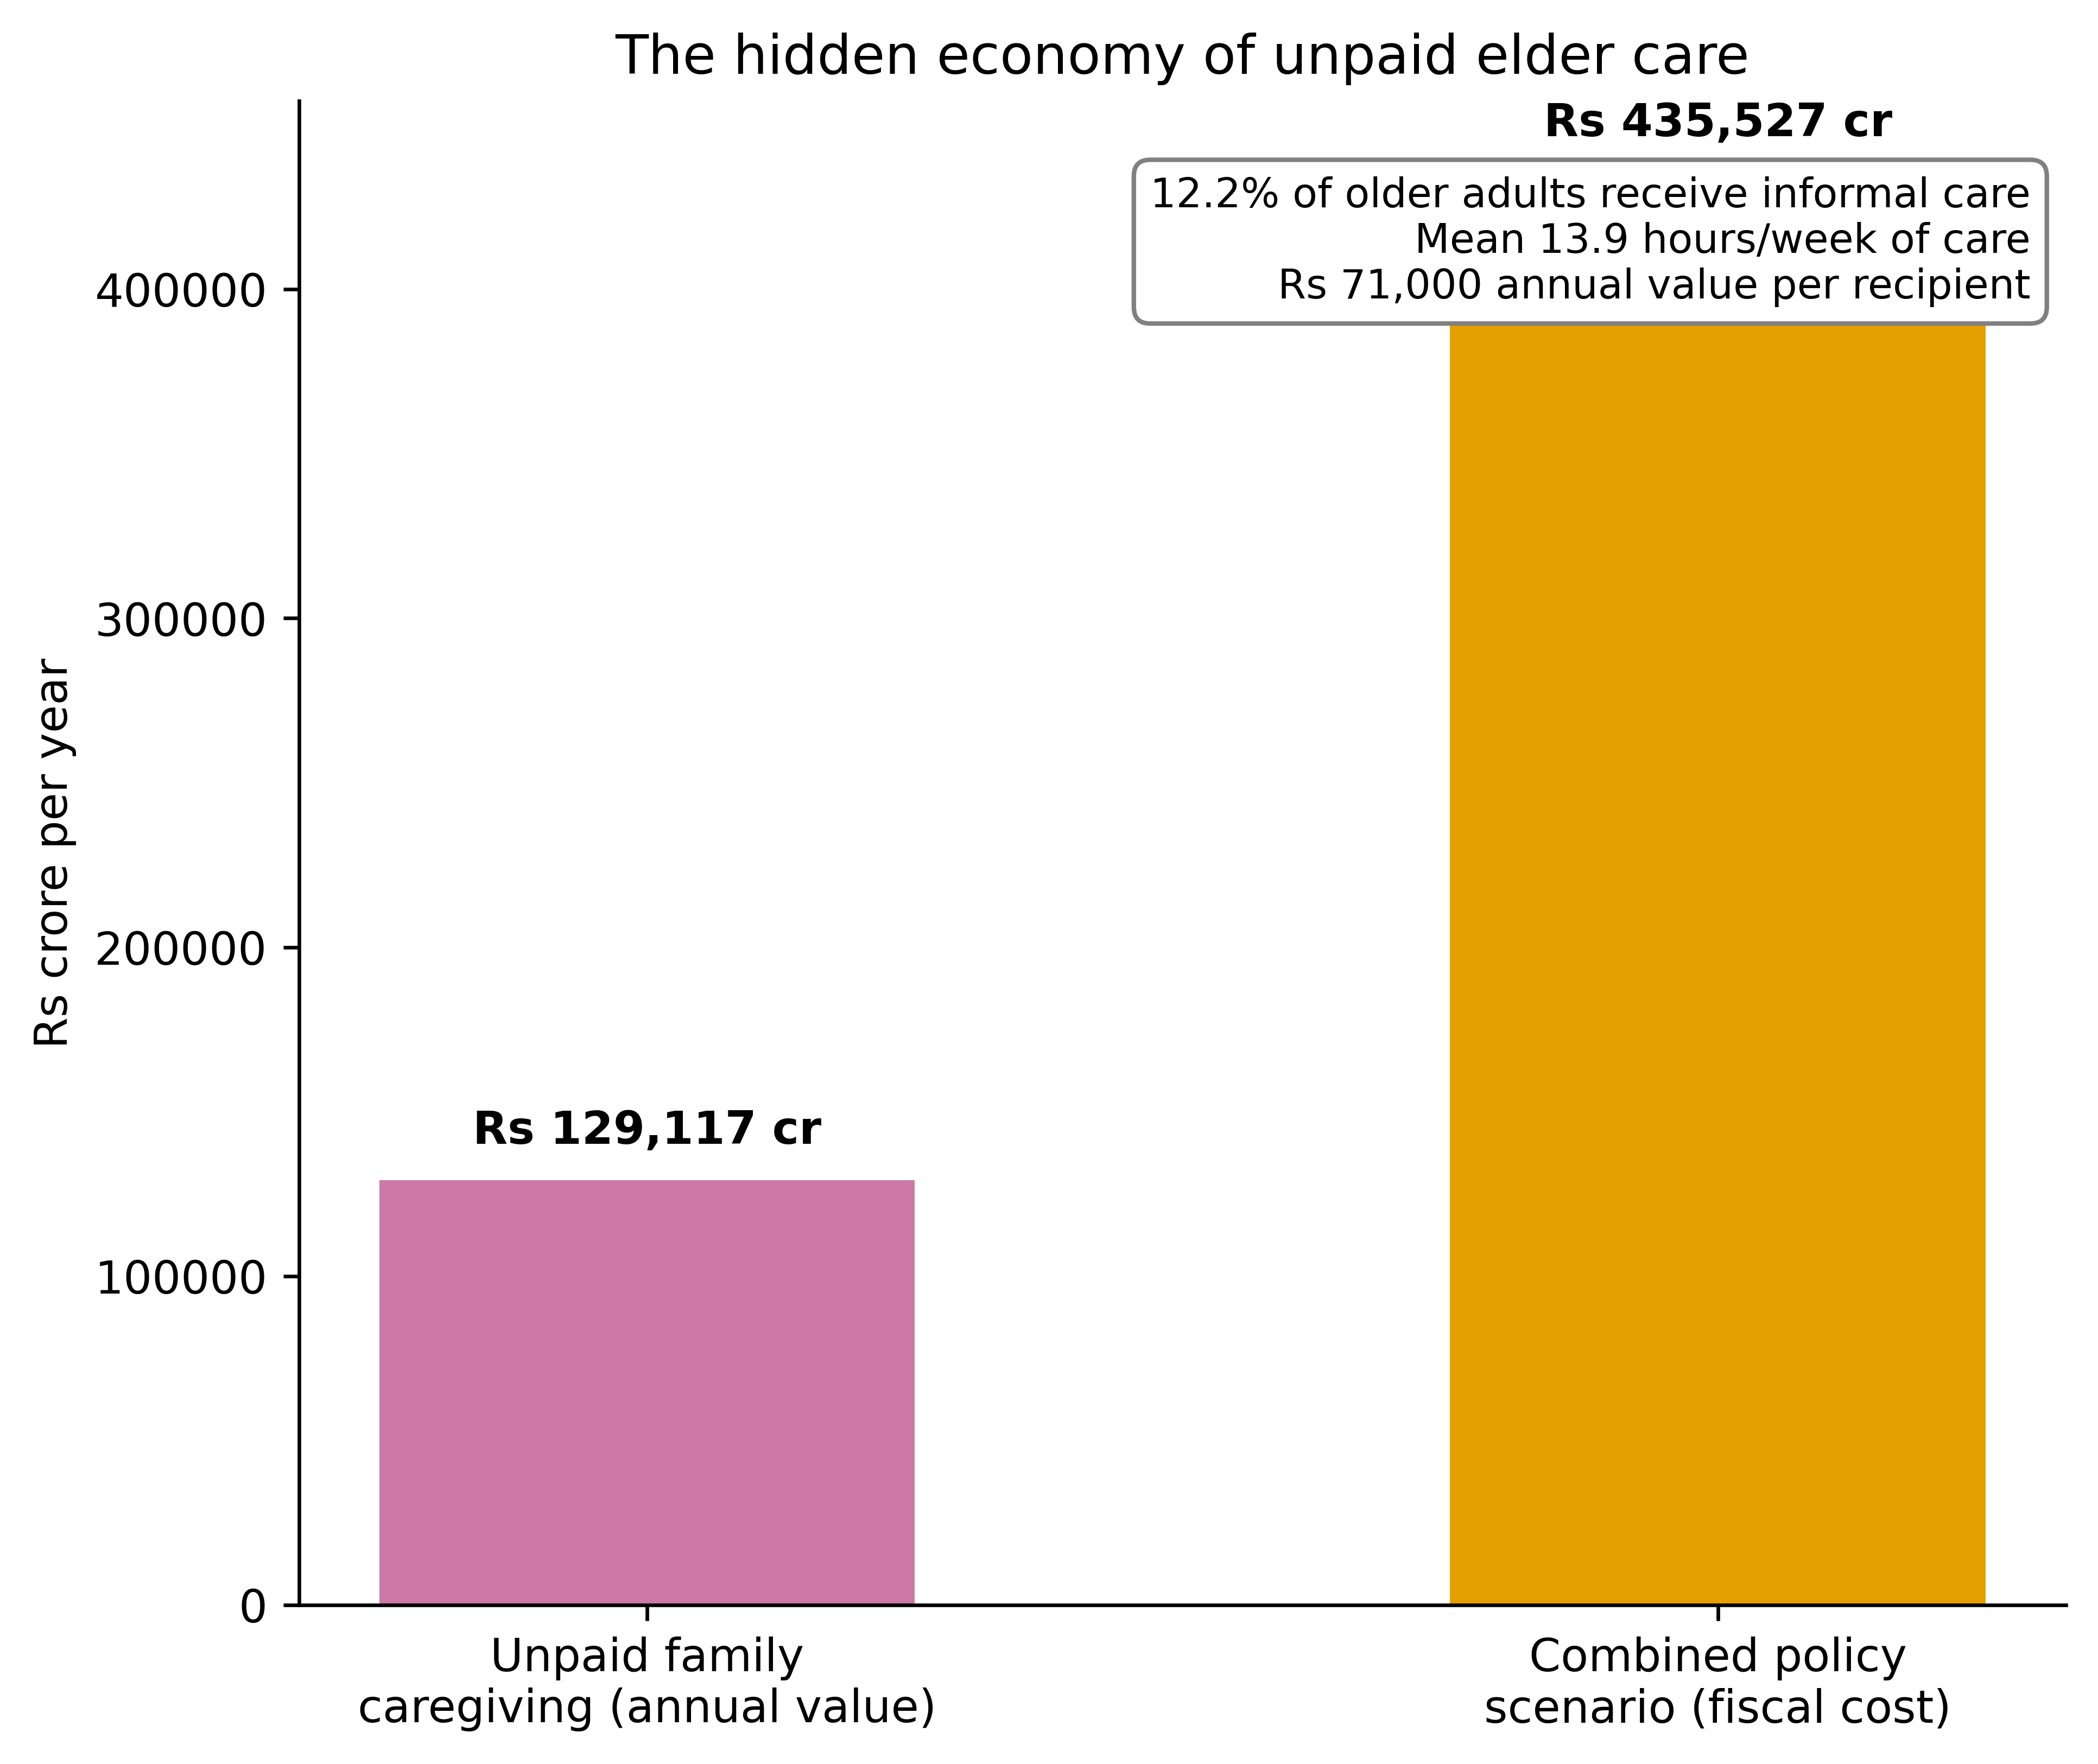
Supplementary Figure S2

