Figure
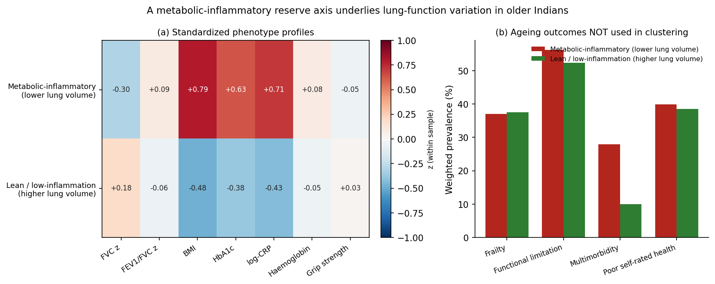
Figure 1. (a) Standardized feature profiles of the two data-driven phenotypes; the metabolic-inflammatory phenotype combines higher BMI, HbA1c, and CRP with lower FVC z-scores. (b) Ageing outcomes not used in clustering: the metabolic-inflammatory phenotype has nearly threefold higher multimorbidity and more functional limitation.

