Figures
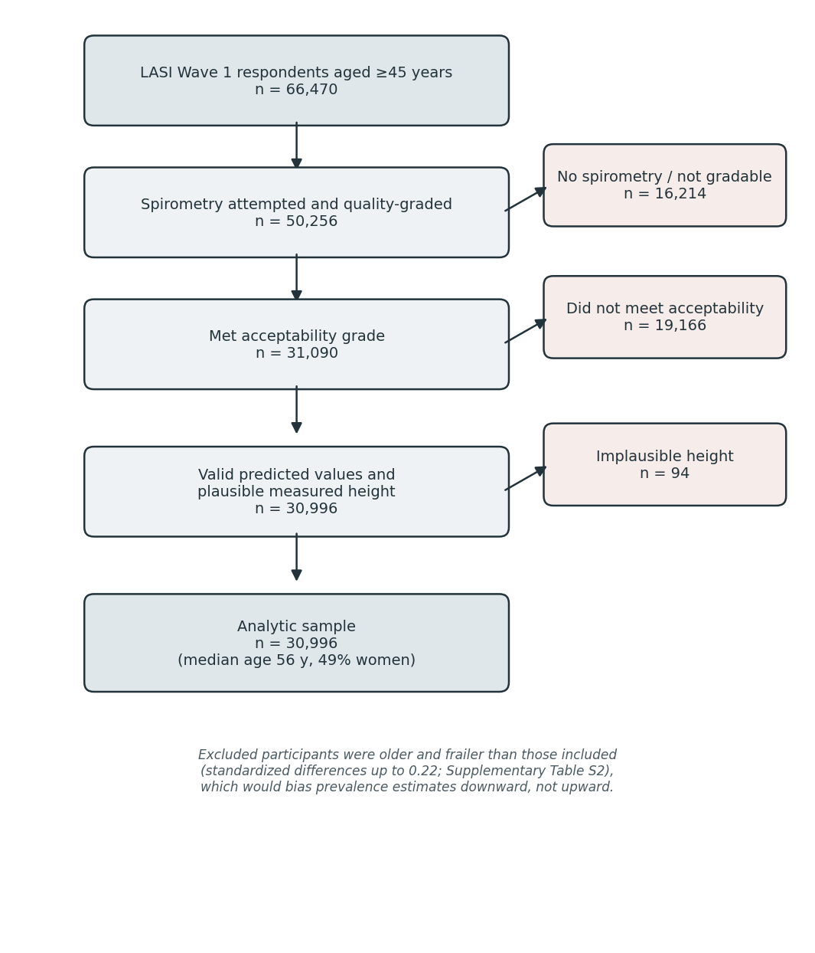
Figure 1. STROBE participant-flow diagram from LASI respondents aged 45 years and older to the analytic sample, with exclusions and quality steps. LASI, Longitudinal Ageing Study in India.

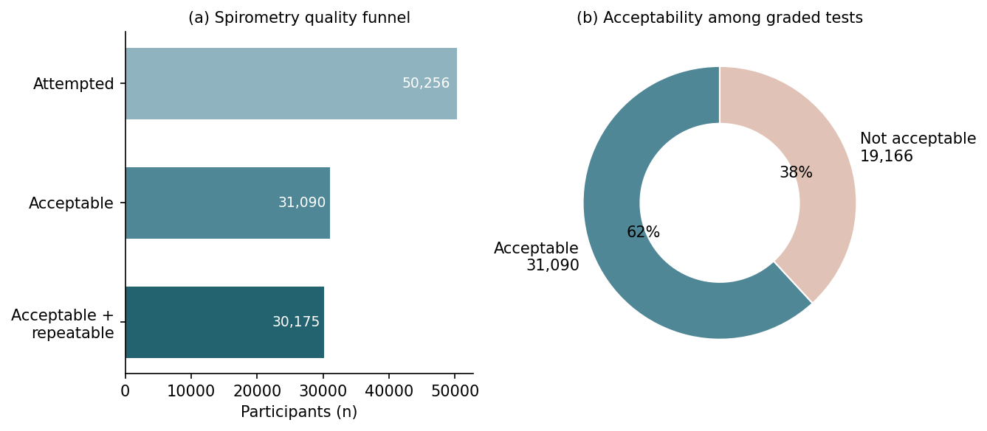
Figure 2. Spirometry quality profile: (a) the grading funnel from attempted to acceptable to acceptable-and-repeatable tests; (b) acceptability among graded tests.

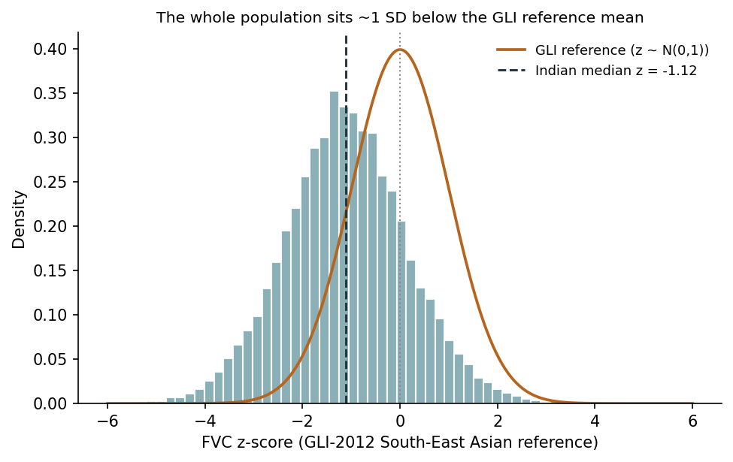
Figure 3. Distribution of forced vital capacity (FVC) z-scores against the GLI-2012 South-East Asian reference. The Indian median lies about one standard deviation below the reference mean (z = 0). GLI, Global Lung Function Initiative.

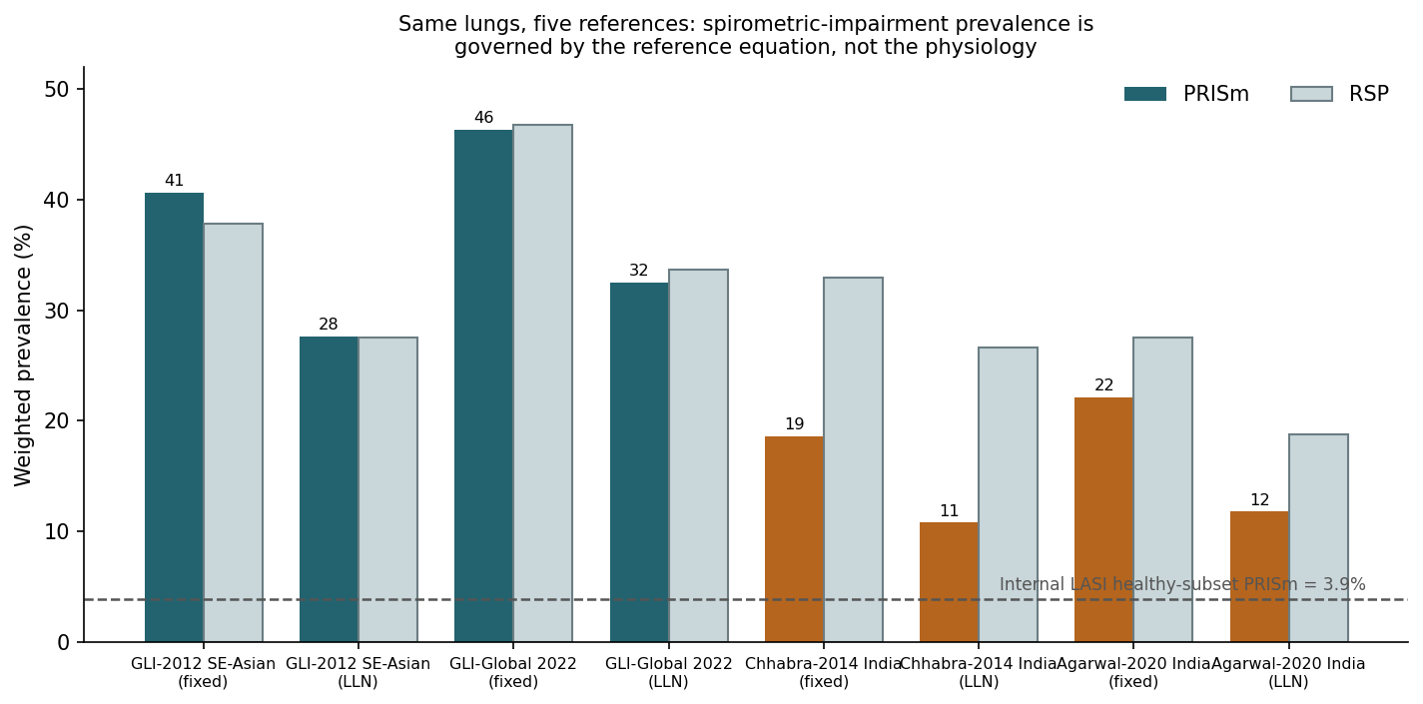
Figure 4. Weighted prevalence of preserved ratio impaired spirometry (PRISm) and the restrictive spirometric pattern (RSP) under five reference equations and two thresholds (fixed and lower limit of normal). The same lungs yield PRISm prevalence from 46% to 4% depending on the reference; the dashed line marks the internal LASI healthy-subset estimate.

