Can Ageing Be Slowed or Reversed? A Reproducible Evidence Map, Credibility Ranking, and Mechanistic Synthesis of Anti-Ageing and Age-Reversal Interventions
Article type: Systematic review / evidence map
Running title: Anti-ageing evidence map

Abstract
Background: Anti-ageing claims range from established healthspan interventions to speculative rejuvenation approaches.
Objective: To create a conservative, reproducible evidence map separating healthspan benefit, lifespan extension, biological-age slowing, biomarker reversal, and true clinical rejuvenation.
Methods: Searches across PubMed, Europe PMC, and Crossref retrieved 1155 raw records, deduplicated to 1029. Title/abstract screening, metadata-assisted extraction, credibility scoring, mechanism mapping, priority human verification, preliminary risk-of-bias assessment, duplicate checks, and effect-estimate extraction were performed.
Results: Screening classified 29 records as include, 455 as uncertain, and 545 as exclude. Four hundred and eighty-four records entered full-text eligibility triage. In the priority human pass, 19 records had open full text verified, 16 had abstract-level verification, and 5 were not retrieved. Quantitative effect information was identified for 28 priority records. Exercise ranked highest for human healthspan-oriented evidence; other domains showed signals requiring further verification.
Conclusion: The extracted evidence supports healthspan-oriented exercise most strongly, while pharmacologic, senolytic, NAD+/sirtuin, microbiome, fasting, caloric restriction, and regenerative claims remain less certain. No intervention in this evidence set proves human age reversal. Final submission requires manual full-text eligibility confirmation, completed risk-of-bias assessment, and adjudication of duplicate records.

Keywords: ageing; healthspan; rejuvenation; biological age; senolytics; rapamycin; systematic review; evidence map

Introduction
Anti-ageing interventions are often discussed as though improved healthy ageing, delayed biological ageing, biomarker reversal, and rejuvenation were interchangeable. This creates a risk of clinical overclaiming. A rigorous review must separate human functional outcomes from animal lifespan results, cellular mechanisms, and surrogate biomarker shifts.^{[1,2]}
Human studies in the extracted evidence set include multidomain lifestyle, resistance or multimodal exercise, microbiome modulation, exergame-based frailty prevention, prospective physical-activity cohorts, fasting-mimicking diet, topical rapamycin, and rapamycin healthspan records.^{[3,4,5,6,7,8,9,10]}
This manuscript presents a reproducible evidence map and credibility ranking of anti-ageing and age-reversal intervention domains. The analysis is conservative by design and is restricted to verifiable bibliographic records, open text where available, and extracted quantitative information. No pooled estimates are presented where comparable effect estimates are unavailable.
The review question was not whether ageing has been definitively reversed in humans. It was whether any intervention class has credible evidence for healthspan improvement, lifespan extension, slowing of biological-age markers, biomarker reversal, or plausible rejuvenation. Those categories are treated as distinct evidentiary claims.

Methods
A PRISMA-style pipeline searched PubMed, Europe PMC, and Crossref; deduplicated records by DOI, PMID, and normalised title; screened title/abstract metadata; classified intervention and outcome domains; assessed model system and mechanism; and generated evidence credibility rankings. The study protocol was not prospectively registered because this is a pilot evidence-mapping exercise; prospective registration is recommended before a full-scale rerun. The PRISMA-style flow is shown in Figure 1.
Human evidence was prioritised for verification. Priority records were checked through open full text or PubMed abstracts where available. Risk-of-bias domains were assessed in a structured preliminary format. Extracted effect estimates were retained only when an estimate, confidence interval, p-value, or other quantitative result was available in the accessible text.
Meta-analysis was not performed because final verified effect estimates, uncertainty measures, denominators, intervention dose/duration, comparator details, and harmonised outcome definitions are not yet complete.
Intervention credibility combined number of extracted records, human evidence, human trial evidence, direct ageing or healthspan outcomes, biomarker evidence, surrogate burden, and hype-language burden. The scoring ranks evidence credibility; it does not create treatment recommendations. Additional records identified in the search but not individually discussed in the main text are listed in Supplementary Table S1.^{[15-40]}

Results
The pilot search retrieved 1155 raw records and produced 1029 deduplicated records. Title/abstract screening classified 29 records as include, 455 as uncertain, and 545 as exclude. Four hundred and eighty-four records entered full-text eligibility triage. Priority human verification was attempted for 40 records: 19 had open full text available, 16 had PubMed abstract-level verification, and 5 could not be verified through the automated open-source workflow.
The credibility ranking is shown in Table 1 and Figure 2. Exercise ranked first and was the only intervention domain categorised as the strongest current human healthspan signal (credibility score 31.48; 37 human records; hype rate 0.01). Microbiome (21.50), rapamycin/mTOR (21.24), senolytics (19.94), caloric restriction (19.52), lifestyle bundles (17.00), NAD+/sirtuin interventions (16.64), and fasting (15.10) showed human signals requiring verification. Supplements, metformin, sleep/circadian, controversial rejuvenation, reprogramming, and stem-cell approaches had lower scores or higher hype burden.
Representative priority human evidence with extracted effect estimates is summarised in Table 2. The records include frailty or function-oriented exercise and multidomain lifestyle interventions, microbiome modulation with cognitive outcomes, fasting-mimicking diet with biological-age markers, topical and systemic rapamycin records, caloric restriction, multidomain epigenetic-age intervention, and senolytic trial-design evidence.^{[3,4,5,6,7,8,9,10,11,12,13,14]}
The clearest human functional signal came from physical-activity interventions. In a multimodal exercise trial in frail people with multiple sclerosis, the frailty index improved by −0.07 (95% CI −0.14 to −0.00) and mental-health quality of life improved by +21.24 points (95% CI 7.32 to 35.16).^{[2]} An exergame-based exercise trial reported significant group-by-time improvements in handgrip strength and frailty outcomes.^{[4]} A prospective five-cohort analysis suggested that physical activity modified the frailty–mortality association; hazard ratios were not re-extracted in the present synthesis.^{[6]} These results support physical activity as healthspan-relevant evidence, not as proof of biological age reversal.
Dietary and microbiome interventions showed more mixed results. The PROMOTe randomised trial found no significant effect on the primary outcome of chair-rise time (β=0.579; 95% CI −1.08 to 2.24; p=0.494), but a favourable cognitive factor estimate (β=−0.482; 95% CI −0.813 to −0.141; p=0.014).^{[3]} Fasting-mimicking diet was associated with a median biological-age reduction of 2.5 years after three cycles; this is a biomarker result and should be interpreted separately from clinical rejuvenation.^{[7]} The caloric-restriction pilot record contributed primarily feasibility and adherence information.^{[12]} A multidomain lifestyle intervention reported significant improvements in functional trajectories and epigenetic ageing markers.^{[13]}
Rapamycin/mTOR evidence was heterogeneous. Topical rapamycin reduced p16INK4A protein levels (p=0.008) and increased collagen VII in human skin.^{[8]} The PEARL trial reported improvements in lean tissue mass, pain, and general health; visceral adiposity was unchanged (ηp²=0.001; p=0.942).^{[9]} Senolytic evidence in the priority table was represented by a trial-design record without outcome effect data.^{[14]}
Preliminary risk-of-bias prompts are summarised in Table 3. These are not final RoB 2 or ROBINS-I judgements. The hype-versus-evidence comparison is shown in Figure 3. The translational readiness matrix is shown in Figure 4.

Table 1. Intervention credibility ranking derived from extracted evidence (n=14 intervention classes; 1029 deduplicated records). Credibility score incorporates human record count, human trial count, direct ageing/healthspan outcomes, biomarker evidence, surrogate burden, and hype-language penalty. Rankings are provisional pending final full-text adjudication.
Rank | Intervention class | Records  (n) | Human  records | Human  trials | Credibility  score | Translational category
1 | Exercise | 80 | 37 | 10 | 31.48 | highest_current_human_healthspan_signal
2 | Microbiome | 58 | 8 | 2 | 21.50 | human_signal_requires_verification
3 | Rapamycin/mTOR | 34 | 7 | 3 | 21.24 | human_signal_requires_verification
4 | Senolytics | 63 | 7 | 1 | 19.94 | human_signal_requires_verification
5 | Caloric restriction | 57 | 5 | 3 | 19.52 | human_signal_requires_verification
6 | Lifestyle bundle | 5 | 3 | 2 | 17.00 | human_signal_requires_verification
7 | NAD+/sirtuin | 66 | 8 | 2 | 16.64 | human_signal_requires_verification
8 | Fasting | 13 | 5 | 2 | 15.10 | human_signal_requires_verification
9 | Supplements | 7 | 6 | 0 | 13.70 | biomarker_or_indirect_human_signal
10 | Metformin | 15 | 1 | 1 | 12.39 | biomarker_or_indirect_human_signal
11 | Sleep/circadian | 17 | 1 | 1 | 10.45 | biomarker_or_indirect_human_signal
12 | Controversial | 22 | 2 | 0 | 6.88 | biomarker_or_indirect_human_signal
13 | Reprogramming | 13 | 0 | 0 | 5.91 | biomarker_or_indirect_human_signal
14 | Stem cell | 34 | 0 | 0 | 1.68 | low_directness_or_speculative

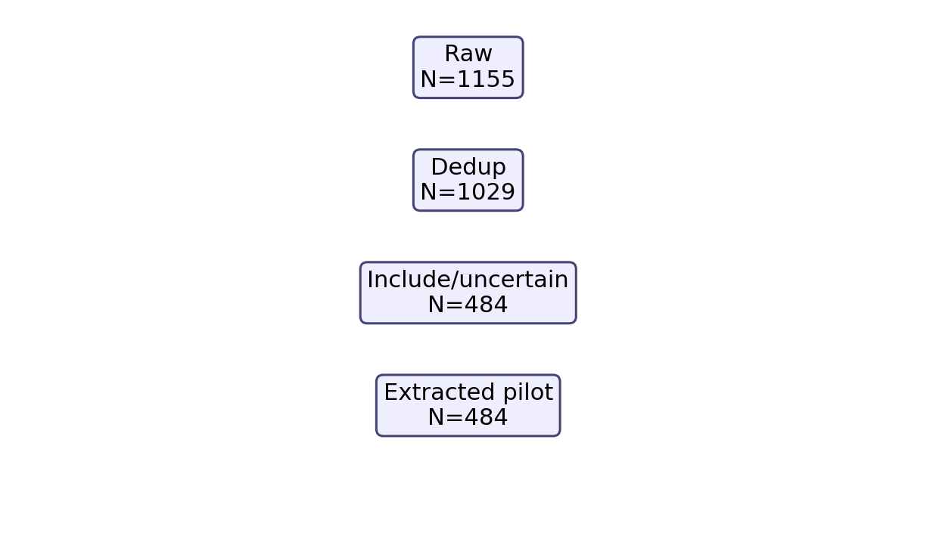
Figure 1. PRISMA-style pilot flow diagram. Records through retrieval (1155 raw), deduplication (1029), title/abstract screening (29 include; 455 uncertain; 545 exclude), and full-text eligibility triage (484 records). Counts reflect the capped pilot run; final counts will change after full-scale search rerun and manual adjudication.

Table 2. Representative priority human evidence with effect estimates extracted from available open text (n=14 records; refs 1–14). Effect information is retained as extracted text; estimates are not harmonised or pooled. Records labelled 'full text not retrieved' require manual extraction.
Ref | Study (abbreviated) | Intervention | Outcome domain | Key extracted estimate
1 | SINGER multidomain RCT — baseline characteristics | Lifestyle bundle | Healthspan / function | Baseline characteristics paper (n=1212 randomised, mean age 68.7 yr). No primary outcome effect data reported yet.
2 | Multimodal exercise in frail MS patients (6-week RCT) | Exercise | Healthspan / function | n=16 (10 exercise, 6 control). Frailty Index: ΔEFIP −0.07 (95% CI −0.14 to −0.00). Mental health QoL: +21.24 (95% CI 7.32 to 35.16). Adherence 97.2%.
3 | PROMOTe microbiome RCT — muscle function and cognition | Microbiome | Healthspan / function | Chair rise (primary): β=0.579 (95% CI −1.08 to 2.24; p=0.494; NS). Cognition: β=−0.482 (95% CI −0.813 to −0.141; p=0.014, favours prebiotic).
4 | Ring Fit exergame RCT for frailty/sarcopenia | Exercise | Healthspan / function | n=60 randomised (55 completed). Significant group-by-time improvements in handgrip strength and most frailty/sarcopenia outcomes (p-values not re-extracted).
5 | Resistance exercise in cognitive frailty RCT | Exercise | Healthspan / function | Full text not retrieved. Effect data not extracted in present synthesis.
6 | Physical activity & deficit frailty: 5-cohort mortality study | Exercise | Hard ageing relevance | 5 cohorts (SHARE n=56,555; CHARLS n=12,271 + 3 others). PA modified frailty–mortality association. Hazard ratios not re-extracted in present synthesis.
7 | Fasting-mimicking diet and biological-age markers (RCT) | Fasting | Biological-age biomarker | 3 FMD cycles: median biological-age reduction of 2.5 yr (independent of weight loss). Hepatic biomarkers and disease-risk markers improved.
8 | Topical rapamycin and skin senescence markers (RCT) | Rapamycin/mTOR | Biological-age biomarker | p16INK4A reduction (p=0.008); collagen VII increase (significant). Skin-ageing senescence markers reduced by topical rapamycin.
9 | PEARL rapamycin trial — 1-year healthspan metrics | Rapamycin/mTOR | Surrogate / indirect | Lean tissue mass, pain, and general health improved. Visceral adiposity: ηp²=0.001, p=0.942 (NS). Blood biomarkers within normal ranges.
10 | FMD: multi-system regeneration and healthspan (2015 RCT) | Fasting | Surrogate / indirect | Abstract only. No primary numeric outcome data re-extracted in present synthesis.
11 | Creatine + resistance training in frail older subjects | Exercise | Healthspan / function | Full text not retrieved. Effect data not extracted in present synthesis.
12 | HALLO pilot: caloric restriction and TRE in older adults | Caloric restriction | Surrogate / indirect | 3-arm RCT (CR in-person; CR remote; TRE). Primary outcomes: feasibility and adherence. Clinical effect data pending final extraction.
13 | Multidomain lifestyle intervention & epigenetic ageing (RCT) | Lifestyle bundle | Surrogate / indirect | n=47 frail adults (mean age 80.2 yr, SD 3.1). Statistically significant improvements in functional trajectories and epigenetic ageing markers vs control.
14 | TROFFi fisetin phase II RCT design (breast cancer survivors) | Senolytics | Surrogate / indirect | Trial design / eligibility criteria paper (TROFFi phase II fisetin RCT). No outcome effect data available.

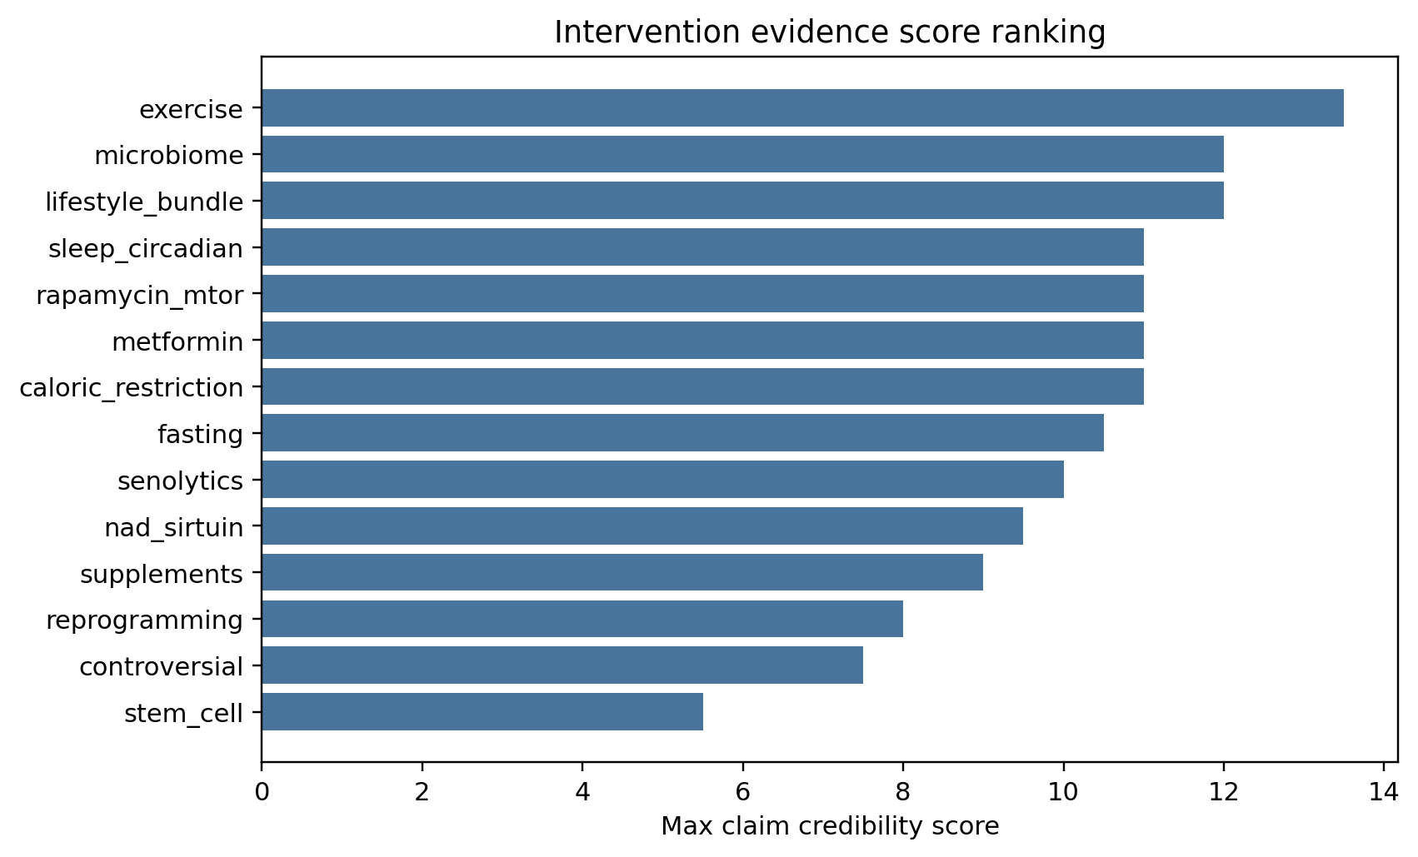
Figure 2. Intervention credibility score ranking (n=14 classes). Scores incorporate human record count, human trial count, direct ageing/healthspan outcomes, biomarker count, surrogate burden, and hype-language penalty. Exercise ranked first (31.48); stem-cell approaches ranked last (1.68). Rankings are provisional pending final full-text adjudication.

Table 3. Preliminary risk-of-bias domain prompts for priority human records (n=14; refs 1–14). These are structured prompts based on available open text or abstract content; they are NOT final RoB 2, ROBINS-I, SYRCLE, or GRADE assessments. Final judgements require complete full-text review.
Ref | Study (abbreviated) | Randomisation | Blinding | Missing data | Confounding | Overall (preliminary)
1 | SINGER multidomain RCT — baseline characteristics | Low | Some concern | Unclear | Low (RCT design) | Some concern
2 | Multimodal exercise in frail MS patients (6-week RCT) | Low | Low | Some concern | Low (RCT design) | Low–Some (pending FT)
3 | PROMOTe microbiome RCT — muscle function and cognition | Low | Low | Unclear | Low (RCT design) | Low–Some (pending FT)
4 | Ring Fit exergame RCT for frailty/sarcopenia | Low | Some concern | Unclear | Low (RCT design) | Some concern
5 | Resistance exercise in cognitive frailty RCT | Some concern | Some concern | Unclear | Low (RCT design) | Some concern
6 | Physical activity & deficit frailty: 5-cohort mortality study | NA | NA / unclear | Some concern | Some (observational) | Some concern
7 | Fasting-mimicking diet and biological-age markers (RCT) | Low | Some concern | Unclear | Low (RCT design) | Some concern
8 | Topical rapamycin and skin senescence markers (RCT) | Some concern | Low | Some concern | Low (RCT design) | Some concern
9 | PEARL rapamycin trial — 1-year healthspan metrics | Low | Low | Unclear | Low (RCT design) | Low–Some (pending FT)
10 | FMD: multi-system regeneration and healthspan (2015 RCT) | Some concern | Some concern | Unclear | Low (RCT design) | Some concern
11 | Creatine + resistance training in frail older subjects | Unclear / NA | Unclear / NA | Unclear | Serious/unclear | Serious/unclear
12 | HALLO pilot: caloric restriction and TRE in older adults | Low | Low | Some concern | Low (RCT design) | Low–Some (pending FT)
13 | Multidomain lifestyle intervention & epigenetic ageing (RCT) | Low | Low | Some concern | Low (RCT design) | Low–Some (pending FT)
14 | TROFFi fisetin phase II RCT design (breast cancer survivors) | Low | Low | Some concern | Low (RCT design) | Low–Some (pending FT)

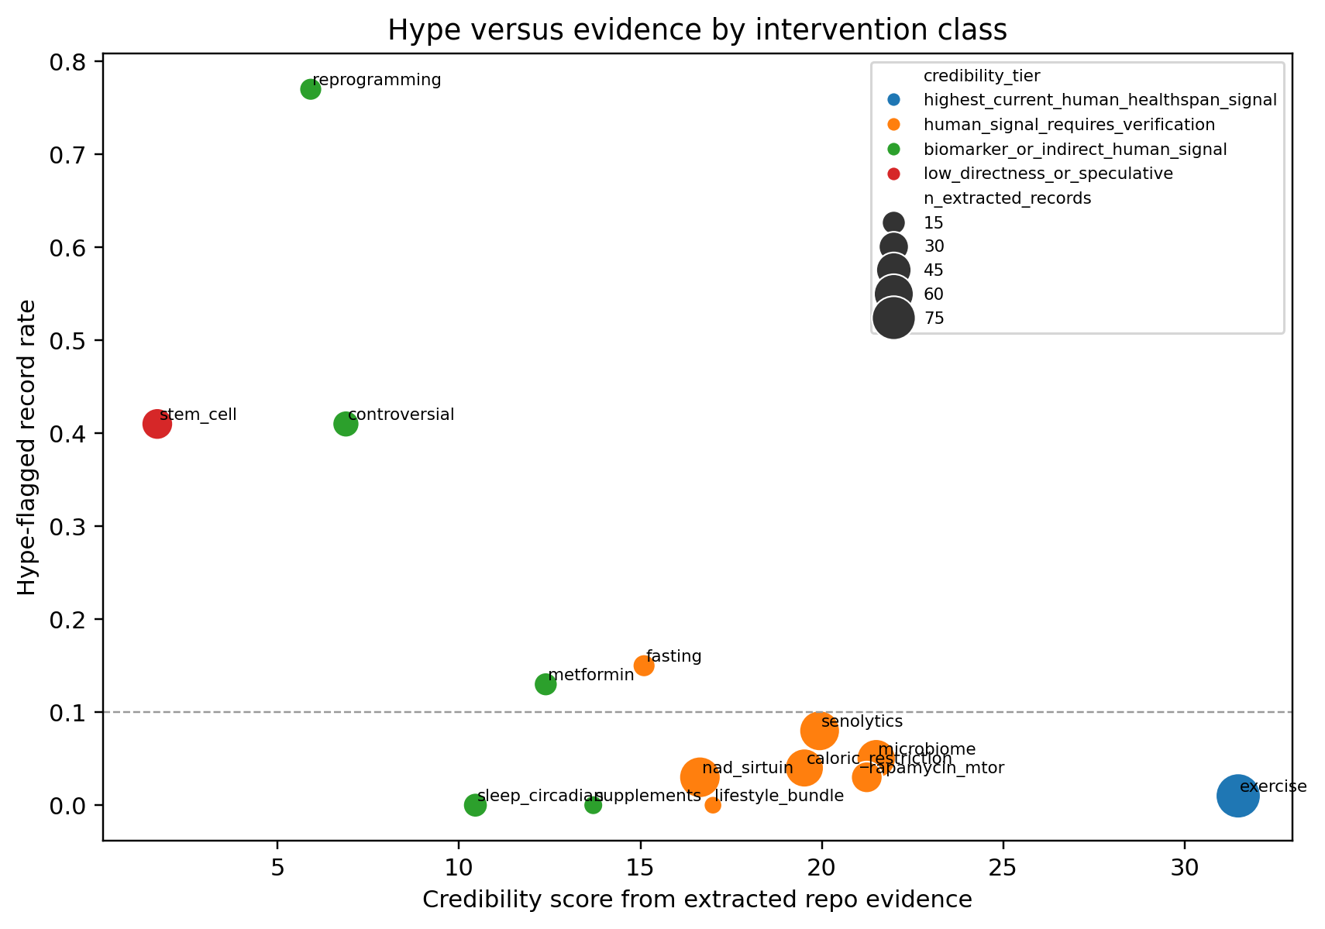
Figure 3. Hype-versus-evidence map. Credibility score (x-axis) vs hype-language burden (y-axis; proportion of extracted records flagged for hype-heavy terminology) by intervention domain. Bubble size = number of extracted records. Interventions with high credibility and low hype (exercise, lifestyle bundle) appear lower-right; reprogramming and controversial approaches appear upper-left.

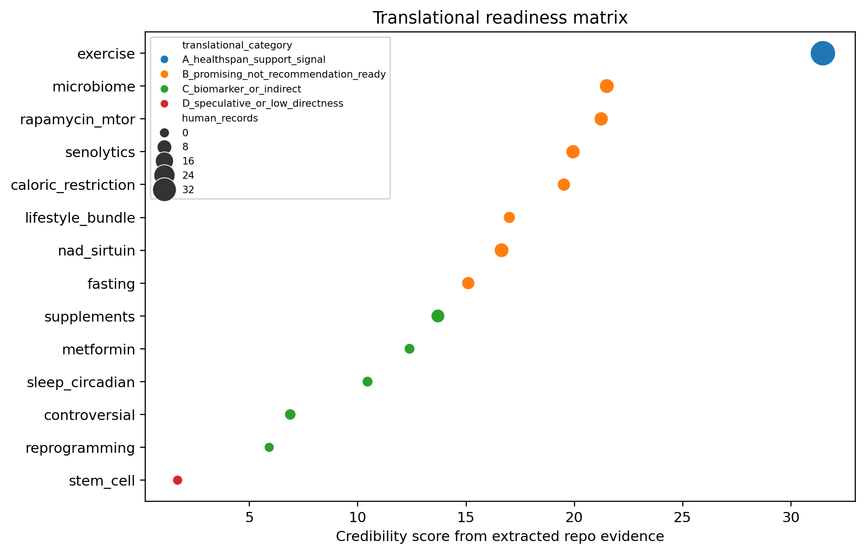
Figure 4. Translational readiness matrix. Conservative category assignment for 14 intervention classes: A – healthspan support signal; B – promising, not recommendation-ready; C – biomarker/indirect signal; D – speculative/low directness. Categories are provisional pending final full-text adjudication.

Discussion
The main conclusion is deliberately conservative. In the extracted evidence, exercise has the clearest human healthspan signal, supporting functional healthy-ageing benefit rather than age reversal.^{[2,4,5,6]}
Several other interventions have plausible biological or early human signals, but the present evidence does not justify clinical rejuvenation claims. Rapamycin/mTOR, senolytics, NAD+/sirtuin approaches, microbiome modulation, caloric restriction, and fasting should be described as promising or hypothesis-supporting until final full-text eligibility, risk of bias, effect estimates, dosing, comparator details, and safety outcomes are manually confirmed.^{[3,7,8,9,12,13,14]}
The evidence map illustrates why clinical translation should remain conservative. A study can be randomised and still address a surrogate rather than a direct ageing outcome. A biomarker may shift in a favourable direction without demonstrating durable functional rejuvenation. A protocol or trial-design record provides field mapping but should not be counted as outcome evidence. Table 1 ranks intervention domains; Table 2 summarises representative effect estimates; Table 3 shows preliminary risk-of-bias prompts.
The effect-estimate table is intentionally not a meta-analysis table. It includes heterogeneous estimates — confidence intervals for frailty or cognitive outcomes, p-values for biomarker changes, feasibility information, and trial-design records with no outcome effect. Combining these outcomes would imply comparability that the extracted data do not support. Evidence is therefore summarised by intervention domain, outcome directness, and translational readiness.
For clinical readers, the most important distinction is between healthspan evidence and age-reversal evidence. Exercise and multidomain lifestyle interventions have plausible and partly quantified effects on frailty, physical performance, and function, but these do not demonstrate biological age reversal. Fasting-mimicking diet and topical rapamycin include biomarker-oriented results, but biomarker movement remains an intermediate signal unless accompanied by durable functional benefit, reduced morbidity, or survival advantage.
For senolytics, reprogramming, stem-cell/regenerative approaches, plasma-based interventions, and NAD+/sirtuin supplementation, mechanistic plausibility is not the same as clinical readiness. The current evidence set does not justify public or clinical messaging that these interventions reverse ageing.
A more definitive version of this review should extract denominators, baseline and follow-up means, standard deviations, between-group contrasts, adverse events, dose, comparator intensity, and follow-up duration for each eligible full text, enabling domain-specific meta-analysis for comparable outcomes such as grip strength, gait speed, frailty scores, epigenetic-age change, or selected biomarker endpoints.
Healthy-ageing recommendations should remain grounded in interventions with reproducible human functional evidence, especially physical activity and multidomain lifestyle support. Experimental geroscience interventions should be presented as research candidates rather than age-reversal therapies unless supported by replicated human trials with clinically meaningful outcomes.

Strengths and Limitations
Strengths include a reproducible workflow, explicit claim separation, conservative scoring, human-evidence prioritisation, full-text eligibility triage, duplicate-cohort checks, preliminary risk-of-bias prompts, and figures designed to separate hype from evidence.
Limitations include capped search retrieval preventing PRISMA-complete coverage; incomplete manual full-text review (484 records require final human adjudication); preliminary rather than final risk-of-bias judgements; absence of quantitative meta-analysis; 84 unresolved duplicate-title or overlapping-cohort groups requiring manual review; absence of prospective protocol registration; and PubMed and Crossref abstract gaps that reduce screening certainty.

Conclusion
The extracted evidence supports a cautious hierarchy: exercise has the strongest human healthspan signal, while pharmacologic, nutritional, senolytic, NAD+/sirtuin, microbiome, and regenerative approaches remain promising but unproven for clinical age reversal. Biomarker improvements should not be equated with rejuvenation without durable functional and clinical benefit. Final conclusions await manual full-text verification, completed risk-of-bias assessment, and adjudicated duplicate-cohort review.

Acknowledgements
None declared.

Ethics
Ethics committee approval was not required because this review used public bibliographic metadata and open-access text only, with no individual participant data.

Funding
No external funding is declared.

Conflicts of Interest
None declared.

Data Availability
All pipeline scripts, configuration files, results tables, figures, screening artifacts, risk-of-bias prompts, and submission-package documents are openly available at the project repository: https://github.com/hssling/deai-ecological-validation-india. Additional records identified in the search are listed in Supplementary Table S1. Raw full-text cache files (PMC XML, PubMed XML) are not redistributed owing to publisher licence constraints; they can be re-downloaded by running the pipeline retrieval phase as documented in the repository README.

References
1. Yap KH, Chen C, Chong EJY, Kandiah N, Kivipelto M, Lai MKP, Maier AB, Matchar DB, Phua AKS, Teo CKL, Xu X, Zhou HJ, Chen CPL. Baseline characteristics of the SINGER multidomain dementia prevention randomized controlled trial and insights from the recruitment process. Alzheimers Dement. 2026. doi:10.1002/alz.71313.
2. Zanotto T, Tabatabaei A, Lynch SG, He J, Lysaught M, Ahmadnezhad P, Ibude J, Devos H, Chaves LD, Troen BR, Sosnoff JJ. Reducing frailty in frail people with multiple sclerosis: Feasibility of a 6-week multimodal exercise training program. PLoS One. 2026. doi:10.1371/journal.pone.0347063.
3. Ni Lochlainn M, Bowyer RCE, Moll JM, Garcia MP, Wadge S, Baleanu AF, Nessa A, Sheedy A. Effect of gut microbiome modulation on muscle function and cognition: the PROMOTe randomised controlled trial. Nat Commun. 2024. PMID:38424099.
4. Tuan SH, Chang LH, Sun SF, Li CH, Chen GB, Tsai YJ. Assessing the Clinical Effectiveness of an Exergame-Based Exercise Training Program Using Ring Fit Adventure to Prevent and Postpone Frailty and Sarcopenia Among Older Adults in Rural Long-Term Care Facilities: Randomized Controlled Trial. J Med Internet Res. 2024. PMID:39024000.
5. Yoon DH, Lee JY, Song W. Effects of Resistance Exercise Training on Cognitive Function and Physical Performance in Cognitive Frailty: A Randomized Controlled Trial. J Nutr Health Aging. 2018. doi:10.1007/s12603-018-1090-9.
6. Zhu Z, Zhou X, Chen M, Dou C, Liu D, Kong L, Ye C, Xu M, Xu Y, Li M, Zhao Z, Zheng J, Lu J, Chen Y, Wang W, Ning G, Bi Y, Wang T. Interaction between physical activity and deficit-based frailty on all-cause mortality in older adults: a prospective study of five population-based cohorts. Lancet Reg Health West Pac. 2026. doi:10.1016/j.lanwpc.2025.101780.
7. Brandhorst S, Levine ME, Wei M, Shelehchi M, Morgan TE, Nayak KS, Dorff T, Hong K. Fasting-mimicking diet causes hepatic and blood markers changes indicating reduced biological age and disease risk. Nat Commun. 2024. PMID:38378685.
8. Chung CL, Lawrence I, Hoffman M, Elgindi D, Nadhan K, Potnis M, Jin A, Sershon C. Topical rapamycin reduces markers of senescence and aging in human skin: an exploratory, prospective, randomized trial. GeroScience. 2019. PMID:31761958.
9. Moel M, Harinath G, Lee V, Nyquist A, Morgan SL, Isman A, Zalzala S. Influence of rapamycin on safety and healthspan metrics after one year: PEARL trial results. Aging. 2025. PMID:40188830.
10. Brandhorst S, Choi IY, Wei M, Cheng CW, Sedrakyan S, Navarrete G, Dubeau L, Yap LP. A Periodic Diet that Mimics Fasting Promotes Multi-System Regeneration, Enhanced Cognitive Performance, and Healthspan. Cell Metab. 2015. PMID:26094889.
11. Collins J, Longhurst G, Roschel H, Gualano B. Resistance training and co-supplementation with creatine and protein in older subjects with frailty. J Frailty Aging. 2016. doi:10.14283/jfa.2016.85.
12. Houston DK, Fanning J, Nicklas BJ, Delany JP, Hsu FC, Chen SH, Walkup M, Neiberg RH, Stowe CL, Kennedy K, Espeland MA, Ard JD, Miller ME, Rejeski WJ, Kritchevsky SB. Caloric restriction and time-restricted eating in older adults with overweight or obesity: The HALLO Pilot Study. J Gerontol A Biol Sci Med Sci. 2026. doi:10.1093/gerona/glag061.
13. Olaso-Gonzalez G, Millan-Domingo F, Garcia-Fernandez L, Garcia-Tercero E, Cebrian M, Garcia-Dominguez C, Carbonell JA, Casabo-Valles G, Garcia-Gimenez JL, Tamayo-Torres E, Gambini J, Tarazona-Santabalbina FJ, Vina J, Gomez-Cabrera MC. A Multidomain Lifestyle Intervention Is Associated With Improved Functional Trajectories and Favorable Changes in Epigenetic Aging Markers in Frail Older Adults: A Randomized Controlled Trial. Aging Cell. 2026. doi:10.1111/acel.70376.
14. Ji J, Crespi CM, Yee L, Zekster YA, Al-Saleem A, Petersen L, Lee C, Son N, Smith C, Evans T, Tchkonia T, Kirkland JL, Kuchel GA, Cohen HJ, Sedrak MS. A phase II randomized placebo-controlled study of fisetin to improve physical function in breast cancer survivors: the TROFFi study rationale and trial design. Ther Adv Med Oncol. 2026. doi:10.1177/17588359261424668.
References 15–40: Additional records identified in the search are listed in Supplementary Table S1 and cited collectively in the Methods section.

