Figures
Figure 1. State-level DEAI ranking across Indian states/UTs using LASI Wave 1 public indicators.
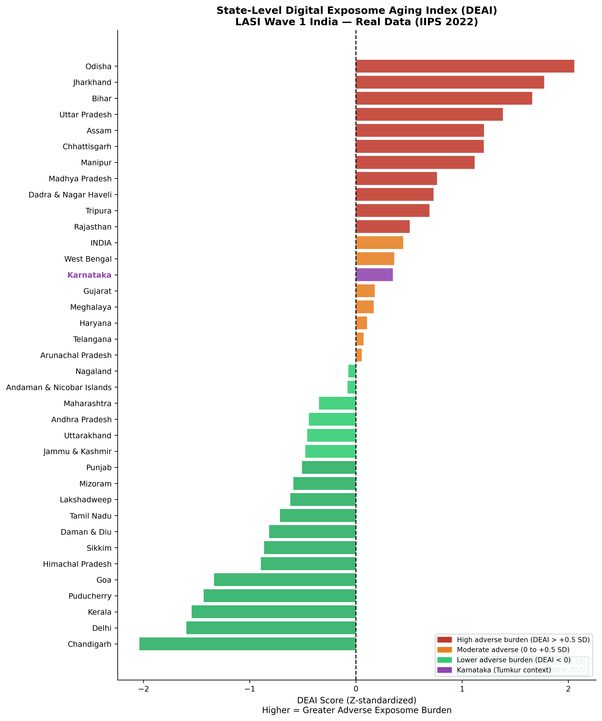

Figure 2. Scatter plots of state-level DEAI against ageing outcomes.
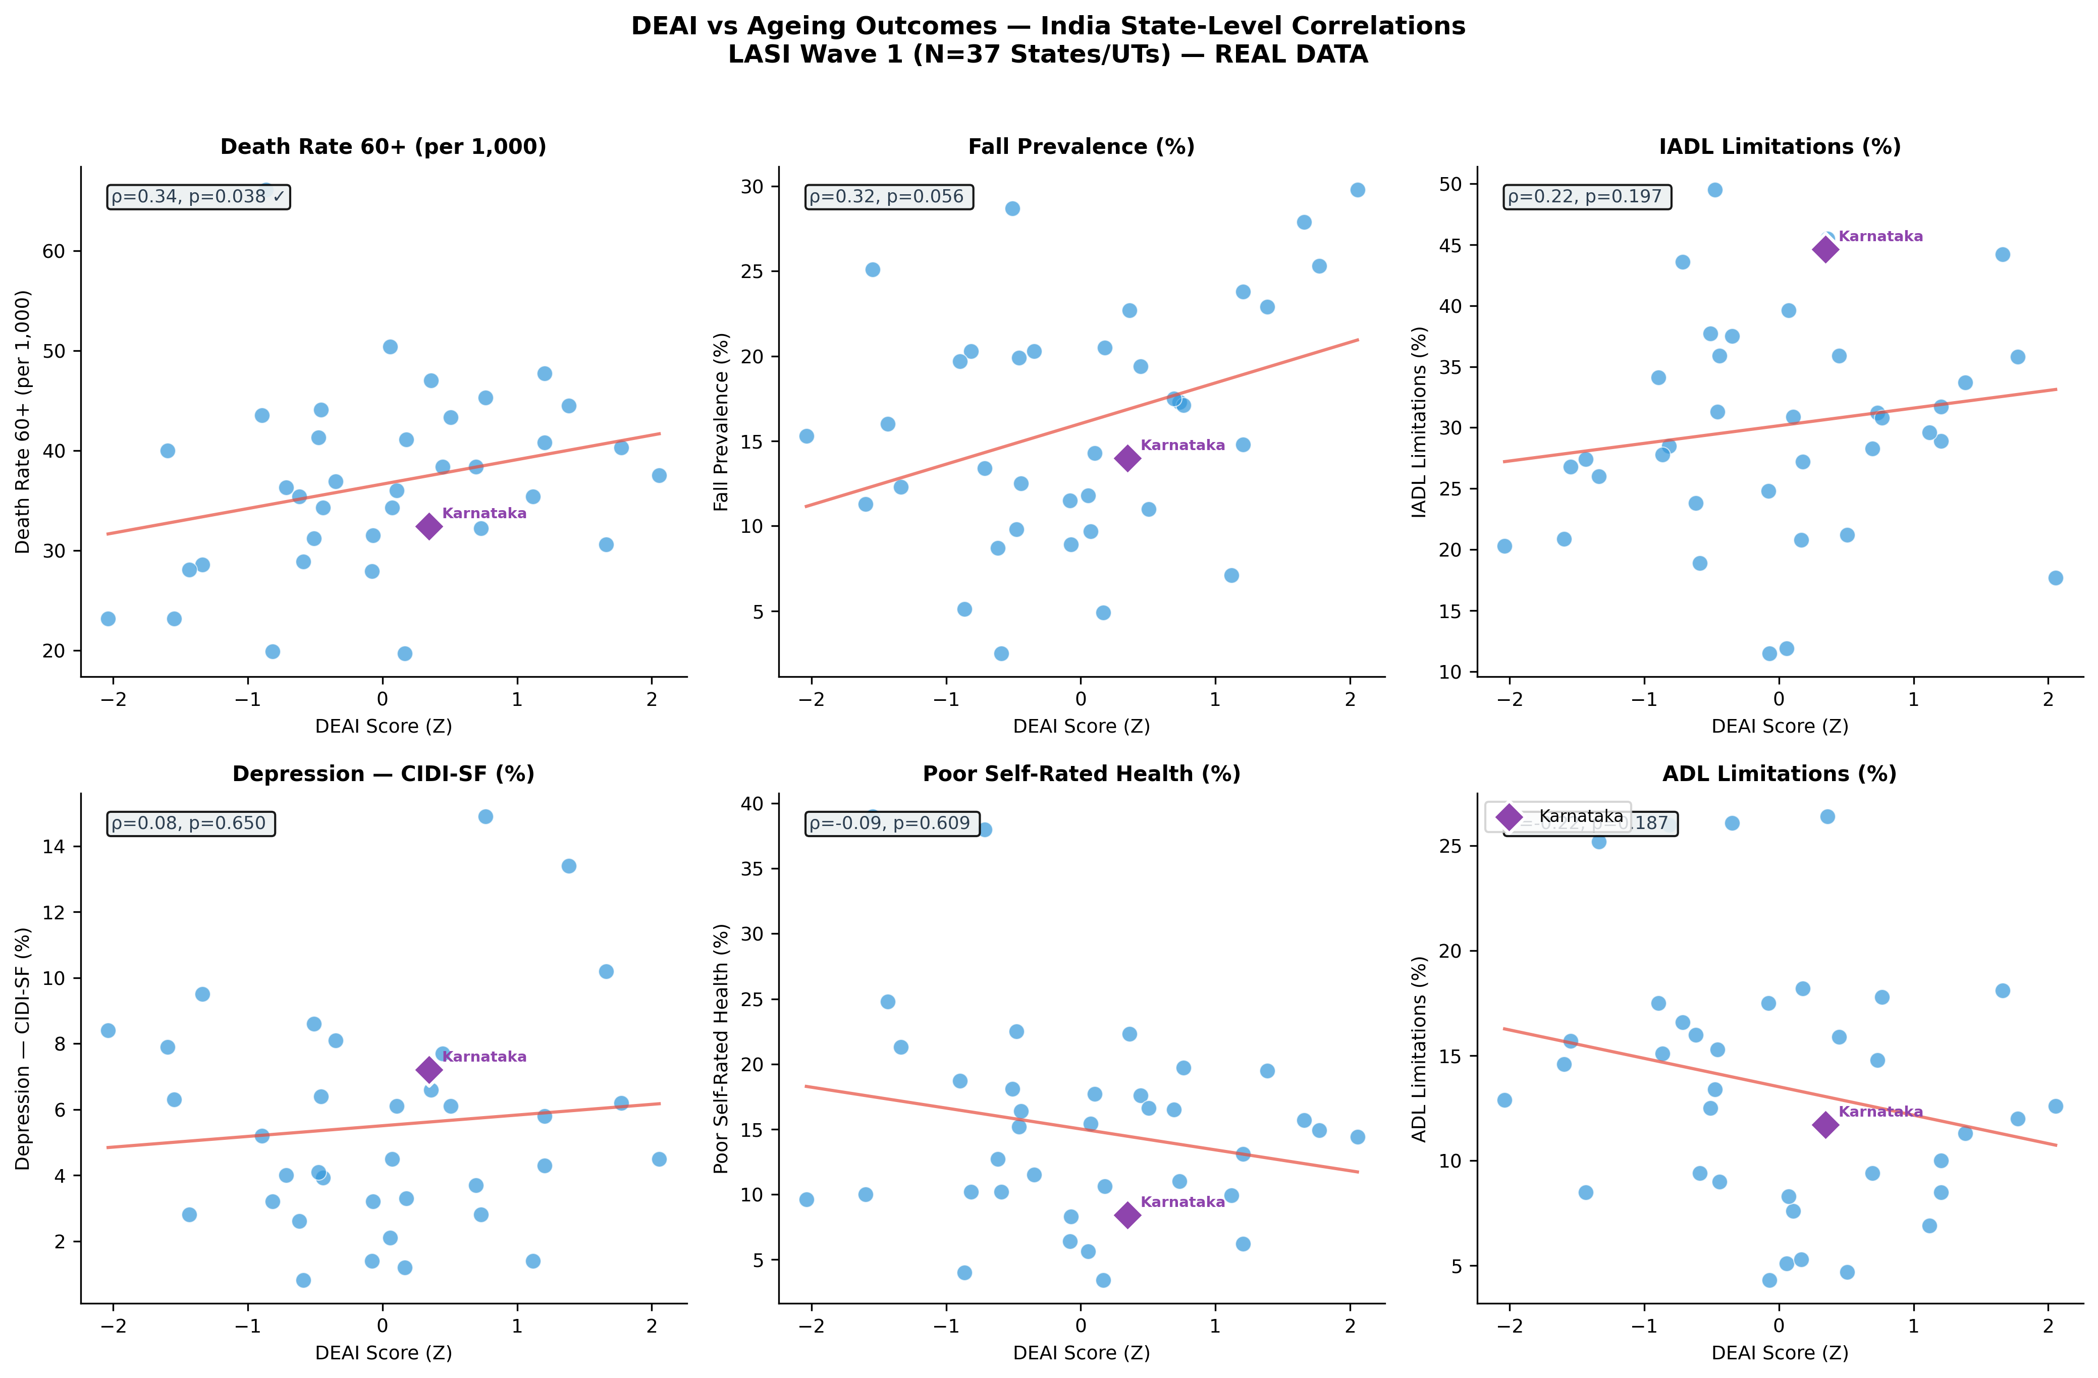

Figure 3. Karnataka exposome profile compared with the India national LASI estimate.
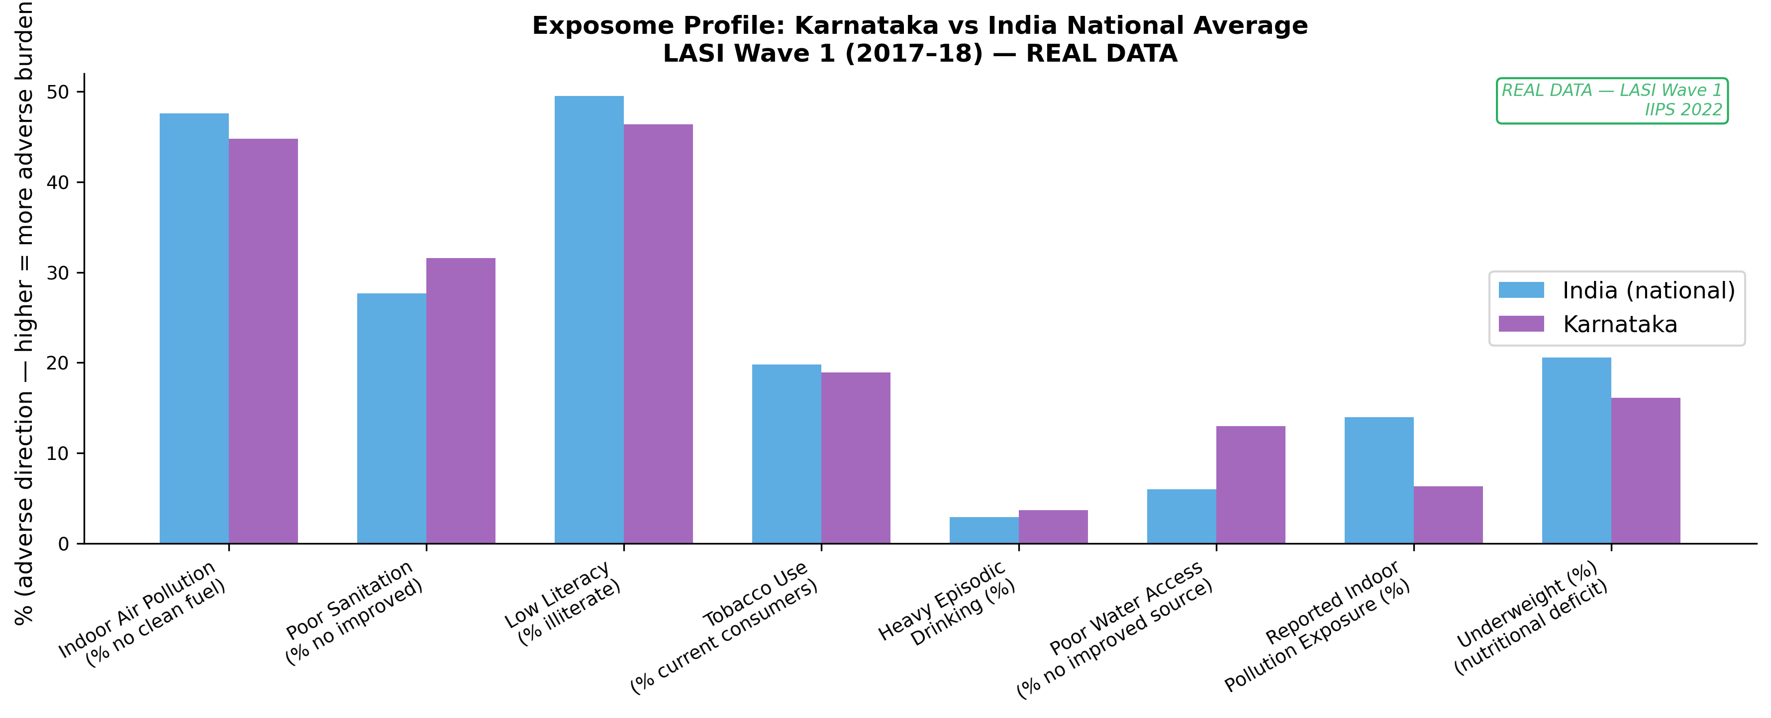

Figure 4. Heatmap of Spearman correlations between DEAI components and ageing outcomes.
