Figures
Figure 1. The diagnosis gap: weighted prevalence of biologically measured versus self-reported diabetes and hypertension among adults aged 45+ (LASI Wave 1). Annotations show the percentage of biologically affected respondents who were undiagnosed.
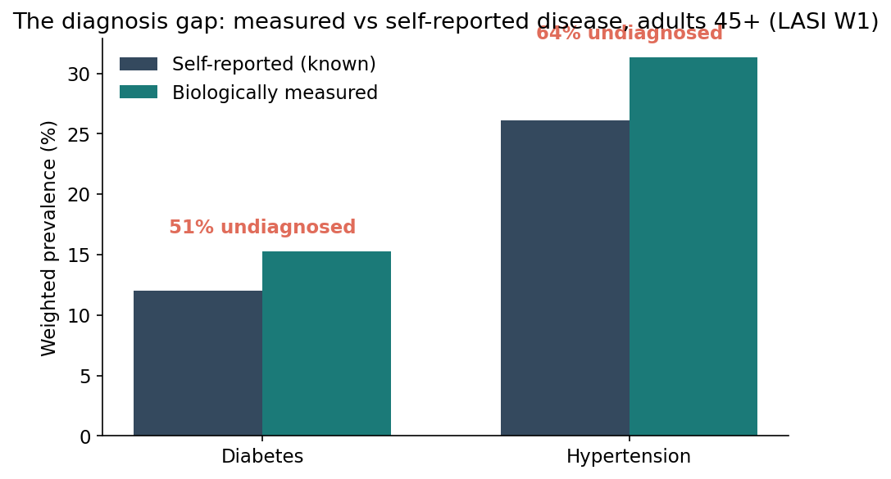
Figure 1
Figure 2. Social patterning of undiagnosed diabetes (among the biochemically diabetic), by residence, sex, education and household wealth.
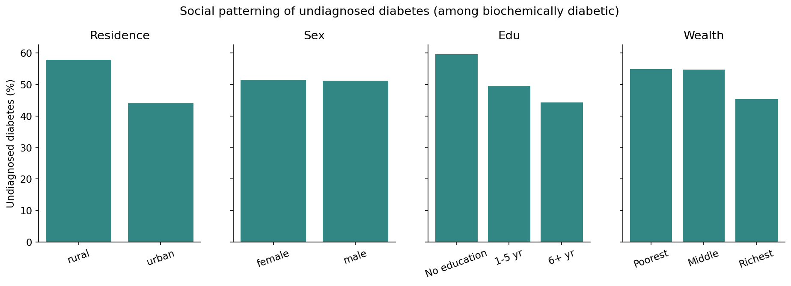
Figure 2
Figure 3. Incremental value of measured biomarker burden for predicting past-year hospitalisation: AUROC (95% CI) across nested models.
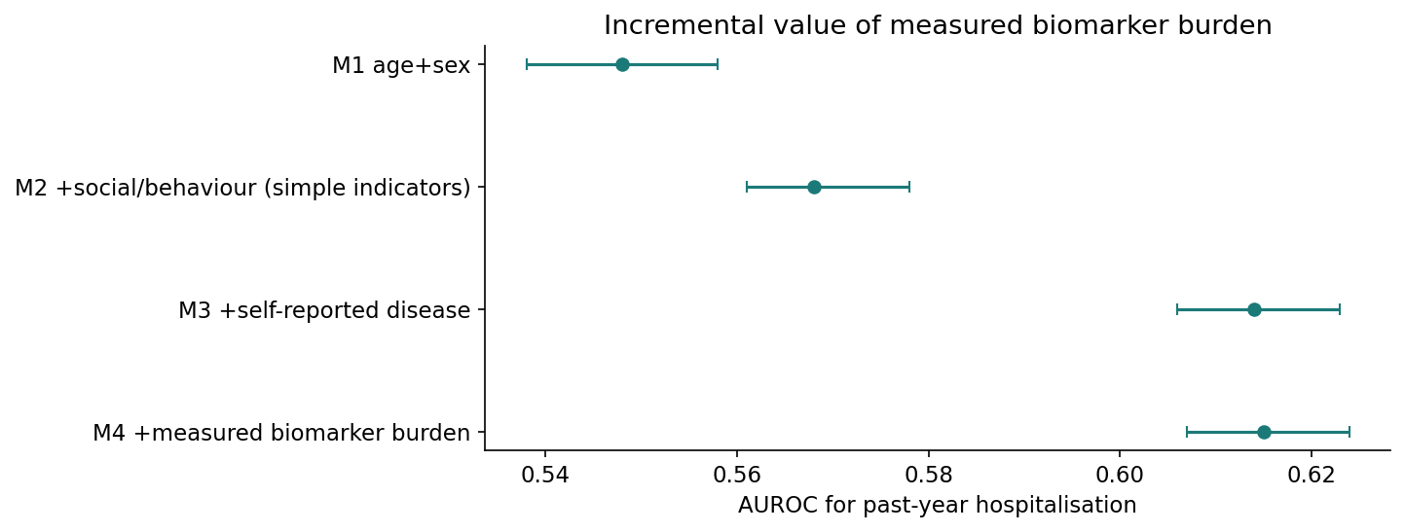
Figure 3
Figure 4. State/union-territory surveillance: weighted prevalence of high multi-system biological burden (>=3 abnormal systems).
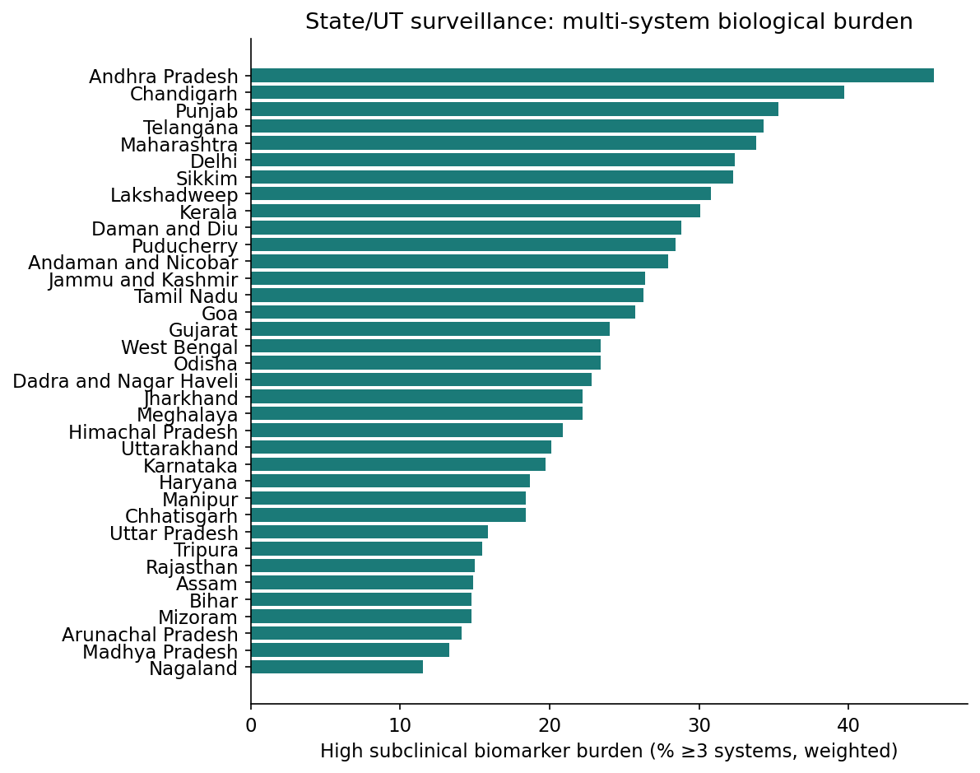
Figure 4
Supplementary Figure S1. Adjusted predictors (incidence-rate ratios) of the subclinical biomarker burden count. The count conflates opposing phenotypes; domain-specific associations (Supplementary Table S4) are the primary exposome analysis.
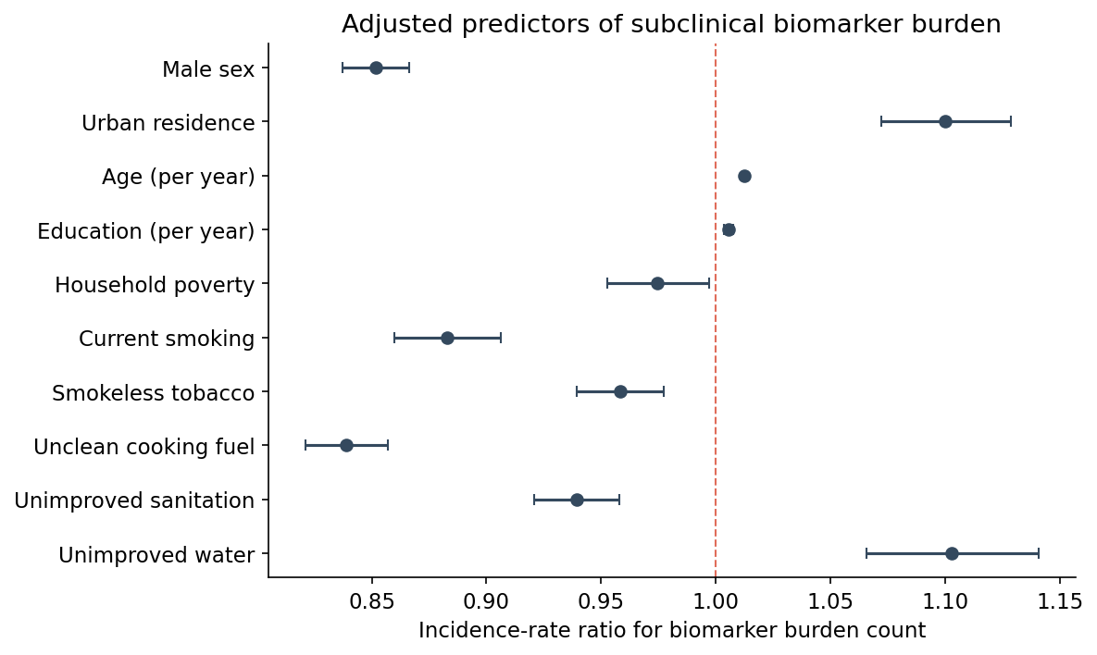
Supplementary Figure S1

