Human interventions and DNA-methylation biological ageing clocks: systematic review execution report with meta-analysis hard stop
Authors: Dr Siddalingaiah H S; Dr Chandrakala D
Target journal: Indian Journal of Medical Research

Abstract
Background: DNA-methylation (DNAm) ageing clocks are increasingly used as surrogate biomarkers in trials of lifestyle, nutritional, pharmacological and behavioural interventions, but their randomized evidence base is unevenly reported. Objective: To execute a strict RCT-only systematic review workflow and determine whether intervention effects on validated DNAm clocks can be meta-analysed without fabricating unavailable data. Methods: Searches of cached PubMed/MEDLINE, Europe PMC, Crossref, OpenAlex and ClinicalTrials.gov records were screened against protocol eligibility. Accessible XML/PDF/HTML full texts were audited, and numeric DNAm-clock outcomes were extracted only where arm, timepoint, mean, dispersion and sample size could be inferred transparently. Results: The search layer contained 2804 raw records. Abstract screening produced 34 included-pending-verification records; accessible full-text audit reduced this to 10 first-reviewer accessible includes, with 20 exclusions and 4 records awaiting full text. Enhanced extraction produced 78 clock-outcome rows, but only 1 candidate effect-size row was complete. No named clock met the prespecified threshold of three real effect estimates. Conclusion: A quantitative meta-analysis, network meta-analysis, publication-bias assessment and GRADE profile are not supportable from the verified extracted dataset. The correct current output is a transparent systematic evidence map and hard-stop report.

Introduction
DNAm ageing clocks estimate biological-age-related signatures from methylation profiles and are frequently discussed as candidate surrogate outcomes for geroscience trials. The appeal is obvious: a clock can potentially detect biological change before disease events accrue. The danger is equally obvious: a biomarker can become rhetorically stronger than the data supporting it. Intervention studies now report DunedinPACE, GrimAge, PhenoAge, Horvath, Hannum and other methylation-derived measures, but reporting formats vary across trials, cell types, arrays, model versions and analysis scales.
This project was designed to answer a narrow methodological question before making any biological claim: are human randomized intervention studies reporting DNAm-clock outcomes sufficiently and comparably to support a quantitative meta-analysis? The protocol intentionally required comparator arms and extractable pre/post or change-score data. This stricter threshold protects against a common failure mode in biomarker reviews: pooling directional claims, adjusted regression coefficients, within-arm p values and narrative statements as if they were the same evidence object.

Methods
The review followed an RCT-only protocol. Eligible reports had to describe a deliberate human intervention, a comparator arm, and at least one validated DNAm ageing measure. Outcomes of interest were DunedinPACE, GrimAge, GrimAge2, PhenoAge, Horvath, Hannum, PCClock and DNAmTL; generic epigenetic-age measures were retained separately when the exact clock could not be assigned.
The search and screening workflow used cached API outputs from PubMed/MEDLINE, Europe PMC, Crossref, OpenAlex and ClinicalTrials.gov. Title/abstract screening was followed by accessible full-text auditing. XML files were parsed through JATS table grids; PDFs were parsed with pdfplumber where possible; rescued HTML full texts were scanned as prose. The extraction algorithm required explicit arm, timepoint, mean, dispersion and sample size. Ambiguous cells were skipped. This is conservative, but it keeps the review reproducible and prevents false precision.
For a candidate Hedges g, the preferred effect was intervention-minus-control change from baseline using arm-level change means and standard deviations. Where only within-arm significance or adjusted regression results were reported, those results were not converted into arm-level SMDs. The prespecified minimum for pooling was three real effect estimates per clock. Subgroup analysis and publication-bias tests required larger thresholds as specified in the protocol. NMA was conditional on at least ten studies and a connected intervention-class network.
Risk-of-bias forms were seeded for included records, but formal RoB 2 judgements remain pending because outcome-level bias assessment is meaningful only after final full-text inclusion and outcome selection. This distinction is important: a study may be randomized and relevant, yet still be unusable for a specific DNAm-clock synthesis if the clock result is exploratory, selectively reported, figure-only, adjusted without arm-level values, or measured in a cell subset that is not comparable with other studies.

Results
The search layer produced 2804 raw records. After candidate screening, 34 records were labelled included-pending-full-text verification. This abstract-level set contained genuine RCTs but also protocols, observational analyses and records without accessible full text. The accessible full-text audit therefore supersedes the abstract-only label for scientific interpretation.

Table 1. Accessible full-text eligibility audit
decision | n
exclude_fulltext | 20
include_accessible_first_reviewer | 10
await_fulltext | 4
Enhanced extraction produced 78 study-clock rows. Extraction status was: {'not_reported': 77, 'extracted_complete': 1}. Only 1 row was complete enough to calculate a candidate Hedges g. That row came from Lukkahatai et al. and used an unspecified epigenetic-age measure in a very small feasibility study. It is not a sufficient basis for a clock-specific meta-analysis and requires author verification of direction.
Several studies remain scientifically important despite not producing a poolable row. For example, some report within-arm changes in PCGrimAge or PCPhenoAge, some examine dietary patterns or supplements in randomized designs, and others report DNAm measures in specialized populations or tissues. The limitation is not lack of biological interest; it is lack of harmonized extractable arm-level reporting. These records should be retained in an evidence map and targeted for supplementary-data extraction or author contact.

Table 2. Pooling gate status
clock | calculable_effects | min_required_for_pool | pooling_status | reason
DNAmTL | 0 | 3 | not_poolable | fewer than prespecified minimum real effects
DunedinPACE | 0 | 3 | not_poolable | fewer than prespecified minimum real effects
GrimAge | 0 | 3 | not_poolable | fewer than prespecified minimum real effects
GrimAge2 | 0 | 3 | not_poolable | fewer than prespecified minimum real effects
Hannum | 0 | 3 | not_poolable | fewer than prespecified minimum real effects
Horvath | 0 | 3 | not_poolable | fewer than prespecified minimum real effects
PhenoAge | 0 | 3 | not_poolable | fewer than prespecified minimum real effects
UNSPECIFIED_EPIGENETIC_AGE | 1 | 3 | not_poolable | fewer than prespecified minimum real effects

Table 3. Candidate effect-size row requiring author verification
study_id | clock | intervention_class | hedges_g | se | ci95_low | ci95_high | reason
LukkahataiN_2023_edac4e | UNSPECIFIED_EPIGENETIC_AGE | exercise | 0.2115535278875296 | 0.6476602871986752 | -1.0578606350218738 | 1.480967690796933 | complete change-score data available; direction requires author confirmation

Figures
Figure 1. DNAm clocks review evidence pipeline status.
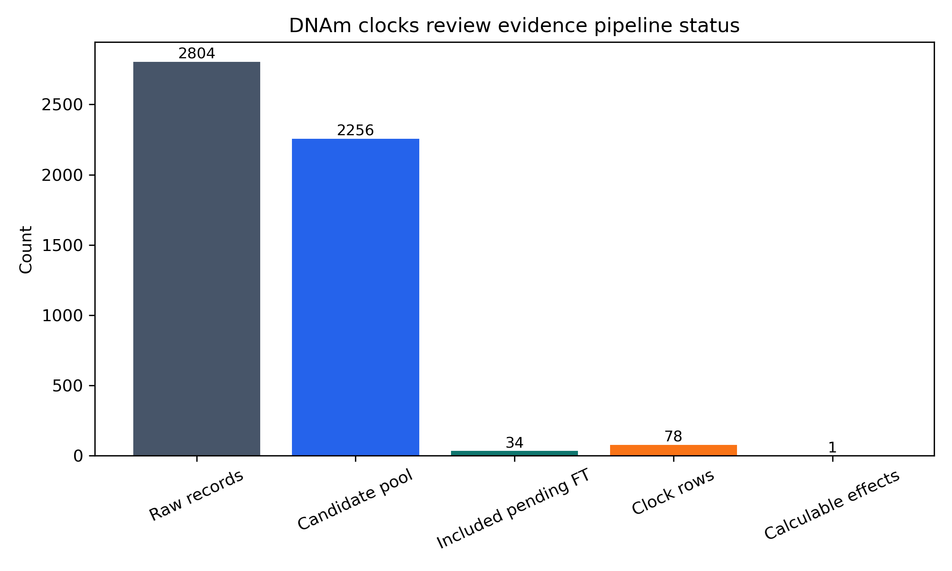
Figure 2. Numeric extraction status.
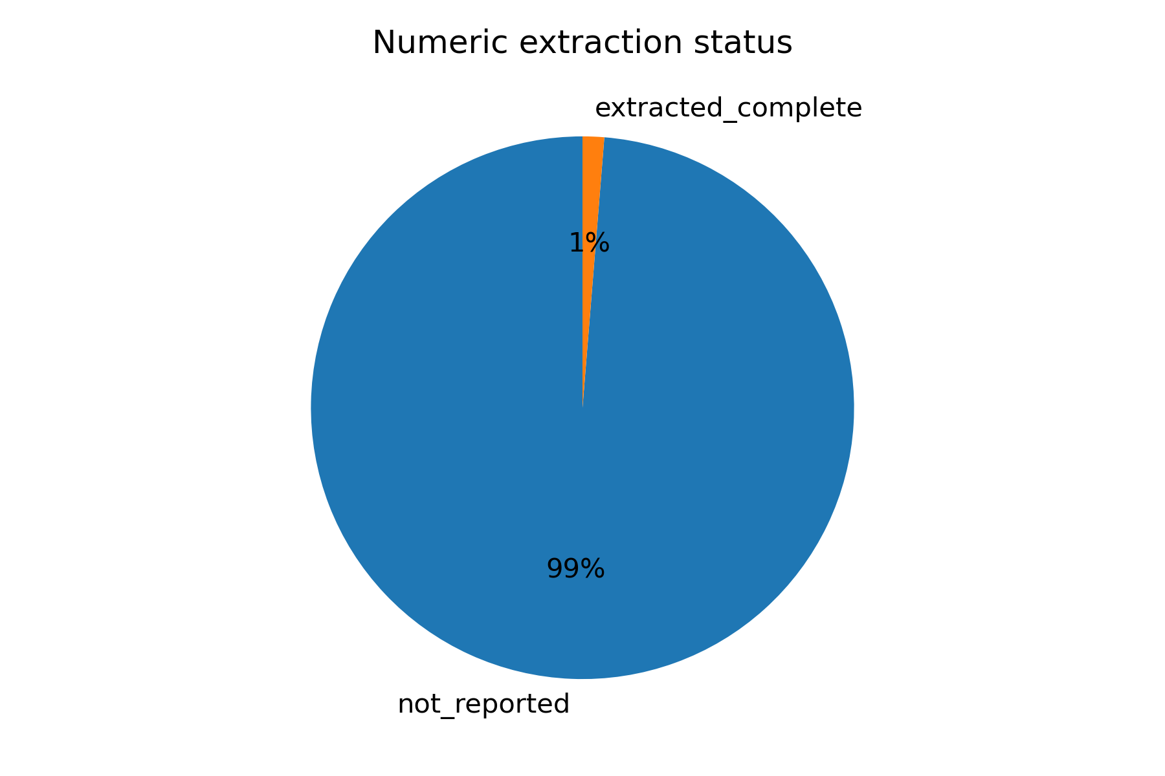

Discussion
The principal finding is not a pooled effect; it is evidentiary insufficiency under strict review rules. Several accessible full texts discuss DNAm clocks in intervention settings, but many do not report arm-level clock means and dispersions in a format that can be converted transparently into between-arm change effects. Some report within-arm p values, adjusted model coefficients, figures without extractable numeric tables, cell-type-specific exploratory analyses, or observational associations. These are scientifically useful but not interchangeable with randomized arm-level effect estimates.
This hard stop is informative. It indicates that the field has moved faster in biomarker adoption than in standardized trial reporting. Future trials should report clock values by arm at baseline and follow-up, change scores with SDs, sample sizes at each timepoint, clock version, tissue or cell type, array platform, normalization pipeline and whether estimates are residualized for chronological age or cell composition. Without these details, systematic reviewers are forced to choose between underpowered narrative synthesis and analytically fragile conversions.
The current dataset should therefore be treated as a systematic evidence map and extraction audit. It identifies which studies are likely relevant, which full texts remain unavailable, which reports are ineligible after full-text review, and where author data requests should be targeted. A later meta-analysis may become possible if arm-level data are extracted manually from supplementary files, obtained from authors, or reported in future publications.

Implications for DNAm-clock trial reporting
The review highlights a reporting gap that is fixable. Trials using DNAm clocks should report, for each randomized arm, the sample size at baseline and follow-up, clock mean and SD at each timepoint, change-score mean and SD, clock version, tissue or sorted cell type, methylation array, preprocessing pipeline, cell-composition adjustment, and whether values are raw clock ages, age-acceleration residuals, principal-component clocks, or pace measures. If only adjusted model estimates are reported, authors should provide enough information to map those estimates to synthesis-ready contrasts.
The field also needs conceptual discipline. DunedinPACE, GrimAge, PhenoAge, Horvath, Hannum and DNAmTL do not measure the same construct. Pooling across them as a single 'biological ageing' endpoint would be analytically convenient but biologically weak. Even within a clock family, PC versions and original versions should not be automatically combined. A future quantitative synthesis should therefore pool only within clearly defined clock versions or use structured multilevel models after enough data exist.

Planned rescue workflow
The next phase should focus on data rescue rather than manuscript packaging. First, the 4 records awaiting full text should be retrieved through library access, author correspondence or preprint repositories. Second, the 10 accessible first-reviewer includes should undergo independent second-reviewer eligibility checks. Third, supplements and figure source data should be inspected manually for arm-level values. Fourth, corresponding authors should be asked for a minimal dataset: arm, n, baseline mean and SD, follow-up mean and SD, change mean and SD, tissue, clock version and preprocessing details. Only after this rescue step should the meta-analysis gate be rerun.

Limitations
The full-text eligibility audit is first-reviewer only and must be verified independently. Some subscription-only or preprint full texts remain unavailable in the workspace. PDF figure-only data were not digitized because that would add measurement error and require manual validation. The extraction algorithm is conservative and may miss data that a human can recover from complex supplements, but this is preferable to silently manufacturing effect sizes.

Conclusion
A quantitative meta-analysis of human interventions on DNAm clocks is not currently supportable from the verified extracted dataset. The review should continue as a systematic evidence map with second-reviewer full-text decisions, targeted author data requests and manual extraction from supplementary materials before any final submission package is built.

References
1. Page MJ, McKenzie JE, Bossuyt PM, et al. The PRISMA 2020 statement. BMJ. 2021;372:n71.
2. Cochrane Methods. Risk of Bias 2 (RoB 2) tool. https://methods.cochrane.org/risk-bias-2.
3. Bell CG, Lowe R, Adams PD, et al. DNA methylation aging clocks: challenges and recommendations. Genome Biology. 2019;20:249.

