Figure File
Figure 1. Screening progress flow for the frailty intervention review.
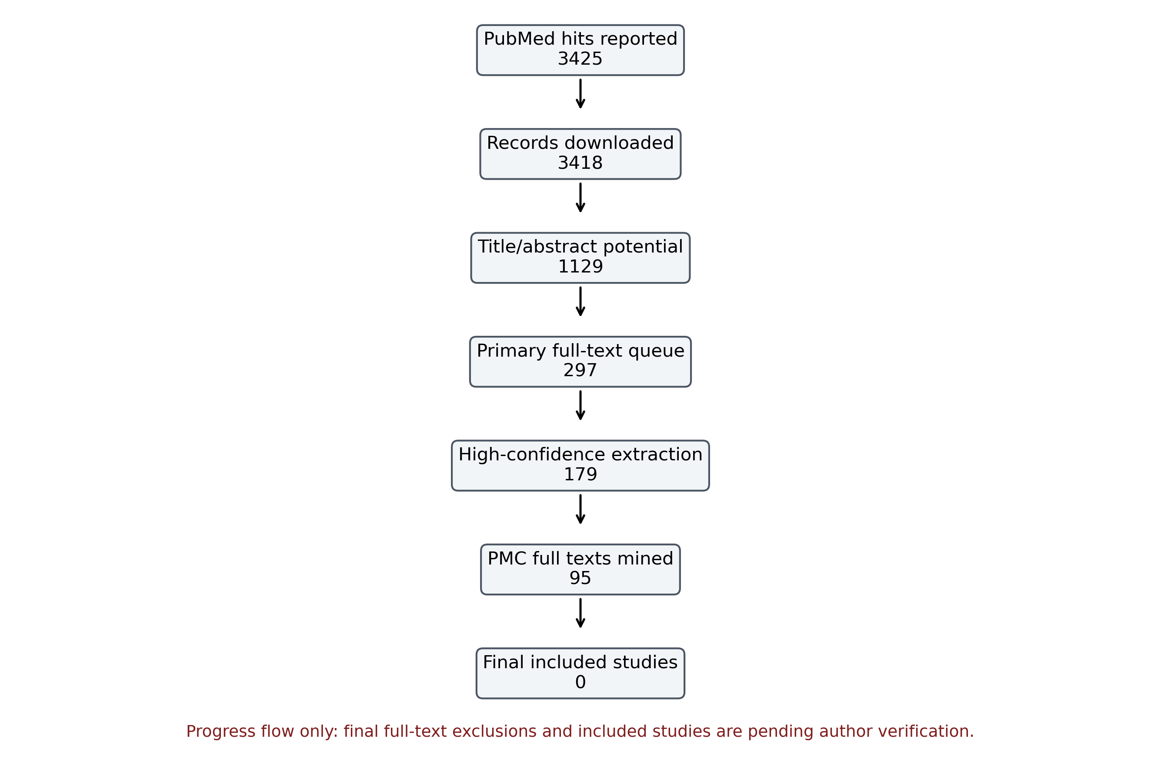
Caption: Records identified, screened and triaged through the current audit stage. This is not the final PRISMA flow diagram because full-text exclusions and final included studies remain pending.

Figure 2. Preliminary intervention-node distribution.
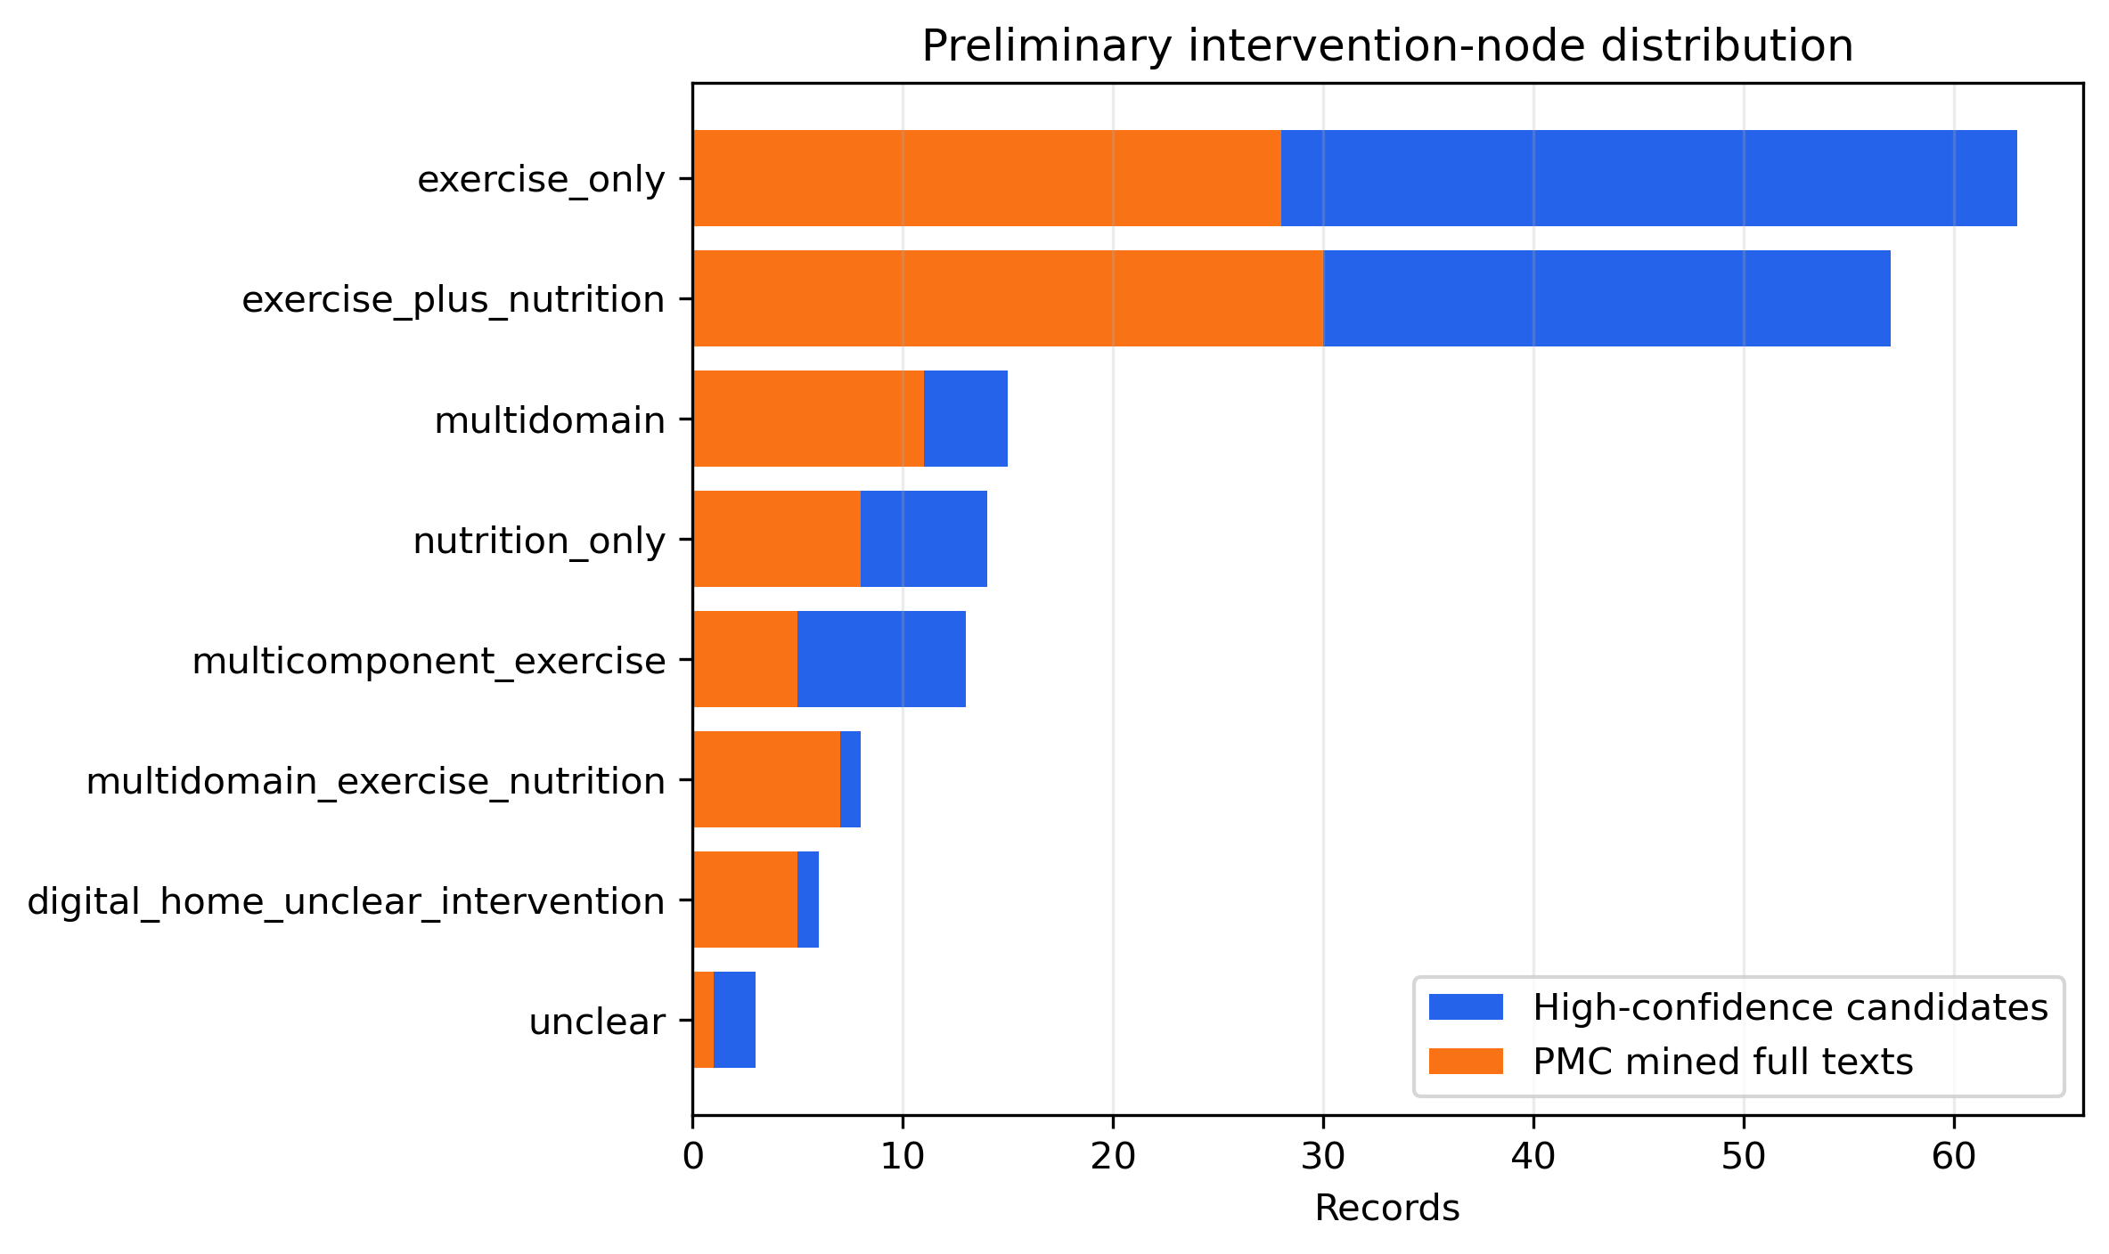
Caption: Distribution of high-confidence candidate records and PMC-mined full texts by preliminary intervention node. Nodes require confirmation after full-text extraction.

