Can Ageing Be Slowed or Reversed? A Reproducible Evidence Map, Credibility Ranking, and Mechanistic Synthesis of Anti-Ageing and Age-Reversal Interventions
Article type: Systematic review / evidence map
Running title: Anti-ageing evidence map

Abstract
Background: Anti-ageing claims range from established healthspan interventions to speculative rejuvenation approaches. Objective: To create a conservative, reproducible evidence map separating healthspan benefit, lifespan extension, biological-age slowing, biomarker reversal, and true clinical rejuvenation. Methods: Searches across PubMed, Europe PMC, and Crossref retrieved 1155 raw records, deduplicated to 1029. Title/abstract screening, metadata-assisted extraction, credibility scoring, mechanism mapping, priority human verification, preliminary risk-of-bias prompts, duplicate checks, and candidate effect extraction were performed. Results: Screening classified 29 records as include, 455 as uncertain, and 545 as exclude. 484 records entered the full-text queue. In the priority human pass, 19 records had open full text verified, 16 had abstract-level verification, and 5 were not retrieved. Candidate numeric effect text was found for 28 records. Exercise ranked highest for human healthspan-oriented evidence; other domains showed signals requiring verification. Conclusion: Repo-held evidence supports healthspan-oriented exercise most strongly, while pharmacologic, senolytic, NAD/sirtuin, microbiome, fasting, caloric restriction, and regenerative claims remain less certain. No intervention in this evidence set proves human age reversal.
Keywords: ageing; healthspan; rejuvenation; biological age; senolytics; rapamycin; systematic review; evidence map

Introduction
Anti-ageing interventions are often discussed as though improved healthy ageing, delayed biological ageing, biomarker reversal, and rejuvenation were interchangeable. This creates risk of clinical overclaiming. A rigorous review must separate human functional outcomes from animal lifespan results, cellular mechanisms, and surrogate biomarker shifts.^{[1,2]}
Human studies in the extracted evidence set include multidomain lifestyle, resistance or multimodal exercise, microbiome modulation, exergame-based frailty prevention, prospective physical-activity cohorts, fasting-mimicking diet, topical rapamycin, and rapamycin healthspan records.^{[3,4,5,6,7,8,9,10]}
This manuscript presents a reproducible evidence map and credibility ranking of anti-ageing and age-reversal intervention domains. The analysis is conservative by design and uses records and extraction artifacts available in the repository, with no fabricated references, effect sizes, or pooled estimates.
The review question was not whether ageing has been definitively reversed in humans. It was whether any intervention class has credible evidence for healthspan improvement, lifespan extension, slowing of biological-age markers, biomarker reversal, or plausible rejuvenation. Those categories are treated as distinct evidentiary claims.

Methods
A PRISMA-style pipeline searched PubMed, Europe PMC, and Crossref; deduplicated records by DOI, PMID, and normalized title; screened title/abstract metadata; generated full-text triage artifacts; extracted intervention, model-system, outcome-domain, and mechanism fields; scored evidence credibility; and generated figures and tables.
High-quality human evidence was prioritized for verification. The top human records were checked through open PMC XML, PubMed XML abstracts, or repository abstracts where available. Preliminary risk-of-bias prompts and candidate effect-size snippets were generated only as aids to manual review. The PRISMA-style flow is shown in Figure 1.
Meta-analysis was not performed because final verified effect sizes, uncertainty measures, denominators, intervention dose/duration, comparator details, and harmonized outcome definitions are not yet complete.
Intervention credibility combined the number of extracted records, human evidence, human trial evidence, direct ageing or healthspan outcomes, biomarker evidence, surrogate burden, and hype-language burden. The scoring was used to rank evidence credibility, not to create treatment recommendations.

Results
The pilot search retrieved 1155 raw records and produced 1029 deduplicated records. Title/abstract screening classified 29 records as include, 455 as uncertain, and 545 as exclude. Four hundred and eighty-four records entered the full-text screening artifact. Priority human verification was attempted for 40 records: 19 had open PMC full text available, 16 had PubMed abstract verification, and 5 were not retrieved by automated lookup.
The first credibility ranking is shown in Table 1 and Figure 2. Exercise ranked first and was the only intervention domain categorized as the strongest current human healthspan signal. Microbiome, rapamycin/mTOR modulation, senolytics, caloric restriction, lifestyle bundles, NAD/sirtuin interventions, and fasting showed human signals requiring verification rather than recommendation-level evidence.
Representative priority human evidence available in the repository is summarized in Table 2. The extracted records include frailty or function-oriented exercise and multidomain lifestyle interventions, microbiome modulation with cognitive outcomes, fasting-mimicking diet with biological-age markers, topical and systemic rapamycin records, caloric restriction, multidomain epigenetic-age intervention, and senolytic trial-design evidence.^{[3,4,5,6,7,8,9,10,11,12,13,14]}
Preliminary risk-of-bias prompts are summarized in Table 3. These are not final RoB 2 or ROBINS-I judgments; they are structured prompts based on the available open text or abstract content.
The hype-versus-evidence comparison is presented in Figure 3. The translational readiness matrix is presented in Figure 4.
Table 1. Intervention credibility ranking based on extracted repository evidence.
Rank | Intervention Domain | Human Records | Human Trial Records | Human Direct-Ageing Records | Credibility Tier | Representative Citation
1 | Exercise / physical activity | 37 | 10 | 7 | Strongest current human healthspan signal | Zanotto et al., 2026 [2]
2 | Microbiome modulation | 8 | 2 | 1 | Human signal; verification required | Ni et al., 2024 [3]
3 | Rapamycin / mTOR modulation | 7 | 3 | 1 | Human signal; verification required | Chung et al., 2019 [8]
4 | Senolytics / senomorphics | 7 | 1 | 0 | Human signal; verification required | Ji et al., 2026 [14]
5 | Caloric restriction | 5 | 3 | 0 | Human signal; verification required | Houston et al., 2026 [12]
6 | Multidomain lifestyle | 3 | 2 | 1 | Human signal; verification required | Yap et al., 2026 [1]
7 | NAD/sirtuin approaches | 8 | 2 | 0 | Human signal; verification required | Pihlstrøm et al., 2024 [18]
8 | Fasting / fasting-mimicking diet | 5 | 2 | 1 | Human signal; verification required | Brandhorst et al., 2024 [7]
9 | Supplements | 6 | 0 | 0 | Biomarker or indirect human signal | No representative human record
10 | Metformin | 1 | 0 | 0 | Biomarker or indirect human signal | No representative human record
Table 2. Representative priority human evidence available in the repository.
Study | Intervention Domain | Design | Outcome Focus | Evidence Source Reviewed | Main Finding Captured From Available Text
Yap et al., 2026 [1] | Multidomain lifestyle | Randomized/clinical trial | Healthspan / functional ageing | Open full text | Multidomain dementia-prevention trial baseline record; randomized healthspan-relevant cohort with frailty and cognitive outcomes planned.
Zanotto et al., 2026 [2] | Exercise / physical activity | Randomized/clinical trial | Healthspan / functional ageing | Open full text | Pilot multimodal exercise record reported high retention/adherence and between-group changes in frailty-related and quality-of-life outcomes.
Ni et al., 2024 [3] | Microbiome modulation | Randomized/clinical trial | Healthspan / functional ageing | PubMed abstract | Prebiotic treatment did not improve chair-rise time but improved a cognitive factor score in the captured abstract.
Tuan et al., 2024 [4] | Exercise / physical activity | Randomized/clinical trial | Healthspan / functional ageing | PubMed abstract | Exergame-based exercise trial reported significant group-by-time improvements in frailty/sarcopenia-related physical outcomes.
Zhu et al., 2026 [6] | Exercise / physical activity | Prospective cohort | Mortality / survival / lifespan | Open full text | Physical activity modified the association between frailty and all-cause mortality across five cohorts.
Brandhorst et al., 2024 [7] | Fasting / fasting-mimicking diet | Randomized/clinical trial | Biological-age biomarker | PubMed abstract | Fasting-mimicking diet record reported a 2.5-year reduction in median biological age marker estimates.
Chung et al., 2019 [8] | Rapamycin / mTOR modulation | Randomized/clinical trial | Biological-age biomarker | PubMed abstract | Topical rapamycin record reported reduced p16INK4A and increased collagen VII markers.
Moel et al., 2025 [9] | Rapamycin / mTOR modulation | Randomized/clinical trial | Surrogate or indirect outcome | PubMed abstract | Rapamycin PEARL record reported selected improvements in lean tissue mass, pain, well-being, or self-rated health, with several biomarkers unchanged.
Brandhorst et al., 2015 [10] | Fasting / fasting-mimicking diet | Randomized/clinical trial | Surrogate or indirect outcome | PubMed abstract | No numeric result available in captured text
Houston et al., 2026 [12] | Caloric restriction | Randomized/clinical trial | Surrogate or indirect outcome | Open full text | s) adults with obesity or overweight to one of three 9-month interventions: (1) 20% CR delivered in-person; (2) 20% CR delivered remotely (RCR); and (3) 8-hour TRE.
Olaso-Gonzalez et al., 2026 [13] | Multidomain lifestyle | Randomized/clinical trial | Surrogate or indirect outcome | Open full text | Multidomain lifestyle trial reported reduced frailty and improved grip strength, gait speed, Tinetti score, and Barthel index.
Ji et al., 2026 [14] | Senolytics / senomorphics | Randomized/clinical trial | Surrogate or indirect outcome | Open full text | Phase II fisetin trial-design record targeting physical function in breast cancer survivors; outcome results not yet established in captured text.
Table 3. Preliminary risk-of-bias prompts for representative priority human records.
Study | Randomization | Blinding | Missing Data | Confounding | Outcome Measurement | Overall Preliminary Judgement
Yap et al., 2026 [1] | Low concern | Some concern | unclear | Low concern (trial design) | Low/some concern | Some concern
Zanotto et al., 2026 [2] | Low concern | Low concern | Some concern | Low concern (trial design) | Low/some concern | Low to some concern
Ni et al., 2024 [3] | Low concern | Low concern | unclear | Low concern (trial design) | Low/some concern | Low to some concern
Tuan et al., 2024 [4] | Low concern | Some concern | unclear | Low concern (trial design) | Low/some concern | Some concern
Yoon et al., 2018 [5] | Some concern | Some concern | unclear | Low concern (trial design) | Low/some concern | Some concern
Zhu et al., 2026 [6] | Not applicable | Not applicable/unclear | Some concern | Some concern (observational confounding) | Low/some concern | Some concern
Brandhorst et al., 2024 [7] | Low concern | Some concern | unclear | Low concern (trial design) | Low/some concern | Some concern
Chung et al., 2019 [8] | Some concern | Low concern | Some concern | Low concern (trial design) | Low/some concern | Some concern
Moel et al., 2025 [9] | Low concern | Low concern | unclear | Low concern (trial design) | Some concern | Low to some concern
Brandhorst et al., 2015 [10] | Some concern | Some concern | unclear | Low concern (trial design) | Some concern | Some concern
COLLINS et al., 2016 [11] | Unclear/not applicable | Unclear/not applicable | unclear | Serious/unclear | Low/some concern | Serious/unclear
Houston et al., 2026 [12] | Low concern | Low concern | Some concern | Low concern (trial design) | Some concern | Low to some concern

Discussion
The main conclusion is deliberately conservative. In the extracted repository evidence, exercise has the clearest human healthspan signal, but this supports functional healthy-ageing benefit rather than age reversal.^{[2,4,5,6]}
Several other interventions have plausible biological or early human signals, but the present evidence does not justify clinical rejuvenation claims. Rapamycin/mTOR, senolytics, NAD/sirtuin approaches, microbiome modulation, caloric restriction, and fasting should be described as promising or hypothesis-supporting until final full-text eligibility, risk of bias, effect sizes, dosing, comparator details, and safety outcomes are manually confirmed.^{[3,7,8,9,12,13,14]}
The evidence map also shows why clinical translation should be conservative. A study can be randomized and still address a surrogate rather than a direct ageing outcome. A biomarker may move in a favorable direction without demonstrating durable functional rejuvenation. A protocol or trial-design record can be valuable for mapping the field but should not be counted as outcome evidence. These distinctions are reflected in the tables: Table 1 ranks intervention domains, Table 2 summarizes representative human evidence, and Table 3 shows preliminary risk-of-bias prompts.
For domains such as senolytics, reprogramming, stem-cell/regenerative approaches, plasma-based interventions, and NAD/sirtuin supplementation, mechanistic plausibility is not the same as clinical readiness. These areas remain important for geroscience research, but the current evidence set does not justify public or clinical messaging that they reverse ageing.
The strongest practical message is therefore conventional but important: interventions already aligned with healthy ageing, particularly physical activity and multidomain lifestyle support, are more defensible than experimental age-reversal claims. Pharmacologic and regenerative strategies should be framed as research candidates unless and until replicated human trials show clinically meaningful functional benefit, acceptable safety, and durable effects.
For MJDRDYPU readership, the practical interpretation is that healthy-ageing advice should remain grounded in established healthspan interventions, especially physical activity and multidomain lifestyle support. Experimental geroscience interventions should not be promoted as age-reversal therapies outside appropriate research settings.

Strengths and Limitations
Strengths include a reproducible workflow, explicit claim separation, conservative scoring, human-evidence prioritization, full-text triage artifacts, duplicate-cohort checks, preliminary RoB prompts, and figures designed to separate hype from evidence.
Limitations include capped search retrieval, incomplete manual full-text review, preliminary rather than final RoB judgments, candidate rather than final effect-size extraction, and the absence of quantitative meta-analysis. Several records in the source tables are protocols, reviews, or metadata-limited records, and the manuscript tables therefore focus on representative human evidence rather than pretending every candidate record is a completed outcome study. These limitations are retained transparently to prevent overclaiming.

Conclusion
The extracted evidence supports a cautious hierarchy: exercise has the strongest human healthspan signal, while several pharmacologic, nutritional, senolytic, NAD/sirtuin, microbiome, and regenerative approaches remain promising but unproven for clinical age reversal. Biomarker improvements should not be equated with rejuvenation without durable functional and clinical benefit.

Ethics
Ethics committee approval was not required because this review used public bibliographic metadata and open-access text where available, with no individual participant data.

Funding
No external funding is declared for this manuscript package.

Conflicts of Interest
None declared.

Data Availability
The reproducible tables, figures, extraction artifacts, and scripts are available in the project repository.

Figures
Figure 1. PRISMA-style pilot flow of records through retrieval, deduplication, screening, and extraction.
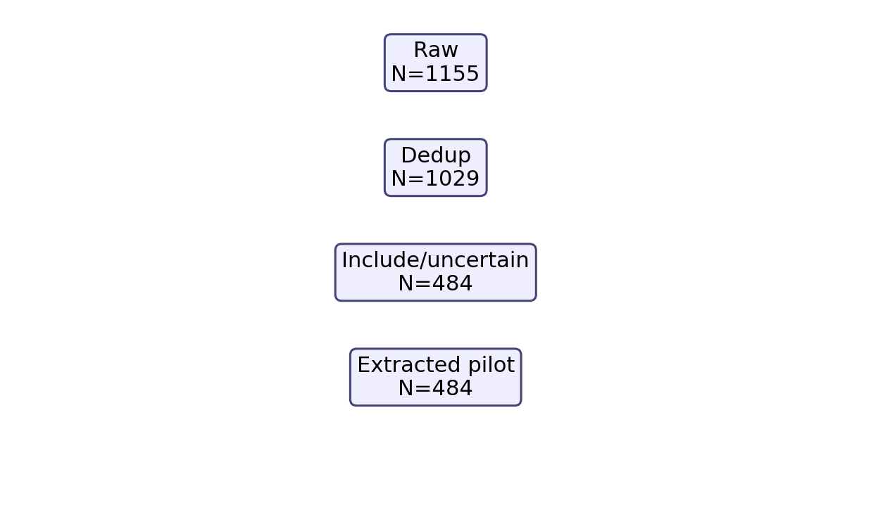
Figure 2. Intervention evidence score ranking based on extracted repository evidence.
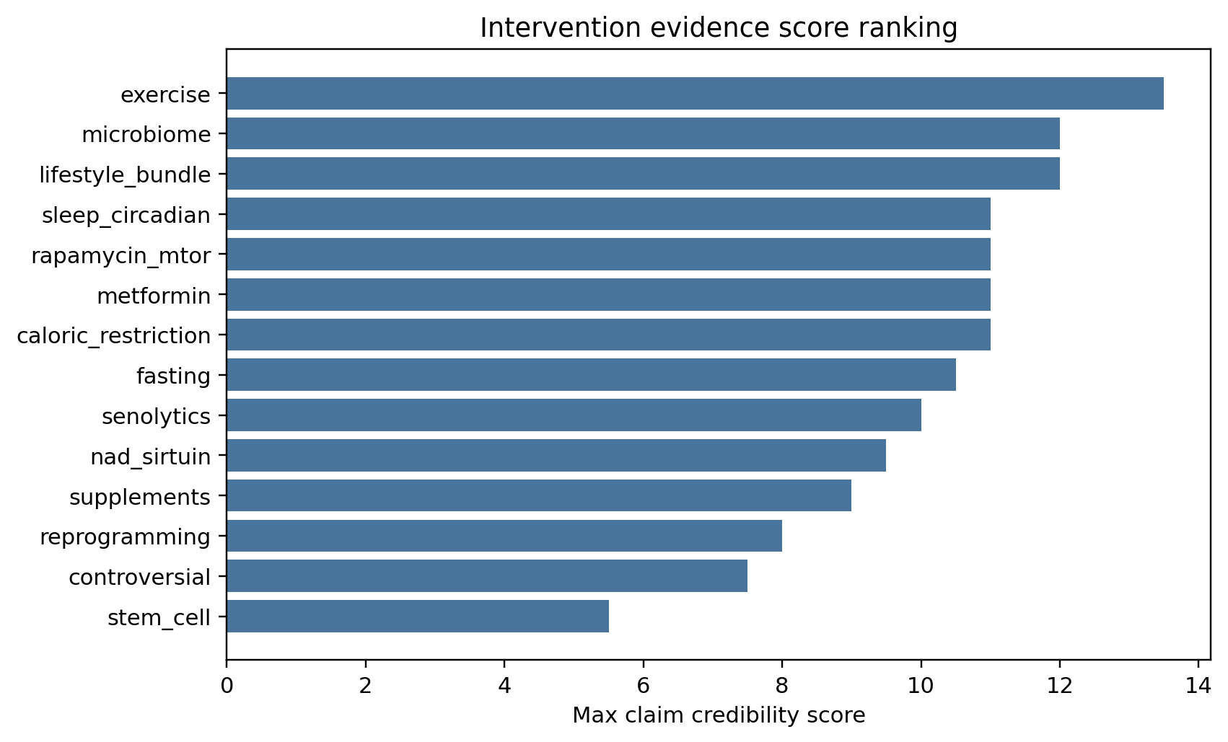
Figure 3. Hype-versus-evidence map comparing credibility score with hype-language burden by intervention domain.
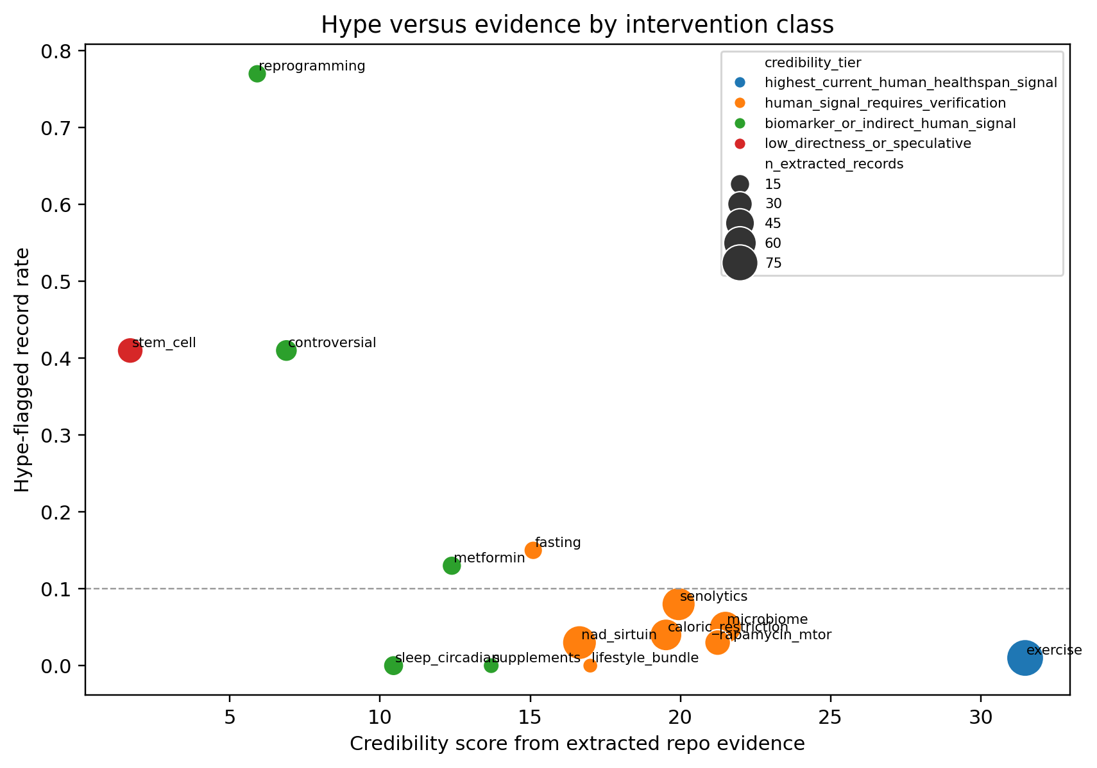
Figure 4. Translational readiness matrix showing conservative category assignment by intervention domain.
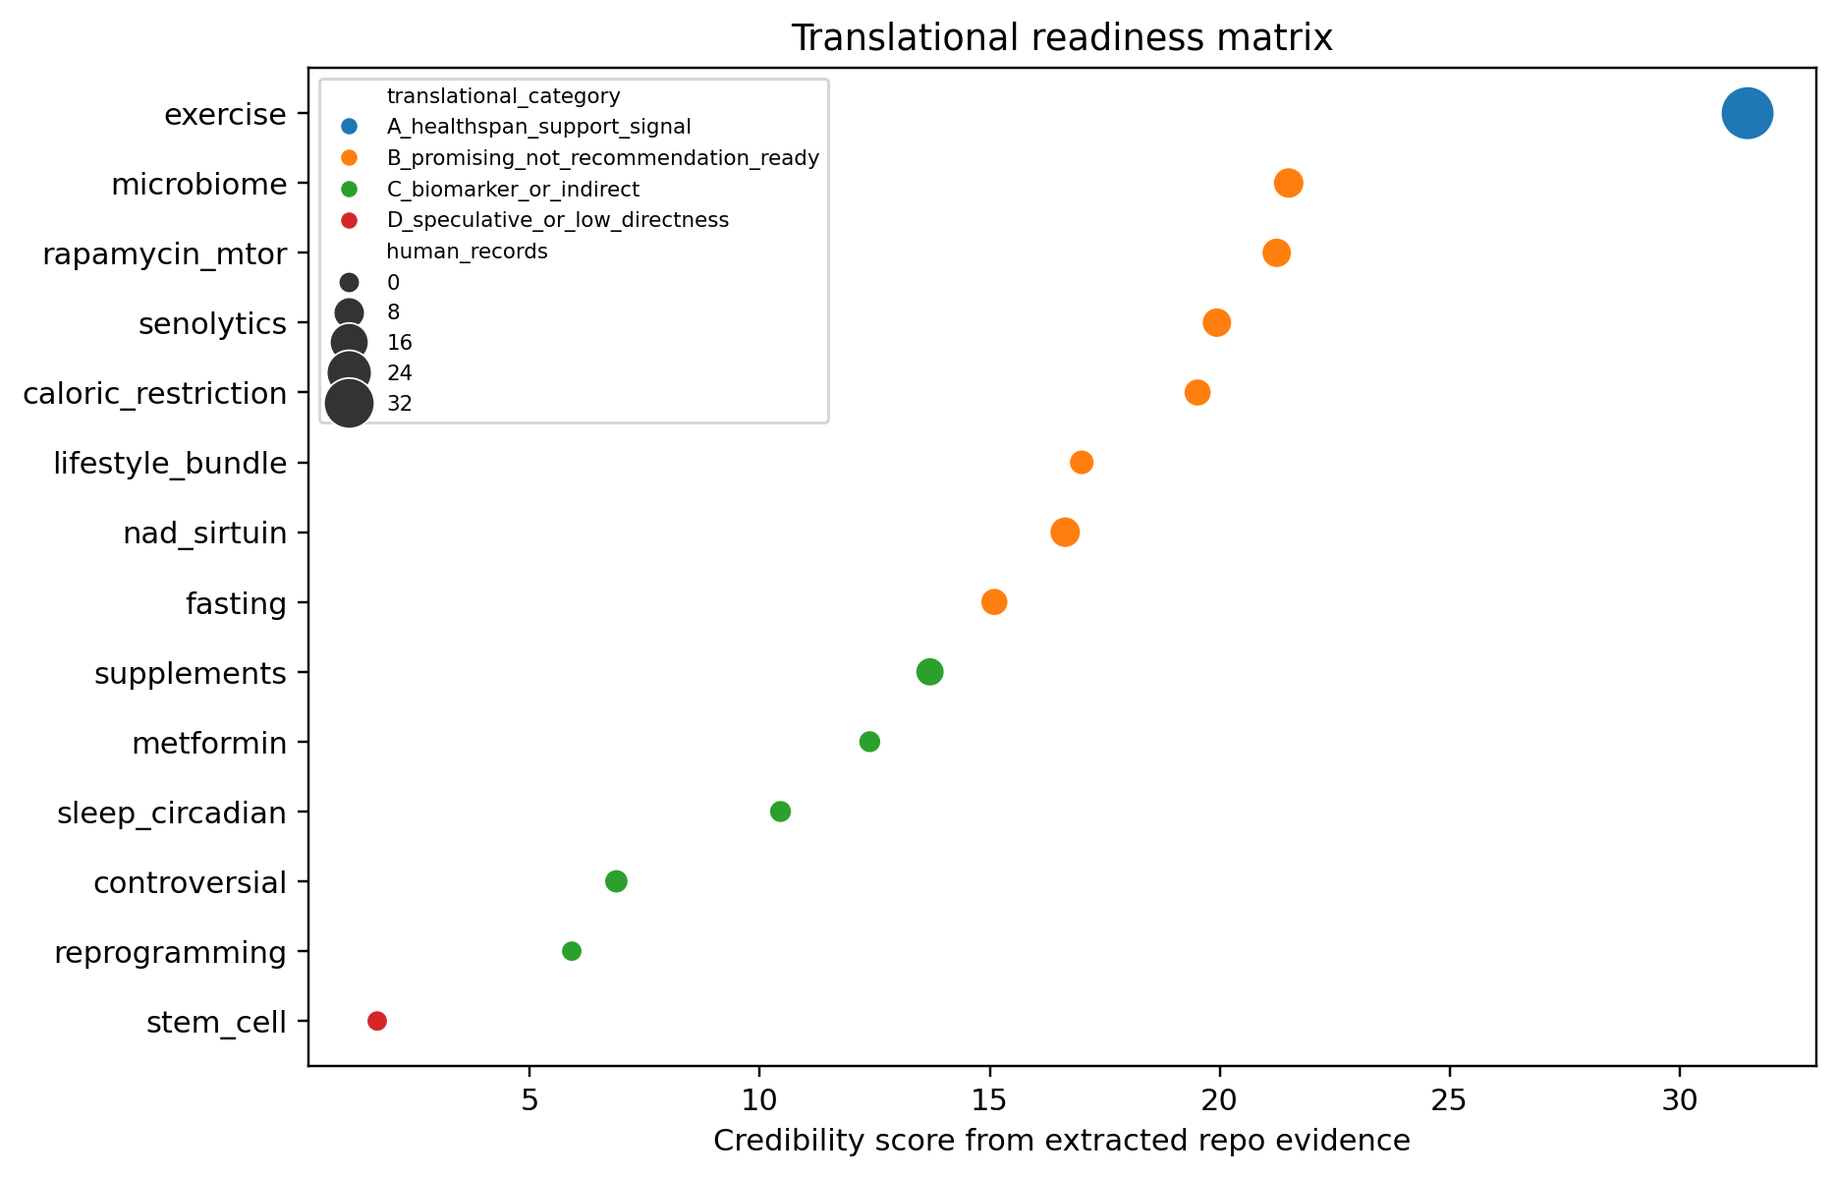

References
1. Yap KH, Chen C, Chong EJY, Kandiah N, Kivipelto M, Lai MKP, Maier AB, Matchar DB, Phua AKS, Teo CKL, Xu X, Zhou HJ, Chen CPL. Baseline characteristics of the SINgapore GERiatric Intervention Study to Reduce Cognitive Decline and Physical Frailty (SINGER) multidomain dementia prevention randomized controlled trial and insights from the recruitment process. Alzheimers Dement. 2026. doi: 10.1002/alz.71313.
2. Zanotto T, Tabatabaei A, Lynch SG, He J, Lysaught M, Ahmadnezhad P, Ibude J, Devos H, Chaves LD, Troen BR, Sosnoff JJ. Reducing frailty in frail people with multiple sclerosis: Feasibility of a 6-week multimodal exercise training program. PLoS One. 2026. doi: 10.1371/journal.pone.0347063.
3. Ni Lochlainn M; Bowyer RCE; Moll JM; García MP; Wadge S; Baleanu AF; Nessa A; Sheedy A. Effect of gut microbiome modulation on muscle function and cognition: the PROMOTe randomised controlled trial. Nature communications. 2024. PMID: 38424099.
4. Tuan SH; Chang LH; Sun SF; Li CH; Chen GB; Tsai YJ. Assessing the Clinical Effectiveness of an Exergame-Based Exercise Training Program Using Ring Fit Adventure to Prevent and Postpone Frailty and Sarcopenia Among Older Adults in Rural Long-Term Care Facilities: Randomized Controlled Trial. Journal of medical Internet research. 2024. PMID: 39024000.
5. Yoon D.H.; Lee Jun-Young; Song Wook. Effects of Resistance Exercise Training on Cognitive Function and Physical Performance in Cognitive Frailty: A Randomized Controlled Trial. The Journal of nutrition, health and aging. 2018. doi: 10.1007/s12603-018-1090-9.
6. Zhu Z, Zhou X, Chen M, Dou C, Liu D, Kong L, Ye C, Xu M, Xu Y, Li M, Zhao Z, Zheng J, Lu J, Chen Y, Wang W, Ning G, Bi Y, Wang T. Interaction between physical activity and deficit-based frailty on all-cause mortality in older adults: a prospective study of five population-based cohorts. Lancet Reg Health West Pac. 2026. doi: 10.1016/j.lanwpc.2025.101780.
7. Brandhorst S; Levine ME; Wei M; Shelehchi M; Morgan TE; Nayak KS; Dorff T; Hong K. Fasting-mimicking diet causes hepatic and blood markers changes indicating reduced biological age and disease risk. Nature communications. 2024. PMID: 38378685.
8. Chung CL; Lawrence I; Hoffman M; Elgindi D; Nadhan K; Potnis M; Jin A; Sershon C. Topical rapamycin reduces markers of senescence and aging in human skin: an exploratory, prospective, randomized trial. GeroScience. 2019. PMID: 31761958.
9. Moel M; Harinath G; Lee V; Nyquist A; Morgan SL; Isman A; Zalzala S. Influence of rapamycin on safety and healthspan metrics after one year: PEARL trial results. Aging. 2025. PMID: 40188830.
10. Brandhorst S; Choi IY; Wei M; Cheng CW; Sedrakyan S; Navarrete G; Dubeau L; Yap LP. A Periodic Diet that Mimics Fasting Promotes Multi-System Regeneration, Enhanced Cognitive Performance, and Healthspan. Cell metabolism. 2015. PMID: 26094889.
11. COLLINS J.; LONGHURST G.; ROSCHEL H.; GUALANO B. RESISTANCE TRAINING AND CO-SUPPLEMENTATION WITH CREATINE AND PROTEIN IN OLDER SUBJECTS WITH FRAILTY. Journal of Frailty & Aging. 2016. doi: 10.14283/jfa.2016.85.
12. Houston DK, Fanning J, Nicklas BJ, Delany JP, Hsu FC, Chen SH, Walkup M, Neiberg RH, Stowe CL, Kennedy K, Espeland MA, Ard JD, Miller ME, Rejeski WJ, Kritchevsky SB. Caloric restriction and time-restricted eating in older adults with overweight or obesity: The Health, Aging, and Later-Life Outcomes Pilot Study. J Gerontol A Biol Sci Med Sci. 2026. doi: 10.1093/gerona/glag061.
13. Olaso-Gonzalez G, Millan-Domingo F, Garcia-Fernandez L, Garcia-Tercero E, Cebrian M, Garcia-Dominguez C, Carbonell JA, Casabo-Valles G, Garcia-Gimenez JL, Tamayo-Torres E, Gambini J, Tarazona-Santabalbina FJ, Vina J, Gomez-Cabrera MC. A Multidomain Lifestyle Intervention Is Associated With Improved Functional Trajectories and Favorable Changes in Epigenetic Aging Markers in Frail Older Adults: A Randomized Controlled Trial. Aging Cell. 2026. doi: 10.1111/acel.70376.
14. Ji J, Crespi CM, Yee L, Zekster YA, Al-Saleem A, Petersen L, Lee C, Son N, Smith C, Evans T, Tchkonia T, Kirkland JL, Kuchel GA, Cohen HJ, Sedrak MS. A phase II randomized placebo-controlled study of fisetin to improve physical function in breast cancer survivors: the TROFFi study rationale and trial design. Ther Adv Med Oncol. 2026. doi: 10.1177/17588359261424668.
15. Mihaiescu-Ion V, Ortega-Gómez S, Domínguez-Navarro A, Ayala-Martinez C, Llerena-Guerrero R, Pérez-Cabezas V, González-Medina G, Losa-Reyna J, Galan-Mercant A. Viability of an educational program for lifestyle changes and an algorithm for the derivation of exercise programs in older people at risk of dependency at primary care: PRICA-POWFRAIL study protocol. BMC Geriatr. 2026. doi: 10.1186/s12877-025-06902-9.
16. Robinson LA, Cavanah AM, Lennon S, Mattingly ML, Pol WV, Huggins KW, Greene MW, Roberts MD, Frugé AD. Epigenetic and microbiome responses to greens supplementation in obese older adults: results from a randomized crossover-controlled trial. Front Nutr. 2026. doi: 10.3389/fnut.2026.1750030.
17. Coleman AE; Creevy KE; Anderson R; Reed MJ; Fajt VR; Aicher KM; Atiee G; Barnett BG. Test of Rapamycin in Aging Dogs (TRIAD): study design and rationale for a prospective, parallel-group, double-masked, randomized, placebo-controlled, multicenter trial of rapamycin in healthy middle-aged dogs from the Dog Aging Project. GeroScience. 2025. PMID: 39951177.
18. Pihlstrøm Lasse; Frich Jan; Walsem Marleen van. J012 NAD-HD: a randomized clinical trial of nicotinamide riboside in Huntington’s disease. J: Clinical therapeutics. 2024. doi: 10.1136/jnnp-2024-ehdn.333.
19. Nilsson MI; Xhuti D; de Maat NM; Hettinga BP; Tarnopolsky MA. Obesity and Metabolic Disease Impair the Anabolic Response to Protein Supplementation and Resistance Exercise: A Retrospective Analysis of a Randomized Clinical Trial with Implications for Aging, Sarcopenic Obesity, and Weight Management. Nutrients. 2024. PMID: 39771028.
20. Journal of Aging and Physical Activ. Erratum. Effects of Dancing Associated With Resistance Training on Functional Parameters and Quality of Life of Aging Women: A Randomized Controlled Trial. Journal of Aging and Physical Activity. 2023. doi: 10.1123/japa.2023-0257.
21. Yi L; Maier AB; Tao R; Lin Z; Vaidya A; Pendse S; Thasma S; Andhalkar N. The efficacy and safety of β-nicotinamide mononucleotide (NMN) supplementation in healthy middle-aged adults: a randomized, multicenter, double-blind, placebo-controlled, parallel-group, dose-dependent clinical trial. GeroScience. 2023. PMID: 36482258.
22. Waziry R; Ryan CP; Corcoran DL; Huffman KM; Kobor MS; Kothari M; Graf GH; Kraus VB. Effect of long-term caloric restriction on DNA methylation measures of biological aging in healthy adults from the CALERIE trial. Nature aging. 2023. PMID: 37118425.
23. Fiorito G; Caini S; Palli D; Bendinelli B; Saieva C; Ermini I; Valentini V; Assedi M. DNA methylation-based biomarkers of aging were slowed down in a two-year diet and physical activity intervention trial: the DAMA study. Aging cell. 2021. PMID: 34535961.
24. Stares A; Bains M. The Additive Effects of Creatine Supplementation and Exercise Training in an Aging Population: A Systematic Review of Randomized Controlled Trials. Journal of geriatric physical therapy (2001). 2020. PMID: 30762623.
25. Casas-Herrero A; Anton-Rodrigo I; Zambom-Ferraresi F; Sáez de Asteasu ML; Martinez-Velilla N; Elexpuru-Estomba J; Marin-Epelde I; Ramon-Espinoza F. Effect of a multicomponent exercise programme (VIVIFRAIL) on functional capacity in frail community elders with cognitive decline: study protocol for a randomized multicentre control trial. Trials. 2019. PMID: 31208471.
26. Vlietstra L.; Fordyce A.M.; Costa E.C.; Coffey S.; Walker X.J.; Whalley G.A.; Waters D.L. Exercise interventions to improve physical frailty and physical frailty components in older adults with hypertension: A systematic review. Ageing Research Reviews. 2025. doi: 10.1016/j.arr.2025.102714.
27. Billot M; Calvani R; Urtamo A; Sánchez-Sánchez JL; Ciccolari-Micaldi C; Chang M; Roller-Wirnsberger R; Wirnsberger G. Preserving Mobility in Older Adults with Physical Frailty and Sarcopenia: Opportunities, Challenges, and Recommendations for Physical Activity Interventions. Clinical interventions in aging. 2020. PMID: 32982201.
28. Muñoz-Pardeza J, López-Gil JF, Hormazábal-Aguayo I, Izquierdo M, Agostinis-Sobrinho C, Ezzatvar Y, García-Hermoso A. Effects of Diactive-1-Supported Progressive Resistance Training on Body Composition in Youth With Type 1 Diabetes. J Cachexia Sarcopenia Muscle. 2026. doi: 10.1002/jcsm.70257.
29. Racette SB, Silver RE, Barry VG, DeGraff JJ, Gunning JA, Kebbe M, Gilhooly CH, Das SK. Diet quality and nutritional adequacy during a 2-year calorie restriction intervention: the Comprehensive Assessment of Long-Term Effects of Reducing Intake of Energy 2 trial. Am J Clin Nutr. 2026. doi: 10.1016/j.ajcnut.2025.101182.
30. Veronese N, Gianfredi V, Smith L, Al-Daghri N, Barratt J, Beaudart C, Bellelli G, Bruyère O, Diaz-Ponce AM, Demurtas J, Firth J, Frederiksen KS, Karpenko O, Limongi F, Petrovic M, Prokopidis K, Reginster JY, Rizzoli R, Ramalho R, Sabico S, Schuch FB, Schlögl M, Shenkin SD, Sieber C, Solmi M, Soysal P, Stubbs B, Yang L, Zanetti M, Maggi S. Recommendations from the European interdisciplinary council on ageing on physical activity and diet for mental health conditions in older adults. Aging Clin Exp Res. 2026. doi: 10.1007/s40520-025-03315-x.
31. Ying YY, Chen X, Yao SY, Chen RX, Ying Y, Qiu H, Xu QQ, Li ZY, Ye CQ, Qian YL, Liang HQ, Sun X, Zhang D. Circadian rhythm disruption impairs ovarian follicular development via NAD<sup>+</sup> metabolic reprogramming. EBioMedicine. 2026. doi: 10.1016/j.ebiom.2026.106200.
32. Berven H, Svensen M, Eikeland H, Tvedten N, Sheard EV, Af Geijerstam SA, Søgnen M, McCann A, Arnsten L, Årseth O, Skjeie V, Hjellbrekke A, Skeie GO, Torres Cleuren YN, Nido GS, Haugarvoll K, Riemer F, Tzoulis C, Dölle C. The NAD-brain pharmacokinetic study of NAD augmentation in blood and brain using oral precursor supplementation. iScience. 2026. doi: 10.1016/j.isci.2026.114764.
33. Kell L, Jones EJ, Gharahdaghi N, Wilkinson DJ, Smith K, Atherton PJ, Simon AK, Cox LS, Alsaleh G. Rapamycin Exerts Its Geroprotective Effects in the Ageing Human Immune System by Enhancing Resilience Against DNA Damage. Aging Cell. 2026. doi: 10.1111/acel.70364.
34. Bautista J, López-Cortés A. Biohacking the human gut microbiome for precision health and therapeutic innovation. Front Microbiol. 2026. doi: 10.3389/fmicb.2026.1776983.
35. Liu C, Lu L, Wei W. Research advances in exercise management for frail older adults. Front Public Health. 2026. doi: 10.3389/fpubh.2026.1763583.
36. Shi M, Ge W. Editorial: Integrated strategies for lifelong health: multidimensional approaches to aging and lifestyle interventions. Front Public Health. 2026. doi: 10.3389/fpubh.2026.1777378.
37. Sáez-Nieto C, Pérez-Rodríguez P, Matovelle P, Rodríguez-Mañas L, Coelho-Júnior HJ, Rodríguez-Sánchez I. Effects of exercise training on frail older adults with heart failure: a systematic-review. Front Aging. 2026. doi: 10.3389/fragi.2026.1800669.
38. Lim MJS, Parlindungan E, See E, Gan CH, Yap R, Yong GJM. Diet, the Gut Microbiome, and Estrogen Physiology: A Review in Menopausal Health and Interventions. Nutrients. 2026. doi: 10.3390/nu18071052.
39. Poisnel G, Lhérault M, Palix C, Turpin A, Felisatti F, Vrillon A, Paquet C, Chocat A, Coulbault L, De La Sayette V, Gonneaud J, Chételat G. Physical activity attenuates the association between allostatic load and early Alzheimer's disease‐related biomarkers in older adults. Alzheimers Dement (N Y). 2026.
40. Gulej R, Patai R, Ungvari A, Kallai A, Tarantini S, Yabluchanskiy A, Huffman DM, Conboy MJ, Conboy IM, Kivimäki M, Csiszar A, Ungvari Z. Impacts of systemic milieu on cerebrovascular and brain aging: insights from heterochronic parabiosis, blood exchange, and plasma transfer experiments. Geroscience. 2025. doi: 10.1007/s11357-025-01657-y.

