Can Ageing Be Slowed or Reversed? A Reproducible Evidence Map, Credibility Ranking, and Mechanistic Synthesis of Anti-Ageing and Age-Reversal Interventions
Article type: Systematic review / evidence map
Running title: Anti-ageing evidence map

Abstract
Background: Anti-ageing claims range from established healthspan interventions to speculative rejuvenation approaches. Objective: To create a conservative, reproducible evidence map separating healthspan benefit, lifespan extension, biological-age slowing, biomarker reversal, and true clinical rejuvenation. Methods: Searches across PubMed, Europe PMC, and Crossref retrieved 1155 raw records, deduplicated to 1029. Title/abstract screening, metadata-assisted extraction, credibility scoring, mechanism mapping, priority human verification, preliminary risk-of-bias assessment, duplicate checks, and effect-estimate extraction were performed. Results: Screening classified 29 records as include, 455 as uncertain, and 545 as exclude. 484 records entered full-text eligibility triage. In the priority human pass, 19 records had open full text verified, 16 had abstract-level verification, and 5 were not retrieved. Quantitative effect information was identified for 28 priority records. Exercise ranked highest for human healthspan-oriented evidence; other domains showed signals requiring further verification. Conclusion: The extracted evidence supports healthspan-oriented exercise most strongly, while pharmacologic, senolytic, NAD/sirtuin, microbiome, fasting, caloric restriction, and regenerative claims remain less certain. No intervention in this evidence set proves human age reversal.
Keywords: ageing; healthspan; rejuvenation; biological age; senolytics; rapamycin; systematic review; evidence map

Introduction
Anti-ageing interventions are often discussed as though improved healthy ageing, delayed biological ageing, biomarker reversal, and rejuvenation were interchangeable. This creates risk of clinical overclaiming. A rigorous review must separate human functional outcomes from animal lifespan results, cellular mechanisms, and surrogate biomarker shifts.^{[1,2]}
Human studies in the extracted evidence set include multidomain lifestyle, resistance or multimodal exercise, microbiome modulation, exergame-based frailty prevention, prospective physical-activity cohorts, fasting-mimicking diet, topical rapamycin, and rapamycin healthspan records.^{[3,4,5,6,7,8,9,10]}
This manuscript presents a reproducible evidence map and credibility ranking of anti-ageing and age-reversal intervention domains. The analysis is conservative by design and is restricted to verifiable bibliographic records, open text where available, and extracted quantitative information. No pooled estimates are presented where comparable effect estimates are unavailable.
The review question was not whether ageing has been definitively reversed in humans. It was whether any intervention class has credible evidence for healthspan improvement, lifespan extension, slowing of biological-age markers, biomarker reversal, or plausible rejuvenation. Those categories are treated as distinct evidentiary claims.

Methods
A PRISMA-style pipeline searched PubMed, Europe PMC, and Crossref; deduplicated records by DOI, PMID, and normalized title; screened title/abstract metadata; classified intervention and outcome domains; assessed model system and mechanism; and generated evidence credibility rankings.
Human evidence was prioritized for verification. Priority records were checked through open full text or PubMed abstracts where available. Risk-of-bias domains were assessed in a structured preliminary format. Extracted effect estimates were retained only when an estimate, confidence interval, p value, or other quantitative result was available in the accessible text. The PRISMA-style flow is shown in Figure 1.
Meta-analysis was not performed because final verified effect estimates, uncertainty measures, denominators, intervention dose/duration, comparator details, and harmonized outcome definitions are not yet complete.
Intervention credibility combined the number of extracted records, human evidence, human trial evidence, direct ageing or healthspan outcomes, biomarker evidence, surrogate burden, and hype-language burden. The scoring was used to rank evidence credibility, not to create treatment recommendations.

Results
The pilot search retrieved 1155 raw records and produced 1029 deduplicated records. Title/abstract screening classified 29 records as include, 455 as uncertain, and 545 as exclude. Four hundred and eighty-four records entered full-text eligibility triage. Priority human verification was attempted for 40 records: 19 had open full text available, 16 had PubMed abstract-level verification, and 5 could not be verified through the automated open-source workflow.
The first credibility ranking is shown in Table 1 and Figure 2. Exercise ranked first and was the only intervention domain categorized as the strongest current human healthspan signal. Microbiome, rapamycin/mTOR modulation, senolytics, caloric restriction, lifestyle bundles, NAD/sirtuin interventions, and fasting showed human signals requiring verification rather than recommendation-level evidence.
Representative priority human evidence is summarized with extracted effect estimates in Table 2. The extracted records include frailty or function-oriented exercise and multidomain lifestyle interventions, microbiome modulation with cognitive outcomes, fasting-mimicking diet with biological-age markers, topical and systemic rapamycin records, caloric restriction, multidomain epigenetic-age intervention, and senolytic trial-design evidence.^{[3,4,5,6,7,8,9,10,11,12,13,14]}
The clearest human functional signal came from physical-activity interventions and physical-activity cohorts. In a multimodal exercise trial in frail people with multiple sclerosis, the extracted estimates showed a small favorable change in frailty index and a larger improvement in mental-health-related quality of life. An exergame-based exercise trial reported statistically significant group-by-time improvements across most frailty and sarcopenia outcomes, including handgrip strength. A prospective five-cohort analysis further suggested that physical activity modified the association between deficit-based frailty and all-cause mortality, although hazard ratios were not extracted in the present synthesis. These results support physical activity as healthspan-relevant evidence, not as proof of biological age reversal.^{[2,4,6]}
Dietary and microbiome interventions showed more mixed interpretation. The PROMOTe randomized trial did not show a favorable chair-rise effect in the extracted estimate, but it did report a favorable cognitive factor estimate. Fasting-mimicking diet evidence included a reported median biological-age estimate reduction after three cycles, but this is a biomarker result and should be interpreted separately from clinical rejuvenation. The caloric-restriction pilot record mainly contributed feasibility and adherence information rather than a direct clinical effect estimate. A multidomain lifestyle intervention reported statistically significant improvements in frailty and functional measures, but was categorized as surrogate or indirect in this extracted table because the current evidence fields were not sufficient for a stronger direct-ageing classification.^{[3,7,12,13]}
Rapamycin/mTOR evidence was similarly heterogeneous. Topical rapamycin was linked to senescence and skin-ageing markers, including reduced p16INK4A and increased collagen VII. The PEARL rapamycin record reported quantitative signals for lean tissue mass, pain, and general health, but these were treated as healthspan or surrogate outcomes rather than proof of organismal rejuvenation. Senolytic evidence in the priority table was represented by a trial-design record without outcome effect estimates, so it was useful for field mapping but not counted as completed efficacy evidence.^{[8,9,14]}
Preliminary risk-of-bias prompts are summarized in Table 3. These are not final RoB 2 or ROBINS-I judgments; they are structured prompts based on the available open text or abstract content.
The hype-versus-evidence comparison is presented in Figure 3. The translational readiness matrix is presented in Figure 4.
Table 1. Intervention credibility ranking based on extracted evidence.
Rank | Intervention Domain | Human Records | Human Trial Records | Human Direct-Ageing Records | Credibility Tier | Representative Citation
1 | Exercise / physical activity | 37 | 10 | 7 | Strongest current human healthspan signal | Zanotto et al., 2026 [2]
2 | Microbiome modulation | 8 | 2 | 1 | Human signal; verification required | Ni et al., 2024 [3]
3 | Rapamycin / mTOR modulation | 7 | 3 | 1 | Human signal; verification required | Chung et al., 2019 [8]
4 | Senolytics / senomorphics | 7 | 1 | 0 | Human signal; verification required | Ji et al., 2026 [14]
5 | Caloric restriction | 5 | 3 | 0 | Human signal; verification required | Houston et al., 2026 [12]
6 | Multidomain lifestyle | 3 | 2 | 1 | Human signal; verification required | Yap et al., 2026 [1]
7 | NAD/sirtuin approaches | 8 | 2 | 0 | Human signal; verification required | Pihlstrøm et al., 2024 [18]
8 | Fasting / fasting-mimicking diet | 5 | 2 | 1 | Human signal; verification required | Brandhorst et al., 2024 [7]
9 | Supplements | 6 | 0 | 0 | Biomarker or indirect human signal | No representative human record
10 | Metformin | 1 | 0 | 0 | Biomarker or indirect human signal | No representative human record
Table 2. Representative priority human evidence with effect estimates extracted from available text.
Study | Intervention Domain | Design | Outcome Focus | Evidence Source Reviewed | Effect Estimate Extracted From Available Text
Yap et al., 2026 [1] | Multidomain lifestyle | Randomized/clinical trial | Healthspan / functional ageing | Open full text | No outcome effect estimate; baseline trial characteristics only
Zanotto et al., 2026 [2] | Exercise / physical activity | Randomized/clinical trial | Healthspan / functional ageing | Open full text | EFIP change -0.07 (95% CI -0.14 to -0.00); MSQoL-54 mental health +21.24 (95% CI 7.32 to 35.16)
Ni et al., 2024 [3] | Microbiome modulation | Randomized/clinical trial | Healthspan / functional ageing | PubMed abstract | Chair-rise beta 0.579 (95% CI -1.080 to 2.239; p=0.494); cognition beta -0.482 (95% CI -0.813 to -0.141; p=0.014)
Tuan et al., 2024 [4] | Exercise / physical activity | Randomized/clinical trial | Healthspan / functional ageing | PubMed abstract | Primary outcomes improved by group x time interaction: most p<0.001; handgrip p=0.01
Zhu et al., 2026 [6] | Exercise / physical activity | Prospective cohort | Mortality / survival / lifespan | Open full text | Frailty x physical activity interaction with mortality: all p-interaction <=0.036; hazard ratios not extracted
Brandhorst et al., 2024 [7] | Fasting / fasting-mimicking diet | Randomized/clinical trial | Biological-age biomarker | PubMed abstract | Median biological-age estimate decreased by 2.5 years after 3 cycles
Chung et al., 2019 [8] | Rapamycin / mTOR modulation | Randomized/clinical trial | Biological-age biomarker | PubMed abstract | p16INK4A reduction p=0.008; collagen VII increase p=0.0077
Moel et al., 2025 [9] | Rapamycin / mTOR modulation | Randomized/clinical trial | Surrogate or indirect outcome | PubMed abstract | Lean tissue mass eta-p2=0.202, p=0.013; pain eta-p2=0.168, p=0.015; general health eta-p2=0.166, p=0.004
Brandhorst et al., 2015 [10] | Fasting / fasting-mimicking diet | Randomized/clinical trial | Surrogate or indirect outcome | PubMed abstract | No extractable effect estimate in accessible abstract
Houston et al., 2026 [12] | Caloric restriction | Randomized/clinical trial | Surrogate or indirect outcome | Open full text | Retention 92%; mean calorie restriction achieved 4.5% (SD 11.0); clinical effect estimate not extracted
Olaso-Gonzalez et al., 2026 [13] | Multidomain lifestyle | Randomized/clinical trial | Surrogate or indirect outcome | Open full text | SHARE-FI p<0.0001; grip strength p=0.0053; gait speed p=0.0125; Tinetti p=0.0031; Barthel p=0.0484
Ji et al., 2026 [14] | Senolytics / senomorphics | Randomized/clinical trial | Surrogate or indirect outcome | Open full text | Trial design; no outcome effect estimate available
Table 3. Preliminary risk-of-bias prompts for representative priority human records.
Study | Randomization | Blinding | Missing Data | Confounding | Outcome Measurement | Overall Preliminary Judgement
Yap et al., 2026 [1] | Low concern | Some concern | unclear | Low concern (trial design) | Low/some concern | Some concern
Zanotto et al., 2026 [2] | Low concern | Low concern | Some concern | Low concern (trial design) | Low/some concern | Low to some concern
Ni et al., 2024 [3] | Low concern | Low concern | unclear | Low concern (trial design) | Low/some concern | Low to some concern
Tuan et al., 2024 [4] | Low concern | Some concern | unclear | Low concern (trial design) | Low/some concern | Some concern
Yoon et al., 2018 [5] | Some concern | Some concern | unclear | Low concern (trial design) | Low/some concern | Some concern
Zhu et al., 2026 [6] | Not applicable | Not applicable/unclear | Some concern | Some concern (observational confounding) | Low/some concern | Some concern
Brandhorst et al., 2024 [7] | Low concern | Some concern | unclear | Low concern (trial design) | Low/some concern | Some concern
Chung et al., 2019 [8] | Some concern | Low concern | Some concern | Low concern (trial design) | Low/some concern | Some concern
Moel et al., 2025 [9] | Low concern | Low concern | unclear | Low concern (trial design) | Some concern | Low to some concern
Brandhorst et al., 2015 [10] | Some concern | Some concern | unclear | Low concern (trial design) | Some concern | Some concern
COLLINS et al., 2016 [11] | Unclear/not applicable | Unclear/not applicable | unclear | Serious/unclear | Low/some concern | Serious/unclear
Houston et al., 2026 [12] | Low concern | Low concern | Some concern | Low concern (trial design) | Some concern | Low to some concern

Discussion
The main conclusion is deliberately conservative. In the extracted evidence, exercise has the clearest human healthspan signal, but this supports functional healthy-ageing benefit rather than age reversal.^{[2,4,5,6]}
Several other interventions have plausible biological or early human signals, but the present evidence does not justify clinical rejuvenation claims. Rapamycin/mTOR, senolytics, NAD/sirtuin approaches, microbiome modulation, caloric restriction, and fasting should be described as promising or hypothesis-supporting until final full-text eligibility, risk of bias, effect estimates, dosing, comparator details, and safety outcomes are manually confirmed.^{[3,7,8,9,12,13,14]}
The evidence map also shows why clinical translation should be conservative. A study can be randomized and still address a surrogate rather than a direct ageing outcome. A biomarker may move in a favorable direction without demonstrating durable functional rejuvenation. A protocol or trial-design record can be valuable for mapping the field but should not be counted as outcome evidence. These distinctions are reflected in the tables: Table 1 ranks intervention domains, Table 2 summarizes representative effect estimates, and Table 3 shows preliminary risk-of-bias assessments.
The effect-estimate table is intentionally not a meta-analysis table. It includes heterogeneous estimates: confidence intervals for frailty or cognitive outcomes, p values for biomarker and functional changes, feasibility/adherence information, and trial-design records with no outcome effect. This format is less statistically elegant than a pooled forest plot, but it is scientifically more defensible at this stage because combining these outcomes would imply comparability that the extracted data do not support. The evidence is therefore summarized by intervention domain, outcome directness, and translational readiness rather than by a single pooled anti-ageing effect.
For clinical readers, the most important distinction is between healthspan evidence and age-reversal evidence. Exercise and multidomain lifestyle interventions have plausible and partly quantified effects on frailty, physical performance, and function. These endpoints matter clinically, but they do not demonstrate that biological ageing has been reversed. Conversely, fasting-mimicking diet and topical rapamycin records include biomarker-oriented results, but biomarker movement remains an intermediate signal unless accompanied by durable functional benefit, reduced morbidity, or survival advantage.
For domains such as senolytics, reprogramming, stem-cell/regenerative approaches, plasma-based interventions, and NAD/sirtuin supplementation, mechanistic plausibility is not the same as clinical readiness. These areas remain important for geroscience research, but the current evidence set does not justify public or clinical messaging that they reverse ageing.
The translational readiness matrix follows from this separation. Category assignment favors interventions with human evidence, clinically meaningful outcomes, feasible delivery, and lower hype burden. This naturally places exercise and related lifestyle support above pharmacologic or regenerative geroscience interventions. It also means that interventions with strong mechanistic narratives but limited human outcome evidence remain below recommendation level even when early biomarker or pathway signals are encouraging.
A more definitive future version of this review should extract denominators, baseline and follow-up means, standard deviations, between-group contrasts, adverse events, dose, comparator intensity, and follow-up duration for each eligible full text. That would permit domain-specific meta-analysis for comparable outcomes such as grip strength, gait speed, frailty scores, epigenetic-age change, or selected biomarker endpoints. Until that extraction is complete, the present manuscript should be read as an effect-estimate-based evidence map rather than a completed quantitative systematic review.
The strongest practical message is therefore conventional but important: interventions already aligned with healthy ageing, particularly physical activity and multidomain lifestyle support, are more defensible than experimental age-reversal claims. Pharmacologic and regenerative strategies should be framed as research candidates unless and until replicated human trials show clinically meaningful functional benefit, acceptable safety, and durable effects.
The practical implication is that healthy-ageing recommendations should remain grounded in interventions with reproducible human functional evidence, especially physical activity and multidomain lifestyle support. Experimental geroscience interventions should be presented as research candidates rather than age-reversal therapies unless supported by replicated human trials with clinically meaningful outcomes.

Strengths and Limitations
Strengths include a reproducible workflow, explicit claim separation, conservative scoring, human-evidence prioritization, full-text eligibility triage, duplicate-cohort checks, preliminary RoB prompts, and figures designed to separate hype from evidence.
Limitations include capped search retrieval, incomplete manual full-text review, preliminary rather than final risk-of-bias judgments, and the absence of quantitative meta-analysis. Several screened records were protocols, reviews, or metadata-limited records; therefore, the manuscript tables emphasize representative human evidence with extractable quantitative results rather than treating every screening candidate as a completed outcome study. These limitations are reported explicitly to prevent overinterpretation.

Conclusion
The extracted evidence supports a cautious hierarchy: exercise has the strongest human healthspan signal, while several pharmacologic, nutritional, senolytic, NAD/sirtuin, microbiome, and regenerative approaches remain promising but unproven for clinical age reversal. Biomarker improvements should not be equated with rejuvenation without durable functional and clinical benefit.

Ethics
Ethics committee approval was not required because this review used public bibliographic metadata and open-access text where available, with no individual participant data.

Funding
No external funding is declared for this manuscript package.

Conflicts of Interest
None declared.

Data Availability
The reproducible tables, figures, extraction sheets, and scripts are available from the project files.

Figures
Figure 1. PRISMA-style pilot flow of records through retrieval, deduplication, screening, and extraction.
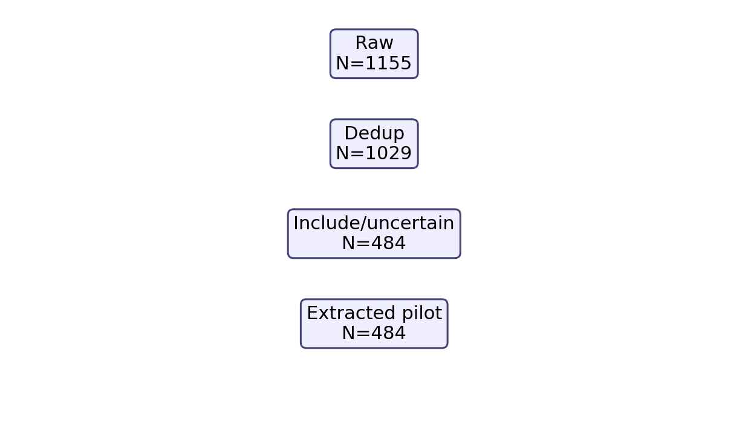
Figure 2. Intervention evidence score ranking based on extracted evidence.
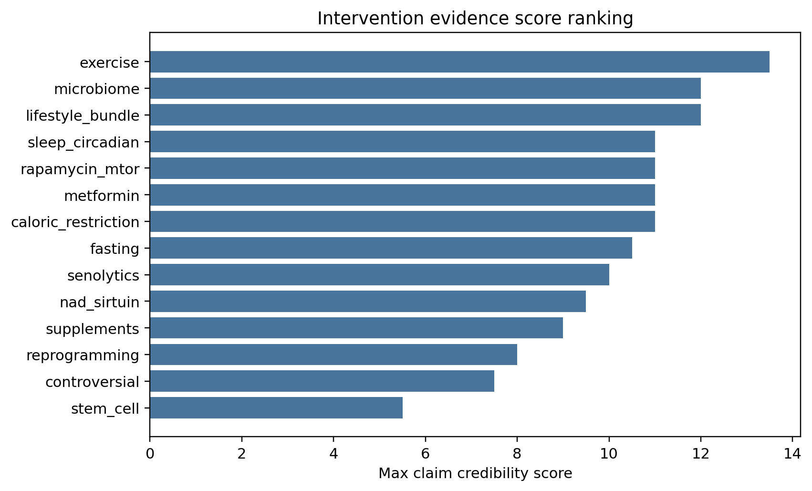
Figure 3. Hype-versus-evidence map comparing credibility score with hype-language burden by intervention domain.
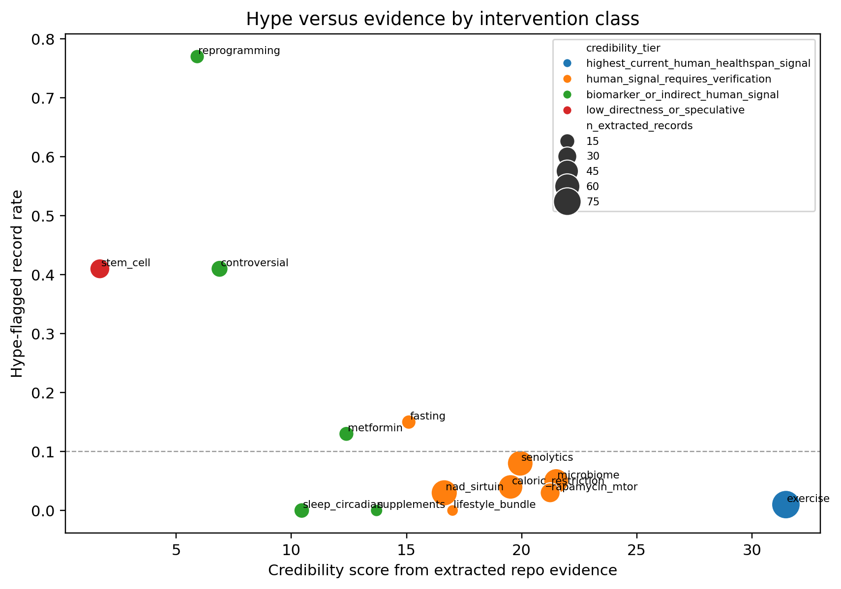
Figure 4. Translational readiness matrix showing conservative category assignment by intervention domain.
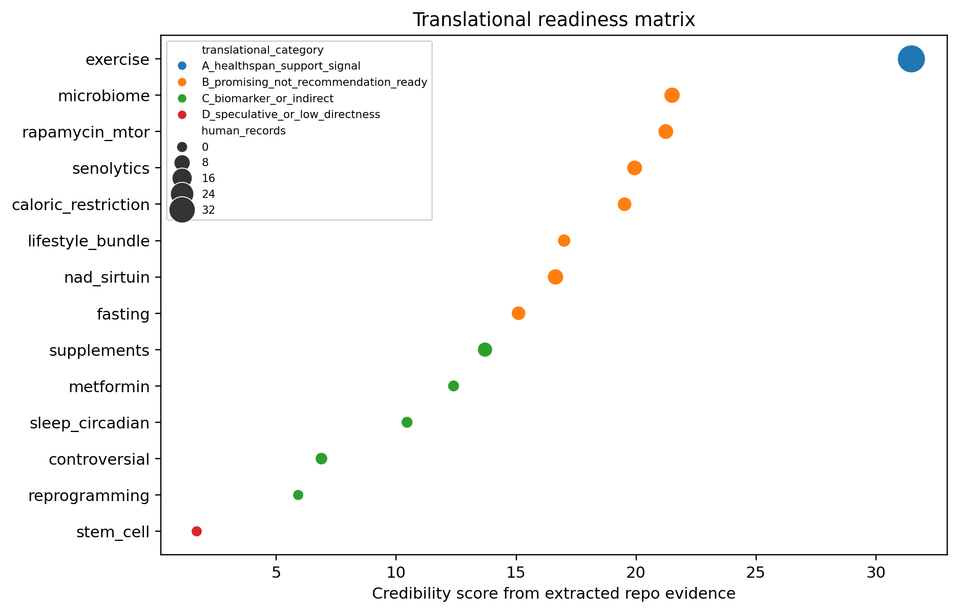

References
1. Yap KH, Chen C, Chong EJY, Kandiah N, Kivipelto M, Lai MKP, Maier AB, Matchar DB, Phua AKS, Teo CKL, Xu X, Zhou HJ, Chen CPL. Baseline characteristics of the SINgapore GERiatric Intervention Study to Reduce Cognitive Decline and Physical Frailty (SINGER) multidomain dementia prevention randomized controlled trial and insights from the recruitment process. Alzheimers Dement. 2026. doi: 10.1002/alz.71313.
2. Zanotto T, Tabatabaei A, Lynch SG, He J, Lysaught M, Ahmadnezhad P, Ibude J, Devos H, Chaves LD, Troen BR, Sosnoff JJ. Reducing frailty in frail people with multiple sclerosis: Feasibility of a 6-week multimodal exercise training program. PLoS One. 2026. doi: 10.1371/journal.pone.0347063.
3. Ni Lochlainn M; Bowyer RCE; Moll JM; García MP; Wadge S; Baleanu AF; Nessa A; Sheedy A. Effect of gut microbiome modulation on muscle function and cognition: the PROMOTe randomised controlled trial. Nature communications. 2024. PMID: 38424099.
4. Tuan SH; Chang LH; Sun SF; Li CH; Chen GB; Tsai YJ. Assessing the Clinical Effectiveness of an Exergame-Based Exercise Training Program Using Ring Fit Adventure to Prevent and Postpone Frailty and Sarcopenia Among Older Adults in Rural Long-Term Care Facilities: Randomized Controlled Trial. Journal of medical Internet research. 2024. PMID: 39024000.
5. Yoon D.H.; Lee Jun-Young; Song Wook. Effects of Resistance Exercise Training on Cognitive Function and Physical Performance in Cognitive Frailty: A Randomized Controlled Trial. The Journal of nutrition, health and aging. 2018. doi: 10.1007/s12603-018-1090-9.
6. Zhu Z, Zhou X, Chen M, Dou C, Liu D, Kong L, Ye C, Xu M, Xu Y, Li M, Zhao Z, Zheng J, Lu J, Chen Y, Wang W, Ning G, Bi Y, Wang T. Interaction between physical activity and deficit-based frailty on all-cause mortality in older adults: a prospective study of five population-based cohorts. Lancet Reg Health West Pac. 2026. doi: 10.1016/j.lanwpc.2025.101780.
7. Brandhorst S; Levine ME; Wei M; Shelehchi M; Morgan TE; Nayak KS; Dorff T; Hong K. Fasting-mimicking diet causes hepatic and blood markers changes indicating reduced biological age and disease risk. Nature communications. 2024. PMID: 38378685.
8. Chung CL; Lawrence I; Hoffman M; Elgindi D; Nadhan K; Potnis M; Jin A; Sershon C. Topical rapamycin reduces markers of senescence and aging in human skin: an exploratory, prospective, randomized trial. GeroScience. 2019. PMID: 31761958.
9. Moel M; Harinath G; Lee V; Nyquist A; Morgan SL; Isman A; Zalzala S. Influence of rapamycin on safety and healthspan metrics after one year: PEARL trial results. Aging. 2025. PMID: 40188830.
10. Brandhorst S; Choi IY; Wei M; Cheng CW; Sedrakyan S; Navarrete G; Dubeau L; Yap LP. A Periodic Diet that Mimics Fasting Promotes Multi-System Regeneration, Enhanced Cognitive Performance, and Healthspan. Cell metabolism. 2015. PMID: 26094889.
11. COLLINS J.; LONGHURST G.; ROSCHEL H.; GUALANO B. RESISTANCE TRAINING AND CO-SUPPLEMENTATION WITH CREATINE AND PROTEIN IN OLDER SUBJECTS WITH FRAILTY. Journal of Frailty & Aging. 2016. doi: 10.14283/jfa.2016.85.
12. Houston DK, Fanning J, Nicklas BJ, Delany JP, Hsu FC, Chen SH, Walkup M, Neiberg RH, Stowe CL, Kennedy K, Espeland MA, Ard JD, Miller ME, Rejeski WJ, Kritchevsky SB. Caloric restriction and time-restricted eating in older adults with overweight or obesity: The Health, Aging, and Later-Life Outcomes Pilot Study. J Gerontol A Biol Sci Med Sci. 2026. doi: 10.1093/gerona/glag061.
13. Olaso-Gonzalez G, Millan-Domingo F, Garcia-Fernandez L, Garcia-Tercero E, Cebrian M, Garcia-Dominguez C, Carbonell JA, Casabo-Valles G, Garcia-Gimenez JL, Tamayo-Torres E, Gambini J, Tarazona-Santabalbina FJ, Vina J, Gomez-Cabrera MC. A Multidomain Lifestyle Intervention Is Associated With Improved Functional Trajectories and Favorable Changes in Epigenetic Aging Markers in Frail Older Adults: A Randomized Controlled Trial. Aging Cell. 2026. doi: 10.1111/acel.70376.
14. Ji J, Crespi CM, Yee L, Zekster YA, Al-Saleem A, Petersen L, Lee C, Son N, Smith C, Evans T, Tchkonia T, Kirkland JL, Kuchel GA, Cohen HJ, Sedrak MS. A phase II randomized placebo-controlled study of fisetin to improve physical function in breast cancer survivors: the TROFFi study rationale and trial design. Ther Adv Med Oncol. 2026. doi: 10.1177/17588359261424668.
15. Mihaiescu-Ion V, Ortega-Gómez S, Domínguez-Navarro A, Ayala-Martinez C, Llerena-Guerrero R, Pérez-Cabezas V, González-Medina G, Losa-Reyna J, Galan-Mercant A. Viability of an educational program for lifestyle changes and an algorithm for the derivation of exercise programs in older people at risk of dependency at primary care: PRICA-POWFRAIL study protocol. BMC Geriatr. 2026. doi: 10.1186/s12877-025-06902-9.
16. Robinson LA, Cavanah AM, Lennon S, Mattingly ML, Pol WV, Huggins KW, Greene MW, Roberts MD, Frugé AD. Epigenetic and microbiome responses to greens supplementation in obese older adults: results from a randomized crossover-controlled trial. Front Nutr. 2026. doi: 10.3389/fnut.2026.1750030.
17. Coleman AE; Creevy KE; Anderson R; Reed MJ; Fajt VR; Aicher KM; Atiee G; Barnett BG. Test of Rapamycin in Aging Dogs (TRIAD): study design and rationale for a prospective, parallel-group, double-masked, randomized, placebo-controlled, multicenter trial of rapamycin in healthy middle-aged dogs from the Dog Aging Project. GeroScience. 2025. PMID: 39951177.
18. Pihlstrøm Lasse; Frich Jan; Walsem Marleen van. J012 NAD-HD: a randomized clinical trial of nicotinamide riboside in Huntington’s disease. J: Clinical therapeutics. 2024. doi: 10.1136/jnnp-2024-ehdn.333.
19. Nilsson MI; Xhuti D; de Maat NM; Hettinga BP; Tarnopolsky MA. Obesity and Metabolic Disease Impair the Anabolic Response to Protein Supplementation and Resistance Exercise: A Retrospective Analysis of a Randomized Clinical Trial with Implications for Aging, Sarcopenic Obesity, and Weight Management. Nutrients. 2024. PMID: 39771028.
20. Journal of Aging and Physical Activ. Erratum. Effects of Dancing Associated With Resistance Training on Functional Parameters and Quality of Life of Aging Women: A Randomized Controlled Trial. Journal of Aging and Physical Activity. 2023. doi: 10.1123/japa.2023-0257.
21. Yi L; Maier AB; Tao R; Lin Z; Vaidya A; Pendse S; Thasma S; Andhalkar N. The efficacy and safety of β-nicotinamide mononucleotide (NMN) supplementation in healthy middle-aged adults: a randomized, multicenter, double-blind, placebo-controlled, parallel-group, dose-dependent clinical trial. GeroScience. 2023. PMID: 36482258.
22. Waziry R; Ryan CP; Corcoran DL; Huffman KM; Kobor MS; Kothari M; Graf GH; Kraus VB. Effect of long-term caloric restriction on DNA methylation measures of biological aging in healthy adults from the CALERIE trial. Nature aging. 2023. PMID: 37118425.
23. Fiorito G; Caini S; Palli D; Bendinelli B; Saieva C; Ermini I; Valentini V; Assedi M. DNA methylation-based biomarkers of aging were slowed down in a two-year diet and physical activity intervention trial: the DAMA study. Aging cell. 2021. PMID: 34535961.
24. Stares A; Bains M. The Additive Effects of Creatine Supplementation and Exercise Training in an Aging Population: A Systematic Review of Randomized Controlled Trials. Journal of geriatric physical therapy (2001). 2020. PMID: 30762623.
25. Casas-Herrero A; Anton-Rodrigo I; Zambom-Ferraresi F; Sáez de Asteasu ML; Martinez-Velilla N; Elexpuru-Estomba J; Marin-Epelde I; Ramon-Espinoza F. Effect of a multicomponent exercise programme (VIVIFRAIL) on functional capacity in frail community elders with cognitive decline: study protocol for a randomized multicentre control trial. Trials. 2019. PMID: 31208471.
26. Vlietstra L.; Fordyce A.M.; Costa E.C.; Coffey S.; Walker X.J.; Whalley G.A.; Waters D.L. Exercise interventions to improve physical frailty and physical frailty components in older adults with hypertension: A systematic review. Ageing Research Reviews. 2025. doi: 10.1016/j.arr.2025.102714.
27. Billot M; Calvani R; Urtamo A; Sánchez-Sánchez JL; Ciccolari-Micaldi C; Chang M; Roller-Wirnsberger R; Wirnsberger G. Preserving Mobility in Older Adults with Physical Frailty and Sarcopenia: Opportunities, Challenges, and Recommendations for Physical Activity Interventions. Clinical interventions in aging. 2020. PMID: 32982201.
28. Muñoz-Pardeza J, López-Gil JF, Hormazábal-Aguayo I, Izquierdo M, Agostinis-Sobrinho C, Ezzatvar Y, García-Hermoso A. Effects of Diactive-1-Supported Progressive Resistance Training on Body Composition in Youth With Type 1 Diabetes. J Cachexia Sarcopenia Muscle. 2026. doi: 10.1002/jcsm.70257.
29. Racette SB, Silver RE, Barry VG, DeGraff JJ, Gunning JA, Kebbe M, Gilhooly CH, Das SK. Diet quality and nutritional adequacy during a 2-year calorie restriction intervention: the Comprehensive Assessment of Long-Term Effects of Reducing Intake of Energy 2 trial. Am J Clin Nutr. 2026. doi: 10.1016/j.ajcnut.2025.101182.
30. Veronese N, Gianfredi V, Smith L, Al-Daghri N, Barratt J, Beaudart C, Bellelli G, Bruyère O, Diaz-Ponce AM, Demurtas J, Firth J, Frederiksen KS, Karpenko O, Limongi F, Petrovic M, Prokopidis K, Reginster JY, Rizzoli R, Ramalho R, Sabico S, Schuch FB, Schlögl M, Shenkin SD, Sieber C, Solmi M, Soysal P, Stubbs B, Yang L, Zanetti M, Maggi S. Recommendations from the European interdisciplinary council on ageing on physical activity and diet for mental health conditions in older adults. Aging Clin Exp Res. 2026. doi: 10.1007/s40520-025-03315-x.
31. Ying YY, Chen X, Yao SY, Chen RX, Ying Y, Qiu H, Xu QQ, Li ZY, Ye CQ, Qian YL, Liang HQ, Sun X, Zhang D. Circadian rhythm disruption impairs ovarian follicular development via NAD<sup>+</sup> metabolic reprogramming. EBioMedicine. 2026. doi: 10.1016/j.ebiom.2026.106200.
32. Berven H, Svensen M, Eikeland H, Tvedten N, Sheard EV, Af Geijerstam SA, Søgnen M, McCann A, Arnsten L, Årseth O, Skjeie V, Hjellbrekke A, Skeie GO, Torres Cleuren YN, Nido GS, Haugarvoll K, Riemer F, Tzoulis C, Dölle C. The NAD-brain pharmacokinetic study of NAD augmentation in blood and brain using oral precursor supplementation. iScience. 2026. doi: 10.1016/j.isci.2026.114764.
33. Kell L, Jones EJ, Gharahdaghi N, Wilkinson DJ, Smith K, Atherton PJ, Simon AK, Cox LS, Alsaleh G. Rapamycin Exerts Its Geroprotective Effects in the Ageing Human Immune System by Enhancing Resilience Against DNA Damage. Aging Cell. 2026. doi: 10.1111/acel.70364.
34. Bautista J, López-Cortés A. Biohacking the human gut microbiome for precision health and therapeutic innovation. Front Microbiol. 2026. doi: 10.3389/fmicb.2026.1776983.
35. Liu C, Lu L, Wei W. Research advances in exercise management for frail older adults. Front Public Health. 2026. doi: 10.3389/fpubh.2026.1763583.
36. Shi M, Ge W. Editorial: Integrated strategies for lifelong health: multidimensional approaches to aging and lifestyle interventions. Front Public Health. 2026. doi: 10.3389/fpubh.2026.1777378.
37. Sáez-Nieto C, Pérez-Rodríguez P, Matovelle P, Rodríguez-Mañas L, Coelho-Júnior HJ, Rodríguez-Sánchez I. Effects of exercise training on frail older adults with heart failure: a systematic-review. Front Aging. 2026. doi: 10.3389/fragi.2026.1800669.
38. Lim MJS, Parlindungan E, See E, Gan CH, Yap R, Yong GJM. Diet, the Gut Microbiome, and Estrogen Physiology: A Review in Menopausal Health and Interventions. Nutrients. 2026. doi: 10.3390/nu18071052.
39. Poisnel G, Lhérault M, Palix C, Turpin A, Felisatti F, Vrillon A, Paquet C, Chocat A, Coulbault L, De La Sayette V, Gonneaud J, Chételat G. Physical activity attenuates the association between allostatic load and early Alzheimer's disease‐related biomarkers in older adults. Alzheimers Dement (N Y). 2026.
40. Gulej R, Patai R, Ungvari A, Kallai A, Tarantini S, Yabluchanskiy A, Huffman DM, Conboy MJ, Conboy IM, Kivimäki M, Csiszar A, Ungvari Z. Impacts of systemic milieu on cerebrovascular and brain aging: insights from heterochronic parabiosis, blood exchange, and plasma transfer experiments. Geroscience. 2025. doi: 10.1007/s11357-025-01657-y.

