Anti-ageing Interventions and DNA Methylation Biomarkers of Biological Age: A Narrow Meta-analysis of Peer-reviewed Human Studies
Article type: Review article / systematic review with quantitative synthesis
Running title: Anti-ageing biomarker meta-analysis

Abstract
Background: Claims that anti-ageing interventions slow or reverse biological ageing have expanded faster than the pool of human trials reporting quantitatively usable biomarker outcomes. A narrow quantitative synthesis is needed to distinguish peer-reviewed, poolable evidence from broader but methodologically heterogeneous claims.
Objective: To perform a conservative meta-analysis of peer-reviewed human intervention studies reporting directly extractable quantitative effects on DNA methylation biomarkers of ageing.
Methods: This add-on was layered on top of the parent systematic review pipeline. Only peer-reviewed human intervention studies with direct between-group effect estimates and confidence intervals or standard errors were eligible for the primary pooled analysis. Preprints, reconstructed endpoints, crossover analyses without paired variance, and studies reporting only p values, medians, or adherence analyses were excluded from the primary pool.
Results: The only peer-reviewed outcome family meeting the primary pooling rule was DunedinPACE, represented by CALERIE and DO-HEALTH. The pooled standardized effect estimate was -0.203 (95% CI -0.306 to -0.100; I2 = 0%).
Conclusion: The peer-reviewed human quantitative evidence base remains narrow. A modest DunedinPACE signal is present, but it rests on two trials and should not be generalized to broad claims of age reversal.
Keywords: anti-ageing; biological age; DunedinPACE; DNA methylation; caloric restriction; omega-3; meta-analysis

Introduction
Human intervention studies increasingly report DNA methylation biomarkers of ageing, but far fewer present treatment contrasts in a form suitable for quantitative synthesis.^{[1,2]}
This matters because biomarker enthusiasm can outrun the actual pool of comparator-based, peer-reviewed human evidence.

Methods
This study was conducted as a quantitative add-on to the parent systematic review of anti-ageing and age-reversal interventions. Search, screening, and source discovery were inherited from the parent pipeline, but quantitative inclusion was stricter.
The primary pool was restricted to peer-reviewed human intervention studies with directly extractable between-group estimates and confidence intervals or standard errors for DNA methylation biomarkers of ageing. Preprints, reconstructed endpoints, crossover analyses without paired variance, p values without uncertainty, and adherence-based within-trial associations were excluded from the primary pooled model.
Same-outcome pooling was limited to outcome families with at least two independent studies and compatible effect metrics. DunedinPACE was treated as a biomarker of the pace of biological ageing rather than a direct clinical outcome.^{[3]}

Results
The only outcome family meeting the prespecified primary pooling rule was DunedinPACE. Two peer-reviewed human intervention trials contributed: CALERIE and DO-HEALTH.^{[1,2]}
The pooled standardized effect estimate was -0.203 (95% CI -0.306 to -0.100; I2 = 0%).
Table 1 summarizes the contributing studies. Figure 1 presents the study-level and pooled estimates.
This direction is consistent with a modest slowing of the pace of biological ageing, but it does not establish organismal rejuvenation or clinical age reversal.
Table 1. Primary peer-reviewed studies contributing to the DunedinPACE pooled analysis.
Study | Year | Intervention | Timepoint | Sample size | Effect estimate (95% CI) | Risk of bias
CALERIE | 2023 | caloric_restriction | 24_months_itt | 128 vs 69 | -0.250 (-0.410 to -0.090) | low
DO-HEALTH | 2025 | omega_3 | 36_months_itt_main_effect | DNAm subset reported in source | -0.170 (-0.310 to -0.040) | Some concerns
Figure 1. Forest plot of the primary peer-reviewed DunedinPACE meta-analysis.
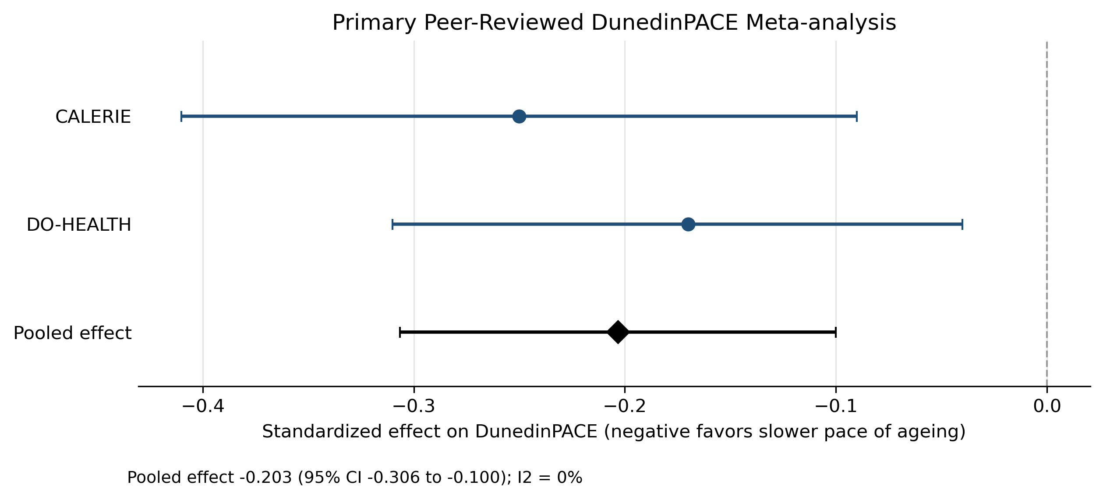
Negative standardized effects favor a slower pace of biological ageing.

Discussion
The main finding is not simply the magnitude of the pooled DunedinPACE effect, but the narrowness of the peer-reviewed evidence base that can be synthesized without weakening methodological standards.
Several additional human intervention-clock studies were identified in the wider audit trail, but most failed the primary pooling rule because they reported medians without variance, p values without confidence intervals, adherence-based regression coefficients, or sensitivity-level reconstructed estimates.
The present pooled result is therefore better interpreted as evidence of biomarker-level modulation than proof of reversed ageing.^{[3]}

Strengths and Limitations
Strengths include strict peer-reviewed-only pooling, direct uncertainty requirements, explicit exclusion of sensitivity-only estimates from the primary model, and a complete audit trail for excluded candidate studies.
Limitations include reliance on two studies for the pooled DunedinPACE model, biomarker rather than clinical endpoints, and incomplete quantitative reporting across the broader literature.

Conclusion
The current peer-reviewed quantitative evidence for anti-ageing interventions on DNA methylation biomarkers is narrow but nonzero. A modest pooled DunedinPACE signal is present across CALERIE and DO-HEALTH, but the field still lacks enough directly extractable randomized contrasts to support broader quantitative claims.

Declarations
Ethics approval and consent to participate: Not applicable; this review used published reports, public bibliographic metadata, and open-access text where available.
Consent for publication: Not applicable.
Funding: No external funding was declared for this manuscript package.
Conflicts of interest: None declared.
Data availability: The extraction tables, pooled datasets, audit files, figure assets, and rendering scripts are available within the project repository.
Author contributions: The author conceived the project, supervised the review process, audited the extracted evidence, and approved the submission package.
Use of software assistance: Automated scripting and computational tooling were used for metadata handling, extraction support, pooling, figure rendering, and document assembly. Final scientific responsibility rests with the author.

References
1. Belsky DW, Huffman KM, Pieper CF, Shalev I, Kraus WE, Kraus VB, et al. Effect of long-term caloric restriction on DNA methylation measures of biological aging in healthy adults from the CALERIE trial. Nature Aging. 2023;3:248-257. doi:10.1038/s43587-022-00357-y.
2. Bischoff-Ferrari HA, Paulussen M, Chocano-Bedoya PO, Vellas B, Rizzoli R, Cao L, et al. Individual and additive effects of vitamin D, omega-3 and exercise on DNA methylation clocks of biological aging in older adults from the DO-HEALTH trial. Nature Aging. 2025;5:266-278. doi:10.1038/s43587-024-00793-y.
3. Belsky DW, Caspi A, Corcoran DL, Sugden K, Poulton R, Arseneault L, et al. DunedinPACE, a DNA methylation biomarker of the pace of aging. eLife. 2022;11:e73420. doi:10.7554/eLife.73420.

