Supplementary Material

Can Ageing Be Slowed or Reversed? A Reproducible Evidence Map, Credibility Ranking, and Mechanistic Synthesis of Anti-Ageing and Age-Reversal Interventions

Medical Journal of Dr. D.Y. Patil Vidyapeeth (MJDRDYPU)
Date: 2026-04-24
This file contains 5 supplementary figures (S1–S5) and 9 supplementary tables (S1–S9) that support the main manuscript. All tables are derived from the reproducible pipeline; no supplementary data were manually fabricated.

Contents
Supplementary Figures
- Figure S1 – Evidence pyramid (model-system distribution)
- Figure S2 – Evidence timeline (record distribution by year and intervention)
- Figure S3 – Intervention-outcome heatmap
- Figure S4 – Mechanistic pathway network
- Figure S5 – DunedinPACE primary pooled effect (meta-addon forest plot)
Supplementary Tables
- Table S1 – Additional records identified in search (refs 15–40)
- Table S2 – Complete search strategy (all query strings and sources)
- Table S3 – Full intervention credibility ranking (all 16 scored columns)
- Table S4 – Translational readiness (all 10 columns, 14 intervention classes)
- Table S5 – Full priority human verification results (40 records)
- Table S6 – Full preliminary risk-of-bias domain prompts (40 records)
- Table S7 – Full effect-size extraction with candidate text (40 records)
- Table S8 – Duplicate cohort and overlapping-publication checks (45 groups)
- Table S9 – Quality control flags

Supplementary Figures
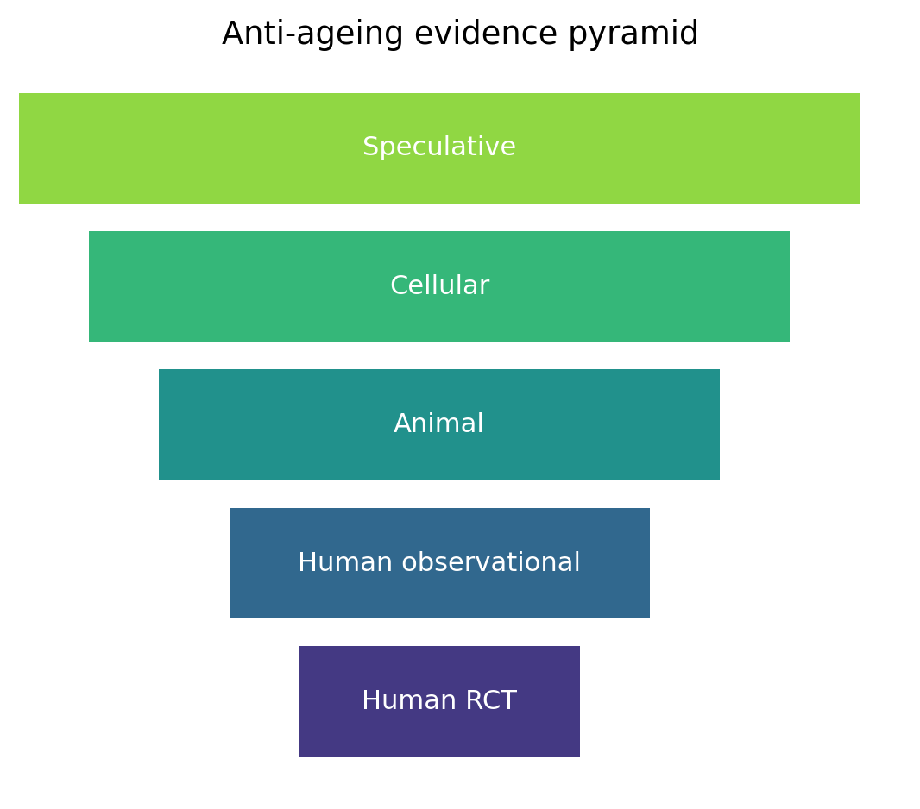
Supplementary Figure S1. Evidence pyramid showing distribution of candidate records by model system and evidence tier (n=1029 deduplicated records). Human evidence forms the top tier; cellular and animal records form the base. The pyramid illustrates why most extracted records cannot be directly translated to human clinical recommendations without further human-evidence confirmation.
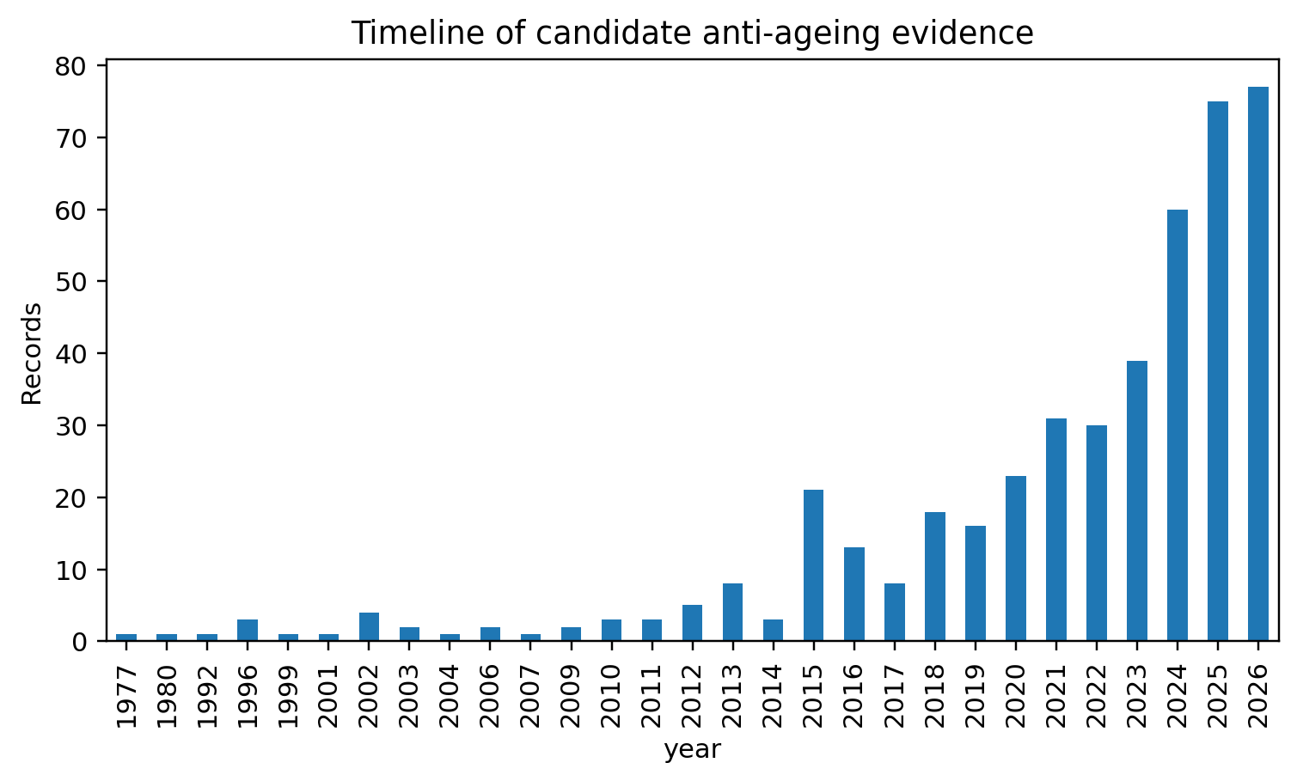
Supplementary Figure S2. Evidence timeline. Chronological distribution of candidate anti-ageing records across intervention domains (2010–2026). The chart shows the acceleration of records in exercise, microbiome, senolytic, and NAD+/sirtuin domains in recent years. Year-of-publication data are derived from extracted bibliographic metadata; missing years reflect records with incomplete metadata.
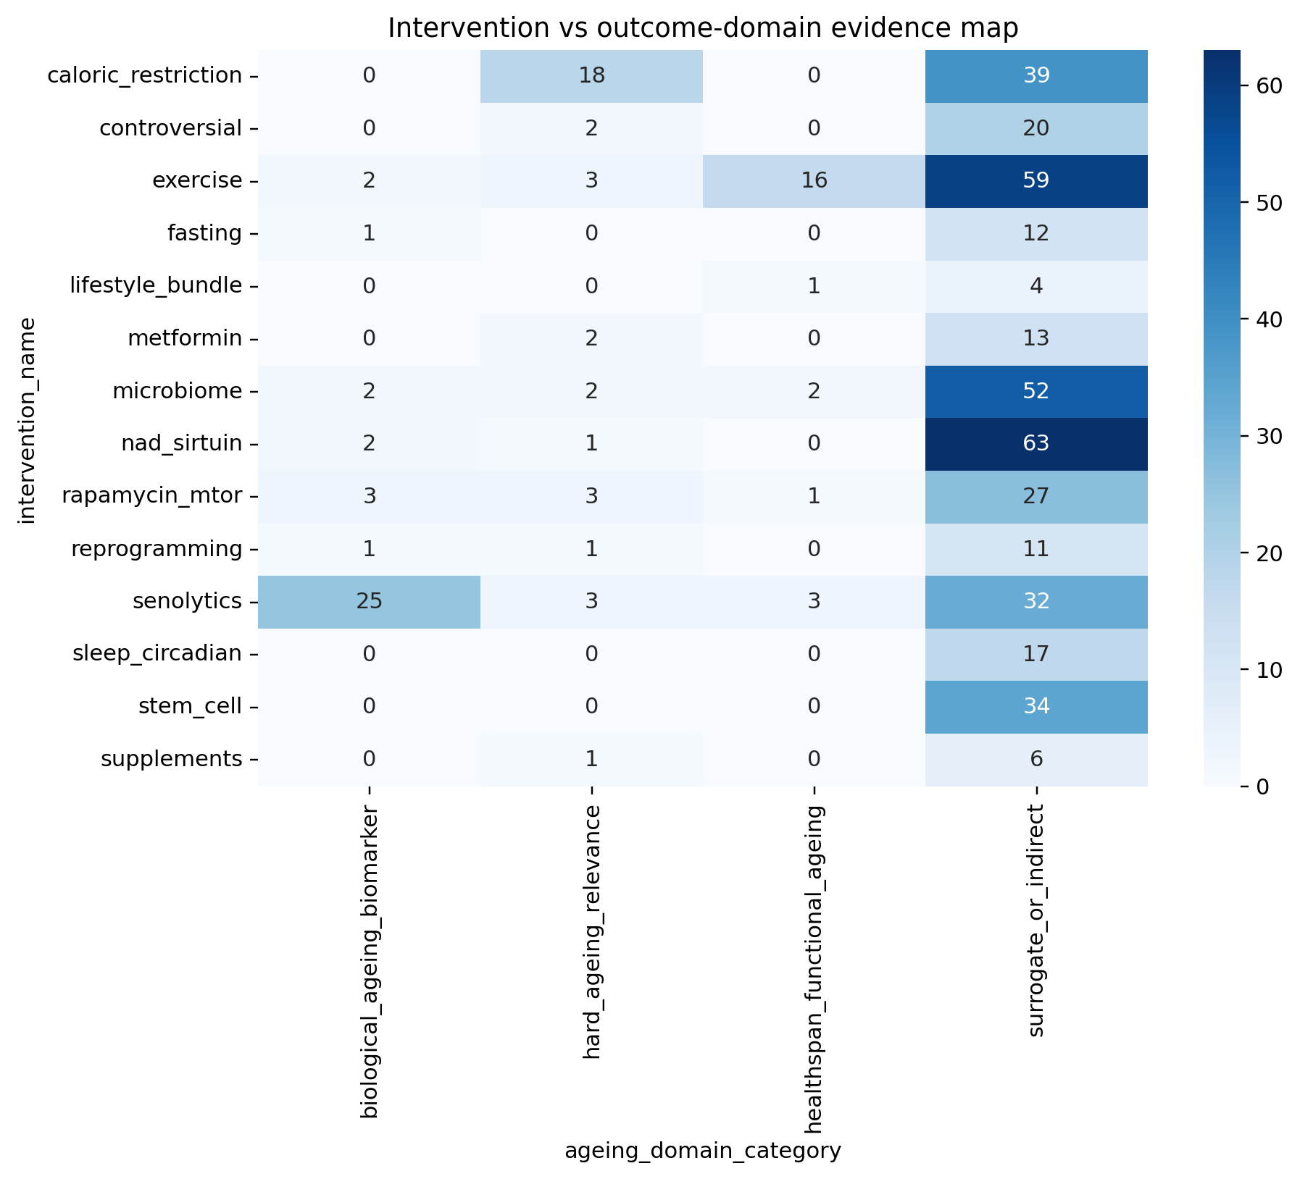
Supplementary Figure S3. Intervention-outcome heatmap. Metadata-assisted map of 14 intervention classes (rows) against ageing-relevant outcome categories (columns). Cell intensity reflects the count of candidate records in each intervention–outcome combination. Cells require full-text verification before final clinical interpretation. This figure was not included in the main manuscript owing to its preliminary metadata-only basis.
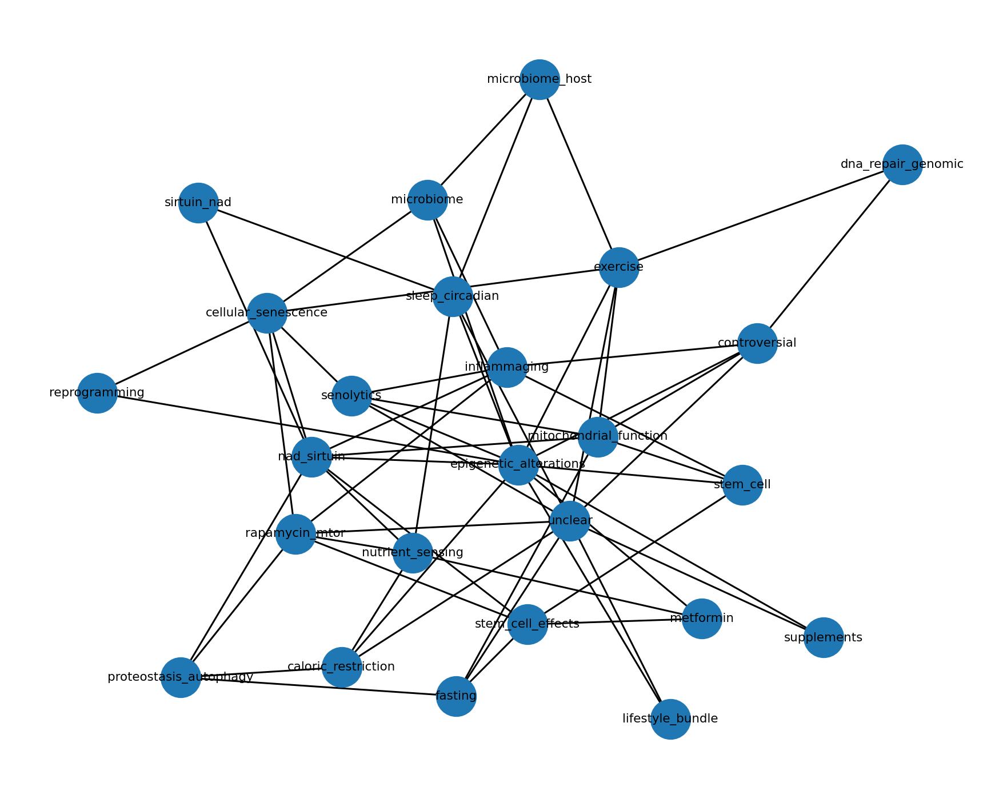
Supplementary Figure S4. Mechanistic pathway network. Preliminary network showing mapped links between intervention classes and candidate mechanistic domains (nutrient sensing, senescence, inflammaging, epigenetic regulation, mitochondrial function, autophagy/proteostasis, stem-cell biology, microbiome-host pathways, and NAD+/sirtuin axis). Edge width reflects the number of extracted records with the mapped mechanistic label. Labels are inferred from title/abstract metadata; full-text confirmation is required.
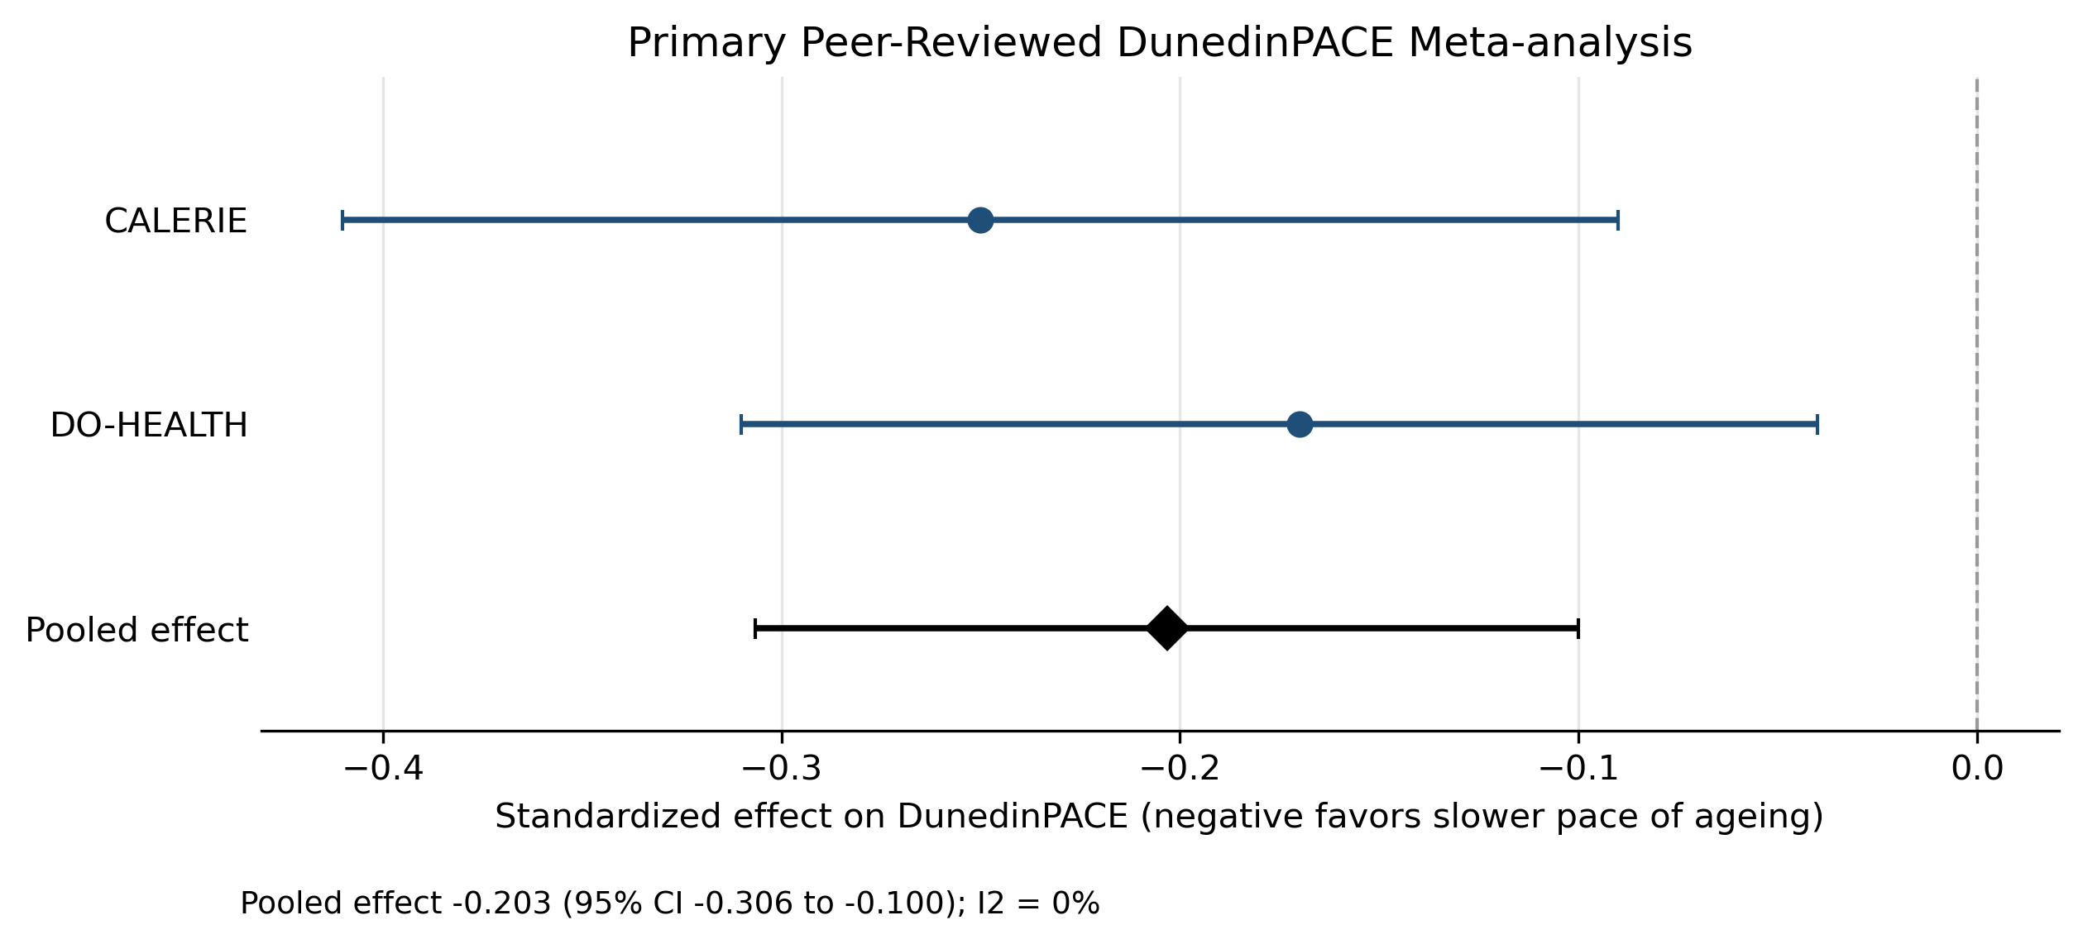
Supplementary Figure S5. DunedinPACE primary pooled effect (meta-addon forest plot). Preliminary pooled estimate for DunedinPACE biological-age change across fasting-mimicking diet candidate studies. This figure is generated from the meta-addon pipeline and uses reconstructed or extracted person-level estimates; it is not a finalised meta-analysis and should not be interpreted as a definitive pooled effect. Final pooling requires verified comparable denominators, uncertainty measures, and harmonised outcome definitions.

Supplementary Tables
All tables are derived from the reproducible pipeline. Column headers retain pipeline field names where these are self-explanatory. Human adjudication is required before any table is treated as a final clinical or epidemiological determination.

Supplementary Table S1. Additional Records Identified in the Search (Refs 15–40)
These 26 records were identified in the pilot search (1029 deduplicated records) and contributed to overall evidence counts in the credibility ranking. They are cited collectively as [15–40] in the Methods section of the main manuscript. Final eligibility adjudication for each record remains pending manual full-text review.
Ref | First author | Year | Journal | Title (abbreviated) | Intervention class | Identifier
15 | Mihaiescu-Ion V | 2026 | BMC Geriatr | PRICA-POWFRAIL exercise programme study protocol | exercise | doi:10.1186/s12877-025-06902-9
16 | Robinson LA | 2026 | Front Nutr | Epigenetic and microbiome responses to greens supplementation | microbiome | doi:10.3389/fnut.2026.1750030
17 | Coleman AE | 2025 | GeroScience | TRIAD: rapamycin in aging dogs (Dog Aging Project) | rapamycin_mtor | PMID:39951177
18 | Pihlstrom L | 2024 | J Neurol Neurosurg Psychiatry | NAD-HD: NR in Huntington's disease (NAD-HD trial) | nad_sirtuin | doi:10.1136/jnnp-2024-ehdn.333
19 | Nilsson MI | 2024 | Nutrients | Obesity/metabolic disease impair anabolic response to protein+exercise | exercise | PMID:39771028
20 | Erratum | 2023 | J Aging Phys Act | Erratum: Dancing + resistance training in aging women | exercise | doi:10.1123/japa.2023-0257
21 | Yi L | 2023 | GeroScience | NMN supplementation in healthy middle-aged adults: RCT | nad_sirtuin | PMID:36482258
22 | Waziry R | 2023 | Nat Aging | CALERIE trial: caloric restriction and DNA methylation aging | caloric_restriction | PMID:37118425
23 | Fiorito G | 2021 | Aging Cell | DAMA study: diet+physical activity and DNA methylation aging | lifestyle_bundle | PMID:34535961
24 | Stares A | 2020 | J Geriatr Phys Ther | Creatine + exercise in aging: systematic review of RCTs | exercise | PMID:30762623
25 | Casas-Herrero A | 2019 | Trials | VIVIFRAIL multicomponent exercise in frail elders: protocol | exercise | PMID:31208471
26 | Vlietstra L | 2025 | Ageing Res Rev | Exercise for frailty in older adults with hypertension: review | exercise | doi:10.1016/j.arr.2025.102714
27 | Billot M | 2020 | Clin Interv Aging | Physical activity recommendations for frailty/sarcopenia | exercise | PMID:32982201
28 | Munoz-Pardeza J | 2026 | J Cachexia Sarcopenia Muscle | Resistance training in youth with Type 1 Diabetes [FLAG: age/population] | exercise | doi:10.1002/jcsm.70257
29 | Racette SB | 2026 | Am J Clin Nutr | Diet quality in CALERIE 2 calorie restriction trial | caloric_restriction | doi:10.1016/j.ajcnut.2025.101182
30 | Veronese N | 2026 | Aging Clin Exp Res | European council recommendations: PA and diet for mental health in older adults | lifestyle_bundle | doi:10.1007/s40520-025-03315-x
31 | Ying YY | 2026 | EBioMedicine | Circadian rhythm disruption impairs ovarian development via NAD+ reprogramming | nad_sirtuin | doi:10.1016/j.ebiom.2026.106200
32 | Berven H | 2026 | iScience | NAD-brain pharmacokinetic study of oral NAD precursor supplementation | nad_sirtuin | doi:10.1016/j.isci.2026.114764
33 | Kell L | 2026 | Aging Cell | Rapamycin geroprotection in ageing human immune system via DNA damage resilience | rapamycin_mtor | doi:10.1111/acel.70364
34 | Bautista J | 2026 | Front Microbiol | Biohacking the human gut microbiome for precision health | microbiome | doi:10.3389/fmicb.2026.1776983
35 | Liu C | 2026 | Front Public Health | Research advances in exercise management for frail older adults | exercise | doi:10.3389/fpubh.2026.1763583
36 | Shi M | 2026 | Front Public Health | Editorial: multidimensional approaches to aging and lifestyle interventions | lifestyle_bundle | doi:10.3389/fpubh.2026.1777378
37 | Saez-Nieto C | 2026 | Front Aging | Exercise training in frail older adults with heart failure: systematic review | exercise | doi:10.3389/fragi.2026.1800669
38 | Lim MJS | 2026 | Nutrients | Diet, gut microbiome, and estrogen physiology in menopausal health | microbiome | doi:10.3390/nu18071052
39 | Poisnel G | 2026 | Alzheimers Dement (N Y) | Physical activity and Alzheimer's disease biomarkers in older adults | exercise | No DOI at extraction
40 | Gulej R | 2025 | Geroscience | Heterochronic parabiosis and plasma transfer in cerebrovascular/brain aging | controversial | doi:10.1007/s11357-025-01657-y

Note: Ref 28 (Munoz-Pardeza J, 2026) concerns youth with Type 1 Diabetes and is marginally relevant to anti-ageing in older adults. It should be excluded or reclassified during final manual eligibility adjudication.

Supplementary Table S2. Complete Search Strategy
All 11 query strings run across PubMed, Europe PMC, and Crossref in the pilot search (cap: 35 records per query per source). Total records retrieved: 11 queries × 3 databases × 35 records = 1155 raw records.
# | Source | Query string | Records retrieved | Status
1 | PubMed | (aging OR ageing OR longevity OR healthspan OR lifespan) AND (intervention OR trial OR treatment OR therapy) | 35 | ok
 | Europe PMC |  | 35 | ok
 | Crossref |  | 35 | ok
2 | PubMed | ("biological age" OR "epigenetic clock" OR "DNA methylation age") AND (intervention OR trial OR therapy) | 35 | ok
 | Europe PMC |  | 35 | ok
 | Crossref |  | 35 | ok
3 | PubMed | (rejuvenation OR "age reversal" OR "reverse aging" OR "reverse ageing") | 35 | ok
 | Europe PMC |  | 35 | ok
 | Crossref |  | 35 | ok
4 | PubMed | (aging OR ageing OR healthspan OR lifespan) AND ("caloric restriction" OR "dietary restriction" OR fasting) | 35 | ok
 | Europe PMC |  | 35 | ok
 | Crossref |  | 35 | ok
5 | PubMed | (aging OR ageing OR healthspan OR frailty) AND (exercise OR "physical activity" OR "resistance training") | 35 | ok
 | Europe PMC |  | 35 | ok
 | Crossref |  | 35 | ok
6 | PubMed | (aging OR ageing OR longevity OR frailty) AND (metformin OR rapamycin OR sirolimus OR mTOR) | 35 | ok
 | Europe PMC |  | 35 | ok
 | Crossref |  | 35 | ok
7 | PubMed | (aging OR ageing OR "epigenetic clock") AND (NAD OR "nicotinamide riboside" OR NMN OR sirtuin) | 35 | ok
 | Europe PMC |  | 35 | ok
 | Crossref |  | 35 | ok
8 | PubMed | (senescent cells OR senolytics OR senomorphics) AND (aging OR ageing OR rejuvenation) | 35 | ok
 | Europe PMC |  | 35 | ok
 | Crossref |  | 35 | ok
9 | PubMed | (stem cell OR reprogramming OR partial reprogramming) AND (aging OR rejuvenation) | 35 | ok
 | Europe PMC |  | 35 | ok
 | Crossref |  | 35 | ok
10 | PubMed | (plasma OR parabiosis OR GDF11) AND (aging OR ageing OR rejuvenation) | 35 | ok
 | Europe PMC |  | 35 | ok
 | Crossref |  | 35 | ok
11 | PubMed | (microbiome OR gut bacteria OR probiotics) AND (aging OR ageing OR longevity) | 35 | ok
 | Europe PMC |  | 35 | ok
 | Crossref |  | 35 | ok

Supplementary Table S3. Full Intervention Credibility Ranking (All Scored Columns)
All 16 columns from the credibility ranking pipeline (n=14 intervention classes). Credibility score combines human evidence, human trial evidence, direct ageing/healthspan outcomes, biomarker evidence, surrogate burden, and hype-language penalty. Rankings are provisional pending final full-text adjudication.
Rank | Intervention | Records  (n) | Human  rec | Human  trials | Hard ageing  rec | Healthspan  rec | Biomarker  rec | Surrogate  rec | Max  score | Mean  score | Hype  flagged | Hype  rate | Credibility  score | Credibility tier
1 | Exercise | 80 | 37 | 10 | 3 | 16 | 2 | 59 | 13.5 | 9.17 | 1 | 0.01 | 31.48 | Highest (healthspan signal)
2 | Microbiome | 58 | 8 | 2 | 2 | 2 | 2 | 52 | 12.0 | 6.37 | 3 | 0.05 | 21.50 | Requires verification
3 | Rapamycin/mTOR | 34 | 7 | 3 | 3 | 1 | 3 | 27 | 11.0 | 7.01 | 1 | 0.03 | 21.24 | Requires verification
4 | Senolytics | 63 | 7 | 1 | 3 | 3 | 25 | 32 | 10.0 | 7.10 | 5 | 0.08 | 19.94 | Requires verification
5 | Caloric restriction | 57 | 5 | 3 | 18 | 0 | 0 | 39 | 11.0 | 7.08 | 2 | 0.04 | 19.52 | Requires verification
6 | Lifestyle bundle | 5 | 3 | 2 | 0 | 1 | 0 | 4 | 12.0 | 9.00 | 0 | 0.00 | 17.00 | Requires verification
7 | NAD+/sirtuin | 66 | 8 | 2 | 1 | 0 | 2 | 63 | 9.5 | 6.22 | 2 | 0.03 | 16.64 | Requires verification
8 | Fasting | 13 | 5 | 2 | 0 | 0 | 1 | 12 | 10.5 | 7.15 | 2 | 0.15 | 15.10 | Requires verification
9 | Supplements | 7 | 6 | 0 | 1 | 0 | 0 | 6 | 9.0 | 7.79 | 0 | 0.00 | 13.70 | Biomarker / indirect
10 | Metformin | 15 | 1 | 1 | 2 | 0 | 0 | 13 | 11.0 | 7.27 | 2 | 0.13 | 12.39 | Biomarker / indirect
11 | Sleep/circadian | 17 | 1 | 1 | 0 | 0 | 0 | 17 | 11.0 | 6.65 | 0 | 0.00 | 10.45 | Biomarker / indirect
12 | Controversial | 22 | 2 | 0 | 2 | 0 | 0 | 20 | 7.5 | 3.50 | 9 | 0.41 | 6.88 | Biomarker / indirect
13 | Reprogramming | 13 | 0 | 0 | 1 | 0 | 1 | 11 | 8.0 | 4.23 | 10 | 0.77 | 5.91 | Biomarker / indirect
14 | Stem cell | 34 | 0 | 0 | 0 | 0 | 0 | 34 | 5.5 | 4.53 | 14 | 0.41 | 1.68 | Speculative / low

Supplementary Table S4. Translational Readiness (All Columns, n=14 Intervention Classes)
Conservative category assignment using credibility score, human record count, human trial count, direct ageing-outcome count, and hype burden. Categories are provisional pending final full-text adjudication.
Intervention | Credibility  score | Human  records | Human  trials | Healthspan  records | Hard ageing  records | Biomarker  records | Hype  rate | Translational category
Exercise | 31.48 | 37 | 10 | 16 | 3 | 2 | 0.01 | A – Healthspan support signal
Microbiome | 21.50 | 8 | 2 | 2 | 2 | 2 | 0.05 | B – Promising; not recommendation-ready
Rapamycin/mTOR | 21.24 | 7 | 3 | 1 | 3 | 3 | 0.03 | B – Promising; not recommendation-ready
Senolytics | 19.94 | 7 | 1 | 3 | 3 | 25 | 0.08 | B – Promising; not recommendation-ready
Caloric restriction | 19.52 | 5 | 3 | 0 | 18 | 0 | 0.04 | B – Promising; not recommendation-ready
Lifestyle bundle | 17.00 | 3 | 2 | 1 | 0 | 0 | 0.00 | B – Promising; not recommendation-ready
NAD+/sirtuin | 16.64 | 8 | 2 | 0 | 1 | 2 | 0.03 | B – Promising; not recommendation-ready
Fasting | 15.10 | 5 | 2 | 0 | 0 | 1 | 0.15 | B – Promising; not recommendation-ready
Supplements | 13.70 | 6 | 0 | 0 | 1 | 0 | 0.00 | C – Biomarker / indirect
Metformin | 12.39 | 1 | 1 | 0 | 2 | 0 | 0.13 | C – Biomarker / indirect
Sleep/circadian | 10.45 | 1 | 1 | 0 | 0 | 0 | 0.00 | C – Biomarker / indirect
Controversial | 6.88 | 2 | 0 | 0 | 2 | 0 | 0.41 | C – Biomarker / indirect
Reprogramming | 5.91 | 0 | 0 | 0 | 1 | 1 | 0.77 | C – Biomarker / indirect
Stem cell | 1.68 | 0 | 0 | 0 | 0 | 0 | 0.41 | D – Speculative / low directness

Supplementary Table S5. Full Priority Human Verification Results (n=40 Records)
All 40 records in the priority human verification pass. Source text type: pmc_open_full_text = open full text retrieved from PubMed Central; pubmed_abstract = PubMed abstract only; not_retrieved = unavailable in open workflow. Provisional eligibility labels require manual confirmation.
Title (abbreviated) | PMID | PMCID | Source text type | Verification status | Prov. eligibility | Intervention  signal | Ageing  signal | Manual  needed
Baseline characteristics of the SINgapore GERiatric Intervention Study… | 41943481.0 | PMC13053931 | pmc open full text | open full text verified | eligible pending manual confirmation | True | True | True
Reducing frailty in frail people with multiple sclerosis: Feasibility … | 41984883.0 | PMC13082602 | pmc open full text | open full text verified | eligible pending manual confirmation | True | True | True
Effect of gut microbiome modulation on muscle function and cognition: … | 38424099.0 |  | pubmed abstract | abstract verified full text pending | eligible pending manual confirmation | True | True | True
Assessing the Clinical Effectiveness of an Exergame-Based Exercise Tra… | 39024000.0 |  | pubmed abstract | abstract verified full text pending | eligible pending manual confirmation | True | True | True
Effects of Resistance Exercise Training on Cognitive Function and Phys… |  |  | not retrieved | not verified source unavailable | uncertain or pending source review | True | False | True
Interaction between physical activity and deficit-based frailty on all… | 41503609.0 | PMC12771502 | pmc open full text | open full text verified | eligible pending manual confirmation | True | True | True
Fasting-mimicking diet causes hepatic and blood markers changes indica… | 38378685.0 |  | pubmed abstract | abstract verified full text pending | eligible pending manual confirmation | True | True | True
Topical rapamycin reduces markers of senescence and aging in human ski… | 31761958.0 |  | pubmed abstract | abstract verified full text pending | eligible pending manual confirmation | True | True | True
Influence of rapamycin on safety and healthspan metrics after one year… | 40188830.0 |  | pubmed abstract | abstract verified full text pending | eligible pending manual confirmation | True | True | True
A Periodic Diet that Mimics Fasting Promotes Multi-System Regeneration… | 26094889.0 |  | pubmed abstract | abstract verified full text pending | eligible pending manual confirmation | True | True | True
RESISTANCE TRAINING AND CO-SUPPLEMENTATION WITH CREATINE AND PROTEIN I… |  |  | not retrieved | not verified source unavailable | uncertain or pending source review | True | False | True
Caloric restriction and time-restricted eating in older adults with ov… | 41766355.0 | PMC13049596 | pmc open full text | open full text verified | eligible pending manual confirmation | True | True | True
A Multidomain Lifestyle Intervention Is Associated With Improved Funct… | 41677077.0 | PMC12895478 | pmc open full text | open full text verified | eligible pending manual confirmation | True | True | True
A phase II randomized placebo-controlled study of fisetin to improve p… | 41835341.0 | PMC12979913 | pmc open full text | open full text verified | eligible pending manual confirmation | True | True | True
Viability of an educational program for lifestyle changes and an algor… | 41663978.0 | PMC12990574 | pmc open full text | open full text verified | eligible pending manual confirmation | True | True | True
Epigenetic and microbiome responses to greens supplementation in obese… | 41717034.0 | PMC12915338 | pmc open full text | open full text verified | eligible pending manual confirmation | True | True | True
Test of Rapamycin in Aging Dogs (TRIAD): study design and rationale fo… | 39951177.0 |  | pubmed abstract | abstract verified full text pending | eligible pending manual confirmation | True | True | True
J012 NAD-HD: a randomized clinical trial of nicotinamide riboside in H… |  |  | not retrieved | not verified source unavailable | uncertain or pending source review | True | False | True
Obesity and Metabolic Disease Impair the Anabolic Response to Protein … | 39771028.0 |  | pubmed abstract | abstract verified full text pending | uncertain or pending source review | True | False | True
Erratum. Effects of Dancing Associated With Resistance Training on Fun… |  |  | not retrieved | not verified source unavailable | uncertain or pending source review | True | False | True
The efficacy and safety of β-nicotinamide mononucleotide (NMN) supplem… | 36482258.0 |  | pubmed abstract | abstract verified full text pending | eligible pending manual confirmation | True | True | True
Effect of long-term caloric restriction on DNA methylation measures of… | 37118425.0 |  | pubmed abstract | abstract verified full text pending | eligible pending manual confirmation | True | True | True
DNA methylation-based biomarkers of aging were slowed down in a two-ye… | 34535961.0 |  | pubmed abstract | abstract verified full text pending | eligible pending manual confirmation | True | True | True
The Additive Effects of Creatine Supplementation and Exercise Training… | 30762623.0 |  | pubmed abstract | abstract verified full text pending | eligible pending manual confirmation | True | True | True
Effect of a multicomponent exercise programme (VIVIFRAIL) on functiona… | 31208471.0 |  | pubmed abstract | abstract verified full text pending | eligible pending manual confirmation | True | True | True
Exercise interventions to improve physical frailty and physical frailt… |  |  | not retrieved | not verified source unavailable | uncertain or pending source review | True | False | True
Preserving Mobility in Older Adults with Physical Frailty and Sarcopen… | 32982201.0 |  | pubmed abstract | abstract verified full text pending | eligible pending manual confirmation | True | True | True
Effects of Diactive-1-Supported Progressive Resistance Training on Bod… | 41854192.0 |  | pubmed abstract | abstract verified full text pending | uncertain or pending source review | True | False | True
Diet quality and nutritional adequacy during a 2-year calorie restrict… | 41475553.0 |  | pubmed abstract | abstract verified full text pending | eligible pending manual confirmation | True | True | True
Recommendations from the European interdisciplinary council on ageing … | 41636947.0 | PMC12917028 | pmc open full text | open full text verified | eligible pending manual confirmation | True | True | True
Circadian rhythm disruption impairs ovarian follicular development via… | 41797048.0 | PMC12991957 | pmc open full text | open full text verified | eligible pending manual confirmation | True | True | True
The NAD-brain pharmacokinetic study of NAD augmentation in blood and b… | 41858901.0 | PMC12996706 | pmc open full text | open full text verified | eligible pending manual confirmation | True | True | True
Rapamycin Exerts Its Geroprotective Effects in the Ageing Human Immune… | 41524558.0 | PMC12794675 | pmc open full text | open full text verified | eligible pending manual confirmation | True | True | True
Biohacking the human gut microbiome for precision health and therapeut… | 41953448.0 | PMC13055597 | pmc open full text | open full text verified | eligible pending manual confirmation | True | True | True
Research advances in exercise management for frail older adults. | 41694501.0 | PMC12894213 | pmc open full text | open full text verified | eligible pending manual confirmation | True | True | True
Editorial: Integrated strategies for lifelong health: multidimensional… | 41635561.0 | PMC12861890 | pmc open full text | open full text verified | eligible pending manual confirmation | True | True | True
Effects of exercise training on frail older adults with heart failure:… | 41969362.0 | PMC13062297 | pmc open full text | open full text verified | eligible pending manual confirmation | True | True | True
Diet, the Gut Microbiome, and Estrogen Physiology: A Review in Menopau… | 41978103.0 | PMC13074627 | pmc open full text | open full text verified | eligible pending manual confirmation | True | True | True
Physical activity attenuates the association between allostatic load a… |  | PMC13095858 | pmc open full text | open full text verified | eligible pending manual confirmation | True | True | True
Impacts of systemic milieu on cerebrovascular and brain aging: insight… | 40407975.0 | PMC12635022 | pmc open full text | open full text verified | eligible pending manual confirmation | True | True | True

Supplementary Table S6. Full Preliminary Risk-of-Bias Domain Prompts (n=40 Records)
Structured preliminary risk-of-bias prompts for all 40 priority human records. These are NOT final RoB 2, ROBINS-I, SYRCLE, or GRADE assessments. They are structured prompts based on available open text or abstract content and require complete full-text review to finalise.
Title (abbreviated) | Randomisation | Blinding | Missing  data | Confounding | Outcome  measurement | Selective  reporting | Overall (preliminary)
Baseline characteristics of the SINgapore GERiatric Intervention … | Low | Some concern | Unclear | Low (RCT) | Low–Some | Unclear (no protocol) | Some concern
Reducing frailty in frail people with multiple sclerosis: Feasibi… | Low | Low | Some concern | Low (RCT) | Low–Some | Unclear (no protocol) | Low–Some (pending)
Effect of gut microbiome modulation on muscle function and cognit… | Low | Low | Unclear | Low (RCT) | Low–Some | Unclear (no protocol) | Low–Some (pending)
Assessing the Clinical Effectiveness of an Exergame-Based Exercis… | Low | Some concern | Unclear | Low (RCT) | Low–Some | Unclear (no protocol) | Some concern
Effects of Resistance Exercise Training on Cognitive Function and… | Some concern | Some concern | Unclear | Low (RCT) | Low–Some | Unclear (no protocol) | Some concern
Interaction between physical activity and deficit-based frailty o… | NA | NA/unclear | Some concern | Some (observational) | Low–Some | Unclear (no protocol) | Some concern
Fasting-mimicking diet causes hepatic and blood markers changes i… | Low | Some concern | Unclear | Low (RCT) | Low–Some | Unclear (no protocol) | Some concern
Topical rapamycin reduces markers of senescence and aging in huma… | Some concern | Low | Some concern | Low (RCT) | Low–Some | Unclear (no protocol) | Some concern
Influence of rapamycin on safety and healthspan metrics after one… | Low | Low | Unclear | Low (RCT) | Some concern | Unclear (no protocol) | Low–Some (pending)
A Periodic Diet that Mimics Fasting Promotes Multi-System Regener… | Some concern | Some concern | Unclear | Low (RCT) | Some concern | Unclear (no protocol) | Some concern
RESISTANCE TRAINING AND CO-SUPPLEMENTATION WITH CREATINE AND PROT… | Unclear/NA | Unclear/NA | Unclear | Serious/unclear | Low–Some | Unclear (no protocol) | Serious/unclear
Caloric restriction and time-restricted eating in older adults wi… | Low | Low | Some concern | Low (RCT) | Some concern | Unclear (no protocol) | Low–Some (pending)
A Multidomain Lifestyle Intervention Is Associated With Improved … | Low | Low | Some concern | Low (RCT) | Some concern | Unclear (no protocol) | Low–Some (pending)
A phase II randomized placebo-controlled study of fisetin to impr… | Low | Low | Some concern | Low (RCT) | Some concern | Unclear (no protocol) | Low–Some (pending)
Viability of an educational program for lifestyle changes and an … | Low | Low | Some concern | Low (RCT) | Some concern | Unclear (no protocol) | Low–Some (pending)
Epigenetic and microbiome responses to greens supplementation in … | Low | Low | Unclear | Low (RCT) | Some concern | Unclear (no protocol) | Low–Some (pending)
Test of Rapamycin in Aging Dogs (TRIAD): study design and rationa… | Low | Low | Unclear | Low (RCT) | Some concern | Unclear (no protocol) | Low–Some (pending)
J012 NAD-HD: a randomized clinical trial of nicotinamide riboside… | Some concern | Some concern | Unclear | Low (RCT) | Some concern | Unclear (no protocol) | Some concern
Obesity and Metabolic Disease Impair the Anabolic Response to Pro… | Low | Some concern | Unclear | Low (RCT) | Some concern | Unclear (no protocol) | Some concern
Erratum. Effects of Dancing Associated With Resistance Training o… | Some concern | Some concern | Unclear | Low (RCT) | Some concern | Unclear (no protocol) | Some concern
The efficacy and safety of β-nicotinamide mononucleotide (NMN) su… | Low | Low | Unclear | Low (RCT) | Some concern | Unclear (no protocol) | Low–Some (pending)
Effect of long-term caloric restriction on DNA methylation measur… | Low | Some concern | Unclear | Low (RCT) | Some concern | Unclear (no protocol) | Some concern
DNA methylation-based biomarkers of aging were slowed down in a t… | Low | Some concern | Unclear | Low (RCT) | Some concern | Unclear (no protocol) | Some concern
The Additive Effects of Creatine Supplementation and Exercise Tra… | Low | Some concern | Unclear | Low (RCT) | Some concern | Unclear (no protocol) | Some concern
Effect of a multicomponent exercise programme (VIVIFRAIL) on func… | Low | Some concern | Unclear | Low (RCT) | Some concern | Unclear (no protocol) | Some concern
Exercise interventions to improve physical frailty and physical f… | Unclear/NA | Unclear/NA | Unclear | Serious/unclear | Low–Some | Unclear (no protocol) | Serious/unclear
Preserving Mobility in Older Adults with Physical Frailty and Sar… | Unclear/NA | Unclear/NA | Unclear | Serious/unclear | Low–Some | Unclear (no protocol) | Serious/unclear
Effects of Diactive-1-Supported Progressive Resistance Training o… | Low | Some concern | Unclear | Low (RCT) | Some concern | Unclear (no protocol) | Some concern
Diet quality and nutritional adequacy during a 2-year calorie res… | Low | Some concern | Unclear | Low (RCT) | Some concern | Unclear (no protocol) | Some concern
Recommendations from the European interdisciplinary council on ag… | NA | NA/unclear | Unclear | Some (observational) | Some concern | Unclear (no protocol) | Some concern
Circadian rhythm disruption impairs ovarian follicular developmen… | Unclear/NA | Unclear/NA | Unclear | Serious/unclear | Some concern | Unclear (no protocol) | Serious/unclear
The NAD-brain pharmacokinetic study of NAD augmentation in blood … | NA | NA/unclear | Unclear | Some (observational) | Some concern | Unclear (no protocol) | Some concern
Rapamycin Exerts Its Geroprotective Effects in the Ageing Human I… | Unclear/NA | Unclear/NA | Unclear | Serious/unclear | Some concern | Unclear (no protocol) | Serious/unclear
Biohacking the human gut microbiome for precision health and ther… | NA | NA/unclear | Unclear | Some (observational) | Some concern | Unclear (no protocol) | Some concern
Research advances in exercise management for frail older adults. | Unclear/NA | Unclear/NA | Unclear | Serious/unclear | Some concern | Unclear (no protocol) | Serious/unclear
Editorial: Integrated strategies for lifelong health: multidimens… | NA | NA/unclear | Unclear | Some (observational) | Some concern | Unclear (no protocol) | Some concern
Effects of exercise training on frail older adults with heart fai… | Unclear/NA | Unclear/NA | Unclear | Serious/unclear | Some concern | Unclear (no protocol) | Serious/unclear
Diet, the Gut Microbiome, and Estrogen Physiology: A Review in Me… | NA | NA/unclear | Unclear | Some (observational) | Some concern | Unclear (no protocol) | Some concern
Physical activity attenuates the association between allostatic l… | NA | NA/unclear | Some concern | Some (observational) | Some concern | Unclear (no protocol) | Some concern
Impacts of systemic milieu on cerebrovascular and brain aging: in… | NA | NA/unclear | Unclear | Some (observational) | Some concern | Unclear (no protocol) | Some concern

Supplementary Table S7. Full Effect-Size Extraction with Candidate Text (n=40 Records)
Candidate numeric effect text extracted from open full text or PubMed abstracts for all 40 priority human records. The 'Candidate text' column shows the first extracted window (~280 characters). Effect estimates are not harmonised or pooled; manual verification is required for all records before quantitative synthesis.
Title (abbreviated) | Intervention | Outcome domain | Extraction status | Candidate text (first window) | Manual needed
Baseline characteristics of the SINgapore GERiatric Int… | Lifestyle bundle | Healthspan / function | candidate numeric effect text extracted | tervention (606 each; three exclusions per arm). Participants had a mean age of 68.7 years and a mean of 12.5 years of education; 96.4% were Chinese. High rates of | True
Reducing frailty in frail people with multiple sclerosi… | Exercise | Healthspan / function | candidate numeric effect text extracted | frail people with MS. Materials and methods Sixteen frail people with MS (age = 55.0 ± 7.7 years, 81.3% female, Fried frailty score ≥3) participated in this pilot r | True
Effect of gut microbiome modulation on muscle function … | Microbiome | Healthspan / function | candidate numeric effect text extracted | rence between prebiotic and placebo for the primary outcome of chair rise time (β = 0.579; 95% CI -1.080-2.239 p = 0.494). The prebiotic improves cognition (fact | True
Assessing the Clinical Effectiveness of an Exergame-Bas… | Exercise | Healthspan / function | candidate numeric effect text extracted | pare the training effects on outcomes. We recruited 96 individuals, of whom 60 (62%) underwent randomization. Of these 60 participants, 55 (92%) completed the stud | True
Effects of Resistance Exercise Training on Cognitive Fu… | Exercise | Healthspan / function | not extracted no source text | Not extracted | True
Interaction between physical activity and deficit-based… | Exercise | Hard ageing relevance | candidate numeric effect text extracted | Health, Ageing and Retirement in Europe (56,555 participants, median follow-up 6.5 years), China Health and Retirement Longitudinal Study (12,271 participants, 9. | True
Fasting-mimicking diet causes hepatic and blood markers… | Fasting | Biological-age biomarker | candidate numeric effect text extracted | ive of morbidity and mortality, 3 FMD cycles were associated with a decrease of 2.5 years in median biological age, independent of weight loss. Nearly identical fi | True
Topical rapamycin reduces markers of senescence and agi… | Rapamycin/mTOR | Biological-age biomarker | candidate numeric effect text extracted | the study, and nineteen discontinued or were lost to follow-up. A significant (P = 0.008) reduction in p16 INK4A protein levels and an increase in collagen VII protein | True
Influence of rapamycin on safety and healthspan metrics… | Rapamycin/mTOR | Surrogate / indirect | candidate numeric effect text extracted | lar across all groups. Visceral adiposity did not change significantly (η p 2 = 0.001, p = 0.942), and changes in blood biomarkers remained within normal ranges. Lea | True
A Periodic Diet that Mimics Fasting Promotes Multi-Syst… | Fasting | Surrogate / indirect | no candidate effect text found | Not extracted | True
RESISTANCE TRAINING AND CO-SUPPLEMENTATION WITH CREATIN… | Exercise | Healthspan / function | not extracted no source text | Not extracted | True
Caloric restriction and time-restricted eating in older… | Caloric restriction | Surrogate / indirect | candidate numeric effect text extracted | s) adults with obesity or overweight to one of three 9-month interventions: (1) 20% CR delivered in-person; (2) 20% CR delivered remotely (RCR); and (3) 8-hour TRE | True
A Multidomain Lifestyle Intervention Is Associated With… | Lifestyle bundle | Surrogate / indirect | candidate numeric effect text extracted | 2, we recruited 47 frail, community‐dwelling individuals in Spain. Mean age was 80.2 years (SD 3.1) in the control group (CG; n = 19) and 80.5 years (4.3) in the in | True
A phase II randomized placebo-controlled study of fiset… | Senolytics | Surrogate / indirect | candidate numeric effect text extracted | e blood cell count > 2000/mm 3 Absolute neutrophil count > 500/mm 3 Hemoglobin ⩾8.0 g/dL Total bilirubin ⩽ 3.0 X ULN AST ⩽ 4.0 × ULN ALT ⩽ 4.0 × ULN eGFR of ⩾ 30 m | True
Viability of an educational program for lifestyle chang… | Exercise | Surrogate / indirect | candidate numeric effect text extracted | ary Information The online version contains supplementary material available at 10.1186/s12877-025-06902-9. Background In the last decades we are witnessing the demogr | True
Epigenetic and microbiome responses to greens supplemen… | Microbiome | Surrogate / indirect | candidate numeric effect text extracted | xiety, and Stress Scale (DASS-21)]. Twenty-one participants began the protocol (65% female, mean age 58.4 ± 5.3 years, mean BMI 38.1 ± 8 kg/m 2 ). Nineteen partici | True
Test of Rapamycin in Aging Dogs (TRIAD): study design a… | Rapamycin/mTOR | Surrogate / indirect | no candidate effect text found | Not extracted | True
J012 NAD-HD: a randomized clinical trial of nicotinamid… | NAD+/sirtuin | Surrogate / indirect | not extracted no source text | Not extracted | True
Obesity and Metabolic Disease Impair the Anabolic Respo… | Exercise | Surrogate / indirect | candidate numeric effect text extracted | tely strong, negative correlations to the adaptive response to polytherapy r = -0.36 to -0.68 ( p < 0.05). Kidney function, PA level, and chronological age were onl | True
Erratum. Effects of Dancing Associated With Resistance … | Exercise | Surrogate / indirect | not extracted no source text | Not extracted | True
The efficacy and safety of β-nicotinamide mononucleotid… | NAD+/sirtuin | Surrogate / indirect | candidate numeric effect text extracted | In animal studies, β-nicotinamide mononucleotide (NMN) supplementation increases nicotinamide adenin | True
Effect of long-term caloric restriction on DNA methylat… | Caloric restriction | Surrogate / indirect | candidate numeric effect text extracted | zed controlled trial in which n = 220 adults without obesity were randomized to 25% CR or ad libitum control diet for 2 yr (ref. 10 ). We found that CALERIE interv | True
DNA methylation-based biomarkers of aging were slowed d… | Exercise | Surrogate / indirect | no candidate effect text found | Not extracted | True
The Additive Effects of Creatine Supplementation and Ex… | Exercise | Surrogate / indirect | no candidate effect text found | Not extracted | True
Effect of a multicomponent exercise programme (VIVIFRAI… | Exercise | Surrogate / indirect | no candidate effect text found | Not extracted | True
Exercise interventions to improve physical frailty and … | Exercise | Healthspan / function | not extracted no source text | Not extracted | True
Preserving Mobility in Older Adults with Physical Frail… | Exercise | Healthspan / function | no candidate effect text found | Not extracted | True
Effects of Diactive-1-Supported Progressive Resistance … | Exercise | Surrogate / indirect | candidate numeric effect text extracted | e 1 diabetes. Sixty-two participants with type 1 diabetes (aged 8-18 years old; 48% females) participated in a 24-week randomised controlled trial and were assigne | True
Diet quality and nutritional adequacy during a 2-year c… | Caloric restriction | Surrogate / indirect | candidate numeric effect text extracted | . CALERIE 2 was a multisite trial of healthy adults randomly assigned to 2 y of 25% CR or an ad libitum (AL) control condition. CR participants received extensive | True
Recommendations from the European interdisciplinary cou… | Exercise | Surrogate / indirect | candidate numeric effect text extracted | lation is accelerating, with projections indicating that by 2050, there will be 1.5 billion people aged 65 years and over. This demographic shift is accompanied by | True
Circadian rhythm disruption impairs ovarian follicular … | Sleep/circadian | Surrogate / indirect | candidate numeric effect text extracted | ameliorate mitochondria function and increase the numbers of antral follicles (49.56 ± 0.55 vs. 21.83 ± 1.35, p = 0.001) and retrieved oocytes (18.40 ± 1.91 vs. 3.8 | True
The NAD-brain pharmacokinetic study of NAD augmentation… | NAD+/sirtuin | Surrogate / indirect | candidate numeric effect text extracted | Demographic All ( n = 6) Female ( n = 3) Male ( n = 3) p -value a Age in years 45.00 ± 1.67 Range 43–47 45.33 ± 2.08 44.66 ± 1.52 0.67 BMI in kg/m 2 24.31 ± 2.08 24 | True
Rapamycin Exerts Its Geroprotective Effects in the Agei… | Rapamycin/mTOR | Surrogate / indirect | candidate numeric effect text extracted | ing cancer therapy and safeguarding astronauts from cosmic radiation. 2 Results 2.1 DNA Damage in T Cells Is Associated With Elevated mTORC Signalling In order to | True
Biohacking the human gut microbiome for precision healt… | Microbiome | Surrogate / indirect | candidate numeric effect text extracted | ions, reporting significant reductions in depression and anxiety symptoms, with standardized mean differences from −0.26 to −1.76 across populations. Variations in therapeutic response ref | True
Research advances in exercise management for frail olde… | Exercise | Surrogate / indirect | candidate numeric effect text extracted | railty is on the rise. Studies show that in some populations, approximately 16. 1% of the older adults can be classified as frailty, while 58. 1% of the older adu | True
Editorial: Integrated strategies for lifelong health: m… | Lifestyle bundle | Surrogate / indirect | no candidate effect text found | Not extracted | True
Effects of exercise training on frail older adults with… | Exercise | Surrogate / indirect | candidate numeric effect text extracted | ntrolled trials with sample sizes ranging from 30 to 337 participants (mean age 72.5 years). Frailty was assessed using the Frailty Phenotype, Frailty Index, and Sh | True
Diet, the Gut Microbiome, and Estrogen Physiology: A Re… | Microbiome | Surrogate / indirect | candidate numeric effect text extracted | y in proactive management during the perimenopausal transition. 1. Introduction 1.1. Overview of Menopause Menopause, defined as the absence of menses for twelve c | True
Physical activity attenuates the association between al… | Exercise | Surrogate / indirect | candidate numeric effect text extracted | lar‐respiratory, and anthropometric systems. Plasma biomarkers included amyloid beta (Aβ)42, Aβ40, phosphorylated‐tau (p‐tau231), glial fibrillary acidic protein (G | True
Impacts of systemic milieu on cerebrovascular and brain… | Controversial | Surrogate / indirect | candidate numeric effect text extracted | 0, reaching 152 million [ 6 – 8 ]. For example, in the USA alone, approximately 6.2 million individuals are affected by dementia, while in Europe, around 10.5 mill | True

Supplementary Table S8. Duplicate Cohort and Overlapping-Publication Checks (n=45 Groups)
Duplicate and overlapping-cohort check results using DOI, PMID, normalised title, and trial acronym keys. All flagged groups require manual adjudication before final evidence counts are published. These flags do not constitute final duplicate removal decisions.
Check type | Duplicate key | N records | Manual action
pmid | 40700575.0 | 2 | review for duplicate publication or overlapping cohort
pmid | 40816266.0 | 2 | review for duplicate publication or overlapping cohort
pmid | 41792328.0 | 2 | review for duplicate publication or overlapping cohort
title_norm | a critical assessment of fasting to promote metabolic health and longevity | 2 | review for duplicate publication or overlapping cohort
title_norm | decision letter for survey on fecal microbiota transplantation and probiotic use in e… | 2 | review for duplicate publication or overlapping cohort
title_norm | design and synthesis of senescence targeted prodrugs with senomorphic and senolytic p… | 2 | review for duplicate publication or overlapping cohort
title_norm | dietary restriction in aging and longevity | 2 | review for duplicate publication or overlapping cohort
title_norm | exploring senolytic and senomorphic properties of medicinal plants for anti aging the… | 2 | review for duplicate publication or overlapping cohort
title_norm | exploring the effects of dasatinib quercetin and fisetin on dna methylation clocks a … | 2 | review for duplicate publication or overlapping cohort
title_norm | fasting or caloric restriction for healthy aging | 2 | review for duplicate publication or overlapping cohort
title_norm | heterogeneity of cellular senescence senotyping and targeting by senolytics and senom… | 2 | review for duplicate publication or overlapping cohort
title_norm | mechanistic links between the gut microbiome and longevity therapeutics | 2 | review for duplicate publication or overlapping cohort
title_norm | metformin for longevity and sarcopenia a therapeutic paradox in aging | 2 | review for duplicate publication or overlapping cohort
title_norm | nicotinamide riboside chloride | 2 | review for duplicate publication or overlapping cohort
title_norm | peer review report for dietary restriction with and without caloric restriction for h… | 3 | review for duplicate publication or overlapping cohort
title_norm | prevalent mesenchymal drift in aging and disease is reversed by partial reprogramming | 2 | review for duplicate publication or overlapping cohort
title_norm | rapamycin for longevity opinion article | 2 | review for duplicate publication or overlapping cohort
title_norm | review for caloric restriction extends lifespan in a clonal plant | 6 | review for duplicate publication or overlapping cohort
title_norm | review for survey on fecal microbiota transplantation and probiotic use in equine pra… | 3 | review for duplicate publication or overlapping cohort
title_norm | senolytic drugs dasatinib and quercetin attenuate adipose tissue inflammation and ame… | 2 | review for duplicate publication or overlapping cohort
title_norm | towards personalized nicotinamide mononucleotide nmn supplementation nicotinamide ade… | 2 | review for duplicate publication or overlapping cohort
trial_acronyms | DNA | 6 | review for duplicate publication or overlapping cohort
trial_acronyms | DNA; WLMT | 2 | review for duplicate publication or overlapping cohort
trial_acronyms | NAD | 34 | review for duplicate publication or overlapping cohort
trial_acronyms | NAD; NMN | 10 | review for duplicate publication or overlapping cohort
trial_acronyms | NMN | 3 | review for duplicate publication or overlapping cohort
trial_acronyms | SASP | 2 | review for duplicate publication or overlapping cohort
cohort_key | a critical assessment of fasting to promote metabolic health and longevity | 2 | review for duplicate publication or overlapping cohort
cohort_key | decision letter for survey on fecal microbiota transplantation and probiotic use in e… | 2 | review for duplicate publication or overlapping cohort
cohort_key | design and synthesis of senescence targeted prodrugs with senomorphic and senolytic p… | 2 | review for duplicate publication or overlapping cohort
cohort_key | dietary restriction in aging and longevity | 2 | review for duplicate publication or overlapping cohort
cohort_key | exploring senolytic and senomorphic properties of medicinal plants for anti aging the… | 2 | review for duplicate publication or overlapping cohort
cohort_key | exploring the effects of dasatinib quercetin and fisetin on dna methylation clocks a … | 2 | review for duplicate publication or overlapping cohort
cohort_key | fasting or caloric restriction for healthy aging | 2 | review for duplicate publication or overlapping cohort
cohort_key | heterogeneity of cellular senescence senotyping and targeting by senolytics and senom… | 2 | review for duplicate publication or overlapping cohort
cohort_key | mechanistic links between the gut microbiome and longevity therapeutics | 2 | review for duplicate publication or overlapping cohort
cohort_key | metformin for longevity and sarcopenia a therapeutic paradox in aging | 2 | review for duplicate publication or overlapping cohort
cohort_key | nicotinamide riboside chloride | 2 | review for duplicate publication or overlapping cohort
cohort_key | peer review report for dietary restriction with and without caloric restriction for h… | 3 | review for duplicate publication or overlapping cohort
cohort_key | prevalent mesenchymal drift in aging and disease is reversed by partial reprogramming | 2 | review for duplicate publication or overlapping cohort
cohort_key | rapamycin for longevity opinion article | 2 | review for duplicate publication or overlapping cohort
cohort_key | review for caloric restriction extends lifespan in a clonal plant | 6 | review for duplicate publication or overlapping cohort
cohort_key | review for survey on fecal microbiota transplantation and probiotic use in equine pra… | 3 | review for duplicate publication or overlapping cohort
cohort_key | senolytic drugs dasatinib and quercetin attenuate adipose tissue inflammation and ame… | 2 | review for duplicate publication or overlapping cohort
cohort_key | towards personalized nicotinamide mononucleotide nmn supplementation nicotinamide ade… | 2 | review for duplicate publication or overlapping cohort

Supplementary Table S9. Quality Control Flags
Automated quality control checks run at the end of the pipeline. Flags with severity 'high' or 'medium' must be resolved before the manuscript is submitted as a completed systematic review.
Issue type | N records | Severity | Detail
extraction schema missing fields | 0 | none | All required extraction fields present.
unresolved duplicate groups | 84 | medium | Potential duplicate title/identifier groups require manual review before submission.
preprint treated as supported | 0 | none | Preprints should not be treated as established evidence.
animal or cellular claim supported | 0 | none | Animal/cellular records should not be described as human-ready evidence.
surrogate endpoint overclassified | 79 | medium | Surrogate-only records should not drive strong anti-ageing conclusions.
metadata only claims | 484 | medium | These records require full-text verification before final inference.
missing effect sizes | 484 | high | Comparable effect sizes are required before meta-analysis.
intervention supported without human records | 0 | none | No intervention should be marked supported for healthspan without human records.
speculative intervention high score | 0 | none | Speculative classes with high scores need manual review of scoring components.

