Figures — Can Ageing Be Slowed or Reversed? A Reproducible Evidence Map and Credibility Ranking of Anti-Ageing and Age-Reversal Interventions
Manuscript mjdrdypu_451_26 — Revision R1. Four figures (Figures 1–4), one per page. Legends are also listed in the main manuscript after the references.

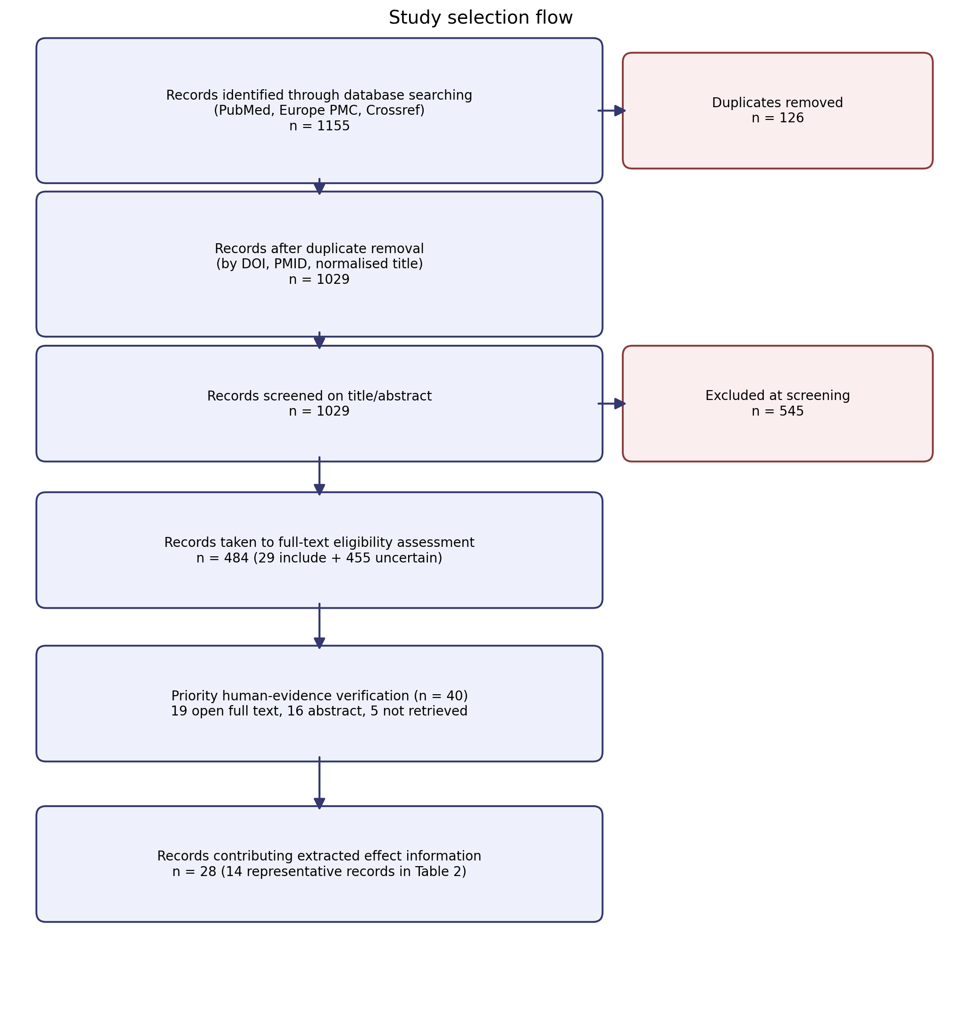
Figure 1. Study selection flow. Records moved from database retrieval (1155 raw), through duplicate removal (126 removed; 1029 retained), title/abstract screening (29 include; 455 uncertain; 545 exclude), full-text eligibility assessment (484 records), and prioritised human-evidence verification (40 records; 19 open full text, 16 abstract, 5 not retrieved), to 28 records contributing extracted effect information.

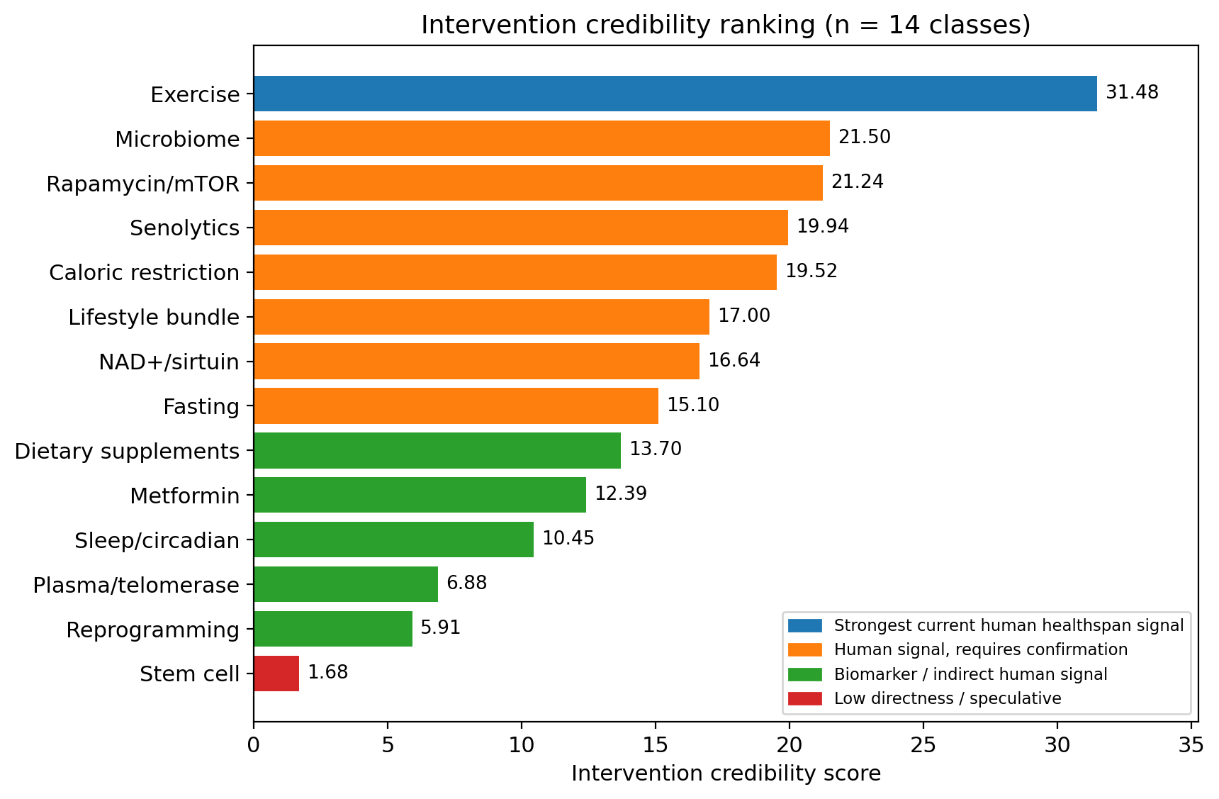
Figure 2. Intervention credibility-score ranking (n=14 classes). The score integrates human record count, human-trial count, direct ageing/healthspan outcomes, biomarker count, surrogate burden, and a promotional-language penalty. Exercise ranked first (31.48); stem-cell approaches ranked last (1.68). Bar colour denotes the translational category.

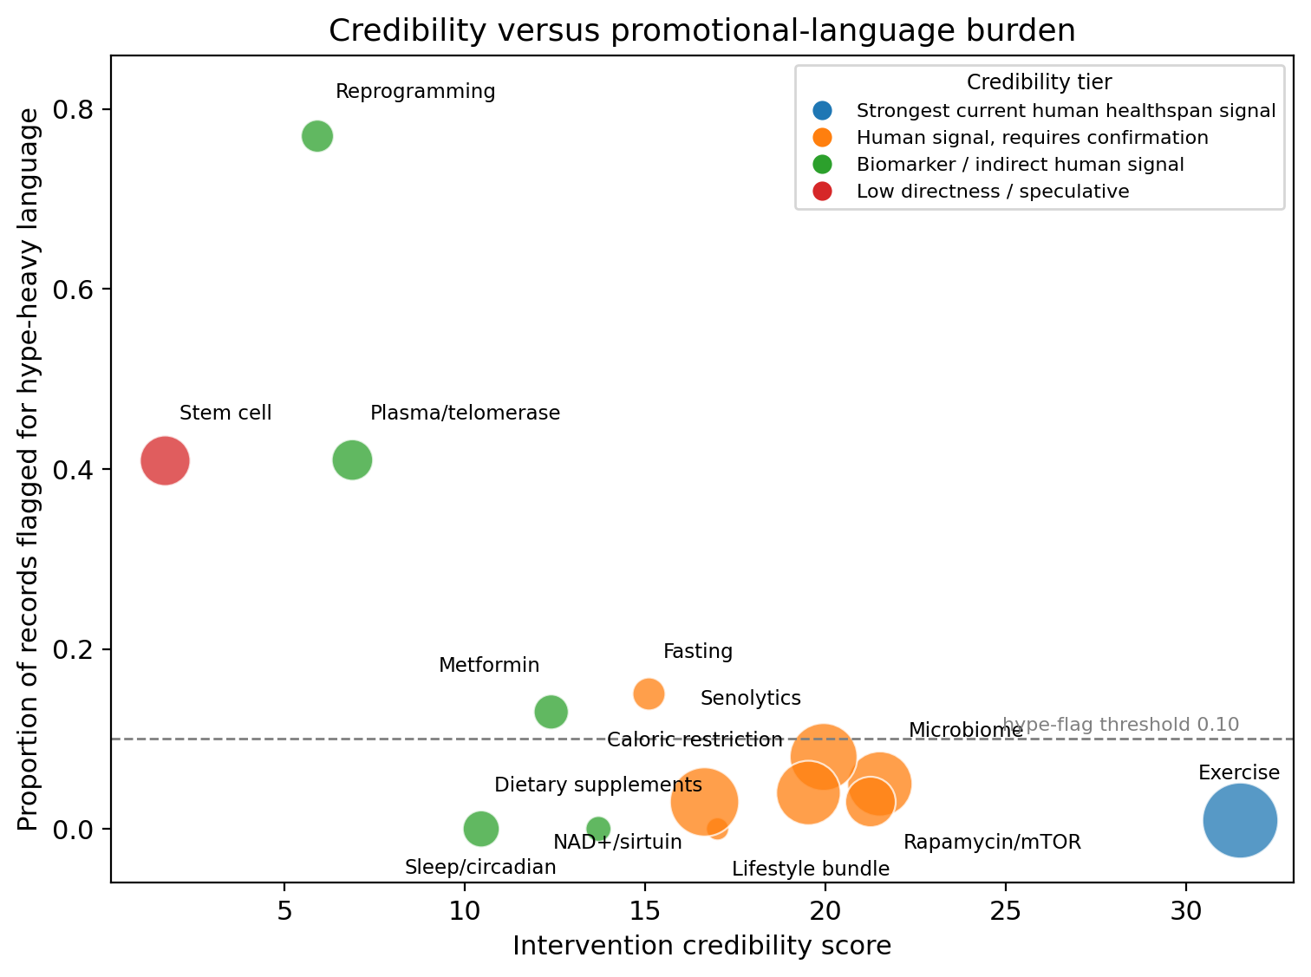
Figure 3. Credibility versus promotional-language burden. Credibility score (x-axis) plotted against the proportion of extracted records flagged for promotional (“hype-heavy”) terminology (y-axis), by intervention domain. Bubble size denotes the number of extracted records. Interventions with high credibility and low promotional burden (exercise, lifestyle bundle) appear lower-right; reprogramming and plasma/telomerase (“controversial”) approaches appear upper-left.

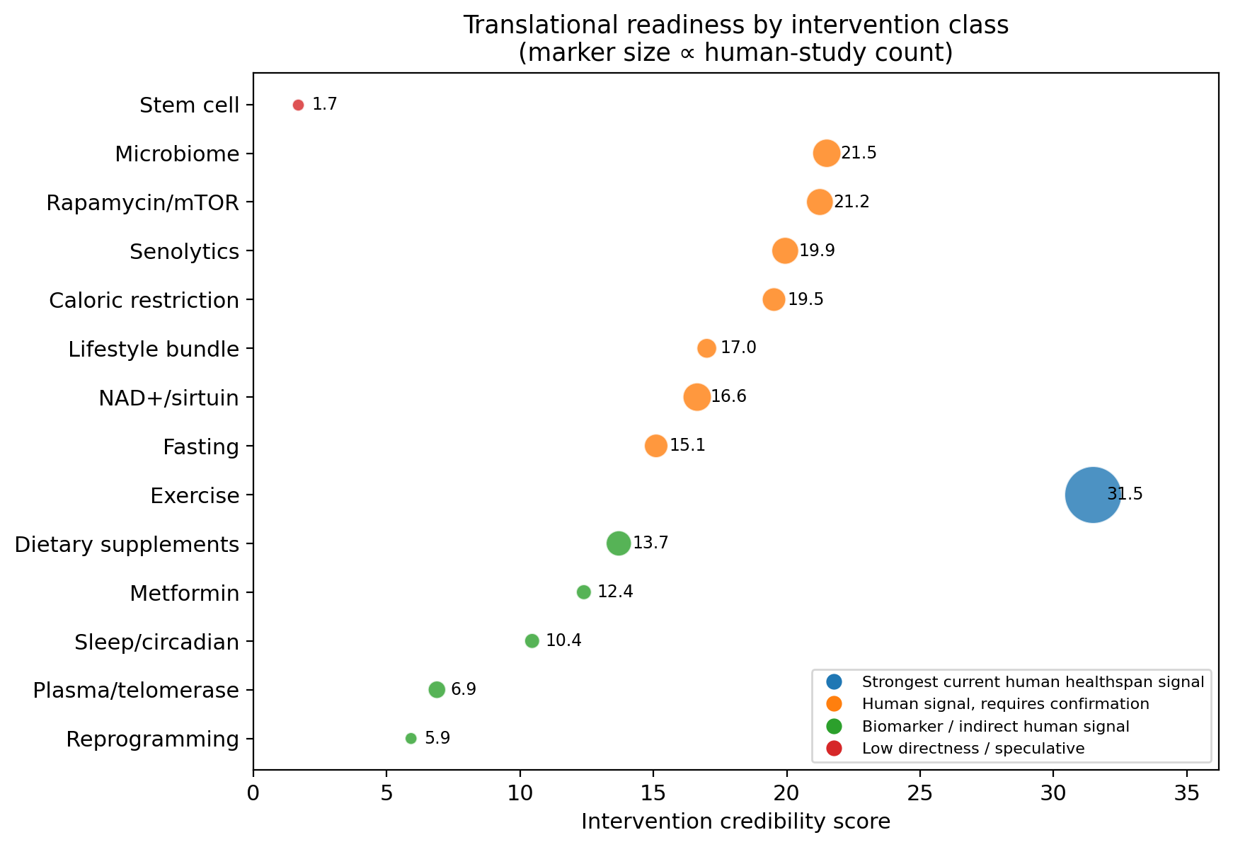
Figure 4. Translational-readiness map. Conservative category assignment for 14 intervention classes: A — healthspan support signal; B — promising, not recommendation-ready; C — biomarker/indirect signal; D — speculative/low directness. Marker size is proportional to the number of human studies.

