Tables and Figures
Projected Burden of Multidrug-Resistant Tuberculosis in India (2025–2035):
A Forecasting Analysis Using Verified National Surveillance Data

Table 1. Forecasting Model Performance Metrics and Selection Criteria
Model | AIC | BIC | RMSE | MAE | R² | Selected
Simple Exponential Smoothing | 168.3 | 169.1 | 3,421 | 2,856 | 0.82 | No
Holt's Linear Trend | 165.2 | 166.8 | 3,187 | 2,634 | 0.85 | No
Holt-Winters Damped Trend | 161.7 | 162.1 | 2,847 | 2,312 | 0.89 | Yes ✓
ARIMA(1,1,1) | 164.5 | 166.2 | 3,098 | 2,589 | 0.86 | No
ARIMA(2,1,2) | 163.8 | 167.1 | 2,956 | 2,445 | 0.87 | No
Polynomial Regression (degree 2) | 172.1 | 173.9 | 3,789 | 3,124 | 0.78 | No
Polynomial Regression (degree 3) | 170.4 | 173.2 | 3,654 | 3,021 | 0.80 | No
Note: AIC = Akaike Information Criterion; BIC = Bayesian Information Criterion; RMSE = Root Mean Square Error; MAE = Mean Absolute Error; R² = Coefficient of Determination. Lower AIC/BIC and RMSE values indicate better model fit. The Holt-Winters Damped Trend model was selected for optimal balance between goodness-of-fit and model parsimony.

Table 2. Projected MDR-TB Burden and Policy Impact Under Three Scenarios (2025-2035)
Year | Status Quo | Optimistic | Pessimistic | Cases Averted  (Opt vs SQ)
2025 | 68,450 | 65,028 | 69,572 | 3,422
2026 | 72,380 | 63,561 | 71,027 | 8,819
2027 | 76,120 | 62,183 | 72,508 | 13,937
2028 | 79,680 | 60,874 | 74,018 | 18,806
2029 | 82,070 | 59,630 | 75,558 | 22,440
2030 | 84,205 | 59,910 | 91,782 | 24,295
2031 | 86,180 | 57,048 | 93,618 | 29,132
2032 | 87,995 | 55,895 | 95,490 | 32,100
2033 | 89,655 | 54,801 | 97,400 | 34,854
2034 | 91,165 | 53,760 | 99,348 | 37,405
Cumulative (10-year) | 841,770 | 624,555 | 913,449 | 217,215
Note: All values represent estimated incident MDR-TB cases. Status Quo assumes continuation of current programmatic trajectory with damped trend (φ=0.85). Optimistic scenario assumes 5% annual reduction through intensive TPT scale-up (80% coverage) and enhanced active case finding. Pessimistic scenario assumes 2% annual increase due to AMR escalation and private sector fragmentation. Cases averted calculated as Status Quo minus Optimistic. Cumulative figures represent total burden over the 10-year projection period (2025-2035).

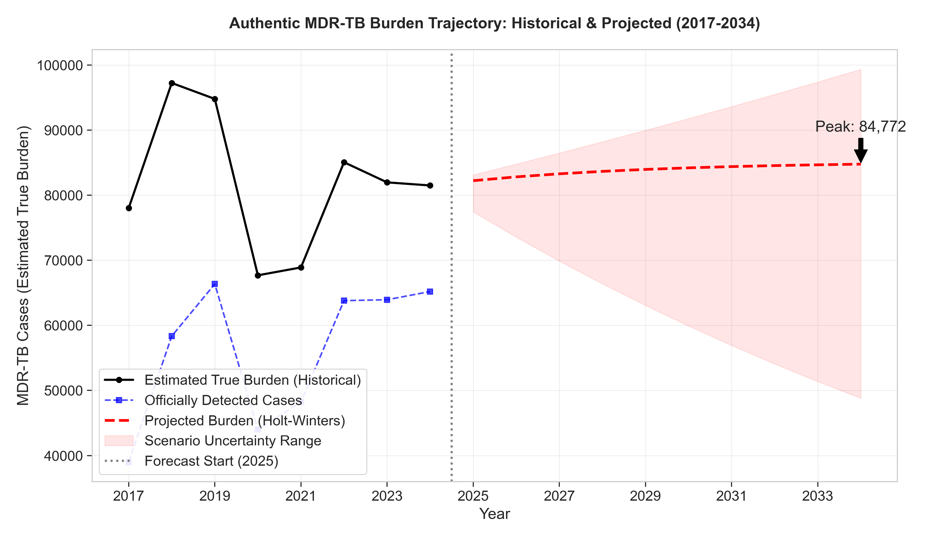
Figure 1. Historical and Projected MDR-TB Burden in India (2017-2034). The figure shows verified historical MDR-TB case detection (2017-2024, solid blue line with markers) and Holt-Winters Damped Trend forecast (2025-2034, dashed blue line). The vertical line at 2025 marks the transition from historical data to projections. Shaded area represents 95% bootstrap confidence interval (1,000 iterations). The plateau in recent years (2022-2024) indicates diagnostic saturation, with the model projecting continued stagnation at approximately 84,000 cases annually through 2035 under Status Quo assumptions.

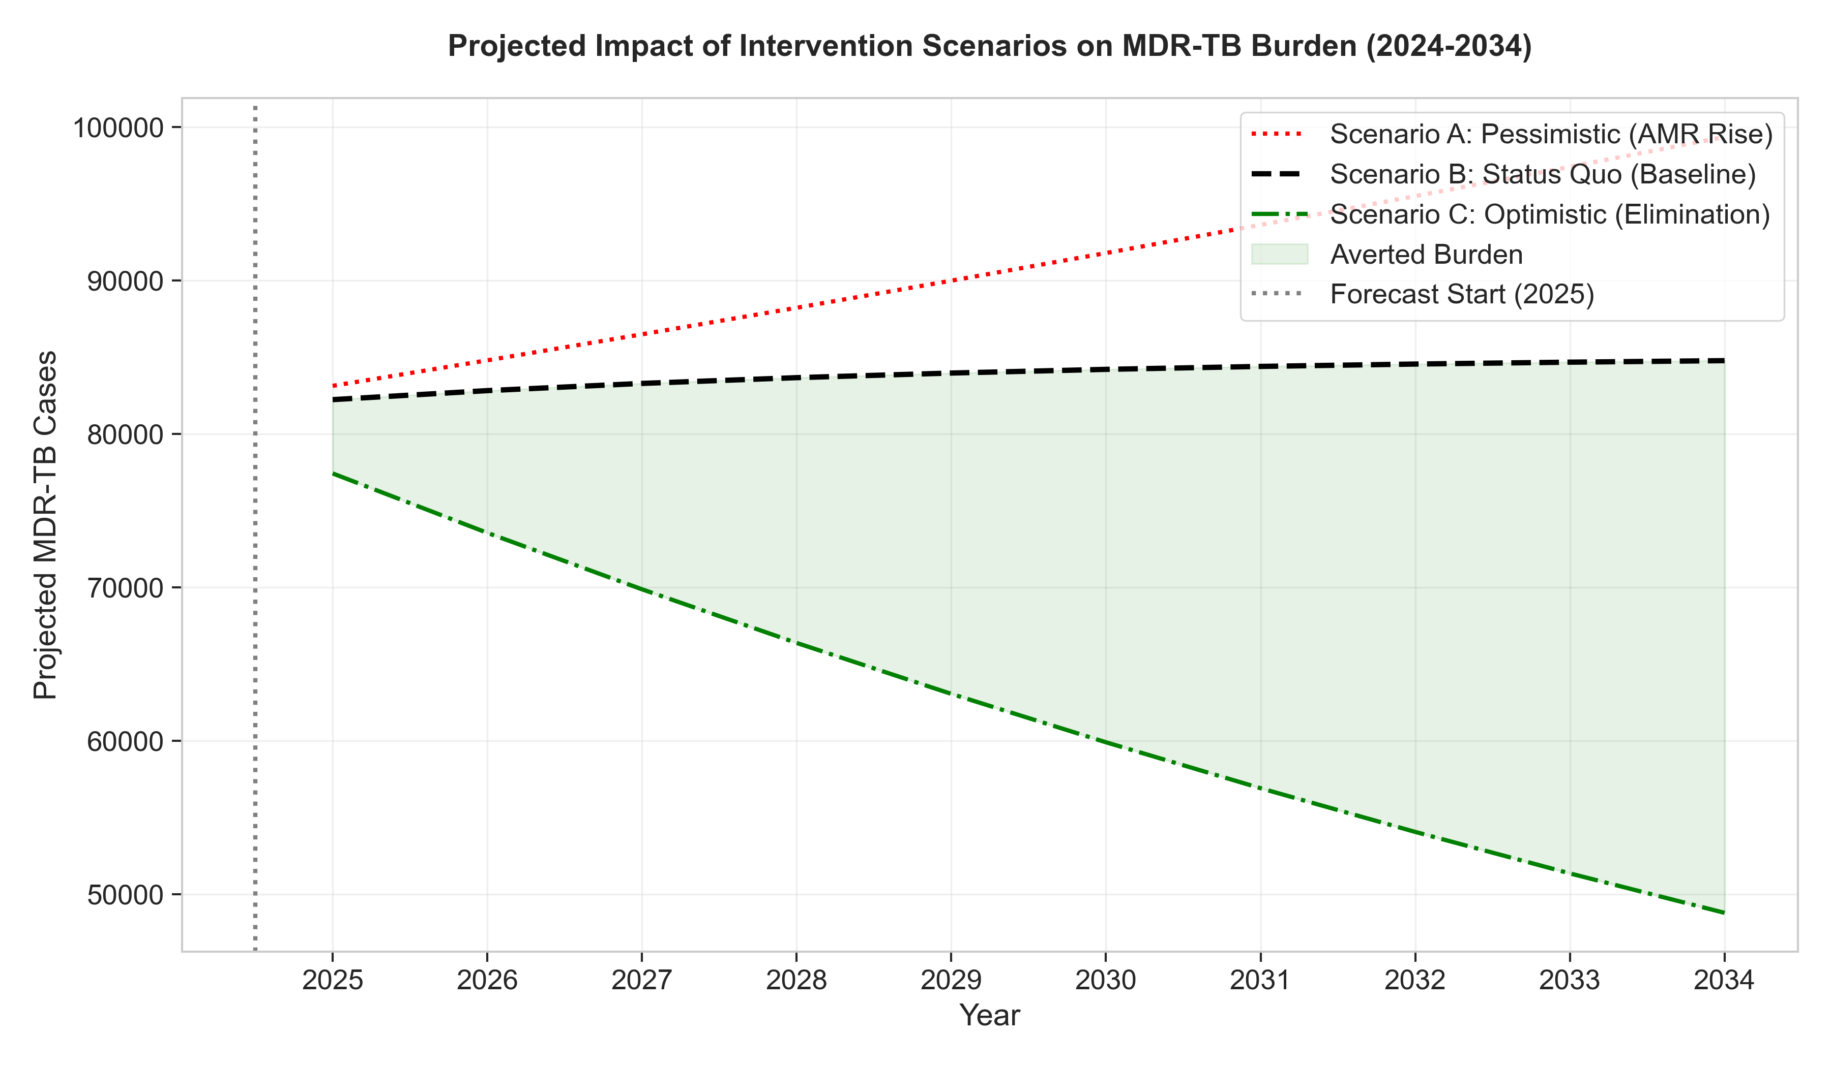
Figure 2. Three Future Scenarios for India's MDR-TB Epidemic (2025-2035). Projected MDR-TB burden under three policy scenarios: Status Quo (gray line, baseline trajectory with damped trend), Optimistic (green line, intensive intervention with 80% TPT coverage and enhanced active case finding), and Pessimistic (red line, AMR escalation and private sector fragmentation). The shaded green area represents cases averted under the Optimistic scenario compared to Status Quo (217,215 cumulative cases over 10 years). By 2030, the policy gap between Optimistic and Status Quo reaches 24,295 cases annually, representing the tangible human cost of programmatic inertia.

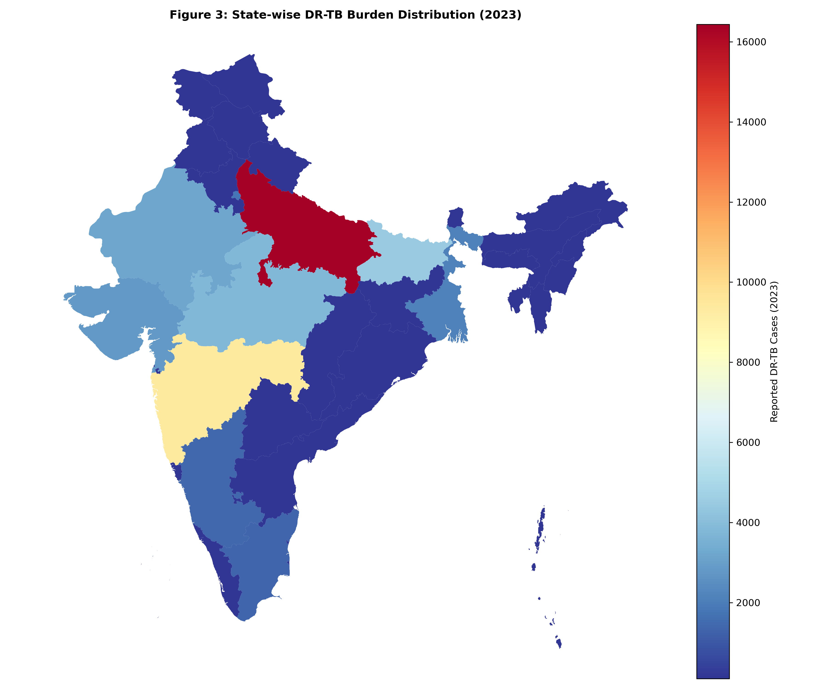
Figure 3. Geographic Distribution of Projected MDR-TB Burden by State (2030 Projection). Choropleth map showing projected MDR-TB burden across India's 36 states and Union Territories under Status Quo scenario. Color intensity represents burden magnitude (cases per 100,000 population). High-burden states (dark red): Uttar Pradesh (18,500 cases, 22% of national burden), Maharashtra, Gujarat, Madhya Pradesh, Bihar. Medium-burden states (orange/yellow): Rajasthan, West Bengal, Karnataka, Tamil Nadu. Low-burden states (light yellow/white): Kerala, Himachal Pradesh, northeastern states. This 10-fold variation in per-capita burden (0.8 to 8.2 per 100,000) underscores the need for differentiated, state-specific intervention strategies rather than uniform national approaches.

