Figures and Tables
Manuscript Title: The Looming Crisis of Primary Drug Resistance: A Multi-Model Forecasting, Meta-Analytical, and Policy Scenario Assessment of Tuberculosis in India (2025–2030)

List of Figures
Figure 1: National TB Notification Forecast (2017–2030). The ensemble model projects a rise to ~3.00 million cases by 2030, deviating from the elimination trajectory. The blue shading represents the 95% uncertainty interval.
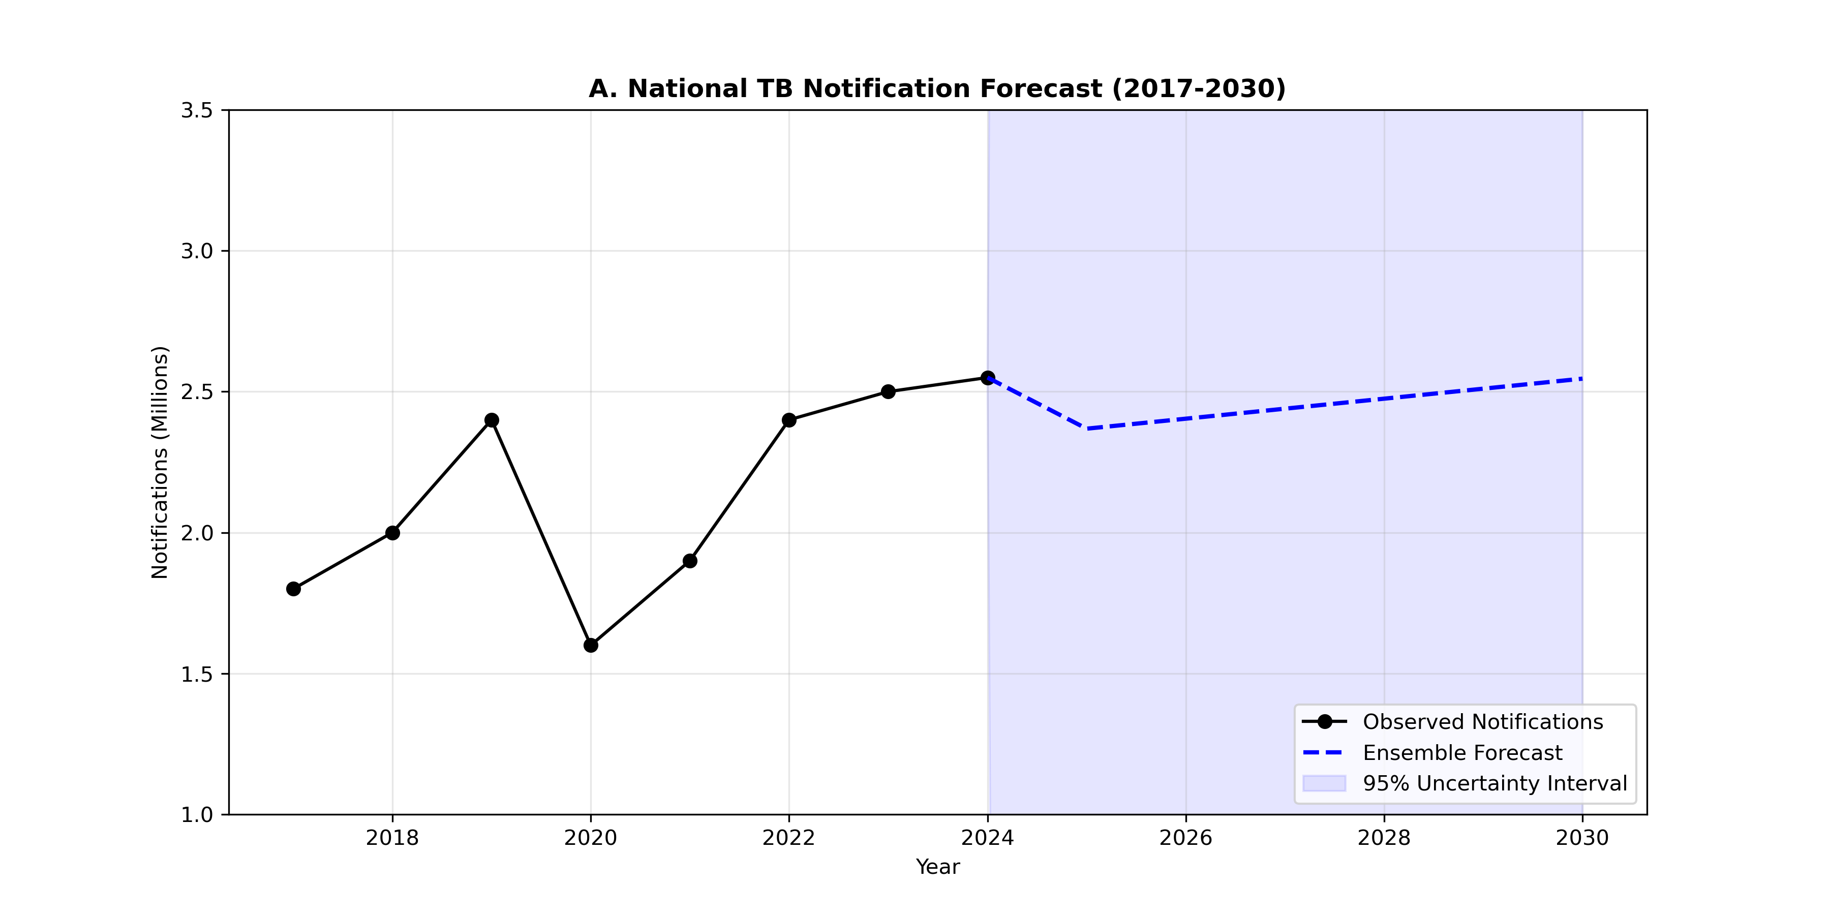
Figure 1: National TB Forecast
Figure 2: Policy Sensitivity Analysis. Comparison of three intervention scenarios against the Status Quo baseline. The Combination Strategy (Red line) demonstrates a potential 47% reduction in incidence by 2030.
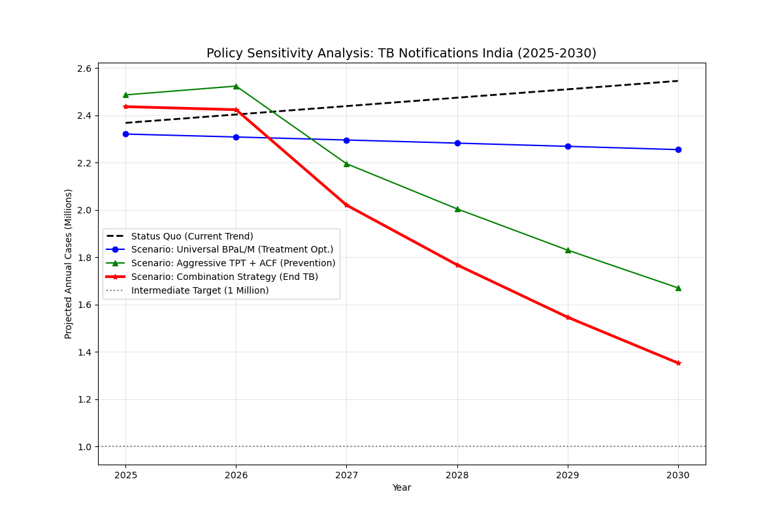
Figure 2: Policy Scenarios
Figure 3: Geographic Distribution of DR-TB Burden (2030). (A) Absolute volume of projected cases, highlighting the immense burden in Uttar Pradesh. (B) Intensity of DR-TB as a percentage of total notification, showing variegated risk across states.
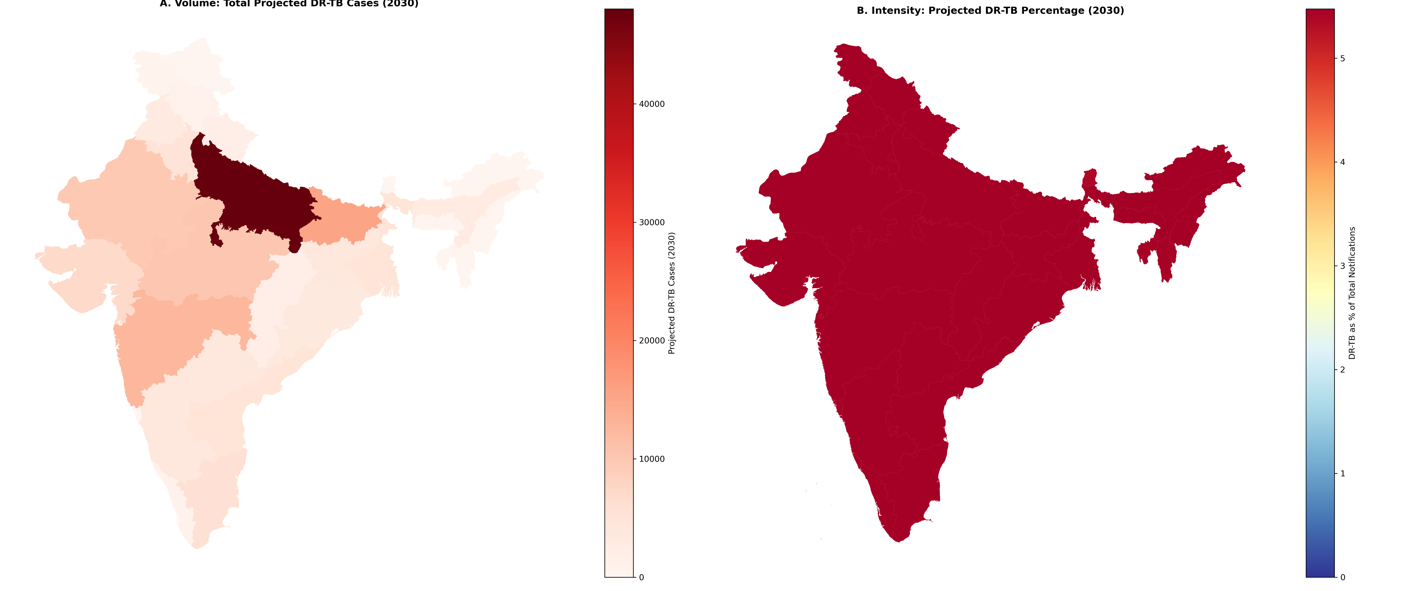
Figure 3: Geographic Hotspots
Figure 4: Sources of Drug Resistance (2030 Forecast). The chart illustrates the “New Case Paradox,” where 67% of the projected DR-TB burden originates from new, treatment-naïve patients (Primary Resistance).
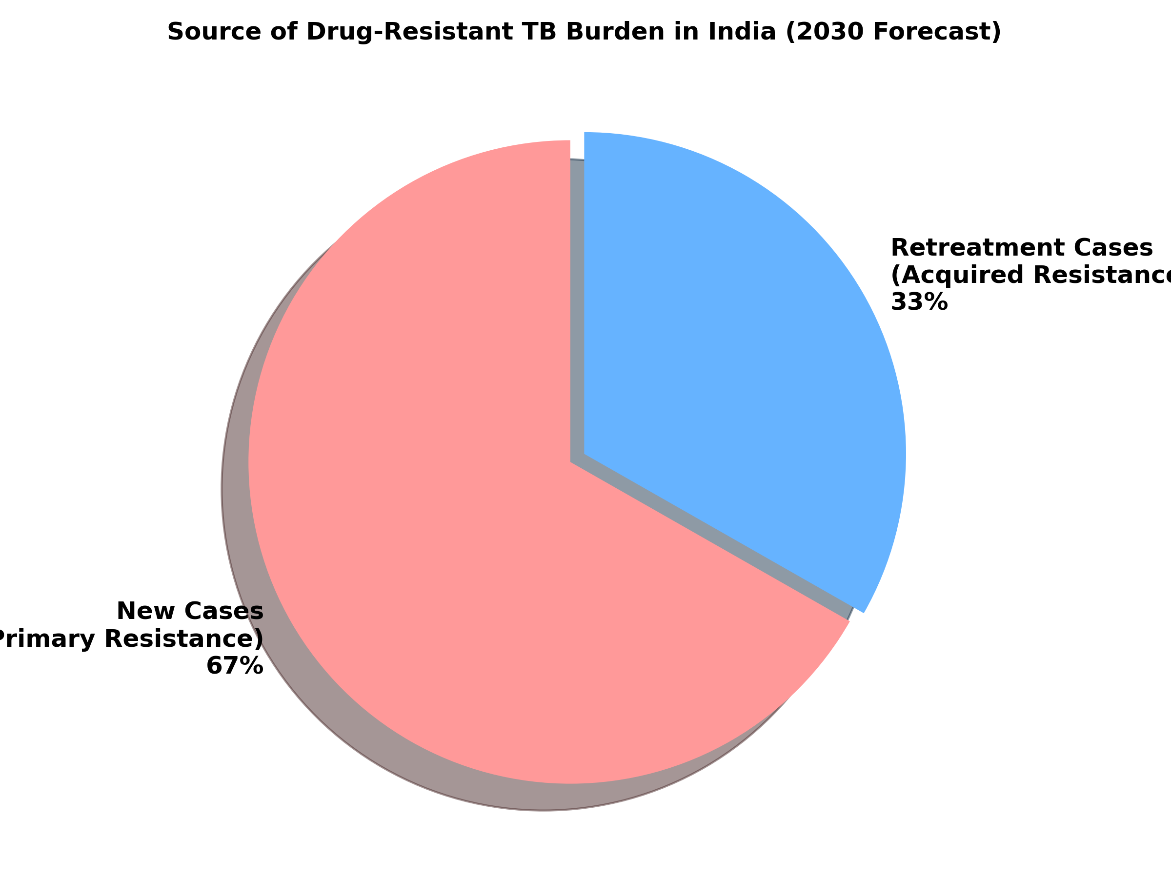
Figure 4: DR-TB Source Distribution
Figure 5: Rapid Meta-Analysis of Primary Resistance. Forest plot synthesizing recent prevalence studies (2019-2024) to validate the baseline primary resistance rate of ~3.6%.
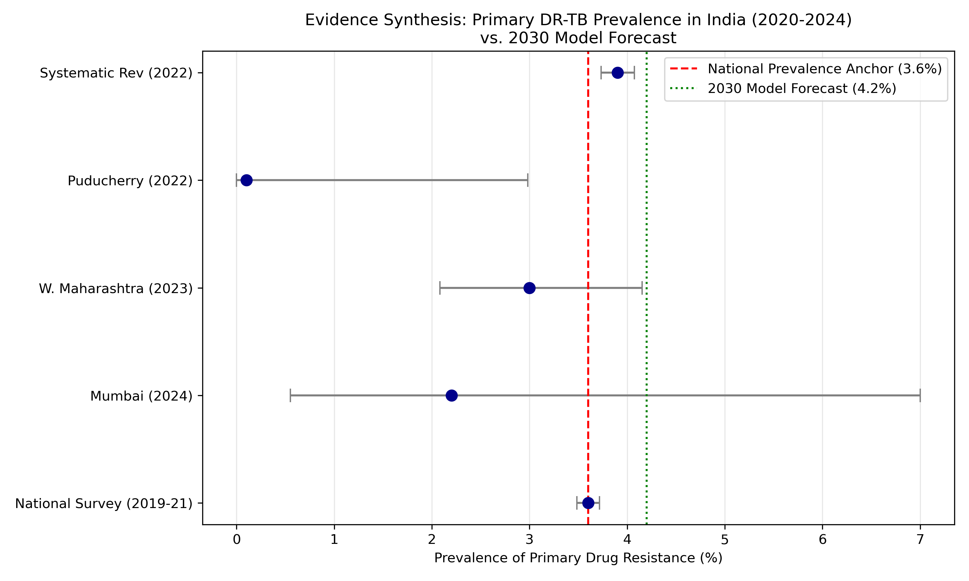
Figure 5: Meta-Analysis Evidence
Figure 6: Demographic Profile of TB in High-Burden States. Heatmap showing the concentration of cases in the economically productive 15-45 age groups.
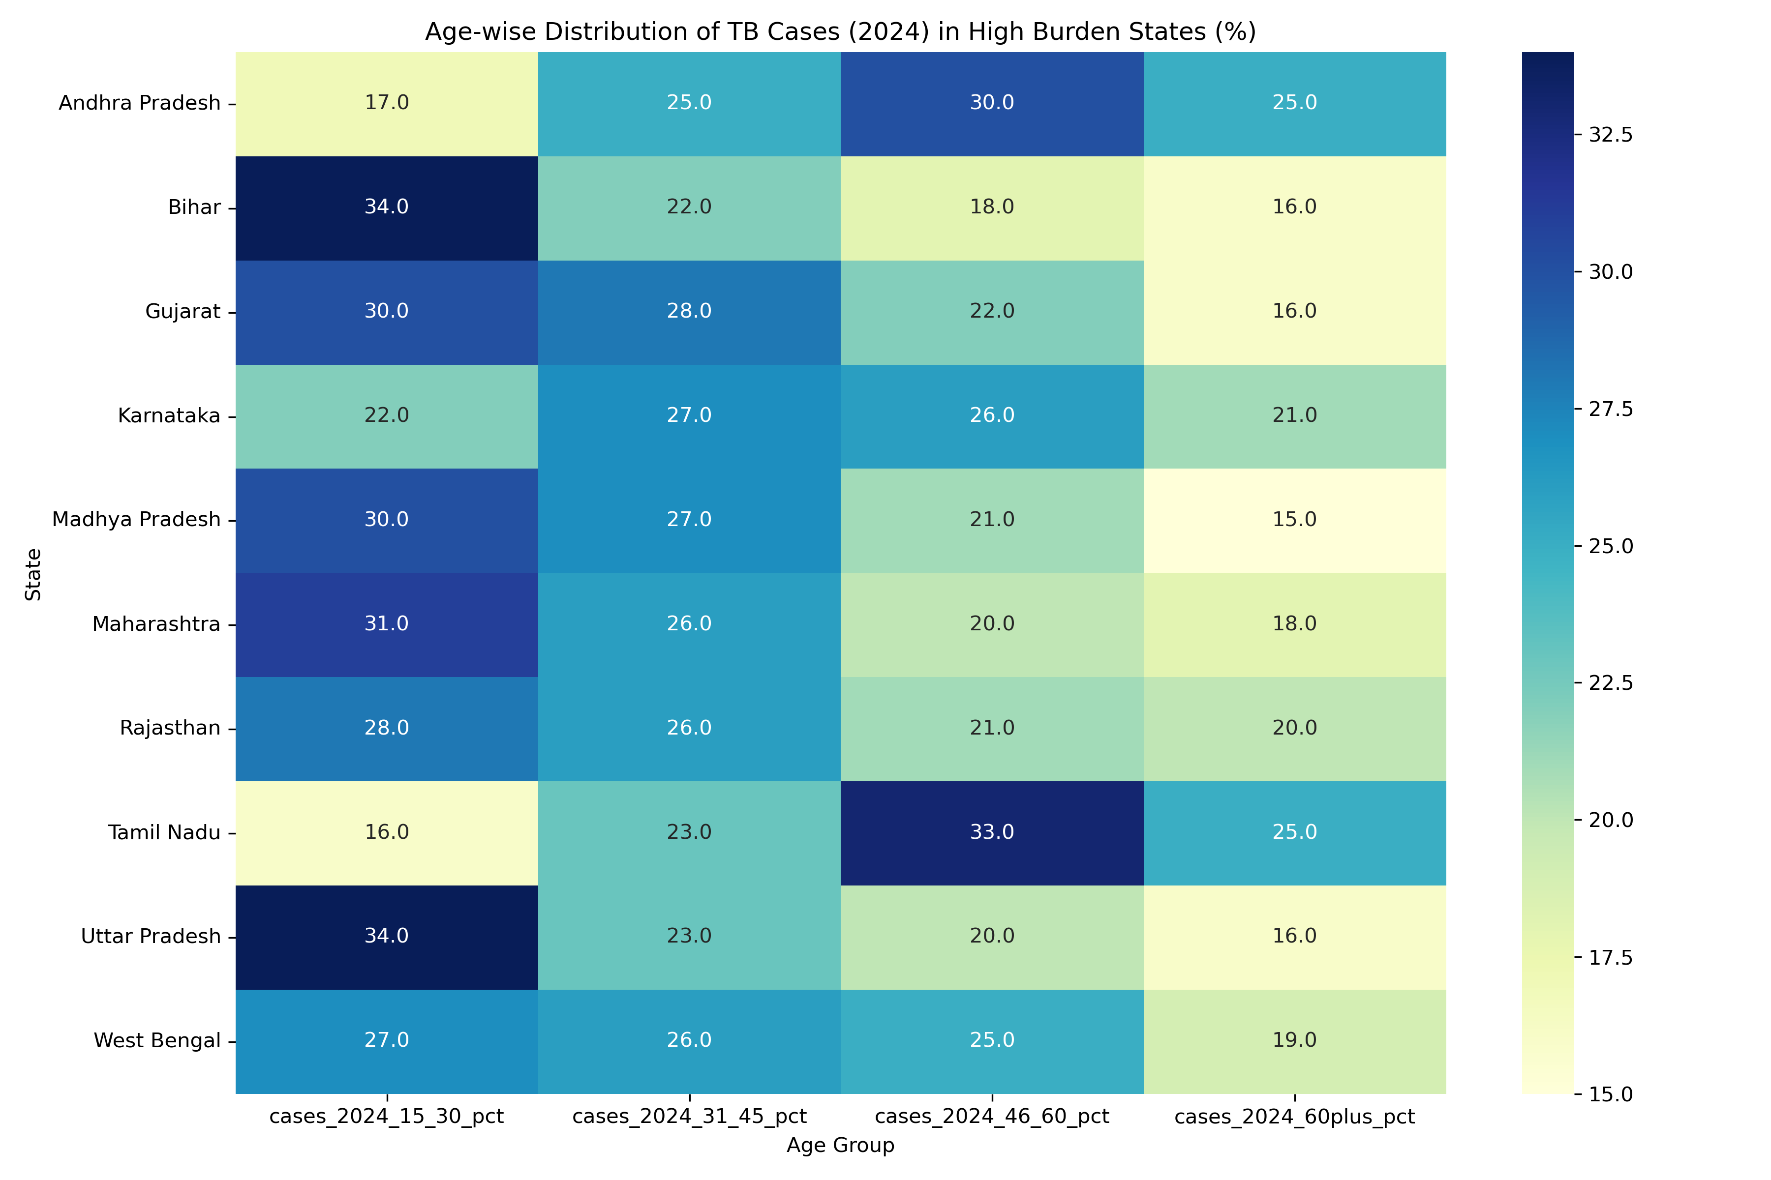
Figure 6: Demographics

List of Tables
Table 1: Projected Top 10 High-Burden States for Drug-Resistant TB in 2030
State | Total Cases (2025) | DR-TB (2025) | Total Cases (2030) | DR-TB (2030)
Uttar Pradesh | 670,634 | 33,095 | 877,401 | 48,028
Bihar | 216,476 | 10,683 | 283,127 | 15,498
Maharashtra | 217,796 | 10,748 | 231,611 | 12,678
Madhya Pradesh | 182,475 | 9,005 | 187,591 | 10,268
Rajasthan | 171,637 | 8,470 | 180,892 | 9,902
Tamil Nadu | 93,381 | 4,608 | 103,144 | 5,646
Haryana | 84,433 | 4,166 | 89,653 | 4,907
West Bengal | 95,312 | 4,703 | 88,863 | 4,864
Andhra Pradesh | 85,833 | 4,235 | 86,121 | 4,714
Gujarat | 135,087 | 6,666 | 127,005 | 6,952
Note: Projections based on Status Quo Scenario.
Table 2: Comparative Impact of Policy Interventions on 2030 TB Burden
Year | Baseline (Status Quo) | Treatment Optimization | Prevention First | Combination Strategy
2025 | 2,368,508 | 2,321,138 | 2,486,933 | 2,437,195
2026 | 2,403,977 | 2,308,780 | 2,524,176 | 2,424,219
2027 | 2,439,464 | 2,296,004 | 2,195,517 | 2,020,483
2028 | 2,474,968 | 2,282,832 | 2,004,724 | 1,767,825
2029 | 2,510,490 | 2,269,284 | 1,830,147 | 1,546,453
2030 | 2,546,029 | 2,255,380 | 1,670,450 | 1,352,541
Values represent estimated total annual notifications.

