Figures and Tables
Manuscript Title: The Looming Crisis of Primary Drug Resistance: A Multi-Model Forecasting, Meta-Analytical, and Policy Scenario Assessment of Tuberculosis in India (2025–2030)

List of Figures
Figure 1: National TB Forecast and Policy Analysis. (A) Ensemble forecast projecting a rise in notification to ~3.00 million by 2030 (Blue shading: 95% Uncertainty). (B) Comparative impact of three intervention scenarios, showing the “Combination Strategy” (Red) achieving a significant decline.
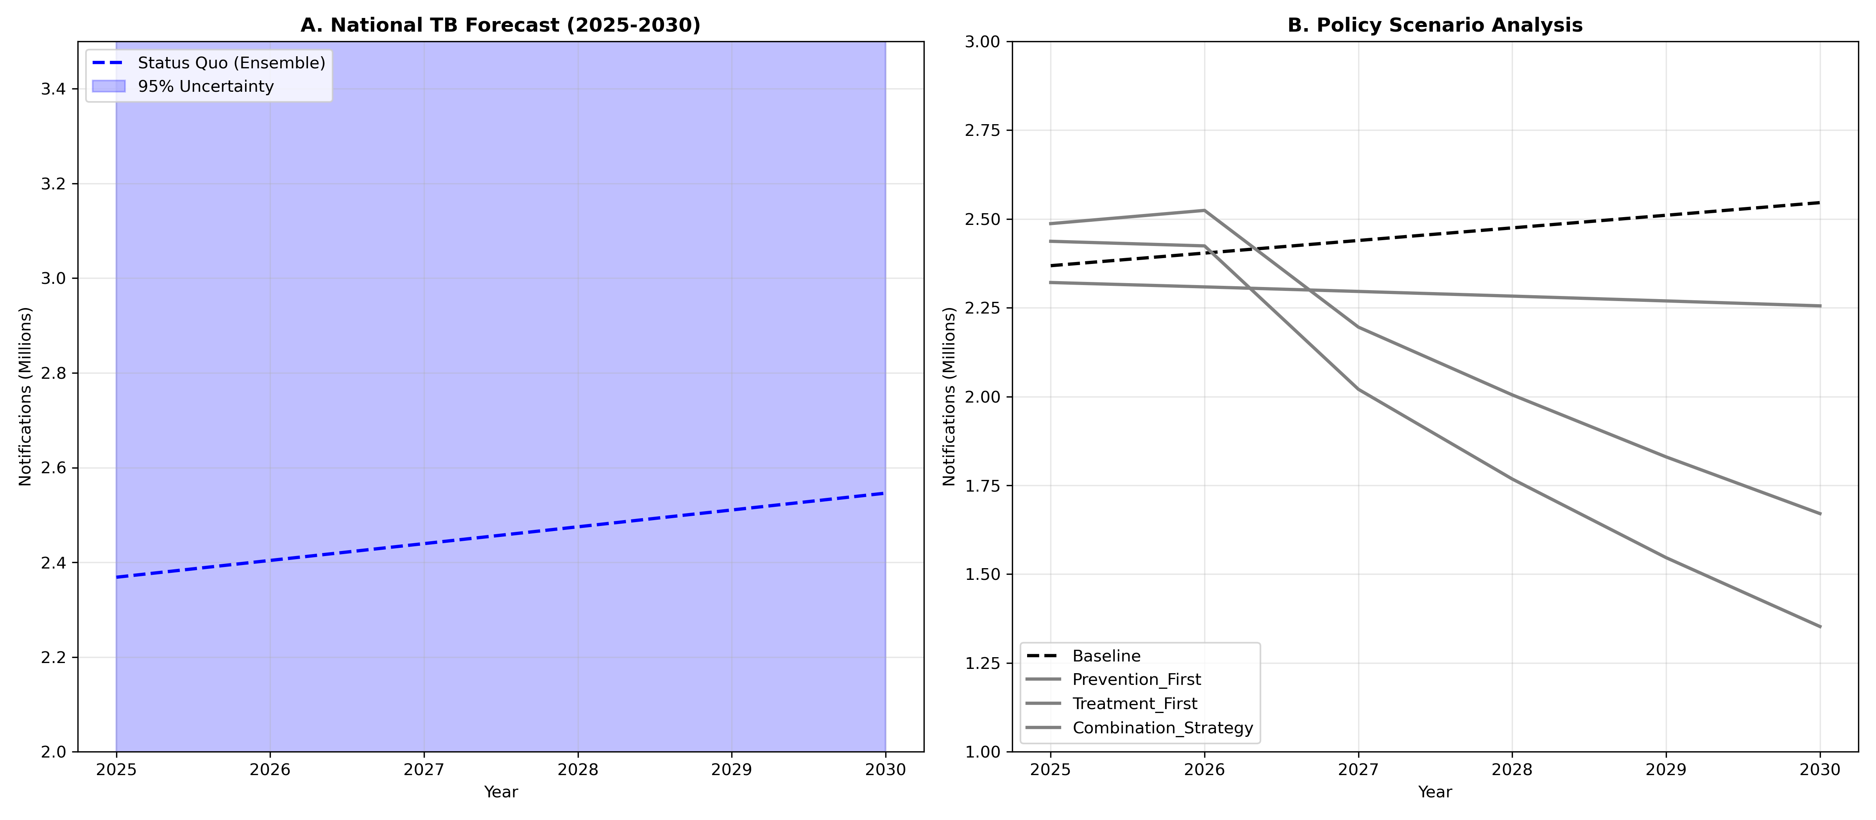
Figure 1: Forecast and Scenarios
Figure 2: Geographic Distribution of DR-TB Burden (2030). (A) Absolute volume of projected cases. (B) Intensity of resistance (% of Total), highlighting hotspots like Maharashtra despite lower total volume compared to UP.
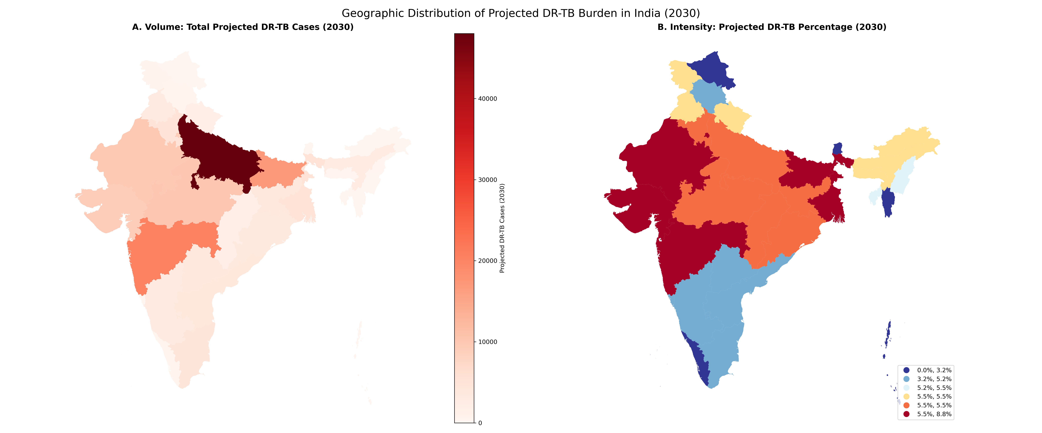
Figure 2: Geographic Hotspots
Figure 3: Dynamics of the Drug-Resistant TB Epidemic (2025–2030). (A) Trend showing dominance of Primary Resistance (New Cases). (B) The Diagnostic Gap in 2030, visualizing ~85,000 missed cases under risk-based screening. (C) The Cost of Inaction: Projected deaths/failures averted by universal regimen optimization.
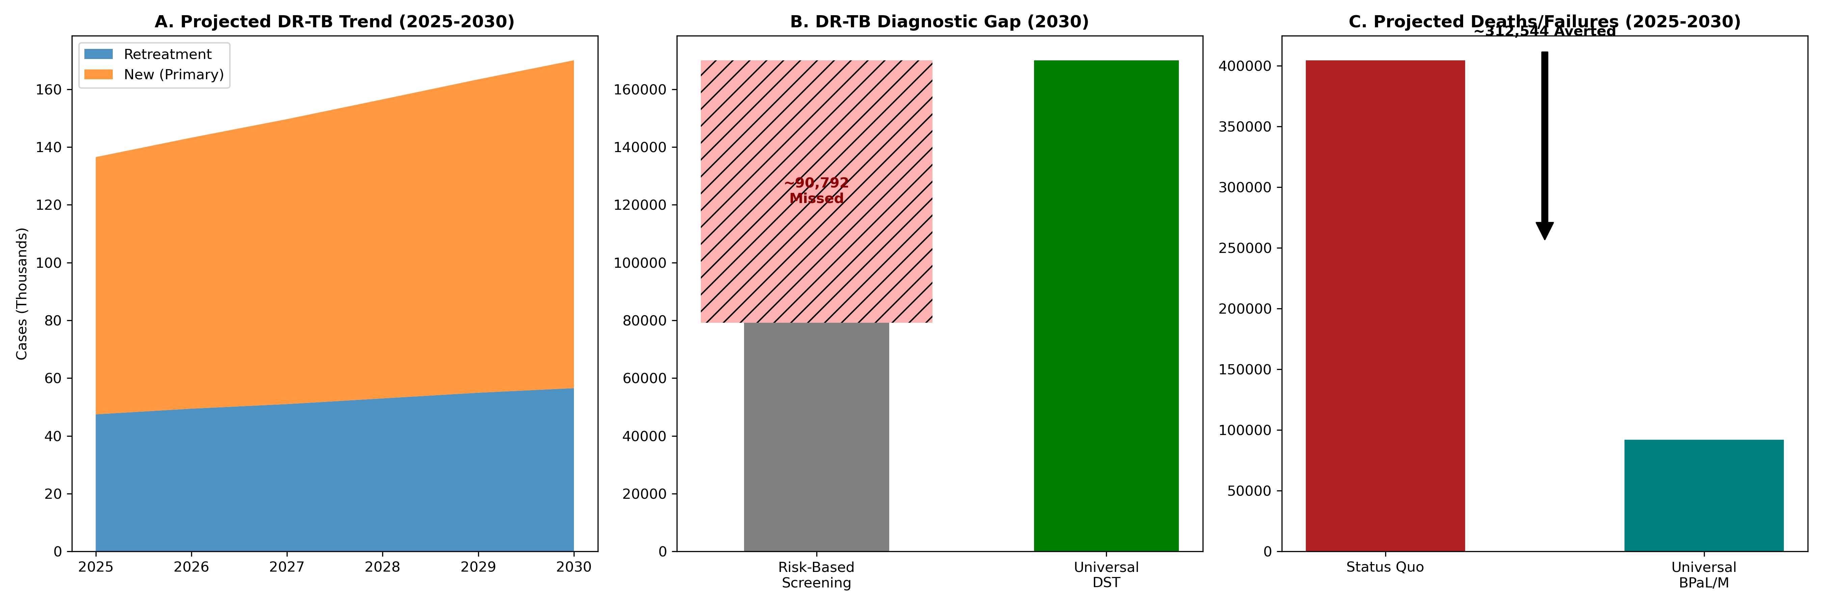
Figure 3: DR-TB Dynamics
Figure 4: Rapid Meta-Analysis Evidence. Forest plot synthesizing recent prevalence studies (2019-2024) to validate the baseline primary resistance rate of ~3.6% used in the forecast model.
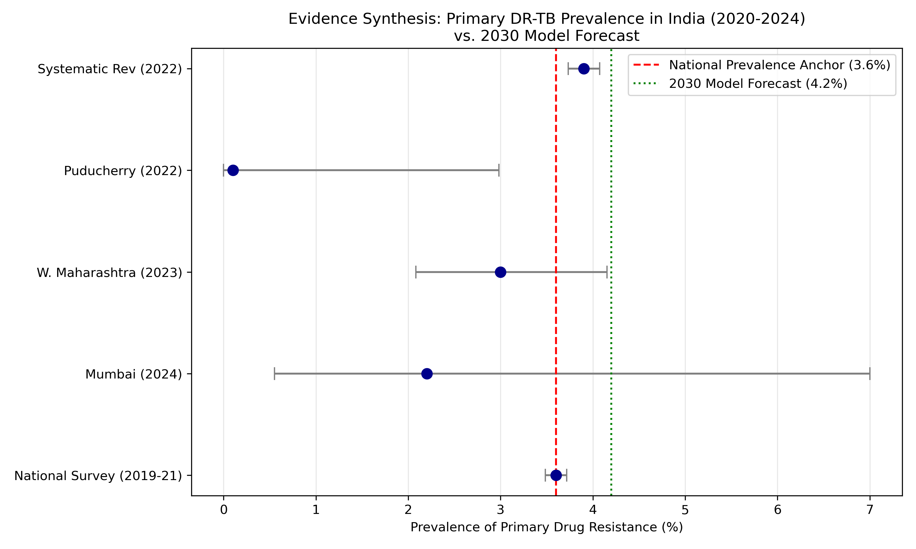
Figure 4: Meta-Analysis Evidence
Figure 5: Demographic Profile of TB in High-Burden States. Heatmap showing the concentration of cases in the economically productive 15-45 age groups.
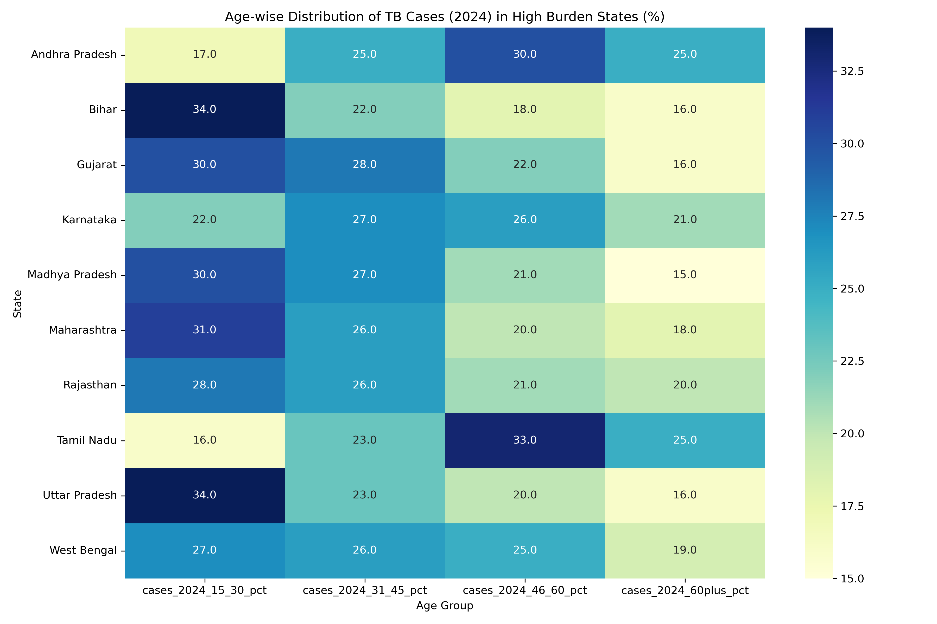
Figure 5: Demographics

List of Tables
Table 1: Projected Top 10 High-Burden States for Drug-Resistant TB in 2030
State | Total Cases (2025) | DR-TB (2025) | Total Cases (2030) | DR-TB (2030)
Uttar Pradesh | 670,634 | 33,095 | 877,401 | 48,028
Bihar | 216,476 | 10,683 | 283,127 | 15,498
Maharashtra | 217,796 | 10,748 | 231,611 | 12,678
Madhya Pradesh | 182,475 | 9,005 | 187,591 | 10,268
Rajasthan | 171,637 | 8,470 | 180,892 | 9,902
(Full table data in Supplementary Materials)
Table 2: Comparative Impact of Policy Interventions on 2030 TB Burden
Year | Baseline (Status Quo) | Treatment Optimization | Prevention First | Combination Strategy
2025 | 2,368,508 | 2,321,138 | 2,486,933 | 2,437,195
2030 | 2,546,029 | 2,255,380 | 1,670,450 | 1,352,541
Values represent estimated total annual notifications.

