Figures
Fig 1
Main figure. State-level injury DALY map in 2021.
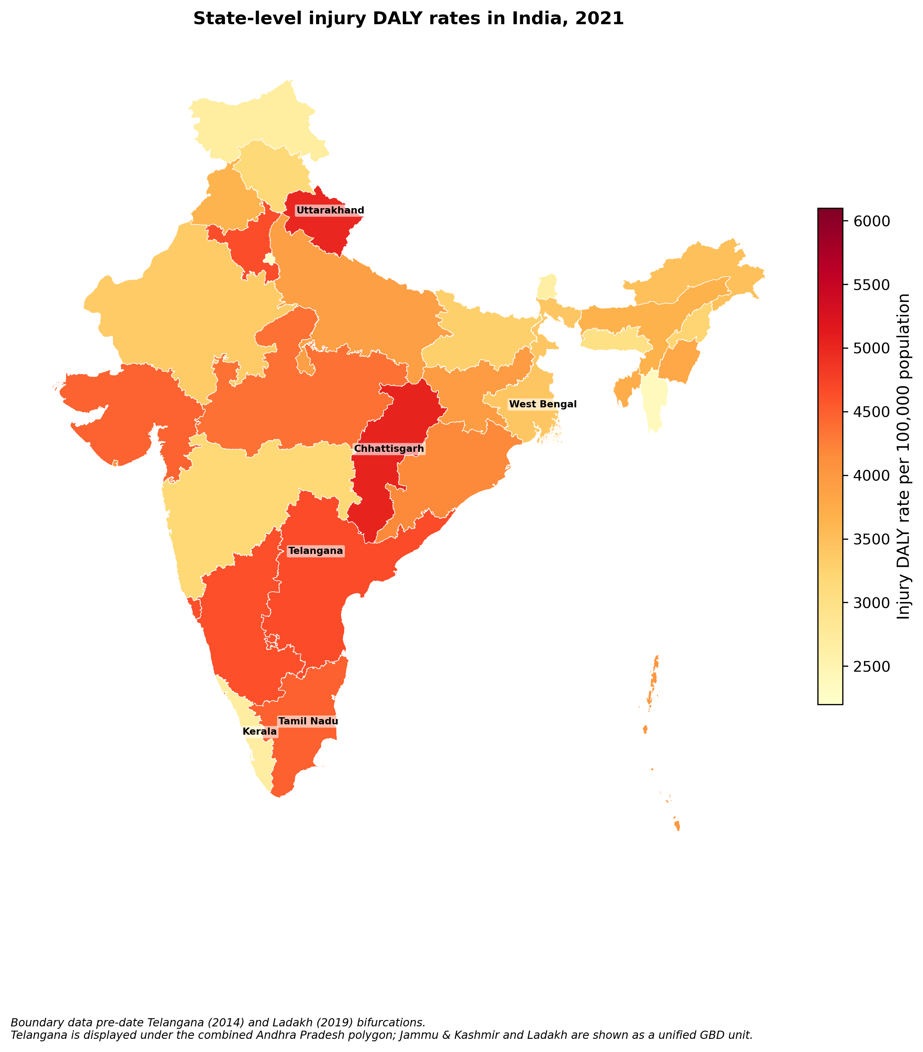

Fig 2
Main figure. Hidden Disability Burden Index by state in 2021.
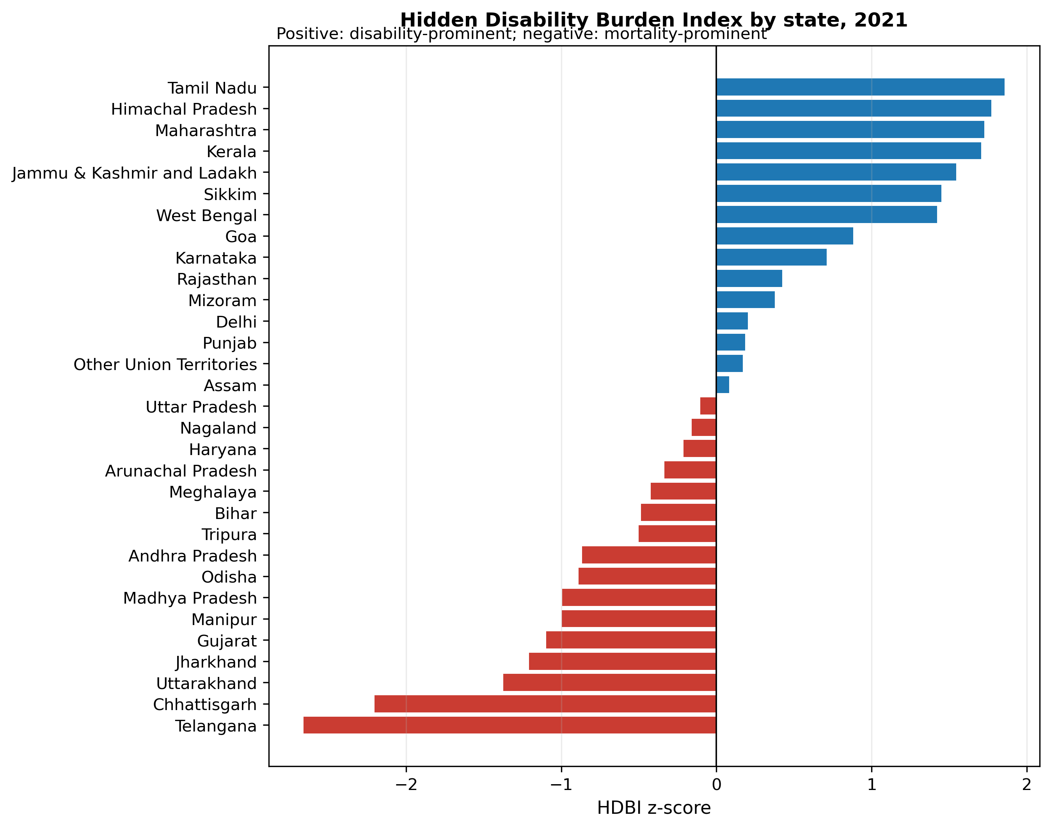

Supplementary Fig S1
Cause-specific injury DALY heatmap by state.
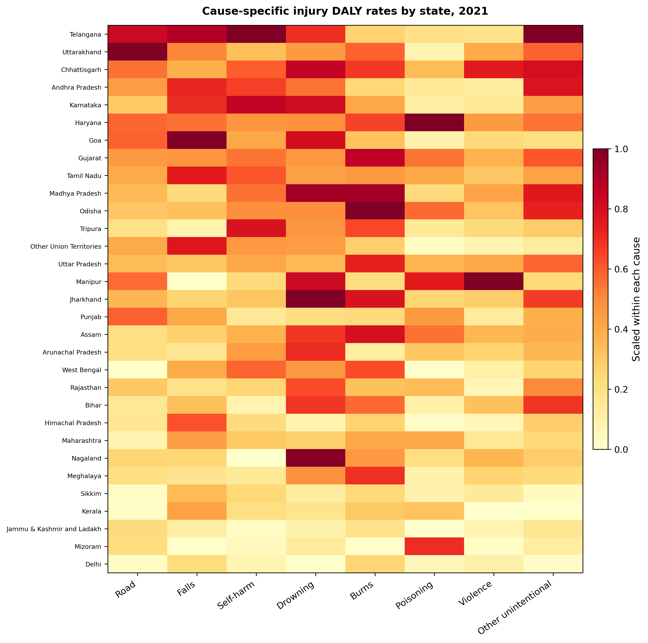

Supplementary Fig S2
Available-year trend series for total DALYs, deaths and YLDs.
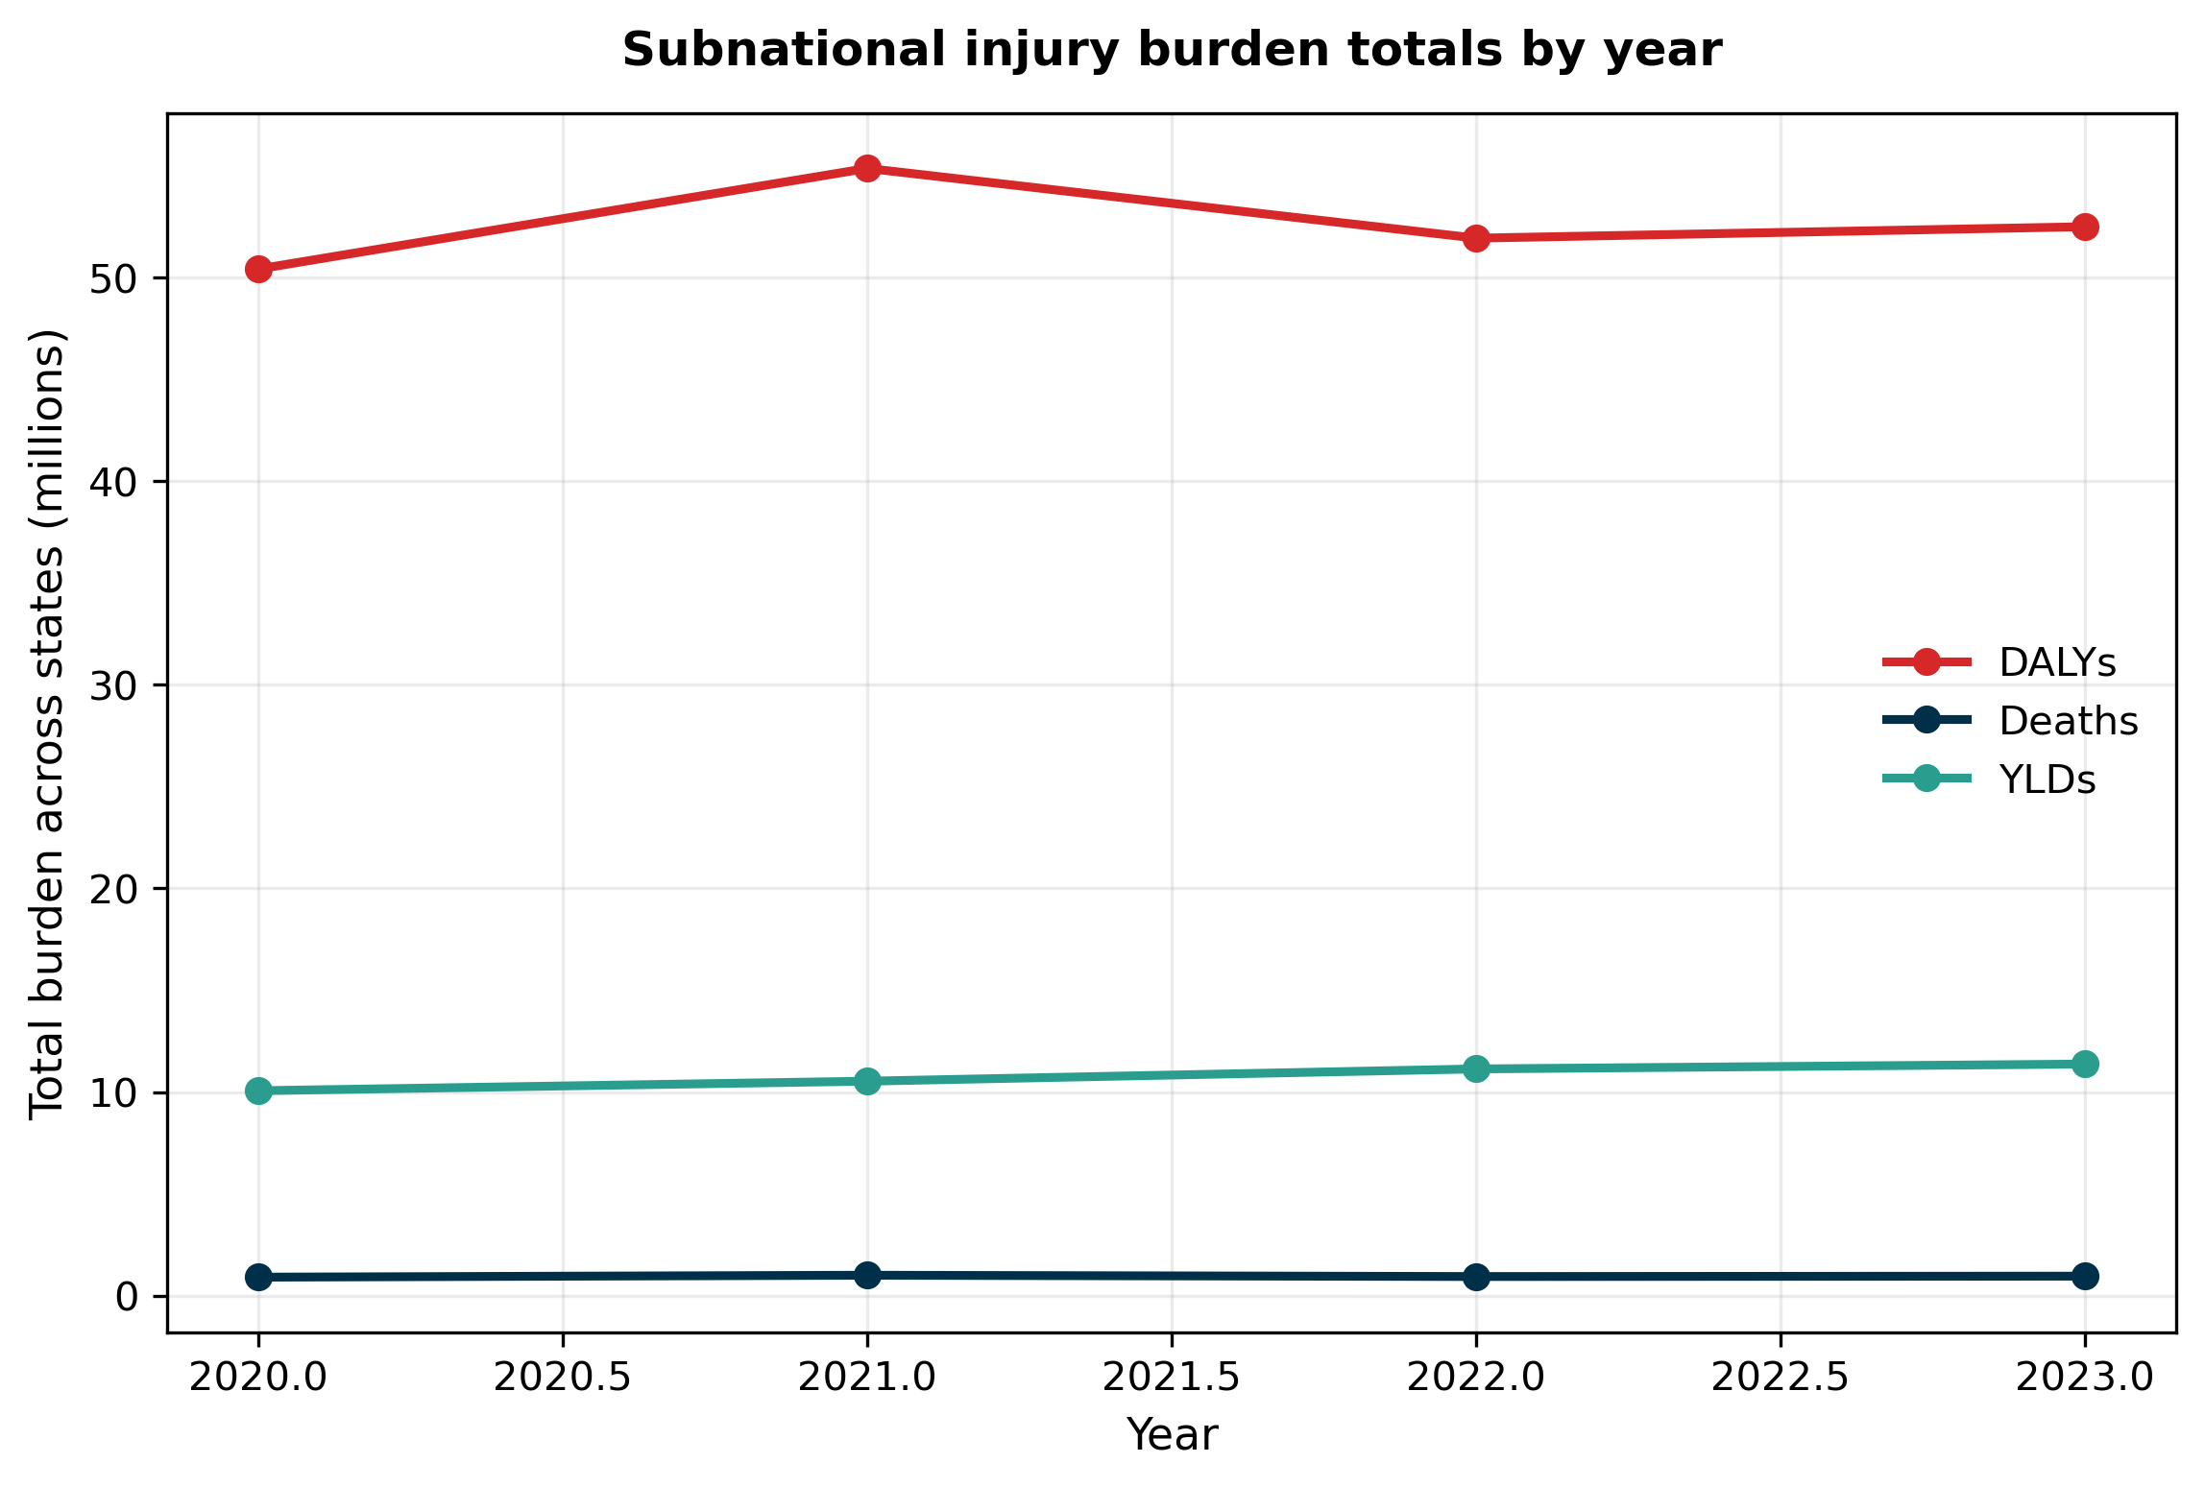

Supplementary Fig S3
State typology by death rate and YLD rate.
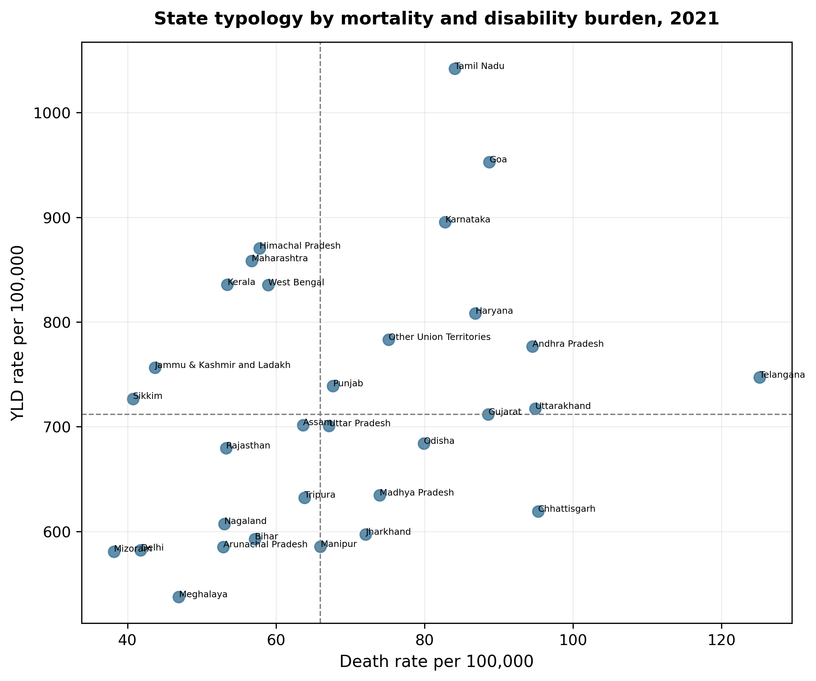

Supplementary Fig S4
Road-injury surveillance-burden rank mismatch.
