Figures
Fig 1
State-level injury DALY map, 2021.
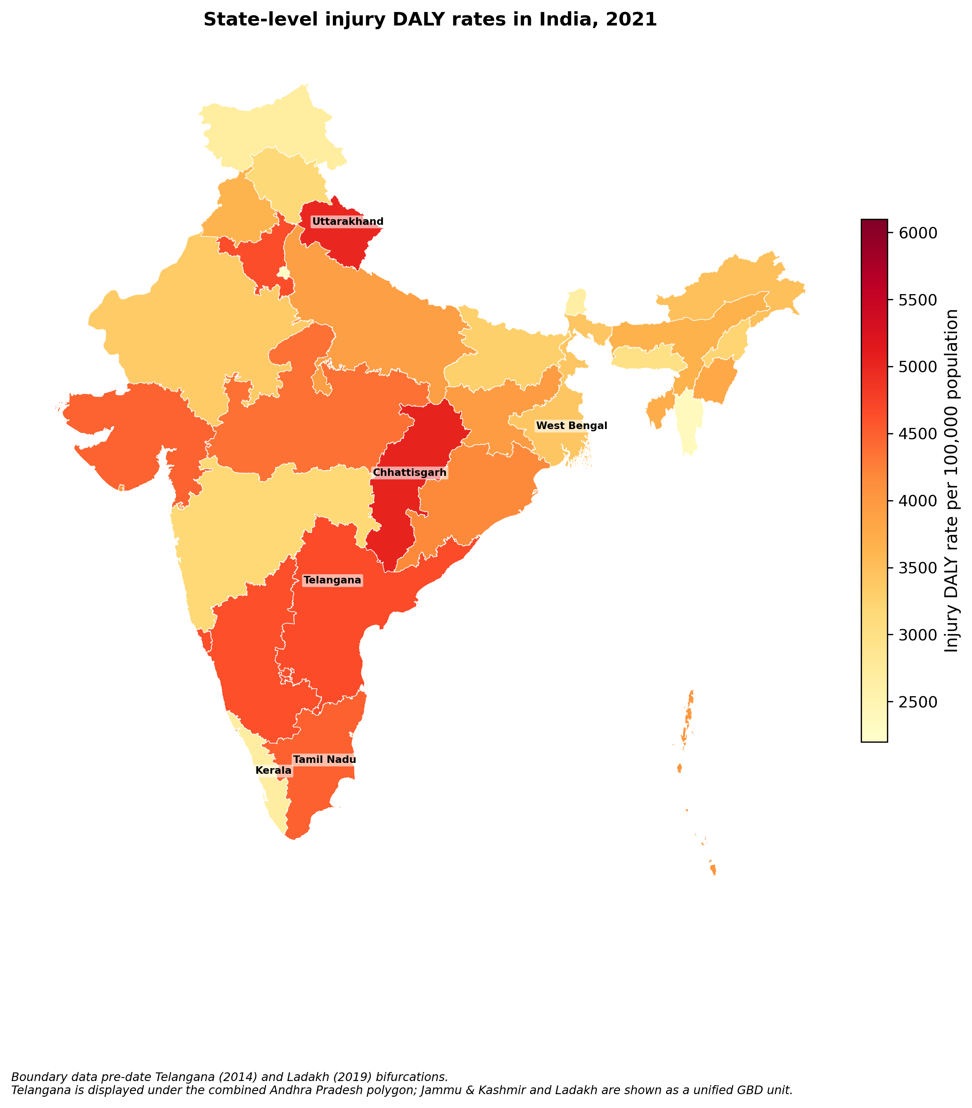

Fig 2
Hidden Disability Burden Index by state, 2021.
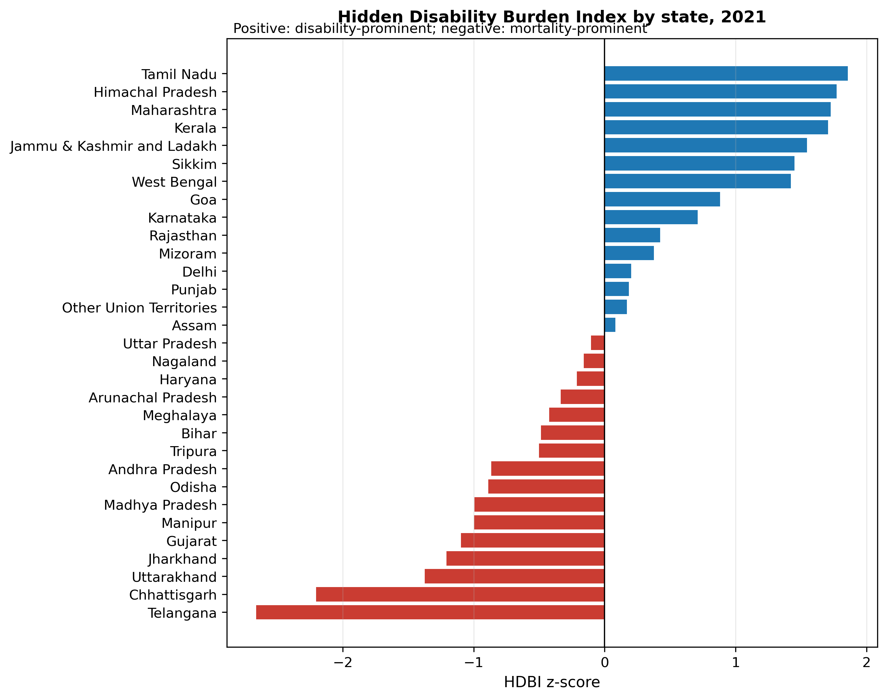

Fig 3
Cause-specific injury DALY heatmap by state.
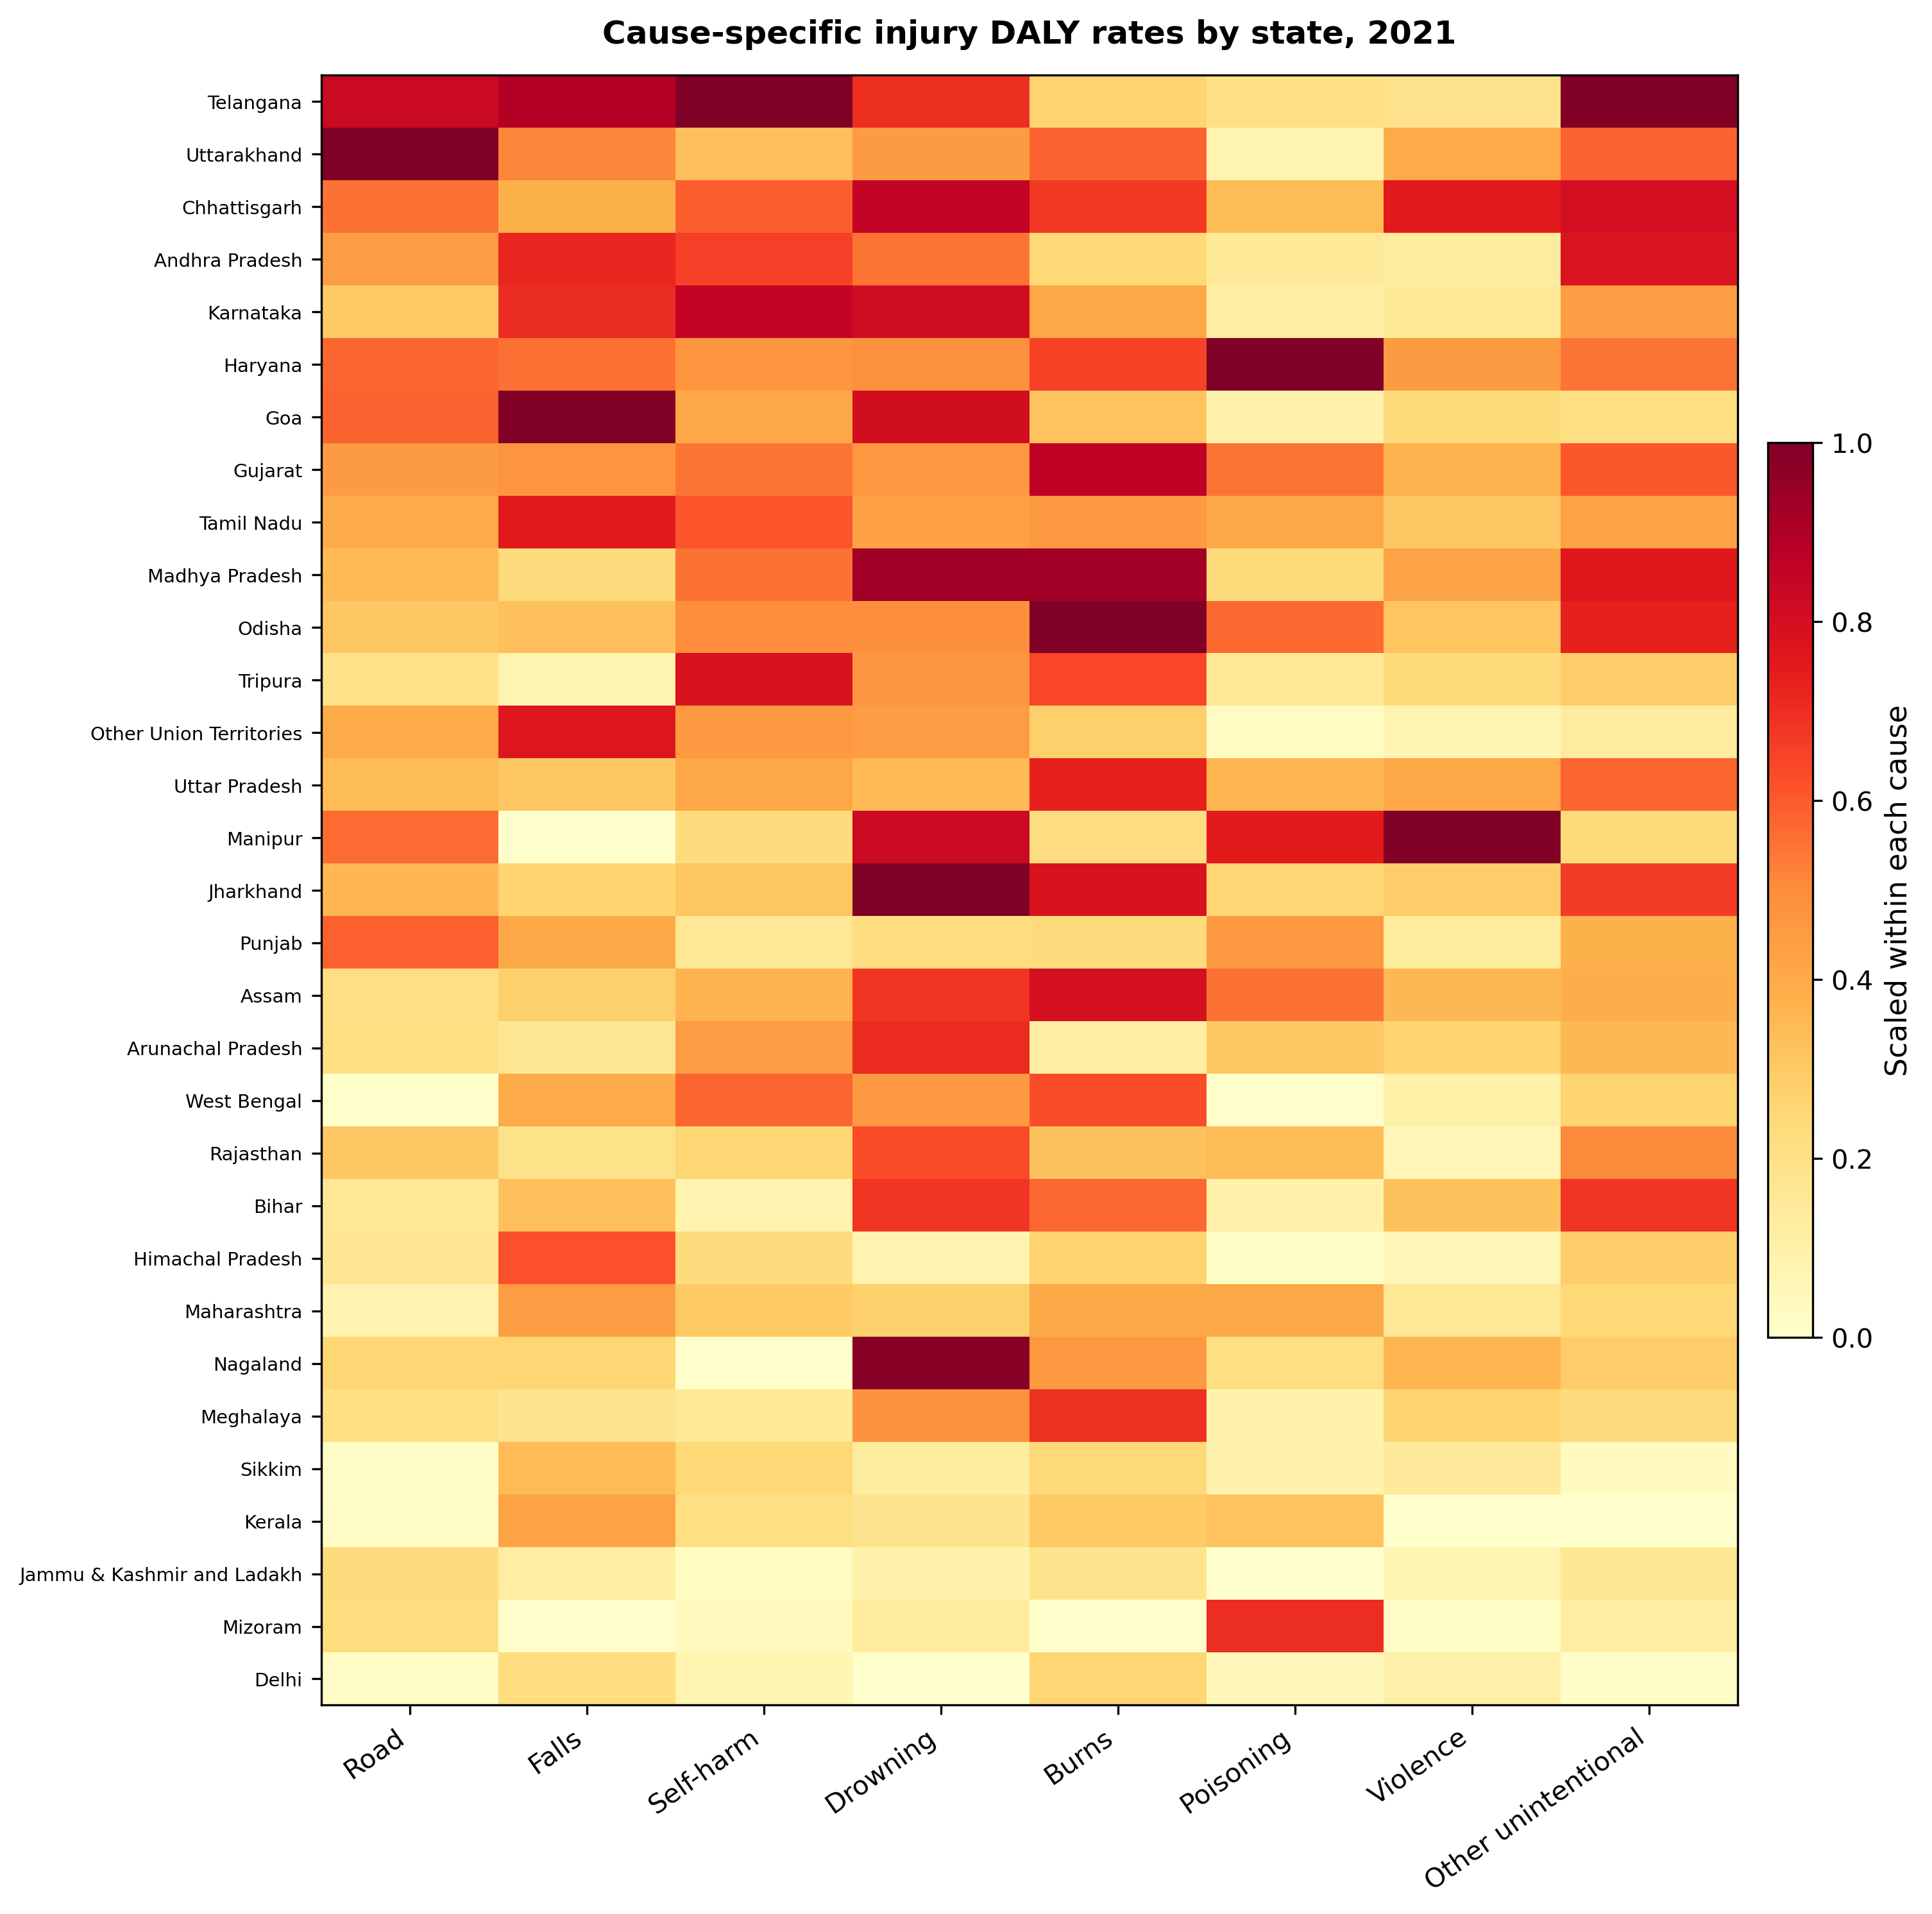

Fig 4
Available-year trend series for burden totals.
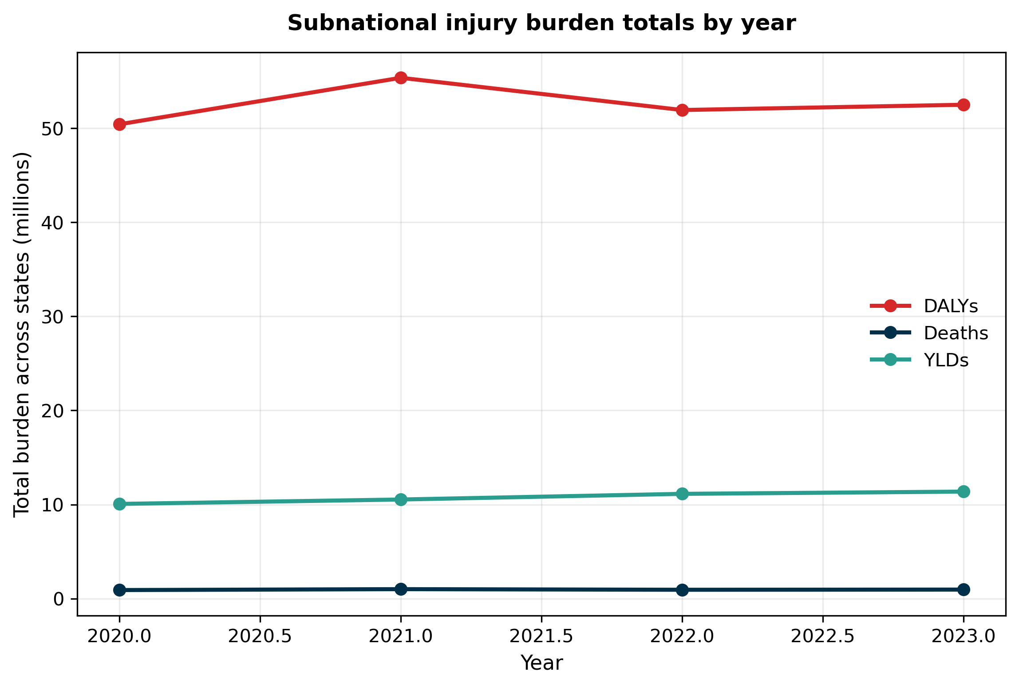

Fig 5
State typology by death rate and YLD rate.
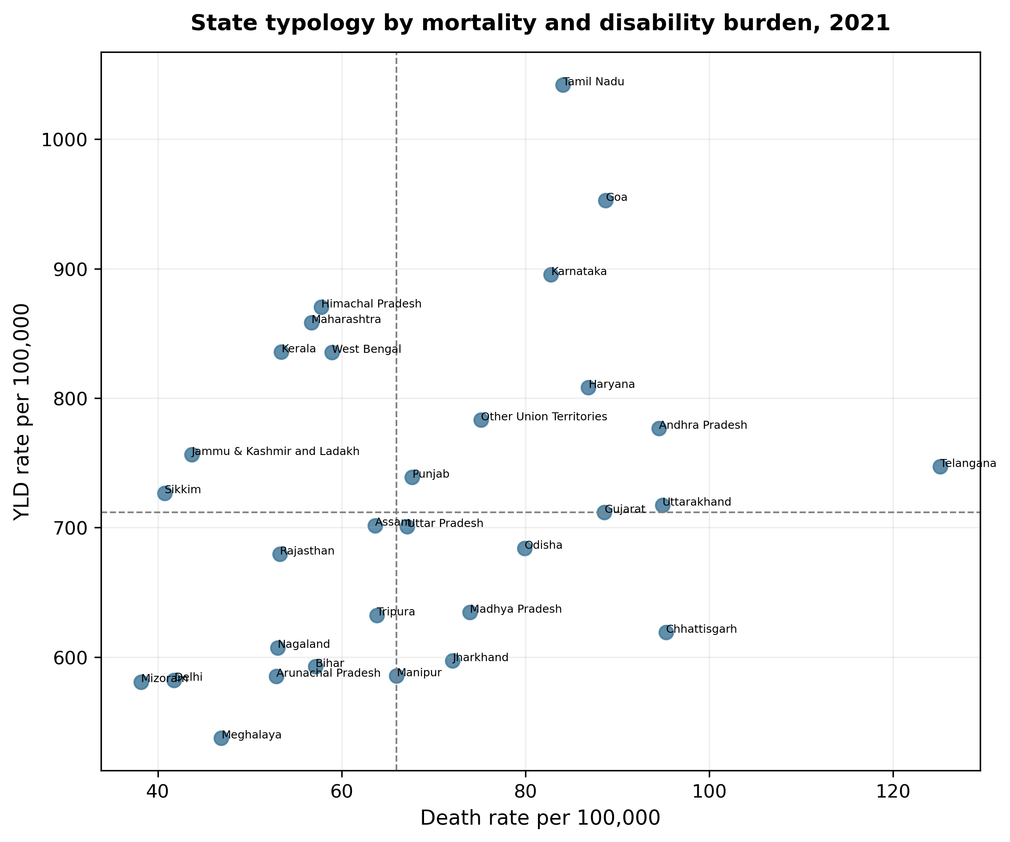

Fig 6
Road-injury surveillance-burden rank mismatch.
