Figures
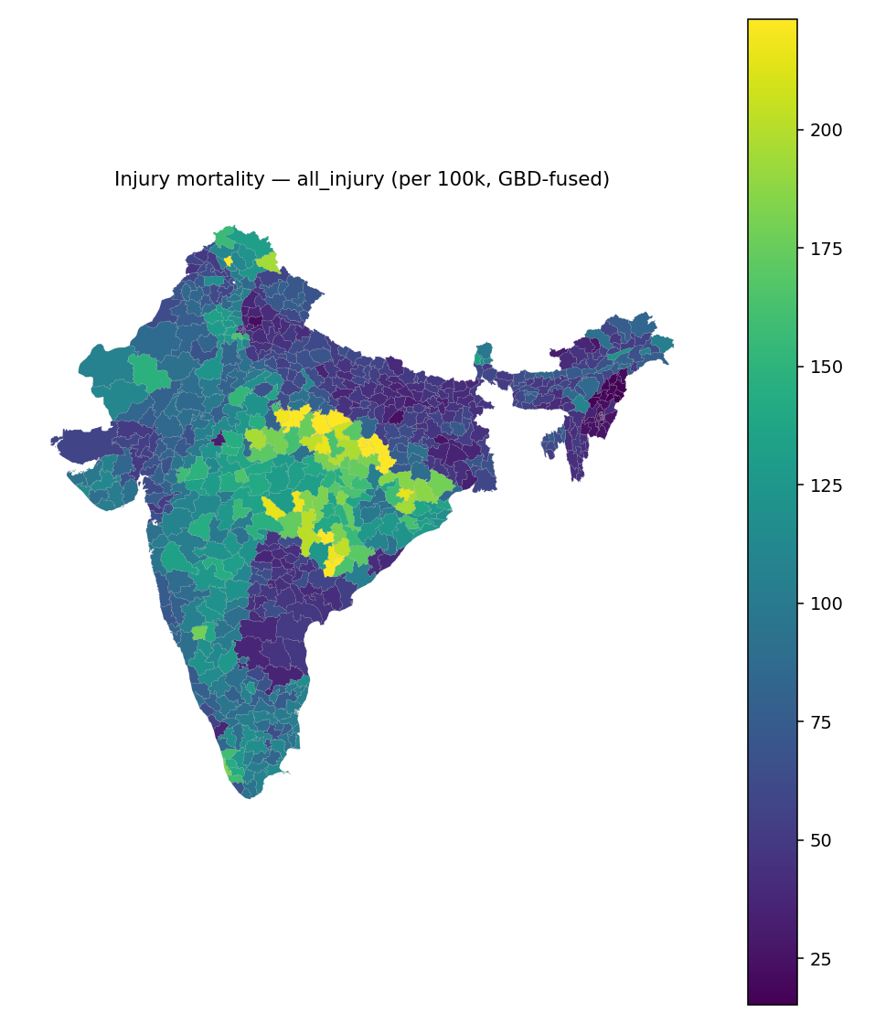
Figure 1. District all-injury mortality rate per 100 000 (posterior mean, GBD/NCRB-fused), 702 districts, 2023.
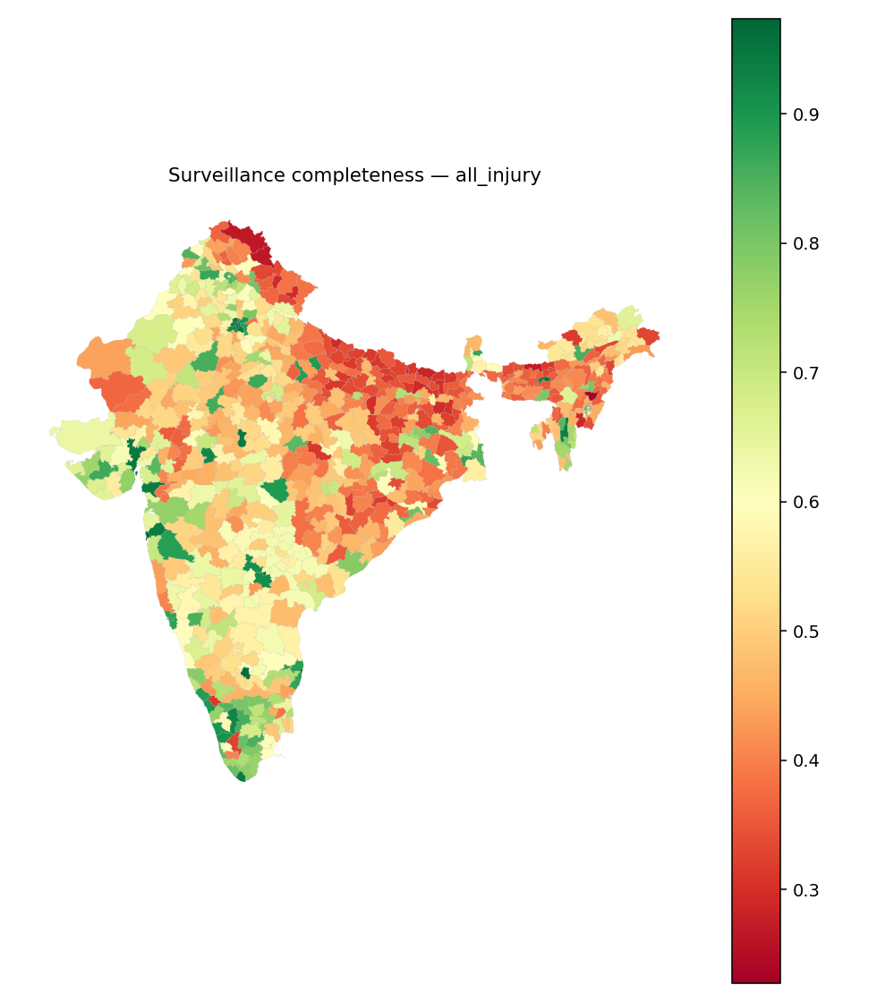
Figure 2. Estimated injury surveillance completeness (administrative/true deaths) by district, all-injury; red indicates severe under-capture.
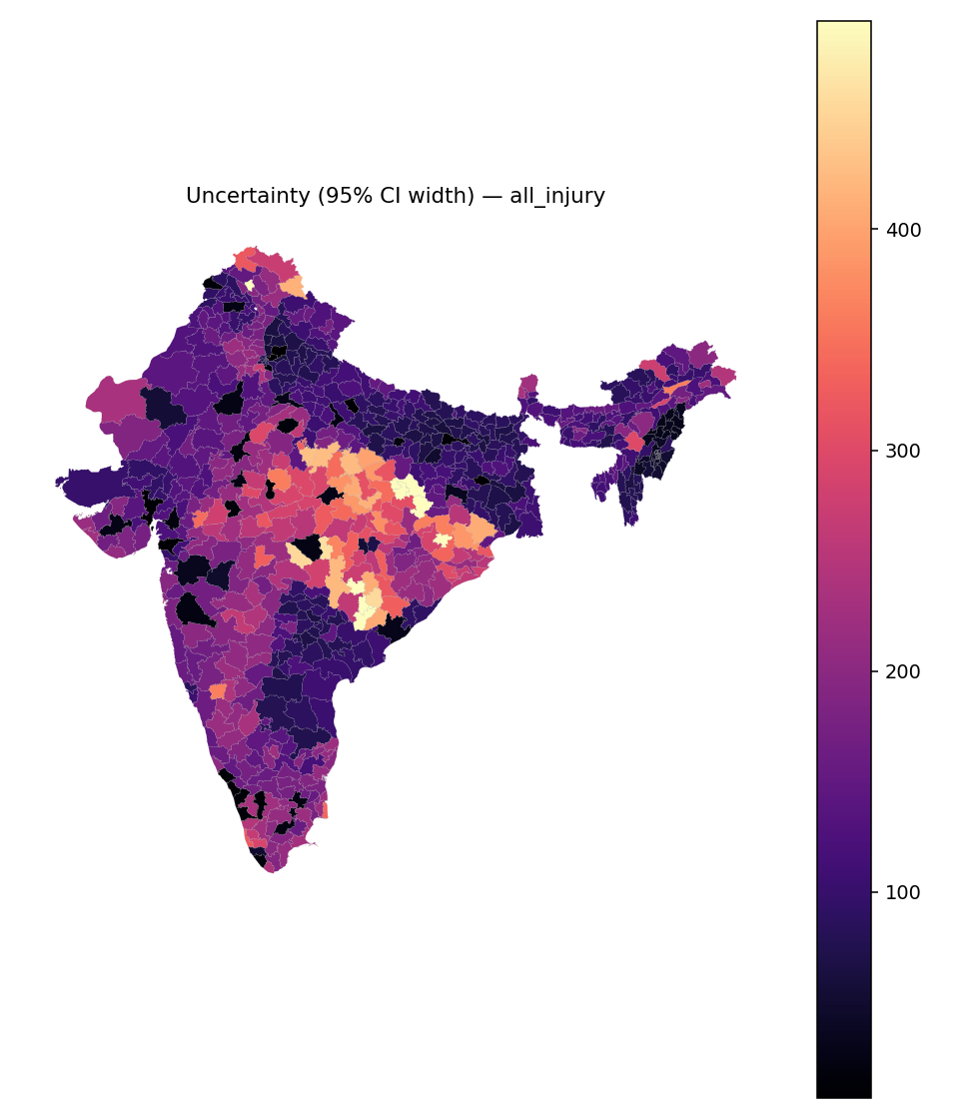
Figure 3. Posterior uncertainty (95% credible-interval width) in district all-injury mortality rate.

