Dietary Guidelines for Indians - Infographic

A visual guide by the National Institute of Nutrition (NIN) to promote health, prevent disease, and ensure a well-nourished nation.

# India's Dual Nutrition Challenge

## Undernutrition

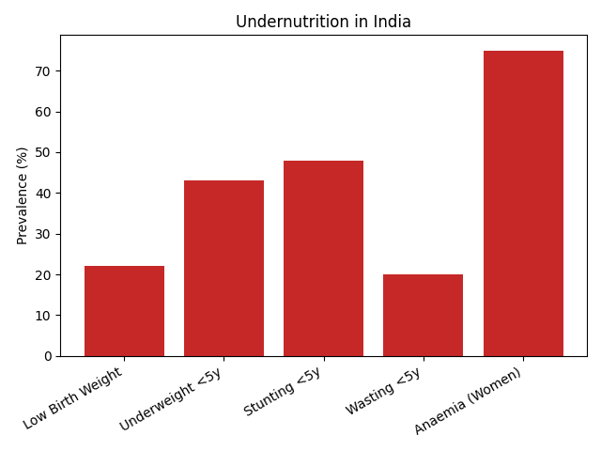

## Overnutrition & NCDs

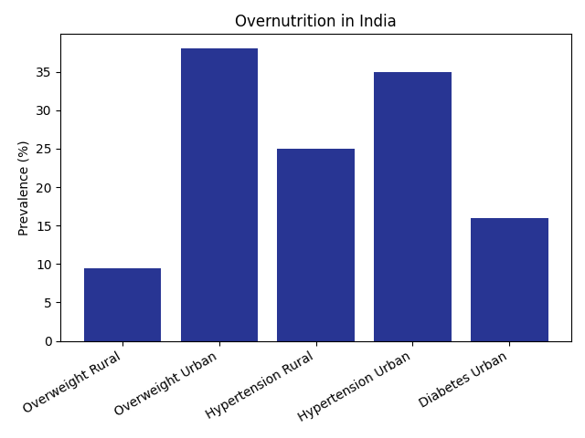

# Guideline 1: The Foundation of a Balanced Diet

A balanced diet provides all necessary nutrients in required amounts and proper proportions. Achieved by eating a variety of foods.

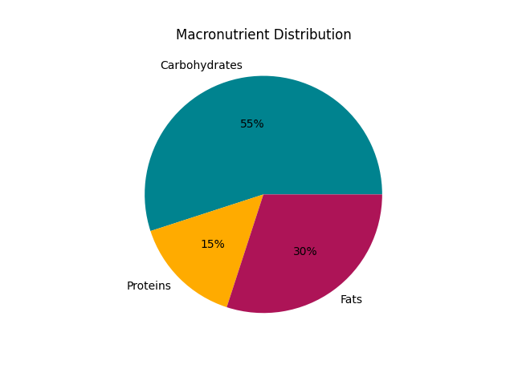

🌾 Cereals, Millets & Pulses – Main source of energy and protein

🥦 Vegetables & Fruits – Rich in vitamins, minerals, and fiber

🥛 Milk, Eggs & Meat – High-quality protein and micronutrients

🥑 Fats, Nuts & Oils – Energy and essential fatty acids

# Nutrition Through Life Stages

|  |  |
| --- | --- |
| Life Stage | Extra Kcal/day |
| Pregnancy | +350 |
| Lactation | +600 |

👶 Infancy (0–6m): Exclusive breastfeeding

🍲 After 6m: Semi-solid complementary foods

🧒 Childhood: Balanced meals, prevent deficiencies

👩 Adolescents: Extra calcium & iron

👵 Elderly: Nutrient-dense, soft, easy-to-digest meals

# Building Healthy Habits for Life

🥦 Eat Vegetables & Fruits – Aim ≥ 300g/day vegetables & ≥ 100g/day fruits

🧂 Limit Salt – <5g/day; avoid pickles, papads, chips

🍳 Cook Smart – Prefer steaming/boiling, avoid reused oil

💧 Hydrate – At least 8 glasses safe water daily

🏃 Be Active – 45 min/day, 5+ days per week

Infographic based on the 'Dietary Guidelines for Indians - A Manual' by NIN-ICMR, Hyderabad.  
This is a visual interpretation and not a replacement for the official document.