**Article Type**

**Mathematical Modelling and Analysis of Cholera Epidemic in the Presence of the Disease Progression Dynamics and Intervention Strategies**

**ABSTRACT**

Cholera is a disease caused by a bacteria called *Vibrio cholera*. Cholera is common in rural areas, where there is poor personal hygiene, poor environmental sanitation, insufficient health facilities, and inadequate access to clean water and safe food. Cholera remains a global health challenge with its frequent outbreaks. This study aims at modifying a mathematical model to understand the progression dynamics of the disease and intervention strategies. The study tends to determine the effectiveness of awareness campaigns and compliance to (personal hygiene, environmental sanitation, access to clean water and food, alongside regular medical check-up), vaccination, treatment, or direct observed therapy shortcuts (DOTS) as preventive measures against cholera progression in the population. The analysis of this model reveals that there exists a region where the model is mathematically and epidemiologically well posed because its solutions were positive and bounded. The next-generation matrix approach was used to investigate the effective reproduction number $R_{e}$. Stability analysis of the cholera model shows that the disease-free equilibrium is both locally and globally asymptotically stable when $R_{e}<1$. This means that when $R_{e}$ is less than 1 $R_{e}<1$ the disease continues to die out due to time. The endemic equilibrium shows that the disease exists in the population when $R_{e}>1$. In an attempt to examine the effect of some parameters of the dynamics of the disease, sensitivity analysis is employed. Finally, numerical simulations are also performed to verify the analytic results. The simulation study revealed that the increase in awareness campaigns and compliance to (personal hygiene, environmental sanitation, access to clean water and food, alongside regular medical check-up), vaccination, and timely treatment such as direct observed therapy short-cut (DOTS) is necessary to achieve a significant and effective control of cholera in the environment.

**KEYWORDS:** *Cholera, Modelling, Control Measures, Epidemic, The Effective Basic Reproduction Number, Sensitivity Analysis, Numerical Simulation.*

1. **Introduction**

Cholera, caused by Vibrio cholerae, is a waterborne disease prevalent in rural and climate-impacted regions of Africa [1,2,3,36]. It manifests through symptoms such as frequent stooling, vomiting, dehydration, and general weakness [4,5]. Mortality data suggest that cholera has resulted in 21,000 to 143,000 deaths across the continent, posing a major public health threat [6].

Environmental pollution, poor drainage systems, and unclean surroundings contribute to the spread of pathogens, worsening public health and making communities less habitable [7,8,35]. The consequences extend beyond health to affect socio-economic structures, disrupt livelihoods, and place enormous strain on healthcare systems, particularly in densely populated and confined settings like correctional facilities [9,10].

To combat these challenges, immediate interventions include providing basic needs, enhancing immunity through medical support, controlling overcrowding, and improving facilities in vulnerable locations [4,7]. Active involvement from government bodies, communities, and global organizations such as WHO and NAFDAC is crucial. Their support through vaccines, treatment kits, healthcare training, and awareness campaigns; remains essential [6,8,11].

Ultimately, the persistence of cholera in Africa is largely linked to inadequate water and sanitation infrastructure and broader socio-economic issues [13,14]. Addressing these requires systemic planning, structural development, and strong policy enforcement, with international collaboration being critical for reducing prevalence and protecting at-risk populations [15,11,16,5].

Researchers have created various epidemic models to understand how diseases spread and to evaluate the effectiveness of control strategies. These models help in predicting transmission patterns and guiding public health interventions [24-32].

**2.1 Model Formulation**

In this section, the application of a mathematical model to cholera progression dynamic is discussed. Considering the infection model for the $S,V,E,I_{A},I_{S},I_{H},R$ and $M$ type of infection model.

**2.2 Model Assumptions**

The model formulation is guided by the following assumptions:

1. I. It is assumed that the susceptible population are recruited through birth or immigration at a constant rate of $π$.
2. II. It is assumed that the vaccine wanes, thereafter they return back to the susceptible class at a rate $φ$
3. III. It is assumed that there can be human to human transmission $β_{1}$ to $β_{4}$ and there can be environment to human transmission at a rate $β_{5}$.
4. IV. It is assumed that all the infected class can recover due to their immunity at a rate $ϕ_{1}$.

V. Those that have fully recovered would move to the susceptible class at a rate $Λ$

VI. The bacterial would reduce by the rate of disinfection in the environment $θ$ or by the decay rate of *Vibrio* cholera $ε$.

1. All model parameters are non-negative.

**2.3 Model Description**

The cholera model developed is a combined system of human population and environmental component. The environment to human transmission and human-to-human transmission are represented by mass action law. The total human population is divided into eight compartments depending on the epidemiological status of individuals. The compartment includes: Susceptible $S\left(t\right)$, Vaccinated $V\left(t\right)$, Exposed $E\left(t\right)$, Asymptomatically infected $I_{A}(t)$, Symptomatically infected $I_{S}(t)$, Hospitalized infected $I_{H}(t)$, Treated $T\left(t\right)$, Recovered $R\left(t\right)$ and the concentration of *Vibrio*  cholera in the environment is denoted as $M\left(t\right)$.

The susceptible population increases due to new birth, vaccine wanes and loss of immunity at the rate $π$, $φ$ and $Λ$. On the other hand, the susceptible population decreases due to vaccination strategy $ω$ and $λ$ as the force of infection together with the campaign parameter $\left(1-z\right)$ where $\left(0≤ z≤ 1\right)$. Also, the exposed class decrease with the proportion of exposed individuals which progresses to symptomatic infected class and the remaining progresses to the asymptomatic infected class at the rate $\left(1-ρ\right)κ$ and $ρκ$ respectively. The asymptomatic infected class increases due to progression rate from exposed individual $ρ$ further decrease by disease induced death rate, recovery rate and detection rate $δ_{1}$, $ϕ_{1}$ and $υ$ respectively. Symptomatic infected class increase by proportion of exposed individuals with progression rate $\left(1-ρ\right)κ$

and reduces by disease induced death rate, recovery rate, treatment rate and hospitalized rate at $δ_{2}$, $ϕ_{2}$, $τ_{1}$ and $χ$ respectively.

At a point the hospitalized infected class increases due to symptomatic infected individuals who are hospitalized at a rate $χ$ and decreases by disease induced death rate, treatment rate, progressing to the recovered class at a recovery rate $δ_{3}$, $τ_{2}$ and $ϕ_{3}$ respectively. The treated class increases by symptomatic infected and hospitalized infected treatment and decreases by recovery rate and disease induced death $ϕ_{4}$ and $δ_{4}$ respectively. And, natural death occurs with all the eight compartment at a constant rate $μ$.

Finally, the concentration of *Vibrio* cholera grows at a constant rate $g$ interacting with asymptomatic infected, symptomatic infected, hospitalized infected and treated compartment at a contact rate $α$ The *Vibrio* cholera decreases by the rate of disinfection in the environment and the decay rate of *Vibrio* cholera at a rate $θ$ and $ε$ respectively.

**2.4 Model Diagram**

The modified model diagram is presented in Figure 1

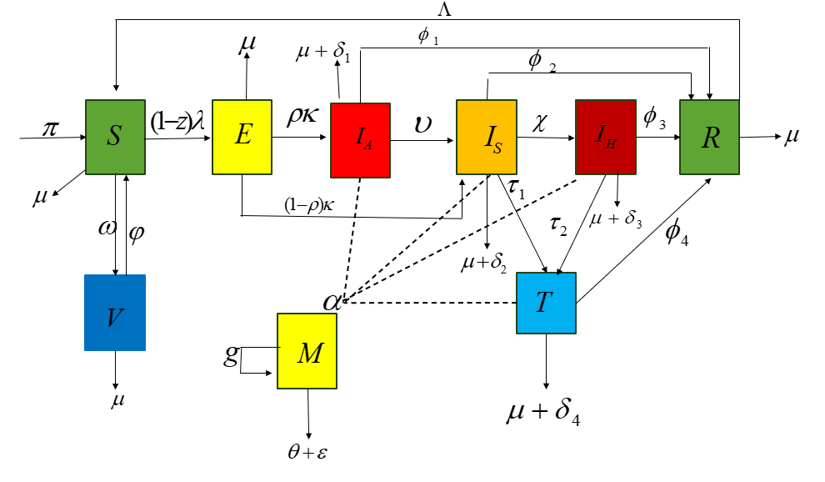

Figure 1. Model flow diagram of the progression dynamic of Cholera

**2.5 Model Equations**

The model is formulated as a system of coupled ordinary differential equation as:

$\frac{dS}{dt}= π-\left(1-z\right)λS-\left(μ+ω\right)S +φV +ΛR$ (1)

$\frac{dV}{dt}=ωS -\left(μ+φ\right)V$ (2)

$\frac{dE}{dt}= \left(1-z\right)λS -\left(κ+μ\right)E$ (3)

$\frac{dI_{A}}{dt}= ρκE -\left(ϕ_{1}+μ+δ_{1}+υ\right)I_{A}$ (4)

$\frac{dI_{S}}{dt}=\left(1-ρ\right)κE + υI_{A}- \left(ϕ_{2}+μ+δ_{2}+τ_{1}+χ\right)I_{S}$ (5)

$\frac{dI_{H}}{dt}=χI_{S}-\left(ϕ_{3}+τ_{2}+μ+δ_{3}\right)I_{H}$ (6)

$\frac{dT}{dt}=τ_{1}I_{S}+τ_{2}I_{H}-\left(μ+δ_{4}+ϕ_{4}\right)T$ (7)

$\frac{dR}{dt}= ϕ_{1}I_{A}+ϕ_{2}I_{S}+ ϕ_{3}I_{H}+ ϕ_{4} T -\left(μ+Λ\right)R$ (8)

$\frac{dM}{dt}= α\left(I_{A}+I_{S}+I_{H}+T\right)-\left(θ+ε-g\right)M$ (9)

$λ= \frac{β_{1}I_{A}+β_{2}I_{S}+ β_{3}I_{H}+ β_{4}T+ β_{5}M}{N}$ (10)

Where $\left(μ+φ\right)= K_{1},$ $\left(κ+μ\right)= K_{2}$,

$\left(ϕ_{1}+μ + δ_{1}+ υ\right)= K_{3}$,

$\left(ϕ_{2}+μ+δ_{2}+τ_{1}+χ\right)= K_{4}$,

$\left(ϕ_{3}+τ_{2}+μ+δ_{3}\right)= K_{5}$, $\left(μ+δ_{4}+ϕ_{4}\right)=K_{6}$,

$\left(μ+Λ\right)= K_{7}$, $\left(θ+ε-g\right)=K_{8}$

**Table 1. Description of Variables**

|  |  |
| --- | --- |
| Variable | Description |
| $$N\left(t\right)$$ | Total human population at time $t$ |
| $$S\left(t\right)$$ | Susceptible individuals at time $t$ |
| $$V\left(t\right)$$ | Vaccinated individuals at time $t$ |
| $$E\left(t\right)$$ | Exposed individuals at time $t$ |
| $$I_{A\left(t\right)}$$ | Asymptomatic infected Individuals at time $t$ |
| $$I_{S\left(t\right)}$$ | Symptomatic infected Individuals at time $t$ |
| $$I_{H\left(t\right)}$$ | Hospitalized infected individuals at time $t$ |
| $$T\left(t\right)$$ | Treated individuals at time $t$ |
| $$R\left(t\right)$$ | Recovered individuals at time $t$ |
| $$M\left(t\right)$$ | Concentration of V.C in contaminating the environment at time $t$ |

**Table 2. Description of Parameters**

|  |  |  |  |
| --- | --- | --- | --- |
| Parameters | Description | Value | Source |
| $$β_{1}$$ | Human to human transmission rate for asymptomatic | 7.0320 $×{10}^{-2}$ | Umar *et al.* (2024) |
| $$β_{2}$$ | Human to human transmission rate for symptomatic | 7.0320 $×{10}^{-4}$ | Umar *et al.* (2024) |
| $$β_{3}$$ | Human to human transmission rate for hospitalized | 7.0320 $×{10}^{-6}$ | Estimated |
| $$β_{4}$$ | Human to human transmission rate for treated | 7.0320 $×{10}^{-8}$ | Estimated |
| $$β_{5}$$ | Environment to human transmission rate | 4.600 $×{10}^{-5}$ | Umar *et al.* (2024) |
| $$π$$ | Recruitment rate | 1(600 $× μ$) | Umar *et al.* (2024) |
| $$μ$$ | Natural death | 0.0017 | Sun *et al.* (2017)} |
| $$ω$$ | Vaccination rate | 0.149 | Mwasa *et al.* (2011) |
| $$φ$$ | Rate of vaccine wane | 0.021 | Mwasa *et al.* (2011) |
| $$κ$$ | Progression rate | 1 | Sun *et al.*(2017) |
| $$ρ$$ | Progression of exposed individuals to symptomatic infected rate | 0.01 | Assumed |
| $$υ$$ | Detection rate | 0.02 | Estimated |
| $$ϕ_{1}$$ | Recovery rate for asymptomatic | 0.2 | NCDC (2022) |
| $$ϕ_{2}$$ | Recovery rate for symptomatic | 0.6 | NCDC (2022) |
| $$ϕ_{3}$$ | Recovery rate for hospitalized | 1 | NCDC (2022) |
| $$ϕ_{4}$$ | Recovery rate for treated | 1.4 | NCDC (2022) |
| $$Λ$$ | Loss of immunity | 0.02 | Estimated |
| $$τ_{1}$$ | Treated rate for symptomatic | 0.4 to 1 | Varies |
| $$τ_{2}$$ | Treated rate for hospitalized | 0.6 to 1 | Varies |
| $$δ_{1}$$ | Disease induced death rate for asymptomatic | 0.6 | NCDC (2022) |
| $$δ_{2}$$ | Disease induced death rate for symptomatic | 0.4 | NCDC (2022) |
| $$δ_{3}$$ | Disease induced death rate for hospitalized | 0.2 | NCDC (2022) |
| $$δ_{4}$$ | Disease induced death rate for treated | 0.1 | NCDC (2022) |
| $$χ$$ | Hospitalized rate | 0.6 | Sun *et al.* (2017) |
| $$α$$ | The rate of human contribution to environmental contamination | 100 | Umar *et al.* (2024) |
| $$g$$ | The growth rate of bacterial | 0.05 | Assumed |
| $$θ$$ | The rate of disinfection in the environment | 0.07 | Sun *et al.* (2017) |
| $$ε$$ | The decay rate of *Vibrio* cholera | 0.2331 | Sun *et al.* (2017) |
| $$z$$ | Rate of awareness and compliance | 0.4 $(0≤z≥1)$ | Assumed |

**2.6 POSITIVITY and boundedness of solution**

Let the initial data $S\left(0\right), V\left(0\right), E\left(0\right), I_{A\left(0\right)}, I_{S\left(0\right)}, I_{H}(0), T(0)$ and $R(0)$ be non- negative, then the solution $S,V,E,I_{A},I_{S},I_{H},T,R$ of the model is non-negative for all $t>0.$

Proof:

Consider the biological feasibility region $D=\left\{(S,V,E,I_{A},I_{S},I_{H},T,R)∈R_{+}^{8} N≤ \frac{π}{μ}\right\}$ It will be shown that D is positive in-variance (i.e. all solutions remain in D for all time $t>0$. The rate of change of total population.

$\frac{dN}{dt}= π-μ\left(S,V,E,I_{A},I_{S},I_{H},T,R\right)$

Where, $N=S+V+E+I_{A}+I_{S}+I_{H}+T+R$

$\frac{dN}{dt}= π-μN$ $⇒\frac{dN}{dt}≤ π-μN$

Using integrating factor

$N\left(t\right)≤ e^{-\int{μ} dt} [\int{π} e^{-\int{μ} dt} dt]$

$N(t)≤ e^{-μt} [\frac{π}{μ} e^{μt}+ C]$

$N\left(t\right)≤ \frac{π}{μ} + Ce^{-μt}=0$

$N\left(0\right)≤ \frac{π}{μ} + C$

$N\left(0\right)- \frac{π}{μ} ≤ C$

Therefore

$N\left(t\right)≤ \frac{π}{μ} + e^{-μt}\left(N\left(0\right)- \frac{π}{μ}\right)$

If, $N\left(0\right)- \frac{π}{μ}$ All solutions of the model with initial conditions in D remain in the region for $t>0$ this implies that D its positively invariant. In this region, the model can be considered as been epidemiologically and mathematically well posed.

**2.7 Disease free equilibrium (DFE)**

Disease-free equilibrium points are steady-state solutions where there is no Vibrio cholera pathogen, that is $E=I_{A}=I_{S}=I_{H}=T=R=M=0$ and at equilibrium point, the normalized model is obtained by setting. At this point

$$\frac{dS}{dt}=\frac{dV}{dt}=\frac{dE}{dt}=\frac{dI_{A}}{dt}=\frac{dI_{S}}{dt}=\frac{dI_{H}}{dt}=\frac{dT}{dt}=\frac{dR}{dt}=\frac{dM}{dt}=0$$

Thus, the disease-free equilibrium points $E_{0}$ for the Cholera model which yields.

$E_{0}$ $=\left( \frac{π\left(μ+φ\right)}{μ\left(μ+ω+φ\right)}, \frac{ω π}{μ\left(μ+ω+φ\right)},0,0,0,0,0,0,0\right)$ (11)

**2.8 The Endemic Equilibrium Point**

An endemic equilibrium point (EEP) represents a steady state in which disease remains in a population at a steady rate over time. In this state, the number of new incidences balances with the number of recoveries and deaths, making sure that the disease neither dies out nor causes an epidemic [17]. Investigating endemic equilibrium points using equation 1 to 9. It was investigated that the model has a unique endemic equilibrium whenever $R_{e}>1$.

**3.1 The Effective Reproduction Number $\left(R_{e}\right)$**

The effective reproduction number is the average number of secondary infections generated from a single infectious source found only in the susceptible class [18,33]. Applying the next generation matrix approach as described in [19,34-36] and obtained by taking the largest dominant or eigenvalues.

$F=\left[\frac{∂F \left(E_{0}\right)}{∂x_{i}}\right]\left[\frac{∂V \left(E_{0}\right)}{∂x_{j}}\right]$ (12)

Where, F is the new infection, V is the transfer term, $E_{0}$ is the disease-free equilibrium point and $x_{i,j}$ stands for the terms in which the infection progresses. Considering the infected compartment from equation 1 to 9.

$$f=\left[\begin{aligned}\left(1-z\right)λS \\ 0 \\ 0 \\ 0 \\ 0 \\ 0\end{aligned}\right]$$

$$v=\left[\begin{aligned}K_{2} \\ -ρκ+ K_{3}I_{A} \\ -\left(1-ρ\right)κE -υI_{A}+ K_{4}I_{S} \\ -χI_{S}+ K_{5}I_{H} \\ -τ_{1}I_{S}- τ_{2}I_{H}+ K_{6}T \\ -α\left( I_{A}+ I_{S}+ I_{H}+ T\right)+ K_{8}M\end{aligned}\right]$$

Hence;

$R_{e}=$ $L_{1}+L_{2}+ L_{3}+L_{4}+L_{5}<1$ (13)

Where, $L_{1=}\frac{\left(1-z\right)S^{0}β_{1}j_{1}}{S^{0}+V^{0}}$, $L_{2=}\frac{\left(1-z\right)S^{0}β_{2}j_{2}}{S^{0}+V^{0}}$, $L_{3=}\frac{\left(1-z\right)S^{0}β_{3}j_{4}}{S^{0}+V^{0}}$

$L_{4=}\frac{\left(1-z\right)S^{0}β_{4}j_{7}}{S^{0}+V^{0}}$ and $L_{5=}\frac{\left(1-z\right)S^{0}β_{5}j_{11}}{S^{0}+V^{0}}$

However, $R_{e}$ is less than 1. This result indicates that when all control parameters are fully implemented the pathogen or bacteria would decrease and the rate at which the population are prone to the infected would also reduce.

**3.2 Local Stability of Disease-Free Equilibrium (LDFE)**

Lemma 1.

The disease-Free equilibrium of model equation is locally asymptotically stable whenever the effective reproduction number $R_{e}$ is less than one $R_{e}<1$ and when $R_{e}>1$ greater than one it is locally asymptomatically unstable [20].Evaluating the local stability of the disease-free equilibrium is determined by the eigenvalues of the Jacobian matrix of the full system equations 1 to 9 gives;

$$J$$

$$=\left[\begin{matrix}\begin{matrix}-(μ+ω) \\ ω \\ \begin{matrix}0 \\ 0 \\ \begin{matrix}0 \\ 0 \\ \begin{matrix}0 \\ \begin{matrix}0 \\ 0\end{matrix}\end{matrix}\end{matrix}\end{matrix}\end{matrix} & \begin{matrix}φ \\ -K_{1} \\ \begin{matrix}0 \\ 0 \\ \begin{matrix}0 \\ 0 \\ \begin{matrix}0 \\ \begin{matrix}0 \\ 0\end{matrix}\end{matrix}\end{matrix}\end{matrix}\end{matrix} & \begin{matrix}\begin{matrix}0 \\ 0 \\ \begin{matrix}-K_{2} \\ ρ κ \\ \begin{matrix}\left(1-ρ\right)κ \\ 0 \\ \begin{matrix}0 \\ \begin{matrix}0 \\ 0\end{matrix}\end{matrix}\end{matrix}\end{matrix}\end{matrix} & \begin{matrix}-b_{1} \\ 0 \\ \begin{matrix}b_{1} \\ -K_{3} \\ \begin{matrix} υ \\ 0 \\ \begin{matrix}0 \\ \begin{matrix}ϕ_{1} \\ α\end{matrix} \end{matrix}\end{matrix}\end{matrix}\end{matrix} & \begin{matrix}\begin{matrix}-b_{2} \\ 0 \\ \begin{matrix}b_{2} \\ 0 \\ \begin{matrix}-K_{4} \\ χ \\ \begin{matrix}τ_{1} \\ \begin{matrix}ϕ_{2} \\ α\end{matrix}\end{matrix}\end{matrix}\end{matrix}\end{matrix} & \begin{matrix}-b_{3} \\ 0 \\ \begin{matrix}b_{3} \\ 0 \\ \begin{matrix}0 \\ -K_{5} \\ \begin{matrix}τ_{2} \\ \begin{matrix}ϕ_{3} \\ α\end{matrix}\end{matrix}\end{matrix}\end{matrix}\end{matrix} & \begin{matrix}\begin{matrix}-b_{4} \\ 0 \\ \begin{matrix}b_{4} \\ 0 \\ \begin{matrix}0 \\ 0 \\ \begin{matrix}{-K}_{6} \\ \begin{matrix}ϕ_{4} \\ α\end{matrix}\end{matrix}\end{matrix}\end{matrix}\end{matrix} & \begin{matrix}Λ \\ 0 \\ \begin{matrix}0 \\ 0 \\ \begin{matrix}0 \\ 0 \\ \begin{matrix}0 \\ \begin{matrix}-K_{7 } \\ 0 \end{matrix}\end{matrix}\end{matrix}\end{matrix}\end{matrix} \begin{matrix}-b_{5} \\ 0 \\ \begin{matrix}b_{5} \\ 0 \\ \begin{matrix}0 \\ 0 \\ \begin{matrix}0 \\ \begin{matrix}0 \\ {-K}_{8}\end{matrix}\end{matrix}\end{matrix}\end{matrix}\end{matrix}\end{matrix}\end{matrix}\end{matrix}\end{matrix}\right]$$

Where, $b_{1=}\frac{\left(1-z\right)β_{1}S^{0}}{S^{0}+V^{0}}$, $b_{2=}\frac{\left(1-z\right)β_{2}S^{0}}{S^{0}+V^{0}}$, $b_{3=}\frac{\left(1-z\right)β_{3}S^{0}}{S^{0}+V^{0}}$, $b_{4=}\frac{\left(1-z\right)β_{4}S^{0}}{S^{0}+V^{0}}$ and $b_{5=}\frac{\left(1-z\right)β_{5}S^{0}}{S^{0}+V^{0}}$

This is computed numerically by substituting the parameter values given in Table 2. The eigenvalues are evaluated to be

$$\left[\begin{matrix}λ_{1} \\ λ_{2} \\ \begin{matrix}λ_{3} \\ λ_{4} \\ \begin{matrix}λ_{5} \\ \begin{matrix}λ_{6} \\ λ_{7} \\ \begin{matrix}λ_{8} \\ λ_{9}\end{matrix}\end{matrix}\end{matrix}\end{matrix}\end{matrix}\right]\left[\begin{matrix} - 0.171700000000000 \\ - 0.001700000000000 \\ \begin{matrix}- 0.0217000000000096 \\ - 0.253099999911070 \\ \begin{matrix}- 2.00169999998126 \\ \begin{matrix}- 1.80170000014670 \\ - 1.50169999969028 \\ \begin{matrix}- 1.00170000031632 \\ - 0.821699999954329\end{matrix}\end{matrix}\end{matrix}\end{matrix}\end{matrix}\right]$$

Hence, it is locally asymptotically stable since all the eigenvalues are all negative and have real roots.

**3.3 Global Stability of Disease-Free Equilibrium (GSDFE)**

Lemma 2. The disease-free equilibrium (DFE) is globally asymptotically stable if all trajectories or variables of the system converge to the (DFE) as time approaches infinity, provided the effective reproduction number $R_{e}$ is less than one $R_{e}<1$ and when $R_{e}$ is greater than one $R_{e}>1$,it is globally asymptotically unstable [21].

The formula is written in this form:

$\frac{dX}{dt}= F\left(X,Y\right)$

$\frac{dY}{dt}= G(X,Y),F(X,0)=0$

Where, $Xϵ R^{m}$ is the number of uninfected individuals and $Iϵ R^{n}$ denote the number of infected individuals. $E_{0}=(X^{0},0)$ denotes the disease-free equilibrium of this system. The conditions (H1) and (H2) below must be met to guarantee globally asymptotic stability.

Condition 1. (H1) $\frac{dX}{dt}= F\left(X,0\right),X^\{0\}$ is globally asymptotically stable.

$F(X,0)=$ $\left[\begin{matrix}π-(μ+ω) S +φ V +Λ R \\ ω S - (μ +φ) V \\ -(μ+Λ) R\end{matrix}\right]\left[\begin{matrix}S'(t) \\ V'(t) \\ R'(t)\end{matrix}\right]$ (14)

And solving these three ordinary differential equations gives.

$$R(t)=R_{0}e^{-\left(μ+Λ\right)t}$$

$$S\left(t\right)=\left(S_{0} -\frac{π}{μ+ω}-\frac{φ}{μ+ω}V\right)e^{-\left(μ+ω\right)t}$$

$$V\left(t\right)=\left(Ce^{\left(μ+φ+ \frac{ω φ}{μ+ω}\right)}+\frac{φ}{μ+ω} A e^{-\left(μ +ω\right)t}+ B\right)e^{-\left(μ+ω\right)t}$$

Where, $=\frac{ω(S_{0}+\frac{π}{μ+ω})}{μ+ω(μ+φ+\frac{ω φ}{μ +ω})}$, $B=\frac{ω π}{(μ+ω)(μ+φ)-ω φ}$

Since all points converges to;

$X^{0}=\left( \frac{π\left(μ+φ\right)}{μ\left(μ+ω+φ\right)}, \frac{ω π}{μ\left(μ+ω+φ\right)},0,0,0,0,0,0,0\right)$ (15)

Then $X^{0}$ is globally asymptotically stable.

Condition 2. $X^{0}=\left(H2\right)G\left(X,Y\right)= AY - G^{0}\left(X,Y\right),G^{0}\left(X,Y\right)≥ 0$ for $\left(X,Y\right)ϵ Ω$ is globally asymptotically stable.

Where, $A=\frac{∂G}{∂Y}(X^{*},0)$ is an M - matrix and $Ω$ is the region where the model makes biological sense. Hence,

$$G\left(X,Y\right)=\left[\begin{aligned}{\left(1-z\right)λ S-K}_{2} \\ ρκ-K_{3}I_{A} \\ \left(1-ρ\right)κE+υI_{A}- K_{4}I_{S} \\ χI_{S}- K_{5}I_{H} \\ τ_{1}I_{S}+τ_{2}I_{H}- K_{6}T \\ α\left( I_{A}+ I_{S}+ I_{H}+ T\right)- K_{8}M\end{aligned}\right]\left[\begin{aligned}E^{'}\left(t\right) \\ I_{A}^{'}\left(t\right) \\ I_{S}^{'}\left(t\right) \\ I_{H}^{'}\left(t\right) \\ T^{'}\left(t\right) \\ M^{'}\left(t\right)\end{aligned}\right]$$

$$\left[\begin{aligned}\begin{matrix}{-K}_{2} \\ ρ κ \\ \left(1-ρ\right)κ\end{matrix} \\ \begin{matrix}0 \\ 0 \\ 0\end{matrix}\end{aligned} \begin{aligned}\begin{matrix}b_{1} \\ -K_{3} \\ υ\end{matrix} \\ \begin{matrix}0 \\ 0 \\ α\end{matrix}\end{aligned} \begin{aligned}\begin{matrix}b_{2} \\ 0 \\ -K_{4}\end{matrix} \\ \begin{matrix}χ \\ τ_{1} \\ α\end{matrix}\end{aligned} \begin{aligned}\begin{matrix}b_{3} \\ 0 \\ 0\end{matrix} \\ \begin{matrix}-K_{5} \\ τ_{2} \\ α\end{matrix}\end{aligned}\begin{aligned} \begin{matrix} b_{4} \\ 0 \\ 0\end{matrix} \\ \begin{matrix}0 \\ {-K}_{6} \\ α\end{matrix}\end{aligned}\begin{aligned} \begin{matrix}b_{5} \\ 0 \\ 0\end{matrix} \\ \begin{matrix}0 \\ 0 \\ -K_{8}\end{matrix}\end{aligned}\right]\left[\begin{aligned}E^{'}\left(t\right) \\ I_{A}^{'}\left(t\right) \\ I_{S}^{'}\left(t\right) \\ I_{H}^{'}\left(t\right) \\ T^{'}\left(t\right) \\ M^{'}\left(t\right)\end{aligned}\right]$$

$$G^{0 \left(X,Y\right)}=AY-G\left(X,Y\right)=\left[\begin{aligned}0+U_{1}+U_{2}+U_{3}+U_{4}+U_{5} \\ 0 \\ 0 \\ 0 \\ 0 \\ 0\end{aligned}\right]$$

where, $U_{1}=\frac{\left(1-z\right)β_{1} }{(\frac{π\left( ω+φ \right)}{μ\left(μ +ω+φ\right)}-S^{0})+(\frac{ω+π }{μ\left(μ+ω+φ\right)}- V^{0})}$ ($\frac{π\left(μ+φ\right)}{μ\left(μ+ω+φ\right)}-S^{0})$,

$U_{2}=\frac{\left(1-z\right)β_{2} }{(\frac{π\left( ω+φ \right)}{μ\left(μ +ω+φ\right)}-S^{0})+(\frac{ω+π }{μ\left(μ+ω+φ\right)}- V^{0})}$ ($\frac{π\left(μ+φ\right)}{μ\left(μ+ω+φ\right)}-S^{0})$,

$U_{3}=\frac{\left(1-z\right)β_{3} }{(\frac{π\left( ω+φ \right)}{μ\left(μ +ω+φ\right)}-S^{0})+(\frac{ω+π }{μ\left(μ+ω+φ\right)}- V^{0})}$ ($\frac{π\left(μ+φ\right)}{μ\left(μ+ω+φ\right)}-S^{0})$,

$U_{4}=\frac{\left(1-z\right)β_{4} }{(\frac{π\left( ω+φ \right)}{μ\left(μ +ω+φ\right)}-S^{0})+(\frac{ω+π }{μ\left(μ+ω+φ\right)}- V^{0})}$ ($\frac{π\left(μ+φ\right)}{μ\left(μ+ω+φ\right)}-S^{0})$,

$U_{5}=\frac{\left(1-z\right)β_{5} }{(\frac{π\left( ω+φ \right)}{μ\left(μ +ω+φ\right)}-S^{0})+(\frac{ω+π }{μ\left(μ+ω+φ\right)}- V^{0})}$ ($\frac{π\left(μ+φ\right)}{μ\left(μ+ω+φ\right)}-S^{0})$

If, $G^\{0\}=(X,Y)=(S^{0}>S)$ and $(V^{0}>V)$ it is shown that $E_{0}=X^{0}=$ $\left( \frac{π\left(μ+φ\right)}{μ\left(μ+ω+φ\right)}, \frac{ω π}{μ\left(μ+ω+φ\right)},0,0,0,0,0,0,0\right)$ is the global asymptotically stability of the equilibrium.

**3.4 Local Stability of Endemic Equilibrium Point (LSEEP)**

Lemma 3. The concept of local stability of the Endemic Equilibrium Point (LSEEP) refers to the system strength to return to its endemic position after a little interruption. If the endemic equilibrium point is locally stable, the disease remains in the population at a steady rate in spite of ting disturbances. However, an unstable endemic equilibrium point will reduce the rate at which the disease remains in the population [22].

Linearizing the Jacobian matrix of the system 1 to 9

$$J=$$

$$\left[\begin{matrix}\begin{matrix}-a_{1} \\ ω \\ \begin{matrix}a_{10} \\ 0 \\ \begin{matrix}0 \\ 0 \\ \begin{matrix}0 \\ \begin{matrix}0 \\ 0\end{matrix}\end{matrix}\end{matrix}\end{matrix}\end{matrix} & \begin{matrix}a_{2} \\ -K_{1} \\ \begin{matrix}a_{11} \\ 0 \\ \begin{matrix}0 \\ 0 \\ \begin{matrix}0 \\ \begin{matrix}0 \\ 0\end{matrix}\end{matrix}\end{matrix}\end{matrix}\end{matrix} & \begin{matrix}\begin{matrix}a_{3} \\ 0 \\ \begin{matrix}{-a}_{12} \\ ρ κ \\ \begin{matrix}a_{19} \\ 0 \\ \begin{matrix}0 \\ \begin{matrix}0 \\ 0\end{matrix}\end{matrix}\end{matrix}\end{matrix}\end{matrix} & \begin{matrix}-a_{4} \\ 0 \\ \begin{matrix}a_{13} \\ -K_{3} \\ \begin{matrix} υ \\ 0 \\ \begin{matrix}0 \\ \begin{matrix}ϕ_{1} \\ α\end{matrix} \end{matrix}\end{matrix}\end{matrix}\end{matrix} & \begin{matrix}\begin{matrix}-a_{5} \\ 0 \\ \begin{matrix}a_{14} \\ 0 \\ \begin{matrix}-K_{4} \\ χ \\ \begin{matrix}τ_{1} \\ \begin{matrix}ϕ_{2} \\ α\end{matrix}\end{matrix}\end{matrix}\end{matrix}\end{matrix} & \begin{matrix}-a_{6} \\ 0 \\ \begin{matrix}a_{15} \\ 0 \\ \begin{matrix}0 \\ -K_{5} \\ \begin{matrix}τ_{2} \\ \begin{matrix}ϕ_{3} \\ α\end{matrix}\end{matrix}\end{matrix}\end{matrix}\end{matrix} & \begin{matrix}\begin{matrix}-a_{7} \\ 0 \\ \begin{matrix}a_{16} \\ 0 \\ \begin{matrix}0 \\ 0 \\ \begin{matrix}{-K}_{6} \\ \begin{matrix}ϕ_{4} \\ α\end{matrix}\end{matrix}\end{matrix}\end{matrix}\end{matrix} & \begin{matrix}a_{8} \\ 0 \\ \begin{matrix}a_{17} \\ 0 \\ \begin{matrix}0 \\ 0 \\ \begin{matrix}0 \\ \begin{matrix}-K_{7 } \\ 0 \end{matrix}\end{matrix}\end{matrix}\end{matrix}\end{matrix} \begin{matrix}-a_{9} \\ 0 \\ \begin{matrix}a_{18} \\ 0 \\ \begin{matrix}0 \\ 0 \\ \begin{matrix}0 \\ \begin{matrix}0 \\ {-K}_{8}\end{matrix}\end{matrix}\end{matrix}\end{matrix}\end{matrix}\end{matrix}\end{matrix}\end{matrix}\end{matrix}\right]$$

Where:

$a_{1}= -\left(1-z\right)λ^{**}+ \frac{\left(1-z\right)S^{**}{ λ}^{**}}{N^{**}} - (μ+ω)$,

$a_{2}=\frac{\left(1-z\right)S^{**}{ λ}^{**}}{N^{**}}+φ$, $a_{3}=\frac{\left(1-z\right)S^{**}{ λ}^{**}}{N^{**}}$,

$a_{4}=-\frac{\left(1-z\right)S^{**}β_{1}}{N^{**}}+\frac{\left(1-z\right)S^{**}{ λ}^{**}}{N^{**}}$, $a_{5}=-\frac{\left(1-z\right)S^{**}β_{2}}{N^{**}}+\frac{\left(1-z\right)S^{**}{ λ}^{**}}{N^{**}}$,

$a_{6}=-\frac{\left(1-z\right)S^{**}β_{3}}{N^{**}}+\frac{\left(1-z\right)S^{**}{ λ}^{**}}{N^{**}}$,

$a_{7}=-\frac{\left(1-z\right)S^{**}β_{4}}{N^{**}}+\frac{\left(1-z\right)S^{**}{ λ}^{**}}{N^{**}}$, $a_{8}=\frac{\left(1-z\right)S^{**}{ λ}^{**}}{N^{**}}$ + Λ

$a_{9}=-\frac{\left(1-z\right)S^{**}β_{5}}{N^{**}}+\frac{\left(1-z\right)S^{**}{ λ}^{**}}{N^{**}}$

$a_{10}= \left(1-z\right)λ^{**}- \frac{\left(1-z\right)S^{**}{ λ}^{**}}{N^{**}}$

$a_{11}=\frac{\left(1-z\right)S^{**}{ λ}^{**}}{N^{**}}$, $a_{12}=-\frac{\left(1-z\right)S^{**}{ λ}^{**}}{N^{**}}$- (κ +μ),

$a_{13}=\frac{\left(1-z\right)S^{**}β_{1}}{N^{**}}-\frac{\left(1-z\right)S^{**}{ λ}^{**}}{N^{**}}$

$a_{14}=\frac{\left(1-z\right)S^{**}β_{2}}{N^{**}}-\frac{\left(1-z\right)S^{**}{ λ}^{**}}{N^{**}}$,

$a_{15}=\frac{\left(1-z\right)S^{**}β_{3}}{N^{**}}-\frac{\left(1-z\right)S^{**}{ λ}^{**}}{N^{**}}$,

$a_{16}=\frac{\left(1-z\right)S^{**}β_{4}}{N^{**}}-\frac{\left(1-z\right)S^{**}{ λ}^{**}}{N^{**}}$,

$a_{17}=-\frac{\left(1-z\right)S^{**}{ λ}^{**}}{N^{**}}$,

$a_{18}=\frac{\left(1-z\right)S^{**}β_{5}}{N^{**}}-\frac{\left(1-z\right)S^{**}{ λ}^{**}}{N^{**}}$ and

$a_{19}=\left(1-ρ\right)κ$

The characteristic equation of the system above is given by:

${P(λ) =λ}^{9} + C_{0} λ^{8} + C_{1} λ^{7}+ C_{2} λ^{6}+ C_{3} λ^{5}+ C_{4} λ^4+ C_{5} λ^{3} + C_{6} λ^{2} + C_{7} λ^{1}+C_{8}$

Where:

$B_{1}=\frac{C_{0}C_{1}-C_{2}}{C_{0}}$, $B_{2}=\frac{C_{0}C_{3}-C_{4}}{C_{0}}$, $B_{3}=\frac{C_{0}C_{5}-C_{6}}{C_{0}}$, $B_{4}=\frac{C_{0}C_{7}-C_{8}}{C_{0}}$,

$D_{1}=\frac{B_{1}C_{2}-B_{2}{ C}_{0}}{B_{1}}$*, $D_{2}=\frac{B_{1}C_{4}-B_{3}{ C}_{0}}{B_{1}}$, $D_{2}=\frac{B_{1}C_{6}-B_{4}{ C}_{0}}{B_{1}}$, $D_{4}=C_{8}$*

$E_{1}=\frac{D_{1}B_{2}-D_{2}B_{1}}{D_{1}}$*, $E_{2}=\frac{D_{1}B_{3}-D_{3}B_{1}}{D_{1}}, E_{3}=\frac{D_{1}B_{4}-D_{4}B_{1}}{D_{1}}$*

$F_{1}=\frac{E_{1}D_{2}-E_{2}D_{1}}{E_{1}}$, $F_{2}=\frac{E_{1}D_{3}-E_{3}D_{1}}{E_{1}}$ *, $H_{3}=D_{4}$ $G_{1}=\frac{F_{1}E_{2}-F_{2}E_{1}}{F_{1}}$ 
 , $G_{2}=\frac{F_{1}E_{3}-F_{3}E_{1}}{F_{1}}$,*

$H_{1}=\frac{G_{1}F_{2}-G_{2}F_{1}}{G_{1}}$, $H_{2}=F_{3}$

$I_{1}=\frac{H_{1}G_{2}-H_{2}G_{1}}{H_{1}}$, $J_{1}=H_{2}$

Where, $J_{1}= H_{2}=F_{3}=D_{4}=C_{8}$

According to Routh Hurwitz criterion as cited in [22], when $R_{e}>1$ the endemic equilibrium $E^{**}$ of the system 1 to 9 is locally asymptomatically stable if:

All coefficients $C_{0},C_{1},C_{2},… C_{8}$ of the characteristic polynomial $P(λ)$ are positive and if $1>0, C_{0}>0, B_{1}>0, D_{1}>0, E_{1}>0, F_{1}>0, G_{1}>0, H_{1}>0, I_{1}>0, C_{8}>0$

**3.5 Global Stability of Endemic Equilibrium Point (GSEEP)**

Lemma 4. The global stability of endemic equilibrium point depicts a constant-state where the disease continuous to grow in the population at a steady level instead of dying out or progressing into an endemic [23].

Let $E^{**}$ be the unique positive equilibrium point of the system equation 1 to 9. If $R_{e}>1$ then the endemic equilibrium $E^{**}$ of the system 1 to 9 is globally asymptotically stable. Using the Lyapunov function gives;

$L(S^{**},V^{**},E^{**},I_{A}^{**},I_{S}^{**},I_{H}^{**},T^{**},M^{**})=$ $\left(S-S^{**}-S^{**}\ln\left(\frac{S^{**}}{S}\right)\right)+\left(V-V^{**}-V^{**}\ln\left(\frac{V^{**}}{V}\right)\right)+$ $\left(E-E^{**}-E^{**}\ln\left(\frac{E^{**}}{E}\right)\right)+$

$\left( I_{A}-{ I_{A}}^{**}-{I_{A}}^{**}\ln\left(\frac{{I_{A}}^{**}}{I_{A}}\right)\right)+$ $\left( I_{S}-{ I_{S}}^{**}-{I_{S}}^{**}\ln\left(\frac{{I_{S}}^{**}}{I_{S}}\right)\right)$

$+\left( I_{H}-{ I_{H}}^{**}-{I_{H}}^{**}\ln\left(\frac{{I_{H}}^{**}}{I_{H}}\right)\right)$ $\left(T-T^{**}-T^{**}\ln\left(\frac{T^{**}}{T}\right)\right)+$

$\left(R-R^{**}-R^{**}\ln\left(\frac{R^{**}}{R}\right)\right)+$ $\left(M-M^{**}-M^{**}\ln\left(\frac{M^{**}}{M}\right)\right)$

The derivative of L along the solution of the system is directly;

$\frac{dL}{dt}= \frac{S-S^{**} }{S}\left[π-\left(1-z\right)λ S-(μ+ω) S +φ V +Λ R\right]+$

$\frac{V-V^{**} }{V}\left[ ω S -(μ+φ) V\right]+$ $\frac{E-E^{**} }{E}\left[\left(1-z\right)λ S -(κ +μ) E\right]$

$\frac{ I_{A}-{ I_{A}}^{**} }{ I_{A}}\left[ρ κ E -(ϕ_{1}+μ+δ_{1}+υ) I_A \right]$ +

$\frac{ I_{S}-{ I_{S}}^{**} }{ I_{S}}\left[\left(1-ρ\right)κ E +υ I_{A}-\left(ϕ_{2}+μ+δ_{2}+τ_{1}+χ\right)I_{S}\right]+$

$\frac{ I_{H}-{ I_{H}}^{**} }{ I_{H}}\left[χ I_{S} -(ϕ_{3}+τ_{2}+μ+δ_{3}) I_H \right]+$

$\frac{T-T^{**} }{T}\left[ τ_{1} I_{S}+τ_{2} I_{H} -(μ+δ_{4}+ϕ_{4}) T\right]+$

$\frac{R-R^{**} }{R}\left[ ϕ_{1} I_{A}+ϕ_{2} I_{S}+ϕ_{3} I_{H} +ϕ_{4} T -(μ+Λ) R\right]+$

$\frac{M-M^{**} }{M}\left[α(I_{A}+I_{S}+I_{H}+T)-(θ+ε-g)M \right]$

By expansion and simplification;

$\frac{dL}{dt}= P-D$

Where P denotes the positive terms and D denotes the negative terms so that

$P=π+ \left(1-z\right)λ S^{**} + \left(μ+ω\right)S^{**}+\left(μ +φ\right)V^{**}+ \left(κ +μ\right)E^{**}+\left(ϕ_{1}+μ+δ_{1}+υ\right)I_{A}^{**}+$ $\left(ϕ_{2}+μ+δ_{2}+τ_{1}+χ\right)I_{S}^{**}+\left(ϕ_{3}+τ_{2}+μ+δ_{3}\right)I_{H}^{**} + \left(μ+δ_{4}+ϕ_{4}\right\})T^{**} + \left(μ+Λ\right)R^{**}$

$D= -μ S - \frac{π S^{**}}{S}-\frac{Λ RS^{**}}{S}-\frac{φ VS^{**}}{S}-μ V-\frac{ω SV^{**}}{V}-μE$

$$-\frac{\left(1-z\right)λ SE^{**}}{E}-μ I_{A}-δ_{1} I_{A}-\frac{ρκ E{I_{A}}^{**}}{I_{A}} -μ I_{S}-δ_{2} I_{S}$$

$-\frac{\left(1-ρ\right)κ E{I_{S}}^{**} }{I_{S}}-\frac{υ I_{A}{ I_{S}}^{**} }{I_{S}} -μ I_{H} -δ_{3} I_{H}-\frac{χ I_{S}{ I_{H}}^{**} }{I_{H}}$

$$-μ T-δ_{4} T-\frac{τ_{1}I_{S}T^{**} }{T}-\frac{τ_{2}I_{H}T^{**} }{T}-\frac{ϕ_{1} I_{A}R^{**} }{R}-\frac{ϕ_{2}I_{S}{ R}^{**} }{R}$$

$-\frac{ϕ_{3}I_{H}{ R}^{**} }{R}-\frac{ϕ_{4}T{ R}^{**} }{R}-θ M -ε M -g M^{**} -\frac{αI_{A}{ M}^{**} }{M}$

$-\frac{αI_{S}{ M}^{**} }{M}-\frac{αI_{H}{ M}^{**} }{M}-\frac{αT{ M}^{**} }{M}$

If $P<D$ then $\frac{dL}{dt}≤0,\frac{dL}{dt}=0,$

$S= S^{**}, V= V^{**} , E= E^{**}, I_A=I_{A}^{**},$

$I_{S}=I_{S}^{**}, I_{H}=I_{H}^{**}, T= T^{**}, R= R^{**} M= M^{**}$

The largest invariant set is $\left(S^{**},V^{**},E^{**},I_{A}^{**},I_{S}^{**},I_{H}^{**},T^{**},M^{**}\right)∈ \frac{dL}{dt}=0$ a unit set of $E^{**}$. Here, $E^{**}$ is the endemic equilibrium signifying that the endemic is globally asymptotically stable.

**3.6 Sensitivity Analysis**

Sensitivity analysis is applied in other to evaluate the effective reproduction number $R_{e}$ with respect to each of the parameters. These reflects the bond between each parameter and the effective basic reproduction number $R_{e}$. The normalized forward sensitivity index of $R_{e}$ with a parameter $x$ is defined as follows:

$X_{x}^{R_{e}} =\frac{{∂R}_{e}}{∂x}×\frac{x}{R_{e}}$ (16)

The values in Table 4 indicates how different parameters have a huge impact on the effective reproduction number as shown below;

Table 4. Sensitivity index of $R_{e}$ with respect to the model parameters.

|  |  |  |
| --- | --- | --- |
| Parameters | Value | Index |
| $$β_{1}$$ | 0.0593 | + |
| $$β_{2}$$ | 0.0241 | + |
| $$β_{3}$$ | 0.0001 | + |
| $$β_{4}$$ | $$9.6224×{10}^{-7}$$ | + |
| $$β_{5}$$ | 0.9166 | + |
| $$π$$ | 1 | + |
| $$μ$$ | -0.9381 | - |
| $$ω$$ | -0.8678 | - |
| $$φ$$ | 0.8028 | + |
| $$κ$$ | 0.0017 | + |
| $$ρ$$ | 0.0629 | + |
| $$υ$$ | -0.0011 | - |
| $$ϕ_{1}$$ | -0.0176 | - |
| $$ϕ_{2}$$ | -0.2781 | - |
| $$ϕ_{3}$$ | -0.1349 | - |
| $$ϕ_{4}$$ | -0.1942 | - |
| $$τ_{1}$$ | -0.0465 | - |
| $$τ_{2}$$ | -0.0116 | - |
| $$δ_{1}$$ | -0.0528 | - |
| $$δ_{2}$$ | -0.1854 | - |
| $$δ_{3}$$ | -0.0269 | - |
| $$δ_{4}$$ | -0.0138 | - |
| $$χ$$ | -0.0349 | - |
| $$α$$ | 0.9166 | + |
| $$g$$ | 0.0003 | + |
| $$θ$$ | -0.0193 | - |
| $$ε$$ | -0.0643 | - |
| $$z$$ | -0.6667 | - |

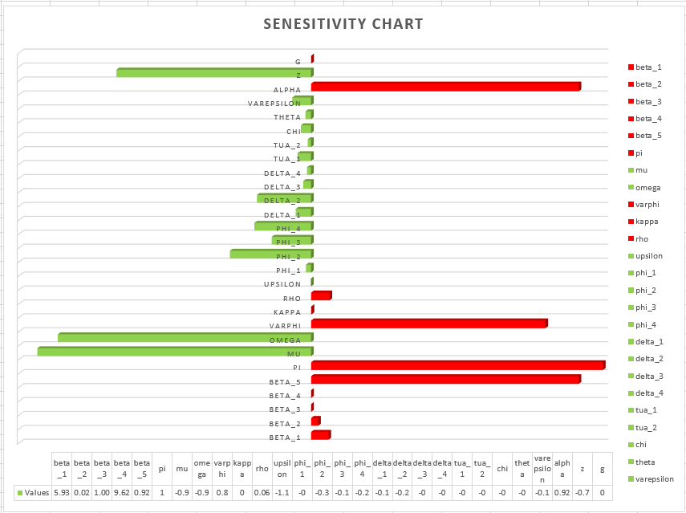

Figure 2. A graph of Sensitivity analysis of Cholera progression dynamics

The parameter sensitivity index utilizes the derivative-based local method, as elaborated in Table 4, showcasing the relationships between various parameters and the effective reproduction number $R_{e}$. Parameters such as $β_{1}, β_{2}, β_{3}, β_{4}, β_{5}, π, φ, κ, ρ, g$ and $α$ exhibit a direct relationship with $R_{e}$, increasing the progression of *Vibrio* cholera within the population. Also, parameters like $z, χ, δ_{1} , δ_{2}, δ_{3}, δ_{4}, τ_{1}, τ_{2}, ϕ_{1}, ϕ_{2}, ϕ_{3} , ϕ_{4}, ω, υ, μ, θ$ and $ε$ showcase an inverse relationship with $R_{e}$, impeding or reducing the spread of *Vibrio* cholera. Strategies such as reducing the force of infection, promoting personal hygiene, environmental sanitation, access to clean water and safe food, medical check-ups, and restricting infected individuals' access to public resources can significantly decrease the effective reproduction number $R_{e}$.

Moreover, timely treatment like Directly Observed Therapy Short-Course (DOTS), awareness campaigns, and compliance can effectively lower the effective reproduction number $R_{e}$ and reduce the progression dynamics of *Vibrio* cholera within the population. This structured discussion follows the Figure 2, allowing for a seamless continuation of the analysis regarding parameter sensitivity in the context of cholera progression dynamics.

**4.1 Numerical Simulation AND DISCUSSION**

Numerical simulation is a digital technique used on the model equation 1 to 9 to evaluate the analytic behaviour of the model. The systems of differential equations was solved over a specific period of time carried out by differential transformation method on Maple. The parameter values used in the simulations are found in the Table 2 with the following initial conditions: $N\left(t\right)=4900$, $S\left(t\right)=1000$, $V\left(t\right)=500$, $E\left(t\right)=800$, $I_{A}\left(t\right)=700$, $I_{S}\left(t\right)=400$ $I_{H}\left(t\right)=500$, $T\left(t\right)=700$, $R\left(t\right)=300$, $M\left(t\right)=1000$.

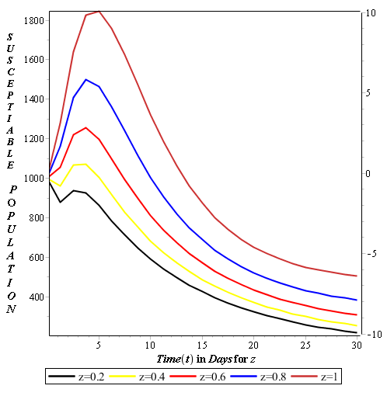

Figure 3. Population of susceptible individuals for z=0.2, 0.4, 0.6, 0.8 and 1

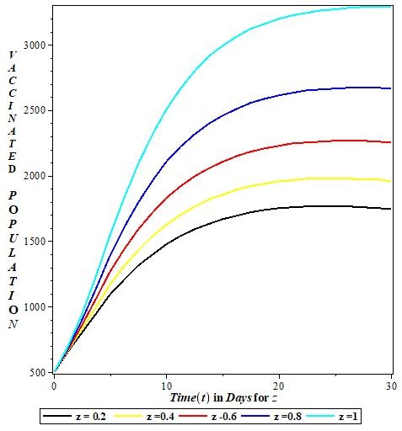

Figure 4. Population of vaccinated individuals for z=0.2,

0.4, 0.6, 0.8 and 1

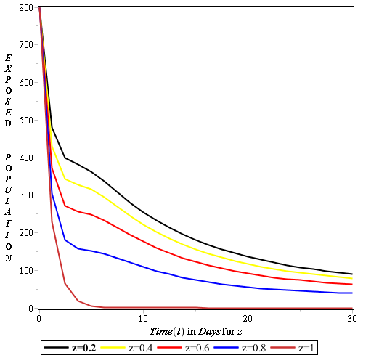

Figure 5. Population of exposed individuals for z=0.2, 0.4, 0.6, 0.8 and 1

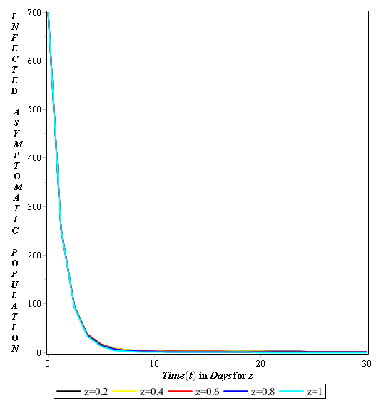

Figure 6. Population of infected asymptomatic individuals for z=0.2, 0.4, 0.6, 0.8 and 1

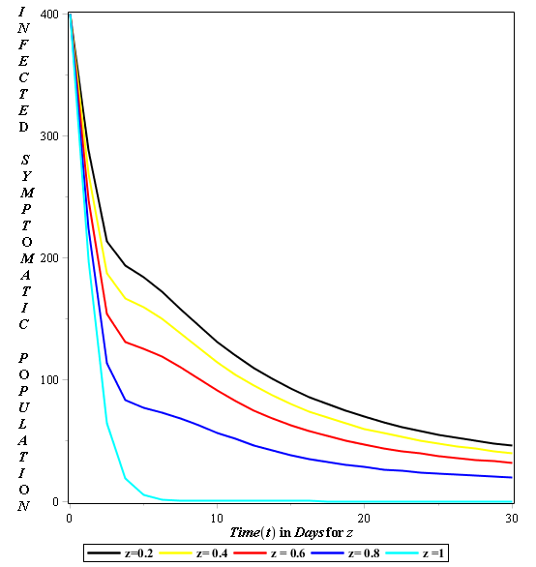

Figure 6. Population of infected symptomatic individuals for z=0.2, 0.4, 0.6, 0.8 and 1

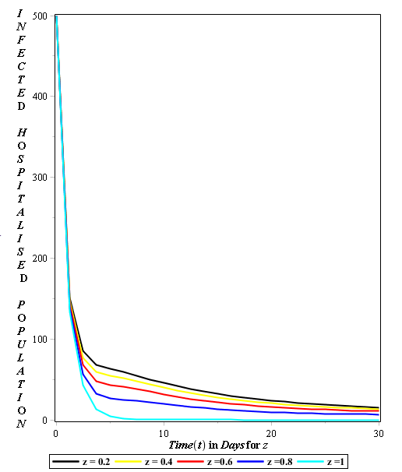

Figure 7. Population of hospitalized individuals for z=0.2, 0.4, 0.6, 0.8 and 1

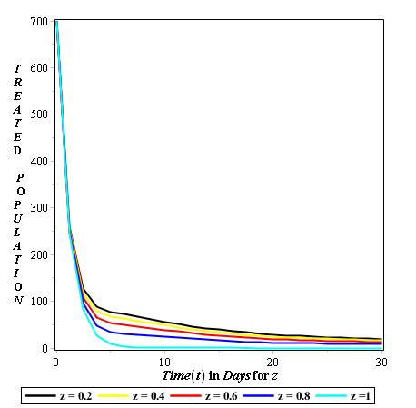

Figure 8. Population of treated individuals for z=0.2, 0.4, 0.6, 0.8 and 1

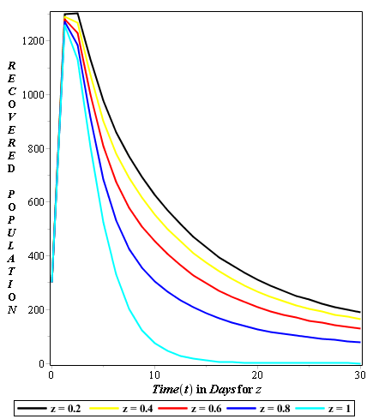

Figure 9. Population of recovered individuals for z=0.2, 0.4, 0.6, 0.8 and 1

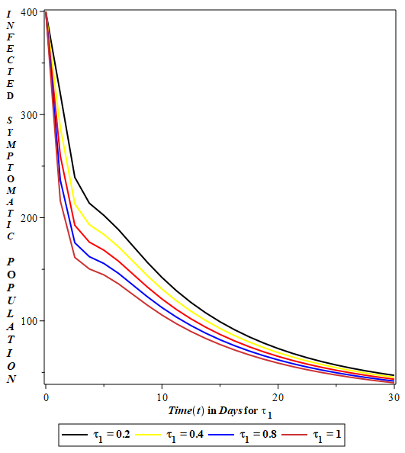

Figure 11. Population of infected symptomatic individuals for $τ_{1}=0.2, 0.4, 0.6, 0.8$ and $1$

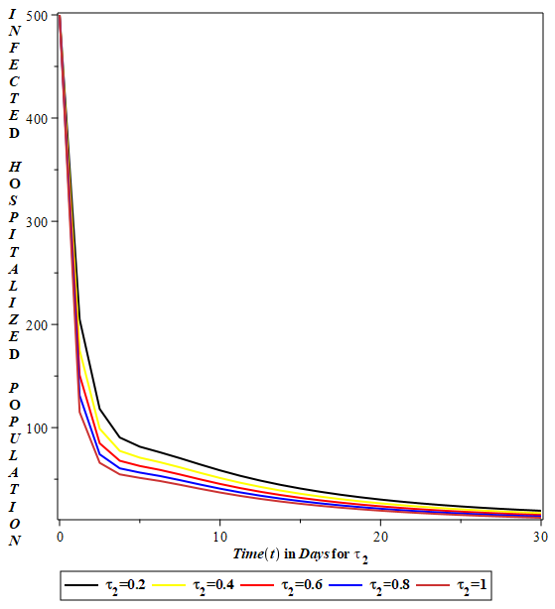

Figure 11. Population of hospitalized individuals for $τ_{2}=0.2, 0.4, 0.6, 0.8$ and $1$

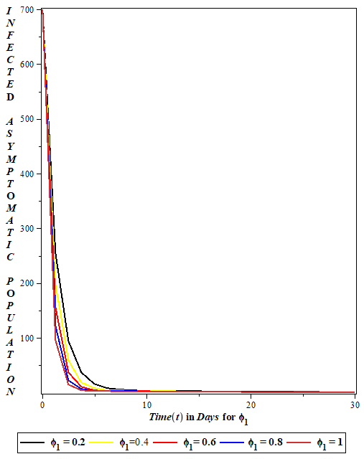

Figure 12. Population of infected asymptomatic individuals for $ϕ_{1}=0.2, 0.4, 0.6, 0.8$ and $1$

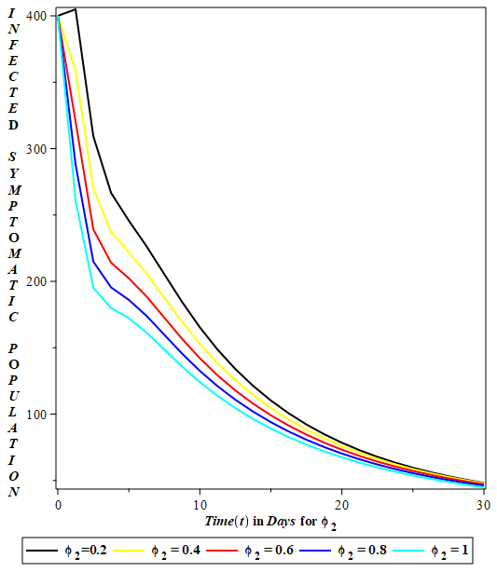

Figure 13. Population of infected symptomatic individuals for $ϕ_{2}=0.2, 0.4, 0.6, 0.8$ and $1$

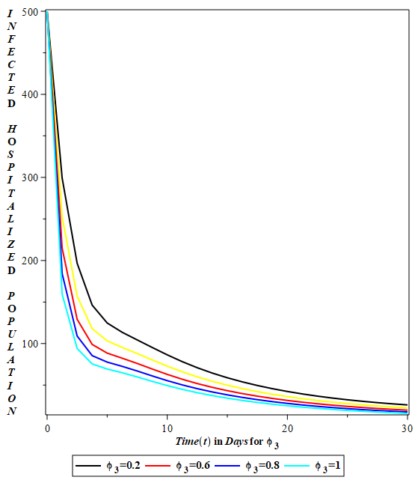

Figure 14. Population of infected symptomatic individuals for $ϕ_{3}=0.2, 0.6, 0.8$ and $1$

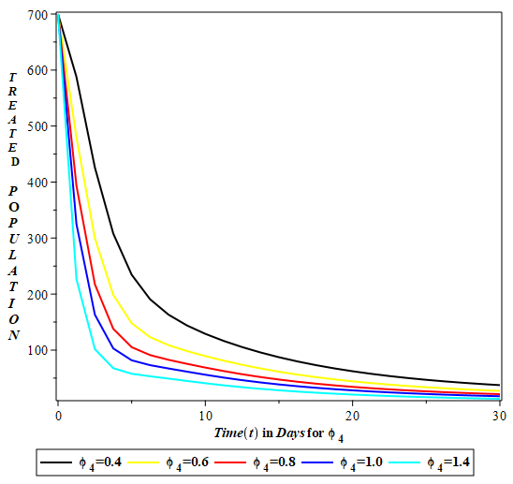

Figure 15. Population of treated individuals for $ϕ_{4}=0.4, 0.6, 0.8, 1.0$ and $1$

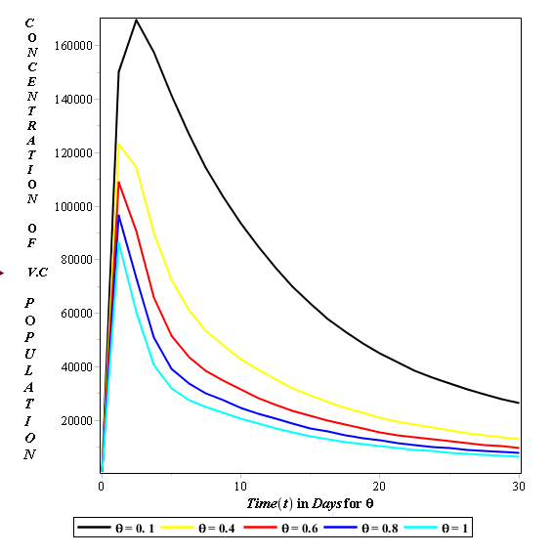

Figure 16. Population of *Vibrio* cholera for $θ=0.1, 0.4, 0.6, 0.8$ and $1$

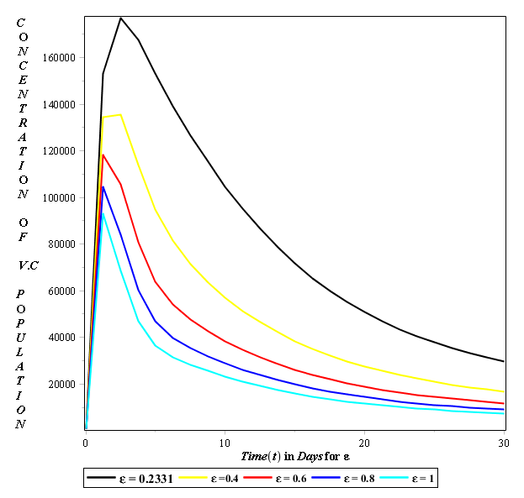

Figure 17. Population of *Vibrio* cholera for $ε=0.2331, 0.4, 0.6, 0.8$ and $1$

Figure 3 showcases the importance of awareness campaigns and compliance parameters $z$ on the susceptible population, implying that at a point when $z$ is introduced at $0.2$ (z = $0.2)$, the population experiences a little increase in size. This is because only a tiny percentage of the susceptible population has adhered to health regulations and is aware of the disease. The graph indicates a massive increase in the susceptible population at a point when $z$ rises up to $1$ $(z=1)$. Which means that the majority of the susceptible population is fully aware of the situation and is genuinely complying with the recommended environmental and personal sanitation practices, drinking clean water and safe food, taking timely treatment, and visiting the doctor on a regular basis.

Figure 4 projects that the increase in awareness campaigns and compliance would grow the rate at which the entire population receives vaccines or gets vaccinated. Which shows the safety of individuals and the level at which the spread of cholera gradually dies out.

The next case scenario occurs in Figure 5, where awareness campaigns and compliance $z$, which include personal hygiene, environmental sanitation, access to clean water and safe food, and regular medical check-ups, are emphasized in order to help exposed individuals lower their risk of contracting *Vibrio* cholerae. The graph has clearly shown that the increase in awareness campaigns and compliance would reduce the rate at which individuals are prone to the disease, hence lowering the population that is exposed. Thus, making sure there are no new incidents as $z$ increases up to $1$.

The Figure 6 illustrates how the awareness campaign has an important effect on the infected asymptomatic individuals because, at a point when everyone is notified about cholera and the entire population is at work in preventing the disease from spreading and people are routinely visiting the doctor for checkups. In line with these happenings, the rate at which individuals get infected asymptomatically would decrease to zero $0$.

Figure 7 showcases the major negative impact $z$ has on the infected symptomatic class, indicating that the increase in $z$ would reduce the rate at which the class gets infected with cholera.

Figure 8 describes the reduction in the hospitalized at a point at which an awareness campaign and compliance are fully introduced in the compartment. Resulting in the reduction of cholera in the population. Figure 9 evaluates the point at which there will be a high decrease in the treated class because individuals are aware of cholera and are complying with health regulations. With this, it has reduced the progression rate of *Vibrio* cholera in the environment. Figure 10 illustrates the growth rate of recovery in the population. Indicating that the more individuals are aware and comply with health policies, the more the class recovers, and at a point there will be no disease to recover from again.

However, Figures 3, 4,5, 6, 7, 8, 9, and 10 have shown the major negative impact that awareness campaigns and compliance have in reducing the spread of *Vibrio* cholera. Adopting these findings would aid in reducing the progression of cholera in the world.

It is observed in Figure 11 that treatment $τ_{1}$ is administered to individuals that are infected symptomatically. The graph shows that the more adequate treatment this infected class receives, the more cholera turns to reduce in the society at large. Figure 12, here the infected hospitalized individuals receive elicit treatment such as Direct Observed Therapy Short-cut (DOTS), and when $τ_{2}$ increases to $1$, the spread of cholera reduces to the minimum.

Furthermore, Figures 11 and Figure 12 shows how $τ_{1}$ and $τ_{2}$ have a great negative impact on the control of cholera in the environment, and it can aid in reducing the progression of cholera in the population.

Figure 13 narrates the importance of having a functional immune system. The graph shows that infected asymptomatic individuals would recover $ϕ_{1}$ due to their immunity. i.e., the higher the immune system, the more infected asymptomatic people recover. This helps in reducing the spread of cholera in the population.

Figure 14 show-case the rate at which adequate treatment would result to high recovery rate $ϕ_{2}$. Resulting to the decrease in the infected Symptomatic compartment.

From Figure 15 it can be seen that the rate at which infected hospitalized individuals recover $ϕ_{3}$ is high due to the rate at which they receive treatment (Direct Observe Therapy Short-Cut). Thereby reducing the rate at which cholera progresses in the population.

Figure 16 explains the rate at which treated individuals recover at a high rate $ϕ_{4}$, and due to this quick recovery, the progression of cholera is reduced in the population.

However, Figure 13, 14, 15, and 16 show how $ϕ_{1}$, $ϕ_{2}$, $ϕ_{3}$, and Figure $ϕ_{4}$ are vital in reducing the progression dynamics of cholera; the more individuals recover, the more the rate at which $R_{e}$ reduces.

Figure 17 shows how quickly the concentration of *Vibrio* cholera in the environment is disinfected $θ$. When the level of disinfection in the environment increases, the population's rate of cholera progression decreases. Also, it demonstrates that $θ$ has a major negative influence on the effective reproduction number $R_{e}$. The concentration of *Vibrio* cholera decays at a steady rate $ε$, as shown in Figure 18. This indicates that cholera's transmission within the population decreases as it decomposes in the environment. The graph describes its significant effects on cholera progression and on the effective basic reproduction number.

**CONCLUSIONS**

A compartmental model for cholera progression dynamics and intervention strategies was developed, which includes susceptible individuals $S\left(t\right)$, vaccinated individuals $V\left(t\right)$, exposed individuals $E\left(t\right)$, asymptomatically infected individuals $I_{A}(t)$, symptomatically infected individuals $I_{S}(t)$, hospitalized infected individuals $I_{H}(t)$, treated individuals $E\left(t\right)$, recovered individuals $R\left(t\right)$, and the concentration of *Vibrios* in the environment is denoted as $M\left(t\right)$. It is established that the model is epidemiologically feasible and well-posed, and it also shows that the disease-free equilibrium exists.

Moreover, the next generation matrix approach was applied to obtain the effective reproduction number $R_{e}$. It was shown that the model has two equilibrium points: the disease-free equilibrium, which is locally asymptotically stable whenever $R_{e}<1$, and unstable otherwise, giving rise to the existence of the endemic equilibrium for $R_{e}>1$. The sensitivity analysis on the effective reproductive number $R_{e}$ was investigated. However, this investigation revealed that the parameters such as recruitment rate, vaccine wane, environment to human transmission rate, and the rate of human contribution to environmental contamination have a major positive impact on the effective reproduction number $R_{e}$. The growth rate of bacteria, the progression rate, and the progression of exposed individuals to symptomatic and human-to-human transmission rates (asymptomatic, symptomatic, hospitalized, and treated) have a minor positive impact on the effective reproduction number $R_{e}$. Parameters like the decay rate of bacteria, the rate of disinfection in the environment, the hospitalization rate, disease-induced death (asymptomatic, symptomatic, hospitalized, and treated), the recovery rate (asymptomatic, symptomatic, hospitalized, and treated), and the detection rate have a minor negative impact on the effective reproduction number ${ R}_{e}$; i.e., when these parameters increase, there would be a low rate at which the disease progresses in the population, leading to a reduction in $R_{e}$.

However, the investigated sensitivity analysis results recommend awareness campaigns and compliance and vaccination rates as the most effective control methods. In order to be accurate, the numerical simulation was carried out to approve the theoretical analysis and explore more patterns of dynamical behaviors of the model. Numerical simulations were also used to examine the effect of the parameters of the model. The results reveal that awareness campaigns and compliance, such as personal hygiene, environmental sanitation, access to clean water, safe food, regular medical check-ups, vaccination rates, timely treatment, good immunity, disinfection rates, and decay rates of bacteria, would reduce the rate at which cholera progresses in society.

# REFERENCES

1. World Health Organization. (2020). Cholera fact sheet. *World Health Organization*.
2. Haque, U., Hossain, M. I. & Rahman, M. (2018). Stochastic modelling of cholera transmission in refugee camps: The role of crowding and sanitation. *PLoS Neglected Tropical Diseases, 12(6),* e0006612.
3. Centers for Disease Control and Prevention. (2022).
4. World Health Organization (WHO). (2024, July). Cholera in the WHO African region: Monthly regional cholera bulletin, July 2024.WHO Regional office for Africa.
5. Kumar, P. N. (2019). Cholera: A global threat. *Journal of Infectious Diseases, 220(5),* 743-754.
6. World Health Organization. (2021). Cholera: *Prevention and control*. Geneva: WHO.
7. Said, B., Rahman, M. & Hossain, M. (2021). The effect of human mobility on cholera spread: Insights from network models. *Epidemiology and Infection, 149,* e5.
8. National Agency for Food and Drug Administration and Control (NAF DAC). (2020).
9. Mart, J., Ogunbawo, T. & Umar, A. (2024b). Cholera outbreak in Lagos: Challenges and interventions. *Journal of Public Health in Africa, 15(2),* 45-60
10. Nguyen, Q. H., Bui, Q. T., & Tran, H. (2020). A spatial model of cholera trans mission: Integrating environmental factors and climate variability. *International Journal of Environmental Research and Public Health, 17(2),* 500.
11. Gonzalez, A. C., Rojas, C. & Pineda, M. (2021). Evaluating the impact of cholera vaccination campaigns: The importance of timely and widespread efforts. *BMC Public Health, 21(1),* 172.
12. UNICEF. (2024). Cholera in Eastern and Southern Africa: Response overview.
13. Ali, M., Paltiel, A. D., & Karpati, A. (2018). Socio-economic factors and cholera transmission: A model addressing disparities in access to healthcare and sanitation. *Journal of Epidemiology and Community Health, 72(1)*, 12-18.
14. Zhou, Y., Lin, Q. & Wang, Y. (2020). Simulating cholera outbreaks with agent-based modelling: Evaluating intervention strategies for vaccination and water quality. *BMC Public Health, 20,* 186.
15. Finger, R., Kuhlman, T., & Walther, M. (2021). The role of mathematical modelling in the management of cholera outbreaks: A review. *Epidemiology and Infection, 149,* e92.
16. Schmid, H., & Wiese, C. (2021). The role of stochastic processes in cholera modeling: Understanding randomness in outbreak dynamics. *Mathematical Medicine and Biology, 38(1),* 45-59
17. World Health Organization. (2022). Endemic. *In WHO Glossary of terms*.
18. P. Van den Driessche, P. & Watmough, J.(2002). Reproduction numbers and sub-threshold endemic

equilibria for compartmental models of disease transmission. *Mathematical Biosciences, 180(12),*29-48.

1. Diekman, O., Heesterbeek, J.A.P. & Metz, J.A.P. (1990). On the Definition and Computation of the Basic Reproduction Ratio in the Model of Infectious Disease in Heterogeneous Populations. *Journal of Mathematical Biology, 2,* 265-382.
2. Bihan, F. & Alicia, D. (2017). Descartes' Rule of Signs for Polynomial Systems Supported on Circuits. *International Mathematics Research Notices, (22),* 6867–6874
3. Anorne, O. F. & Okeke, A. A. (2020). Mathematical model for Lassa fever transmission and control. *Mathematics and computer science, vol 5, No.6* 2020pp, 110-188.
4. Martins, O. O., Atiku, F. A. & Juuko, H. (2022). Mathematical model for prevention and control of cholera transmission in a variable population. *RESEARCH IN MATHEMATICS 2022, VOL. 9,* NO. 1, 1–13.
5. Osman, S., Makinde, O. D. & Theuri, D.M. (2018). Mathematical modelling of transmission dynamics of anthrax in human and animal population, *Mathematics Theory Model. 8*, 47–67.
6. Olopade I. A, Ajao S. O., Idayat M. T., Iorhen S. F. and Philemon E. M. (2024). Analysis of a mathematical model of transmission dynamics of HIV/AIDS with saturated incidence rate. *Ethiopia. Journal of Science & Technology,* 17(2): 123-141.
7. Olopade, I.A., Adesanya, A.O. and Akinwumi, T.O. (2021a). Mathematical Transmission of SEIR Epidemic Model with Natural Immunity.Asian Journal of Pure and Applied Mathematics. 3(1):19-29.
8. Akinola, E. I; Awoyemi, BE; Olopade, IA; Falowo, OD; Akinwumi, TO (2021). Mathematical Analysis of a Diarrhoea Model in the Presence of Vaccination and Treatment Waves with Sensitivity Analysis. *J. Appl. Sci. Environ. Manage*. Vol. 25 (7) 1077-1084.
9. Olopade, I.A., Adewale, S.O., Mohammed, I.T., Adeniran, G.A., Ajao, S.O. and Ogunsola, A.W. (2021b). Effect of Effective Contact Tracing in Curtaining the Spread of Covid19. Asian Journal of Research in Biosciences. 3(2):118-134.
10. Olopade, I.A., Adesanya, A.O. and Mohammed, I.T. (2017). Mathematical Analysis of the Global Dynamics of an SVEIR Epidemic Model with Herd Immunity. International Journal of Science and Engineering Investigations. (IJSEI). 6(69):141-148.
11. Adesola I. O., Mohammed I. T., Philemon M. E., Akinwumi T. O., Sangoniyi S. O., Adeniran G. A., Ajao S. O., & Adewale S. O. (2024a). A Study of a Class Continuous SIR Epidemic Model with History. *Journal of Basics and Applied Sciences Research*, *2*(1): 54–60. <https://doi.org/10.33003/jobasr-2024-v2i1-28>
12. Olopade I. A, Akinwumi T. O, Ajao S. O, Mohammed I. T, Sangoniyi S. O, Adeniran G. A, Bello B. O and Adewale S. O (2024a). Analyzing the Mathematical Impact of Vaccination in Mitigating Rift Valley Fever Spread among Livestock. African Journal of Sciences and Traditional Medicine, 1(1): 43-68. <https://doi.org/10.58578/ajstm.v1i1.3361>
13. Adewale S.O., Adeniran G.A., Olopade I.A., Ajao S.O., Mohammed I.T. (2017). Mathematical and Sensitivity Analysis of the Dynamical Spread of Cholera. International Journal of Innovation and Applied Studies. ISSN 2028-9324, 19(1), pp. 46-54.
14. Olopade I. A., Ajao S, Akinwumi T, Adeniran G, Aderenle R, Adesanya A (2024b). Mathematical Modelling of the Impacts of Syphilis Multi-stage Treatments. ***Modeling Earth Systems and Environment,*** 10: 5489–5502. <https://doi.org/10.1007/s40808-024-02075-3>
15. Philemon M. E., Olopade I. A., &Ogbaji E. O. (2023). Mathematical Analysis of the Effect of Quarantine on the Dynamical Transmission of Monkey-Pox. Asian Journal of Pure and Applied Mathematics. 5(1): 473–492.
16. Olopade IA, Adewale SO, Mohammed IT, Ajao SO, Oyedemi OT (2016). Mathematical analysis of the role of detection in the dynamical spread of HIV-TB Co-infection. Journal of Advances in Mathematics.;11(10):5715-5740.
17. Adesola, O.I., Oloruntoyin, S.S., Emmanuel, P.M., Temilade, M.I., Adeyemi, A.G., Oladele, A.S., Mamman, A.U and Kareem, A.A. (2024b). Mathematical modelling and analyzing the dynamics of condom efficacy and compliance in the spread of HIV/AIDS. Asian Research Journal of Current Science 6(1): 54–65.
18. Adesola, O. I., Uwaunyin, N. G., Oladapo, O. P.(2025).

Mathematical Modeling and Analysis of Diarrhea Transmission with Campaign-Based Control Measure and Treatment. *Quantum Journal Of Medical and Health Sciences*, *4*(2), 9-30. <https://doi.org/10.55197/qjmhs.v4i2.128>