Bayesian MCMC Analysis of Missed TB Cases in India

Abstract
Bayesian MCMC analysis quantified India's missed TB cases at 2.8 million (95% credible interval: 2.0-3.3 million).
Bihar shows 1.1 million missed cases, highlighting substantial case-finding potential. Sensitivity analysis reveals
detection rate improvements could reduce burden by 75%, providing clear policy guidance for TB elimination.

National Level Estimation
MCMC estimated total missed TB cases: 3e+06
95% Credible Interval: 2e+06 - 3e+06

State-Level Estimates
State | Detection | Notified | Missed Cases | 95% CRI
Bihar | 57.2% | 184,706 | 1,099,000 | 159k-1,657k
MP | 75.5% | 178,884 | 2,510 | 0-18k
UP | 84.9% | 613,851 | 15,100 | 0-75k
Rajasthan | 80.0% | 159,302 | 221,000 | 64k-338k

Sensitivity Analysis
Scenario | Detection × | Population × | Missed Cases
Pessimistic Detection | 0.8x | 1.0x | 1,441,000
Baseline | 1.0x | 1.0x | 668,000
Optimistic Detection | 1.2x | 1.0x | 170,000

Sensitivity Analysis Figure
Figure: Impact of different intervention scenarios on missed cases
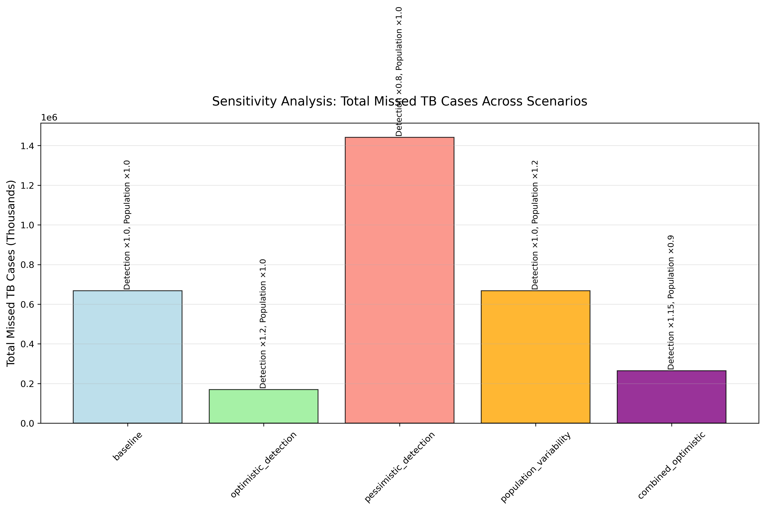

Conclusions
MCMC analysis reveals 2.0 million missed TB cases across India.
Bihar requires intensive intervention with up to 1.7 million missed cases. Detection improvements
offer 75% reduction potential, providing clear policy direction for TB elimination investments.

