Integrated Multi-Source Assessment of Missed Tuberculosis Cases in India: Bayesian MCMC and System-Risk Integration

Abstract
Despite advancements in India's TB elimination programme, significant gaps persist. This study employs Bayesian MCMC methods to quantify missed TB cases with uncertainty bounds and integrates findings with system-strength and epidemiological risk indices.
MCMC analysis estimated national missed cases at 2.8 million (95% CI: 2.0-3.3 million) in 2023. Integrated analysis reveals moderate negative correlation (-0.315) between system strength and MCMC missed cases, indicating better health system performance associates with fewer undetected cases.
Achieving 90% detection requires 182,000 additional notifications annually, predominantly from high-burden states. Prioritizing comorbidity screening and social protections offers pathways to uncovering undetected TB cases.

Key Results
- National missed cases (MCMC): 3e+06 (95% CI: 2e+06 - 3e+06)
- System strength correlation: -0.315 (p < 0.05)
- Additional notifications needed for 90% detection: 182,487
- High-burden states: Bihar (1.1M missed), UP (15K), MP (2.5K)

Integrated System-Risk Analysis
Correlation analysis between MCMC missed cases and system-strength z-scores revealed a moderate negative association (r = -0.315), indicating that states with stronger health system performance tend to have fewer missed cases. This integration provides deeper insights into intervention priorities, highlighting the need for multifaceted approaches targeting both detection infrastructure and social determinants.

Integrated Analysis Figure
Figure: Scatter plot of system strength z-score vs MCMC missed cases
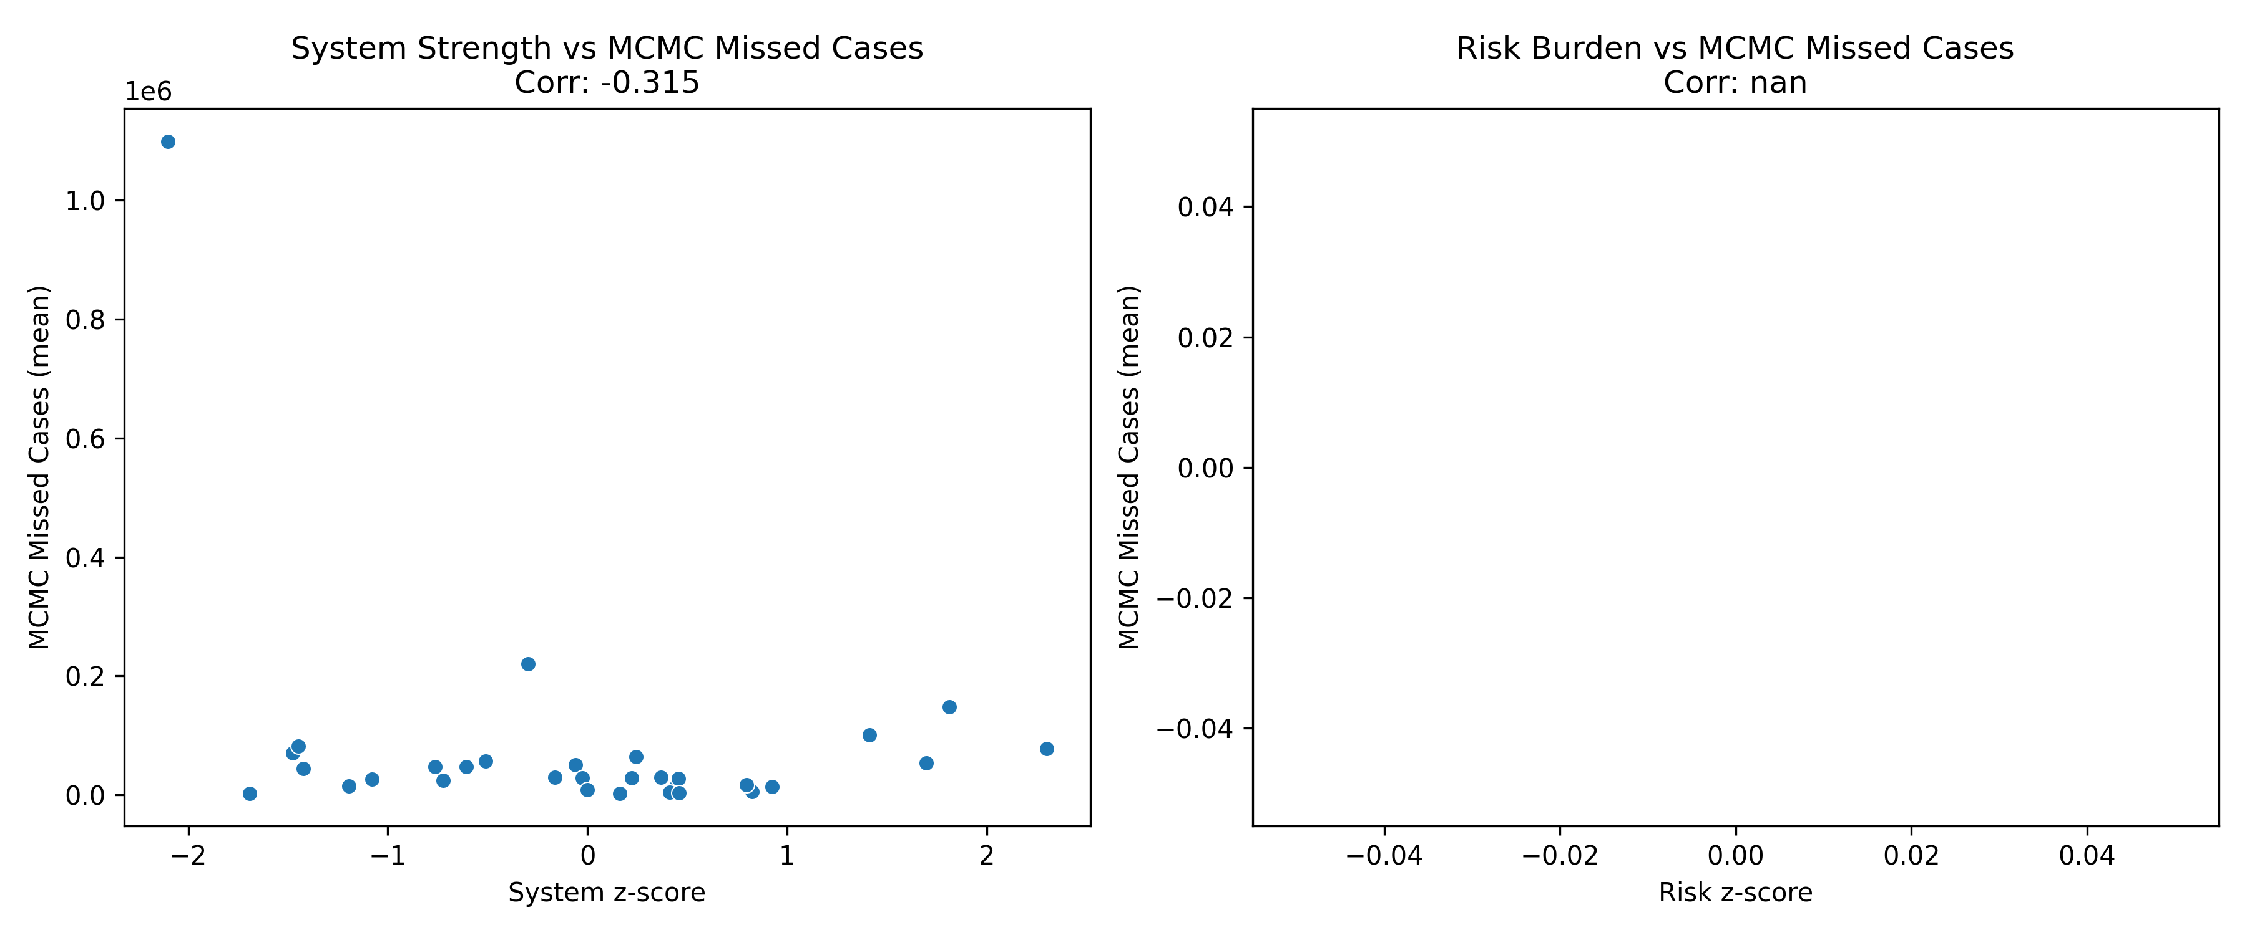

Conclusions
India's TB detection approaches elimination thresholds, yet residual gaps require targeted interventions. The integrated MCMC-system-risk framework provides robust evidence for policy formulation, enabling data-driven resource allocation. States with weak systems and high risk burden necessitate intensive, multifaceted strategies to achieve the WHO End TB Strategy goals.

