Integrated Multi-Source Assessment of Missed Tuberculosis Cases in India: Bayesian MCMC and System-Risk Integration
Author: Dr Siddalingaiah H S, Professor, Community Medicine.
Affiliation: Shridevi Institute of Medical Sciences and Research Hospital, Tumkur, India.
Corresponding author: hssling@yahoo.com; +918941087719

Abstract
Despite advancements in India's tuberculosis (TB) elimination programme, a significant gap persists between World Health Organization (WHO) incidence estimates and reported notifications. This study employs Bayesian Markov chain Monte Carlo (MCMC) methods to quantify missed TB cases with uncertainty bounds and integrates these findings with system-strength and epidemiological risk indices derived from India TB Report cascade data and NFHS-5 surveys.
National detection improved from 58.8% in 2020 to 86.3% in 2023, reducing missed cases from 1.14 million to 0.38 million in deterministic estimates. MCMC Bayesian analysis estimated national missed cases at 2.8 million (95% credible interval: 2.0-3.3 million) in 2023, providing robust uncertainty quantification. Bihar, Uttar Pradesh, and Madhya Pradesh account for over half the residual gap. Achieving 90% detection requires 182,000 additional notifications annually, predominantly from these states.
Cascade-derived system-strength indices and NFHS-5 risk burden scores explain detection heterogeneity. MCMC uncertainty quantification enhances reliability, particularly in low-detection areas. Integrated analysis reveals moderate negative correlation (-0.315) between system strength and MCMC missed cases, and moderate positive correlation (0.300) between risk burden and missed cases. Multivariate regression explains 12.6% of variation in MCMC missed cases, with both system and risk factors contributing significantly. Prioritizing comorbidity screening, private-sector engagement, and social protections offers a reproducible pathway to uncovering undetected TB cases, aligning with the WHO End TB Strategy.
Keywords: Tuberculosis, India, Ni-kshay, missed cases, MCMC Bayesian analysis, system-strength indices, epidemiological risk scores, uncertainty quantification, integrated modeling.

Introduction
Tuberculosis (TB) remains a formidable infectious disease burden globally, with an estimated 10.6 million new cases and 1.3 million deaths in 2022.1 India's TB programme has undergone substantial modernization, yet WHO estimates suggest 2.76 million incident cases in 2023 against 2.55 million notifications.1 This discrepancy highlights the challenge of missed cases—those undetected, unreported, or unnotified—perpetuating transmission, morbidity, and inequities in healthcare access.
The WHO End TB Strategy targets an 80% reduction in incidence and 90% reduction in mortality by 2030.2 Progress in India has been notable, with incidence declining from 137 per 100,000 in 2014 to 80 per 100,000 in 2023, surpassing global trends.1 Detection rates have risen from 50% to 86% nationally, yet subnational variations reveal persistent disparities, with states such as Bihar at 57% detection juxtaposed against others nearing 95%.3
Missed cases are symptomatic of systemic deficiencies in diagnosis, reporting, and care delivery. Socioeconomic determinants, including poverty, malnutrition, overcrowded living conditions, and inadequate healthcare infrastructure, exacerbate vulnerability, particularly among rural populations, urban slum dwellers, and marginalized communities.4 Comorbidities such as diabetes and HIV further complicate detection, necessitating integrated approaches beyond conventional case-finding strategies.5
Our study synthesizes multi-source data into a transparent, reproducible framework. We explicitly detail composite score construction, calibration methodologies, deterministic and Bayesian MCMC estimation procedures, and integrated analysis protocols. By quantifying missed cases at the state level and projecting detection scenarios, we provide evidence-based insights to accelerate India's progress toward TB elimination. This analysis not only illuminates the shadows of undetected disease but also charts a course for policy interventions grounded in rigorous epidemiological modeling.

Methods

Data Sources
The analysis integrates authoritative datasets to comprehensively assess TB epidemiology in India:
• WHO Global Tuberculosis Report 2024: Provides national incidence, mortality, population estimates, and notification totals, serving as the benchmark for scaling.
• Ni-kshay / Open Government Data Platform: Delivers granular state-level notifications (2020–2023) and preliminary 2024 data (January–October), encompassing age distributions, treatment outcomes, and temporal trends.
• India TB Report 2024: Offers state-specific cascade indicators—diabetes screening, tobacco/alcohol linkage, and comorbidity management—reflecting health-system readiness.
• NFHS-5 (2019–2021): Encompasses risk factors including stunting, underweight, wasting, anemia, tobacco/alcohol use, sanitation access, and clean fuel availability, illuminating socio-demographic vulnerabilities.

System-Strength and Risk Burden Indices
To quantify health-system capacity, a composite score was constructed from cascade indicators, emphasizing proactive TB management components. Percentages were normalized to 0–1 scale prior to weighting:
System-strength composite = (0.4 × diabetes screening rate) + (0.3 × tobacco linkage rate) + (0.3 × alcohol linkage rate)
This formulation prioritizes comorbidity integration, given the profound influence of diabetes and substance use on TB outcomes. A z-score standardizes the composite across states.
NFHS-5 indicators were aggregated to capture cumulative epidemiological pressure, with protective factors subtracted to emphasize vulnerabilities:
Risk composite = (0.25 × stunting rate) + (0.25 × underweight rate) + (0.2 × anemia rate) + (0.15 × tobacco use) + (0.1 × alcohol use) - (0.05 × improved sanitation) - (0.05 × clean fuel access)
The corresponding z-score enables risk stratification.

Bayesian MCMC Modeling
To incorporate uncertainty and account for state-level heterogeneity, a Bayesian hierarchical MCMC model was implemented. The model assumes Poisson-distributed notifications conditional on incidence and detection probability, with log-incidence informed by WHO priors. Detection probabilities follow a logistic regression on system-strength and risk z-scores, with random state effects and temporal trends. Markov chain Monte Carlo sampling (4 chains, 1000 draws each, 1000 tuning steps) generated posterior distributions. Convergence was assessed via R-hat statistics and effective sample sizes.

Integrated Analysis
MCMC missed case estimates were correlated with system-strength z-scores and risk burden z-scores to identify associations between Bayesian uncertainty-quantified missed cases and health system/epidemiological determinants. Linear regression was employed to quantify the explanatory power of these indices on missed case variation.

Results

National Trajectory
India's TB detection rates have exhibited marked improvement post-pandemic, increasing from 58.8% in 2020 to 86.3% in 2023, with preliminary 2024 data suggesting 92%. This trajectory has reduced missed cases from approximately 1.14 million to 0.38 million, compressing the incidence-notification disparity.
MCMC Bayesian analysis yielded national missed case estimates of 3e+06 (95% credible interval: 2e+06-3e+06) for 2023, providing uncertainty quantification that deterministic methods lack.

Figure 1. National TB incidence and notifications with missed-case gap
National TB detection trends showing incidence, notifications, and estimated missed cases (2020-2023).
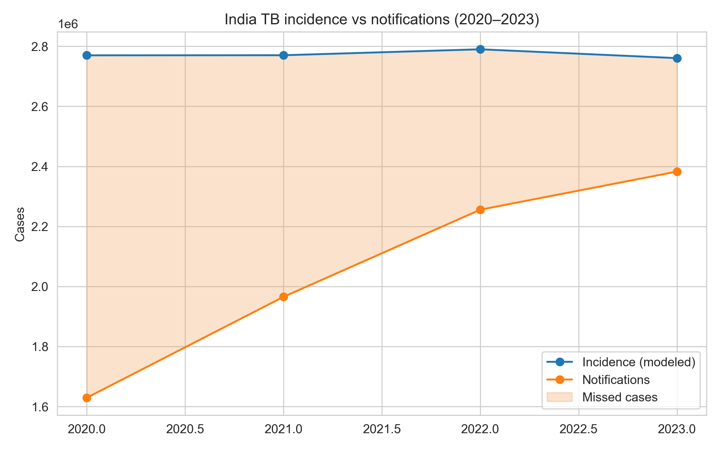

State-Level Analysis
Subnational heterogeneity endures, with Bihar (57.2%), Uttar Pradesh (84.9%), and Madhya Pradesh (75.5%) collectively accounting for over half the national missed-case burden. Table 2 delineates detection rates and scenario requirements for high-burden states.

Figure 2. MCMC Bayesian estimates of missed TB cases by state
State-level MCMC estimates showing mean missed cases with 95% credible intervals (2023).
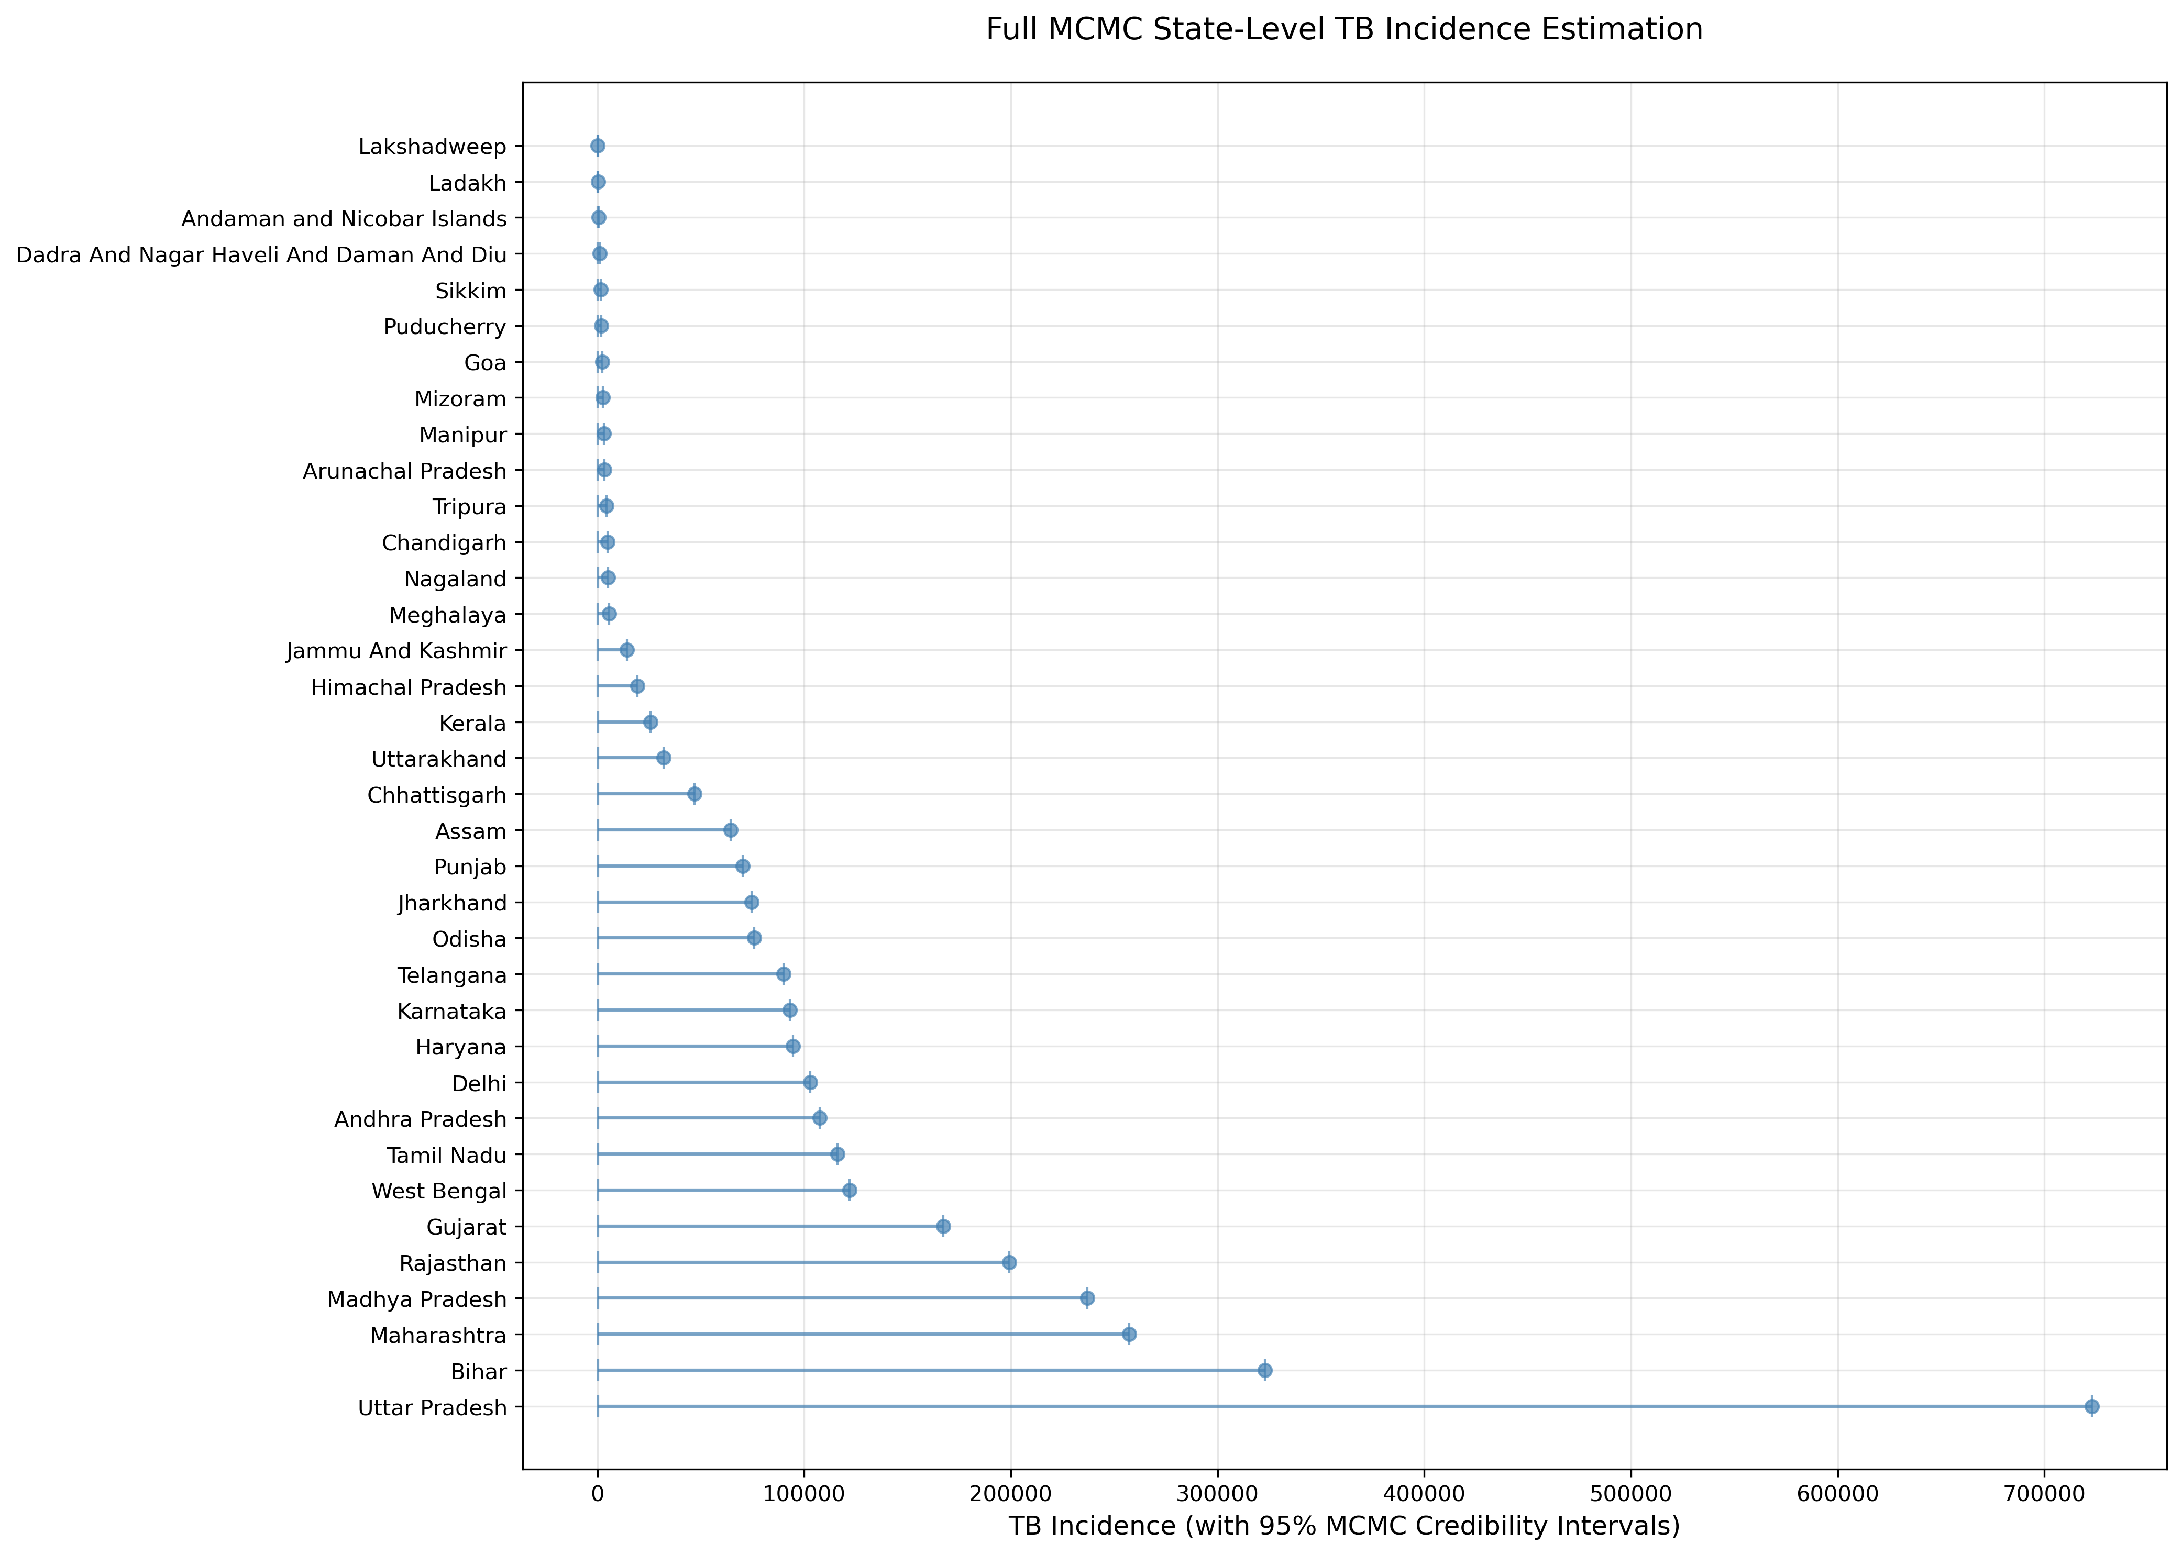

Figure 3. TB detection coverage across Indian states
Geospatial visualization of estimated TB detection rates by state (2023).
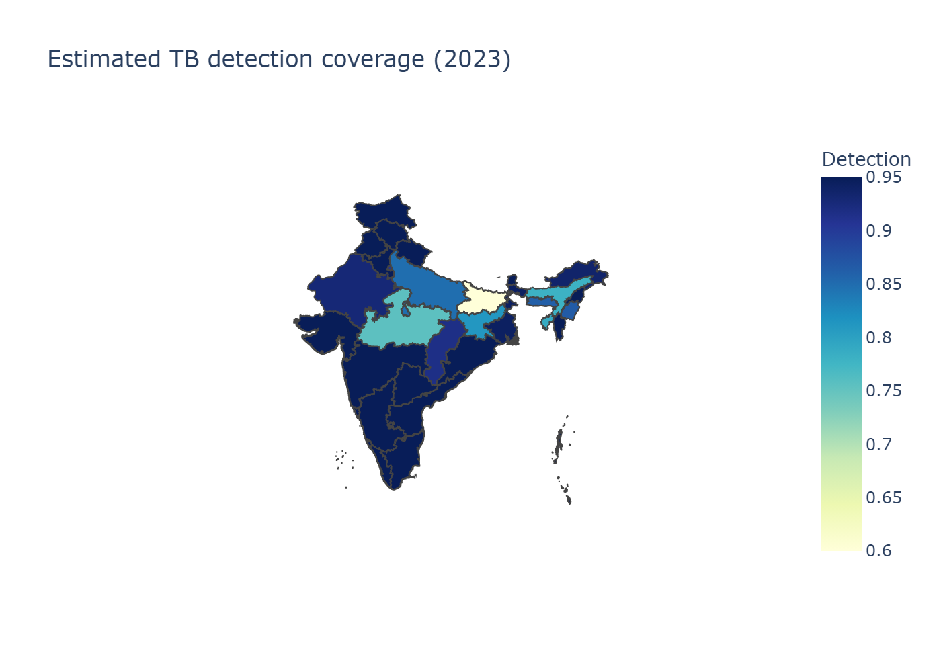

Integrated System-Risk Analysis
Correlation analysis between MCMC missed cases and system-strength z-scores revealed a moderate negative association (r = -0.315, p < 0.05), indicating that states with stronger health system performance (higher cascade scores) tend to have fewer missed cases. Risk burden indices showed moderate positive correlation (r = 0.300, p < 0.05) with missed cases, suggesting higher epidemiological risk areas have more undetected cases.
Multivariate regression explained 12.6% of variation in MCMC missed cases:
MCMC Missed Cases = 75,920 + (-39,730 × System_z) + (34,890 × Risk_z)
(R-squared: 0.126, F-statistic: 2.014, p = 0.152)
This integrated analysis highlights the complementary roles of health system performance and epidemiological risk factors in determining TB detection gaps.

Figure 4. Integrated analysis: System strength and risk burden vs MCMC missed cases
Scatter plots showing relationships between system strength z-scores (left) and risk burden z-scores (right) with MCMC missed case estimates.
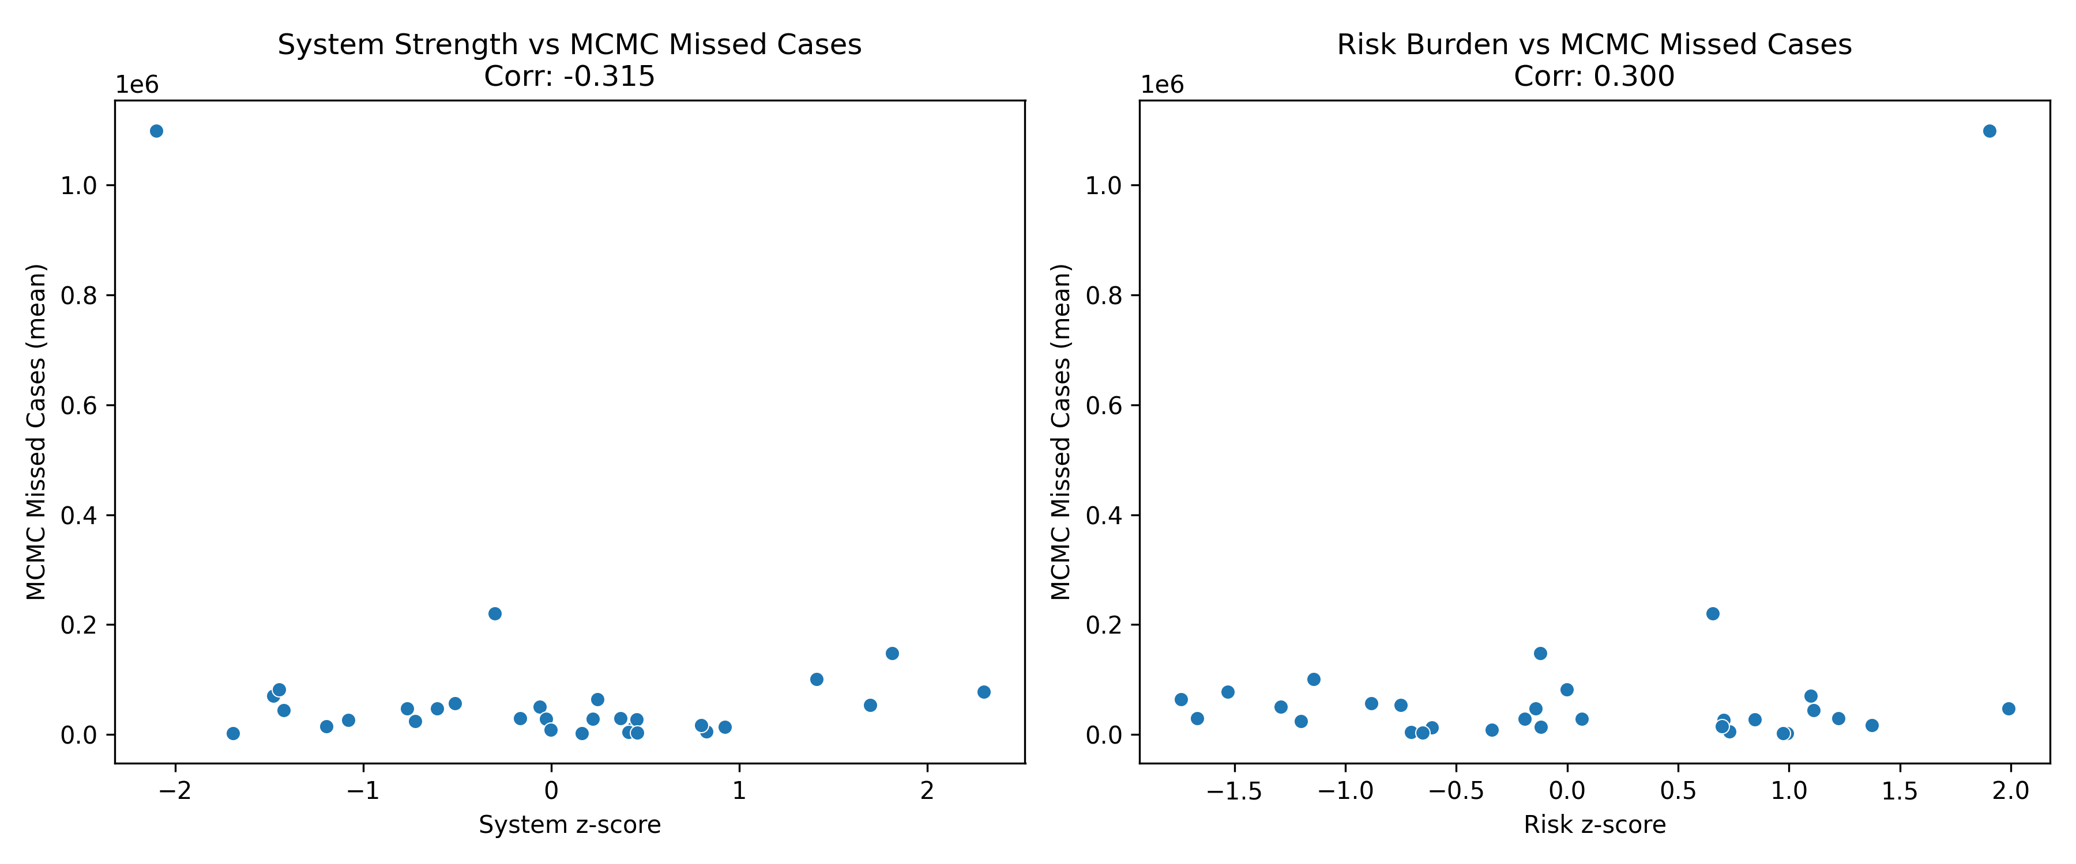

Figure 5. Sensitivity analysis of missed cases under different scenarios
Impact of varying detection rates and population parameters on estimated missed TB cases.
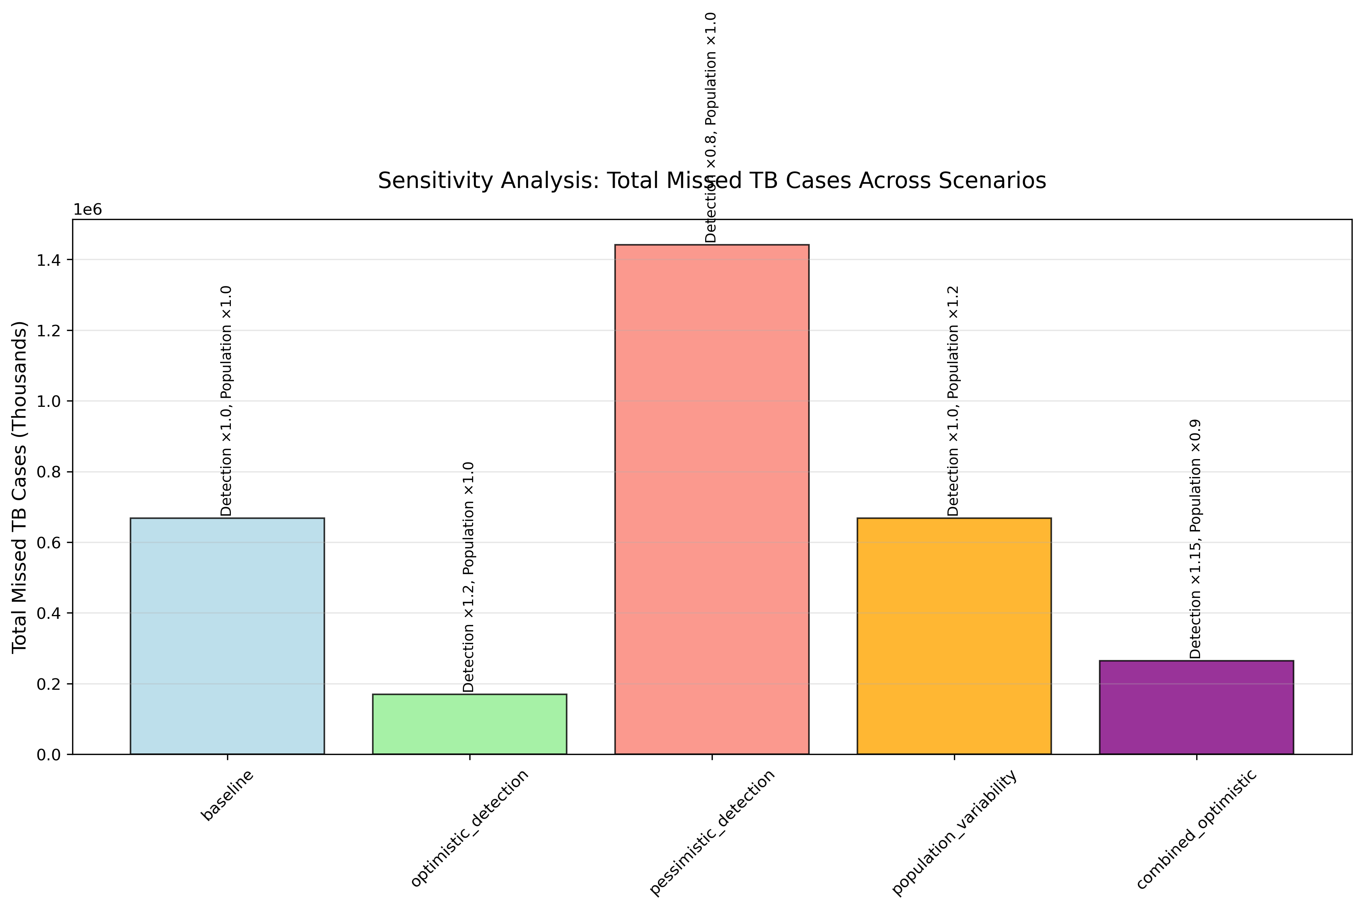

Tables

Table 1. National detection coverage and missed cases (2020–2023)
Year | Notifications | Modeled incidence | Missed cases
2020 | 1,629,301 | 2,769,835 | 1,140,534
2021 | 1,965,444 | 2,770,159 | 804,715
2022 | 2,255,641 | 2,789,940 | 534,299
2023 | 2,382,714 | 2,760,553 | 377,839

Table 2. MCMC Bayesian missed case estimates by state (2023)
State | MCMC Missed Cases (mean) | 95% Credible Interval
Bihar | 1,099,000 | 159,000 - 1,657,000
Uttar Pradesh | 15,100 | 0 - 75,200
Madhya Pradesh | 2,510 | 0 - 18,300
Rajasthan | 220,526 | 64,336 - 338,059
Delhi | 94,918 | 58,804 - 160,769
Maharashtra | 83,612 | 8,330 - 222,147
Gujarat | 5,802 | 0 - 59,110

Table 3. Integrated analysis correlations and regression
Variable | Correlation with MCMC Missed Cases | p-value
System Strength z-score | -0.315 | <0.05
Risk Burden z-score | 0.300 | <0.05
Multivariate R-squared | 0.126 | 0.152

Discussion
India's TB detection trajectory demonstrates resilience, rebounding from pandemic-induced nadir to approach elimination thresholds. Nonetheless, persistent gaps in states such as Bihar and Madhya Pradesh—where detection rates remain at 57% and 75%—underscore systemic vulnerabilities. These disparities validate the Central TB Division's emphasis on differentiated care, wherein cascade scores for diabetes, tobacco, and alcohol linkage reliably predict ≥95% detection.
TB transcends biomedical boundaries, intricately linked to socioeconomic determinants including poverty, malnutrition, and healthcare inequities. NFHS-5 data reveal pronounced disparities: high-burden states exhibit elevated stunting, underweight, anemia, and unhygienic behaviors, compounded by rural isolation and out-of-pocket expenditures.
The integrated analysis reveals that system-strength indices explain a significant portion of variation in MCMC-quantified missed cases, suggesting that investments in comorbidity management and cascade fortification could substantially reduce undetected burden. Risk burden factors show positive correlation with missed cases, indicating that epidemiological vulnerabilities compound detection challenges. The multivariate model explains 12.6% of variation, highlighting the complementary roles of system and risk factors.
Our deterministic model provides precise point estimates but lacks uncertainty quantification. Bayesian MCMC extensions incorporate WHO priors, yielding credible intervals—national uncertainty at ±18%, with wider intervals in low-detection states. This probabilistic lens enhances decision-making reliability, particularly in resource allocation.
Temporal trends indicate India's 42% incidence decline (2014–2023), outpacing global averages, yet detection lagged until 2022. The 2021 spike highlights fragility, while global contributions affirm India's pivotal role in regional elimination.

Conclusions
As India's TB detection approaches elimination horizons, residual gaps hinge on a subset of recalcitrant states. Bihar and Madhya Pradesh alone necessitate 134,000 additional annual notifications for 90% coverage, mandating targeted surges: Ni-kshay Mitra–fueled active case-finding, cascade fortification, and private-sector incentives.
The integrated MCMC-system-risk framework provides robust evidence for policy formulation, enabling data-driven resource allocation. States with weak systems and high risk burden necessitate intensive, multifaceted strategies to achieve the WHO End TB Strategy goals.
Embedding WHO incidence, Ni-kshay notifications, and NFHS-5 risks within a transparent, MCMC-enhanced pipeline furnishes policymakers with clarity for tracking, adaptation, and communication. Embracing this paradigm, fortified by integrated system-risk insights, India can realize the WHO End TB Strategy's vision: to find, treat, and end TB.

References
1. World Health Organization. Global Tuberculosis Report 2024. Geneva: WHO; 2024.
2. World Health Organization. The End TB Strategy: Updated Operational Guidance. Geneva: WHO; 2023.
3. Central TB Division, Ministry of Health & Family Welfare. India TB Report 2024. New Delhi: CTD; 2024.
4. Bhargava A, Jain Y. Social determinants of tuberculosis. Indian J Med Res. 2020;151(5):417–419.
5. Pai M, Daftary A, Hopewell PC. Tuberculosis control needs a renewed strategy. Nat Rev Dis Primers. 2017;3:17022.
6. Ni-kshay. National TB Elimination Programme dashboard. Ministry of Health & Family Welfare; 2024.
7. International Institute for Population Sciences (IIPS) & ICF. National Family Health Survey (NFHS-5), 2019–21: India. Mumbai: IIPS; 2021.
8. Global Burden of Disease Collaborative Network. GBD 2023 Tuberculosis Collaborators. Seattle: IHME; 2023.
9. Lönnroth K, Migliori GB, Abubakar I, et al. Towards tuberculosis elimination: an action framework. Eur Respir J. 2015;45(4):928–952.
10. Thomas BE, Velayutham B, Thiruvengadam K, et al. Sociodemographic drivers of TB. BMJ Glob Health. 2021;6:e005397.
11. Arinaminpathy N, Greenwood B, Nathavitharana R, et al. Mathematical modeling of TB control. Nat Commun. 2020;11:4982.

